Group 18 – Class Design Specification
Group 18 – Class Design Specification

Design for class “Cart”
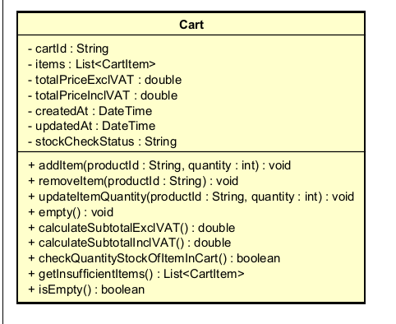

Table 1. Example of attribute design
# | Name | Data type | Default value | Description
1 | cartId | String | null | Cart ID
2 | items | List | [] | List of items in the cart
3 | totalPriceExclVAT | double | 0.0 | Total price excluding VAT
4 | totalPriceInclVAT | double | 0.0 | Total price including VAT
5 | createdAt | DateTime | now() | Cart creation time
6 | updatedAt | DateTime | now() | Last updated time
7 | stockCheckStatus | String | "UNCHECKED" | Stock checking status

Table 2. Example of operation design

# | Name | Return type | Description (purpose)
1 | addItem(productId:String, quantity:int) | void | Add a product to the cart
2 | removeItem(productId:String) | void | Remove a product from the cart
3 | updateItemQuantity(productId:String, quantity:int) | void | Update item quantity
4 | empty() | void | Clear the entire cart
5 | calculateSubtotalExclVAT() | double | Calculate total price excluding VAT
6 | calculateSubtotalInclVAT() | double | Calculate total price including VAT
7 | checkQuantityStockOfItemInCart() | boolean | Check stock availability for each item
8 | getInsufficientItems() | List | Get list of items with insufficient stock
9 | isEmpty() | boolean | Check if the cart is empty

Parameters :
- productId: product identifier
- quantity: desired quantity
Exceptions:
- InvalidQuantityException: if quantity ≤ 0
- ProductNotFoundException: if the product does not exist
- InsufficientStockException: if requested quantity exceeds available stock
Methods:
- addItem(): Adds a new item or increases quantity if the item already exists in the cart.
- checkQuantityStockOfItemInCart(): Iterates through all CartItems and compares requested quantity with available stock.
- calculateSubtotalInclVAT(): Adds 10% VAT to item prices according to the problem requirement.

Design for class “CartItem”
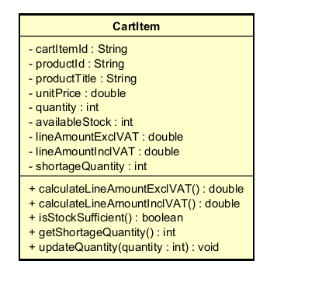

Table 1. Example of attribute design
# | Name | Data type | Default value | Description
1 | cartItemId | String | null | Cart item ID
2 | productId | String | null | Product ID
3 | productTitle | String | "" | Product title
4 | unitPrice | double | 0.0 | Unit price excluding VAT
5 | quantity | int | 1 | Selected quantity
6 | availableStock | int | 0 | Current available stock
7 | lineAmountExclVAT | double | 0.0 | Line amount excluding VAT
8 | lineAmountInclVAT | double | 0.0 | Line amount including VAT
9 | shortageQuantity | int | 0 | Quantity shortage if stock is insufficient

Table 2. Example of operation design
# | Name | Return type | Description (purpose)
1 | calculateLineAmountExclVAT() | double | Calculate line amount excluding VAT
2 | calculateLineAmountInclVAT() | double | Calculate line amount including VAT
3 | isStockSufficient() | boolean | Check if stock is sufficient
4 | getShortageQuantity() | int | Return shortage quantity
5 | updateQuantity(quantity:int) | void | Update item quantity

Exception
- InvalidQuantityException: if the quantity is invalid

Design for class “DeliveryInfo”
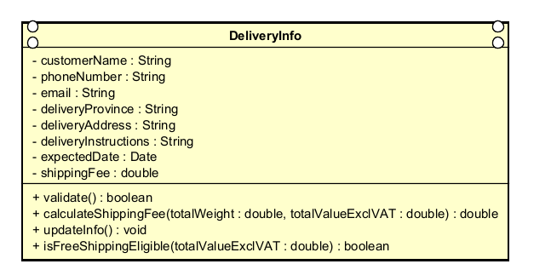

Table 1. Example of attribute design
# | Name | Data type | Default value | Description
1 | customerName | String | "" | Receiver's name
2 | phoneNumber | String | "" | Phone number
3 | email | String | "" | Email for receiving invoice
4 | deliveryProvince | String | "" | Province/City
5 | deliveryAddress | String | "" | Delivery address
6 | deliveryInstructions | String | "" | Delivery instructions/notes
7 | expectedDate | Date | null | Expected delivery date
8 | shippingFee | double | 0.0 | Current shipping fee

Table 2. Example of operation design
# | Name | Return type | Description (purpose)
1 | validate() | boolean | Validate delivery information
2 | calculateShippingFee(totalWeight:double, totalValueExclVAT:double) | double | Calculate shipping fee
3 | updateInfo(...) | void | Update delivery information
4 | isFreeShippingEligible(totalValueExclVAT:double) | boolean | Update delivery information

Parameters
- totalWeight: total weight of the order
- totalValueExclVAT: total order value excluding VAT
Exceptions
- InvalidDeliveryInfoException: if required fields are missing or invalid format
- InvalidProvinceException: if the province/city is invalid
Methods
- validate(): checks customer name, phone number, email, address, and province/city.
- calculateShippingFee() follows the problem requirements:
- Hanoi / Ho Chi Minh City: 22,000 VND for the first 3 kg
- Other provinces: 30,000 VND for the first 0.5 kg
- Additional 2,500 VND for every next 0.5 kg
- Free shipping up to 25,000 VND if total item value > 100,000 VND

Design for class “Invoice”
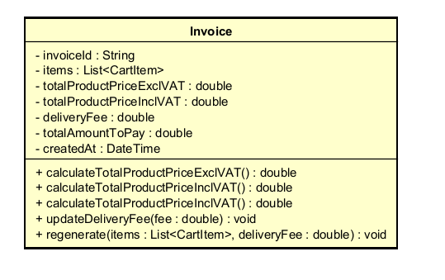

Table 1. Example of attribute design
# | Name | Data type | Default value | Description
1 | invoiceId | String | null | Invoice ID
2 | items | List | [] | List of items
3 | totalProductPriceExclVAT | double | 0.0 | Total product price excluding VAT
4 | totalProductPriceInclVAT | double | 0.0 | Total product price including VAT
5 | deliveryFee | double | 0.0 | Shipping fee
6 | totalAmountToPay | double | 0.0 | Total amount to pay
7 | createdAt | DateTime | now() | Invoice creation time

Table 2. Example of operation design
# | Name | Return type | Description (purpose)
1 | calculateTotalProductPriceExclVAT() | double | Calculate total product price excluding VAT
2 | calculateTotalProductPriceInclVAT() | double | Calculate total product price including VAT
3 | calculateTotalAmountToPay() | double | Calculate final payable amount
4 | updateDeliveryFee(fee:double) | void | Update shipping fee
5 | regenerate(items:List, deliveryFee:double) | void | Regenerate invoice when cart or delivery changes

Method
- totalAmountToPay = totalProductPriceInclVAT + deliveryFee
- Shipping fee is not subject to VAT, as specified in the requirements.

Design for class “Order”
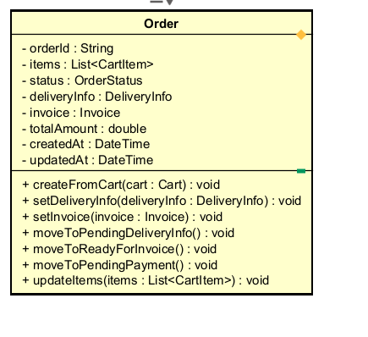

Table 1. Example of attribute design
# | Name | Data type | Default value | Description
1 | orderId | String | null | Order ID
2 | items | List | [] | List of ordered items
3 | status | OrderStatus | DRAFT | Order status
4 | deliveryInfo | DeliveryInfo | null | Delivery information
5 | invoice | Invoice | null | Current invoice
6 | totalAmount | double | 0.0 | Total order amount
7 | createdAt | DateTime | now() | Creation time
8 | updatedAt | DateTime | now() | Last updated time

Table 2. Example of operation design
# | Name | Return type | Description (purpose)
1 | createFromCart(cart:Cart) | void | Initialize order from cart
2 | setDeliveryInfo(deliveryInfo:DeliveryInfo) | void | Attach delivery information
3 | setInvoice(invoice:Invoice) | void | Attach invoice
4 | moveToPendingDeliveryInfo() | void | Change state to pending delivery info
5 | moveToReadyForInvoice() | void | Change state to ready for invoice
6 | moveToPendingPayment() | void | Change state to pending payment
7 | updateItems(items:List) | void | Update order items

Exception
- InvalidOrderStateException: if an invalid state transition occurs
State machine diagram
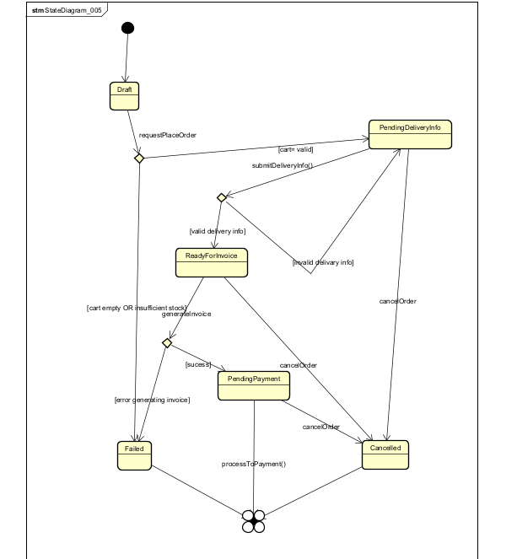

Design for class “CartService”

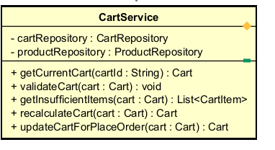
Table 1. Example of attribute design
# | Name | Data type | Default value | Description
1 | cartRepository | CartRepository | injected | Access to cart data
2 | productRepository | ProductRepository | injected | Access to product stock data

Table 2. Example of operation design
# | Name | Return type | Description (purpose)
1 | getCurrentCart(cartId:String) | Cart | Retrieve the current cart
2 | validateCartStock(cart:Cart) | boolean | Validate stock for the entire cart
3 | getInsufficientItems(cart:Cart) | List | Get list of items with insufficient stock
4 | recalculateCart(cart:Cart) | Cart | Recalculate cart subtotal
5 | updateCartForPlaceOrder(cart:Cart) | Cart | Normalize/prepare cart before creating order
Methods
- validateCartStock() calls cart.checkQuantityStockOfItemInCart()
- recalculateCart() recalculates prices after quantity changes

Design for class “DeliveryService”
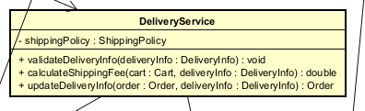

Table 1. Example of attribute design
# | Name | Data type | Default value | Description
1 | shippingPolicy | ShippingPolicy | injected | Shipping fee calculation policy

Table 2. Example of operation design
# | Name | Return type | Description (purpose)
1 | validateDeliveryInfo(deliveryInfo:DeliveryInfo) | void | Validate delivery information
2 | calculateShippingFee(cart:Cart, deliveryInfo:DeliveryInfo) | double | Calculate shipping fee
3 | updateDeliveryInfo(order:Order, deliveryInfo:DeliveryInfo) | Order | Attach/update delivery information for the order
Exception
- InvalidDeliveryInfoException if the delivery information is invalid
Method
- Calculate total weight from CartItem
- Use total value excluding VAT to check the free shipping rule

Design for class “InvoiceService”
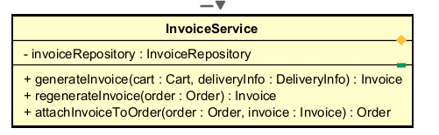

Table 1. Example of attribute design
# | Name | Data type | Default value | Description
1 | invoiceRepository | InvoiceRepository | injected | Access invoices

Table 2. Example of operation design
# | Name | Return type | Description (purpose)
1 | generateInvoice(cart:Cart, deliveryInfo:DeliveryInfo) | Invoice | Create an invoice from cart and delivery information
2 | regenerateInvoice(order:Order) | Invoice | Regenerate an invoice when cart or delivery changes
3 | attachInvoiceToOrder(order:Order, invoice:Invoice) | Order | Attach an invoice to an order
Method
- generateInvoice() calculates:
- Total product amount excluding VAT
- Total product amount including VAT
- Shipping fee
- Total amount to pay

Design for class “PlaceOrderControl”
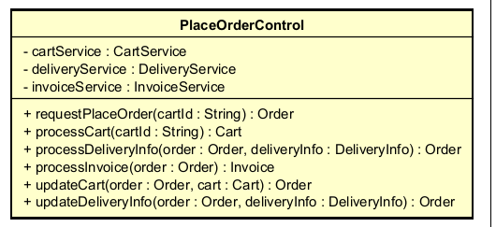
Table 1. Example of attribute design
# | Name | Data type | Default value | Description
1 | cartService | CartService | injected | Service for handling cart
2 | deliveryService | DeliveryService | injected | Service for handling delivery
3 | invoiceService | InvoiceService | injected | Service for generating invoices

Table 2. Example of operation design
# | Name | Return type | Description (purpose)
1 | requestPlaceOrder(cartId:String) | Order | Start the place order use case
2 | processCart(cartId:String) | Cart | Validate and normalize the cart
3 | processDeliveryInfo(order:Order, deliveryInfo:DeliveryInfo) | Order | Process delivery information
4 | processInvoice(order:Order) | Invoice | Generate a temporary invoice
5 | updateCart(order:Order, cart:Cart) | Order | Update the order when the cart changes
6 | updateDeliveryInfo(order:Order, deliveryInfo:DeliveryInfo) | Order | Cập nhật lại delivery + Update delivery info and invoice
Parameter
- cartId: Cart identifier
- order: The order being processed
- deliveryInfo: New delivery information
Exception
- InsufficientStockException: Thrown when items in the cart are out of stock
- InvalidDeliveryInfoException: Thrown when delivery information is invalid
- EmptyCartException: Thrown when the cart is empty
Method
- requestPlaceOrder()
- Load current cart
- Check if cart is empty
- Validate stock availability
- Create order from cart
- Proceed to input delivery information
- processDeliveryInfo()
- Validate delivery information
- Calculate shipping fee
- Update order
- processInvoice()
- Generate invoice
- Attach invoice to order
- Move order to PENDING_PAYMENT status

Design for class “CartScreen”
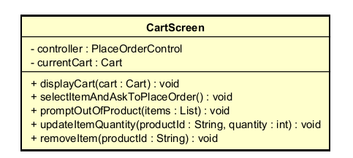

Table 1. Example of attribute design
# | Name | Data type | Default value | Description
1 | controller | PlaceOrderControl | injected | Controller place order
2 | currentCart | Cart | null | Currently displayed cart

Table 2. Example of operation design
# | Name | Return type | Description (purpose)
1 | displayCart(cart:Cart) | void | Display the cart
2 | selectItemAndAskToPlaceOrder() | void | Customer confirms to start placing an order
3 | promptOutOfProduct(insufficientItems:List) | void | Notify items that are out of stock
4 | updateItemQuantity(productId:String, quantity:int) | void | Allow updating item quantity
5 | removeItem(productId:String) | void | Allow removing an item from the cart

Design for class “DeliveryForm”
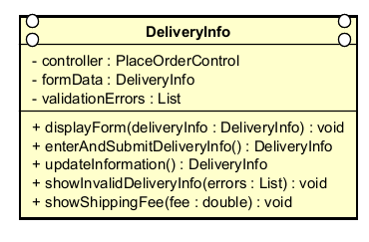
Table 1. Example of attribute design
# | Name | Data type | Default value | Description
1 | controller | PlaceOrderControl | injected | Controller place order
2 | formData | DeliveryInfo | empty | Delivery form data
3 | validationErrors | List | [] | List of validation errors

Table 2. Example of operation design
# | Name | Return type | Description (purpose)
1 | displayForm(deliveryInfo:DeliveryInfo) | void | Display the form
2 | enterAndSubmitDeliveryInfo() | DeliveryInfo | Enter and submit delivery information
3 | updateInformation() | DeliveryInfo | Update the information
4 | showInvalidDeliveryInfo(errors:List) | void | Show input validation errors
5 | showShippingFee(fee:double) | void | Display shipping fee after calculation

Design for class “InvoiceScreen”
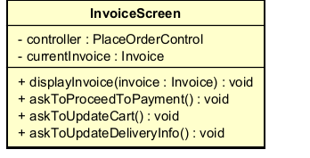

- Table 1. Example of attribute design
# | Name | Data type | Default value | Description
1 | controller | PlaceOrderControl | injected | Place order controller
2 | currentInvoice | Invoice | null | Currently displayed invoice

- Table 2. Example of operation design
# | Name | Return type | Description (purpose)
1 | displayInvoice(invoice:Invoice) | void | Display temporary invoice
2 | askToProceedToPayment() | void | Yêu cầu sang bước thanh toán
3 | askToUpdateCart() | void | Go back to update cart
4 | askToUpdateDeliveryInfo() | void | Go back to update delivery information

Design for class “ProductDetailScreen”

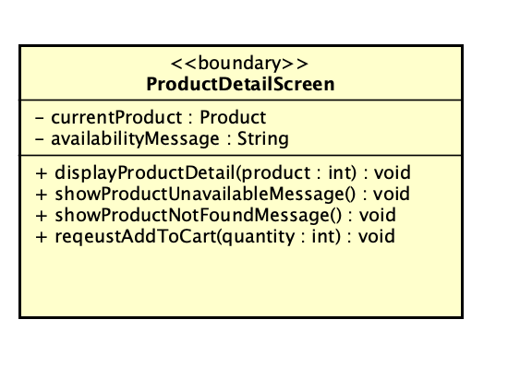
Table 1. Example of attribute design
# | Name | Data type | Default value | Description
1 | currentProduct | Product | null | Product currently displayed
2 | availabilityMessage | String | “” | Availability notification
3 | generalInfo | String | “” | General product information
4 | specificInfo | String | “” | Type-specific product information

Table 2. Example of operation design
# | Name | Return type | Description (purpose)
1 | displayProductDetail(product: Product) | void | Display full product information
2 | showProductUnavailableMessage() | void | Show unavailable notification
3 | showProductNotFoundMessage() | void | Show product not found error
4 | requestAddToCart(quantity: int) | void | Request adding product to cart

Parameter:
- product: product to display; must not be null.
- quantity: number of items to add; must be > 0.
Exception:
- IllegalArgumentException if product is null.
- InvalidQuantityException if quantity ≤ 0.

Method
- displayProductDetail() extracts general and specific info and renders UI.
- showProductUnavailableMessage() displays availability warning.
- showProductNotFoundMessage() displays error.
- requestAddToCart() triggers Add-to-Cart use case.

Other diagrams
- Optional sequence diagram.

Design for class “ProductListScreen”

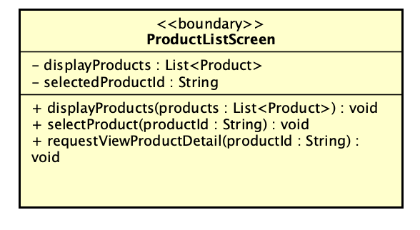
Table 1. Example of attribute design
# | Name | Data type | Default value | Description
1 | displayedProducts | List<Product> | empty list | List of products currently displayed on screen
2 | selectedProductID | String | null | ID of the product selected by the customer
3 | searchKeyword | String | “” | Current search keyword
4 | filterCriteria | String | “” | Current filtering condition

Table 2. Example of operation design
# | Name | Return type | Description (purpose)
1 | displayProducts( products:List<Product>) | void | Display a list of products on the screen
2 | selectProduct( productID: String) | void | Record the selected product

Parameter:
- products: list of products to display; default empty.
- productId: selected product ID; must be valid.

Exception:
- IllegalArgumentException if productId is null or empty
- ProductNotInDisplayedListException if not found in displayed list
Method
- displayProducts() updates displayedProducts and renders UI.
- selectProduct() updates selectedProductId.
- requestViewProductDetail() sends request to controller.

Design for class “ViewProductDetailController”
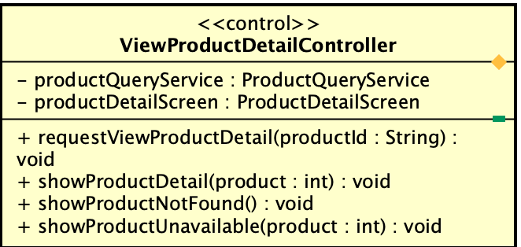

Table 1. Example of attribute design
# | Name | Data type | Default value | Description
1 | productService | ProductService | null | Service to retrieve product data
2 | productDetailScreen | ProductDetailScreen | null | UI screen for displaying details

Table 2. Example of operation design
# | Name | Return type | Description (purpose)
1 | requestViewProductDetail(productId: String) | void | Handle request from UI
2 | showProductDetail(product: Product) | void | Send product data to UI
3 | showProductNotFound() | void | Display not found error
4 | showProductUnavailable(product: Product) | void | Display unavailable status

Parameter:
- productId: ID of product
- product: retrieved product object.

Exception:
- IllegalArgumentException if productId invalid.
- SystemDataAccessException if retrieval fails.

Method
- requestViewProductDetail():
- Validate productId
- Call service
- Handle null → not found
- Check availability
- Display result
- showProductDetail() updates UI.
- showProductUnavailable() displays product + warning.

Other diagrams
- showProductUnavailable() displays product + warning.

Design for class “ProductQueryService”
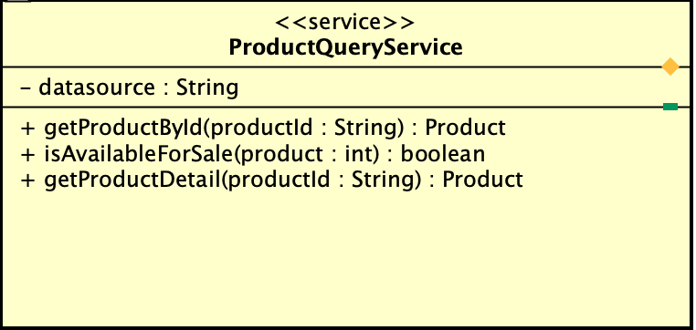

Table 1. Attribute design
# | Name | Data type | Default value | Description
1 | dataSource | String | null | Data source for product retrieval

Table 2. Example of operation design
# | Name | Return type | Description (purpose)
1 | getProductById(productId: String) | Product | Retrieve product by ID
2 | isAvailableForSale(product: Product) | boolean | Check availability
3 | getProductDetail(productId: String) | Product | Retrieve full product det

Parameter:
- productId: product identifier.
- product: product object.

Exception:
- IllegalArgumentException if invalid ID
- SystemDataAccessException if data access fails.

Method
- getProductById() retrieves product.
- getProductDetail() returns full detail
- isAvailableForSale() checks status and stock.

Other diagrams
- Not required

Design for class “Product”
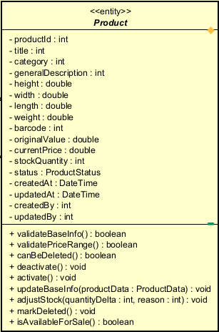

Table 1. Example of attribute design
# | Name | Data type | Default value | Description
1 | productId | String | null | Product identifier
2 | title | String | "" | Product title
3 | category | String | "" | Category
4 | generalDescription | String | "" | General description
5 | height | double | 0.0 | Height
6 | width | double | 0.0 | Width
7 | length | double | 0.0 | Length
8 | weight | double | 0.0 | Weight
9 | barcode | String | "" | Barcode
10 | originalValue | double | 0.0 | Original value excluding VAT
11 | currentPrice | double | 0.0 | Current price excluding VAT
12 | stockQuantity | int | 0 | Stock quantity
13 | status | ProductStatus | DRAFT | Product status
14 | createdAt | DateTime | now() | Creation time
15 | updatedAt | DateTime | now() | Last updated time
16 | createdBy | String | null | Manager who created the product
17 | updatedBy | String | null | Manager who most recently updated the product

Table 2. Example of operation design
# | Name | Return type | Description (purpose)
1 | validateBaseInfo() | boolean | Validate the general product information
2 | validatePriceRange() | boolean | Check whether currentPrice is within 30%–150% of originalValue
3 | canBeDeleted() | boolean | Check whether the product can be physically deleted
4 | deactivate() | void | Change the status to deactivated
5 | activate() | void | Reactivate the product
6 | updateBaseInfo(...) | void | Update general information
7 | adjustStock(quantityDelta:int, reason:String) | void | Adjust stock quantity
8 | markDeleted() | void | Mark the product as deleted
9 | isAvailableForSale() | boolean | Check whether the product is still available for sale

Parameter:
- quantityDelta: 0, amount of stock increase/decrease
- reason: "", reason for stock change
- title/category/generalDescription/...: updated data

Exception:
- InvalidProductInfoException if the general data is invalid
- InvalidPriceRangeException if the price is outside the allowed range
- ProductDeletionNotAllowedException if deletion is requested but not allowed by policy
- InvalidStockAdjustmentException if stock becomes negative or the reason is empty

Method
- validateBaseInfo() checks title, dimensions, weight, barcode, originalValue, and currentPrice.
- validatePriceRange() checks 0.3 * originalValue <= currentPrice <= 1.5 * originalValue.
- canBeDeleted() returns true when stockQuantity == 0.
- deactivate() changes status = DEACTIVATED.
- markDeleted() is only called after passing canBeDeleted().

Other diagrams
- State diagram for Product
- Activity diagram for delete/deactivate decision

Design for class “Book”
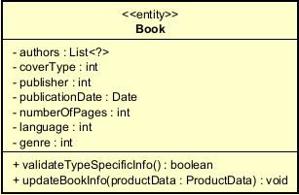
Table 1. Example of attribute design
# | Name | Data type | Default value | Description
1 | authors | List | [] | List of authors
2 | coverType | String | "" | Paperback/Hardcover
3 | publisher | String | "" | Publisher
4 | publicationDate | Date | null | Publication date
5 | numberOfPages | int | 0 | Number of pages
6 | language | String | "" | Language
7 | genre | String | "" | Genre

Table 2. Example of operation design
# | Name | Return type | Description (purpose)
1 | validateTypeSpecificInfo() | boolean | Validate book-specific information
2 | updateBookInfo(...) | void | Update book-specific information

Parameter:
- authors: list of authors
- coverType: cover type
- publisher: publisher

Exception:
- InvalidProductInfoException if authors are missing, publisher is missing, or the publication date is invalid

Method
- Check that authors is not empty, publisher is not empty, and publicationDate is valid.

Other diagrams
- None

Design for class “CD”
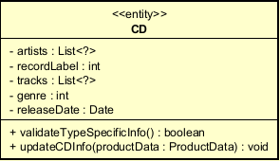
Table 1. Example of attribute design
# | Name | Data type | Default value | Description
1 | artists | List | [] | Artists
2 | recordLabel | String | "" | Record label
3 | tracks | List | [] | List of tracks
4 | genre | String | "" | Genre
5 | releaseDate | Date | null | Release date

Table 2. Example of operation design
# | Name | Return type | Description (purpose)
1 | validateTypeSpecificInfo() | boolean | Validate CD-specific information
2 | updateCDInfo(...) | void | Update CD-specific information

Exception:
- InvalidProductInfoException if artist, recordLabel, or track list is missing

Design for class “DVD”
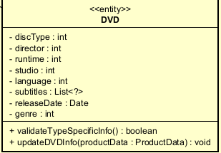

Table 1. Example of attribute design
# | Name | Data type | Default value | Description
1 | discType | String | "" | Blu-ray / HD-DVD
2 | director | String | "" | Director
3 | runtime | int | 0 | Runtime
4 | studio | String | "" | Studio
5 | language | String | "" | Language
6 | subtitles | List | [] | Subtitles
7 | releaseDate | Date | null | Release date
8 | genre | String | "" | Genre

Table 2. Example of operation design
# | Name | Return type | Description (purpose)
1 | validateTypeSpecificInfo() | boolean | Validate DVD-specific information
2 | updateDVDInfo(...) | void | Update DVD-specific information

Design for class “Newspaper”
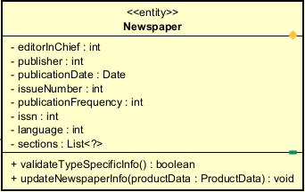
Table 1. Example of attribute design
# | Name | Data type | Default value | Description
1 | editorInChief | String | "" | Editor-in-chief
2 | publisher | String | "" | Publisher
3 | publicationDate | Date | null | Publication date
4 | issueNumber | String | "" | Issue number
5 | publicationFrequency | String | "" | Publication frequency
6 | issn | String | "" | ISSN
7 | language | String | "" | Language
8 | sections | List | [] | Sections

Table 2. Example of operation design
# | Name | Return type | Description (purpose)
1 | validateTypeSpecificInfo() | boolean | Validate newspaper-specific information
2 | updateNewspaperInfo(...) | void | Update newspaper-specific information

Design for class “ProductHistory”
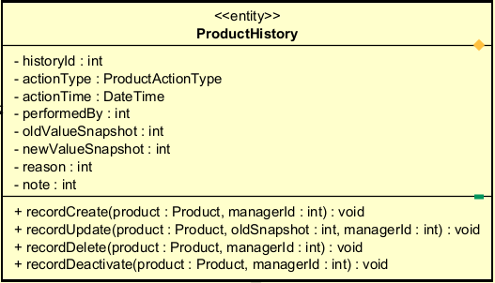
Table 1. Example of attribute design
# | Name | Data type | Default value | Description
1 | historyId | String | null | History identifier
2 | productId | String | null | Related product ID
3 | actionType | String | "" | CREATE / UPDATE / DELETE / DEACTIVATE / STOCK_ADJUST
4 | actionTime | DateTime | now() | Action time
5 | performedBy | String | null | Person who performed the action
6 | oldValueSnapshot | String | null | Snapshot before the change
7 | newValueSnapshot | String | null | Snapshot after the change
8 | reason | String | "" | Reason for the action
9 | note | String | "" | Additional note

Table 2. Example of operation design
# | Name | Return type | Description (purpose)
1 | recordCreate(...) | void | Record creation history
2 | recordUpdate(...) | void | Record update history
3 | recordDelete(...) | void | Record deletion history
4 | recordDeactivate(...) | void | Record deactivation history
5 | recordStockAdjustment(...) | void | Record stock adjustment history

Parameter:
- productId: product ID
- performedBy: manager performing the action
- reason: reason for the change
- oldSnapshot/newSnapshot: data before/after the change
Method
- Each method sets the corresponding actionType, timestamp, actor, and snapshots

Design for class “ProductManagementService”
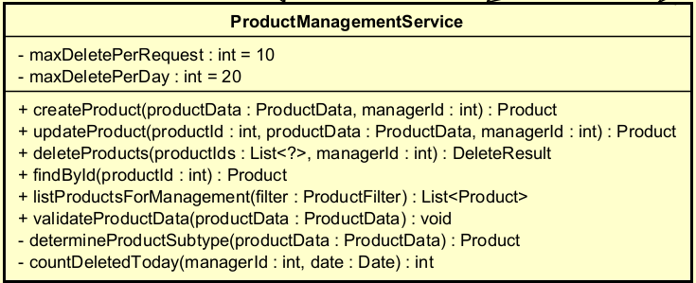

Table 1. Example of attribute design
# | Name | Data type | Default value | Description
1 | productRepository | ProductRepository | injected | Access product data
2 | validator | ProductValidator | injected | Validate data
3 | maxDeletePerRequest | int | 10 | Maximum deletions per request
4 | maxDeletePerDay | int | 20 | Maximum deletions per day

Table 2. Example of operation design
# | Name | Return type | Description (purpose)
1 | createProduct(productData:ProductData, managerId:String) | Product | Create a new product
2 | updateProduct(productId:String, productData:ProductData, managerId:String) | Product | Update a product
3 | deleteProducts(productIds:List, managerId:String) | DeleteResult | Delete/deactivate a list of products
4 | findById(productId:String) | Product | Find a product by ID
5 | listProductsForManagement(filter:ProductFilter) | List | Retrieve product list for management
6 | validateProductData(productData:ProductData) | void | Validate input data
7 | determineProductSubtype(productData:ProductData) | Product | Instantiate the correct subtype
8 | countDeletedToday(managerId:String, date:Date) | int | Count how many products were deleted today

Parameter:
- productData: DTO containing data entered from the form
- productIds: list of selected product IDs
- managerId: person performing the action
- filter: list filtering condition

Exception:
- InvalidProductInfoException if the form data is invalid
- ProductNotFoundException if the product cannot be found
- DeletionLimitExceededException if it exceeds 10 per request or 20 per day
- InvalidPriceRangeException if the price is invalid
- ProductDeletionNotAllowedException if the deletion logic is invalid

Method
- createProduct():
  - validate data
  - instantiate the appropriate subtype (Book/CD/DVD/Newspaper)
  - set status to ACTIVE
  - save
- updateProduct():
  - load product
  - validate
  - update common + type-specific information
  - save
- deleteProducts():
  - check selected quantity <= 10
  - check total number deleted today <= 20
  - for each product:
    - if stockQuantity == 0 → delete/mark deleted
    - otherwise → deactivate
  - return DeleteResult

Design for class “ProductHistoryService”
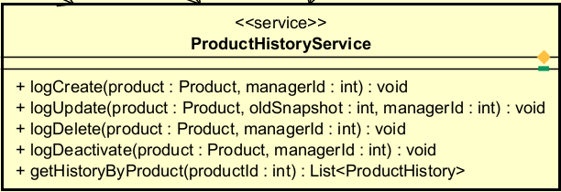
Table 1. Example of attribute design
# | Name | Data type | Default value | Description
1 | historyRepository | ProductHistoryRepository | injected | Access history data

Table 2. Example of operation design
# | Name | Return type | Description (purpose)
1 | logCreate(product:Product, managerId:String) | void | Log create history
2 | logUpdate(product:Product, oldSnapshot:String, managerId:String) | void | Log update history
3 | logDelete(product:Product, managerId:String) | void | Log delete history
4 | logDeactivate(product:Product, managerId:String) | void | Log deactivate history
5 | logStockAdjustment(product:Product, reason:String, managerId:String) | void | Log stock adjustment history
6 | getHistoryByProduct(productId:String) | List | Query history

Method
- Create a ProductHistory object and save it to the repository according to the corresponding action

Design for class “CreateProductController”
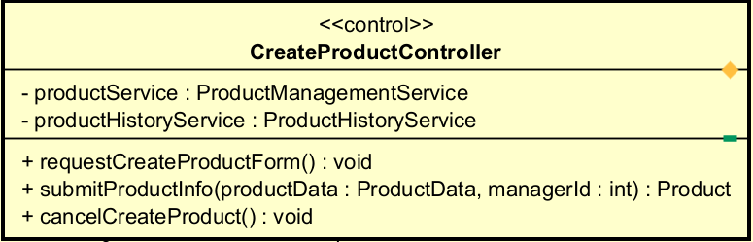

Table 1. Example of attribute design
# | Name | Data type | Default value | Description
1 | productService | ProductService | injected | Product creation service
2 | productHistoryService | ProductHistoryService | injected | History logging service

Table 2. Example of operation design
# | Name | Return type | Description (purpose)
1 | requestCreateProductForm() | void | Request to open the creation screen
2 | submitProductInfo(productData:ProductData, managerId:String) | Product | Receive and process the create request
3 | cancelCreateProduct() | void | Cancel the creation operation

Method
- submitProductInfo() calls productService.createProduct(), then productHistoryService.logCreate().

Design for class “UpdateProductController”
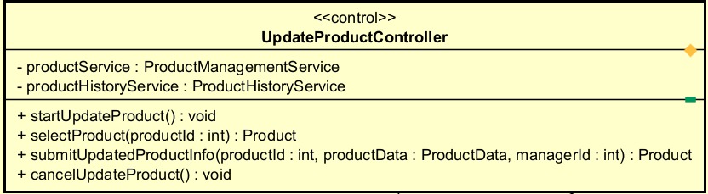

Table 1. Example of attribute design
# | Name | Data type | Default value | Description
1 | productService | ProductService | injected | Update service
2 | productHistoryService | ProductHistoryService | injected | History logging

Table 2. Example of operation design
# | Name | Return type | Description (purpose)
1 | startUpdateProduct() | void | Start the update use case
2 | selectProduct(productId:String) | Product | Select the product to update
3 | submitUpdatedProductInfo(productId:String, productData:ProductData, managerId:String) | Product | Process the update request
4 | cancelUpdateProduct() | void | Cancel update

Method
- submitUpdatedProductInfo() loads the old product, snapshots the old value, performs update, and logs history

Design for class “DeleteProductController”
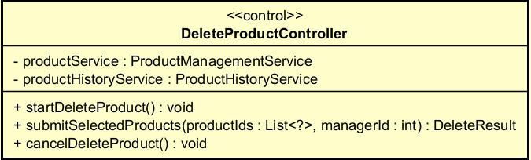

Table 1. Example of attribute design
# | Name | Data type | Default value | Description
1 | productService | ProductService | injected | Delete/deactivate service
2 | productHistoryService | ProductHistoryService | injected | History logging

Table 2. Example of operation design
# | Name | Return type | Description (purpose)
1 | startDeleteProduct() | void | Start the delete use case
2 | submitSelectedProducts(productIds:List, managerId:String) | DeleteResult | Process the selected product list
3 | cancelDeleteProduct() | void | Cancel deletion

Method
- Call productService.deleteProducts()
- For each item in the result:
  - if physically deleted → logDelete()
  - if deactivated → logDeactivate()

Design for class “CreateProductScreen”
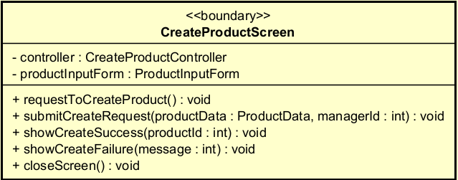

Table 1. Example of attribute design
# | Name | Data type | Default value | Description
1 | controller | CreateProductController | injected | Coordinating controller
2 | productInputForm | ProductInputForm | null | Data input form

Table 2. Example of operation design
# | Name | Return type | Description (purpose)
1 | requestToCreateProduct() | void | Open the product creation form
2 | showCreateSuccess(productId:String) | void | Display successful creation
3 | showCreateFailure(message:String) | void | Display creation error
4 | closeScreen() | void | Close the screen

Design for class “ProductInputForm”
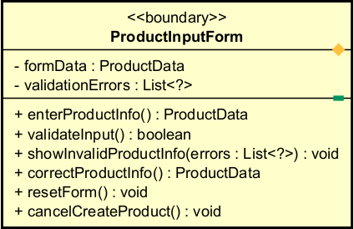

Table 1. Example of attribute design
# | Name | Data type | Default value | Description
1 | formData | ProductData | empty | Data entered by the user
2 | validationErrors | List | [] | List of validation errors

Table 2. Example of operation design
# | Name | Return type | Description (purpose)
1 | enterProductInfo() | ProductData | Enter product data
2 | validateInput() | boolean | Validate input on the form side
3 | showInvalidProductInfo(errors:List) | void | Display errors
4 | correctProductInfo() | ProductData | Allow re-entry
5 | resetForm() | void | Reset form
6 | cancelCreateProduct() | void | Cancel operation

Design for class “DeleteProductScreen”
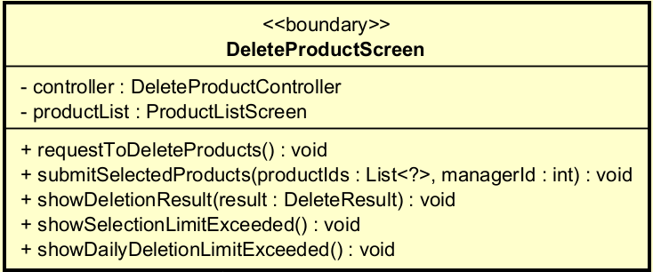

Table 1. Example of attribute design
# | Name | Data type | Default value | Description
1 | controller | DeleteProductController | injected | Delete controller
2 | productList | ProductList | null | Product list for selection

Table 2. Example of operation design
# | Name | Return type | Description (purpose)
1 | requestToDeleteProducts() | void | Open the delete function
2 | confirmDelete(productIds:List) | void | Confirm deletion
3 | showDeletionResult(result:DeleteResult) | void | Display result
4 | showSelectionLimitExceeded() | void | Notify that 10 items/request is exceeded
5 | showDailyDeletionLimitExceeded() | void | Notify that 20 items/day is exceeded

Design for class “ProductUpdateScreen”

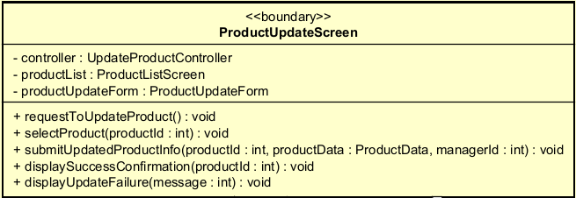

Table 1. Example of attribute design
# | Name | Data type | Default value | Description
1 | controller | UpdateProductController | injected | Update controller
2 | productList | ProductList | null | List for selecting products
3 | productUpdateForm | ProductUpdateForm | null | Data editing form

Table 2. Example of operation design
# | Name | Return type | Description (purpose)
1 | requestToUpdateProduct() | void | Start the update use case
2 | showProductList(products:List) | void | Display the list
3 | selectProduct(productId:String) | void | Select product
4 | displaySuccessConfirmation(productId:String) | void | Notify successful update
5 | displayUpdateFailure(message:String) | void | Notify error

Design for class “ProductUpdateForm”

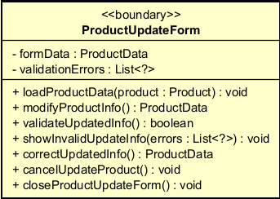

Table 1. Example of attribute design
# | Name | Data type | Default value | Description
1 | formData | ProductData | empty | Updated data
2 | validationErrors | List | [] | Validation errors

Table 2. Example of operation design
# | Name | Return type | Description (purpose)
1 | loadProductData(product:Product) | void | Load current product data into the form
2 | modifyProductInfo() | ProductData | Modify information
3 | validateUpdatedInfo() | boolean | Validate updated data
4 | showInvalidUpdateInfo(errors:List) | void | Display errors
5 | correctUpdatedInfo() | ProductData | Allow correction
6 | cancelUpdateProduct() | void | Cancel update
7 | closeProductUpdateForm() | void | Close the form

Design for class “ProductListScreen”
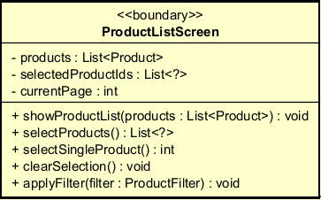

Table 1. Example of attribute design
# | Name | Data type | Default value | Description
1 | products | List | [] | Product list
2 | selectedProductIds | List | [] | List of selected IDs
3 | filter | ProductFilter | null | Filter
4 | currentPage | int | 1 | Current page

Table 2. Example of operation design
# | Name | Return type | Description (purpose)
1 | showProductList(products:List) | void | Display the list
2 | selectProducts() | List | Select multiple products
3 | selectSingleProduct() | String | Select one product for update
4 | clearSelection() | void | Clear selection
5 | applyFilter(filter:ProductFilter) | void | Apply filter

Design for class “PaymentScreen”
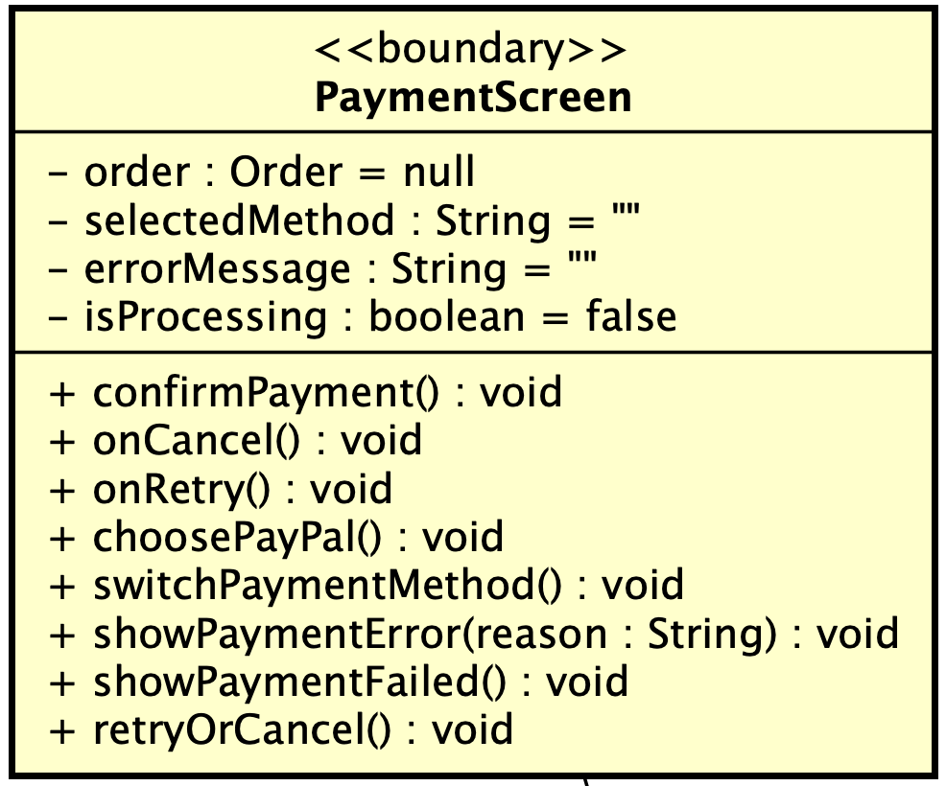
Table 1. Example of attribute design
# | Name | Data type | Default value | Description
1 | order | Order | null | current order
2 | selectedMethod | string | "" | selected payment method
3 | errorMessage | string | "" | error message
4 | isProcessing | boolean | false | loading state

Table 2. Example of operation design
# | Name | Return type | Description
1 | confirmPayment() | void | trigger payment
2 | onCancel() | void | cancel payment
3 | onRetry() | void | retry payment
4 | choosePayPal() | void | select PayPal
5 | switchPaymentMethod() | void | switch method
6 | showPaymentError(reason:String) | void | show error
7 | showPaymentFailed() | void | show failure UI
8 | retryOrCancel() | void | user decision

Parameter:
- reason: error message

Method
- call PaymentController.payOrder(order)
- handle UI state (loading/error)

Design for class “PaymentController”
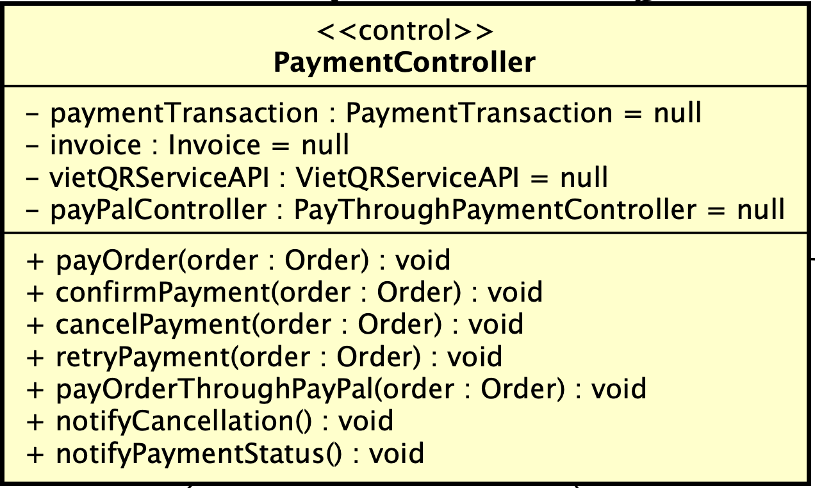
Table 1. Example of attribute design
# | Name | Data type | Default | Description
1 | paymentTransaction | PaymentTransaction | null | current transaction
2 | invoice | Invoice | null | invoice object
3 | vietQRServiceAPI | VietQRServiceAPI | null | external API
4 | payPalController | PayThroughPaymentController | null | PayPal flow

Table 2. Example of operation design
# | Name | Return type | Description
1 | payOrder(order:Order) | void | start payment
2 | confirmPayment(order:Order) | void | confirm payment
3 | cancelPayment(order:Order) | void | cancel payment
4 | retryPayment(order:Order) | void | retry flow
5 | payOrderThroughPayPal(order:Order) | void | PayPal flow
6 | notifyCancellation() | void | notify cancel
7 | notifyPaymentStatus() | void | notify result

Parameter:
- order: Order (object, pass by reference)
Exception:
- PaymentFailedException if payment fails
Method
- create PaymentTransaction
- call appropriate flow:
  - PayPal -> payOrderThroughPayPal
  - QR -> call QR controller
- update transaction state

Design for class “PayByQRCodeController”
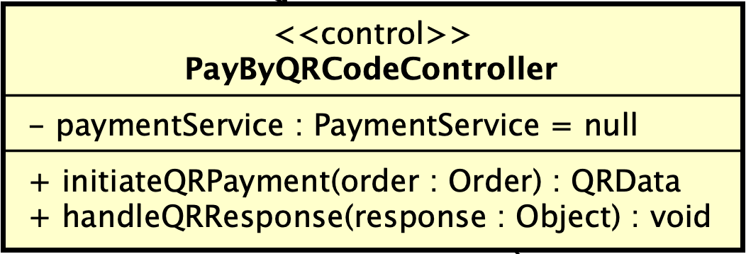
Table 1. Example of attribute design
# | Name | Data type | Default | Description
1 | paymentService | PaymentService | null | business logic

Table 2. Example of operation design
# | Name | Return type | Description
1 | initiateQRPayment(order:Order) | QRData | create QR
2 | handleQRResponse(response) | void | process response

Parameter:
- call paymentService.createQRPayment(order)
- return QR data for UI

Design for class “PaymentService”
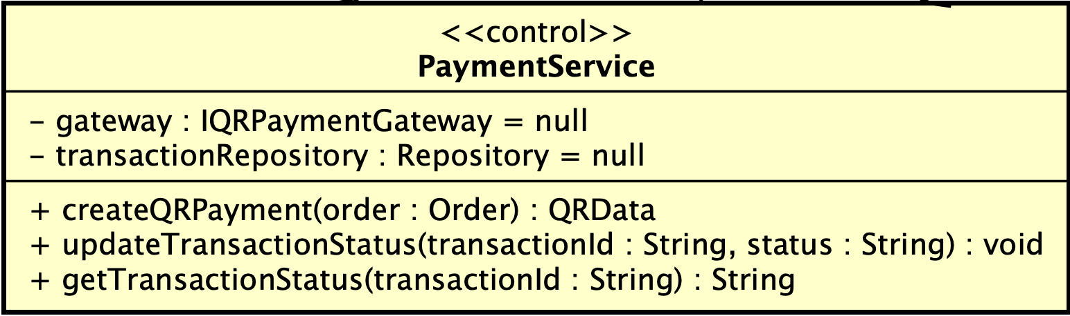
Table 1. Example of attribute design
# | Name | Data type | Default | Description
1 | gateway | IQRPaymentGateway | null | abstraction
2 | transactionRepository | Repository | null | DB access

Table 2. Example of operation design
# | Name | Return type | Description
1 | createQRPayment(order:Order) | QRData | create transaction
2 | updateTransactionStatus(transactionId:String, status:String) | void | update
3 | getTransactionStatus(transactionId:String) | String | get status

Exception:
- PaymentFailedException if gateway fails
Method
- create PaymentTransaction (PENDING)
- call gateway.generateQRCode()
- save transaction
- return QR

Design for class “PaymentTransaction”
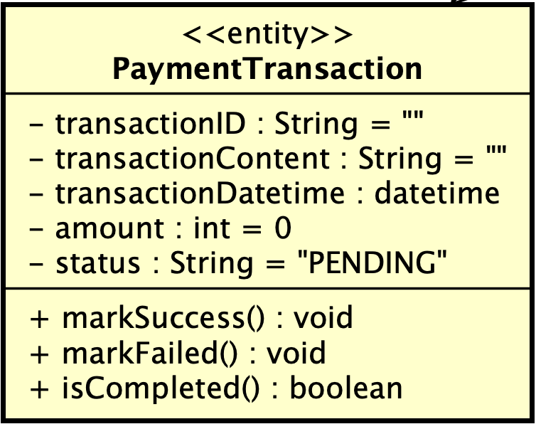
Table 1. Example of attribute design
# | Name | Data type | Default | Description
1 | transactionID | String | "" | unique id
2 | transactionContent | String | "" | content
3 | transactionDatetime | datetime | now | time
4 | amount | int | 0 | amount
5 | status | enum | PENDING | state

Table 2. Example of operation design
# | Name | Return type | Description
1 | markSuccess() | void | set SUCCESS
2 | markFailed() | void | set FAILED
3 | isCompleted() | boolean | check done

Method
- change status
- persist to DB

Other diagram
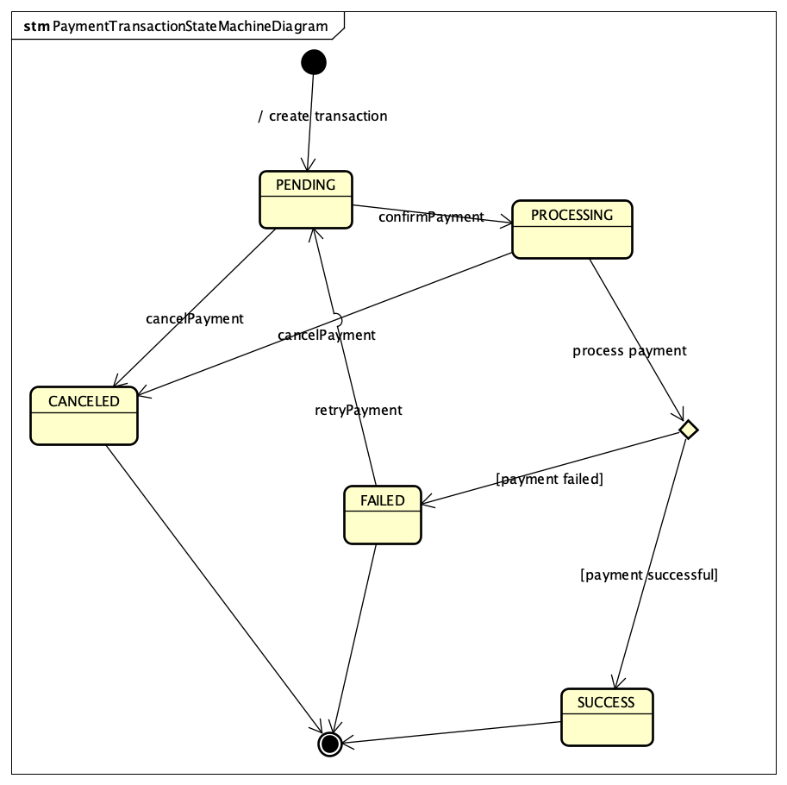

Design for class “VietQRServiceAPI”
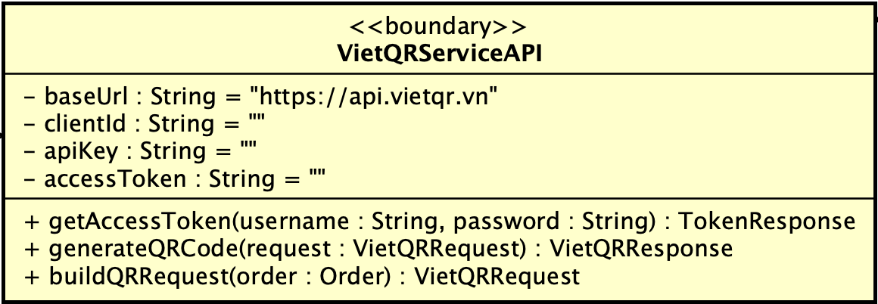
Table 1. Example of attribute design

# | Name | Data type | Default value | Description
1 | baseUrl | String | "https://api.vietqr.vn" | API endpoint
2 | clientId | String | "" | authentication id
3 | apiKey | String | "" | authentication key
4 | accessToken | String | "" | bearer token

Table 2. Example of operation design
# | Name | Return type | Description
1 | getAccessToken(username:String, password:String) | TokenResponse | get token
2 | generateQRCode(request:VietQRRequest) | VietQRResponse | create QR
3 | buildQRRequest(order:Order) | VietQRRequest | map order → request

Parameter:
- username/password: credential
- request contains:
  - accountNo
  - accountName
  - acqId
  - amount
  - addInfo

Exception:
- PaymentFailedException if API call fails

Method
- getAccessToken():
  - POST /get-token
  - lưu bearer token
- generateQRCode():
  - attach header: Authorization: Bearer <token>
  - POST /generate
  - return QR data
- buildQRRequest():
  - map:
    - order.totalAmount -> amount
    - orderId -> addInfo

Design for class “PaymentResultScreen”
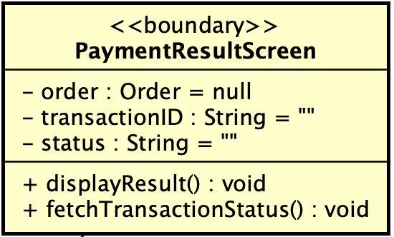
Table 1. Example of attribute design
# | Name | Data type | Default | Description
1 | order | Order | null | order
2 | transactionID | String | "" | id
3 | status | String | "" | result

Table 2. Example of operation design
# | Name | Return type | Description
1 | displayResult() | void | show result
2 | fetchTransactionStatus() | void | call backend

Design for class “VietQRCallbackHandler”
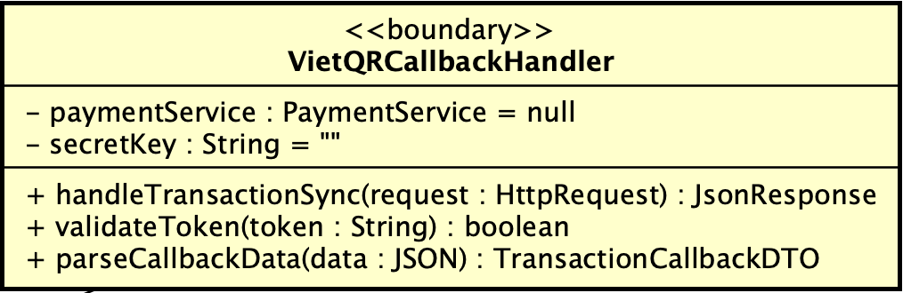
Table 1. Example of attribute design
# | Name | Data type | Default value | Description
1 | paymentService | PaymentService | null | business service
2 | secretKey | String | "" | validate token

Table 2. Example of operation design
# | Name | Return type | Description
1 | handleTransactionSync(request:HttpRequest) | JsonResponse | receive callback
2 | validateToken(token:String) | boolean | validate bearer token
3 | parseCallbackData(data:JSON) | TransactionCallbackDTO | parse request

Method
- parse request
- call updateTransactionStatus()
- return success response

Design for class “IQRPaymentGateway”
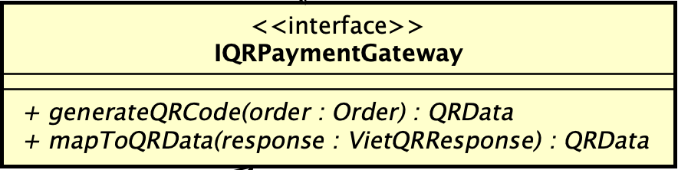
Table 2. Example of operation design
# | Name | Return type | Description
1 | generateQRCode(order:Order) | QRData | create QR
2 | mapToQRData(response:VietQRResponse) | QRData | map API response

Parameter:
- order: Order object
Method:
- define contract giữa service và gateway

Design for class “VietQRGateway”
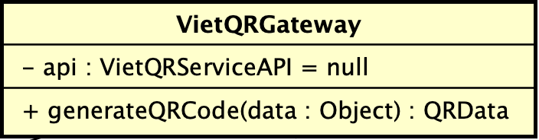
Table 1. Example of attribute design
# | Name | Data type | Default | Description
1 | api | VietQRServiceAPI | null | external API

Table 2. Example of operation design
# | Name | Return type | Description
1 | generateQRCode(data) | QRData | implement

Method
- call API
- map response → QRData

Design for class “QRPaymentScreen”
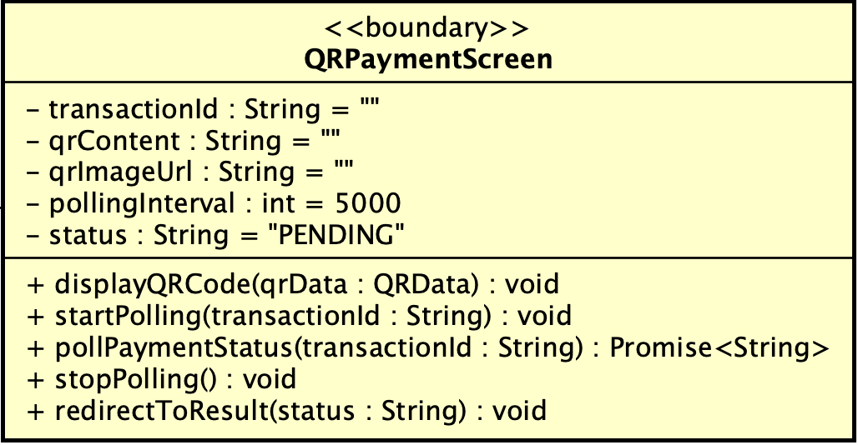
Table 1. Example of attribute design
# | Name | Data type | Default value | Description
1 | transactionId | string | "" | payment transaction id
2 | qrContent | string | "" | QR content string
3 | qrImageUrl | string | "" | QR image URL
4 | pollingInterval | number | 5000 | polling interval (ms)
5 | status | string | "PENDING" | transaction status

Table 2. Example of operation design
# | Name | Return type | Description (purpose)
1 | displayQRCode(qrData:QRData) | void | render QR code
2 | startPolling(transactionId:String) | void | start polling status
3 | pollPaymentStatus(transactionId:String) | Promise<String> | call backend API
4 | stopPolling() | void | stop polling
5 | redirectToResult(status:String) | void | navigate result screen

Parameter:
- qrData: contains qrContent, qrImageUrl
- transactionId: unique transaction
Method
- display QR từ generateQRCode API
- polling /payment/status
- nếu status != PENDING → redirect

Design for class “PayPalBoundary”
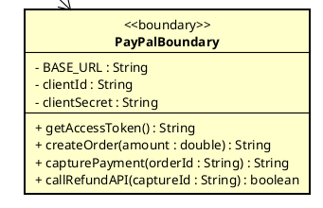

Table 1. Attribute design
# | Name | Data type | Default value | Description
1 | BASE_URL | String | "https://api-m.sandbox.paypal.com" | The base URL for the PayPal REST API sandbox.
2 | clientID | String | “” | Unique identifier for the application provided by PayPal.
3 | clientSecret | String | “” | Private key used for OAuth 2.0 authentication

Table 2. Example of operation design
# | Name | Return type | Description (purpose)
1 | getAccessToken | String | Requests a Bearer token to authorize subsequent API calls
2 | createOrder | String | Creates a PayPal order and returns the unique Order ID.
3 | capturePayment | Object | Finalizes the transaction after the buyer's approval.
4 | callRefundAPI | Object | Excutes a refund request for a specific transaction ID.

Parameter:
- amount: double - Total payment amount (including VAT and shipping).
- orderId: String - The ID returned by PayPal after order creation.
Exception:
- PayPalAuthException if: Authentication fails due to invalid credentials.
- PayPalNetworkException if: There is a connection timeout or server error.
Method
- Uses HTTP POST requests to interact with PayPal's V2 Orders and Refund APIs.
- Handles JSON responses to extract necessary transaction data.

Design for class “PayThroughPayPalController”
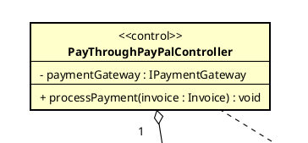

Table 1. Attribute design
# | Name | Data type | Default value | Description
1 | paymentGateway | IPatmentGateway | null | Reference to the PayPal gateway implementation.

Table 2. Example of operation design
# | Name | Return type | Description (purpose)
1 | processPayment | void | Coodinates the end-to-end payment workflow.

Parameter:
- invoice: Invoice - Contains billing information and shipping fees.
Exception:
- PaymentCanceledException if: The user cancels the transaction manually.

Method
- Extracts final price from the invoice.
- Invokes paymentGateway.payOrder() and logs the result into a PaymentTransaction.

Design for class “IPaymentGateway”
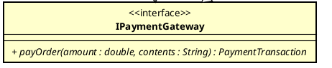

Table 2. Example of operation design
# | Name | Return type | Description (purpose)
1 | payOrder | PaymentTransaction | Interface for processing a payment order.

Parameter:
- amount: double - The total amount to be paid.
- contents: String - Transaction description.

Design for class “IRefundGateway”
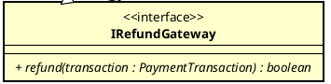

Table 2. Example of operation design
# | Name | Return type | Description (purpose)
1 | refund | boolean | Abstract method to process an automated refund for a previous transaction.

Parameter:
- transaction: PaymentTransaction - The original successful transaction to be refunded.

Design for class “PayPalGateway”
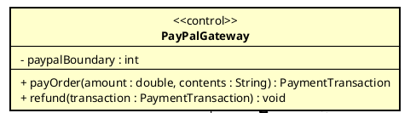

Table 1. Example of attribute design
# | Name | Data type | Default value | Description
1 | paypalBoundary | PayPalBoundary | new PayPalBoundary() | Direct interface to PayPal API communication.

Table 2. Example of operation design
# | Name | Return type | Description (purpose)
1 | payOrder | PaymentTransaction | Processes a payment via the PayPal API boundary.
2 | refund | boolean | Processes a refund via the PayPal API boundary.

Method
- Wraps business data into API-compatible objects.
- Returns a PaymentTransaction entity containing the PayPal reference ID.

Design for class “RefundService”
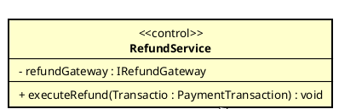

Table 1. Example of attribute design
# | Name | Data type | Default value | Description
1 | refundGateway | IRefundGateway | null | The specific gateway used for the refund process.

Table 2. Example of operation design
# | Name | Return type | Description (purpose)
1 | executeRefund | void | Manages automated or manual refund logic.

Method
- Identifies the payment method.
- Calls refundGateway.refund() for PayPal transactions.
- Notifies the Product Manager for manual refund if the method is VietQR.

Thẻ 2
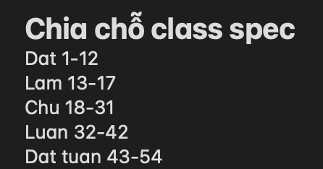

fix:
Chu: 18 - 34
Luan: 35 - 45
Dat tuat: 46 - 52

