Group 18 - Screen Specifications

Product List Screen
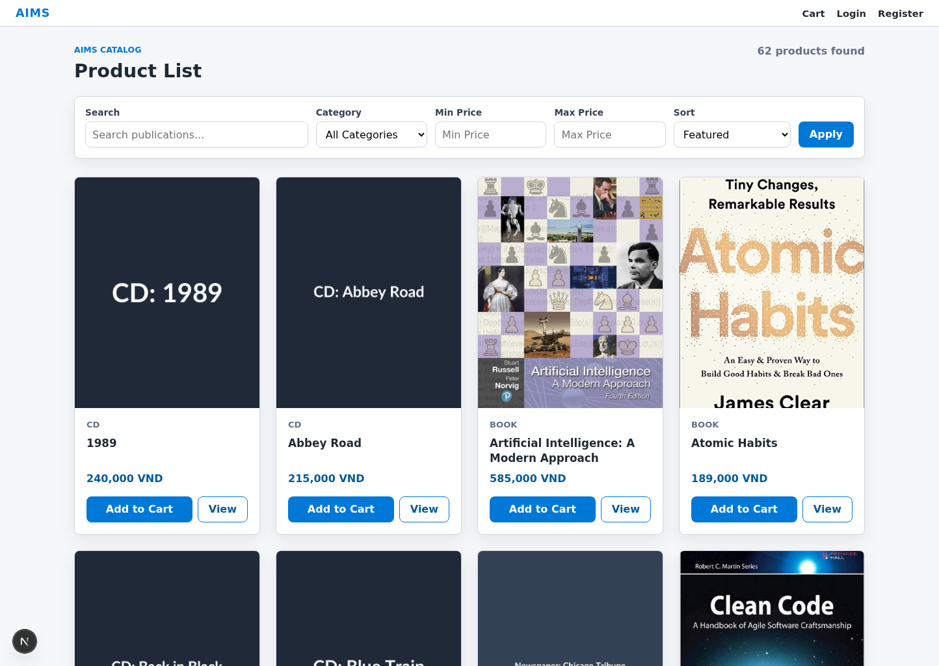

Screen Specification:
Date of creation | Approved by | Reviewed by | Person in charge
19/04/2026 | Chu Tuan Linh | Chu Tuan Linh | Thanh Huu Dat
Control | Operation | Function
Search bar | Input / Click Search | Search products by title or category
Category filter | Select | Filter products by category
Price range filter | Select | Filter products by price range
Sort dropdown | Select | Sort products according to the selected criterion
Product list area | Initial | Display the current customer-visible products as a grid; on first load the backend returns a random set of products
Product card / hover preview | Click | Show a quick product preview on hover; the View button navigates to the Product Detail Screen
Add to Cart button | Click | Add the selected product with default quantity to the cart
Cart button / cart badge | Click | Open the Cart Screen from the global account bar
Pagination control | Click | Navigate between product pages when more results are available

Defining the field attributes
Item | Length | Type | Color | Remarks
Product title | 80 characters | Text | Primary text | Maximum 2 lines, ellipsis if overflow
Category | 30 characters | Text | Secondary text | Left-justified
Current price | 20 digits | Numeral | Primary text | Displayed as 1,000 VND
Availability status | 20 characters | Text | Text / State | Use text, disabled-button state, or preview badge; do not rely on color only
Search keyword | 100 characters | Text | Primary text | User input
Price range | 30 characters | Text | Primary text | Dropdown value
Sort criterion | 30 characters | Text | Primary text | Dropdown value

Product Detail Preview / Product Detail Screen
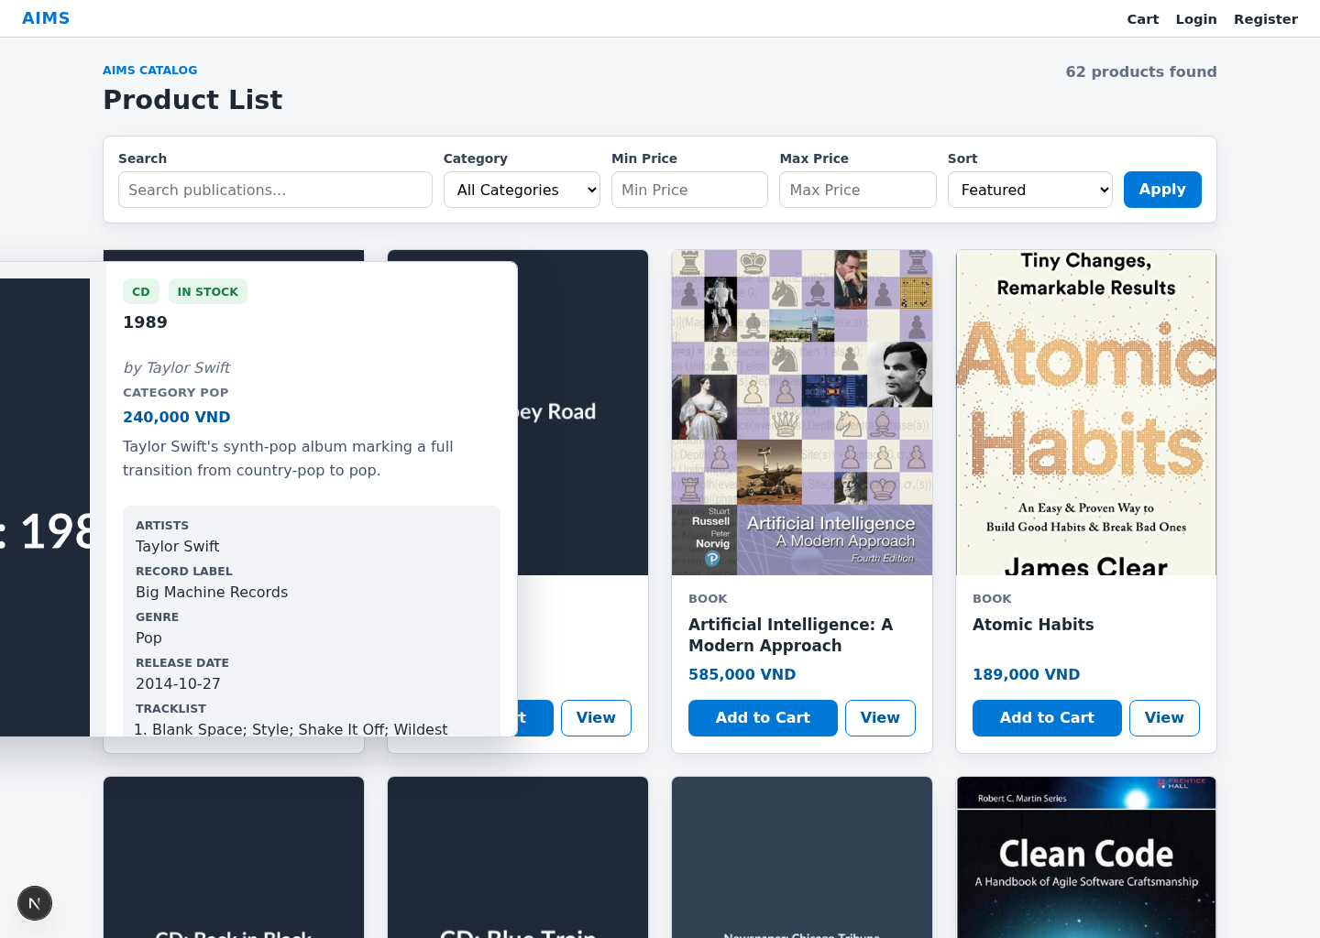

Screen Specification:
Date of creation | Approved by | Reviewed by | Person in charge
19/04/2026 | Chu Tuan Linh | Chu Tuan Linh | Thanh Huu Dat
Control | Operation | Function
Preview behavior | Hover / leave / back navigation | Show a quick preview from the product list, or return to the Product List Screen
Product image area | Initial | Display the product image
Product information and specification area | Initial | Display detailed information of the selected product, including type-specific attributes and physical specifications
Quantity selector | Click / Input | Increase or decrease the desired quantity on the full Product Detail Screen
Add to Cart button | Click | Add the selected quantity of the product to the cart from the full Product Detail Screen
View details / Back area | Click | Open the full Product Detail Screen or return to the Product List Screen
Description area | Initial | Display product description, availability, and type-specific attributes

Defining the field attributes
Item | Length | Type | Color | Remarks
Product title | 120 characters | Text | Primary text | Full title should be visible
Category | 30 characters | Text | Secondary text | Left-justified
Current price | 20 digits | Numeral | Primary text | Displayed as 1,000 VND
Description | 500 characters | Text | Primary text | Multi-line
Product-specific attributes | 200 characters | Text | Primary text | Depends on product type
Quantity | 4 digits | Numeral | Primary text | Must be greater than 0
Availability status | 20 characters | Text | Warning / Success / Neutral | Show readable text state; the quick preview and full detail page must not rely on color only

Cart Screen
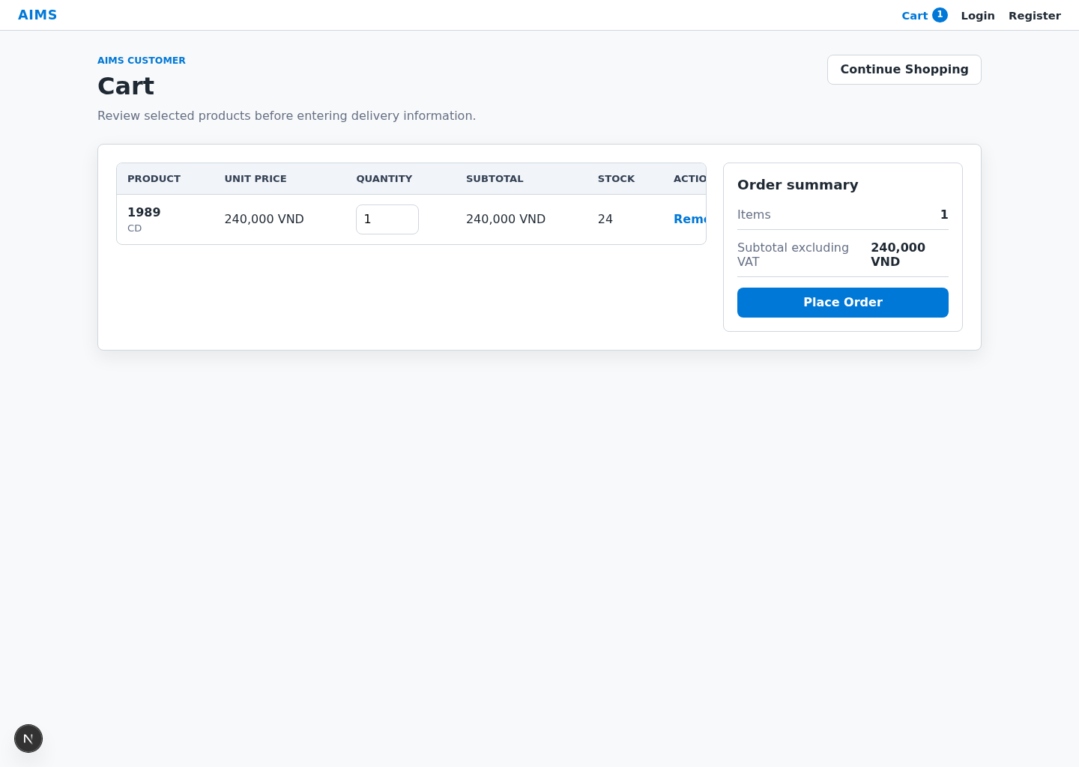
Screen Specification:
Date of creation | Approved by | Reviewed by | Person in charge
19/04/2026 | Chu Tuan Linh | Chu Tuan Linh | Thanh Huu Dat
Control | Operation | Function
Cart items area | Initial | Display products currently added to the cart
Quantity selector | Click / Input | Update the quantity of a cart item
Remove button | Click | Remove the selected item from the cart after user confirmation
Subtotal area | Initial | Display total product price excluding VAT
Stock warning area | Initial | Display insufficient stock information if any item exceeds available quantity
Continue Shopping button | Click | Return to the Product List Screen
Place Order button | Click | Proceed to the Delivery Information screen if cart is valid
Continue Shopping / Back navigation | Click | Return to the Product List Screen when the user chooses to continue shopping

Defining the field attributes
Item | Length | Type | Color | Remarks
Product title | 80 characters | Text | Primary text | Left-justified
Unit price | 20 digits | Numeral | Primary text | Displayed as 1,000 VND
Quantity | 4 digits | Numeral | Primary text | Editable
Item subtotal | 20 digits | Numeral | Primary text | Calculated field
Cart subtotal excluding VAT | 20 digits | Numeral | Primary text | Calculated field
Stock warning message | 120 characters | Text | Warning / Error | Display available quantity clearly

Delivery Form
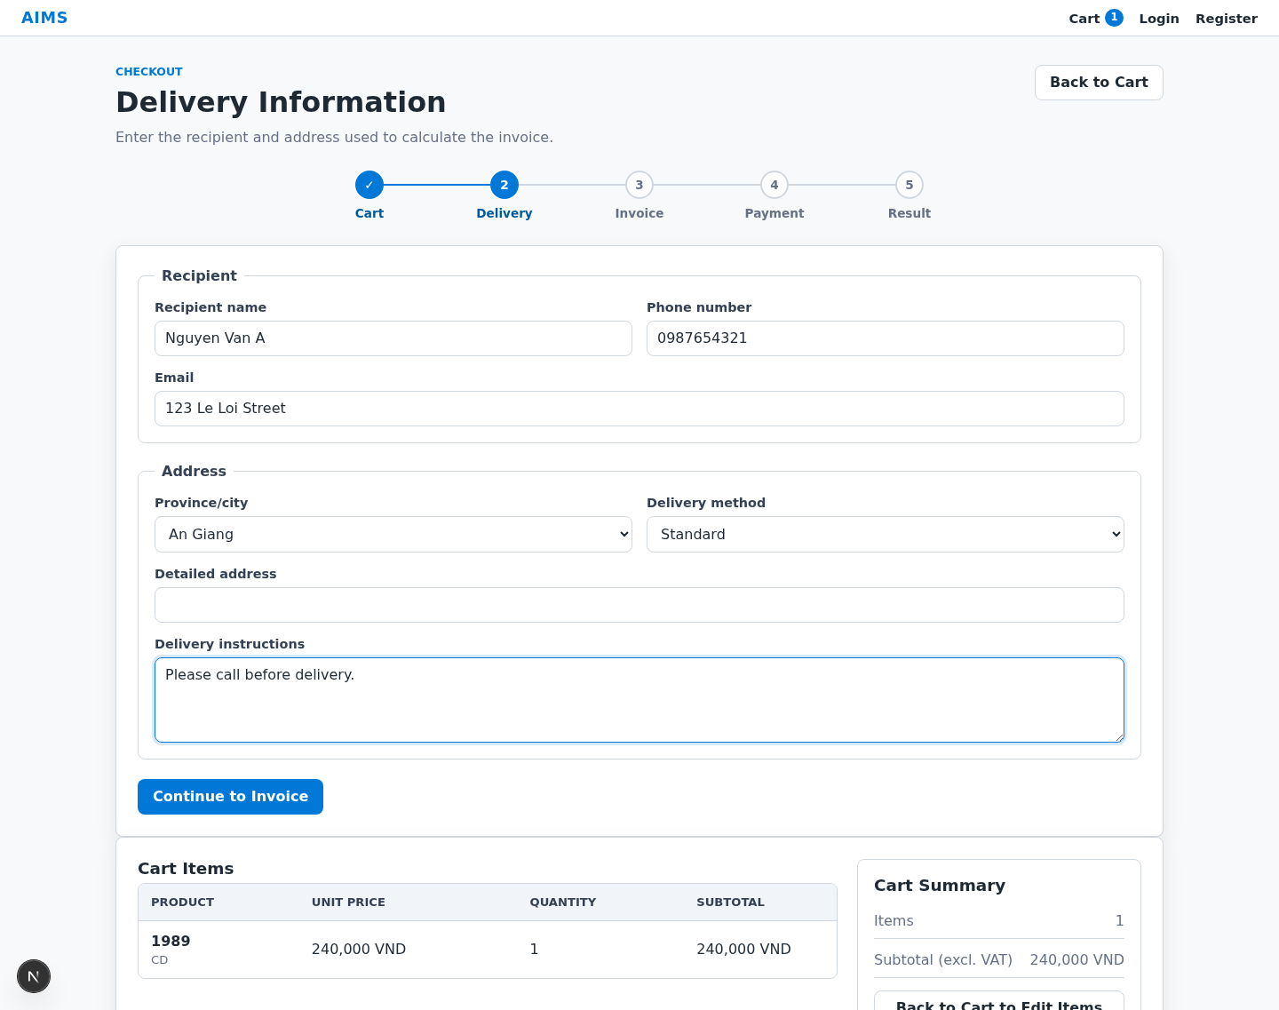
Screen Specification:
Date of creation | Approved by | Reviewed by | Person in charge
19/04/2026 | Chu Tuan Linh | Chu Tuan Linh | Thanh Huu Dat
Control | Operation | Function
Recipient Name field | Input | Enter recipient full name
Phone Number field | Input | Enter recipient phone number
Email field | Input | Enter recipient email address
Province/City field | Select | Enter or select delivery province/city
Address field | Input | Enter detailed delivery address
Delivery Method field | Select | Select delivery method
Delivery fee area | Initial / Auto update | Display recalculated delivery fee based on province and current order summary
Order summary / live preview area | Initial | Display current cart and invoice preview information during delivery information entry
Back button | Click | Return to the Cart Screen
Continue button | Click | Validate input, save delivery information, and proceed to the Invoice Screen

Defining the field attributes
Item | Length | Type | Color | Remarks
Recipient name | 100 characters | Text | Primary text | Required
Phone number | 11 digits | Numeral | Primary text | Required, 10–11 digits
Email | 100 characters | Text | Primary text | Required, standard email format
Province/City | 50 characters | Text | Primary text | Required
Address | 200 characters | Text | Primary text | Required
Delivery method | 30 characters | Text | Primary text | Dropdown value
Delivery fee | 20 digits | Numeral | Primary text | Auto-calculated, based on province and current order summary
Validation message | 120 characters | Text | Error | Displayed below related field

Invoice Screen
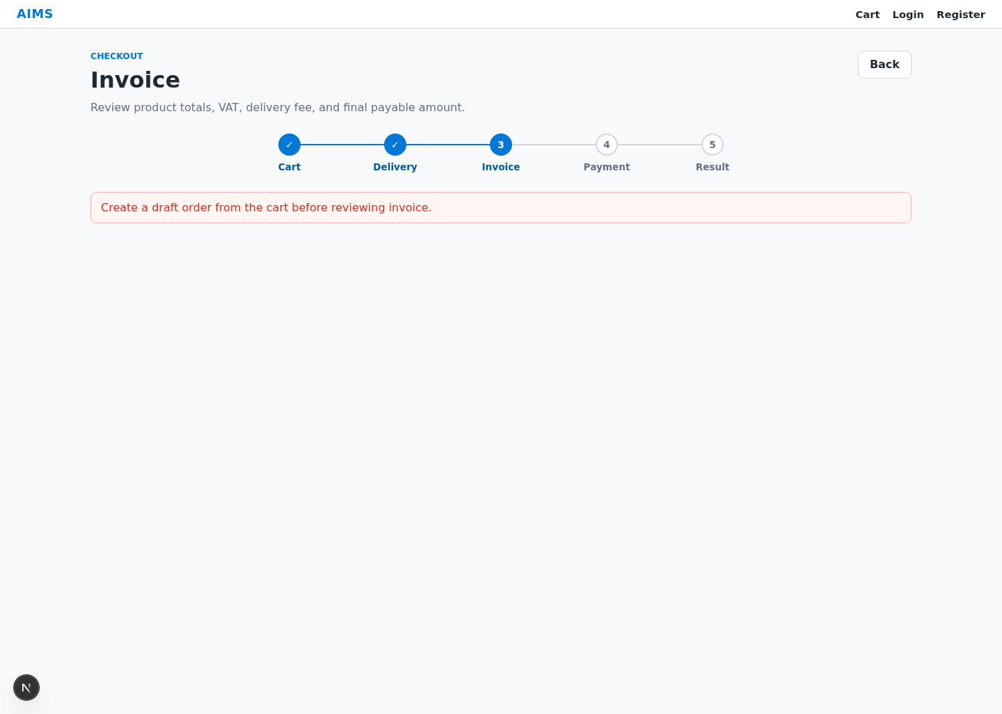
Screen Specification:
Date of creation | Approved by | Reviewed by | Person in charge
19/04/2026 | Chu Tuan Linh | Chu Tuan Linh | Thanh Huu Dat
Control | Operation | Function
Customer information area | Initial | Display entered delivery information
Product list area | Initial | Display products, quantities, and prices in the invoice
Subtotal excluding VAT area | Initial | Display total product price excluding VAT
VAT area | Initial | Display VAT amount
Total including VAT area | Initial | Display total product price including VAT
Delivery fee area | Initial | Display delivery fee
Final payable amount area | Initial | Display final amount to be paid
Back button | Click | Return to the Delivery Information Screen
Proceed to Payment button | Click | Open the Payment Method Screen after confirming the current invoice

Defining the field attributes
Item | Length | Type | Color | Remarks
Recipient name | 100 characters | Text | Primary text | Read-only
Phone number | 11 digits | Numeral | Primary text | Read-only
Email | 100 characters | Text | Primary text | Read-only
Delivery address | 200 characters | Text | Primary text | Read-only
Product title | 80 characters | Text | Primary text | Left-justified
Unit price | 20 digits | Numeral | Primary text | 1,000 VND
Quantity | 4 digits | Numeral | Primary text | Read-only
Item total | 20 digits | Numeral | Primary text | Calculated
Subtotal excluding VAT | 20 digits | Numeral | Primary text | Calculated
VAT | 20 digits | Numeral | Primary text | Calculated
Total including VAT | 20 digits | Numeral | Primary text | Calculated
Delivery fee | 20 digits | Numeral | Primary text | Calculated
Final payable amount | 20 digits | Numeral | Accent | Calculated, emphasized

Payment Method Screen
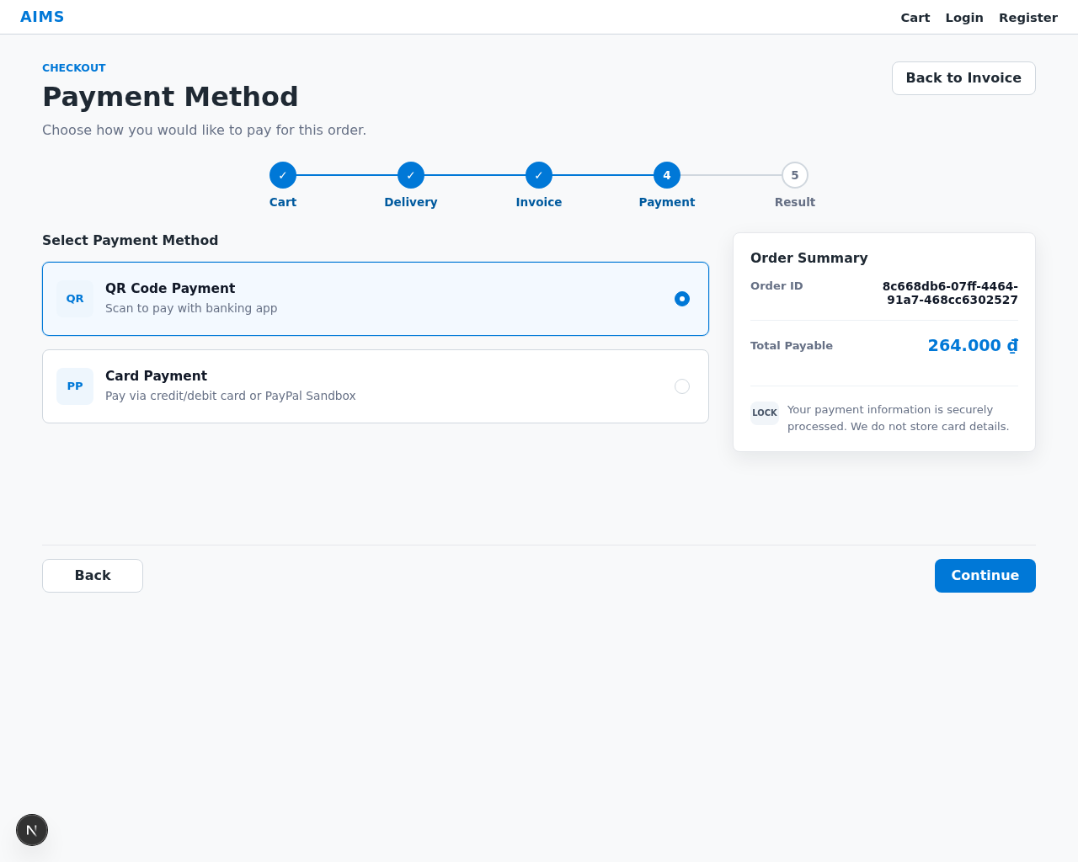

Screen Specification:
Date of creation | Approved by | Reviewed by | Person in charge
19/04/2026 | Ta Hai Luan | Ta Hai Luan | Chu Tuan Linh
Control | Operation | Function
QR Payment option | Click | Select QR code as the payment method
Card Payment option | Click | Select card payment as the payment method
Order amount area | Initial | Display the final payable amount
Order ID area | Initial | Display the order identifier
Back button | Click | Return to the Invoice Screen
Continue button | Click | Proceed to the selected payment screen

Defining the field attributes
Item | Length | Type | Color | Remarks
Payment method name | 30 characters | Text | Primary text | QR Payment / Card Payment
Payment method description | 120 characters | Text | Secondary text | Short explanation
Selected state | 10 characters | Text | Primary / Accent | Highlight selected option
Order ID | 30 characters | Text | Primary text | Read-only
Final payable amount | 20 digits | Numeral | Accent | Read-only

QR Payment Screen
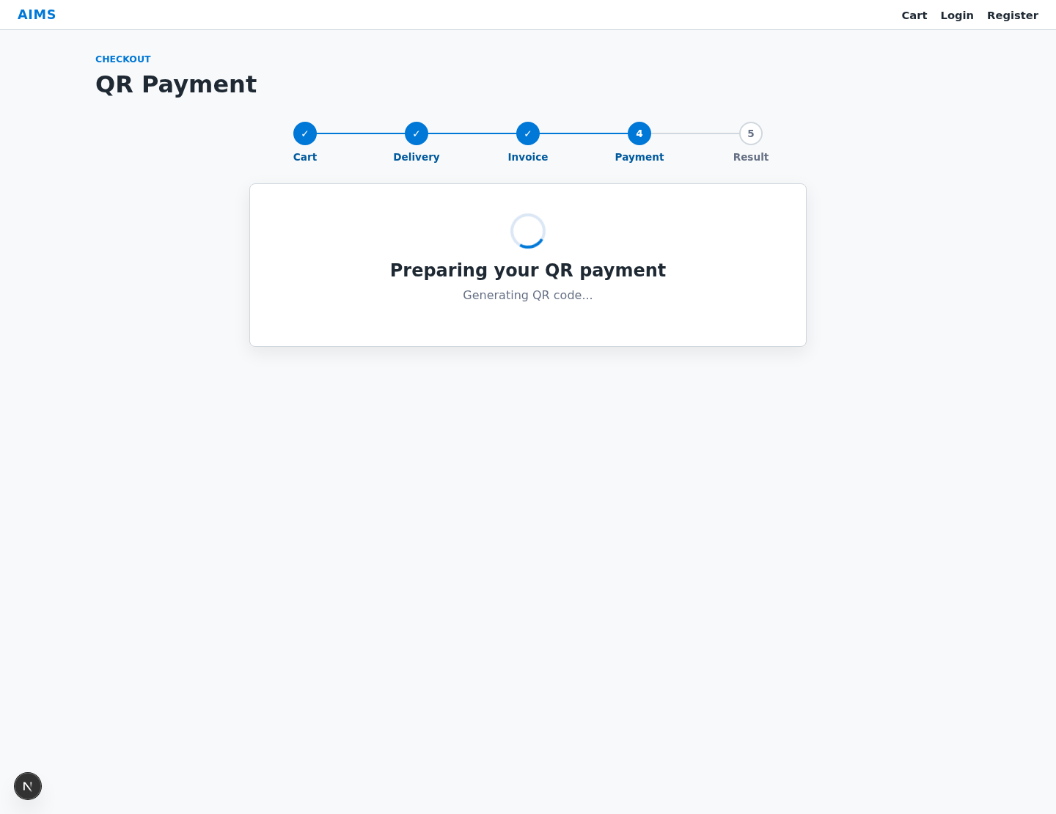

Screen Specification:
Date of creation | Approved by | Reviewed by | Person in charge
19/04/2026 | Ta Hai Luan | Ta Hai Luan | Chu Tuan Linh
Control | Operation | Function
QR code area | Initial | Display the QR code generated for the current VietQR payment transaction
Amount area | Initial | Display the amount to be paid
Order ID area | Initial | Display the order identifier
Transaction content/reference area | Initial | Display payment reference information
Check Payment Status button | Click | Check whether the payment has been completed and refresh the displayed payment state
Switch Payment Method button | Click | Return to the Payment Method Screen
Back button | Click | Return to the Invoice Screen
Payment status message area | Initial / Auto update | Display waiting, success, cancelled, timeout, or failure status

Defining the field attributes
Item | Length | Type | Color | Remarks
QR code | N/A | Image | N/A | Centered in payment area
Amount | 20 digits | Numeral | Primary text | 1,000 VND
Order ID | 30 characters | Text | Primary text | Read-only
Transaction content/reference | 100 characters | Text | Primary text | Read-only
Payment status | 30 characters | Text | Success / Warning / Error | Waiting, Success, Cancelled, Timeout, Failed
Status message | 120 characters | Text | Primary text | Helpful, non-technical

Card Payment Screen (PayPal)
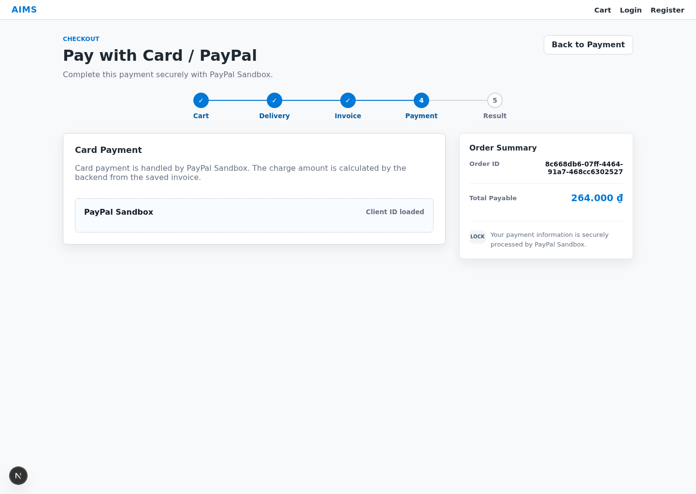

Screen Specification:
Date of creation | Approved by | Reviewed by | Person in charge
19/04/2026 | Ta Hai Luan | Ta Hai Luan | Chu Tuan Linh
Control | Operation | Function
PayPal button area | Click | Render PayPal checkout buttons for the current order
Fallback Pay with PayPal button | Click | Redirect to PayPal if the SDK button cannot be rendered
Payment status / capture area | Initial / Auto update | Display loading, success, cancelled, or failed capture state
Error message area | View | Displays PayPal SDK or capture errors
Order summary area | Initial | Display the order ID and final payable amount
Back to Payment button | Click | Return to the Payment Method Screen
PayPal cancellation / retry flow | Automatic / Click | Return to the card payment screen in cancelled state and allow the user to retry or go back
PayPal approval button | Click | Open the PayPal approval flow and capture payment after buyer approval
Result state area | Initial / Auto update | Display success, failed, or cancelled payment result

Defining the field attributes
Item | Length | Type | Color | Remarks
Item | Length | Type | Color | Remarks
PayPal button container | - | Embedded control | Primary | Rendered by PayPal SDK when the client ID is available
Fallback payment button | - | Button | Primary | Visible only when the PayPal SDK button is unavailable
Gateway state | 30 characters | Text | Primary / Warning / Success / Error | Loading, success, failed, or cancelled
Error message | 120 characters | Text | Error | Displayed when PayPal initialization or capture fails
Order ID | 30 characters | Text | Primary text | Read-only
Final payable amount | 20 digits | Numeral | Accent | Read-only
Security note | 120 characters | Text | Secondary text | Indicates that payment is securely processed by PayPal Sandbox
Retry link / action | - | Button / Link | Primary / Secondary | Shown on failed or cancelled result states

Order Result Screen
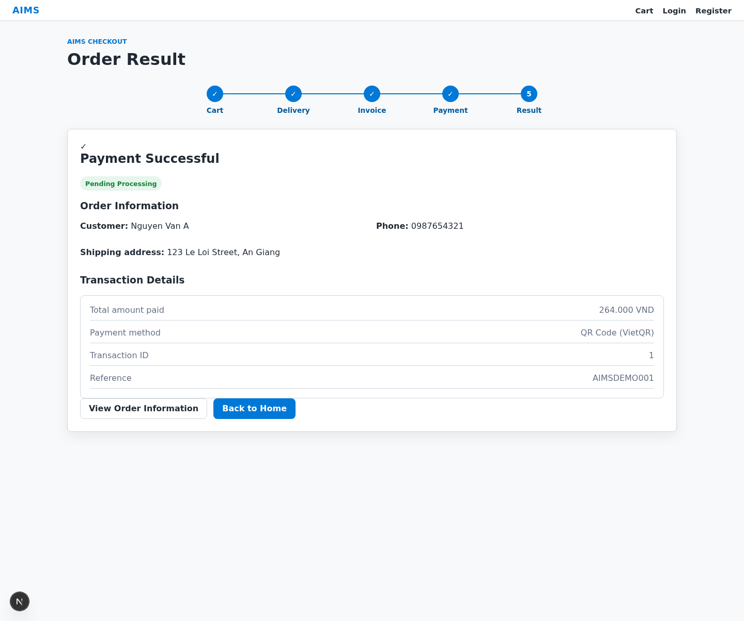

Screen Specification:
Date of creation | Approved by | Reviewed by | Person in charge
19/04/2026 | Ta Hai Luan | Ta Hai Luan | Chu Tuan Linh
Control | Operation | Function
Result status area | Initial | Display payment result and order state
Order information area | Initial | Display general information of the order
Transaction information area | Initial | Display payment transaction information
View Order Information button | Click | Open detailed order information
Back to Home button | Click | Return to the Product List Screen

Defining the field attributes
Item | Length | Type | Color | Remarks
Payment result | 30 characters | Text | Success / Error | Success or failure status
Order status | 30 characters | Text | Warning / Primary | Use “Pending Processing” after successful payment
Customer name | 100 characters | Text | Primary text | Read-only
Phone number | 11 digits | Numeral | Primary text | Read-only
Shipping address | 200 characters | Text | Primary text | Read-only
Province/City | 50 characters | Text | Primary text | Read-only
Total amount | 20 digits | Numeral | Accent | Read-only
Transaction ID | 50 characters | Text | Primary text | Read-only
Transaction content | 100 characters | Text | Primary text | Read-only
Transaction datetime | 16 characters | Text | Primary text | DD/MM/YYYY HH:mm

Create Product Screen
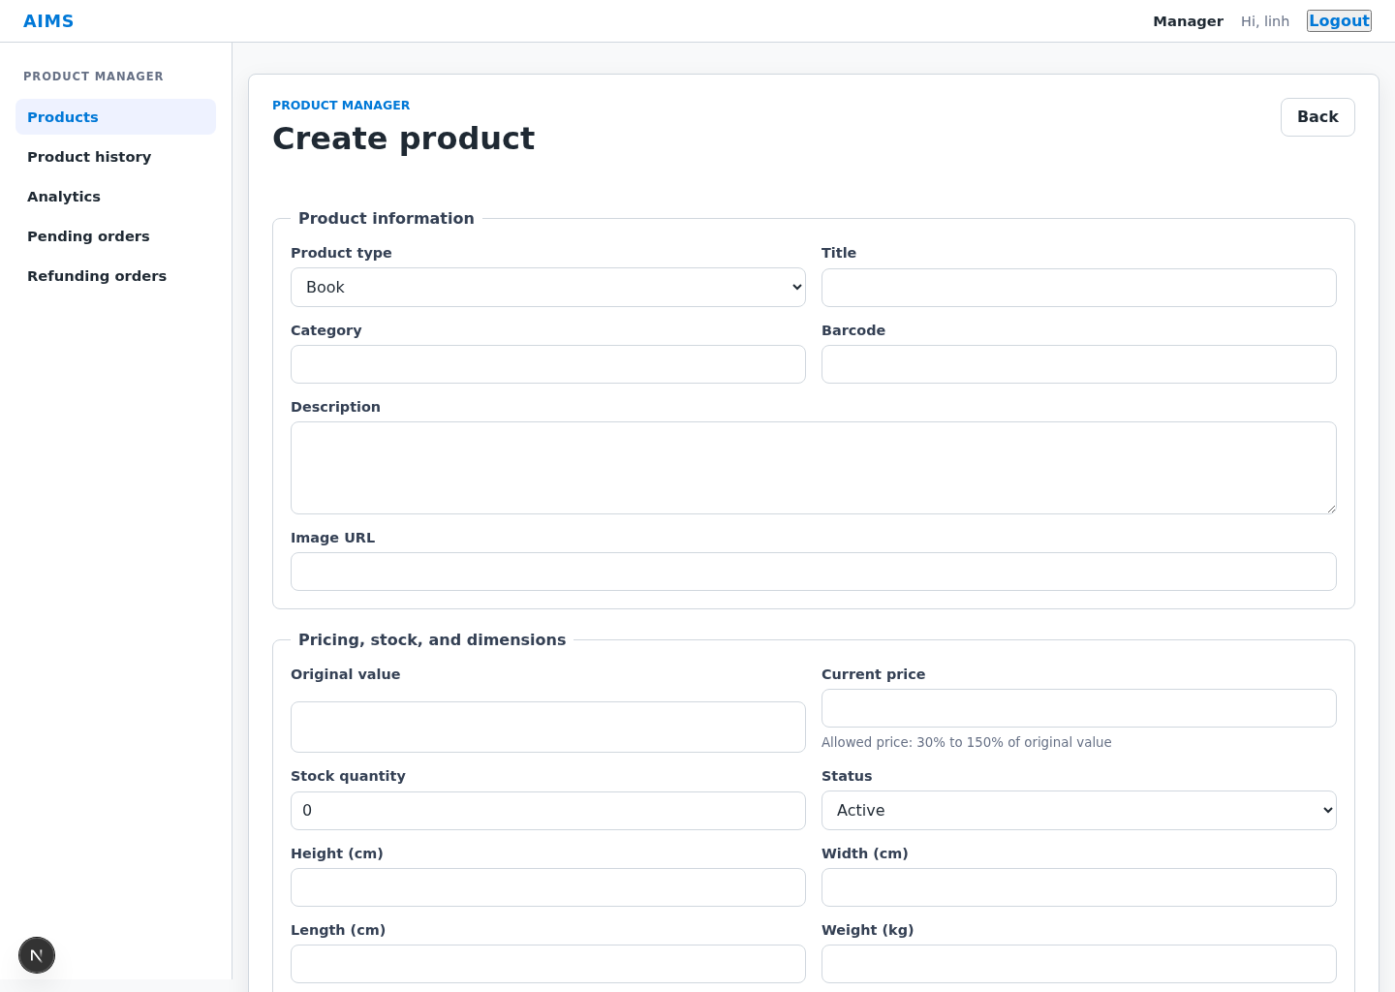
Screen Specification:
Date of creation | Approved by | Reviewed by | Person in charge
19/04/2026 | Chu Tuan Linh | Chu Tuan Linh | Le Tung Lam
Control | Operation | Function
Product information form | Enter product data | Allows manager to input general product information such as title, category, price, barcode, description, weight, dimensions, stock quantity, and image
Product type selector | Select product type | Allows manager to choose product type (Book/CD/DVD/Newspaper) and dynamically display corresponding type-specific fields
Type-specific fields | Enter data | Allows manager to input additional attributes depending on product type
Image URL field | Enter | Allows manager to provide a product image URL for display in the system
Create button | Click | Validates all required fields and submits product creation request to the system
Back button | Click | Cancel creation and navigate back to the product list screen
Validation message area | View | Displays validation errors such as missing fields or invalid input
Success navigation | View | After successful creation, the system returns to the product list and refreshes it
Success notification | View | Displays successful creation feedback when available

Defining the field attributes
Item | Length | Type | Color | Remarks
Title | ≤ 255 | Text | Default / Error | Mandatory
Category | - | Text | Default | Mandatory, free text
Original value | ≥ 0 | Number | Default / Error | Mandatory
Current price | 20 digits | Number | Default / Error | Mandatory, validated against allowed price ratio
Description | ≤ 1000 | Textarea | Default | Optional
Weight | > 0 | Number | Default / Error | Mandatory
Height / Width / Length | > 0 | Number | Default / Error | Mandatory as separate numeric inputs
Stock quantity | ≥ 0 | Integer | Default / Error | Mandatory
Product type | - | Dropdown | Default | Mandatory
Image URL | ≤ 255 | Text | Default / Error | Optional, format URL
Type-specific creator field | ≤ 255 | Text | Default | Required depending on the selected product type
Type-specific publication / producer field | ≤ 255 | Text | Default | Required depending on the selected product type
Type-specific numeric/date field | Depends on type | Text / Number / Date | Default | Required depending on the selected product type
Additional type-specific optional field | Depends on type | Text | Default | Shown only when defined for the selected product type

Update Product Screen
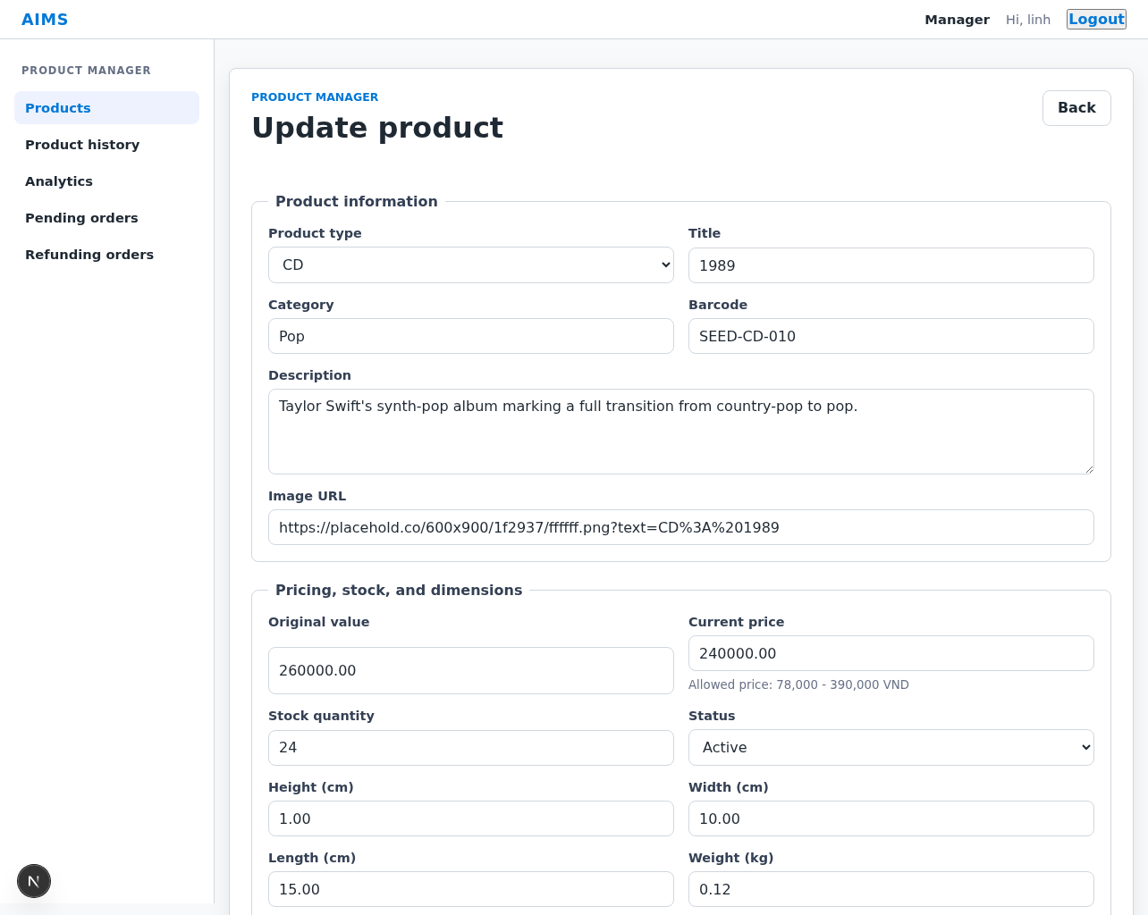
Screen Specification:
Date of creation | Approved by | Reviewed by | Person in charge
19/04/2026 | Chu Tuan Linh | Chu Tuan Linh | Le Tung Lam
Control | Operation | Function
Product information form | View current data | Displays current product information for editing.
Editable fields | Modify product data | Allows manager to update product information
Product type selector | View / Select | Displays or allows change of product type
Update button | Click | Validates and submits updated product data
Back button | Click | Return to the product list without saving changes
Stock adjustment reason field | Input | Required when the stock quantity is changed
Validation message area | View | Displays invalid input errors
Success navigation | View | After successful update, return to the product list and refresh it

Defining the field attributes
Item | Length | Type | Color | Remarks
Original value | ≥ 0 | Number | Default / Error | Mandatory
Title | ≤ 255 | Text | Default / Error | Mandatory
Category | - | Text | Default | Mandatory, free text
Current price | ≥ 0 | Number | Default / Error | Mandatory, validated against allowed price ratio
Stock quantity | ≥ 0 | Integer | Default / Error | Mandatory
Description | ≤ 1000 | Textarea | Default | Optional
Image URL | ≤ 255 | Text | Default | Optional
Product type | - | Dropdown | Default | Editable; changing type refreshes the type-specific fields.
Type-specific fields | - | Text / Number / Date | Default | Validate according to the selected product type

Delete Product Dialog
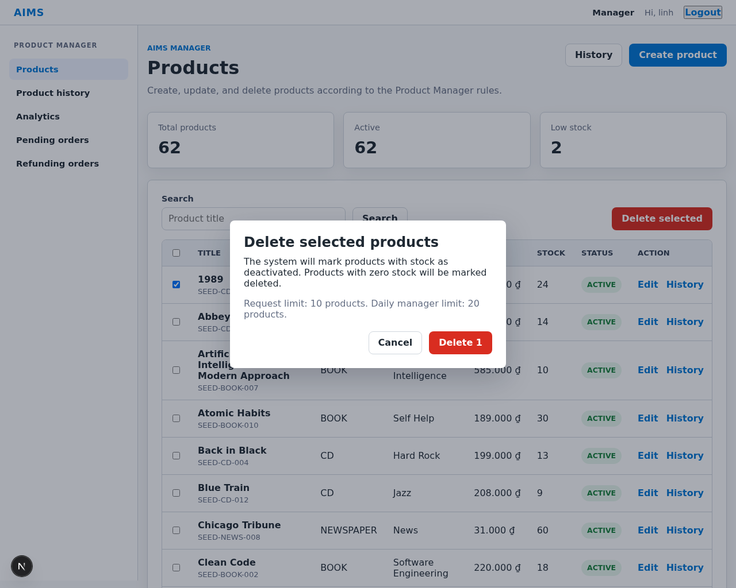
Screen Specification:
Date of creation | Approved by | Reviewed by | Person in charge
19/04/2026 | Chu Tuan Linh | Chu Tuan Linh | Le Tung Lam
Control | Operation | Function
Selected product count / scope | View | Displays how many selected products will be affected by delete/deactivate processing.
Warning message | View | Warn that products with remaining stock will be deactivated, while zero-stock products are marked deleted.
Confirm Delete button | Click | Sends delete request to system
Cancel button | Click | Cancels deletion and closes popup
Request limit note | View | Displays per-request and per-day delete limits for Product Managers
Error message area | View | Displays deletion errors if any
Result notification | View | Displays deletion result.

Defining the field attributes
Item | Length | Type | Color | Remarks
Selected product count | - | Label | Default | Display how many products are affected
Delete/deactivate policy | 120 characters | Text | Default | Explain zero-stock delete vs in-stock deactivate behavior
Warning message | - | Label | Warning (yellow/red) | Includes irreversible action and manager delete limits
Confirm button | - | Button | Danger (red) | Deletion
Cancel button | - | Button | Default | Cancel

Login Screen
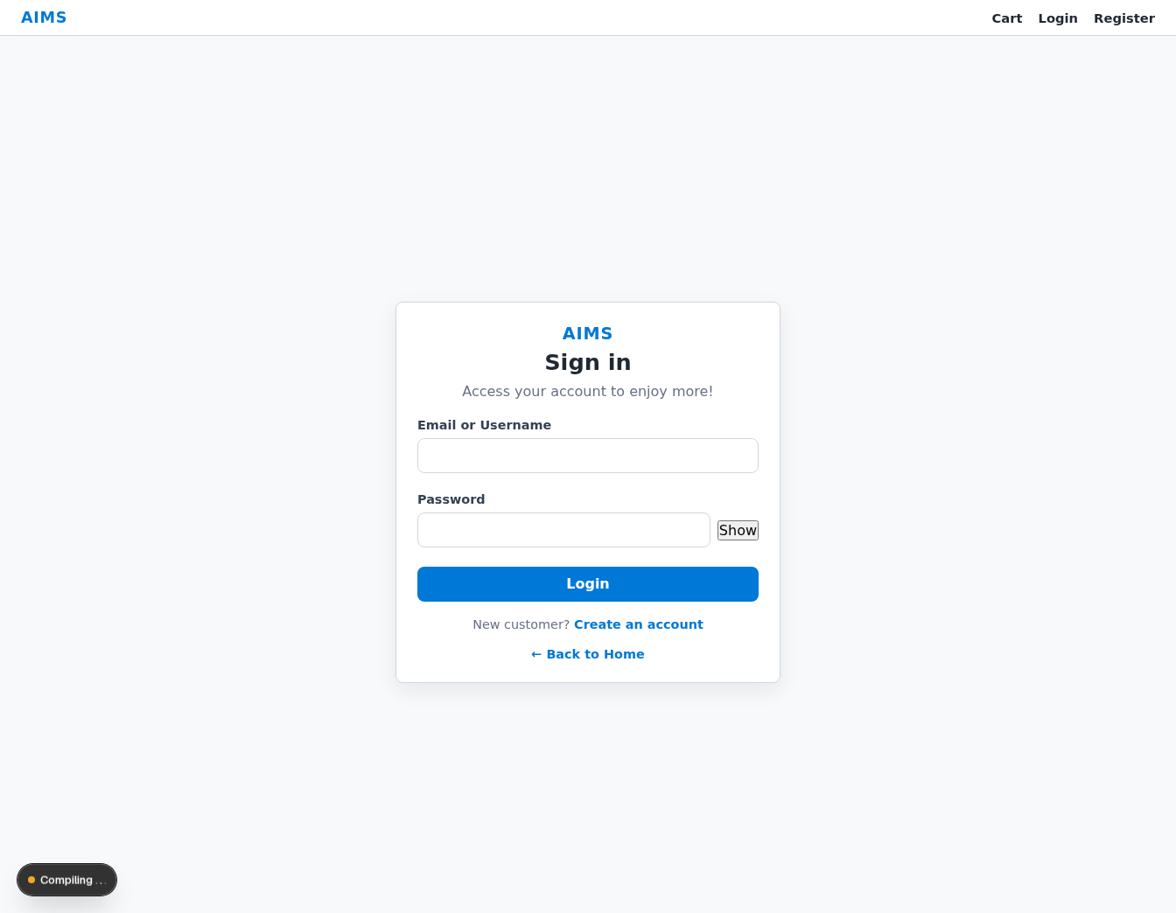
Screen Specification:
Date of creation | Approved by | Reviewed by | Person in charge
19/04/2026 | Chu Tuan Linh | Chu Tuan Linh | Le Tung Lam
Control | Operation | Function
Username / Email field | Enter | Allows admin to input login identifier.
Password field | Enter | Allows admin to input password securely.
Show/Hide password icon | Click | Toggles password visibility.
Login button | Click | Sends authentication request to system.
Role-based redirect | Automatic | Redirects customers to the catalog and staff users to their protected workspace after successful login.
Error message area | View | Displays login errors.
Back to Home link | Click | Return to the Product List Screen.

Defining the field attributes
Item | Length | Type | Color | Remarks
Username / Email | ≤ 255 | Text | Default / Error | Mandatory
Password | ≥ 6 | Password | Default / Error | Mandatory
Login button | - | Button | Primary | Submit login
Error message | - | Label | Error (red) | Display when login fail

User Management Screen
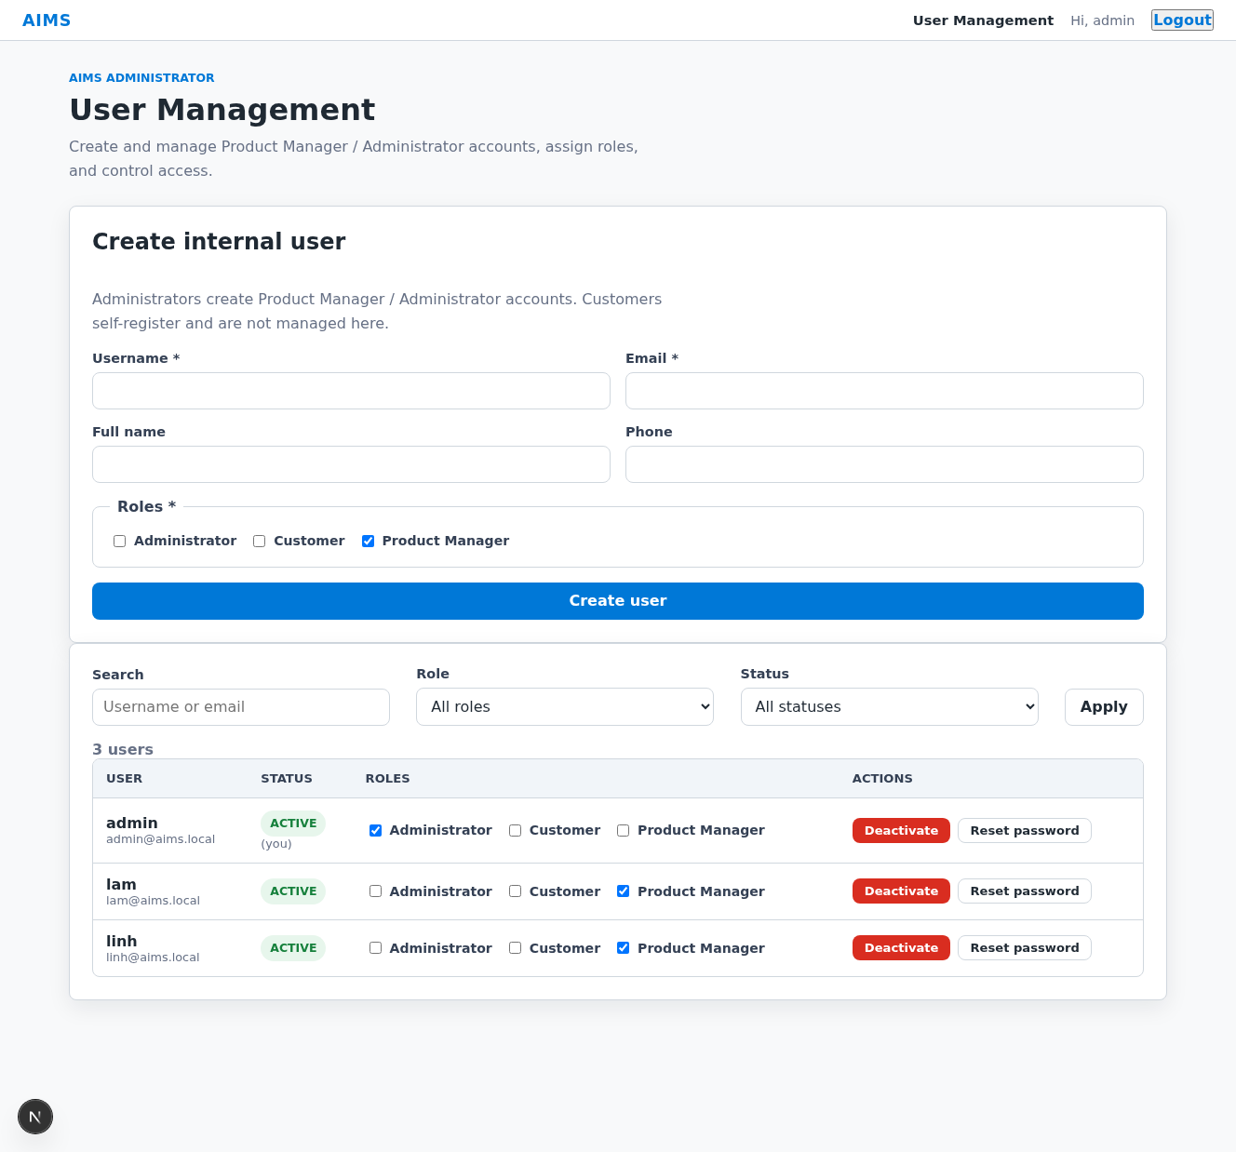
Screen Specification:
Date of creation | Approved by | Reviewed by | Person in charge
19/04/2026 | Chu Tuan Linh | Chu Tuan Linh | Le Tung Lam
Control | Operation | Function
Search field | Enter keyword | Allows admin to search users
Role filter | Select | Filters users by role.
Status filter | Select | Filters users by status
User list/table | View | Displays user list
Create user form | Input / Select | Allows administrators to create an internal user and assign one or more roles
User row actions | Click | Update roles, status, or reset password inline within the same screen
Pagination control | Click | Navigates pages
Notice area | View | Displays success or error feedback for create/update actions
Empty state message | View | Displays when no users found

Defining the field attributes
Item | Length | Type | Color | Remarks
Search keyword | ≤ 255 | Text | Default | Optional
Role filter | - | Dropdown | Default | Filter by role
Status filter | - | Dropdown | Default | Filter by status
User table | - | Table | Default | Display user list
User name | ≤ 255 | Text | Default | Read-only
Email | ≤ 255 | Text | Default | Format email
Phone | 10–11 | Text | Default | Numeric only
Role | - | Text | Default | Display role
Status | - | Badge | Green/Red | Active/Blocked
Pagination | - | Control | Default | Page navigation

User Management Actions (Inline Editing)
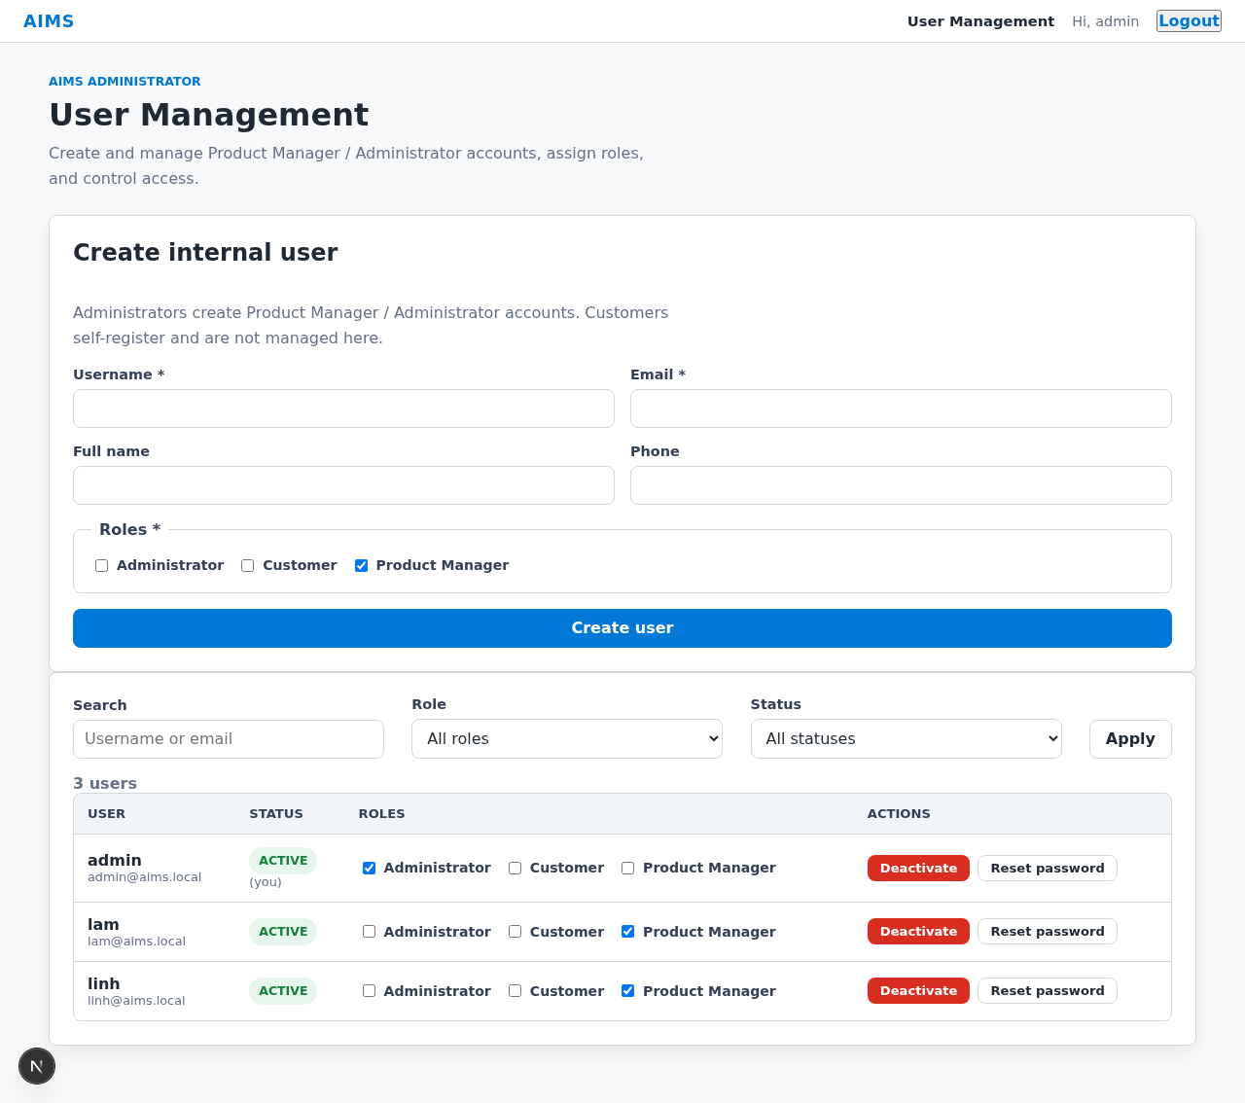
Screen Specification:
Date of creation | Approved by | Reviewed by | Person in charge
19/04/2026 | Chu Tuan Linh | Chu Tuan Linh | Le Tung Lam
Control | Operation | Function
User information section / row | View | Displays user information inside the User Management table.
Role checkbox list | View / Select | Allows changing user roles inline.
Status action button | Click | Allows activating or deactivating a user inline.
Save roles button | Click | Saves updated user roles.
Reset password button | Click | Initiates password reset and emails the new password to the user.
Inline notice area | View | Displays success or error feedback inside the User Management screen.
Error message area | View | Displays errors if update fails.
Success notification | View | Displays successful update result.

Defining the field attributes
Item | Length | Type | Color | Remarks
Username | - | Text | Disabled | Read-only
Full name | ≤ 255 | Text | Default | Optional
Email | ≤ 255 | Text | Default | Format email
Role options | - | Checkbox list | Default | Inline multi-select
Status action | - | Button | Default / Danger | Activate / Deactivate
Reset password action | - | Button | Warning | Emails a new password
Save roles button | - | Button | Primary | Save role changes
Error / success notice | - | Label | Error / Success | Inline feedback
Error message | - | Label | Error (red) | Display error
Success message | - | Label | Success (green) | Display success

