BÁO CÁO LAB 10 - REMOTE DNS CACHE POISONING
Họ tên: Nguyễn Hoàng Tiến Đạt
MSSV: 1150080011
Lớp: 11_ĐH_CNPM1
Ngày thực hành: 3/11/2026

1. Môi trường và địa chỉ IP
............................................................................................................................
............................................................................................................................
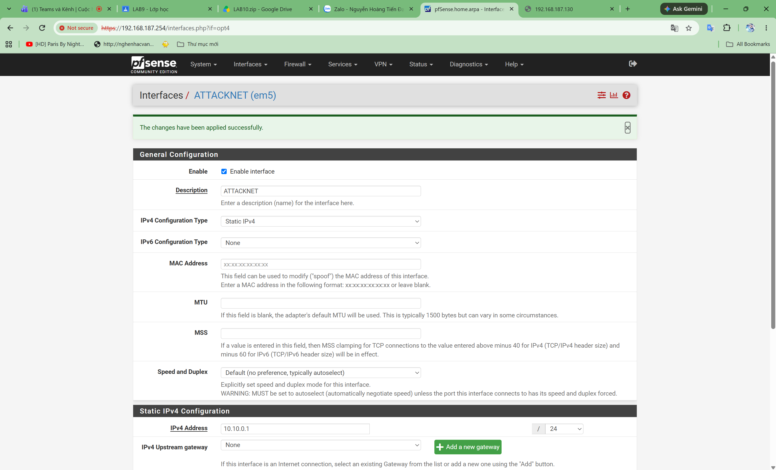
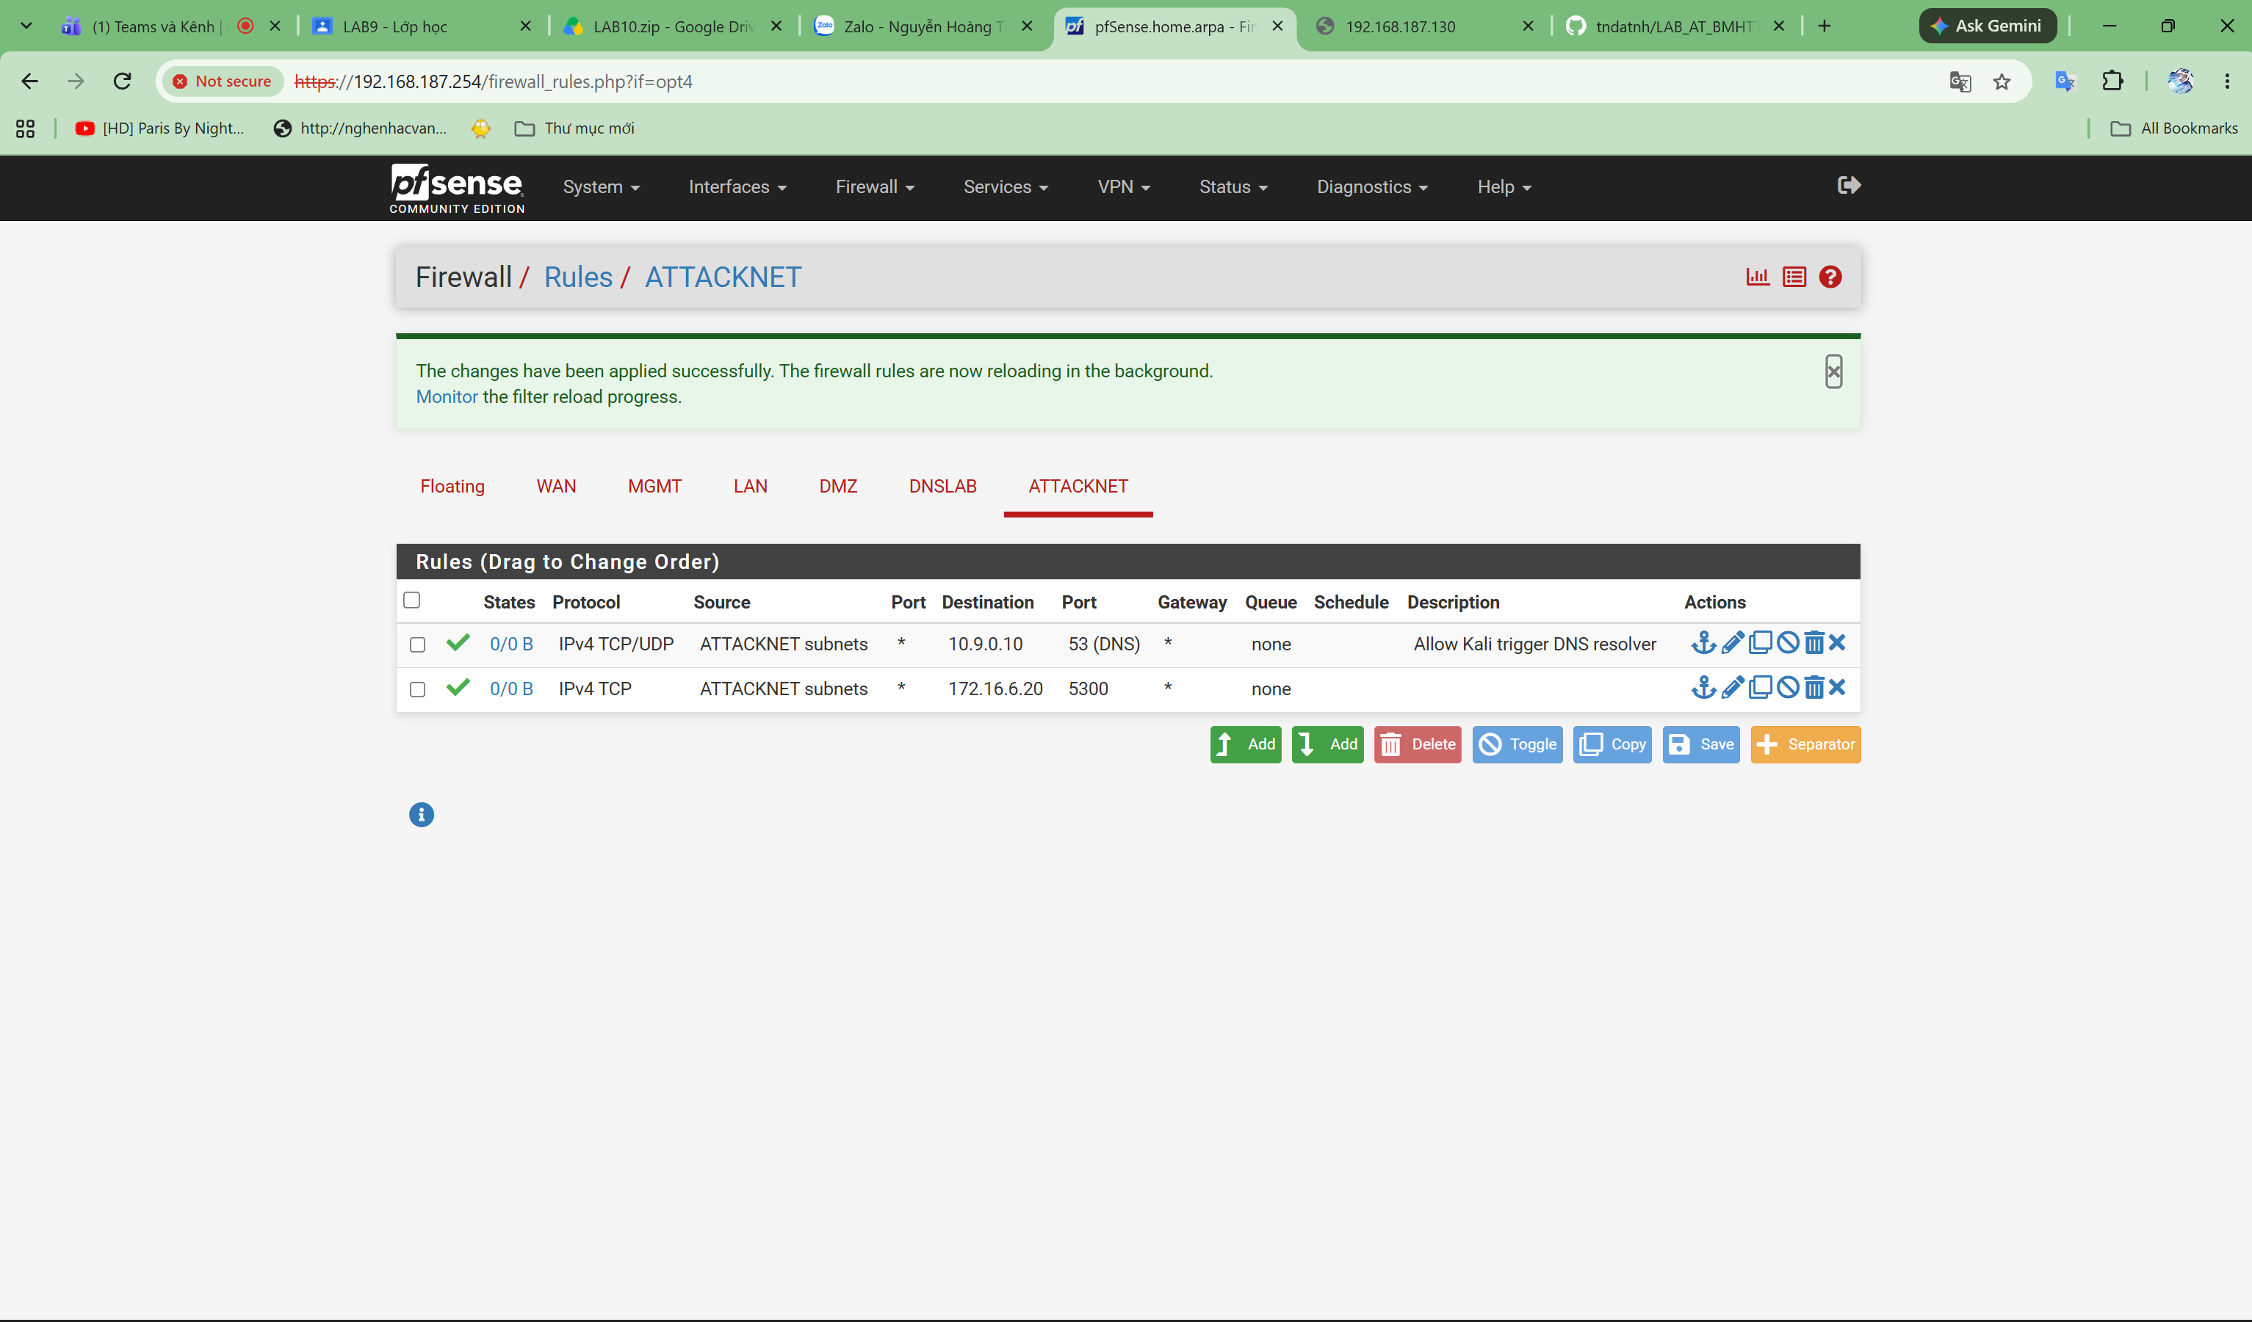
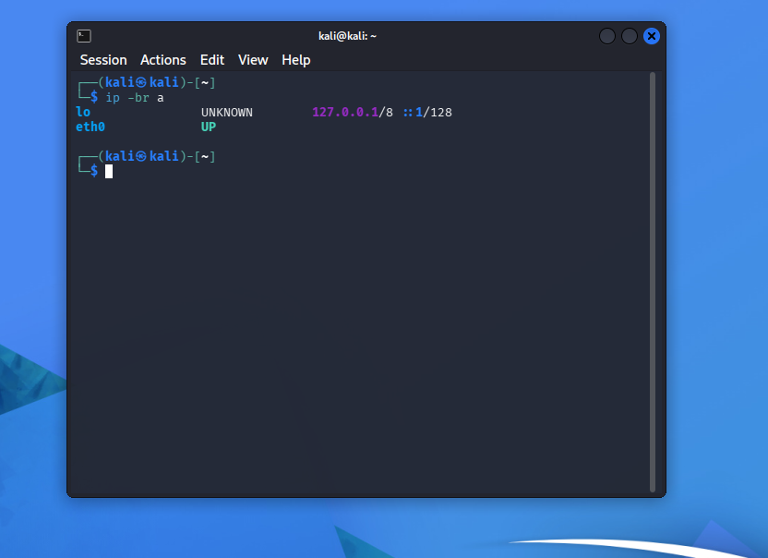

2. Baseline
............................................................................................................................
............................................................................................................................

3. Chứng minh attacker không sniff DNSLAB
............................................................................................................................
............................................................................................................................

4. Remote poisoning - log PENDING/HIT/CACHE
............................................................................................................................
............................................................................................................................

5. Packet capture
............................................................................................................................
............................................................................................................................

6. Kết quả Victim sau poison
............................................................................................................................
............................................................................................................................

7. Restore + hardening
............................................................................................................................
............................................................................................................................

8. Trả lời 12 câu hỏi phân tích
............................................................................................................................
............................................................................................................................

