AUTISM SPECTRUM DISORDER
Block 1 , History & Evolution of the ASD Concept

Learning Objectives
- Trace the origins of the autism concept , from Bleuler and Sukhareva through Kanner and Asperger to the modern spectrum.
- Understand how nosology evolved across DSM editions and why that matters clinically.
- Grasp the Neurodiversity and Double Empathy frameworks and their implications for practice.
- Identify high-yield exam facts, common clinical errors, and the reasoning behind DSM-5 changes.

1. First Principles: What Is a Psychiatric Diagnosis?
Before tracing the history, it is worth anchoring in first principles. A psychiatric diagnosis is a consensus decision by experts that a particular cluster of behaviours, experiences, and functional impairments is sufficiently distinct from the norm , and sufficiently consistent across individuals , to be named. It is not a blood test, not a biopsy. It is a socially constructed agreement about meaningful deviation from a statistical average.
The crucial corollary: the average changes, the diagnosis changes, but the underlying neurodevelopmental variant does not. The children Leo Kanner described in 1943 existed in 1843 and in 1643 , they simply had no diagnosis. They had a reputation, a legend, or in some cultures, a special role. Understanding ASD history is therefore not merely studying a disease: it is studying the history of how humanity perceives difference, names it, and decides what to do with it.

2. The Linguistic Precursor: Bleuler, 1911
The word 'autism' was coined not in the context of child development, but in the study of schizophrenia. Eugen Bleuler, the Swiss psychiatrist who also gave us the term 'schizophrenia,' used 'autism' in 1911 to describe the self-referential withdrawal and inner-world preoccupation he observed in his adult patients with dementia praecox. The word derives from the Greek autos (self) , a retreat into an internal world, away from external reality.
Leo Kanner would borrow this term three decades later. Understanding this origin matters clinically: early confusion between childhood autism and childhood schizophrenia persisted into the DSM-III era and explains why autism did not appear as an independent diagnosis until 1980.

Exam Pearl , Bleuler
Year: 1911 | Context: Schizophrenia (dementia praecox), NOT childhood autism.
Kanner borrowed the term 'autism' for a different, distinct condition in 1943.
Conflating autism with childhood schizophrenia was the dominant error for decades.

3. The Forgotten Pioneer: Grunya Sukhareva, 1925
Most textbooks begin the history of autism with Kanner in 1943. This is historically inaccurate. In 1925, Russian child psychiatrist Grunya Sukhareva published a detailed paper describing six boys whom she diagnosed with 'schizoid psychopathy of childhood.' Her descriptions included: restricted and circumscribed interests, unusual social behaviour, stilted and formal language, exceptional rote memory, poor motor coordination, and intense preoccupation with specific topics.
Sukhareva was 18 years ahead of Kanner , and her clinical descriptions were arguably more precise. She also identified familial patterns, anticipating by decades what we now call the Broader Autism Phenotype.
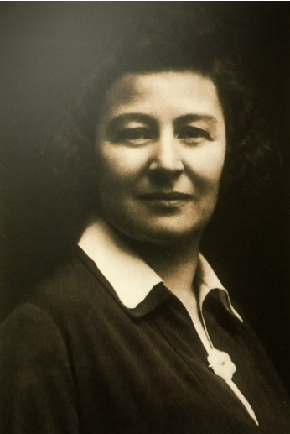
Why is she absent from most curricula? She wrote in Russian, worked in the Soviet Union, and was a woman practising in a field dominated by Western European and American men. Her exclusion from the canonical history of psychiatry is a lesson about how science works , and a reminder to read broadly and cite generously.

Exam Pearl , Sukhareva
Year: 1925 | Term used: 'Schizoid psychopathy of childhood'
Described: restricted interests, unusual sociability, special memory, stilted language.
18 years before Kanner. Rarely appears in exam answers , but impresses consultants who know.
Grunya Sukhareva

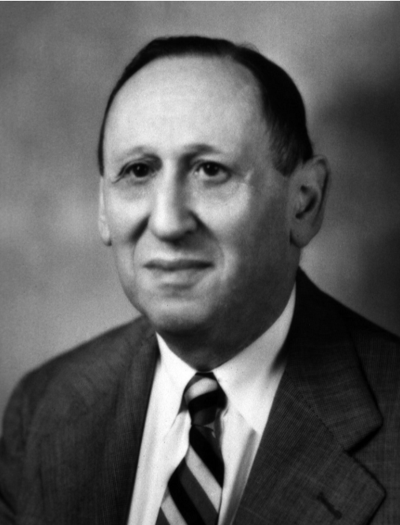
4. Leo Kanner, 1943: 'Autistic Disturbances of Affective Contact'
In 1943, Leo Kanner , an Austrian-born child psychiatrist at Johns Hopkins University , published what became the founding document of modern autism research. He described 11 children (8 boys, 3 girls) presenting with a distinctive and previously undescribed pattern of behaviour. Kanner identified five core features:
- Autistic aloneness , a profound inability to relate to people from the very beginning of life.
- Insistence on sameness , 'anxiously obsessive desire for the maintenance of sameness'; distress at minor environmental changes.
- Echolalia , immediate and delayed repetition of heard speech without communicative intent.
- Excellent rote memory , for sequences, poems, and factual material.
- Onset from early life , distinguishing the condition from acquired dementia or psychosis.

Kanner's observations were brilliant, accurate, and enduring. However, in the same paper he made a passing observation that would metastasise into a clinical catastrophe: he noted that the parents of his subjects seemed 'cold,' highly intelligent, professionally accomplished, but emotionally frigid. This casual remark was to become psychiatry's most damaging theoretical detour.

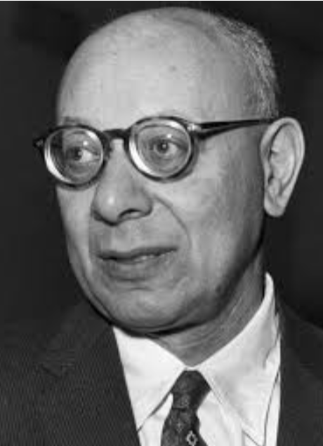
5. The Refrigerator Mother Theory: Psychiatry's Greatest Embarrassment
Bruno Bettelheim, a psychoanalyst who had survived the Nazi concentration camps, seized on Kanner's observation and constructed an entire theoretical framework. His 1967 book The Empty Fortress argued that autism was caused by emotionally cold, rejecting mothers , 'refrigerator mothers' , whose failure of love had driven the child into autistic withdrawal. He explicitly compared autistic children to inmates of concentration camps responding to an annihilating environment.
Mothers who were already exhausted, frightened, and grieving were now told by the psychiatric establishment that they had caused their child's condition through emotional failure. Many were placed in psychotherapy to correct their supposed coldness. The harm done to families in this era was profound and, in many cases, irreversible.
The evidence for this theory: none. It was clinical speculation built on a single paragraph of Kanner's paper, interpreted through a psychoanalytic lens.
The refutation: In 1977, Michael Rutter and Susan Folstein published the first rigorous twin study of autism. Monozygotic (identical) twins showed ~60% concordance for autism; dizygotic (fraternal) twins showed only 3-15% concordance. Since both types of twins share the same mother equally, the mother cannot be the primary variable. The difference in concordance pointed unambiguously to genetic causation. Bettelheim was discredited. The refrigerator mother theory collapsed.

Clinical Warning , Legacy of the Refrigerator Mother
NEVER imply parental causation in your history-taking or formulation.
Questions phrased carelessly ('Did she bond with him normally?' without context) can re-traumatise.
When parents, especially mothers, come to you, they carry a generation of institutional gaslighting.
You must earn that trust. Every appointment. Every time.

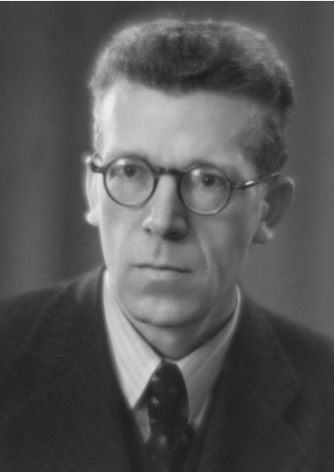
6. Hans Asperger, 1944: The Viennese Counterpart
One year after Kanner, and independently of him, Hans Asperger , a Viennese paediatrician , described four boys with what he called 'autistischen Psychopathen im Kindesalter' (autistic psychopathy in childhood). The term 'psychopathy' did not carry its modern pejorative connotation; it simply meant personality disorder.
Asperger's cases differed from Kanner's in one clinically decisive way: they had normal to above-average language development and normal intelligence. Yet they exhibited the same characteristic social difficulties, restricted and intense interests, stilted communicative style, and unusual sensory responses.
Asperger contributed two ideas that were genuinely revolutionary for 1944:
- Genetic contribution: He noted similar traits in the fathers of his patients , an early observation of what we now call the Broader Autism Phenotype.
- Dimensional thinking: He described the traits as existing on a continuum, with sub-threshold expression in relatives , the seed of what would become spectrum conceptualisation.

Asperger's paper was published in German, in wartime Vienna, and remained largely inaccessible to the English-speaking world for almost four decades. It was Lorna Wing , a British psychiatrist whose own daughter had autism , who translated and reintroduced his work in 1981, coining the term 'Asperger's Syndrome' and recognising its clinical significance.

7. Lorna Wing and the Spectrum Concept, 1981
Lorna Wing's 1981 paper was arguably the most transformative single contribution to autism nosology in the post-Kanner era. She made two enduring contributions:

7a. The Triad of Impairments
- Social interaction , difficulty with reciprocal, two-way social relationships.
- Social communication , impairments in verbal and non-verbal communication.
- Social imagination , difficulty understanding others' perspectives; inflexible, rigid thinking.

7b. The Spectrum
More important than the Triad was Wing's reconceptualisation of autism as a spectrum , a dimension rather than a category. She argued that autism should not be understood as a fence you are either inside or outside, but as a continuum of expression, ranging from the nonverbal child with profound intellectual disability to the articulate professional who finds social reciprocity bewildering.
The analogy that captures this best: think of the electromagnetic spectrum. Radio waves and gamma rays are both real; neither is 'more real' than the other. They differ in frequency and in what they interact with. The clinical question is not 'is this autism or not?' but 'where on the spectrum, and what support is needed?'

8. DSM Evolution: From Infantile Autism to ASD
The diagnostic codification of autism across DSM editions reflects , and in turn shaped , how clinicians understood the condition. The evolution is itself a story of progressive dimensional thinking replacing categorical rigidity.

Year | Figure / Event | Significance
1980 | DSM-III: Infantile Autism | First official classification. Monothetic criteria: must meet ALL listed features. Binary, restrictive , many affected individuals excluded.
1987 | DSM-III-R | Polythetic approach: meet a threshold number from a list. More flexible. More children eligible.
1992 | ICD-10 | Autistic disorder (Childhood/Infantile autism),Rett's syndrome, Other childhood disintegrative disorder,Overactive disorder associated with mental retardation and stereotyped movements,Asperger's syndrome,Other pervasive developmental disorders, Pervasive developmental disorder, unspecified (PDD-NOS).
1994 | DSM-IV | PDD umbrella: 5 subtypes , Autistic Disorder, Asperger's Syndrome, PDD-NOS, Childhood Disintegrative Disorder, Rett Syndrome. Three-domain model: social, communication, RRBIs.
2013 | DSM-5 | Single ASD diagnosis. Two-domain model (social communication + RRBIs). Sensory criteria added (new). Severity specifiers (Level 1-3). All PDD subtypes collapsed. Social Communication Disorder introduced.
2022 | ICD-11 | Convergence with DSM-5. Dimensional descriptors: with/without intellectual impairment; with/without functional language impairment. Autism-in-adults better accommodated.

High-Yield DSM-5 Changes , What Changed and Why
COLLAPSED: Three domains (social, communication, RRBIs) -> Two domains (social communication is one domain).
COLLAPSED: Five PDD subtypes -> One ASD diagnosis with specifiers.
ADDED: Sensory hyper/hypo-reactivity as a B criterion (absent in DSM-IV entirely).
ADDED: Severity levels 1, 2, 3 , based on support required, not IQ or language.
ADDED: Social Communication Disorder , for pragmatic deficits WITHOUT restricted/repetitive behaviours.
Rationale: research showed the PDD subtypes lacked reliability and biological validity; clinicians disagreed on subtype assignment.

9. The Neurodiversity Paradigm: Judy Singer, 1998
The neurodiversity paradigm, a term publicised by Australian sociologist and autistic person Judy Singer in 1998, proposes that autism , and other neurodevelopmental variants , represent forms of natural human neurological variation rather than pathological deficits to be corrected. Singer drew on the concept of biodiversity: just as biological diversity strengthens ecosystems, neurodiversity enriches human cognition and culture.
This paradigm does not deny that autistic people experience suffering. It argues that much of this suffering arises from a world built for a single neurotype, rather than from the autism itself. The therapeutic implication is significant: interventions should not aim solely to make autistic people more neurotypical, but also to make environments, institutions, and clinicians more attuned to autistic ways of being.
Monotropism (Murray, 2005) offers a complementary cognitive model: autistic attention is characterised by deep, intensive, single-channel focus , the attentional tunnel. This explains passionate circumscribed interests, distress at interruption, and extraordinary depth of knowledge in narrow domains. From a neurodiversity lens, this is not a deficit but a different attentional architecture.

10. The Double Empathy Problem: Damian Milton, 2012
Perhaps the most philosophically provocative recent contribution to ASD theory is Damian Milton's Double Empathy Problem (2012). The classical view held that autistic individuals have a 'Theory of Mind deficit' , an impaired ability to model the mental states of others, leading to social dysfunction. Simon Baron-Cohen's 'false belief' task research in the 1980s was the canonical evidence.
Milton challenged the framing. If autistic individuals struggle to read neurotypical minds, he observed, neurotypical individuals are equally unable to read autistic minds. The empathy breakdown is bidirectional. It is not that autistic people lack empathy , extensive qualitative research shows they experience empathy profoundly, often painfully so. It is that two neurotypes, operating with different social 'operating systems,' fail to translate fluently to each other.
The clinical implications are direct:
- Social skills training that teaches only neurotypical-style interaction may be misguided and potentially harmful.
- Clinicians must work to understand autistic communication styles , not just train autistic people to mask theirs.
- Masking/camouflaging , the effortful mimicry of neurotypical behaviour , carries a significant mental health cost, particularly in women. Research links chronic masking to burnout, depression, suicidality, and delayed diagnosis.

11. The Female Phenotype and Late Diagnosis
One of the most consequential oversights in autism research was the systematic underrepresentation of women and girls. Kanner's original sample was predominantly male. The diagnostic criteria were developed, validated, and normed primarily on male presentations. Leo Kanner and Hans Asperger both drew their case descriptions from boys.
Females with ASD are diagnosed on average 4 to 5 years later than males. The female autistic phenotype tends to involve more social camouflaging, stronger motivation to imitate neurotypical social behaviour, more internalising presentations (anxiety, depression, eating disorders), and interests that are less stereotypically 'unusual' , passion for fictional characters and social dynamics, for instance, rather than trains or statistics.
The consequence of this diagnostic gap: women with ASD are frequently misdiagnosed with borderline personality disorder, anxiety, depression, ADHD, or eating disorders , often for decades. When they eventually receive an autism diagnosis in their 30s or 40s, many describe it as a profound relief and a retrospective explanation for a lifetime of effortful difference.

Clinical Error , The Female Phenotype Trap
Error: Diagnosing 'just social anxiety' in a woman who has always 'tried too hard' socially.
Why dangerous: Females with ASD are diagnosed 4-5 years later on average; chronic masking leads to burnout.
Red flag triad: Lifetime history of feeling different + intense circumscribed interests + repeated misdiagnosis.
Action: Use AQ-10 at first visit; refer with explicit mention of possible late-diagnosed ASD in a female.

12. Master Timeline at a Glance
Year | Figure / Event | Significance
1911 | Bleuler | Coins 'autism' in context of schizophrenia (self-referential withdrawal).
1925 | Sukhareva | 'Schizoid psychopathy of childhood' , 18 years before Kanner; more precise description.
1943 | Kanner | 'Autistic disturbances of affective contact': 5 core features; names the syndrome.
1944 | Asperger | 'Autistischen Psychopathen': normal language, genetic familial pattern, dimensional thinking.
1967 | Bettelheim | 'The Empty Fortress': refrigerator mother theory. No evidence. Maximum harm.
1977 | Rutter & Folstein | Twin study: MZ 60% concordance vs DZ 3-15%. Genetic aetiology established. Bettelheim refuted.
1981 | Lorna Wing | Reintroduces Asperger's work; coins 'Asperger's Syndrome'; proposes Triad + Spectrum.
1994 | DSM-IV / ICD-10 | PDD umbrella with 5 subtypes; three-domain model becomes standard.
1998 | Judy Singer | Neurodiversity paradigm: neurological variation, not pathology.
2005 | Murray | Monotropism: autistic attention as deep single-channel focus.
2012 | Damian Milton | Double Empathy Problem: mutual failure between neurotypes; bidirectional mismatch.
2013 | DSM-5 | ASD replaces all PDD subtypes; two domains; sensory criteria; severity levels.
2022 | ICD-11 | Dimensional descriptors; convergence with DSM-5; late-diagnosed adults better accommodated.

14. Vital Clinical Errors , Do Not Make These
Error 1 , Refrigerator Mother Legacy
Never imply parental cause in your history-taking or formulation.
Careless phrasing ('Did she bond with him normally?') re-traumatises families.

Error 2 , Conflating 'Spectrum' with 'Mild'
'He's on the spectrum, so he's high-functioning' is NOT automatic.
Spectrum means dimensional , not a gradient from severe to trivial.

Error 3 , Forgetting Sensory Criteria
DSM-5 added sensory hyper/hypo-reactivity as a B criterion. DSM-IV did not have it.
Child covering ears in assemblies, refusing textured food, or distressed by clothing: listen.

A Final Thought
The history of ASD is a mirror held up to psychiatry itself: our brilliance, our blind spots, and our capacity to cause harm while intending to help. Sukhareva saw it first. Kanner named it. Asperger broadened it. Bettelheim weaponised it. Wing restored it. Milton flipped the question entirely.
The diagnostic map has been redrawn repeatedly , and it will be redrawn again. What endures is the person in front of you. Carry the map lightly. See the person clearly.
"The map is not the territory. The diagnosis is not the person. Know the map. See the person."

