# Economic Scan Report for San Diego, CA

## Summary

San Diego's economic landscape in 2023 highlights both resilience and challenges. The Retail Trade sector leads with a $16.2 billion GRP, closely followed by Wholesale Trade at $14.9 billion and Real Estate and Rental and Leasing at $12.3 billion. These figures emphasize the city's strong consumer-focused economy despite pressures such as high living costs. San Diego's performance aligns with California’s broader economic goals, yet it uniquely excels in tourism, defense, and innovation, offering both growth and employment prospects. For local policymakers, the robust GRP in sectors like retail and real estate suggests needed focus on infrastructure and policy innovation, potentially enhancing housing affordability through mixed-use developments. If these trends persist, urban development and investment may increase, strengthening San Diego's economy and requiring strategic planning. Policymakers could utilize this data to drive investments in infrastructure, housing, and workforce development, ensuring sustained economic inclusivity. Despite unemployment showing a decrease to 4.6% in September 2024, it remains slightly higher than the national average, signaling essential areas for economic stabilization and strategic planning to ensure workforce readiness and sectoral growth. Continued job availability shifts highlight potential economic slowdowns, affecting local business dynamics and underscoring the need for strategic policy interventions. Salary trends and educational attainment gains reveal the importance of aligning workforce development with market demand, indicating substantial opportunities in bolstering San Diego's educational and economic policies. Rising interest rates and inflation trends present a mixed forecast for economic conditions, suggesting a comprehensive policy framework to maintain San Diego's economic resilience amidst these challenges, with a focus on housing, small businesses, and sustainable infrastructure. The county's dynamic industry contributions and employment trends further demonstrate a need for strategic economic policymaking to support San Diego's continual growth and stability in key sectors.

## Section 1: Gross Regional Product

San Diego's Gross Regional Product (GRP) landscape illustrates a dynamic yet complex economic profile. In 2023, the region's Retail Trade sector led with a GRP of $16.2 billion, followed closely by Wholesale Trade at $14.9 billion. The Real Estate and Rental and Leasing sector also saw significant growth, reaching $12.3 billion. These figures highlight notable sectoral resilience, particularly in consumer-focused industries amid broader economic pressures like high living costs and inflation.

In comparison to state and national figures, these industries reflect robust performance within San Diego, aligning with California's emphasis on commerce, technology, and lifestyle sectors. While California's economic breadth includes tech and agriculture, San Diego's strengths lie particularly in tourism, defense, and innovation, where GRP growth signals sustained sectoral contributions and employment opportunities.

For local policymakers, these insights are crucial. The strong GRP in retail and wholesale trade underscores the necessity to maintain infrastructure and regulatory support to sustain consumer-driven growth. Additionally, the prominence of the real estate sector suggests a potential focus area for addressing housing affordability challenges through innovative policy solutions such as incentivizing mixed-use and high-density developments.

If these trends continue, San Diego can expect to see a fortified local economy buttressed by retail and real estate. Such growth may attract further investment, drive job creation, and intensify urban development, calling for strategic urban planning and economic policies. Policymakers could leverage this data to support strategic investments in infrastructure, housing, and workforce development, ensuring the city's overall economic vitality and inclusivity.

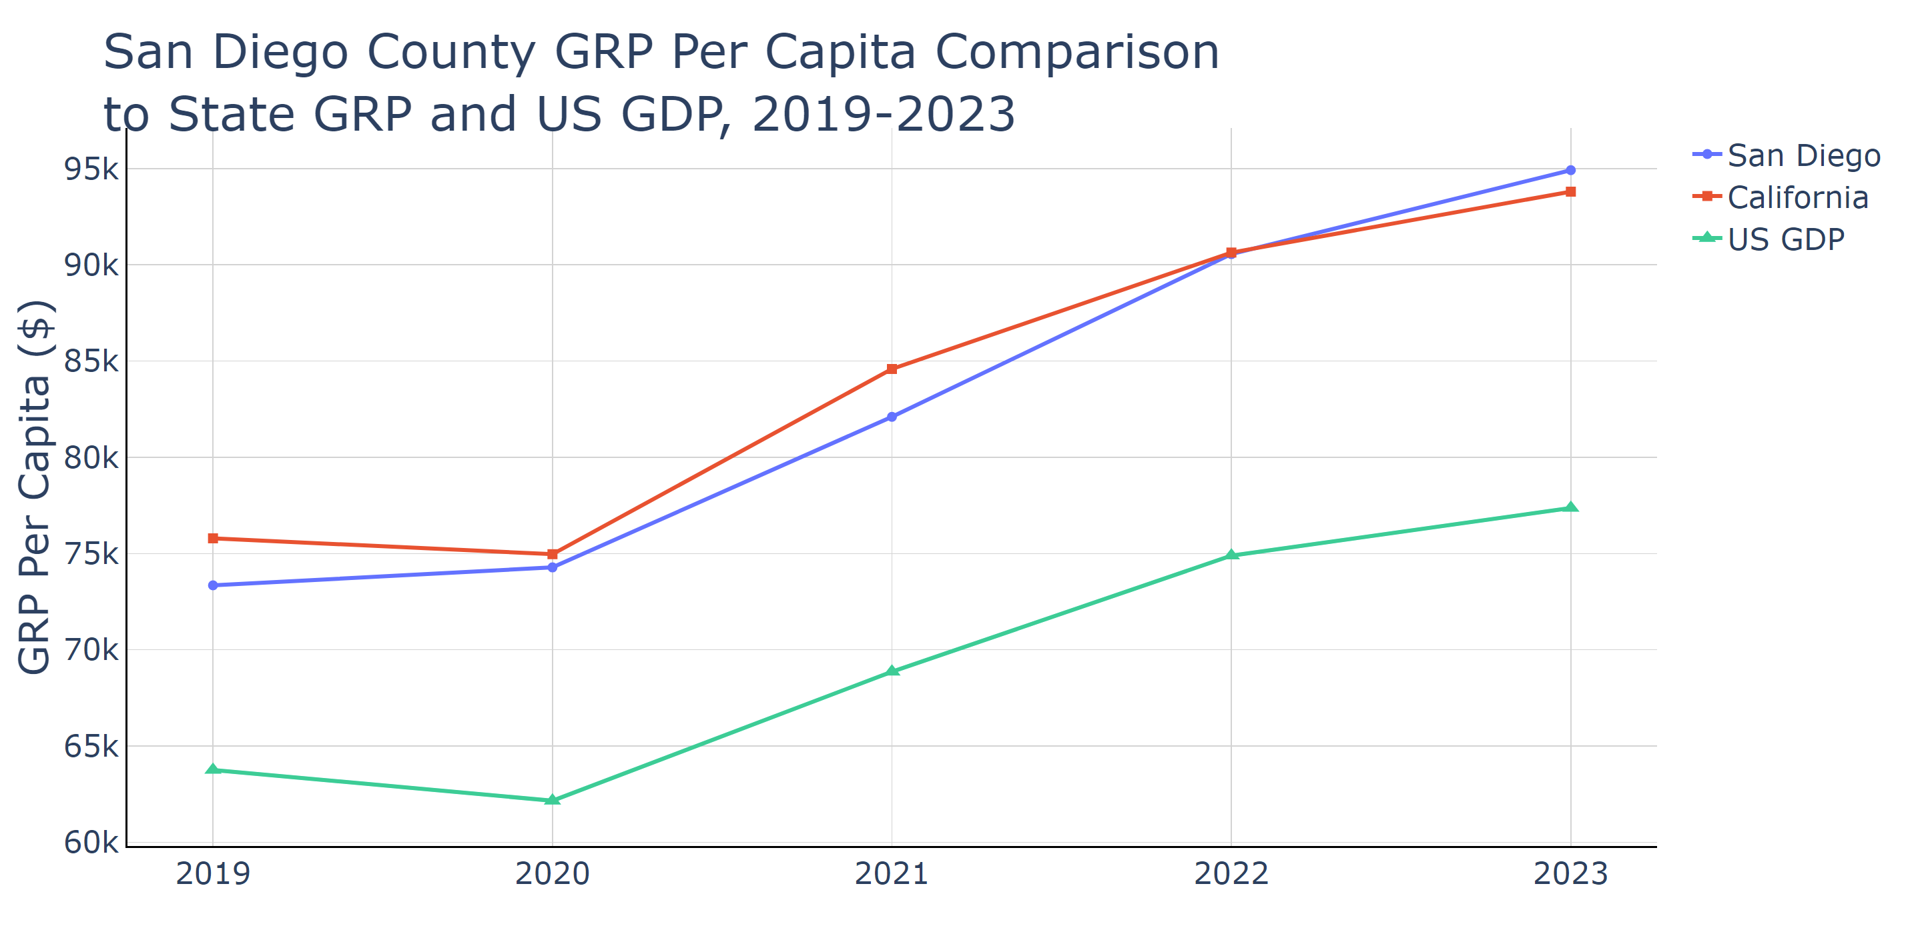

Source: Lightcast Nov 2024

## Section 2: Jobs

### Unemployment

San Diego County, CA showed a decreasing trend in unemployment from August 2024, at 5.1%, to September 2024, at 4.6%. While improvements are evident, this rate remains higher than Maricopa County, AZ, with 3.4%, and slightly higher than the national average of 3.9%. However, San Diego's unemployment rate is notably lower than Philadelphia County, PA, at 4.2%, and the state of California, which had a rate of 5.3% in September. These figures suggest that despite facing financial strains, San Diego is faring better than some other areas in California.

The importance of this data lies in its ability to guide local policymakers in identifying workforce challenges and assessing the implications for budget planning and economic recovery initiatives. Continued efforts to reduce unemployment will be crucial in maintaining economic stability, particularly given San Diego's reliance on diverse sectors like defense, tourism, and technology.

If current trends persist, San Diego may face challenges balancing job market demands with cost-of-living pressures. The region's economic strategy might benefit from focused efforts on creating quality jobs with sustainable wages, especially within growing industries such as technology and defense. Public policymakers could use this data to tailor workforce development programs and incentivize industries that show potential for economic impact and job creation. Additionally, aligning educational priorities with job market needs could aid in reducing unemployment rates further. Overall, strategic economic policy and investment will be key to sustaining San Diego's economic growth and stability.

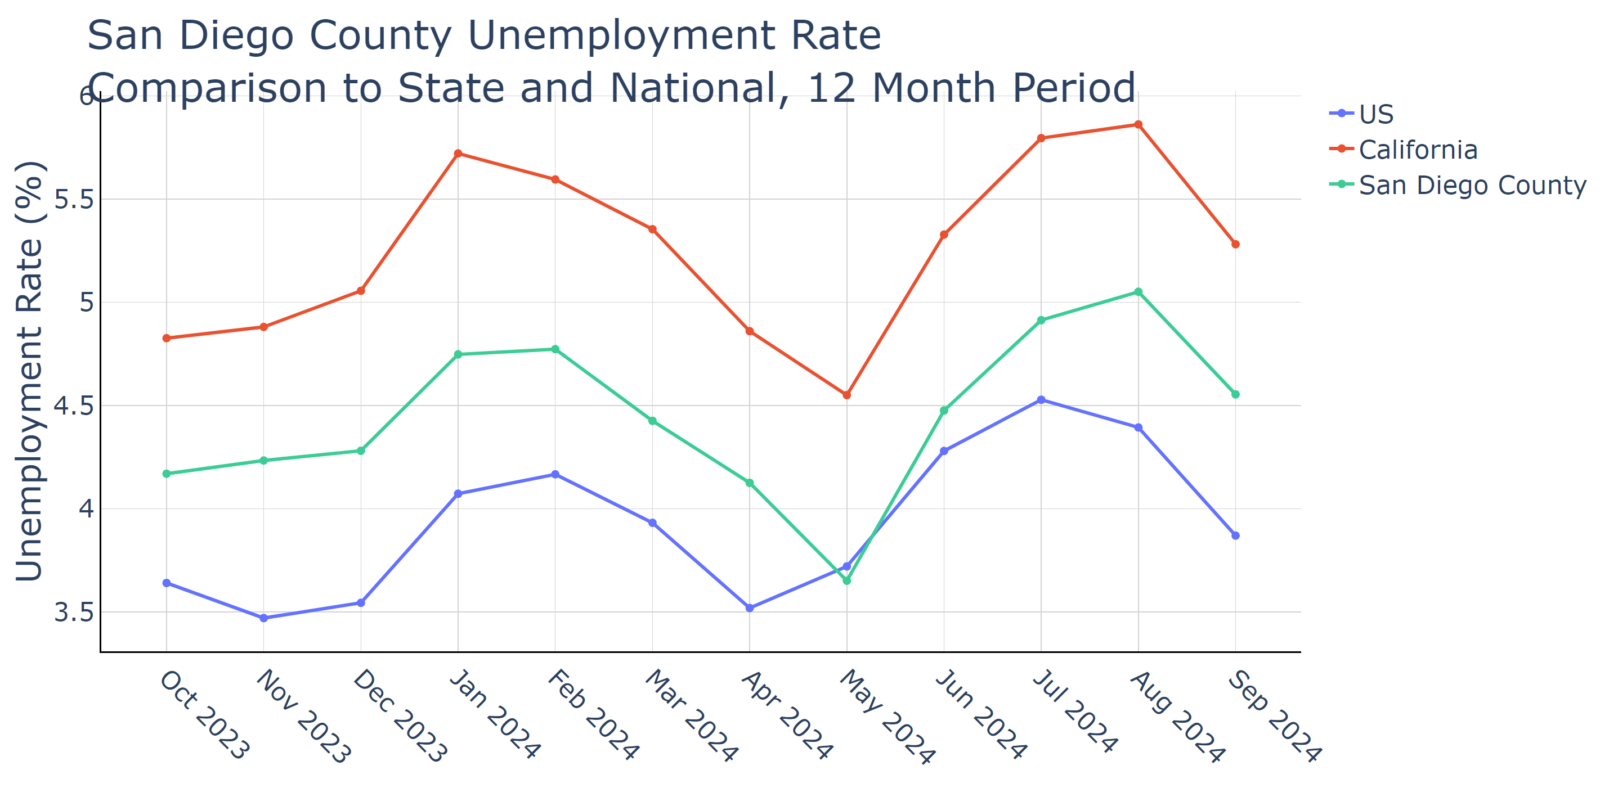

Source: Lightcast Nov 2024

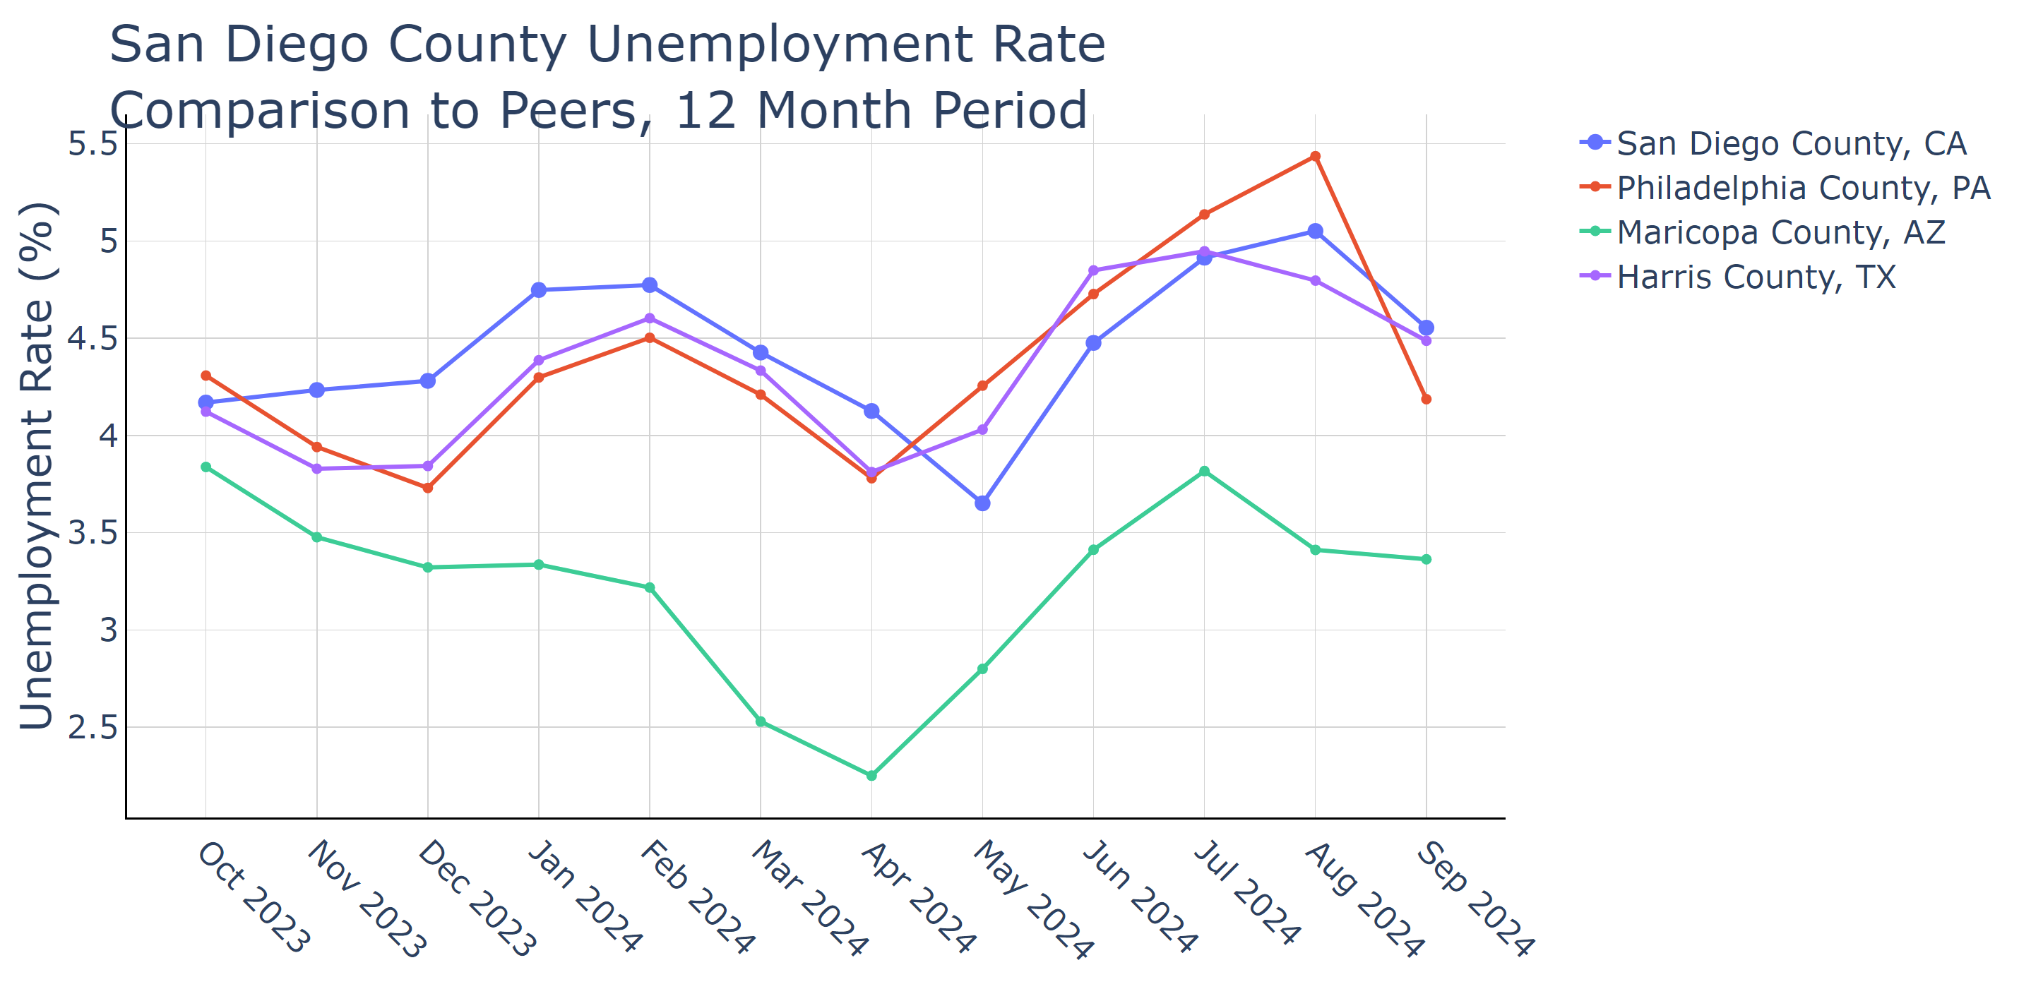

Source: Lightcast Nov 2024

### Industry Job Postings

The analysis of job postings in San Diego, CA over the past year reveals significant shifts in the city's employment landscape. Despite a robust economic development effort, San Diego has witnessed a pronounced decrease in job listings across various sectors. Notably, the Professional, Scientific, and Technical Services sector, which heavily influences the city's tech-driven economy, saw a 28.51% decline in postings, while Admin/Support/Waste Management and Remediation Services reduced by 39.86%. These reductions signal potential challenges in sustaining growth in key innovative sectors vital to San Diego's economic vibrancy.

The median advertised salary in the region reflects broader economic conditions, though specific figures weren't detailed. A decrease in job availability amidst a rising budget suggests economic pressures affecting job creation, potentially influenced by cost-of-living challenges and fiscal limitations in critical sectors like education and judiciary which also impact local economic stability.

If current trends continue, San Diego might face slower economic growth, affecting local businesses and housing affordability, increasing economic disparities. This could strain the city's public services, including housing and education, further complicating efforts to maintain economic opportunity for its residents.

Policymakers in San Diego could leverage this data to strategize on economic revitalization, particularly focusing on policies that drive stability in declining sectors and fostering job creation. Emphasizing investment in high-potential growth sectors and addressing structural barriers could mitigate the impacts of the current trends, catalyzing sustainable economic health for the community. Additionally, aligning budget priorities to support workforce development initiatives could transform short-term job posting declines into longer-term economic resilience.

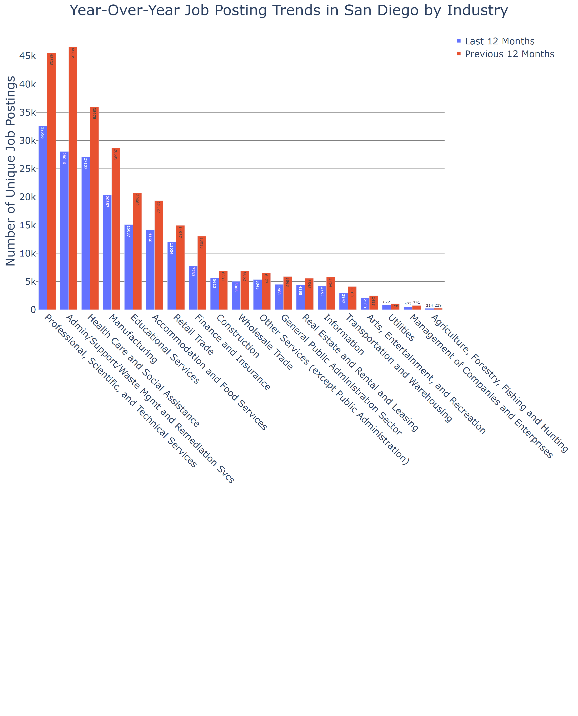

Source: Lightcast Nov 2024

## Section 3: Talent and Workforce

### Education

San Diego's educational attainment data reveals significant trends in the city's growing emphasis on higher education. From 2019 to 2023, there was a notable increase in residents holding Bachelor's and Graduate Degrees, with Bachelor's Degree holders rising from 28.05% to 29.75% and those with Graduate Degrees increasing from 19.32% to 22.29%. This shift underscores San Diego's commitment to fostering a skilled workforce, aligning with its diverse economic sectors including technology and defense, which demand higher educational qualifications.

The importance of this data lies in its implications for local policymakers who can leverage these trends to boost San Diego's economic development. A more educated populace supports the city's strategic economic goals by enhancing workforce readiness and innovation capacity, crucial for sustaining competitive industries and attracting high-value businesses.

If the trend of increasing educational attainment persists, San Diego's economy could experience strengthened innovation, higher job quality, and wage growth. Residents would benefit from increased employment opportunities in emerging and expanding sectors, while housing markets might see shifts as more affluent segments drive demand.

Public policymakers could use this data to devise strategies that continue to support educational initiatives in San Diego, ensuring that infrastructure and housing developments match the needs of a graduating class with higher educational aspirations. This would involve aligning economic planning with education and housing policies to create a balanced, thriving urban environment.

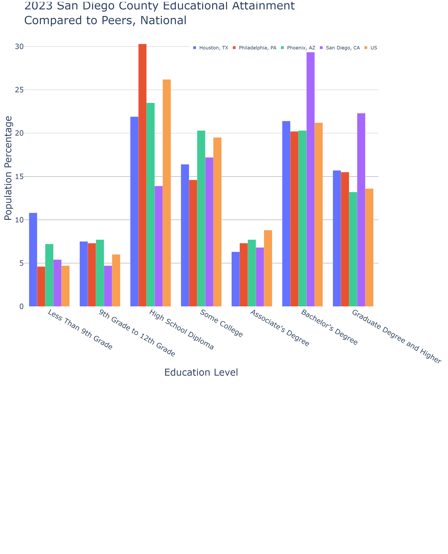

Source: Lightcast Nov 2024

### Skills Gap

The skills gap in San Diego County highlights significant challenges and opportunities within the local economy, particularly in key sectors that influence the region’s workforce dynamics. From 2023 to 2028, the county anticipates a notable variance in job openings across different occupations, juxtaposed against substantial regional completions in related educational programs. For instance, the anticipated skills gap for Compensation and Benefits Managers is stark, with over 7,402 regional completions against a total of just 539 openings, suggesting an oversupply of talent relative to job availability.

The critical importance of this data for local policymakers lies in identifying and addressing workforce alignment with labor market needs. It underscores the necessity for adaptive education and training programs, particularly with occupations like Social Science Research Assistants forecasting significant growth in job openings, while traditional roles like Database Architects are seeing a decline.

If these trends continue, the local economy might face an excess of qualified professionals in some fields, leading to underemployment, while potentially facing shortages in others. Such imbalances could push qualified talent out of San Diego, affecting local businesses and economic growth.

Policymakers could utilize this skills gap data to better align educational programs with employment demand, adjusting curriculums and vocational training to reflect the economic needs of San Diego. This alignment is vital for sectors like industrial production and technology, where ensuring a steady supply of skilled workers is crucial for maintaining competitive business operations and fostering economic resilience. By proactively managing these insights, San Diego can better position itself to harness the full potential of its workforce, addressing current gaps and nurturing future opportunities.

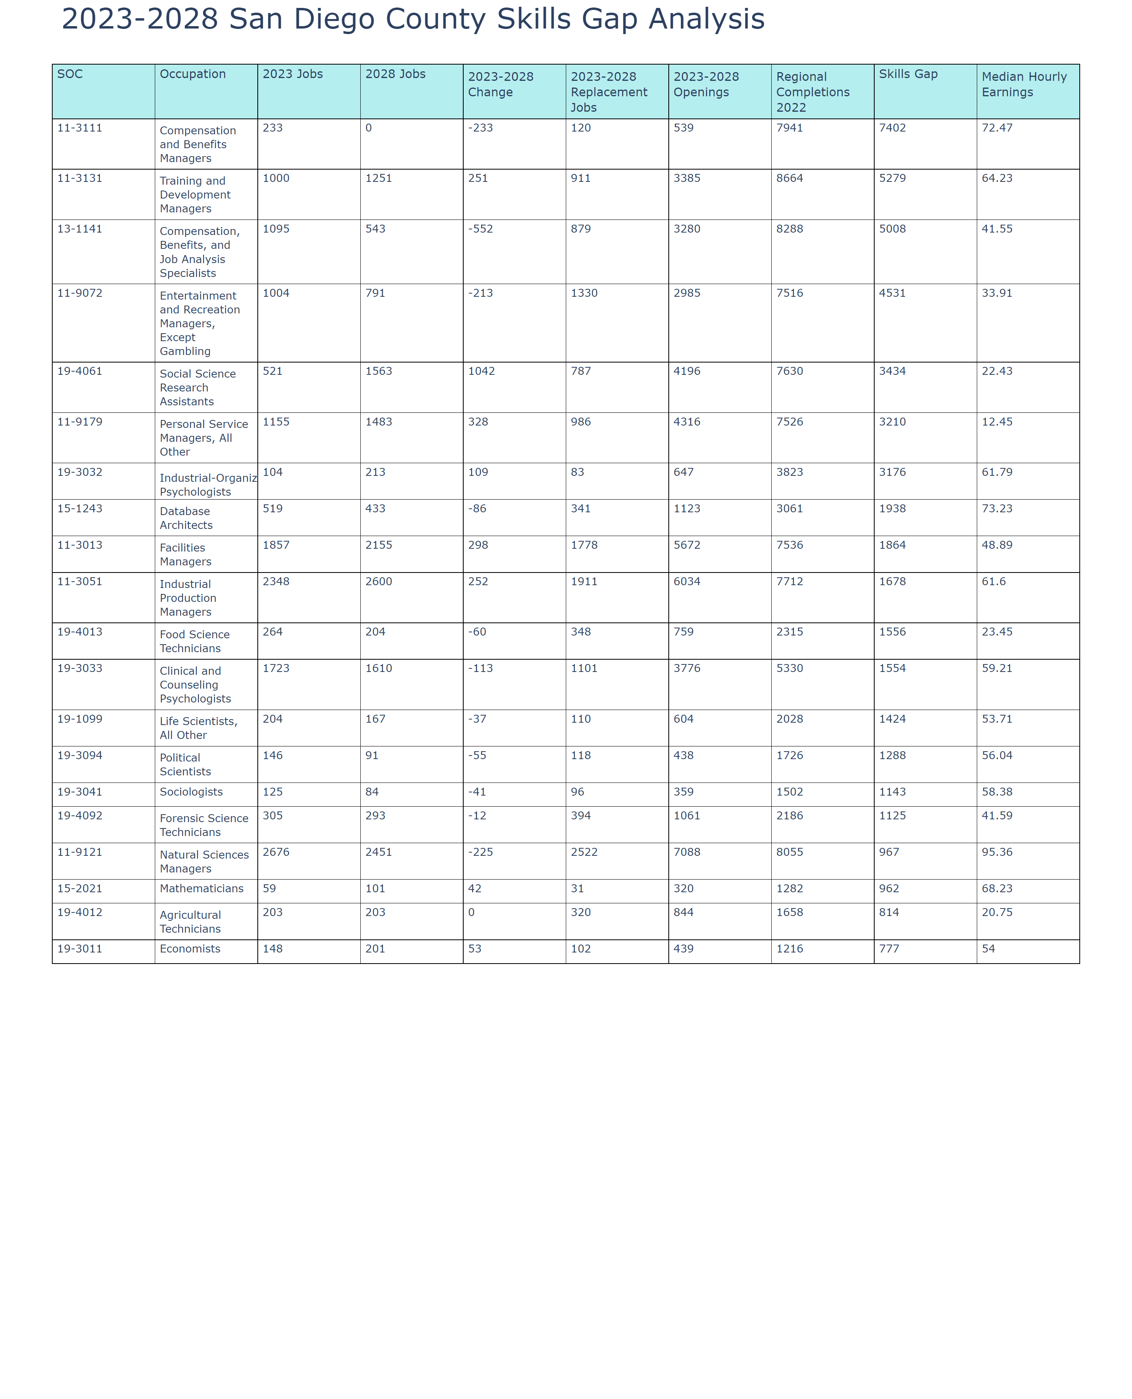

Source: Lightcast Nov 2024

## Section 4: Capital

Interest rates and inflation rates show important trends for San Diego's economic landscape. 1-year rates are fluctuating but have generally decreased from earlier highs, potentially indicating a more cautious short-term economic climate. Conversely, 10- and 30-year rates show less volatility and more gradual movements, hinting at expectations of steadier long-term economic conditions. Inflation rates, meanwhile, have steadily decreased from over 3% to currently 2.65%, indicating a cooling inflationary environment, which is crucial for restoring purchasing power stability.

For San Diego, these trends are significant. High short-term rates can dampen immediate business investments and consumer spending, impacting the local sectors like tourism and small businesses, which rely on responsive demand. However, the lower inflation rates help relieve some pressure on cost of living, a critical point in a city grappling with high housing costs and cost-of-living pressures.

If these trends continue, San Diego might experience eased pressures on housing affordability in the medium term due to cooling inflation, potentially stabilizing the rental and housing markets. For business sectors, lowered inflation could invigorate discretionary consumer spending, although high short-term rates might delay immediate recovery.

Public policymakers could leverage this data by prioritizing initiatives that alleviate short-term rate pressure, such as supporting financial incentives for housing and small businesses, which are pivotal to the city’s economic fabric. Additionally, measures aimed at ensuring long-term economic resilience, like investing in sustainable infrastructure and fostering technological innovation, would capitalize on stable long-term rates and strengthening consumer confidence.

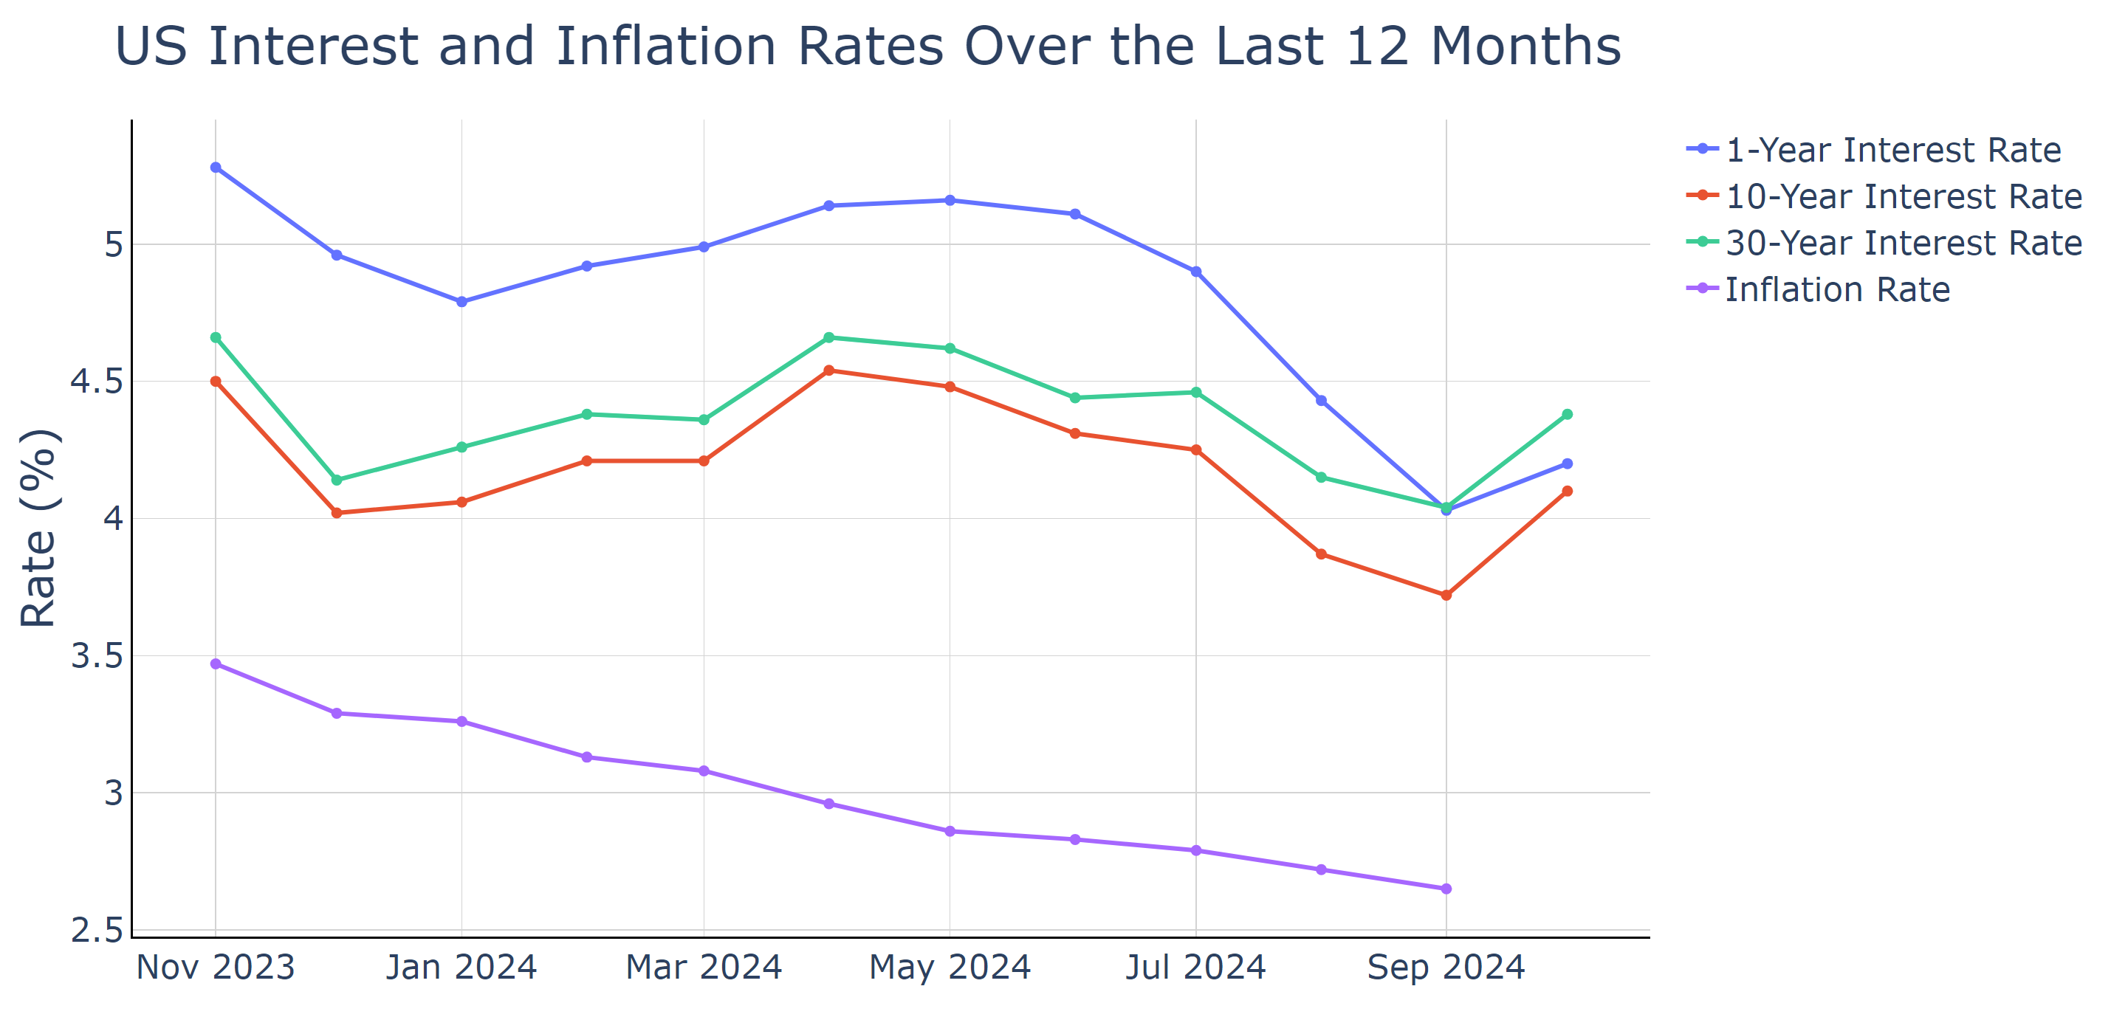

Source: Federal Reserve System (US) Nov 2024

## Section 5: Income and Housing

### Median Household Income

The median household income in San Diego, CA, has shown a consistent upward trend, reaching $142,898 in 2023—a significant rise from $114,244 in 2019. This increase in income aligns with broader economic growth efforts and strategic budget expansions to support local economic priorities amid fiscal challenges. San Diego's economic landscape, characterized by defense spending, innovation, and tourism, plays a crucial role in this upward income trajectory.

For local policymakers, this data reveals positive momentum in household income growth, which is crucial for understanding economic well-being and planning budget allocations. This trend highlights the success of policies aimed at economic diversification and development initiatives that foster job creation and income growth.

If this rising trend in median income continues, San Diego could experience improved consumer spending, further stimulating local businesses. Additionally, higher incomes could alleviate some pressure on the housing market by enhancing affordability for residents, despite high costs. However, adequate policies are essential to ensure that economic growth benefits are equitably distributed, mitigating disparities.

Policymakers can use this data to justify investments in sectors yielding significant economic returns, prioritize affordable housing policies to address cost pressures, and refine community-centric initiatives to ensure inclusivity. Monitoring income trends allows for strategic adjustments in economic planning, ensuring that growth aligns with residents' needs while addressing potential imbalances in the market.

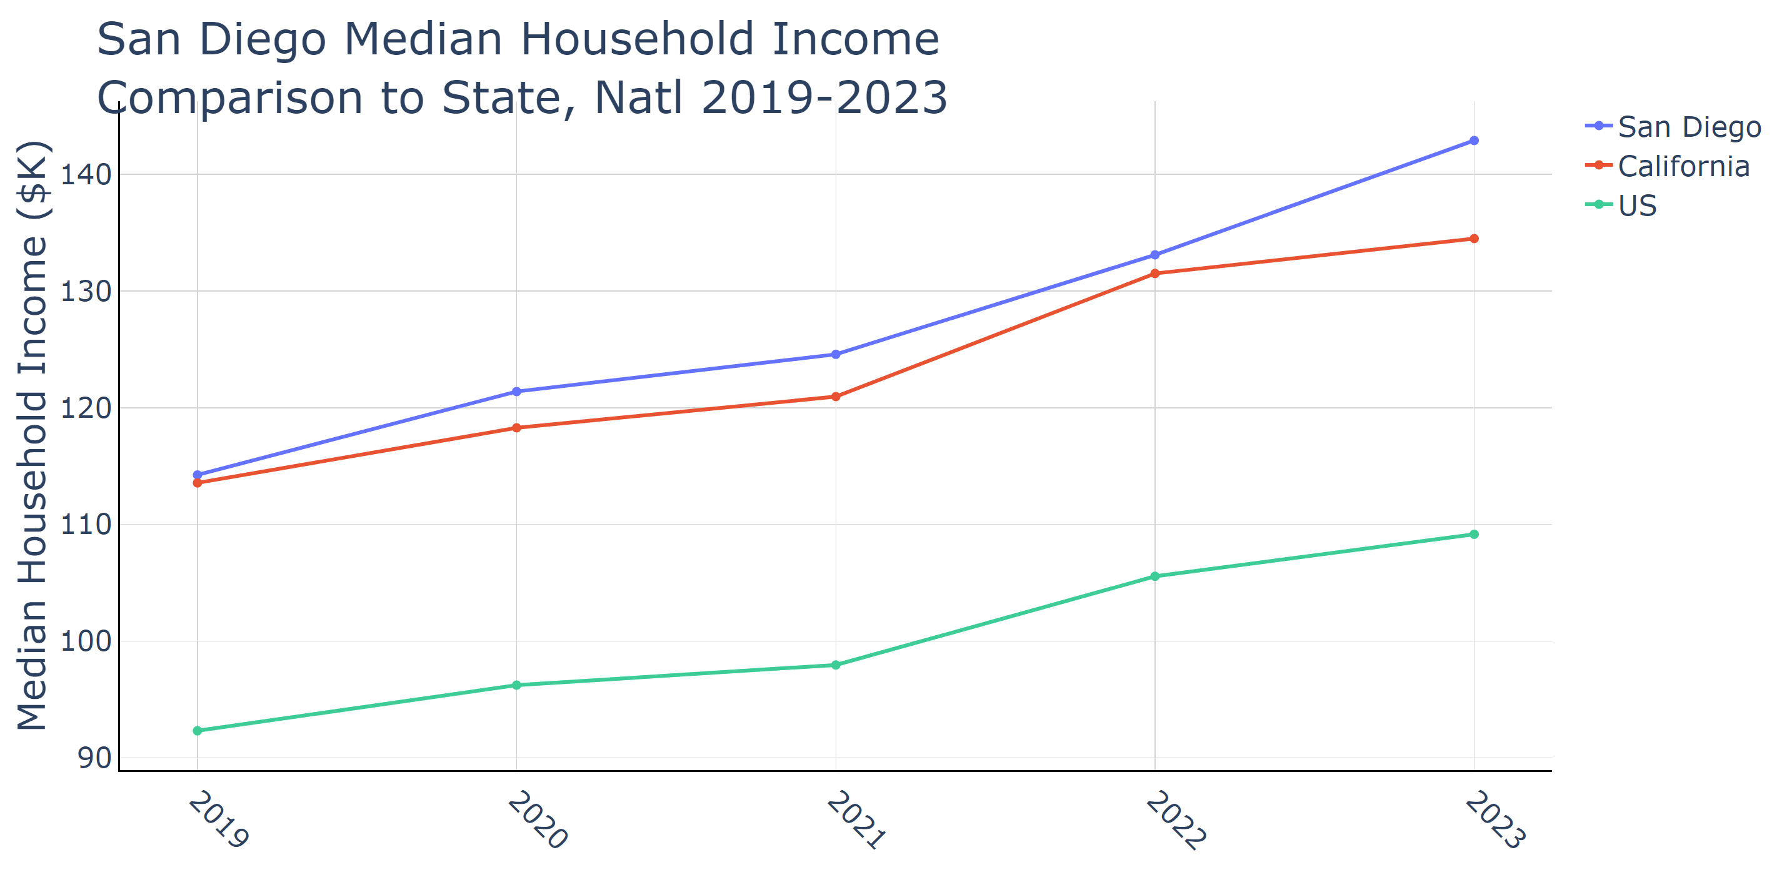

Source: US Census Bureau ACS Nov 2024

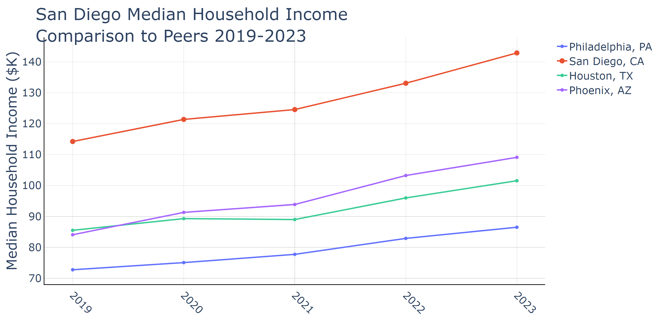

Source: US Census Bureau ACS Nov 2024

### Median Home Price

San Diego's median home price has witnessed significant growth from 2019 to 2023, reflecting the dynamic nature of its housing market. In 2019, the median home price was $658,400, escalating to $923,900 by 2023. This increase underscores the strong demand in San Diego, driven by its appealing coastal location and robust economic sectors like defense, tourism, and technology.

For local policymakers, these figures highlight the urgent need to address housing affordability. As home prices continue to rise, it becomes more challenging for middle and lower-income residents to access housing, exacerbating socioeconomic disparities. This trend could impact the local economy by limiting workforce availability and affecting consumer spending.

If this trend persists, San Diego may face intensified issues related to housing affordability, potentially deterring new residents and businesses, and straining public services. Rising home prices could also ripple into rental markets, increasing pressure on the already significant rental segment, which constitutes about 53% of housing units.

To address these challenges, public policymakers might leverage this data to advocate for increased housing production and reform zoning laws favoring multi-family developments. By creating more affordable housing options, policymakers can help ensure that the rising costs do not hinder economic growth and accessibility for all residents in the region.

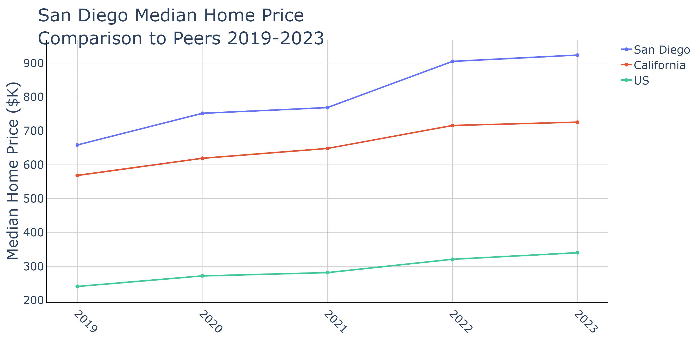

Source: US Census Bureau ACS Nov 2024

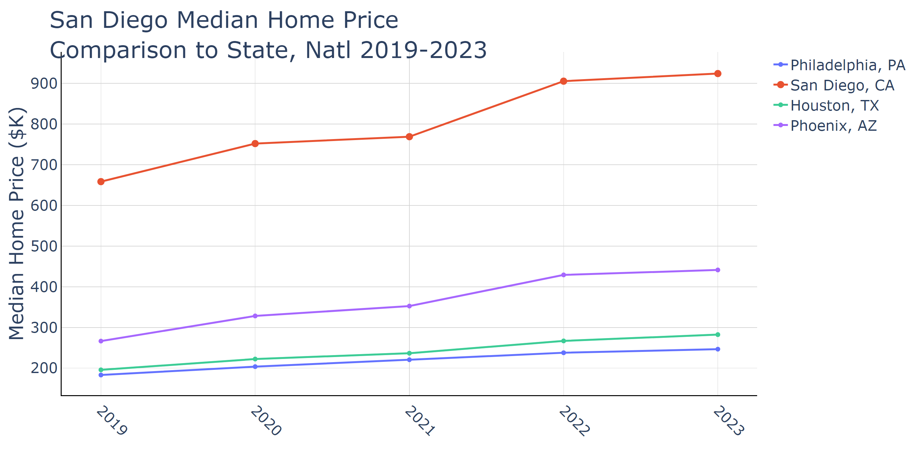

Source: US Census Bureau ACS Nov 2024

### Housing Starts

San Diego County's housing starts data reveal important insights into the region’s housing market dynamics. By 2023, total housing units reached 10,944, with multi-family units comprising a significant portion at 8,065. This reflects a 23.44% increase from 2019, showing a robust trend in construction activity despite a population decline from 3,330,458 in 2019 to 3,252,468 in 2023. The per capita housing start rate also increased, suggesting a concerted effort to improve housing availability relative to the population.

This upward trend underscores a proactive response to the county’s significant housing demands. Such growth is critical for local policymakers aiming to address housing shortages, a prevalent issue due to elevated living costs and low vacancy rates. The substantial expansion in multi-family units is particularly pertinent for increasing housing density and addressing affordability issues, which have been persistent challenges in the region.

Should this trend continue, it may alleviate some short-term housing pressures, offering more options for San Diego residents. However, the high cost of housing remains a formidable challenge, suggesting that continued investment in mixed-use developments and affordable housing projects is essential.

Local officials could leverage this data to fine-tune zoning regulations and encourage high-density housing development. Such an approach may align with existing city initiatives aimed at broadening access to affordable housing. By doing so, they can foster a more balanced supply-demand ratio, support local economic growth, and work towards creating a more inclusive housing market. Comparing this with peer regions, San Diego's growth in housing starts per capita remains behind areas like Maricopa County, illuminating opportunities for further development and policy innovation.

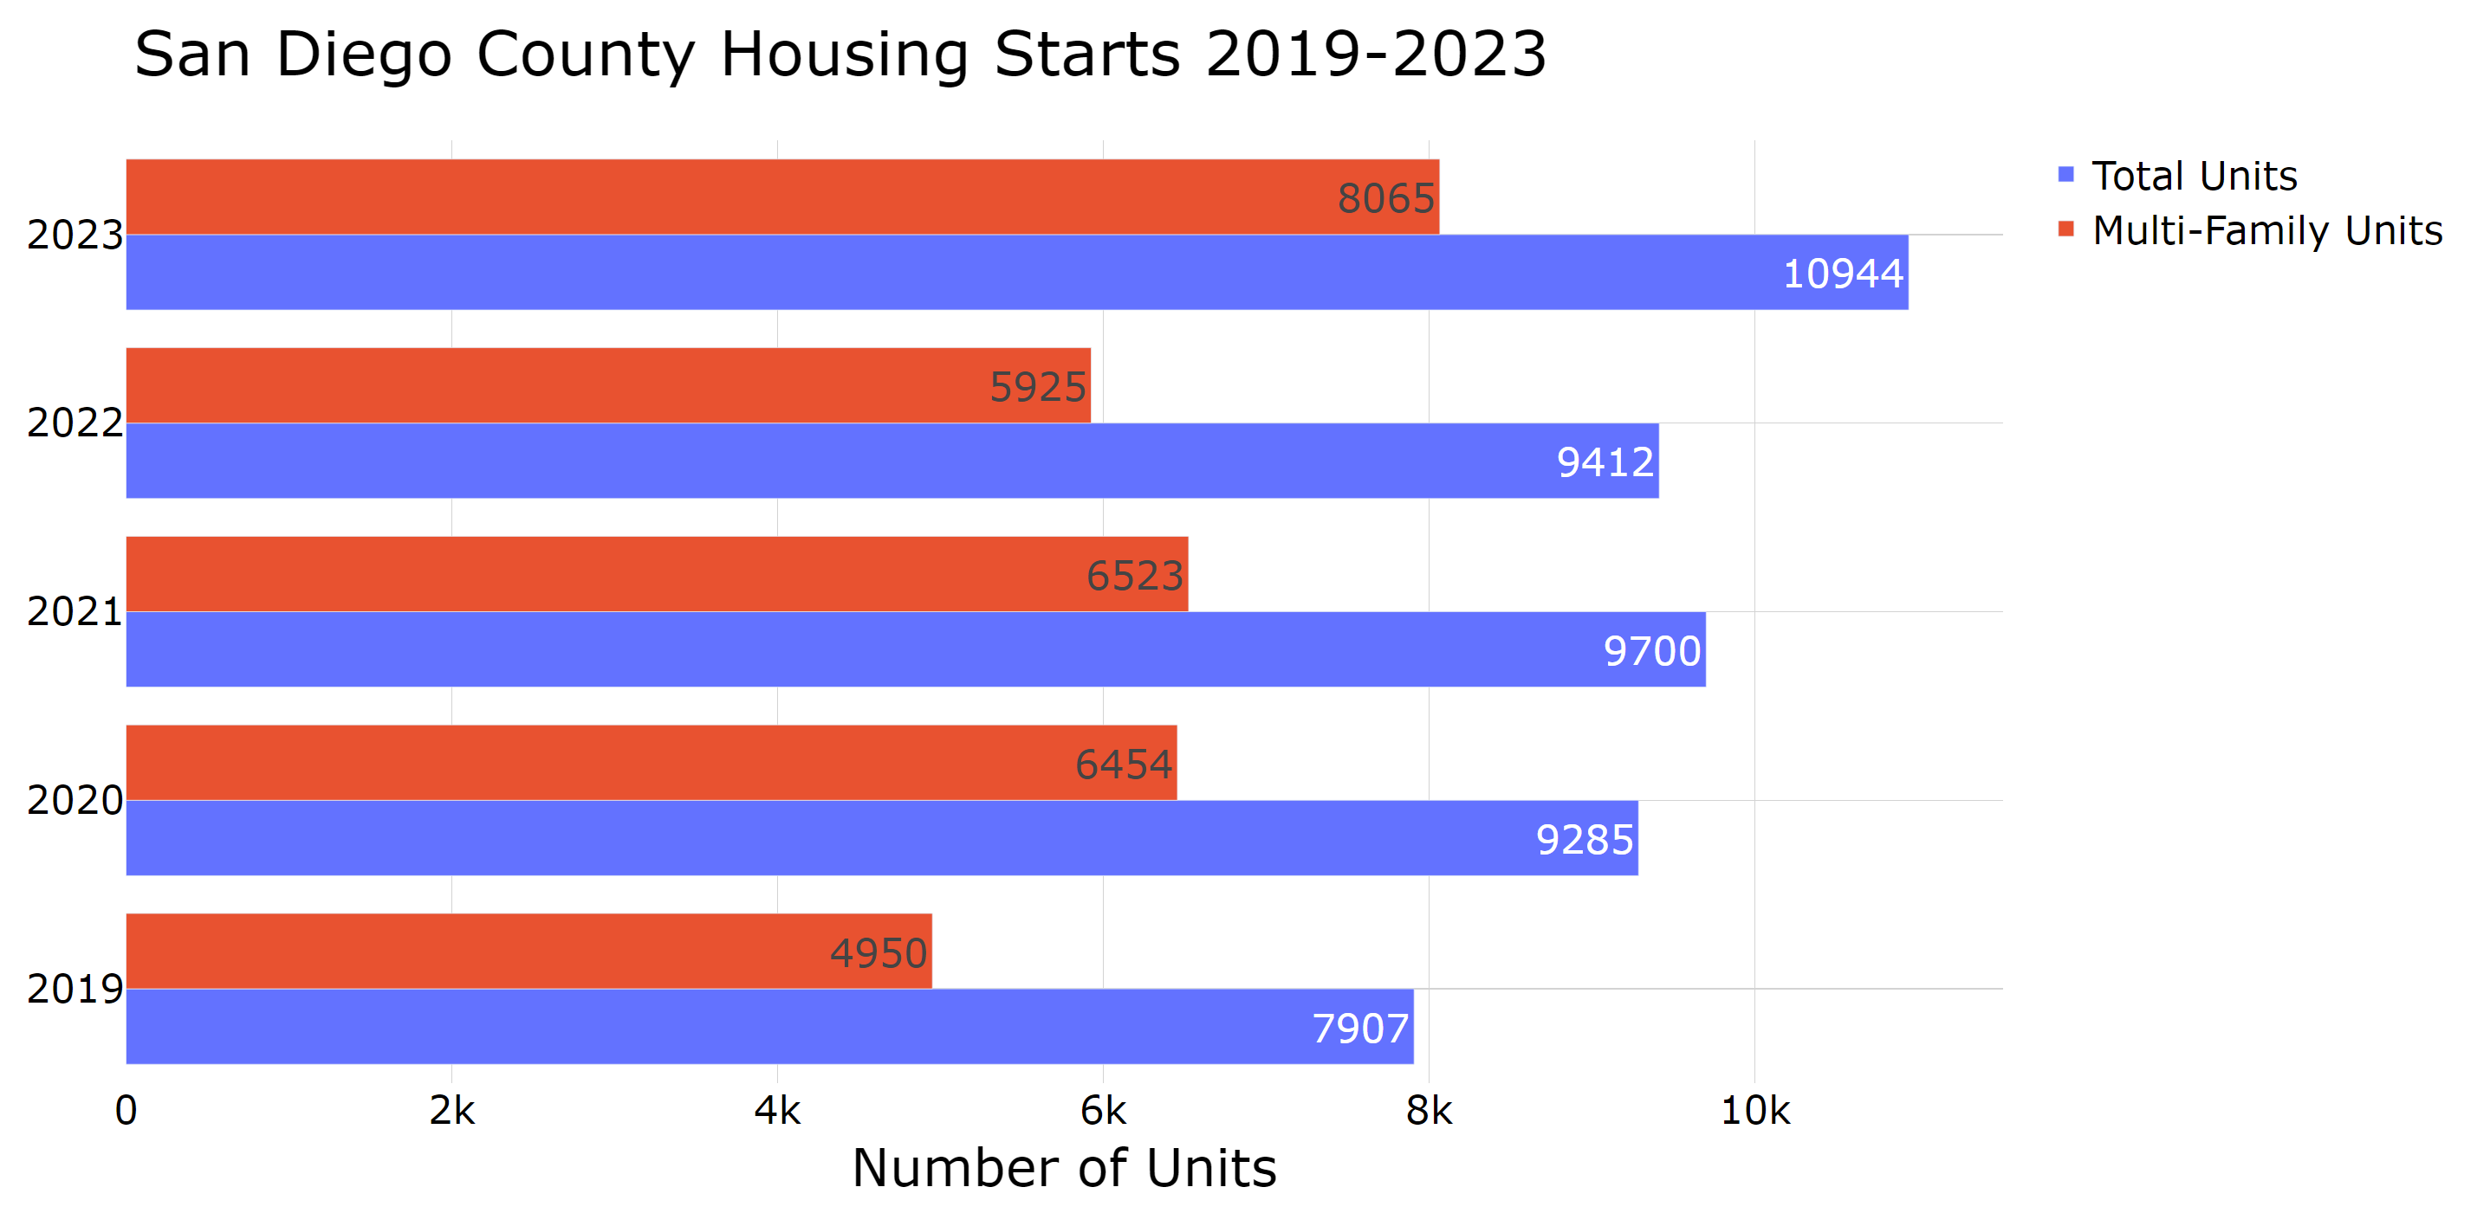

Source: US Census Bureau ACS Nov 2024

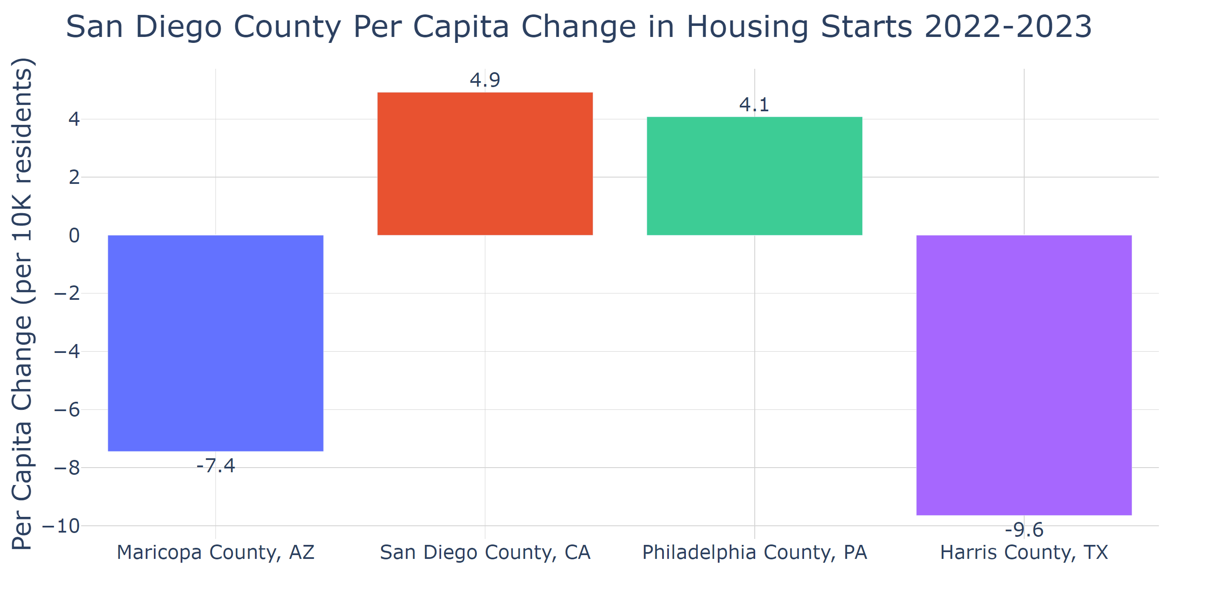

Source: US Census Bureau ACS Nov 2024

## Section 6: Business Activity

The data for the San Diego County firms indicate an upward trend in the number of businesses, increasing from 61,321 in 2017 to 68,078 in 2022. This growth is mirrored in the per capita firms, which rose from 0.018476 in 2017 to 0.020780 in 2022, outpacing state and national rates. Such growth underscores San Diego’s economic resilience and could stimulate the local job market and broader economic development. This upward trend reflects a robust business environment likely supported by San Diego's diverse economy, dynamic small business initiatives, and strategic investment efforts.

For local policymakers, this data is crucial for planning and strategizing future economic initiatives. The growing number of firms could suggest expanding business opportunities and might justify further investments in infrastructure and services supporting the business ecosystem. It also highlights the importance of policies facilitating business growth, such as incentives for startups and measures to streamline regulatory processes.

Continuation of this growth trend could significantly impact San Diego by strengthening economic stability and enhancing employment rates, albeit with challenges. An increasing number of firms can enrich the local economy by creating more jobs and diversifying market offerings. However, this may also intensify pressures on infrastructure, housing, and labor markets, as more businesses and workers move to the area.

Public policymakers could leverage this data to make informed decisions about resource distribution, labor market strategies, and housing policies to handle potential economic pressures spurred by continued business growth. Policymakers might also consider supportive measures for small businesses, given their significant contribution to job creation and economic diversity within the region.

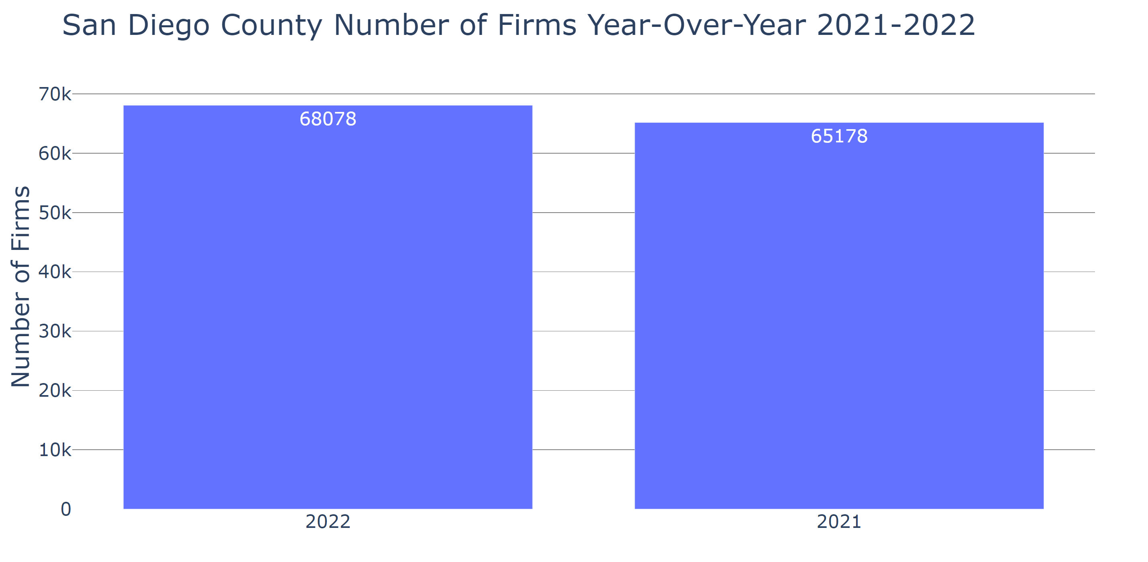

Source: US Census Bureau, 2022 Business Dynamics Statistics Nov 2024

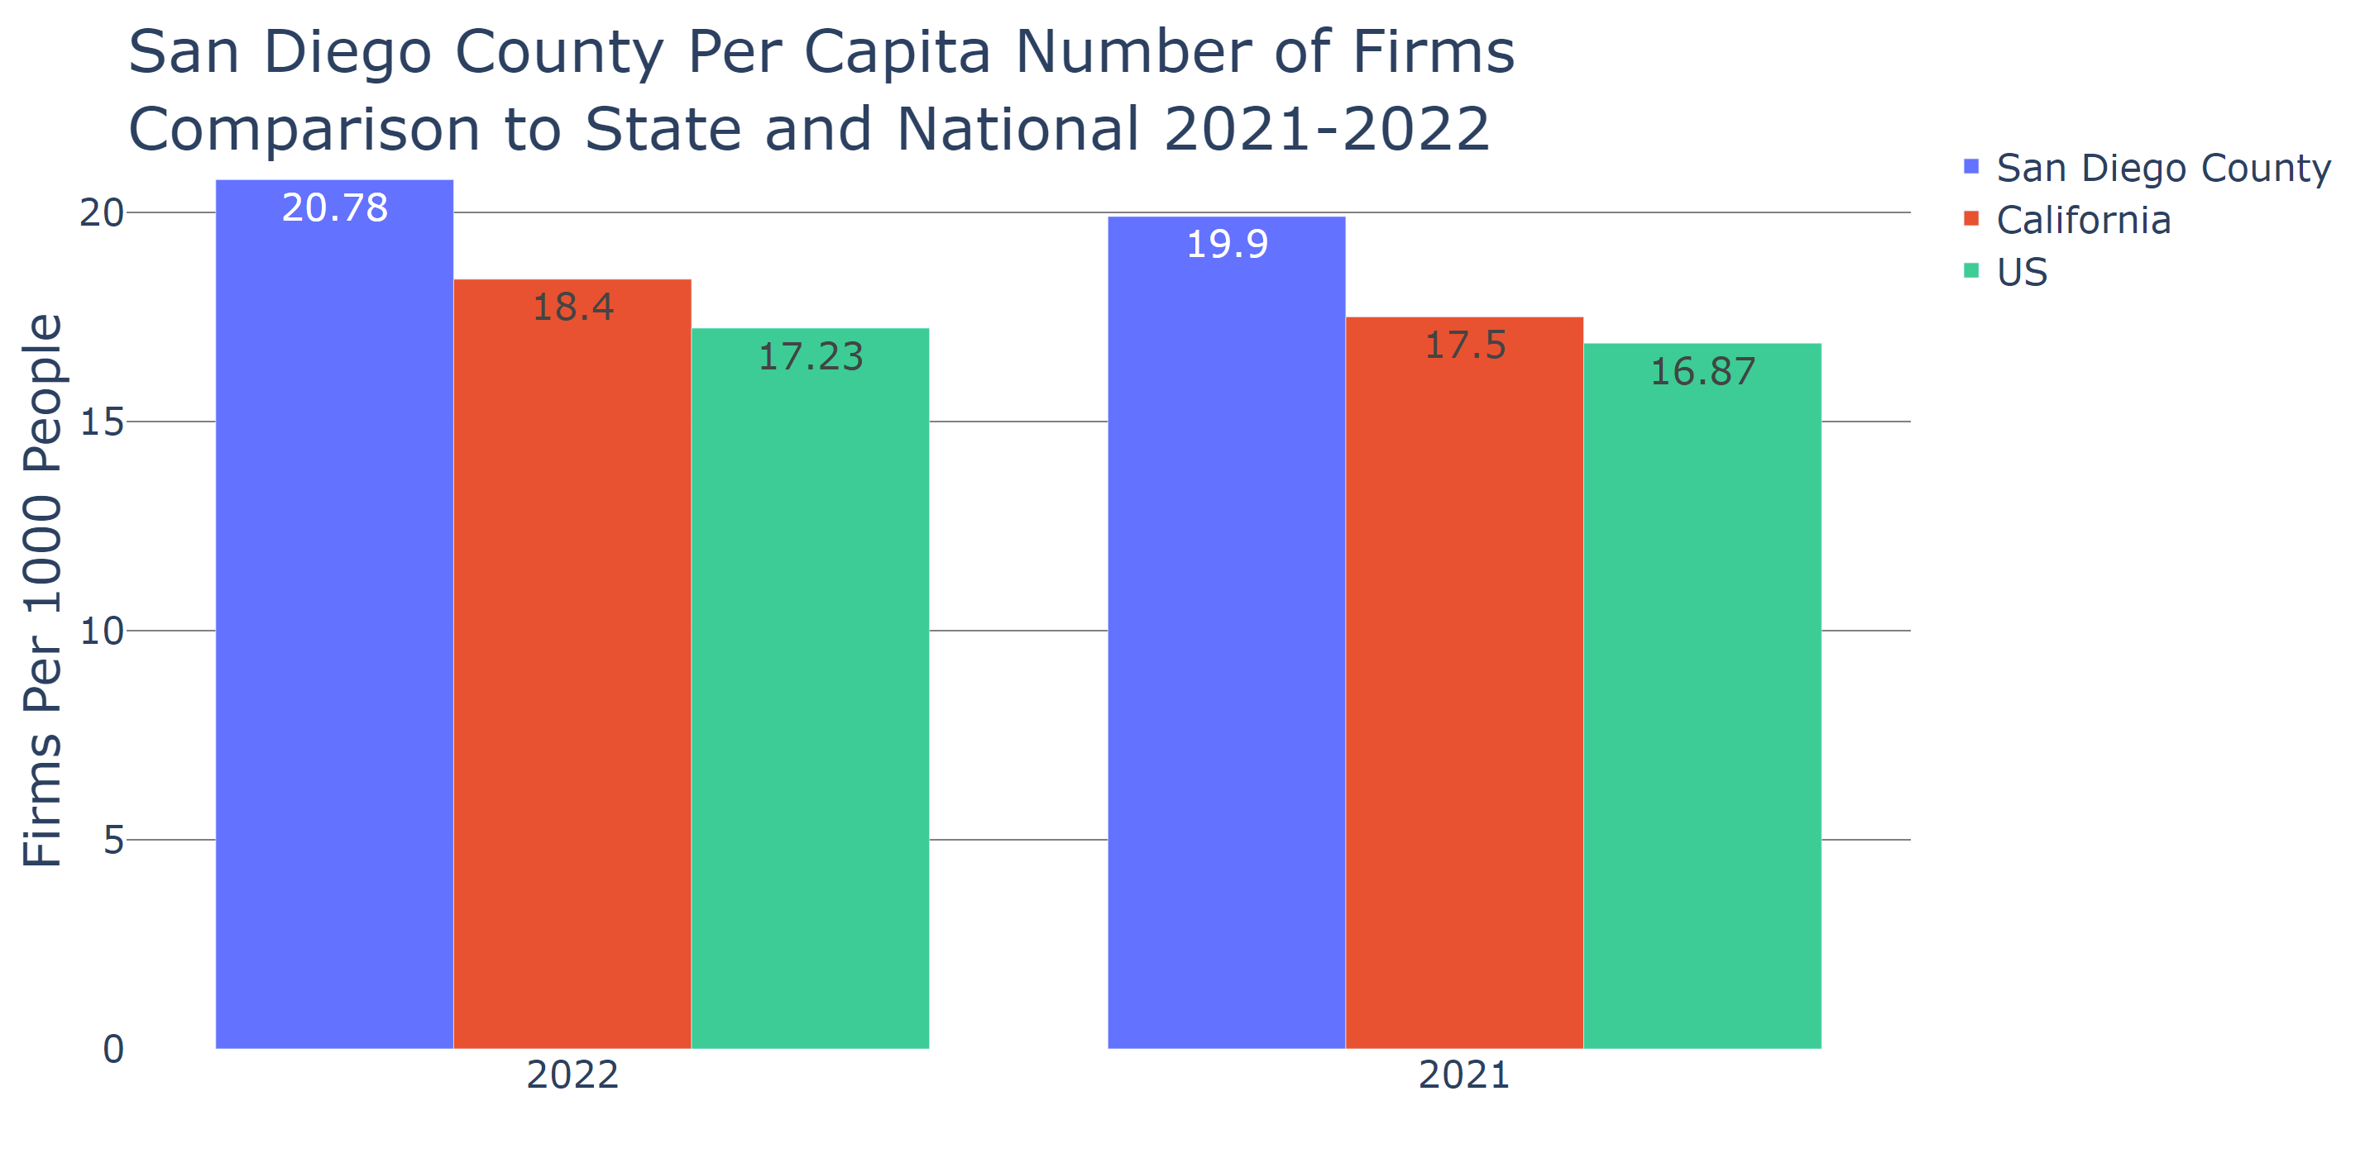

Source: US Census Bureau, 2022 Business Dynamics Statistics Nov 2024

## Section 7: Industry Clusters

In San Diego County, the Information industry cluster saw a modest growth of 761 jobs from 2019 to 2023, reflecting a small gain in employment despite a decline in its Location Quotient from 0.9 to 0.8. This implies that while there is job growth, the sector's relative concentration compared to the national average has slightly diminished. This trend may indicate a shift in local industry composition or increased competition from other sectors, such as technology and innovation, which are strong in San Diego. Nevertheless, a stable information sector supports the region's economic resilience, particularly given its role in enabling technology partnerships and collaborations.

The Arts, Entertainment, and Recreation sector experienced a decline of 3,210 jobs, translating to a 5.6% reduction in workforce during the same period, while maintaining a stable Location Quotient of 1.2. This sector's contraction may be attributed to the broader economic impact and social distancing measures during the COVID-19 pandemic. However, its enduring Location Quotient suggests continued regional significance, driven by San Diego's vibrant cultural scene. As public health measures evolve, there is potential for recovery and renewed growth, which is crucial for cultural tourism and community engagement.

Lastly, the Accommodation and Food Services sector faced a slight job decrease of 1,366, reflecting a minimal 0.7% decline. The compromised Location Quotient from 1.2 to 1.1 signals minor shifts in its competitive standing, likely due to challenges in visitor numbers and regulatory impacts on small businesses. However, the persistence of this industry underlines its critical role in supporting San Diego's tourism and hospitality offerings. Public policymakers could leverage this data by bolstering support initiatives aimed at recovery in these industries, safeguarding jobs, and enhancing economic security. Given these insights, strategic investments in infrastructure and community-focused initiatives will be integral for reinforcing San Diego's diversified economic foundation.

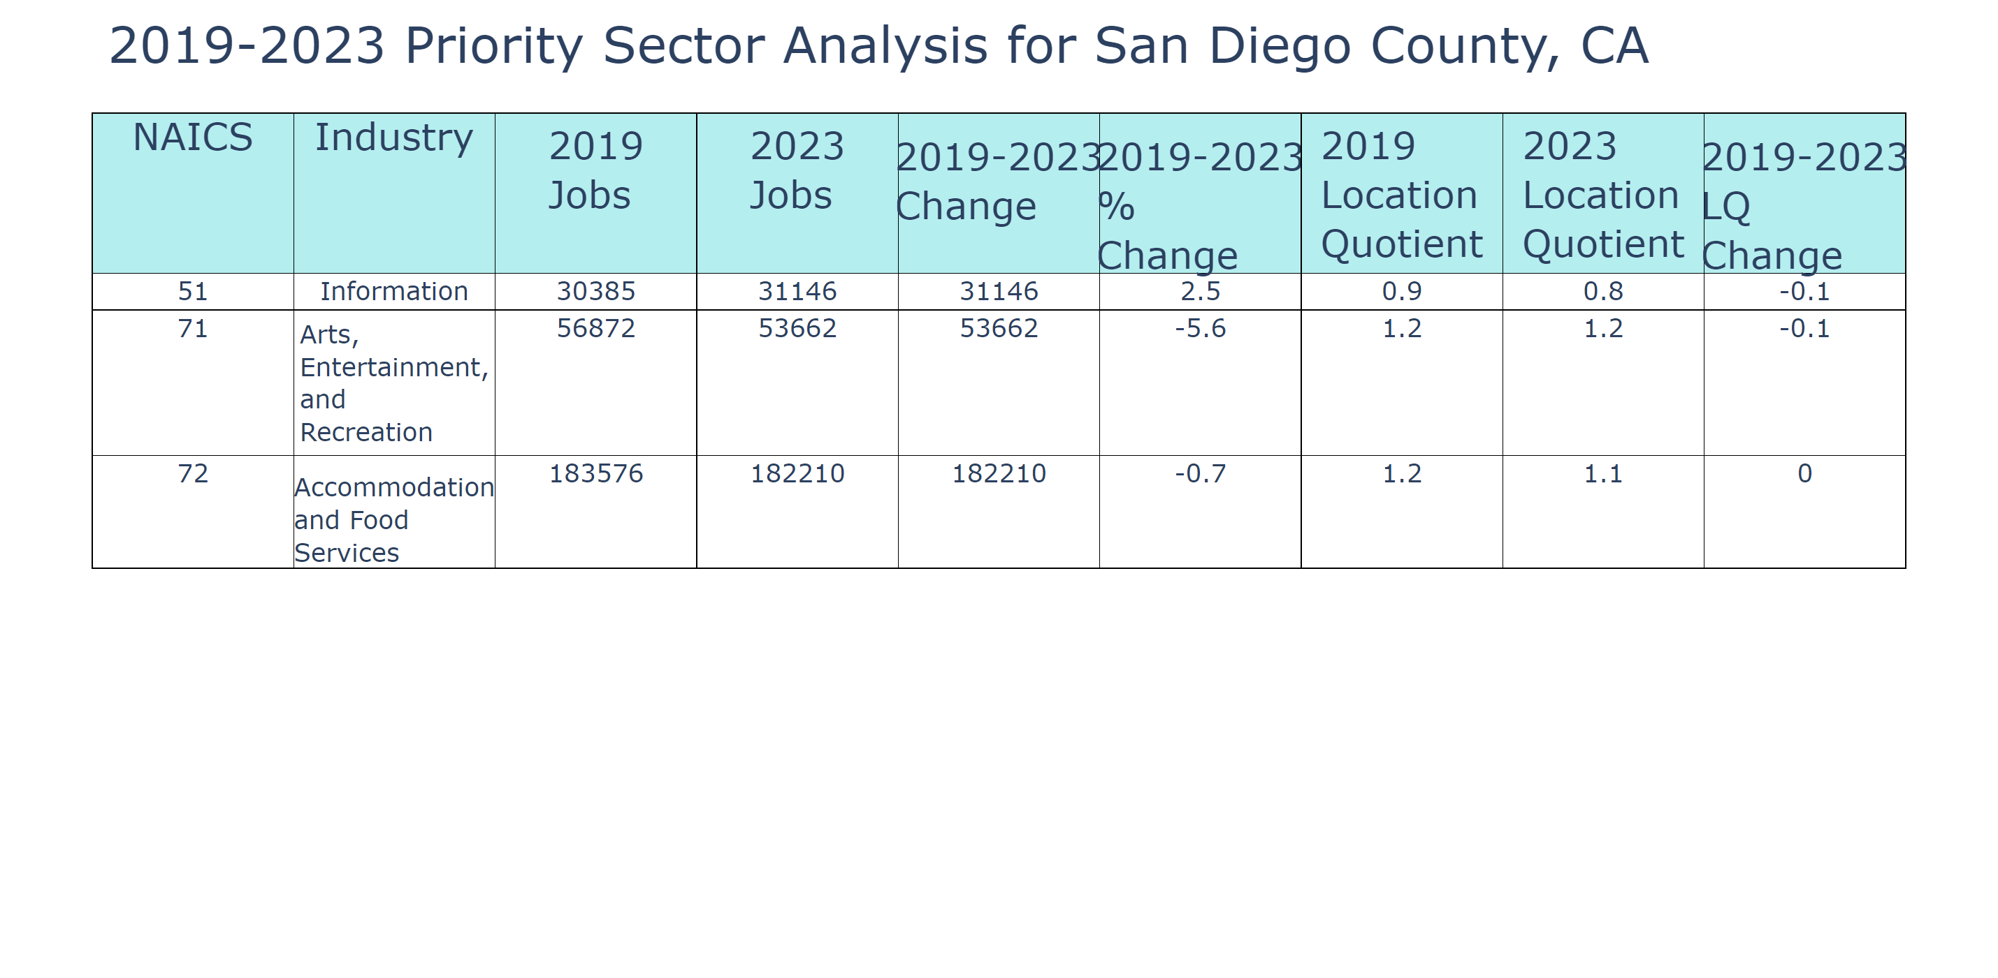

Lightcast Nov 2024

## Section 8: Industry Impact

### Mean Earnings

In San Diego, CA, the mean earnings per worker reflect diverse industry contributions to the local economy. Health Care and Social Assistance stand out with average earnings of $77,547.30, demonstrating growth of 82.47%. The Government sector also shows significant average earnings of $106,987.52 with a growth rate of 126.01%. While these figures highlight robust areas, the Accommodation and Food Services industry shows lower mean earnings at $38,447.40 but a strong growth trajectory of 101.79%.

In comparison to peer cities, such as Houston, TX, San Diego's mean earnings vary. For instance, while Houston's Utilities sector has average earnings of $222,881.89, San Diego lacks some sectors like Mining and Utilities, emphasizing its diverse economic landscape without oil and utility dependency.

These earnings data are crucial for local policymakers to understand the economic drivers and support sectors with potential for growth or require intervention. If existing trends continue, San Diego may see increased opportunities in high-growth industries like Health Care and Government, supporting local job creation and economic resilience.

Public policymakers could leverage this data in strategic planning to bolster sectors showing potential while addressing disparities in industries like Accommodation and Food Services. By fostering a balanced approach, they can develop infrastructures that attract skilled labor, ensure sustainable economic growth, and address housing needs, given the impact on affordability and socio-economic mobility.

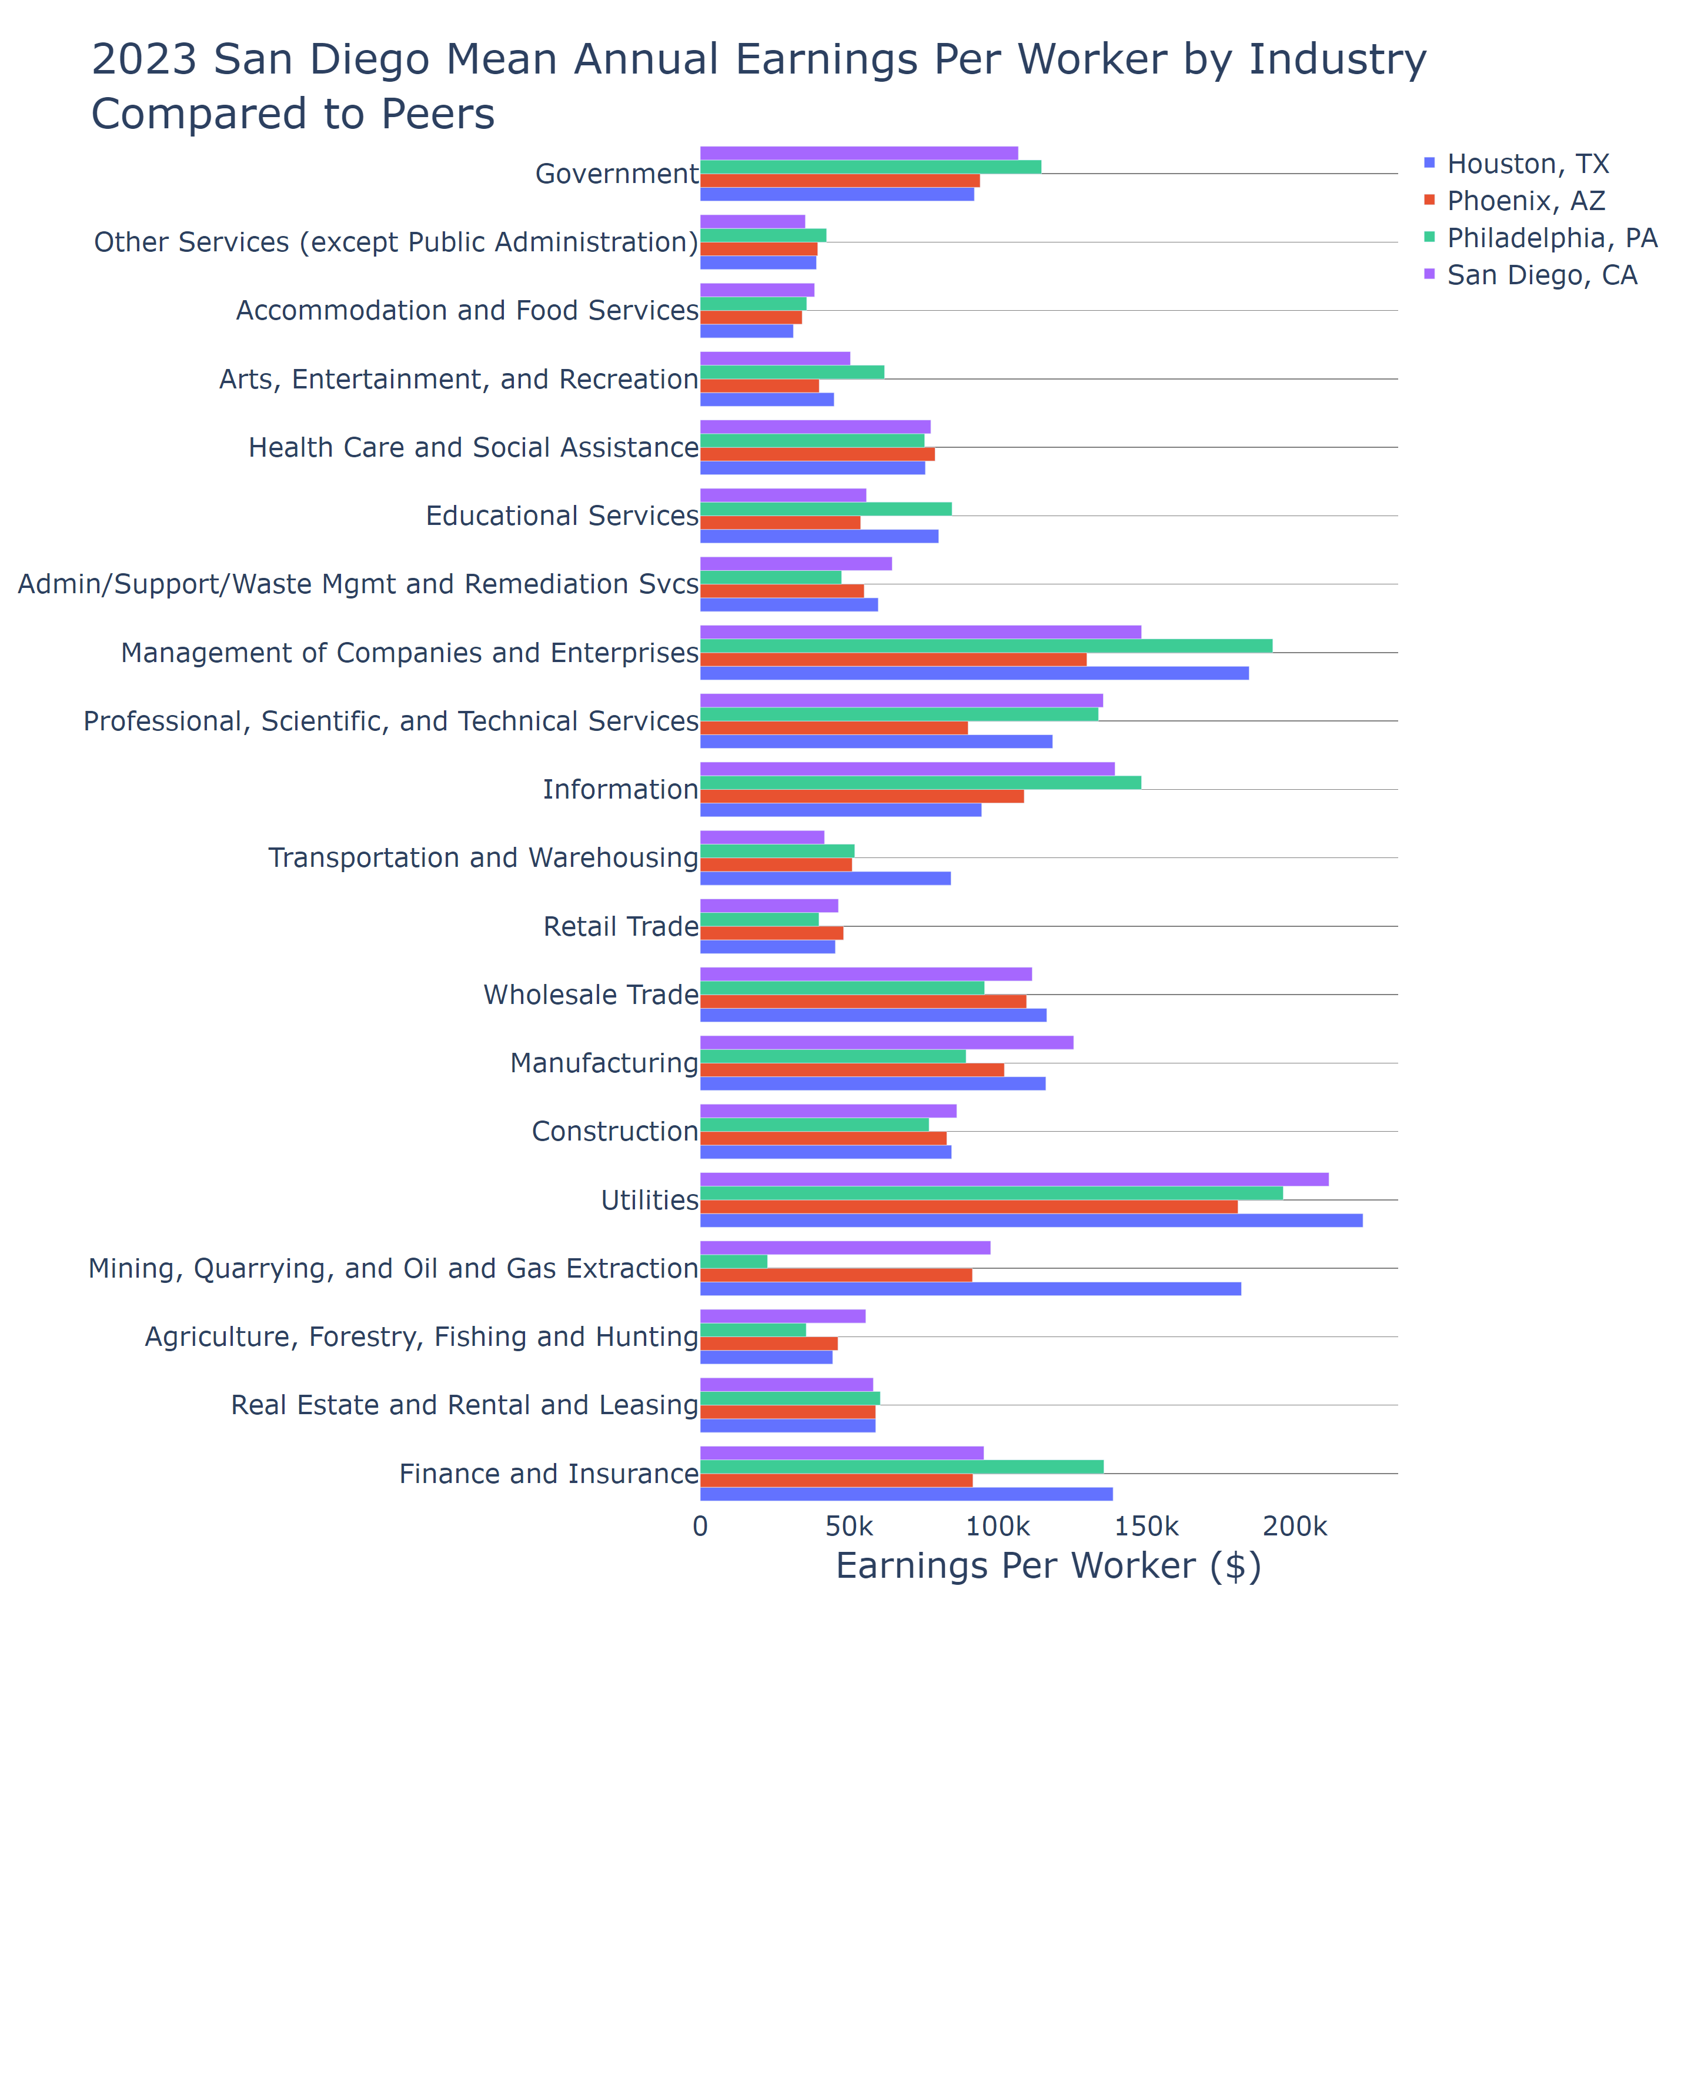

Lightcast Nov 2024

### Jobs

In San Diego, the jobs by industry data reveals significant employment concentrations in key sectors, reflecting its dynamic economic structure. Government manages the largest sector with 156,140 jobs, underscoring the importance of public administration in the region's economy. This is followed by Health Care and Social Assistance at 127,749 jobs, demonstrating a robust demand for healthcare services aligned with San Diego’s demographic needs. Accommodation and Food Services provide 91,600 jobs, revealing the sector's critical role in supporting the city’s substantial tourism industry. In comparison to its peers, such as Houston, where industries like Mining and Oil dominate, San Diego's economy is more service-oriented, with a pronounced focus on public service and healthcare.

This job distribution holds significant implications for local policymakers. Understanding these trends can aid in refining workforce development programs by aligning educational initiatives with industry demand, especially in high-growth sectors like healthcare. Moreover, investing in infrastructure that supports service sectors could bolster economic resilience, especially given tourism’s vulnerability to external shocks like pandemics.

Should these trends persist, San Diego could continue seeing economic stability driven by government and healthcare employment, although challenges such as wage disparity and housing affordability may persist. For future strategic planning, public policymakers should emphasize supporting these critical sectors through targeted economic policies, facilitating collaborative initiatives with local businesses and educational institutions, and prioritizing affordable housing development to support the active workforce.

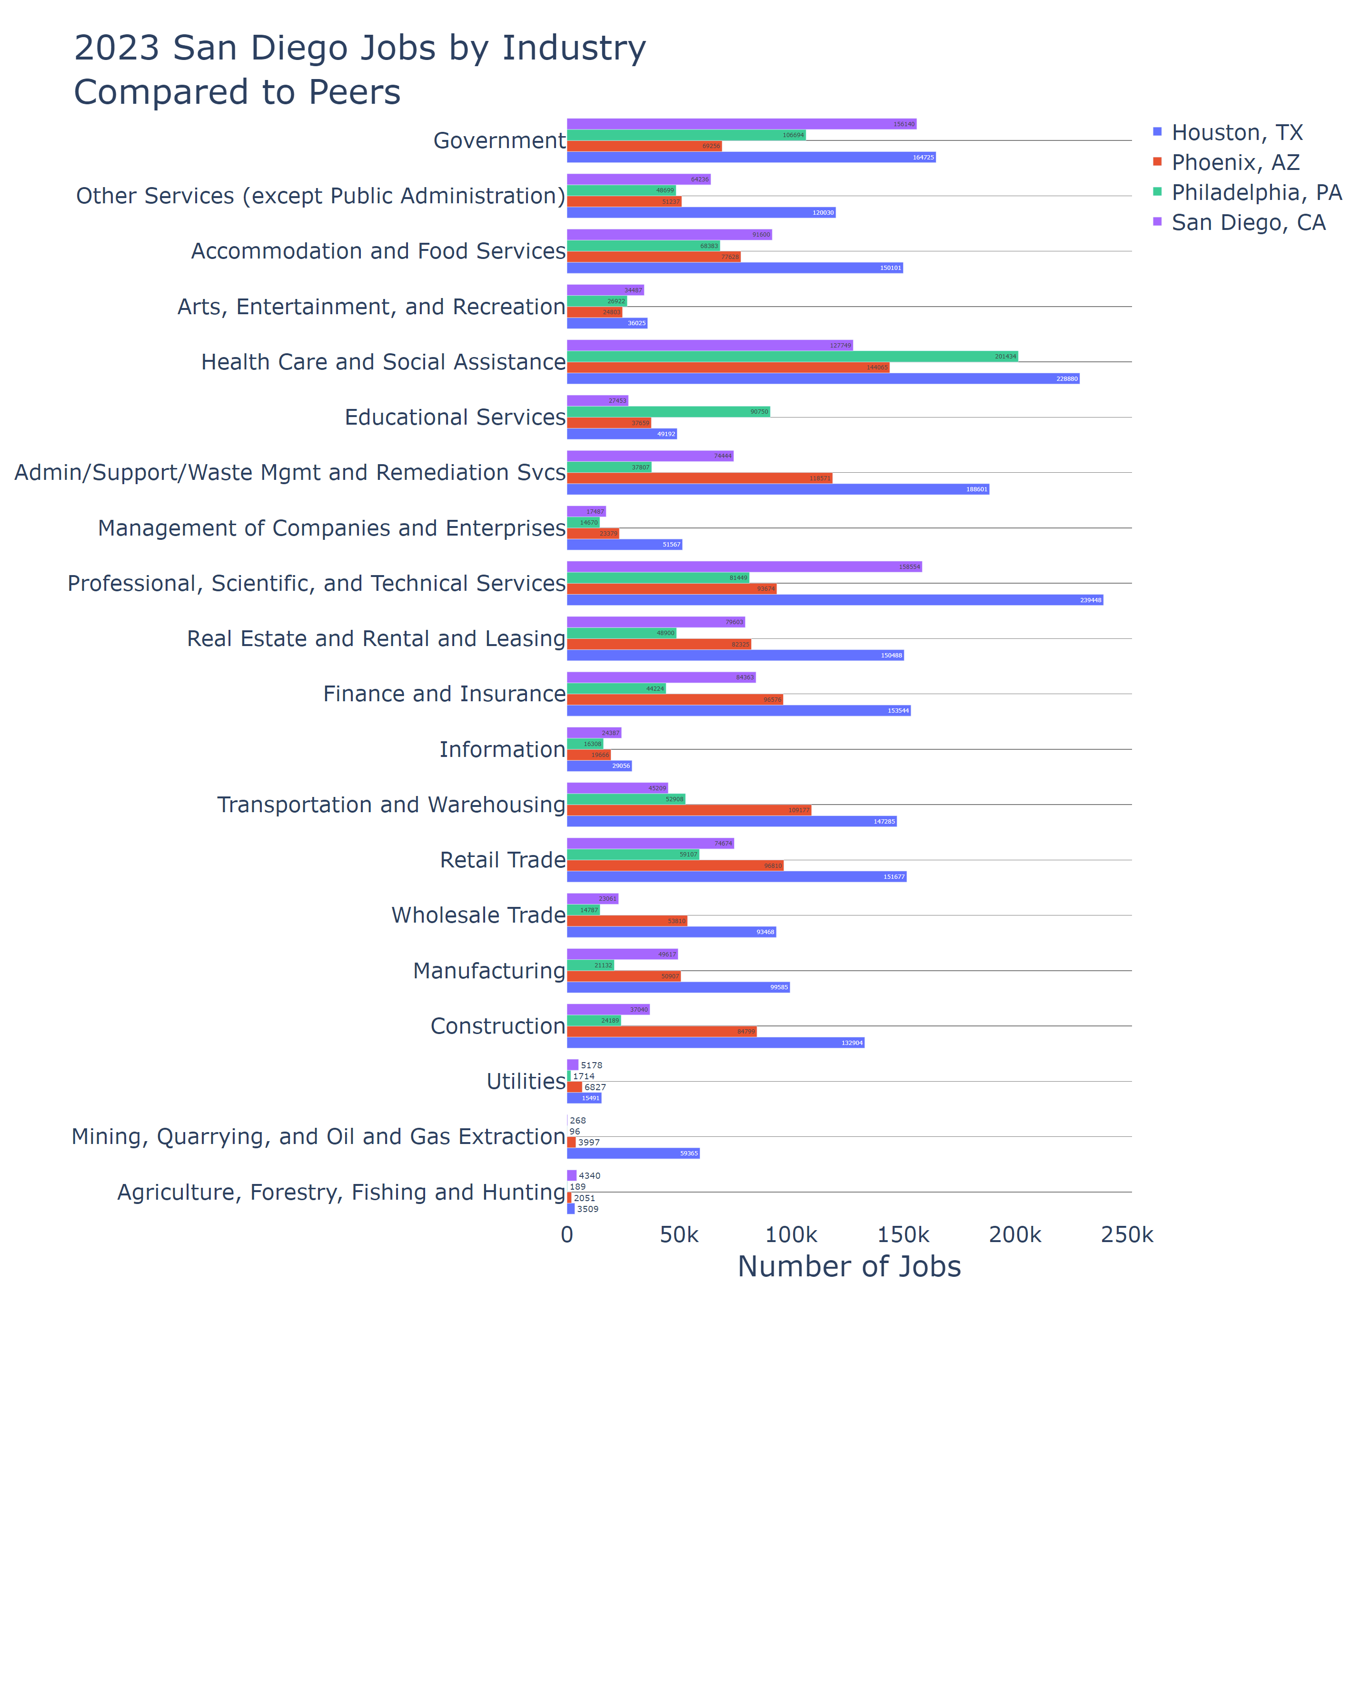

Lightcast Nov 2024