# Economic Scan Report for San Diego County, CA

## Summary

San Diego County exhibits a diverse economic landscape, with a strong commercial base driven by retail and wholesale trade sectors. The county's gross regional product (GRP) highlights key strengths in trade-related industries and real estate, though there's a reliance that suggests potential vulnerabilities compared to state and national trends favoring technology and services. The county's unemployment rates, slightly above the national average, call for policy actions targeting job creation and workforce development, addressing structural challenges. Meanwhile, job postings in major sectors like healthcare and technical services have decreased, indicating a need for targeted economic recovery and job training programs to align with sector demands. Education trends reveal a positive upward shift, with increased higher education attainment, promising opportunities for attracting skilled industries, although disparities in educational access remain a concern. Skills gaps, particularly in managerial and technical roles, emphasize the necessity for robust responses to align training with market needs, ensuring San Diego's economic resilience.

Additionally, financial conditions such as declining interest rates and moderating inflation present a dual opportunity: cheaper borrowing costs that could spur business investments, and the potential to ease housing market pressures. San Diego’s recent robust entrepreneurial growth, with firm numbers rising, underscores the effectiveness of local economic strategies. Median household income increases reflect economic vitality but also amplify affordability challenges within the housing market, which continues to see price escalation. The increase in housing starts, particularly in multi-family units, suggests a proactive approach to affordability, encouraging diversity in housing stock.

Collectively, these data points guide local economic policies, advocating for continued housing development, and cultivating high-performing sectors such as healthcare and tech. Policymakers should prioritize inclusive growth and support for underserved sectors, aligning with broader economic resilience and equity strategies to ensure long-term prosperity.

## Section 1: Gross Regional Product

San Diego County's gross regional product (GRP) reveals significant economic activity across multiple sectors, illustrating its diverse economic landscape. In 2023, the Retail Trade sector, leading with $16.2 billion, and Wholesale Trade at $14.9 billion, highlight the region's robust commercial base. Real Estate and Rental and Leasing also posted strong figures at $12.3 billion, reflecting the area's ongoing residential and commercial property activities. Alternatively, sectors like Transportation and Warehousing contributed $4.76 billion, demonstrating steady growth indicative of San Diego's logistical capabilities.

In comparison to the state and national economic outputs, San Diego County's GRP composition showcases unique strengths and weaknesses. While California’s broader economic structure emphasizes technology and entertainment, San Diego's economy remains heavily reliant on trade-related industries. Nationally, there is a marked shift towards services and technology, where San Diego could diversify further to enhance resilience.

The data is crucial for policymakers focused on sustaining growth and addressing economic vulnerabilities. With certain sectors like Utilities and Arts, Entertainment, and Recreation showing lower outputs relative to state averages, there's potential to foster innovation or tourism-driven enhancements in these areas.

If trends persist, San Diego could continue to excel in trade and real estate but may face challenges in sectors lagging behind. Policymakers should consider incentivizing technology and renewable energy initiatives while supporting underperforming sectors through strategic investments and partnerships with educational institutions.

This comparative analysis aids in aligning San Diego’s economic development policies with broader state and national trends, ensuring sustained growth and economic resilience in the coming years.

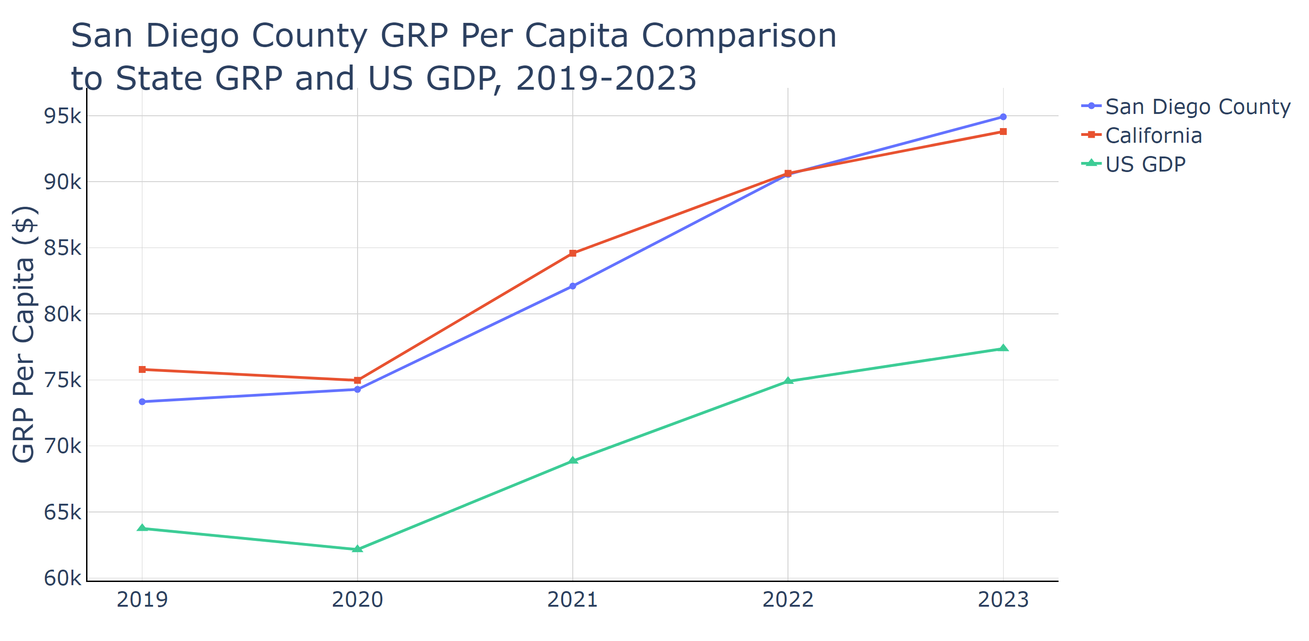

Source: Lightcast Nov 2024

## Section 2: Jobs

### Unemployment

San Diego County's unemployment rates from January to September 2024 reveal an overall downward trend, with fluctuations reflecting broader economic dynamics. As of September, San Diego's rate was 4.6%, a decrease from 5.1% in August but still higher than both the national average of 3.9% and comparable to California's state average of 5.3%. Notably, San Diego's unemployment is relatively lower than Wayne County, MI, which was 5.2% in September, yet remains higher than Maricopa County, AZ (3.4%) and Miami-Dade County, FL (2.1%).

Understanding these figures is crucial for local policymakers as they indicate competitive challenges and economic disparities within the region. The relatively high unemployment may suggest structural issues needing attention, such as skill mismatches or labor market barriers, compounded by San Diego's high cost of living and housing affordability crisis.

If current unemployment trends continue without intervention, San Diego might face increased economic strain, potentially impacting local businesses and exacerbating social inequalities. Consequently, regional stakeholders must consider targeted workforce development programs and policies to enhance job creation and employment support, aligning with San Diego's broader economic strategy that prioritizes public health and equity initiatives. Engaging in such efforts could help stabilize the job market, addressing challenges while capitalizing on opportunities within the county's diverse economic sectors.

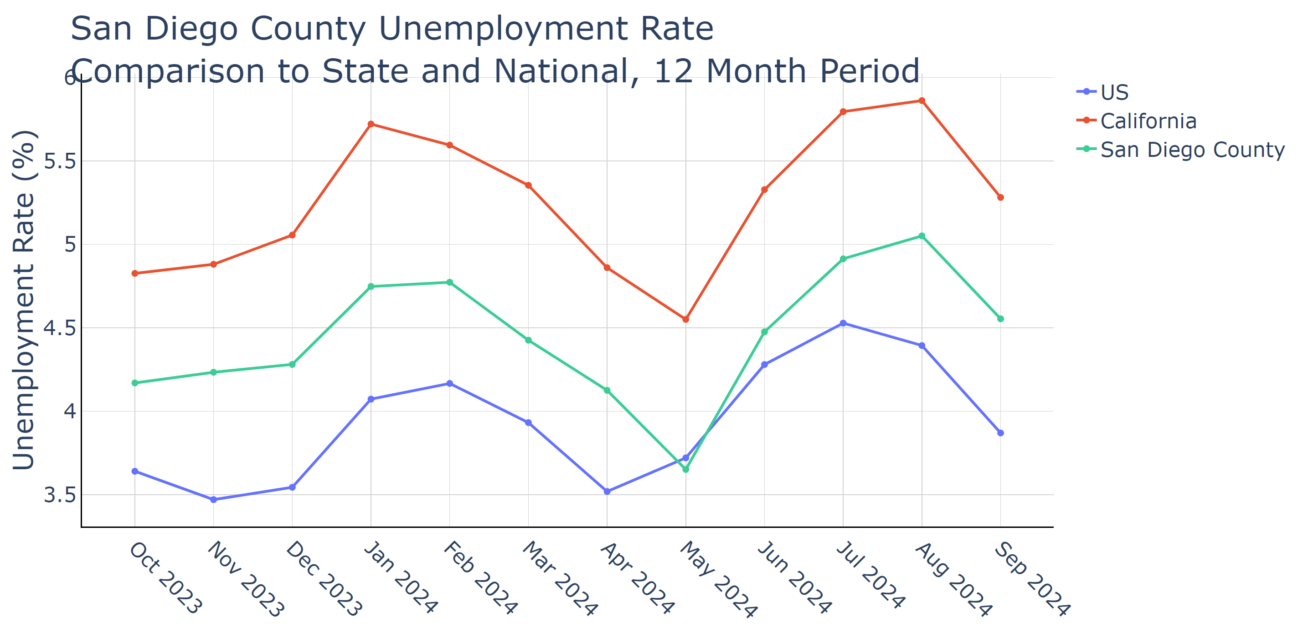

Source: Lightcast Nov 2024

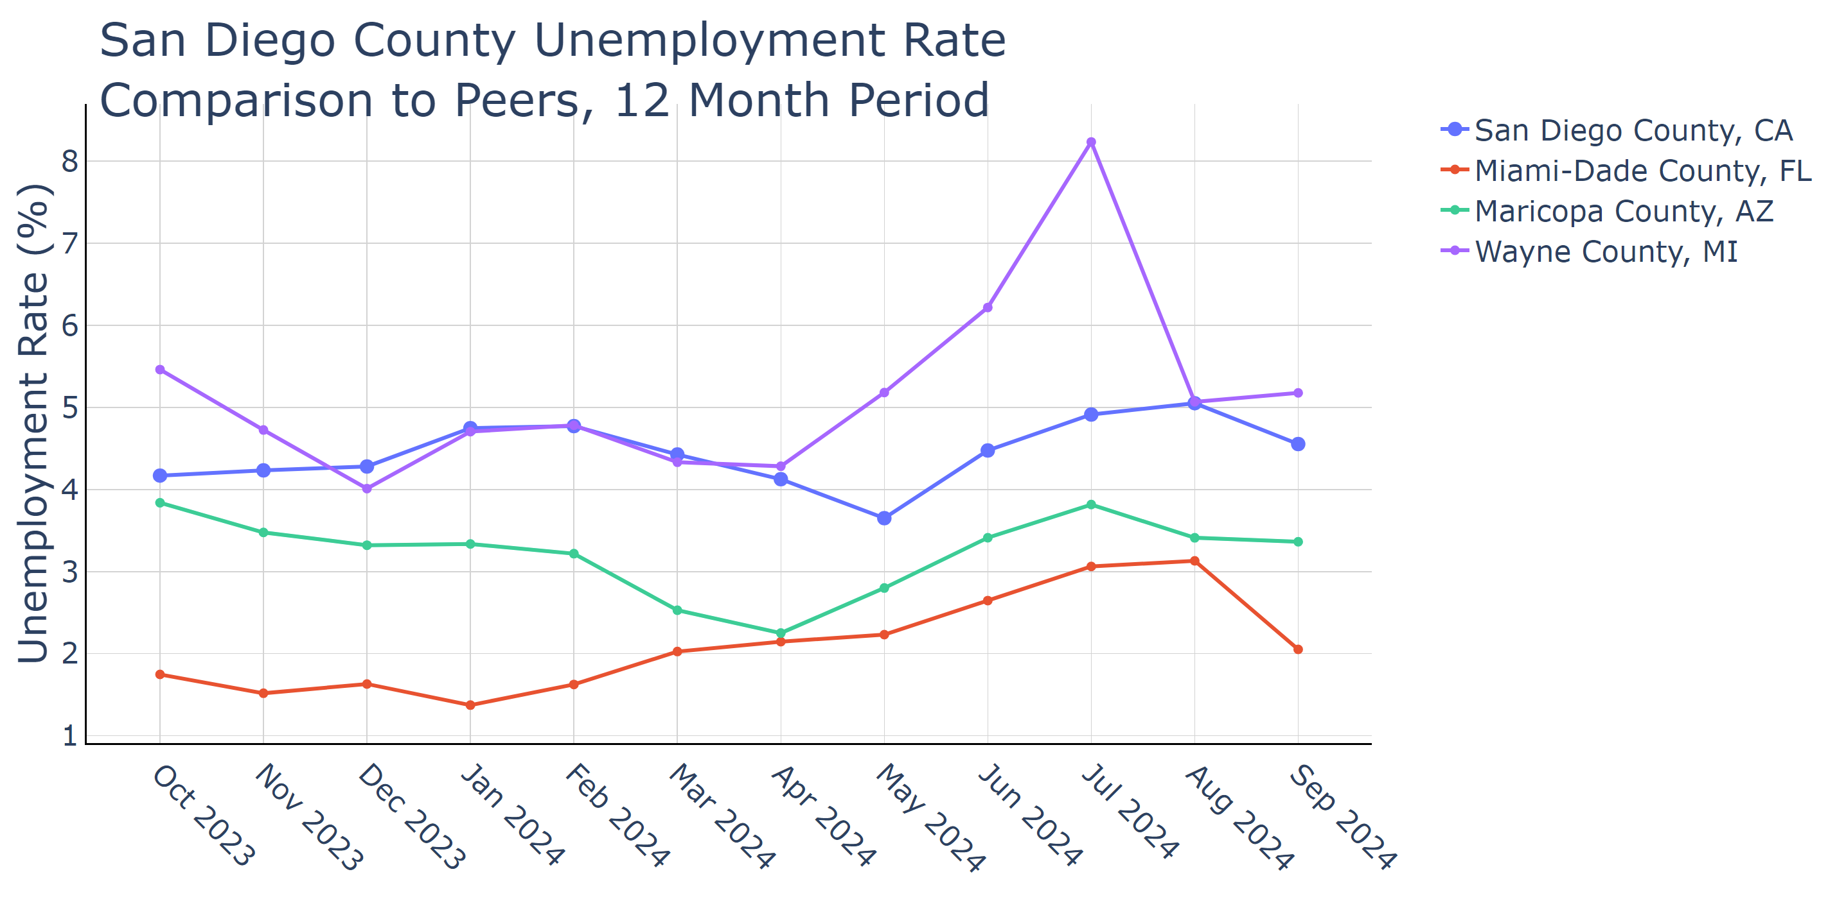

Source: Lightcast Nov 2024

### Industry Job Postings

The recent data on job postings in San Diego County highlights a substantial downturn across multiple industries over the past 12 months, with a significant impact on key sectors such as Health Care and Social Assistance, which showed a 24.16% decrease, and Professional, Scientific, and Technical Services, with a 25.67% decline. Overall, the manufacturing sector experienced a 29.44% drop. Despite this decrease, postings in Healthcare remain the highest, aligning with San Diego's emphasis on enhancing public health initiatives.

For local policymakers, this decline suggests a need for strategizing economic recovery and job creation, especially given the county’s focus on community resilience and equity. Policymakers could leverage these insights to bolster sectors experiencing decreases or consider re-skilling and up-skilling programs to align workforce capabilities with emerging industry needs.

If these trends continue, San Diego's economic landscape could face challenges. Reduced job postings may lead to slower economic growth, affecting housing demand as employment opportunities diminish. Conversely, stagnant growth in certain sectors may also encourage a transition towards emerging industries, potentially reshaping the local economy.

Public policymakers can use this data to prioritize economic development projects that cater to sectors still showing promise, like life sciences and healthcare. Further investment in training programs can prepare the displaced workforce for in-demand sectors, while also ensuring strategic alignment with San Diego’s budget focus on resilience and public health. Additionally, tracking these trends will be crucial to implementing adaptable policies that address these economic shifts effectively.

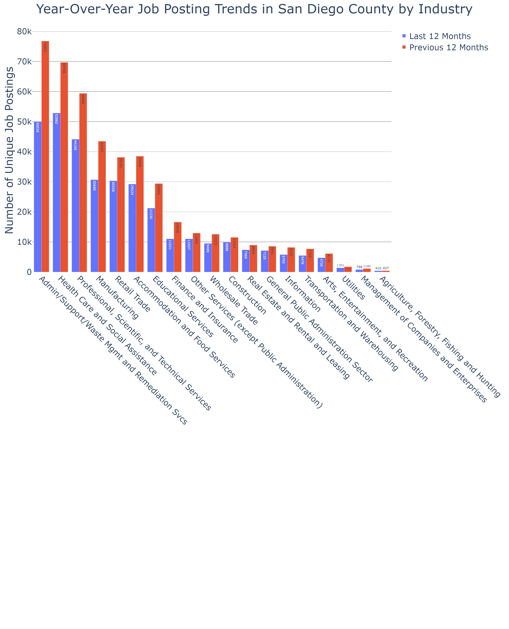

Source: Lightcast Nov 2024

## Section 3: Talent and Workforce

### Education

San Diego County's educational attainment data from 2019 to 2023 shows a discernible upward trend in higher education. Those holding a Bachelor's degree increased from 23.52% to 24.96%, while Graduate degrees rose from 14.90% to 16.15%. Conversely, there has been a decline in lower education levels; residents with education 'Less Than 9th Grade' decreased from 6.75% to 6.14%, and those in '9th Grade to 12th Grade' from 6.11% to 5.27%. This trend towards higher educational attainment is crucial, signaling a shift that may enhance San Diego's competitive edge in attracting businesses in sectors demanding skilled labor, such as technology and healthcare.

For local policymakers, this evolution presents both opportunities and challenges. It underscores the need to support education systems and align workforce development programs with industry needs. If this trend continues, the county could see a greater influx of high-paying job opportunities, which can support economic resilience and contribute to housing market growth. Yet, there is also a risk of growing disparity if educational opportunities are not equitable.

Public policymakers can utilize this data to prioritize funding and initiatives that promote access to higher education for underrepresented communities. This could involve enhancing scholarship programs or investing in community college systems, ensuring that all residents can benefit from the opportunities a thriving knowledge economy provides.

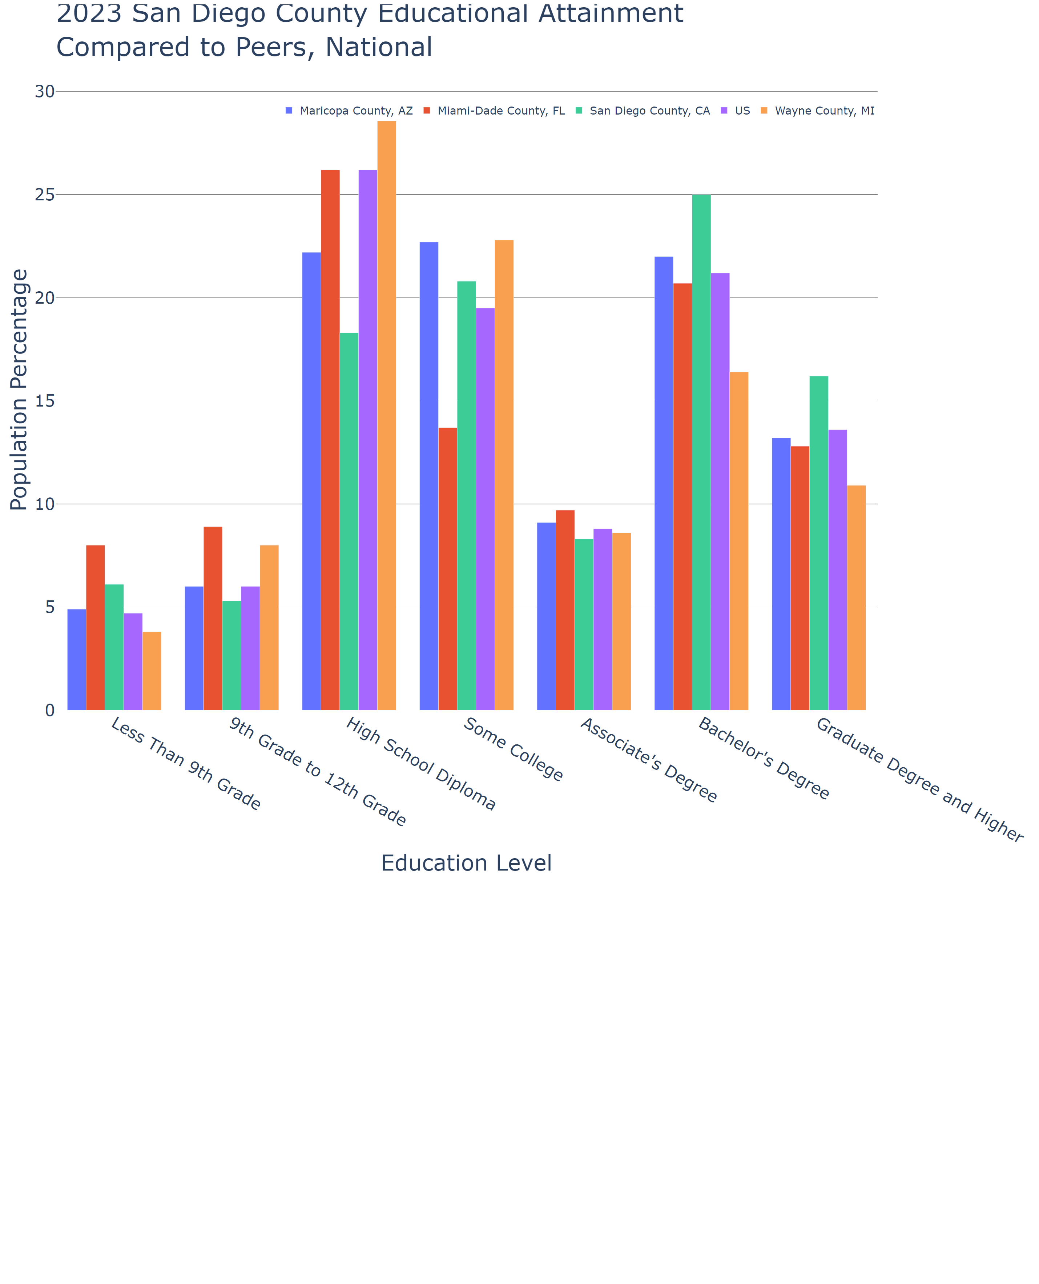

Source: Lightcast Nov 2024

### Skills Gap

The skills gap data for San Diego County, California, highlights a notable disparity between job openings and the supply of qualified individuals from educational completions, particularly in technical and managerial roles. For example, there is a substantial gap for Compensation and Benefits Managers, with a skills gap of 7402 despite high median hourly earnings at $72.47. Similarly, Database Architects face a significant skills gap of 1938 with high earnings potential at $73.23 per hour. Over time, these gaps suggest an increasing demand for specialized skills that are currently undersupplied by regional education systems.

This data underscores critical challenges for local policymakers aiming to align workforce development with evolving market demands. Particularly, San Diego's strategic position as a hub for technology and innovation—coupled with its considerable investments in education and training initiatives—necessitates a robust response to these gaps. Persistent skills shortages could define future economic trajectories, potentially hindering business growth and economic diversification unless addressed systematically.

Future trends, if consistent, portend a growing mismatch that could stunt economic potential, exacerbate wage inequalities, and marginalize local talent. Policymakers could harness this data to inform targeted training initiatives, invest in education reforms, and build partnerships with local industries to bridge these gaps effectively. Collaboration between educational institutions, businesses, and government could facilitate tailored programs that enhance workforce readiness, ensuring San Diego's economic resilience and continued prosperity.

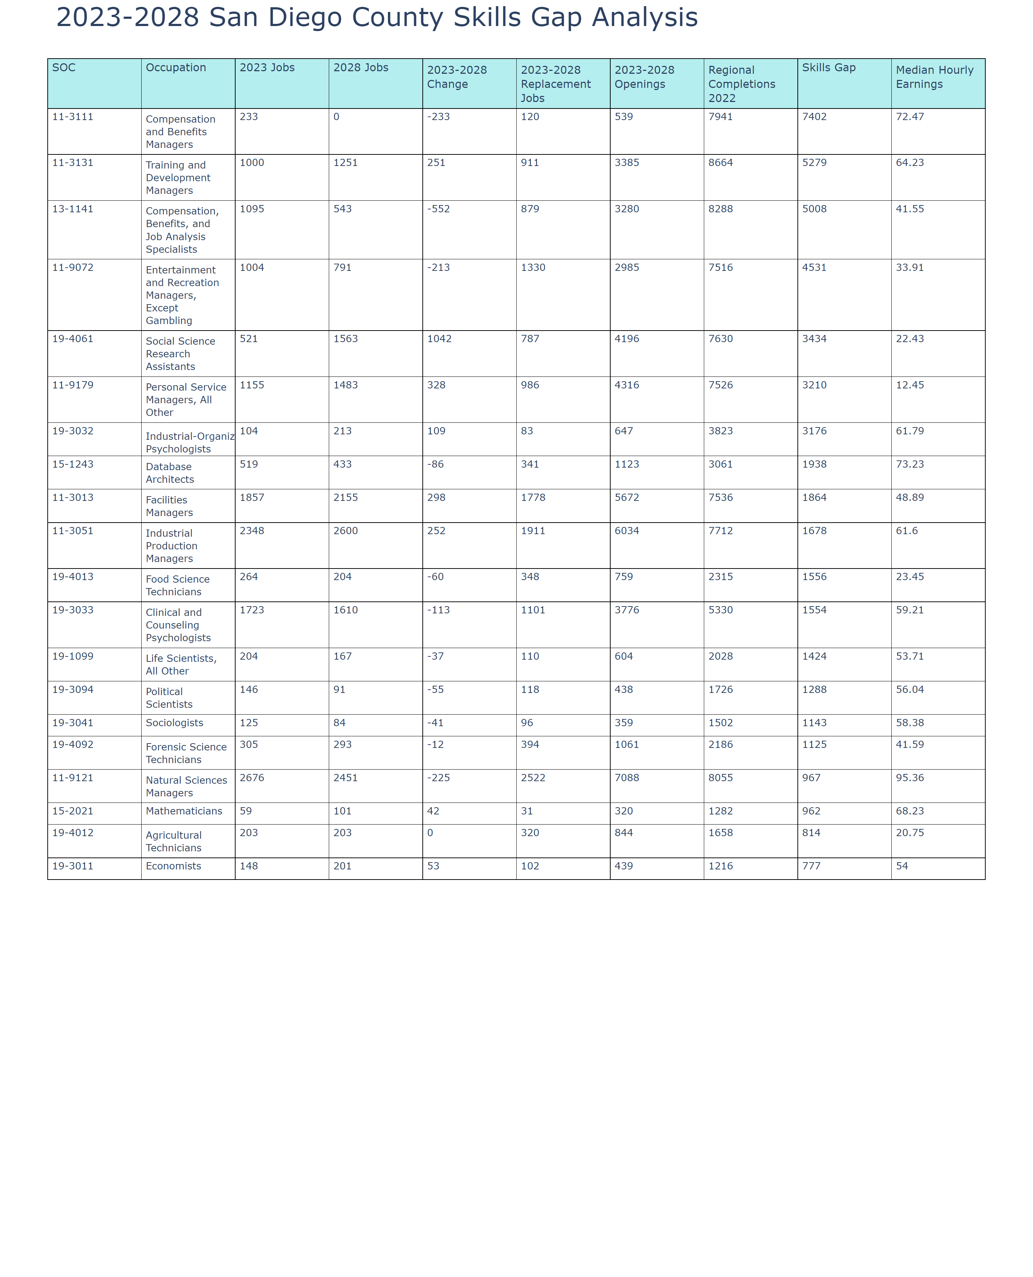

Source: Lightcast Nov 2024

## Section 4: Capital

The economic data shows a notable decrease in both interest rates and inflation over recent months, reflecting broader national trends. The 1-year interest rate, which has been volatile, decreased from 5.28% in November 2023 to 4.2% by October 2024. Similarly, 10-year and 30-year interest rates saw declines from 4.5% and 4.66% in November 2023 to 4.1% and 4.38% in October 2024, respectively. Inflation also eased from a high of 3.47% in November 2023 to 2.65% in September 2024, indicating a near-stabilization inflationary environment.

For San Diego County, this decline in interest rates can have several implications. Lower interest rates often lead to reduced borrowing costs, potentially stimulating investment, particularly within the business sectors and real estate developments. For homeowners and prospective buyers, this can mean lower mortgage rates, potentially offsetting some of the challenges posed by high housing prices, which are a significant concern in San Diego's market. Meanwhile, moderating inflation rates can aid in boosting consumer confidence by preserving purchasing power, a critical element amid high living costs in the county.

If this trend continues, the local economy could experience an uptick in business investments, particularly in sectors like tourism and tech, which are central to San Diego's economic landscape. Moreover, a stable inflation rate complements San Diego's fiscal strategy focusing on public health and safety, potentially allowing for more predictable budget allocations and planning.

Policymakers in San Diego could leverage this data to support initiatives aimed at improving housing affordability, such as incentivizing construction and investment in affordable housing sectors. Additionally, these trends might prompt the exploration of economic development strategies that harness lowered capital costs to spur local innovation and entrepreneurship. Understanding these dynamics helps San Diego position itself strategically to harness potential growth opportunities while mitigating economic disparities.

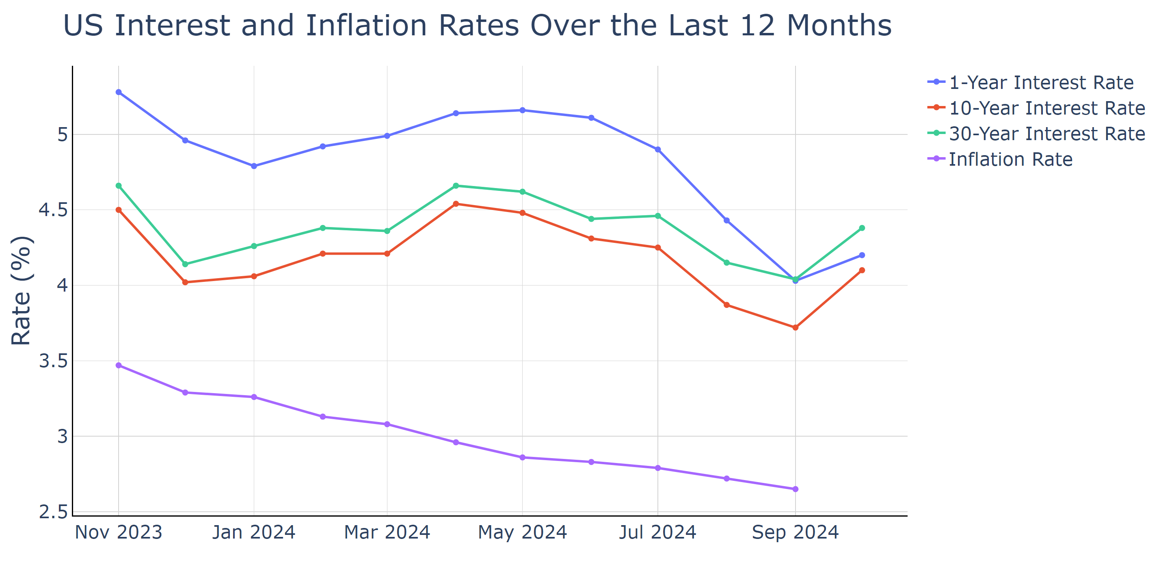

Source: Federal Reserve System (US) Nov 2024

## Section 5: Income and Housing

### Median Household Income

San Diego County, CA, has seen a significant increase in median household income over recent years, rising from $118,862 in 2020 to $139,510 in 2023, indicating a strong economic trajectory. This growth reflects an increase of roughly 17.4% over three years, outpacing many peer regions like Maricopa County, AZ, Miami-Dade County, FL, and Wayne County, MI, suggesting robust local economic activities possibly spurred by sectors such as tourism, life sciences, and military-related enterprises.

The rising median income is crucial for local policymakers as it outlines the growing economic prosperity within the region. Additionally, higher incomes can lead to increased spending and investment in local businesses, stimulating further economic development. However, these increases also heighten the demand for housing and challenge affordability, particularly as San Diego's housing market faces significant supply constraints and escalating prices.

If this trend continues, while San Diego's economy may continue to strengthen, disparities in income distribution and cost of living could become more pronounced. The local economy might experience increased commercial activity but could also see pressures on housing and infrastructure as more residents with higher incomes seek accommodations in the area, potentially leading to gentrification.

Policymakers can leverage this data by planning for balanced regional growth that takes into account housing affordability and accessibility. Initiatives could focus on expanding affordable housing, fostering equitable economic participation across diverse communities, and strategically managing infrastructure development to sustain long-term economic health. By aligning fiscal policies with this income growth, San Diego County can foster a more inclusive and resilient economic environment for all residents.

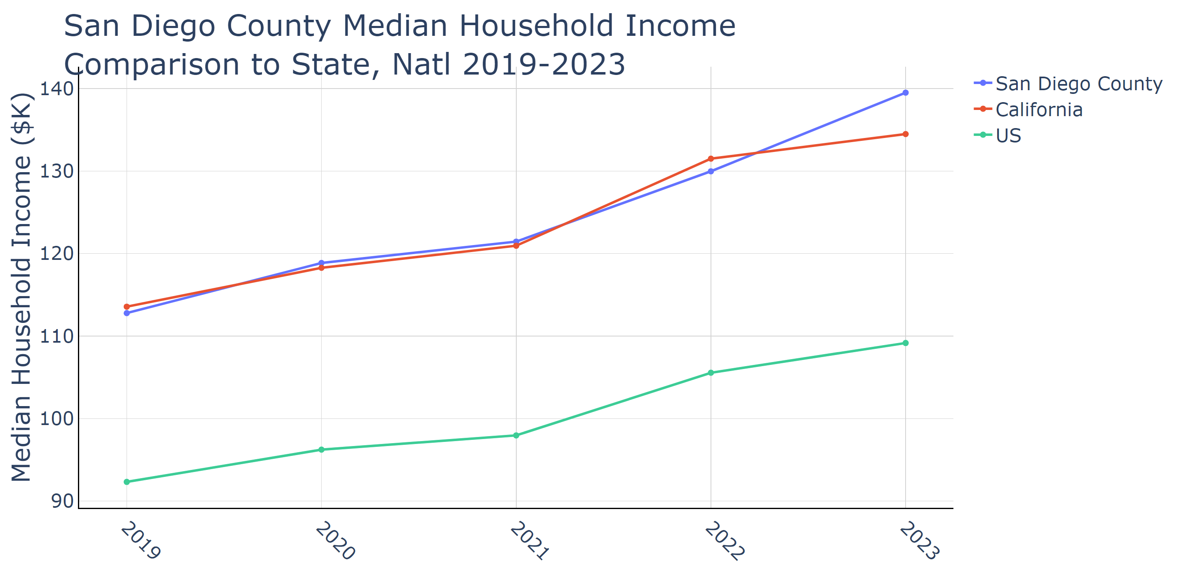

Source: US Census Bureau ACS Nov 2024

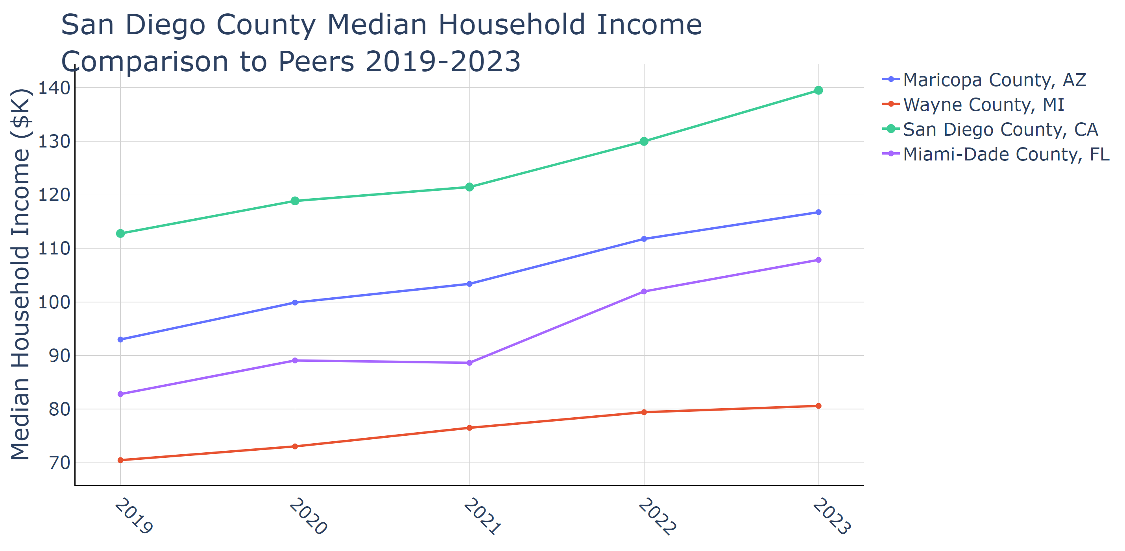

Source: US Census Bureau ACS Nov 2024

### Median Home Price

San Diego County's median home price has seen a noticeable upward trend from $619,300 in 2019 to $864,900 in 2023. This consistent increase reflects strong demand and a limited supply of housing, which exacerbates challenges related to home affordability. Within the past five years, housing costs have sky-rocketed, making San Diego County one of the more expensive U.S. markets, second only to regions like San Francisco and Los Angeles when assessed nationally.

For local policymakers, understanding these trends is crucial as they underscore the urgent need for policies that address housing affordability and availability. The rise in home prices can lead to economic strain on residents, particularly middle to lower-income families, resulting in increased pressure on rental markets, further social inequalities, and potentially incentivizing out-migration to more affordable areas.

If these trends persist, San Diego County could face heightened socioeconomic disparities, with potential adverse effects on local businesses and the broader economy. Future homeowner and resident shifts would likely impact consumer spending patterns and labor markets, significantly affecting retailers and small businesses reliant on local purchasing power.

Public policymakers are encouraged to utilize this data to guide strategic investments in affordable housing projects, land use policies that encourage medium-density developments, and incentives for first-time homebuyers. Addressing these issues, and drawing from comparative data with peer regions like Maricopa County, AZ, and Miami-Dade County, FL, where median home prices are significantly lower, could inspire inclusive growth and a balanced approach to regulatory adjustment in housing markets.

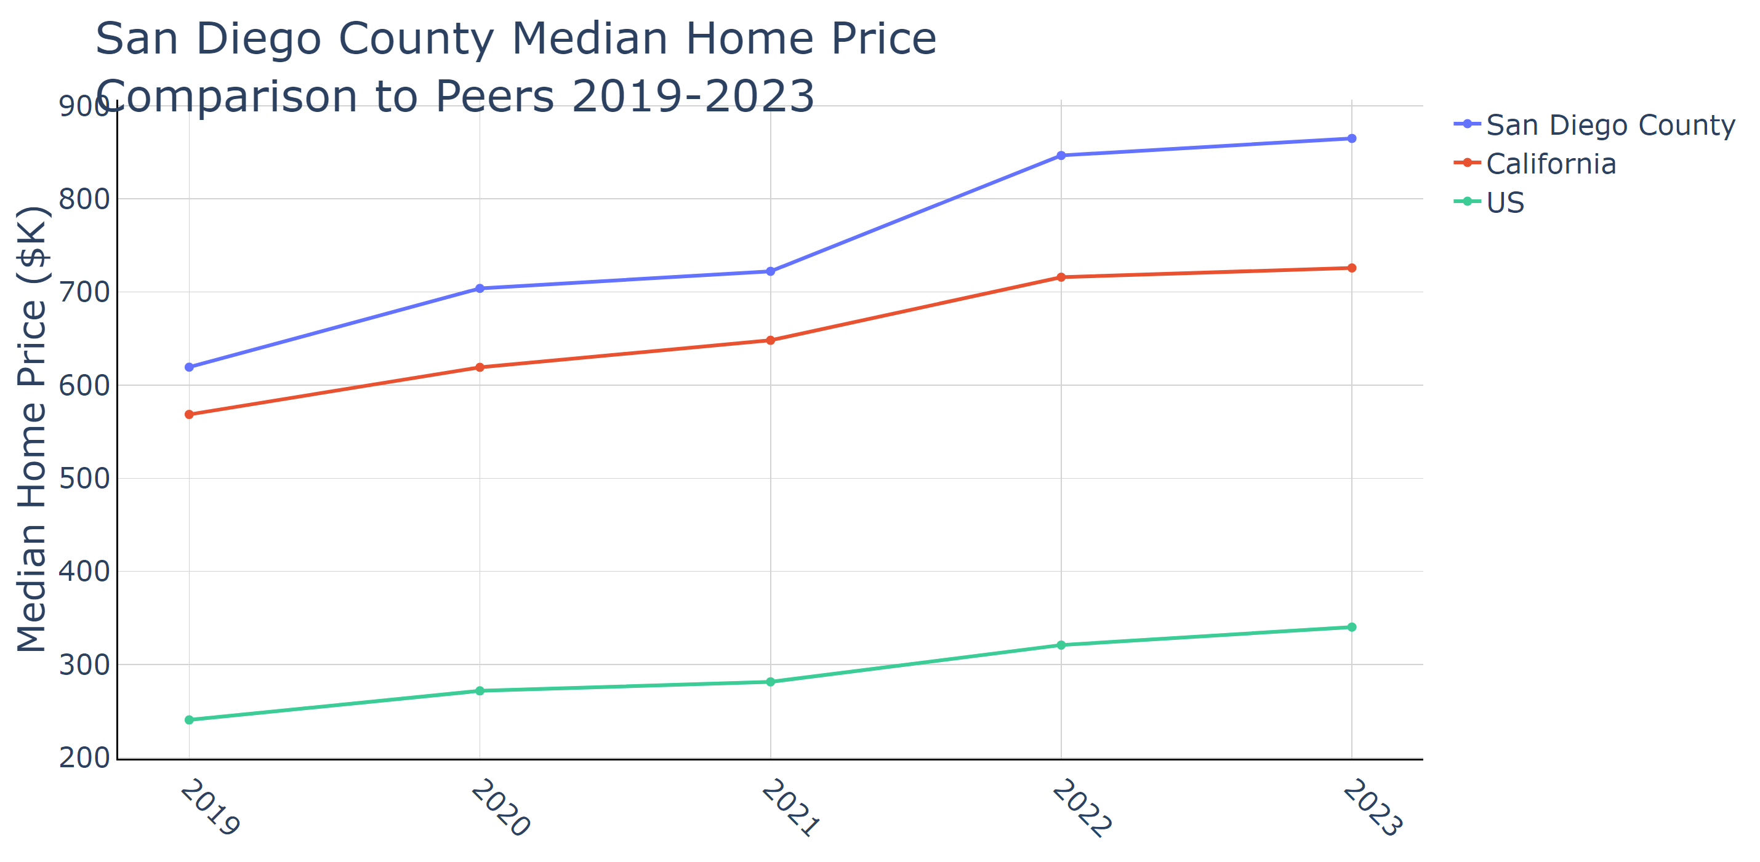

Source: US Census Bureau ACS Nov 2024

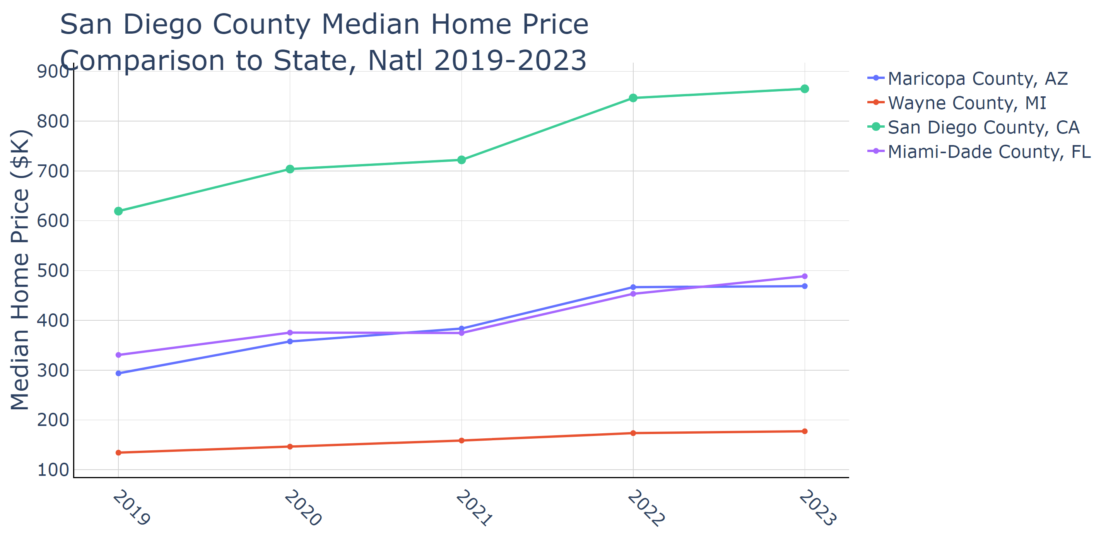

Source: US Census Bureau ACS Nov 2024

### Housing Starts

San Diego County has witnessed an upward trajectory in housing starts over the past five years, with the 2023 data illustrating 10,944 total housing units initiated and 8,065 of those being multi-family units. This figure represents a substantial increase from 2019 when total starts were at 7,907 units, showcasing an ongoing trend towards addressing the region’s housing supply crisis. The county's total per capita housing starts increased to 0.003365 in 2023, aligning with the county's budgetary emphasis on community resilience and equity.

For local policymakers, the increase in housing starts, particularly in the multi-family sector, is significant. San Diego is addressing concerns of housing affordability in response to its expensive real estate market, accented by high demand and limited supply. The consistent rise, even in the face of declining population figures, implies an aggressive response to accommodate present and future residents and mitigate displacement pressures due to high housing costs.

If the trend of increasing housing starts continues, San Diego County could expect a stabilization of home prices and potential easing of rental burdens in the long term. This expansion of the housing stock is pivotal for supporting economic activities by retaining a diverse workforce, especially in high-growth sectors like technology and life sciences. Businesses could benefit from enhanced labor market stability due to improved housing availability.

Policymakers can leverage this data to advocate for sustained or increased funding and support for residential development projects, prioritizing areas with a significant need for affordable housing. They could also use this momentum to refine zoning laws or land use policies to encourage balanced growth across various housing types while integrating infrastructure and public services improvements to support the anticipated population and economic growth.

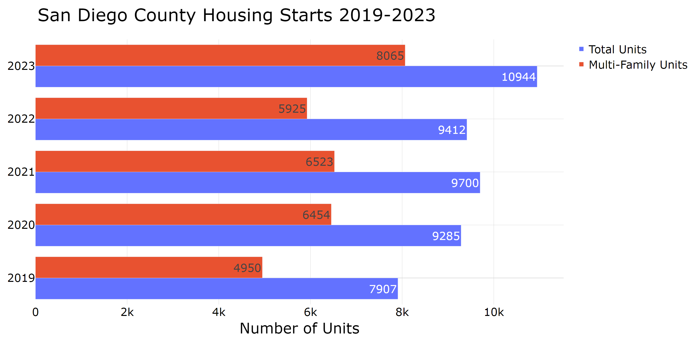

Source: US Census Bureau ACS Nov 2024

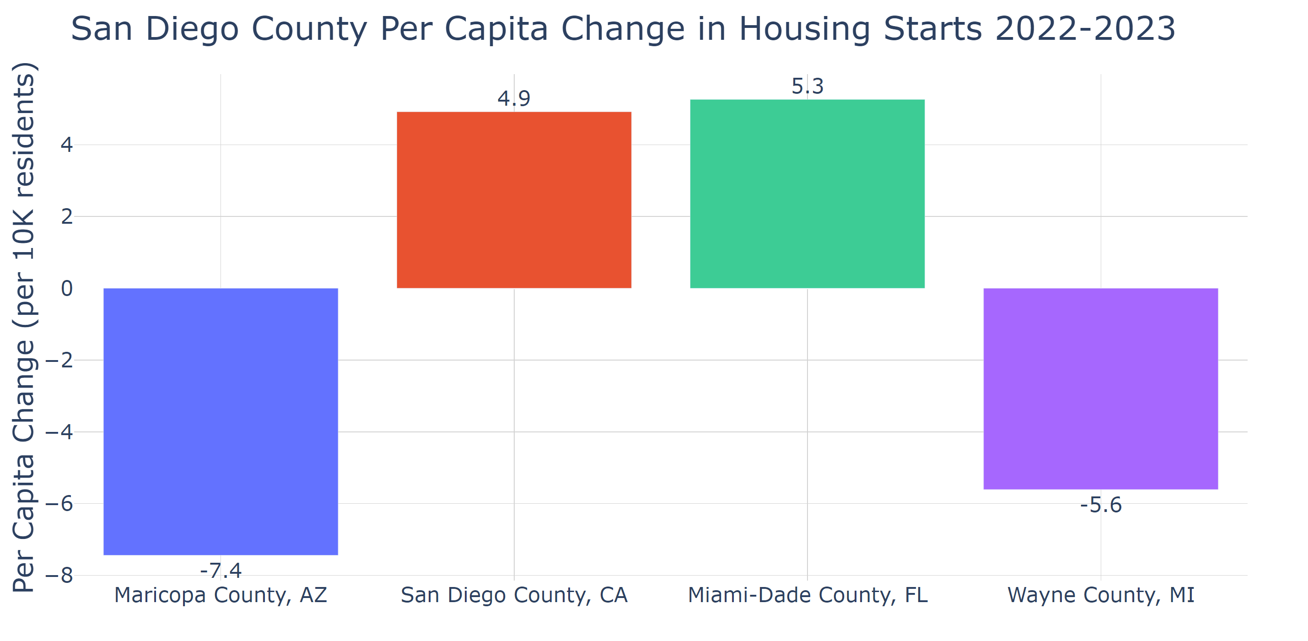

Source: US Census Bureau ACS Nov 2024

## Section 6: Business Activity

San Diego County has demonstrated a steady growth in the number of firms over the past several years, from 61,321 firms in 2017 to 68,078 firms in 2022. This increase is notable against the backdrop of San Diego County's strategic budgetary focus on community resilience and economic equity. The per capita firms data for San Diego indicates a rise from 0.018476 in 2017 to 0.020780 in 2022, surpassing both the state (0.018398) and national (0.017227) averages in 2022. This suggests strong entrepreneurial activity and a thriving business environment, reflective of the county's diverse economic landscape which includes robust sectors such as tourism, life sciences, and military services.

This data is important for local policymakers as it indicates not only economic growth but also highlights the effectiveness of San Diego's economic strategies and policies. The county's increasing per capita firms rate signifies potential economic opportunities that support job creation and enhance economic resilience, vital for sustaining the population's living standards amid ongoing challenges in housing and cost of living.

If this trend continues, San Diego could see strengthened economic vitality, attracting more businesses and residents, potentially alleviating regional unemployment pressures. However, the high cost of living and housing affordability issues remain critical challenges that could impact the local workforce’s ability to thrive.

Public policymakers could utilize this data to bolster support for local businesses, foster innovation, and continue regional growth strategies that maintain momentum across industries. They could also prioritize creating affordable housing solutions and infrastructure improvements to support the expanding economy and workforce demands, ensuring that economic growth translates into tangible benefits for all residents.

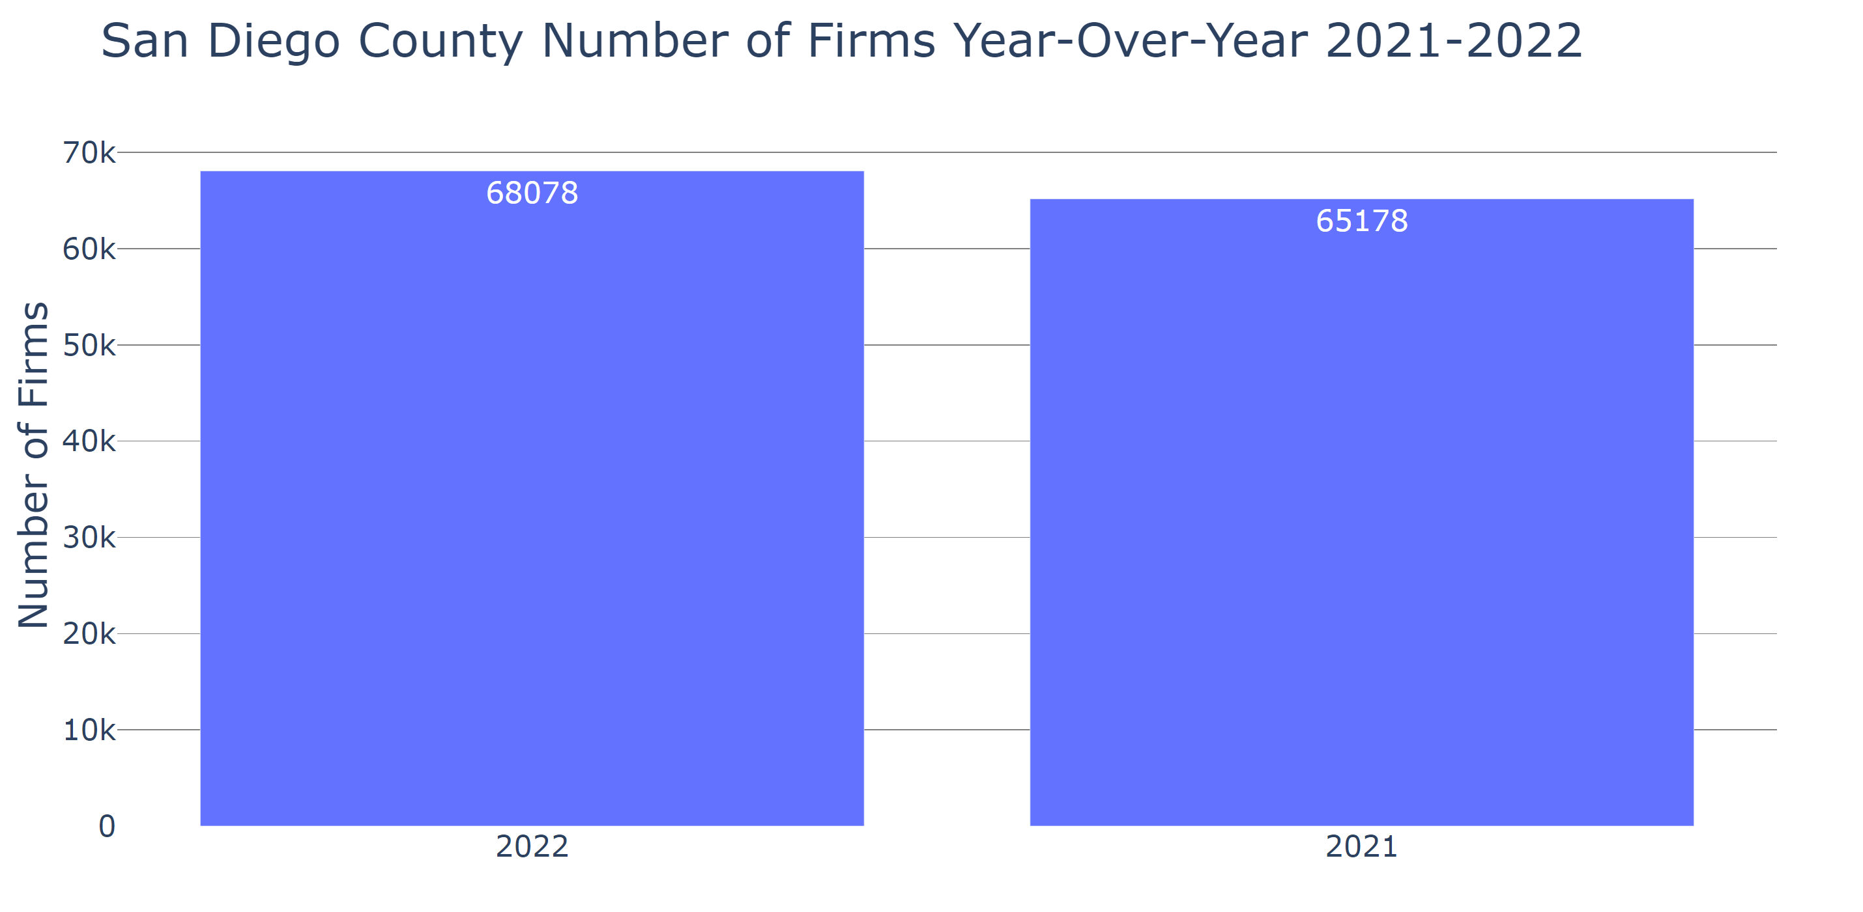

Source: US Census Bureau, 2022 Business Dynamics Statistics Nov 2024

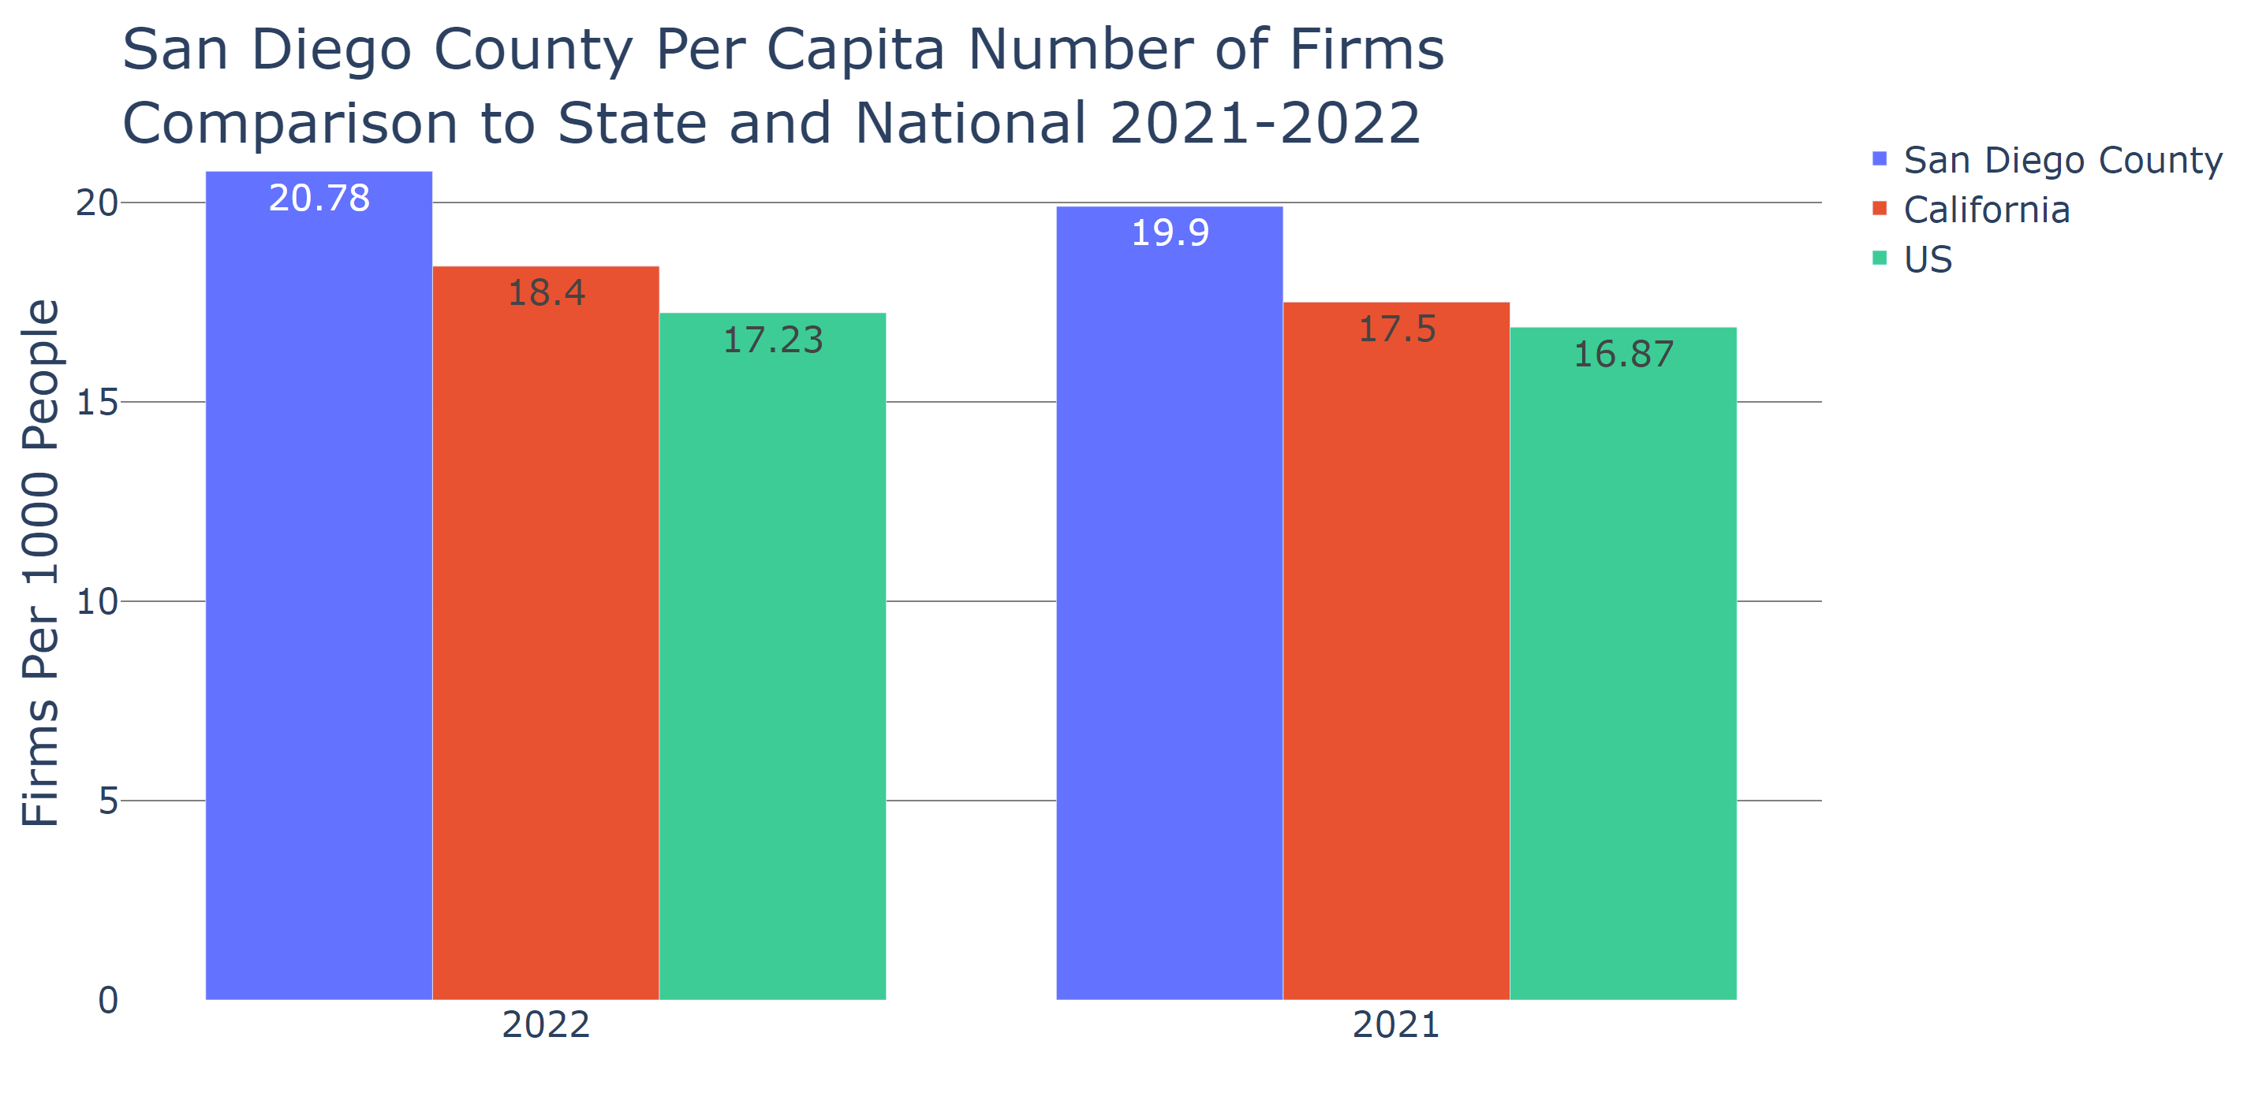

Source: US Census Bureau, 2022 Business Dynamics Statistics Nov 2024

## Section 7: Industry Clusters

San Diego County's transportation and warehousing industry has grown significantly from 2019 to 2023, with a 19.8% increase in jobs. Despite this growth, the location quotient remains stable at 0.5, suggesting the industry is not regionally concentrated relative to the national average. This expansion reflects both a strategic response to the county's logistic needs and the influence of its geographic positioning near the U.S.-Mexico border, emphasizing opportunities in regional trade and transportation efficiencies. This data is crucial for policymakers who aim to support infrastructure development, potentially enhancing cross-border trade and employment in logistics.

The arts, entertainment, and recreation sector experienced a 5.6% decline in employment over the same period, accompanied by a minor dip in the location quotient from 1.2 to 1.1. This downturn can be attributed in part to disruptions from the pandemic, which impacted venues and events that are pivotal to San Diego’s cultural identity and tourism-dependent economy. For local leaders, revitalizing this sector is vital for bolstering economic diversification and tourism. Future trends could include a rebound as health measures improve, supporting economic recovery in related businesses and downtown areas.

Government remains a stable employment sector in San Diego County, showing minimal change in job numbers and maintaining its location quotient at 1.3. As a significant regional employer, this constancy underscores its role in providing essential services amid budget expansions focused on public health and safety. A steady government sector impacts the local economy by ensuring continued public service delivery and potentially boosting economic stability during periods of broader economic fluctuation, with potential growth in public health careers and community safety initiatives.

For policymakers, these trends offer insights into targeted areas for development investments, particularly in enhancing transportation logistics, supporting arts growth post-pandemic, and ensuring robust government services. Equipping policymakers with these insights can aid in decision-making to retain and attract businesses, address workforce needs, and enhance housing strategies to support economic vitality and resilience in San Diego County.

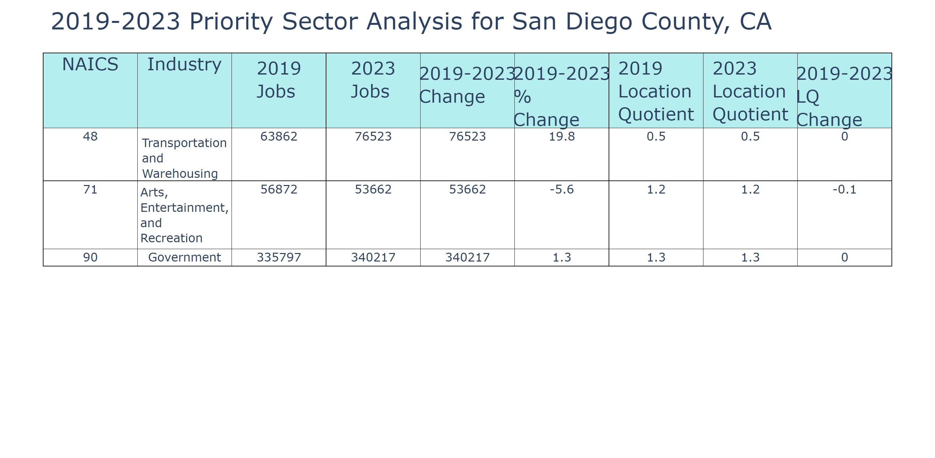

Lightcast Nov 2024

## Section 8: Industry Impact

### Mean Earnings

San Diego County's mean earnings per worker across various industries highlight its distinctive economic dynamics. For instance, in 2023, the earnings in San Diego's Health Care and Social Assistance sector reached about $74,923, showcasing one of the county's standout performance indicators. When compared to peer regions, such as Maricopa County, Arizona, and Wayne County, Michigan, San Diego generally mirrors or exceeds these areas in sectors like technology and healthcare, reflecting its advanced industry base and the presence of major institutions like UC San Diego. These industries are central to San Diego’s robust economic stature.

This data is crucial for local policymakers as it underscores the sectors where San Diego leads and where there is opportunity for strategic investment to stimulate further economic activity. Healthcare's earnings strength, for example, suggests it can be leveraged to enhance workforce development programs to drive inclusion and support economic resilience.

If current trends persist, San Diego may witness continued wage growth in tech and health-related fields, potentially intensifying the cost-of-living challenges and influencing the housing market demand. This could impact local businesses in terms of talent retention and necessitate an amplified focus on affordable housing solutions to maintain a balanced socioeconomic environment.

Public policymakers could use this earnings data to craft targeted economic policies that bolster high-performing sectors, thus enhancing job quality and growth. By integrating these insights with housing and social support initiatives, local leaders can ensure that San Diego's economic development remains inclusive and sustainable. Comparing peer statistics also helps to benchmark progress and identify potential areas for improvement or innovation.

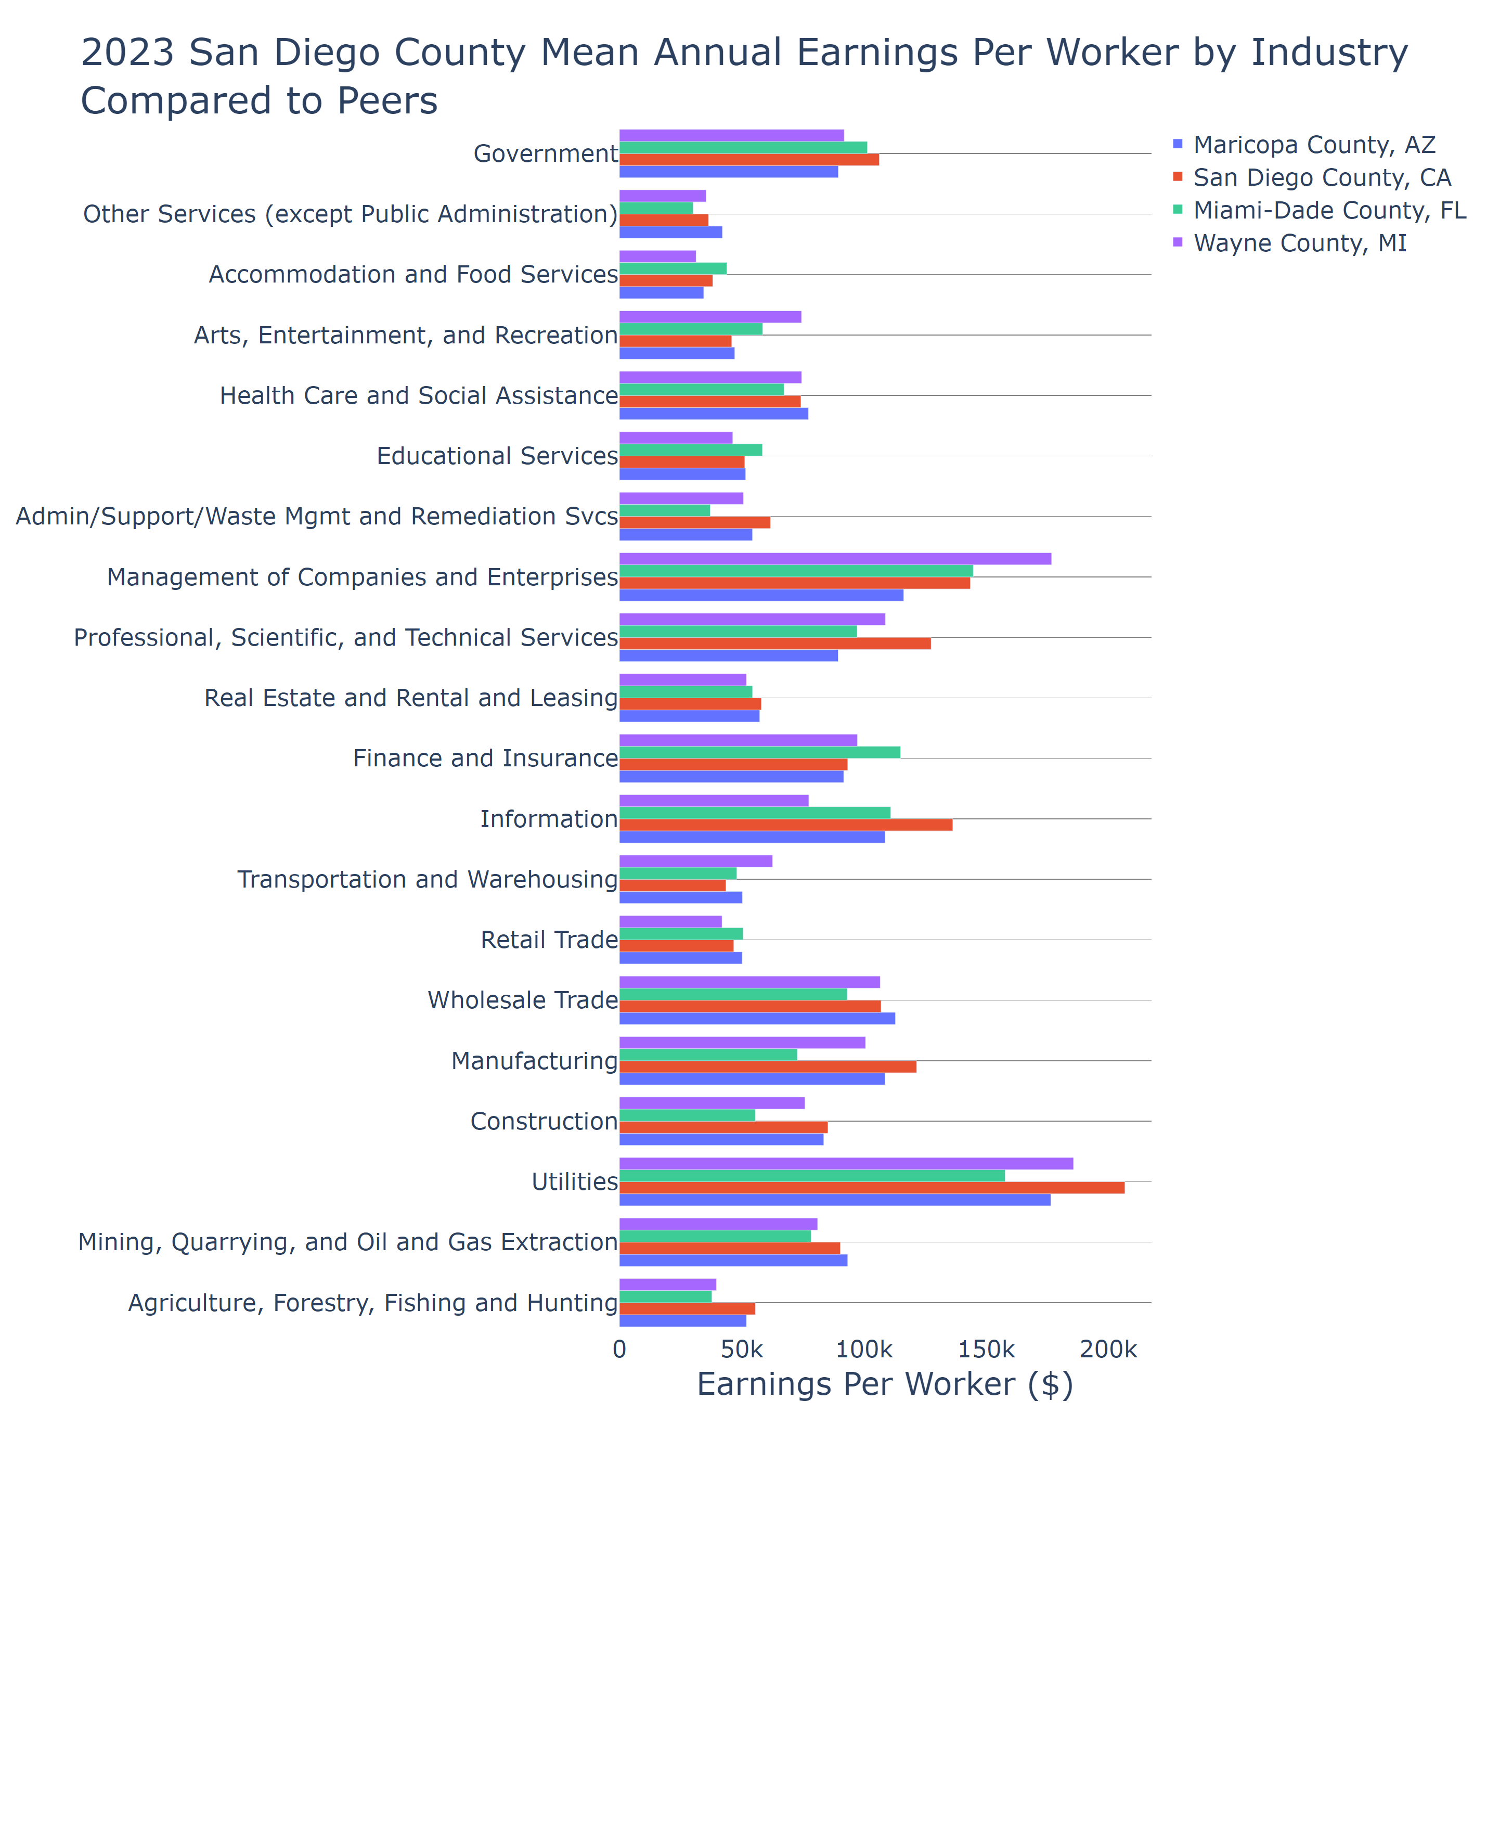

Lightcast Nov 2024

### Jobs

San Diego County's job landscape reveals some critical insights that align with its focus on healthcare, education, tourism, and a dynamic tech-driven economy. Compared to peers such as Wayne County, MI, and Maricopa County, AZ, San Diego's sectors reflect a strong emphasis on healthcare and education, which have been rapidly growing. In 2023, the health care and social assistance sector, with firms like UC San Diego and Scripps Health, has become a major employment generator. Further propelling the local economy is its tourism sector, substantially contributing to job numbers through hospitality and services.

This data highlights the importance for policymakers in focusing on these growing sectors to ensure robust economic development. Notably, the tech and innovation sectors, sometimes intertwined with educational institutions, point toward a promising future trajectory if current investments and policies continue. As industries like manufacturing face job losses, the expansion of the life sciences and healthcare sectors is crucial.

San Diego's approach to fostering a balanced economy can serve as a model, especially regarding educational and health services. By using this data, policymakers could implement strategies that enhance workforce development and address housing challenges, critical for retaining talent amid high living costs. Additionally, investments in technology and environmental sustainability could further cement San Diego's position as an economic frontrunner among its peers.

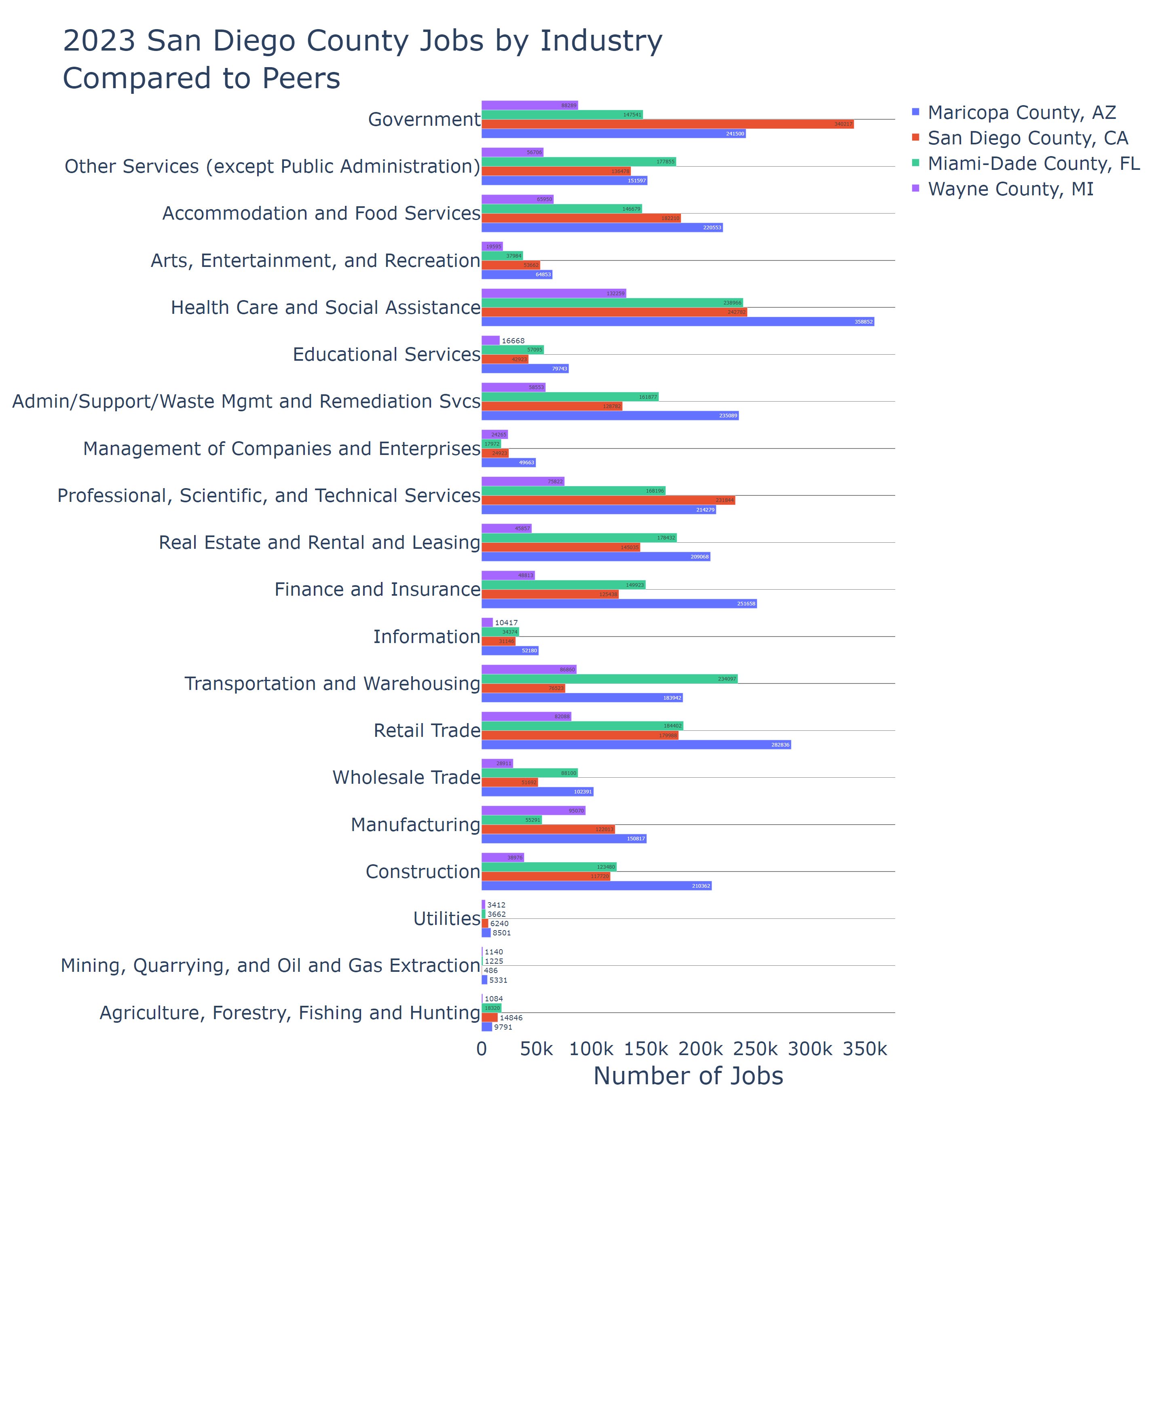

Lightcast Nov 2024