San Diego County's Gross Regional Product (GRP) Report

To generate the San Diego County's Gross Regional Product (GRP) report, we will analyze the provided data from the CSV files, focusing on the GRP data for San Diego County, California, and the United States from 2019 to 2023. The analysis will examine both the total GRP in dollars and the GRP per capita for each year.

San Diego County's total GRP has shown a consistent increase from 2019 to 2023, growing from approximately $244.28 billion in 2019 to $308.71 billion in 2023. This robust economic performance is further reflected in the GRP per capita, which rose from $73,346.92 in 2019 to $94,915.87 in 2023. This significant increase suggests that the economic output per person in San Diego County has improved, indicating a rise in productivity and economic prosperity.

Despite a slight decrease in the population of San Diego County from 3,330,458 in 2019 to 3,252,468 in 2023, the GRP per capita continued to increase. This trend indicates that the economic growth outpaced the population decline, further emphasizing the county's resilient and expanding economy.

In conclusion, San Diego County has experienced robust economic growth over the past five years, as evidenced by the increase in both total GRP and GRP per capita. This growth suggests a resilient and expanding economy, with improvements in productivity and economic output per resident. The data reflects a positive economic trajectory for the county, even amidst population changes. This analysis provides a comprehensive overview of the economic performance of San Diego County, highlighting its strengths and areas of growth.

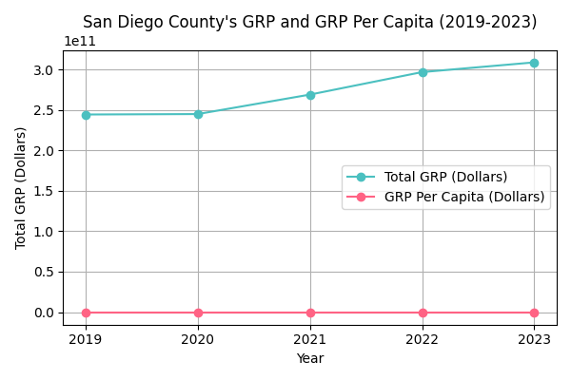

San Diego County's GRP and GRP Per Capita (2019-2023)

|  |  |  |  |
| --- | --- | --- | --- |
| Year | Total GRP (Dollars) | GRP Per Capita (Dollars) |  |
| 2019 | 244,278,846,457.50 | 73,346.92 |  |
| 2020 | 244,822,303,264.04 | 74,277.60 |  |
| 2021 | 268,873,550,391.04 | 82,099.95 |  |
| 2022 | 296,683,894,891.99 | 90,557.10 |  |
| 2023 | 308,710,843,090.86 | 94,915.87 |  |

San Diego County's GRP and GRP Per Capita (2019-2023)