San Diego County Economic Report: Unemployment and Job Market Trends

The unemployment rate in San Diego County has experienced notable fluctuations throughout 2023 and 2024. Starting in October 2023, the rate was at 4.17%, gradually increasing to a peak of 5.05% in August 2024 before slightly decreasing to 4.55% in September 2024. This trend indicates a dynamic labor market with varying employment conditions over the months. When compared to peer counties in September 2024, San Diego's unemployment rate of 4.55% was higher than Maricopa County, AZ, at 3.36% and Miami-Dade County, FL, at 2.05%, but lower than Wayne County, MI, which stood at 5.18%. This comparison highlights San Diego's moderate position in terms of unemployment relative to these regions.

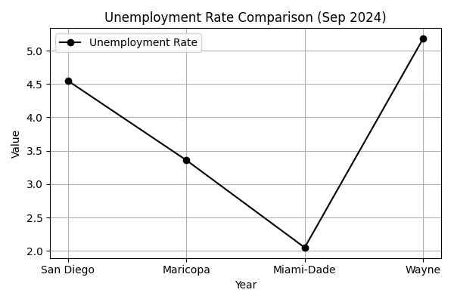

Unemployment Rate Comparison (September 2024)

|  |  |  |  |
| --- | --- | --- | --- |
|  | County | Unemployment Rate (Sep 2024) |  |
|  | ------------------------- | ------------------------------ |  |
|  | San Diego County, CA | 4.55% |  |
|  | Maricopa County, AZ | 3.36% |  |
|  | Miami-Dade County, FL | 2.05% |  |
|  | Wayne County, MI | 5.18% |  |

Unemployment Rates in Peer Counties (September 2024)

In addition to unemployment trends, the job market in San Diego County has shown a decrease in job postings across various industries from 2023 to 2024. The Health Care and Social Assistance sector, despite having the highest number of job postings at 52,862, experienced a significant decline of 24.16%. Similarly, the Admin/Support/Waste Management and Remediation Services sector saw a 34.86% decrease, marking the largest drop among the major industries. Other sectors such as Professional, Scientific, and Technical Services, Manufacturing, and Retail Trade also faced reductions in job postings, indicating a potential slowdown in hiring activities. This overall decline suggests economic challenges or shifts in the labor market that may require strategic workforce development and planning.

San Diego County's economic landscape in 2023 and 2024 reflects a moderate unemployment rate compared to its peers, with some fluctuations observed throughout the year. The job market, however, shows a concerning trend of declining job postings across key industries, which could signal underlying economic challenges. Continuous monitoring and analysis of these trends are crucial for understanding the county's economic health and for informing future workforce development strategies. By addressing these challenges proactively, San Diego can better position itself to adapt to changing economic conditions and support its labor market effectively.