San Diego County Gross Regional Product Analysis (2019-2023)

The Gross Regional Product (GRP) of San Diego County offers a comprehensive view of the region's economic performance over the past five years. In 2019, the GRP stood at approximately $244.28 billion, and by 2023, it had risen to about $308.71 billion. This growth of approximately 26.4% over the five-year period highlights the region's robust economic expansion. The annual GRP figures reveal a steady increase, with $244.82 billion in 2020, $268.87 billion in 2021, $296.68 billion in 2022, and reaching $308.71 billion in 2023. This upward trend underscores the county's resilience and adaptability in the face of economic challenges.

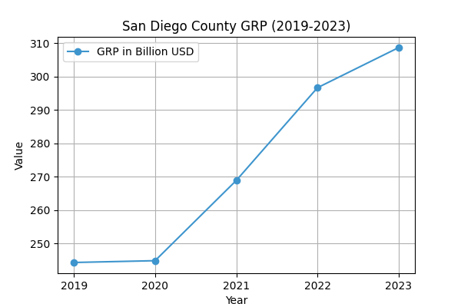

San Diego County GRP from 2019 to 2023

The per capita GRP also saw a significant rise, moving from approximately $73,347 in 2019 to about $94,916 in 2023. This increase indicates a notable enhancement in economic productivity per individual within the region. The growth in per capita GRP reflects the county's ability to generate more economic value per resident, contributing to overall prosperity.

In 2023, several key industries played pivotal roles in driving the GRP. The Government sector emerged as the largest contributor, with an output of $52.92 billion. Following closely were the Professional, Scientific, and Technical Services sector at $37.04 billion, and the Manufacturing sector at $31.67 billion. The Health Care and Social Assistance sector contributed $20.21 billion, while the Finance and Insurance sector added $19.50 billion. These figures highlight the diverse economic base of San Diego County, with significant contributions from both public and private sectors.

|  |  |  |  |
| --- | --- | --- | --- |
|  | Industry | Contribution in Billion USD |  |
|  | --------------------------------------- | ----------------------------- |  |
|  | Government | 52.92 |  |
|  | Professional, Scientific, and Technical Services | 37.04 |  |
|  | Manufacturing | 31.67 |  |
|  | Health Care and Social Assistance | 20.21 |  |
|  | Finance and Insurance | 19.50 |  |

Industry Contributions to San Diego County GRP in 2023

The trends observed over the five-year period reveal that the Government sector consistently remained the largest contributor to the GRP. The Professional, Scientific, and Technical Services sector demonstrated robust growth, underscoring the region's focus on innovation and technology. Similarly, the Manufacturing sector's growth indicates a strong industrial base, while the Health Care and Social Assistance sector's expansion reflects the increasing demand for health services. When compared to state and national averages, San Diego County's per capita GRP in 2023 was higher than both, with $94,916 compared to California's average of $93,800 and the national average of $77,366. This suggests that San Diego County is economically more productive on a per-person basis, reinforcing its status as a vital economic hub in California.