# Report

The economic landscape of San Diego County from 2019 to 2023 reveals a robust trajectory of growth, as evidenced by the consistent rise in the Gross Regional Product (GRP). In 2019, the county's GRP stood at $244.28 billion, with a population of 3,330,458, resulting in a GRP per capita of $73,346.92. The following year, despite the global challenges posed by the COVID-19 pandemic, San Diego County's economy demonstrated resilience. The GRP slightly increased to $244.82 billion, while the population decreased to 3,296,045, leading to a higher GRP per capita of $74,277.60. This suggests that the economic output per individual improved even amidst adversity.  
  
The year 2021 marked a significant rebound for the region's economy. The GRP surged to $268.87 billion, with the population slightly declining to 3,274,954. Consequently, the GRP per capita rose to $82,099.95, reflecting a strong recovery from the pandemic's economic impact. This upward trend continued into 2022, with the GRP reaching $296.68 billion and the population stabilizing at 3,276,208. The GRP per capita further increased to $90,557.10, indicating enhanced economic performance and possibly a shift towards higher value-added activities.  
  
In 2023, San Diego County's GRP achieved its highest point at $308.71 billion, while the population slightly decreased to 3,252,468. The GRP per capita climbed to $94,915.87, suggesting improved economic conditions and efficiency, possibly driven by investments in high-value sectors. Overall, the data from 2019 to 2023 underscores the county's economic resilience and growth, with the GRP and GRP per capita consistently rising, outpacing population growth and indicating productivity improvements.

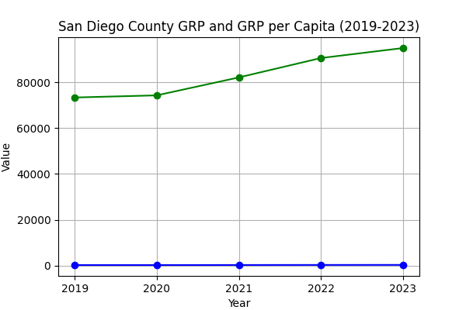

|  |  |  |  |
| --- | --- | --- | --- |
| Year | Total GRP (billion) | Population | GRP per Capita |
| 2019 | 244.28 | 3,330,458 | 73,346.92 |
| 2020 | 244.82 | 3,296,045 | 74,277.60 |
| 2021 | 268.87 | 3,274,954 | 82,099.95 |
| 2022 | 296.68 | 3,276,208 | 90,557.10 |
| 2023 | 308.71 | 3,252,468 | 94,915.87 |