San Diego County Economic Trends from 2019 to 2023

San Diego County's Gross Regional Product (GRP) has exhibited a consistent upward trend from 2019 to 2023, reflecting a robust economic recovery. In 2019, the total GRP was approximately $2,988.9 billion, but it dipped slightly to $2,961.2 billion in 2020, likely due to the economic impact of the COVID-19 pandemic. The following years saw a strong rebound, with GRP increasing to $3,310.9 billion in 2021, $3,537.4 billion in 2022, and reaching $3,650.09 billion in 2023, indicating a resilient and growing economy.  
  
Per capita GRP also showed a positive trajectory, increasing from $75,788.64 in 2019 to $93,799.67 in 2023. This growth suggests that the economic benefits are being distributed across the population, reflecting a strong economic performance relative to population growth.  
  
The government sector has been the largest contributor to GRP, with significant increases each year. In 2019, it contributed $331.8 billion, rising to $390.1 billion in 2023. This steady growth indicates that public spending and services are a significant driver of the local economy. The finance and insurance sector also showed strong growth, contributing $195.1 billion in 2019 and $245.0 billion in 2023, reflecting a robust financial services industry in San Diego County.  
  
Health care and social assistance have grown steadily, with contributions increasing from $206.2 billion in 2019 to $249.3 billion in 2023. This growth aligns with the increasing demand for health services and the aging population. The professional, scientific, and technical services sector has also seen significant growth, rising from $286.9 billion in 2019 to $347.2 billion in 2023, highlighting the importance of tech and professional services in the county's economy.  
  
Manufacturing has shown substantial growth, despite some fluctuations. Contributions increased from $320.9 billion in 2019 to $380.2 billion in 2023, suggesting a resilient industrial base. Retail trade has also seen strong growth, indicating a recovering consumer market. Contributions rose from $143.4 billion in 2019 to $198.0 billion in 2023, which is crucial for economic health.  
  
Transportation and warehousing have shown consistent growth, reflecting increased economic activity and possibly improved logistics and supply chain management. Contributions increased from $86.6 billion in 2019 to $119.9 billion in 2023. The accommodation and food services sector has recovered significantly post-pandemic, with contributions rising from $90.8 billion in 2019 to $111.6 billion in 2023, showing resilience and a strong rebound in consumer spending on leisure and hospitality.  
  
Overall, San Diego County's economy appears to be on a solid growth trajectory, with key drivers in public services, financial services, health care, and tech. These trends suggest a diverse and resilient economy, with implications for continued investment and job creation in these sectors.

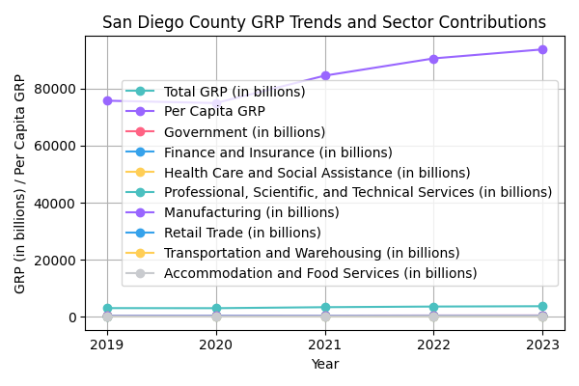

San Diego County GRP Trends and Sector Contributions

|  |  |  |  |  |  |  |  |  |  |  |
| --- | --- | --- | --- | --- | --- | --- | --- | --- | --- | --- |
| Year | Total GRP (in billions) | Per Capita GRP | Government (in billions) | Finance and Insurance (in billions) | Health Care and Social Assistance (in billions) | Professional, Scientific, and Technical Services (in billions) | Manufacturing (in billions) | Retail Trade (in billions) | Transportation and Warehousing (in billions) | Accommodation and Food Services (in billions) |
| 2019 | 2,988.92 | 75,788.64 | 331.84 | 195.12 | 206.21 | 286.91 | 320.92 | 143.41 | 86.63 | 90.83 |
| 2020 | 2,961.22 | 74,964.48 | 343.21 | 218.74 | 211.60 | 293.80 | 310.81 | 144.30 | 73.38 | 71.78 |
| 2021 | 3,310.97 | 84,586.57 | 355.83 | 250.04 | 227.31 | 328.10 | 350.32 | 166.93 | 90.51 | 95.73 |
| 2022 | 3,537.47 | 90,636.25 | 368.31 | 249.62 | 249.61 | 347.38 | 384.71 | 180.38 | 119.97 | 114.00 |
| 2023 | 3,650.09 | 93,799.67 | 390.10 | 245.03 | 249.35 | 347.16 | 380.16 | 198.04 | 119.97 | 111.65 |

San Diego County GRP and Sector Contributions by Year