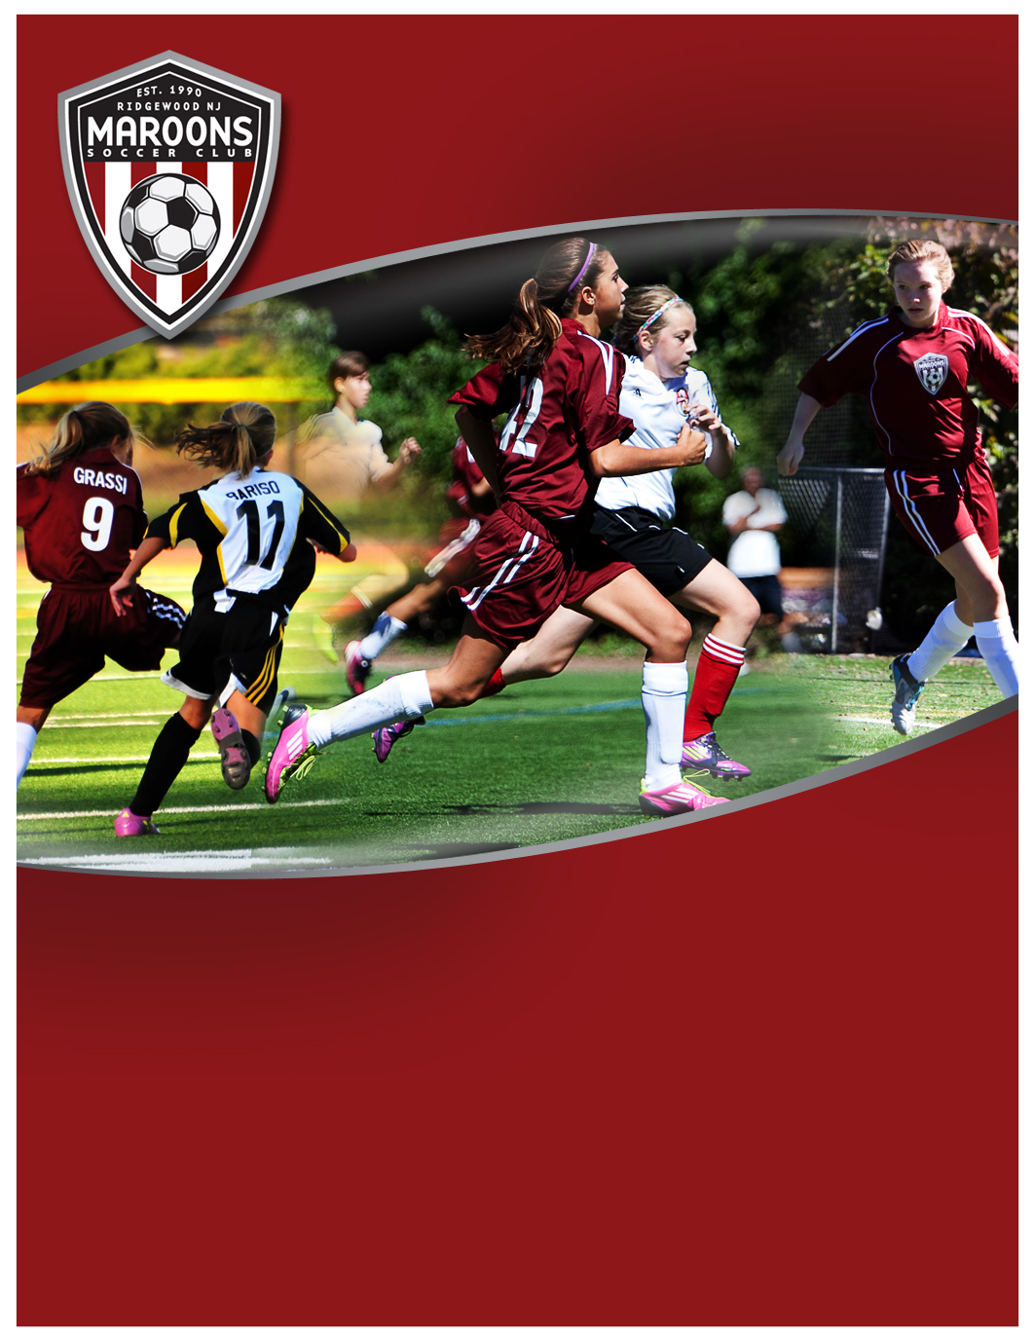­

Sign-up at www.MaroonsSoccer.com

See back for more details

**Program Participants:**

Players U15 to U19, freshmen to seniors in high school 2012-13

**Learning Objective:**

Advance the technical and small-space tactical abilities, understanding, and speed of play for the high school player.

**Program Overview:**

December 2012 through February 2013

10 Week Program held at ETA, 1 Tice Road, Franklin Lakes, NJ.

**Girls High School Winter Development Program**

COST: $220



**Developing intelligent, skilled & confident soccer players  
who play the beautiful game, beautifully.**

**www.MaroonsSoccer.com**

**Girls High School**

**Winter Development Program**

**Learning Agenda:**

* Strengthen technical proficiency for improvements with 1st touch
* Accelerate abilities for 1-2 touch play, tight space ball skills, and ability to maintain   
  individual and team possession
* Creativity, skill, and confidence in 1v1, 1v2, 2v1, and 2v2
* Improvements in speed of play
* Tactical decision making in small-sided games format
* Improved game intelligence & decision making, ability to read visual cues
* Improved positioning and anticipation

**Program Details:**

10 Week Program held at ETA, indoor turf facility, 1 Tice Road, Franklin Lakes, NJ.

Girls, Saturdays 11am - Noon; Dec 8, 15, January 5, 12, 19, 26, Feb 2, 9, 16, 23

**Class size is limited.**

High School Winter Development Program will benefit players in advance of the Maroons Soccer Club Spring Season U16 and/or U19 Tryouts (to be scheduled in November following high school season).

**Program Instructor:**

Program is run by Maroons Soccer Club Academy coach Aidan McCluskey.

McCluskey leverages his keen insights to the game he gathered by playing at the highest level with the proven coaching techniques from the NSCAA Advanced National Diploma, geared toward improving and advancing the technical and tactical abilities of the competitive high school and college level player.

**Program Cost: $220**

**To Sign-Up:**

Go to [Community Pass](https://register.communitypass.net/reg/login.cfm?8%3CN%21%29%21%5EN%28G%3C%29HJ7RZ6%5C%25QC%3A%271OT%40%3F0%2D%3DD%0A), from organization select “***Maroons Soccer Club”***;

Then from activity select ***“MSC HS Soccer Winter Program 2012-13***”, and complete registration.

For more information, visit [www.MaroonsSoccer.com](http://www.MaroonsSoccer.com), or contact:

Coach Aidan McCluskey

[McDubs@aol.com](mailto:McDubs@aol.com)

Cell: 551-804-1479