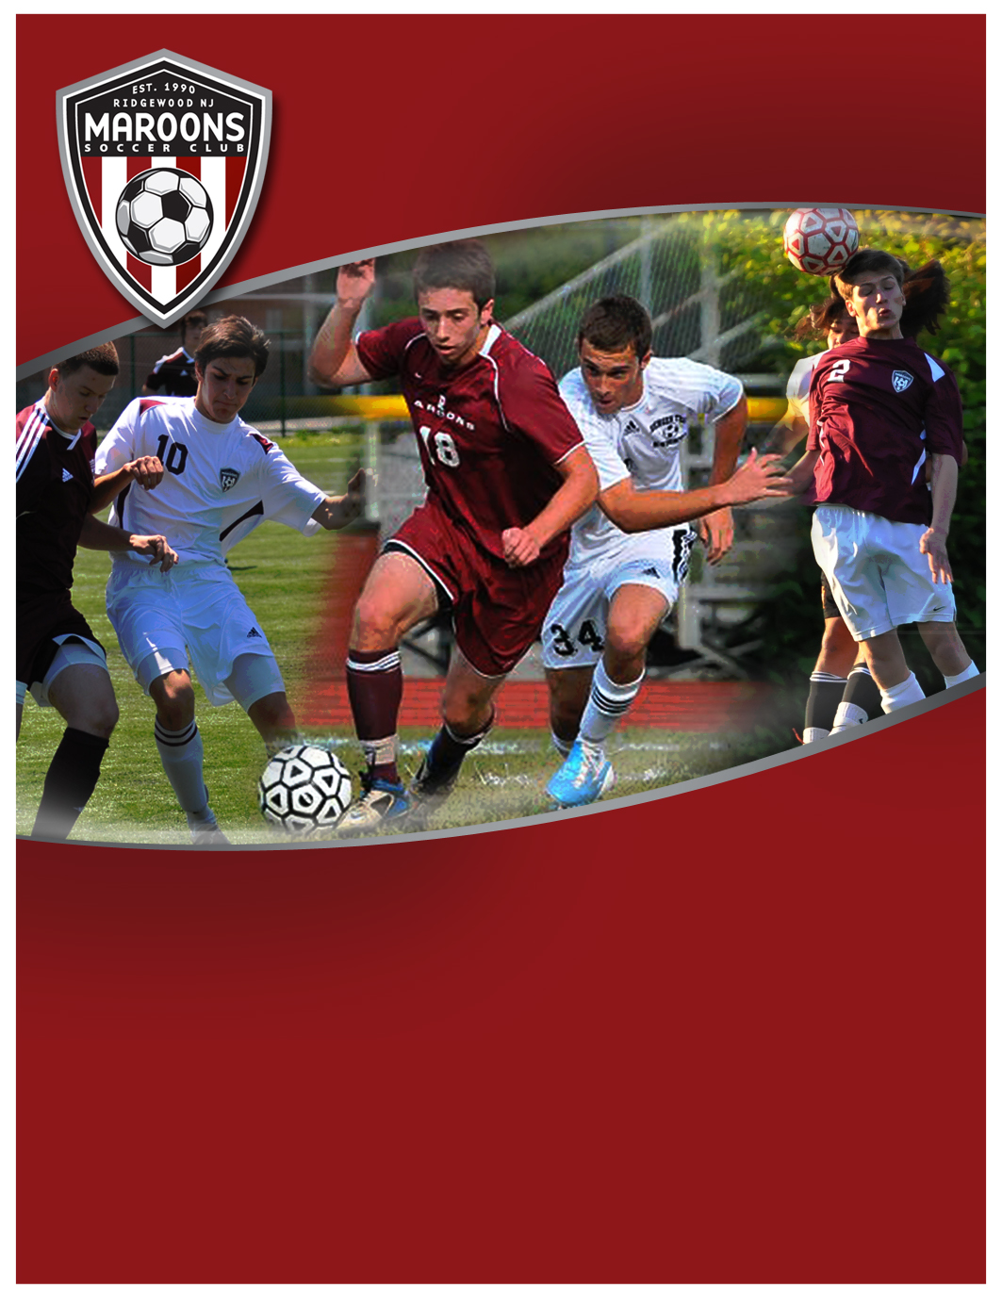­

Team Cost: $750 All Inclusive winter & spring

COST: $550

**Boys U15 Winter-Spring 2013**

**Tryouts 2 Dec., 11a-1p, Maple Turf**

**Team Participants:**

Competitive U15 players who demonstrate a high technical and tactical ability in the game. Players must turn 15 after August 1, 2013.

**Team Overview:**

A high level team focused on “A Flight” competition in Northern Counties; and, spring US Club State Cup.

Program includes spring league, US Club State Cup, a minimum of 1 day/week winter training December through mid-March, minimum of 2x week training mid-Feb through mid-June. Training held in Ridgewood and/or Glen Rock.

Season runs early March through mid-June 2013; HS Winter Development Program supplements this team.

Sign-up at www.MaroonsSoccer.com

See back for more details



**Boys U15 Winter-Spring 2013**

**Tryouts 2 Dec, 11a-1p Maple Turf**

**Tryout Details:**

Tryouts will be held on 2 December, 11a-1p at Maple Turf, located at corner of

Northern Parkway and Meadowbrook, just north of Graydon pool in Ridgewood. Players must

pre-register for tryouts through Community Pass, see details below.

**Team Details:**

Maroons Soccer Club is seeking players for a talented U15 Boys team. Players should be capable of developing their technical and tactical abilities to play highly competitive soccer. The core of the team is being formed by combining the top teams from Maroons Soccer Club and Glen Rock Shooting Stars. Players must demonstrate a high technical foundation and an ability to play high-touch, intelligent, possession-style soccer.

This team is focused on “A Flight” competition in Northern Counties in the spring, with games primarily on Sundays. Additionally, team will compete in the US Club State Cup.

Training plans include a 10 week winter development program on Tuesdays 5:30-6:30, Dec to mid-March at ETA, 1 Tice Road, Franklin Lakes, NJ, about 20 minutes from Ridgewood. Additional outdoor winter training will be added as weather and field conditions permit. Spring training will be 7:30-9 p.m. a minimum of 2x week and based in Ridgewood and/or Glen Rock.

This will be a high level team and players are expected to make the dedication necessary.

**Team Structure:**

This Team will be managed by Doug Milbrodt, former coach of Glen Rock Shooting Stars Boys U14 team, and coached & trained by Mike Cobb, Maroons Soccer Club Director of Player Development & Coaching.

Coach Cobb leverages his own playing experience with the proven coaching techniques from the NSCAA Advanced National Diploma and USSF National D License, geared toward improving and advancing the technical and tactical abilities of the competitive high school and college level player.

**Team Cost: $750 All Inclusive**

Cost is fully inclusive, including ETA winter space, training, league, US Club State Cup, referees,

insurance, uniform, training shirt, and Club fees

**To Register for Tryouts:**

Go to [Community Pass](https://register.communitypass.net/reg/login.cfm?8%3CN%21%29%21%5EN%28G%3C%29HJ7RZ6%5C%25QC%3A%271OT%40%3F0%2D%3DD%0A), from organization select “***Maroons Soccer Club”***;

Then from activity select ***“MSC HS Soccer Spring 2013***”, and complete registration.

For more information, visit www.MaroonsSoccer.com, or contact Mike Cobb:

[MichaelCobb@optonline.net](mailto:MichaelCobb@optonline.net)

Cell 201-8157180

**Developing intelligent, skilled & confident soccer players  
who play the beautiful game, beautifully.**

**www.MaroonsSoccer.com**