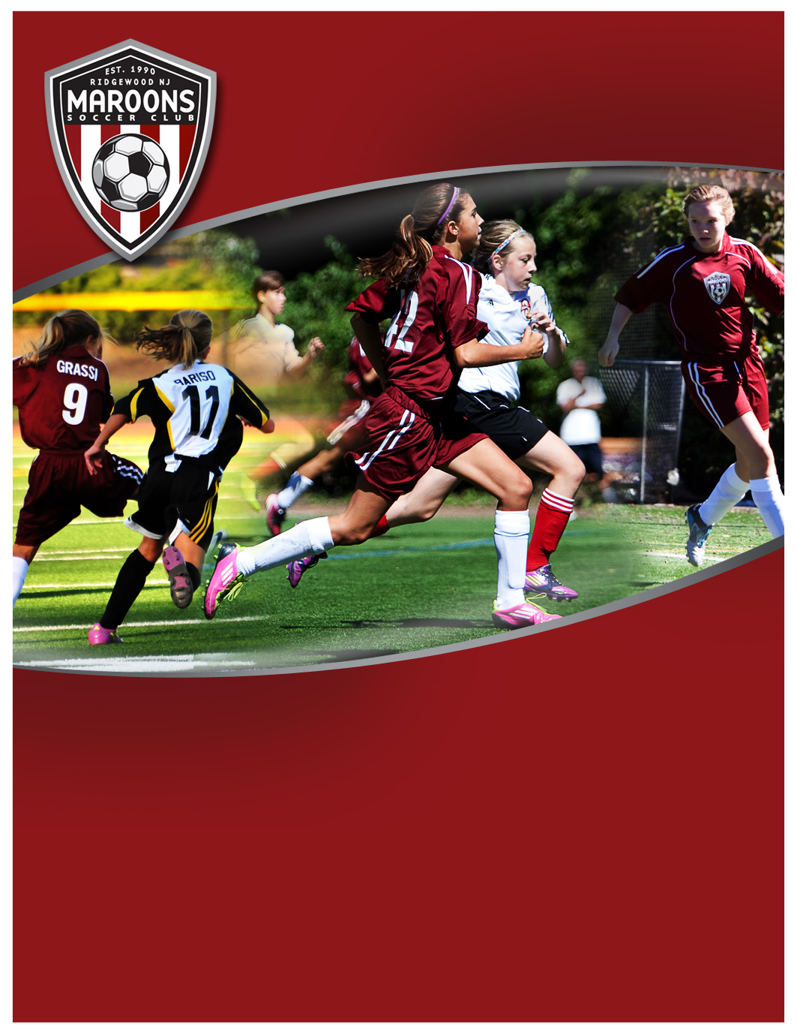­

**Girls U19 Spring 2013**

**Initial Session 26 Nov., 7-9 p.m., Maple Turf**

**Team Participants:**

Players U15 to U19, freshmen to seniors in high school 2012-13

**Team Overview:**

U19 Girls development team focused on accelerating each player’s ability to play high-touch, intelligent, possession-style soccer. This team is similar to a Varsity team, featuring a mix of players across age groups. Team expects to play in a competitive “B Flight” in the Northern Counties League. Games are primarily on Sundays and there will be a minimum of 2 training sessions each week.

Season runs early March through mid-June 2013; Girls HS Winter Development Program supplements this team and is recommended.

Team Cost: $550, All Inclusive

COST: $550

Sign-up at www.MaroonsSoccer.com

See back for more details



**Girls U19 Spring 2013**

**Initial Session 26 Nov, 7-9 p.m., Maple Turf, Pre-Register**

**Tryout Details:**

An initial session will be held on Monday, 26 November, 7-9 p.m. at Maple Turf, located at corner

of Northern Parkway and Meadowbrook, just north of Graydon pool in Ridgewood. Players must

pre-register through Community Pass, see below. This session will assess players and interest.

**Team Details:**

Maroons Soccer Club is seeking players for our U19 Girls team. This is a development program focused on advancing each player’s technical and tactical abilities. Key focus will be developing each player’s ability to play high-touch, intelligent, possession-style soccer.

This team will compete at U19 level and will be structured similar to a high school varsity team, featuring players across age groups, from U15 through U19, freshmen to seniors. Team will play Northern Counties League and is expecting to play “B Flight” depending on team ability; Games primarily on Sundays. Training will be a minimum of 2x a week in Ridgewood.

Roster size will be 18 players given the occasional conflicts natural to high school.  If more than 18 players sign-up, the better players will be selected. If selected, you are expected to make every effort to attend each training session and game.  It is understood that there might be a few conflicts along the way.  Participation is especially important so the team can train and play games to quickly solidify the team, build cohesiveness and team understanding, and be prepared for March league play.

This team will have outdoor training sessions as weather and field conditions permit throughout the winter. Players are also encouraged to join the Saturday Maroons Soccer Club Girls High School Winter Development program (extra cost), which runs at ETA from December thru mid-March, see web.

**Team Management:**

Team is managed by Maroons Soccer Club Academy Coach, Aidan McCluskey, who will train and bring in other high level coaches with expertise with the high school player to teach the curriculum for this group. Each Coach involved with the team will leverage personal playing experience with the proven coaching techniques from the NSCAA Coaching Diplomas, geared toward improving and advancing the technical and tactical abilities of the competitive high school and college level player.

**Team Cost: $550 All Inclusive**

Cost is fully inclusive, including training, league, referees, insurance, uniform, training shirt, and Club fees

**To Register for the Initial Session & Team:**

Go to [Community Pass](https://register.communitypass.net/reg/login.cfm?8%3CN%21%29%21%5EN%28G%3C%29HJ7RZ6%5C%25QC%3A%271OT%40%3F0%2D%3DD%0A), from organization select “***Maroons Soccer Club”***;

Then from activity select ***“MSC HS Soccer Spring 2013***”, and complete registration.

For more information, visit www.MaroonsSoccer.com, or contact Aidan McCluskey:

[McDubs@aol.com](mailto:McDubs@aol.com)

Cell 551-804-1479

**Developing intelligent, skilled & confident soccer players  
who play the beautiful game, beautifully.**

**www.MaroonsSoccer.com**