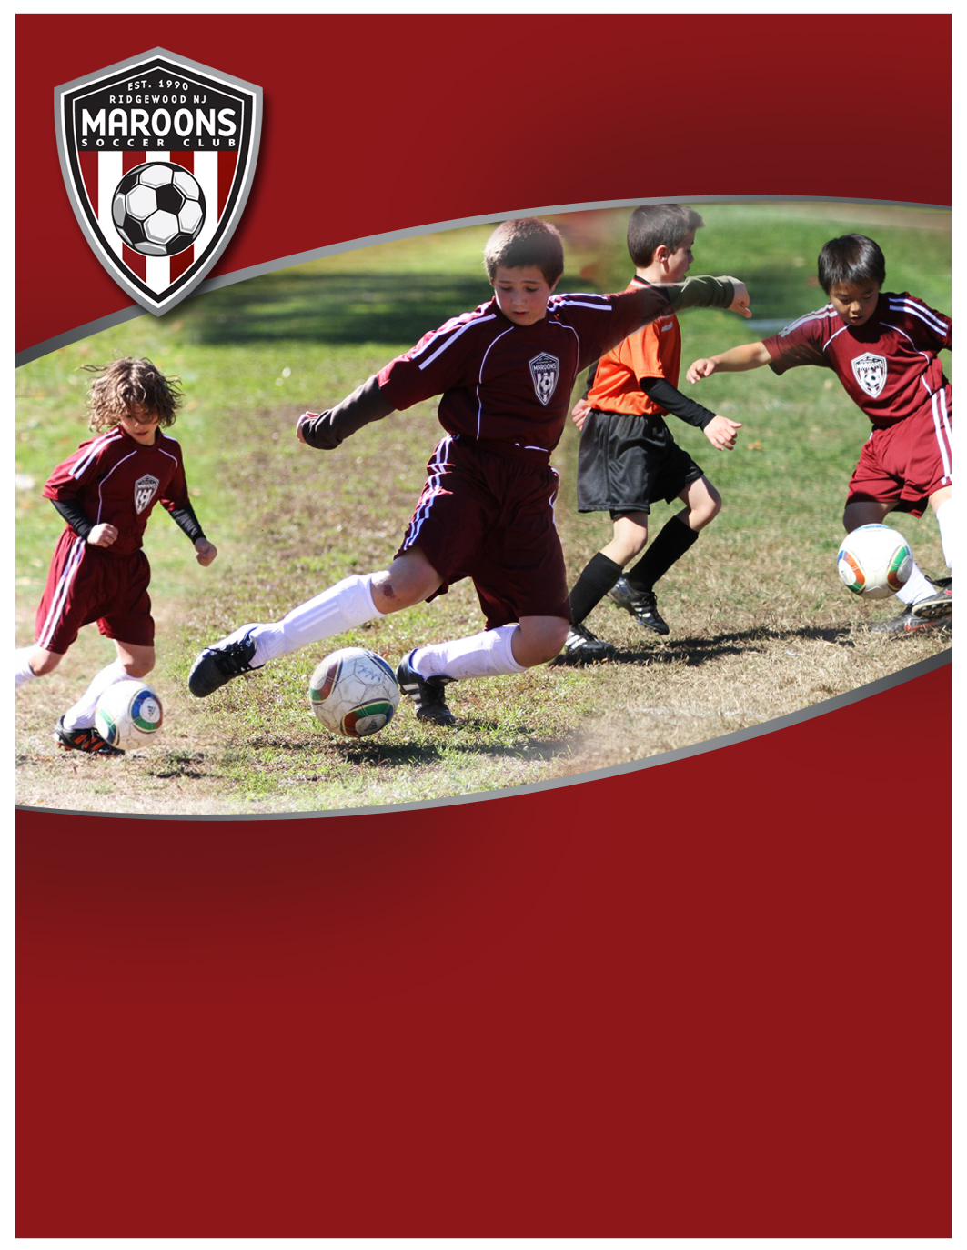­

**Program Participants:**

Players looking to improve their comfort and confidence with a ball. Players will be grouped by appropriate ages based on registrations.

**Learning Objective:**

Enhance player confidence, comfort, and ability to manipulate a ball using a broad spectrum of skills.

**Program Overview:**

8-week program run January-February 2013 held on turf at F.O.R.C.E, 22 Hollywood Ave, Ho-Ho-Kus, NJ.

COST: $85

Sign-up at www.MaroonsSoccer.com

See back for more details

**Ball Manipulation to Mastery**

**Players develop individual technical abilities with the ball as they progress from manipulation to mastery**



**Program Description:**

Ball-focused course with high individual ball manipulation where players learn the technical aspects of dribbling and touch, skill moves, ball manipulation with all portions of both feet, and tight space maneuvers. Repetitive 1v1 situations increase ability to execute skills in game situations.

Some of the best players in the world are true BALL MASTERS, including Mesi, Xavi, Mata, Cazorla. This course provides “Deep Practice” for the individual with ball. Players will have heavy repetition of various skills performed with both feet.

Objective is to develop talented players who are comfortable holding a ball under pressure and in tight spaces, capable to manipulate the ball away from pressure, and consistently create attacking opportunities. Players will develop a more instinctive play, improvising, creating magic, and constantly running at defenders in the final third.

**Program Details:**

8-Week Program held on Saturdays at F.O.R.C.E., indoor turf, 22 Hollywood Ave, Ho-Ho-Kus, NJ. Classes held on January 5, 12, 19, 26, February 2, 9, 23, March 2, 9 (No session 16 Feb for School break). Nine sessions are offered and players can attend any 8, providing flexibility for their schedule.

Each class will be 1-hour and held on Saturdays between noon-3p. The specific 1-hour time slot between noon and 3 p.m. will be confirmed based on registrations and structuring each age group.

**Come experience the magic of Ball Manipulation to Mastery. A FREE introductory class will be held on December 22. To reserve your spot, email** [**CarolynMuccio1@yahoo.com**](mailto:CarolynMuccio1@yahoo.com)**.**

**Each class limited to 12 participants.**

**Program Instructors:**

Program is run by Maroons Soccer Club Academy Trainers Mike Cobb, Amy McCambridge, Aidan McClusky, Rocco Orlando

**Program Cost: $85**

**To Sign-Up:**

Go to [Community Pass](https://register.communitypass.net/reg/login.cfm?8%3CN%21%29%21%5EN%28G%3C%29HJ7RZ6%5C%25QC%3A%271OT%40%3F0%2D%3DD%0A), from organization select “***Maroons Soccer Club”***;

Then from activity select ***“MSC Ball Manipulation to Mastery***”, and complete registration.

For more information, visit www.MaroonsSoccer.com, or contact:

[CarolynMuccio1@yahoo.com](mailto:CarolynMuccio1@yahoo.com), 201-280-1494

**Ball Manipulation to Mastery**

**Players develop individual technical abilities with the ball**

**as they progress from manipulation to mastery**

**Developing intelligent, skilled & confident soccer players  
who play the beautiful game, beautifully.**

**www.MaroonsSoccer.com**