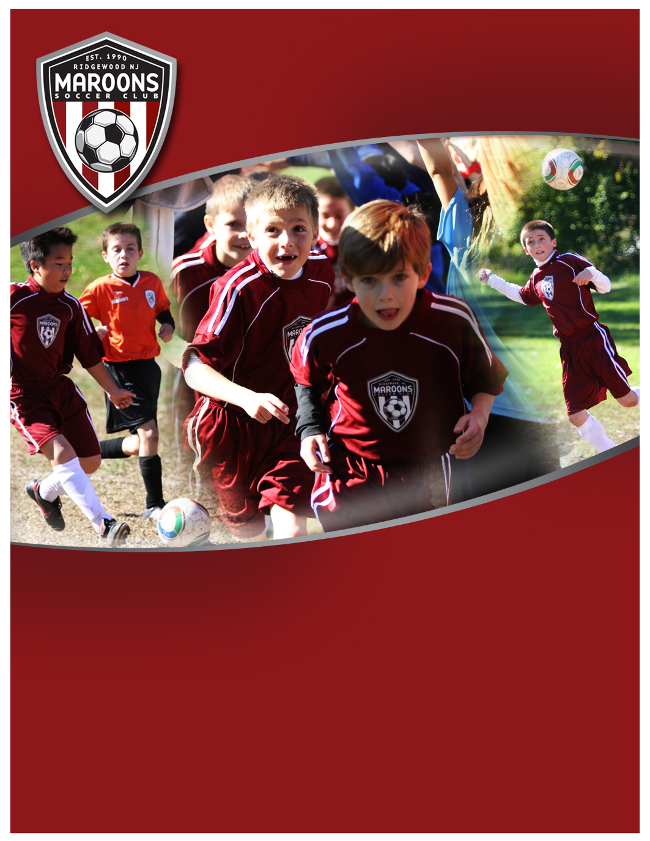­

**Program Participants:**

Players who are turning 7 years old after August 1st, typically 1st graders. There are NO tryouts and ALL players are accepted.

**Learning Objective:**

Ignite an interest in soccer in a FUN and enjoyable environment; build confidence, develop motor skills, develop fundamental skills to manipulate a soccer ball, and introduce basic game understanding.

**Program Overview:**

Eight (8) one hour sessions, 1 per week for 8 weeks, from Jan-Feb 2013 held on turf at F.O.R.C.E, 22 Hollywood Ave, Ho-Ho-Kus, NJ. Program features a fun, simplified games-based program to foster skill development and imaginative, creative play.

**Mini Maroons U7 Winter 2013**

**Simplified games that foster skill development**

**And imaginative, creative play**

COST: $80

Sign-up at www.MaroonsSoccer.com

See back for more details



**Program Description:**

MiniMaroons U7 soccer program is an enhancement to the ***KinderKicker U4-U6*** program that continues with a fun, simplified games-based program. Emphasis is on an "*all-ball*" approach that uses a range of activities and techniques to maximize a player’s touches and to build player confidence and ability to manipulate the ball during play.

Training emphasizes simplified games that foster skill development and imaginative, creative play. This FUN program helps increase player interest and builds a foundation for players thinking about trying out for travel club soccer in the spring.

**Program Details:**

Eight (8) one hour sessions, 1 per week for 8 weeks, held on turf at F.O.R.C.E, 22 Hollywood Ave, Ho-Ho-Kus, NJ. Program features a fun, simplified games-based program to foster skill development and imaginative, creative play.

Classes held on Saturdays, 10-Noon on January 5, 12, 19, 26, February 2, 9, 23, March 2, 9 (No session 16 Feb for School break). Nine sessions are offered and players can attend any 8, providing flexibility for their schedule. Specific hour session (10-11 or 11-noon) will be confirmed following registrations.

Players need to wear shin guards and sneakers or soccer boots (cleats).

**Each class limited to 12 participants.**

**Program Instructors:**

Taught by the Professional Coach Trainers of ***Sports Domain Academy (SDA)*** and Maroons Academy Trainers.

**Program Cost: $80**

**To Sign-Up:**

Go to [Community Pass](https://register.communitypass.net/reg/login.cfm?8%3CN%21%29%21%5EN%28G%3C%29HJ7RZ6%5C%25QC%3A%271OT%40%3F0%2D%3DD%0A), from organization select “***Maroons Soccer Club”***;

Then from activity select ***“MSC Mini Maroons U7***”, and complete registration.

For more information, visit www.MaroonsSoccer.com, or contact:

[CarolynMuccio1@yahoo.com](mailto:CarolynMuccio1@yahoo.com), 201-280-1494

**Mini Maroons U7 Winter 2013**

**Simplified games that foster skill development**

**and imaginative, creative play**

**Developing intelligent, skilled & confident soccer players  
who play the beautiful game, beautifully.**

**www.MaroonsSoccer.com**