**DataPower Automation using Urban Code Deployment**

**Nithendra Santosh nandyala**

Datapower developer

Miracle Software Systems, Inc.

**Install IBM UrbanCode Deploy Server**

Create the following directory on the hard drive:

C:\i

Locate the file you downloaded for UrbanCode Deploy – it should have come in a single zip file, and you should have renamed it to IBM_UCD_Server_Package.zip.

Right-click on the zip file and select Extract All…

Click the “Extract” button and wait for the files to be processed. This will extract all files into a new sub- directory under C:\i named ibm-ucd-install.

Open the Windows 7 Start menu and type cmd in the ‘Search Programs and Files’ area.

IMPORTANT!!! IN THE NEXT STEP YOU MUST RUN THE COMMAND PROMPT AS ADMINISTRATOR OR SOME PARTS OF THE INSTALLATION WILL NOT CONFIGURE CORRECTLY!!!

In the search results, locate cmd.exe… right-click on it and select “Run as Administrator”... confirm any dialogs that appear.

In the new command window, change directories to C:\i\ibm-ucd-install\

Start the installation by executing the batch file

**install-server.bat**

Respond to the prompts as indicated below. (Note: It is ok if the installation program reports that it can't find tools.jar. )

Enter **F** to display the full license agreement.

Enter **Y** to accept the license agreement.

**UrbanCode Deploy Server installation directory**: C:\IBM\ibm-ucd\server (NOT default)

**If it prompts that the specified directory doesn't exist, respond**: Yes (default)

Home directory of JRE/JDK used to run the server: C:\Program Files (x86)\Java\jdk1.7.0_67 (default) - NOTE: Your value here will be different… confirm it is set to your JRE or JDK (JRE is sufficient in this particular value.)

**Host name to access the Web UI**: ucd.deploy-server.com (NOT default)

**Web UI to always use secure connections using SSL**: Yes (default)

**Port on which Web UI listens for secure HTTPS requests**: 8443 (default)

**Port on which Web UI redirects unsecured HTTP requests**: 8080 (default)

Initial password for the admin user: admin (NOT default)

- the system will ask you to confirm password in the next prompt

**Port for agent communication**: 7918 (default)

**Require mutual authentication**: No (default)

**Port and hostname of Rational License Key Server**: <none> (default)

**Create database schema**: Yes (default)

**Database type to use**: derby (default)

**Database username**: ibm_ucd (default)

**Database password**: password (default)

**Install Server as a Windows service?** Y (NOT default)

**Service name**: ibm-urbancode-deploy (default)

**User account to run the new UrbanCode service**: .\localsystem (default)

Start UrbanCode service automatically? **Y** (NOT default)

Press the **Enter/Return** key when prompted to exit the installation script. Wait a

few minutes to allow the server to start before continuing.

Open a browser window and enter the URL:

**http://ucd.deploy-server.com:8080**



If you see the login prompt for UrbanCode Deploy, then the server is running.

Ignore the warning banners in blue andd for now.

Click the IBM UrbanCode Deploy **Help** menu button Click **Tools**

Click the link for **IBM UrbanCode Deploy Agent** to initiate a file download.

|  |
| --- |
|  |

Return to the UrbanCode Deploy browser window (or log in again if you have closed it - - username

**admin** password **admin**.)

Click the Resources tab on the dashboard. On the Resources page click the **Agents** tab.

You should see a resource named **localhost**, and the status value should be **Online**.



**Set Up Agent and Resources**

An agent can be installed either via the command line or via the UCD browser interface (**see Resources → Agents → Install New Agent button)**. Once an agent is installed it will show up the in the list of agents. Its status should be “online”, otherwise check and correct the problem.

A Resource in UCD is a deployment target, so create a Resource (**see Resources → Resources → Create Top Level Group button**) named “**appliance1**”. Use the “**Actions**” dropdown to assign the agent (**DPAgent**) to each of the appliances.

The Resource defines the information (as properties) needed to find and use the target, in this case a DataPower appliance. Click on the “**appliance1**” link and then the Configuration tab associated with that Resource. (This is not the Global Configuration tab near the top of the browser.)

Click on Resource Properties. Use the **Add** **Property** **button** to define these properties:

**dpHostname**

**dpPassword**

**dpUserid**

**dpXMIPort**

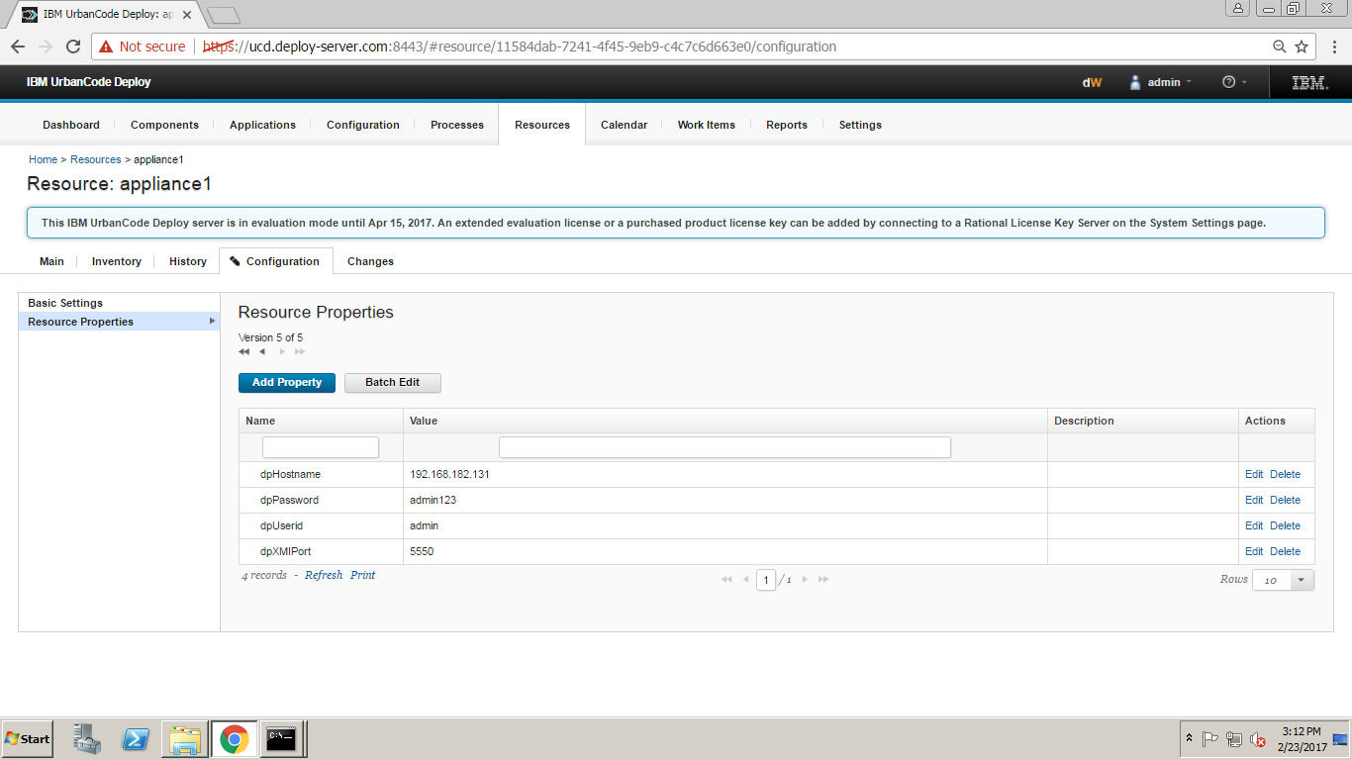

These are the same values (with different property names) that you collected in device.*.properties. These values will be used automatically by the DataPower plugin steps when we define a Component, in the next section.

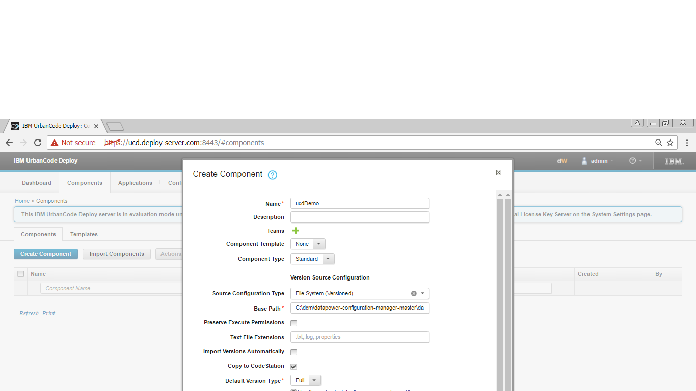

This completes the foundation for deploying appliances.

**Define a Component**

A UCD component generally describes a single DataPower service. Set up a **component** for the **ucdDemo** service:

Use the **Components → Components → Create New Component button** to create the new component object

(Component templates are a good thing to use when you have a bunch of similar services, if you get to that point in applying UCD to DataPower deployments.)

Assign a name (e.g. **ucdDemo**) and description



Choose a Source Config Type and fill in the required information

(For this example I used Subversion and pointed it to the same subversion server that I used for the command-line example. I accepted most of the defaults. I also had to install subversion on my Windows VM since the UCD agent runs “svn” from the command line.)

Select Import Version Automatically

Save the Component object

Open the **ucdDemo** link and move to the **Processes** **tab** (NOTE: This is the Processes tab associated with this particular object, not the global Processes tab near the top of the browser.)

Use the Create New Process button to create a process named “**deployUcdDemo**” and save

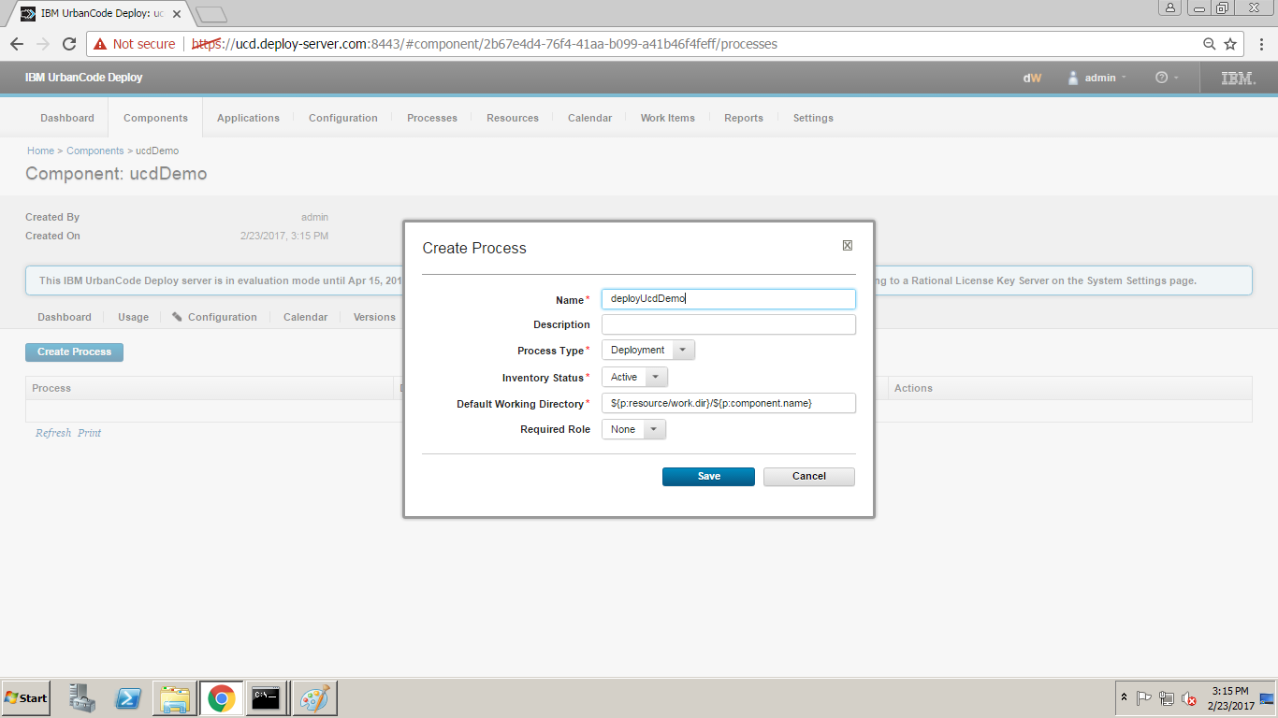

Open the **deployUcdDemo** link, which automatically brings up the **Design** tab with prepopulated Start and Finish steps.

This is a **drag-and-drop** user interface where you can define the steps for the UCD agent to follow while deploying the **ucdDemo** service. Expand the Step Palette's **Infrastructure → WebSphere DataPower** Review the set of deployment steps that are available. 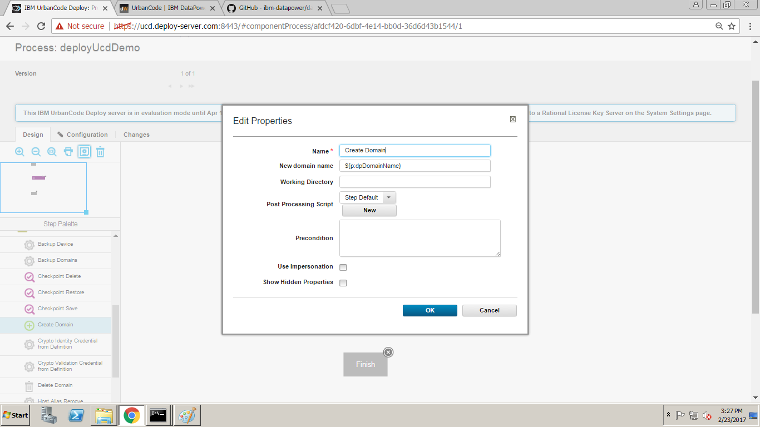

Drag a Create Domain step from the palette into the process. It will automatically bring up the Edit Properties dialog.

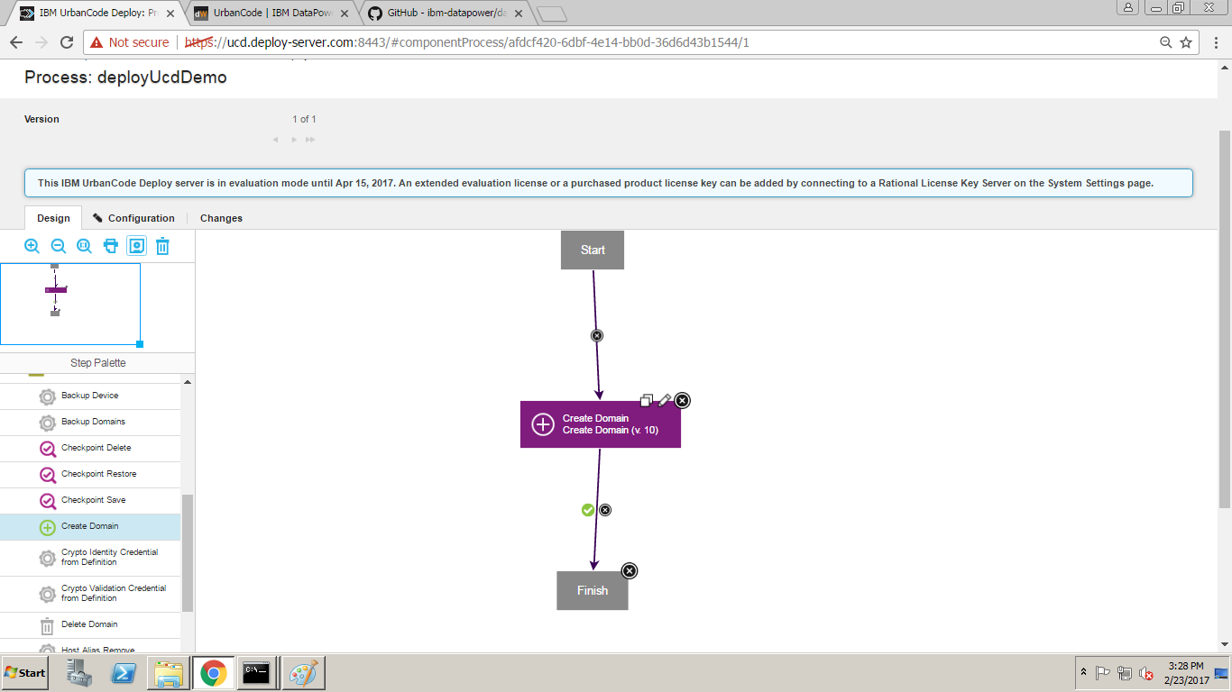

Drag a Save Configuration step into the process and set a meaningful name for the step. The default values are all fine.

Arrange the steps so that they are neatly aligned and “wire” them together.

This component process will:

Ensure that the target domain exists on the appliance

Save that updated configuration.

Save the entire process by clicking on the little **floppy disk icon** in the Tools palette.

Before we leave the component process there is one thing worth seeing. Edit the Create Domain step (click on the little pencil icon) and then click the Show Hidden Properties checkbox. Every step provided by the DataPower plugin has these same hidden properties, which tell the agent how to connect to each DataPower appliance. These properties are defined in the **appliance1**.

**Define an Application**

Create the Application (see **Applications → Create New Application**) and give it a meaningful name (e.g. **ucdDemo**). The browser will automatically click the **ucdDemo** link for you. Later you can click that link to get to this same page.

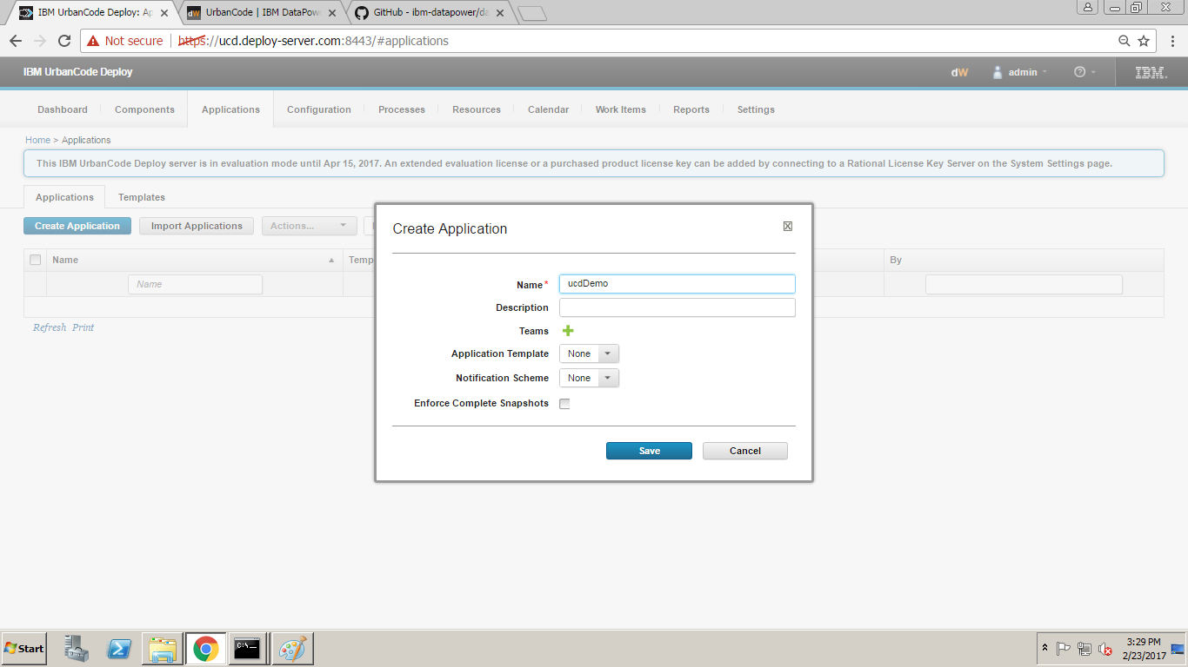

Use the **Create New Environment button** to create the “**dev**” environment, then click on the “dev” link.

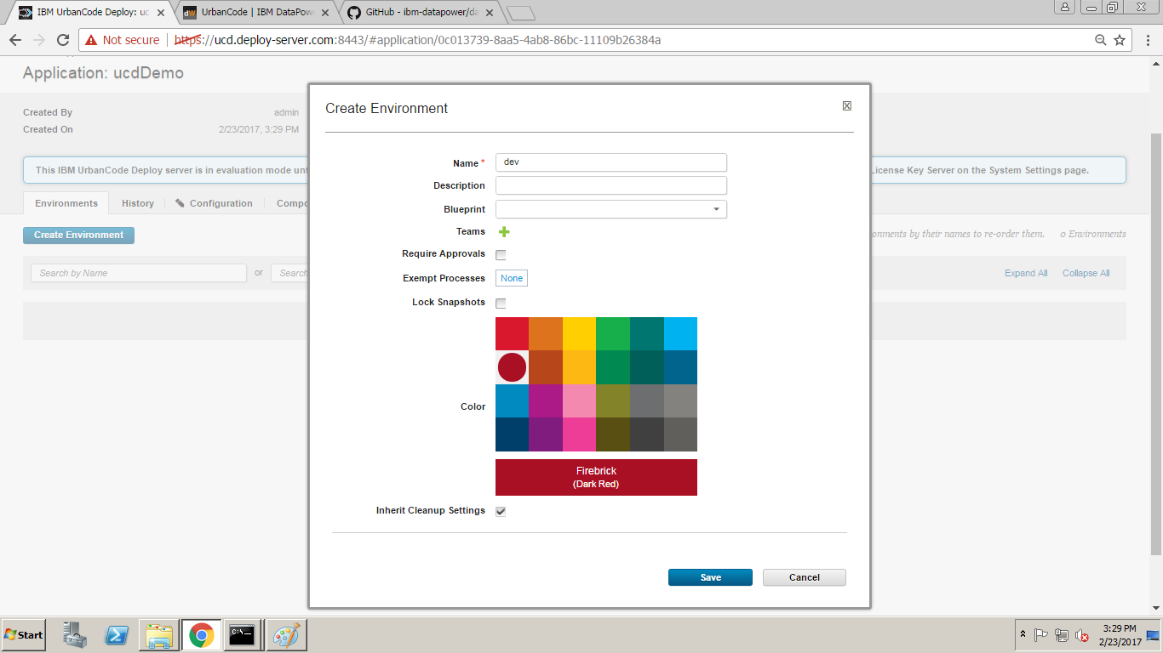

Click on the Configuration tab for the “**dev**” Environment (not the global Configuration tab near the top of the browser), then click on Environment Properties. Use the Add Property button to define the “**dpDomainName**” property (e.g. **ucdDemoDev**). This is the name of the domain on the target appliance(s) for the domain.

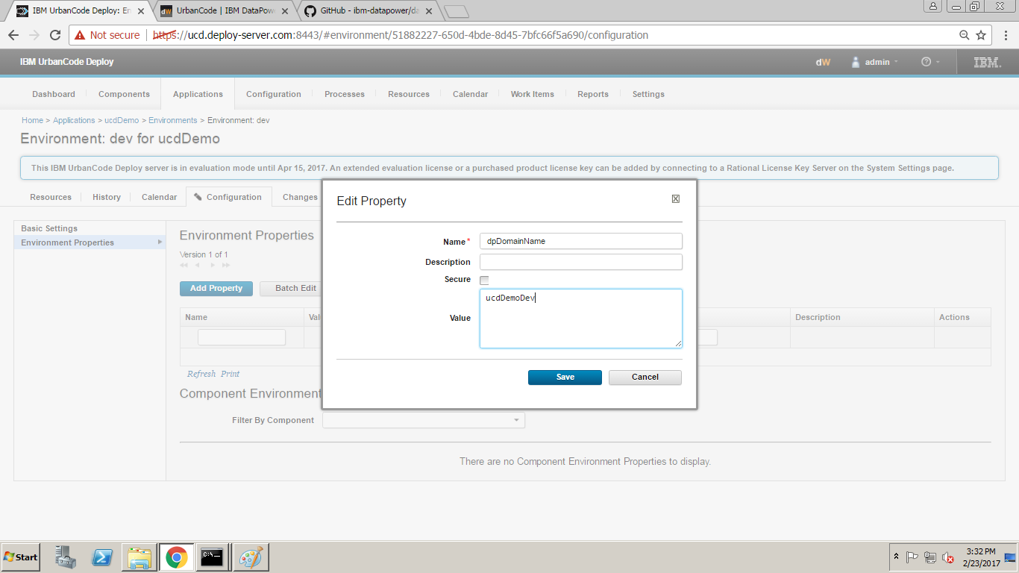

Switch back to the Resources tab for the Environment and use the Add Base Resources button to begin adding appliance1 to the “dev” environment. Click the checkbox for appliance1 and its subordinate DPAgent and then click OK.

Return to the main page for the Application (the title is “**Application: ucdDemo**” and the breadcrumb trail above the title **is Home > Applications > ucdDemo**).

Click on the Components tab for the Application and click on the Add Component button.

Add the ucdDemo component to the Application. UCD requires that you explicitly define which Components may be referenced by a particular Application. This avoids an Application inadvertently referencing a Component that should not be referenced by that Application.

Click on the **Processes** **tab** for the Application and use the Create New Application button to create an application named **deployUcdDemo**. Accept all the defaults and press Save.

Click the **deployUcdDemo link**. This brings up a process editing tab similar to the Component Process tab. Note that the Step Palette is very different from the one presented in the Component Process tab.

Drag an Install Component step into the process, give it a meaningful name, and choose the **ucdDemo** Component and the **deployUcdDemo** Component Process.

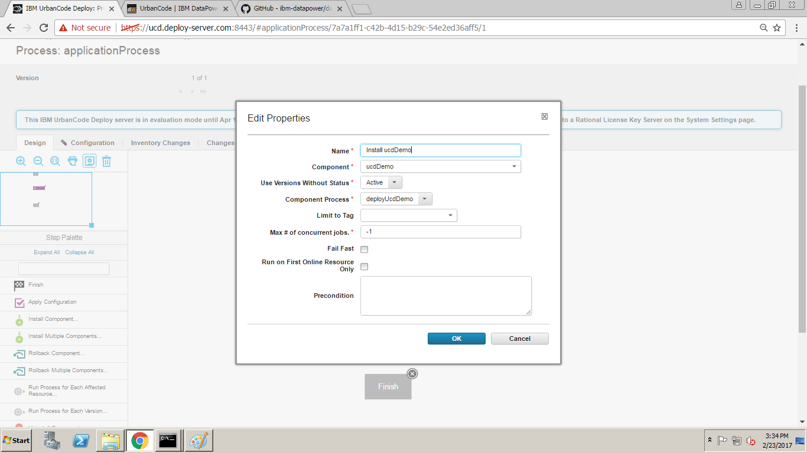

Wire the Start, Install Component, and Finish steps together and Save the Process.

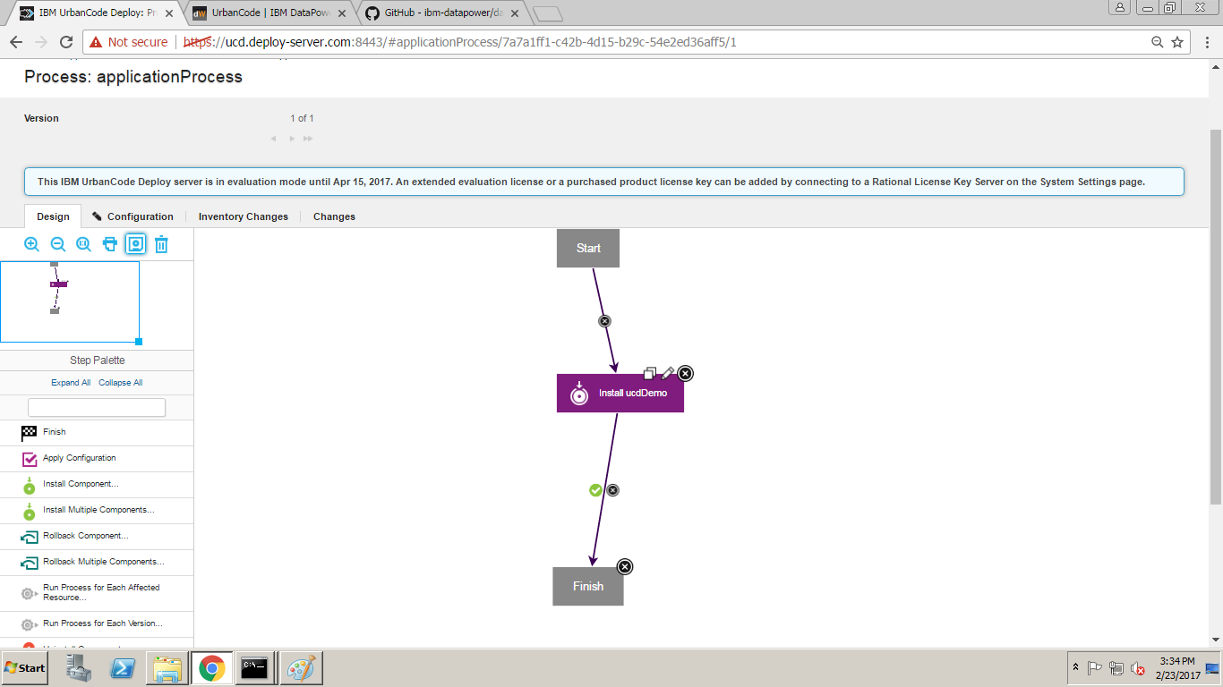

**Add Component to Resource**

UCD requires that each component be explicitly declared is being deployed by each Resource.

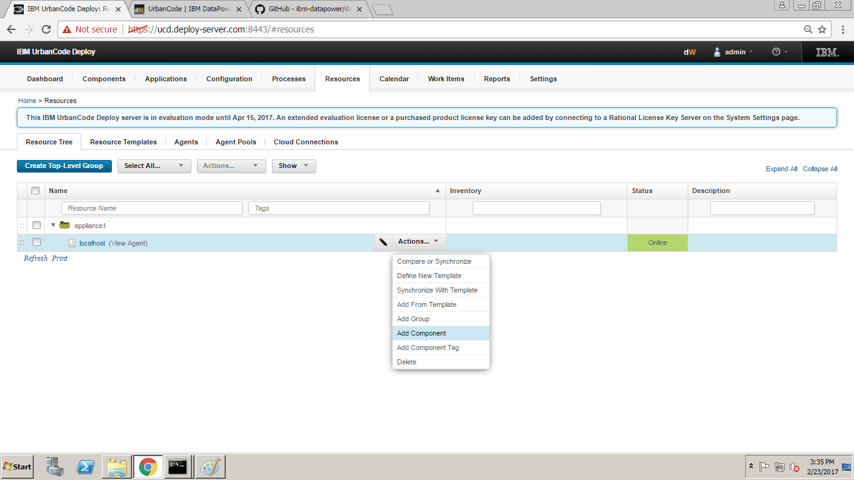

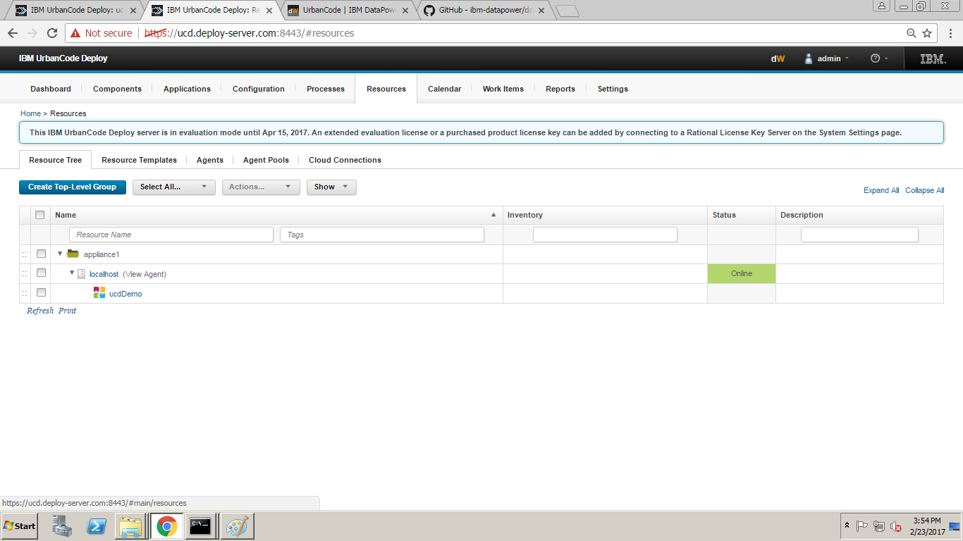

**Go to the global Resources tab and expand appliance1**



**Click the link for the agent (e.g. DPAgent)**

**Choose Create New … Component**

**Select the component to deploy (e.g. ucdDemo) and Save**

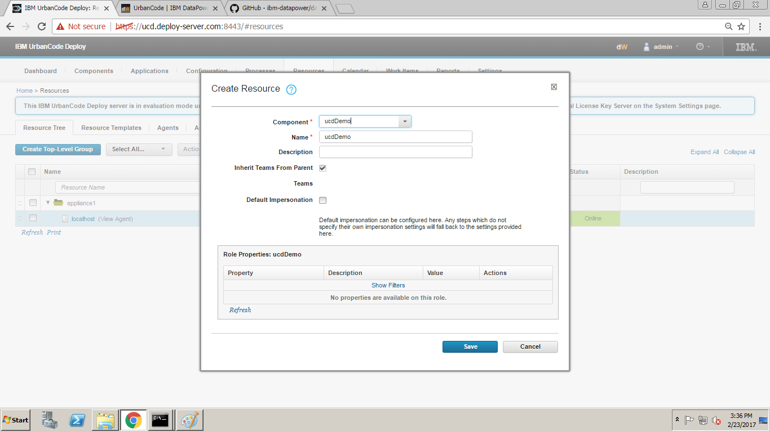

**Deploy an Application**

Return to the main page for the **ucdDemo** Application (see step 6 in previous section).

Press the “**play**” button associated with the dev environment.

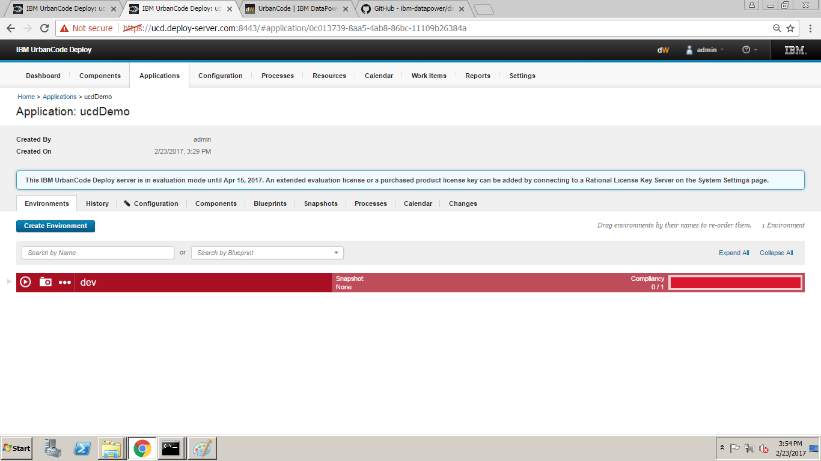

Uncheck the Only Changed Versions checkbox, since we want to deploy regardless of whether the underlying ucdDemo service has been changed

Choose the **deployUcdDemo** process in the Process dropdown then choose Submit.

The Result should be

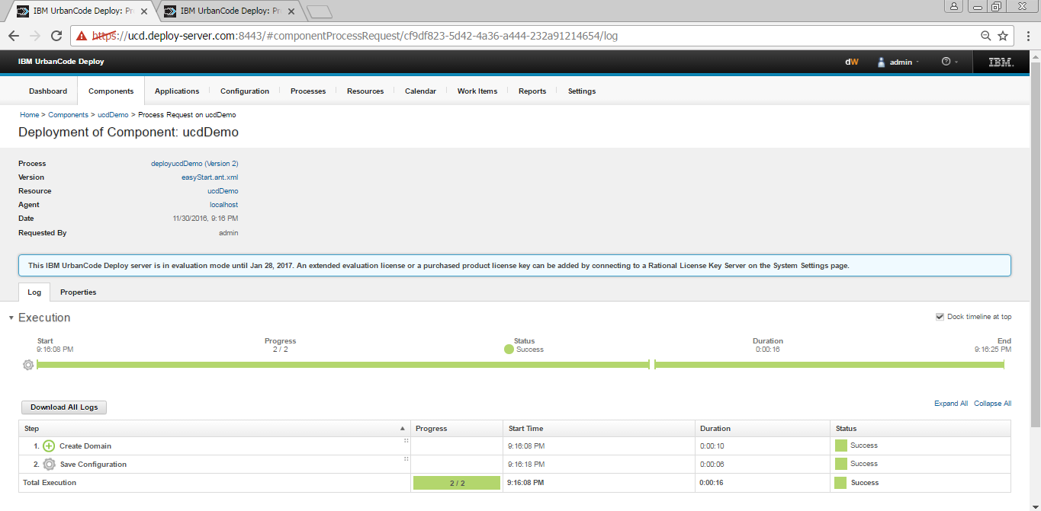

We Should Check DataPower Login to make sure the domain.

