Psychology Client Tracker

Travis Nelson

Regis University

5/17/2018

Abstract

The Psychology Client Tracker is an application that can be utilized by mental health professionals to create, edit, and track client notes pertaining to their scheduled sessions. As psychologists continue to meet with their clients, additional remarks can easily be added to their notes. As clients transition out of therapy or to a new therapist, their information can be exported and/or deleted when it is no longer relevant.

This application will be written in the Java programming language as the front and back-end applications. It will utilize a MySQL database on the back-end that will run on a Linux server, hosted on a popular cloud service such as Amazon Web Services or Microsoft Azure. Secure user login and industry-standard encryption methods will be utilized to protect client information as required by moral and legal obligations.

The Psychology Client Tracker can help reduce administrative costs pertaining to note taking, and increase the security of those notes as they are held for years due to regulatory requirements. This application can help increase the amount of mental health services provided to those who need it most.

Psychology Client Tracker

Design Goals

The design goals of the Psychology Client Tracker application are as follows:
- Utilize the Java programming language to create the front-end application that the user will interact with for client note creation and editing
- Utilize the Java programming language to create the back-end application that the front-end application will interact with to read and write information from the database
- Create a MySQL database that will store all client information that will be displayed on the front-end application
- Front-end application will be lightweight and simple as to allow for easier client note creation and less time learning the user interface
- Create a user login that requires a username and password before accessing client notes
- Industry standards for encryption utilized to secure the transfer of data from the front-end application to the server, and vice-versa

Use Case Diagram
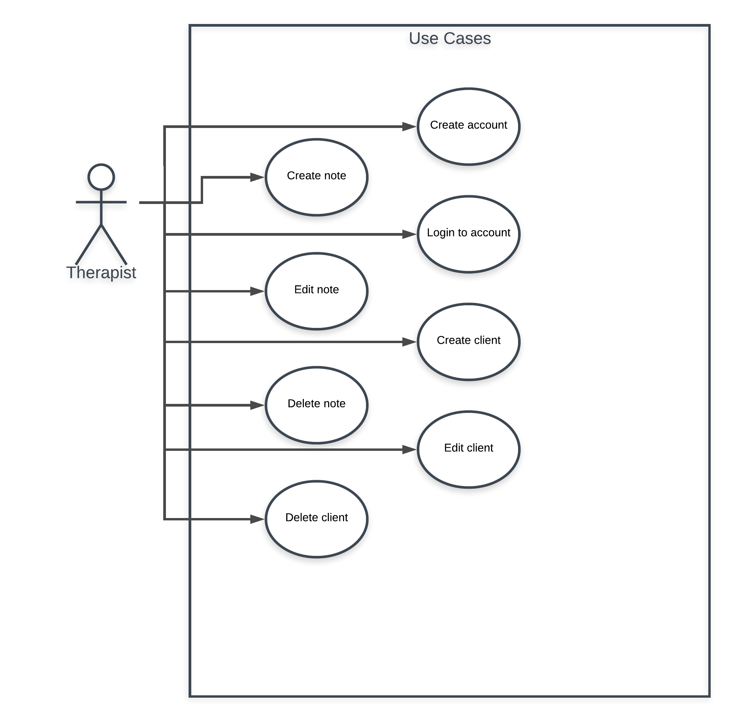

Envisioned Architecture

The envisioned architecture for this given project is to utilize a three-tiered approach. The first-tier would be the presentation tier. This tier would present the user interface to the therapist, and allow for the entry of client notes.

When the therapist is done with data entry, he/she would click a “submit” button, and that data would be captured within the second-tier, or the logic tier. The logic tier serves as the “middle man” between tiers one and three, sending data back and forth and processing information as needed to be better handled by the receiving tier.

The third-tier would be the data tier, which stores and returns data depending on the request received from the logic tier. The data tier would be a hosted Linux server via a product such as Amazon Web Services or Microsoft Azure.

This three-tiered approach allows for the application to be broken into three logic pieces that are all critical to the success of this project.

Common Good Considerations

This application has the ability to potentially reduce mental health care costs while simultaneously increasing the security of client’s information. Any decrease in mental health service costs can have a huge impact on the population by expanding existing services into a price range that fits more household budgets.

For an application pertaining to the mental health field, it is important to take security into consideration. Ensuring only authorized users have access to client data is not only morally the right thing to do, but it is also legally-mandated. Ensuring an adequate login system is implemented will be an important part of this project.

In addition to denying access to client information for users who lack the proper credentials, protecting client information as it is sent from the user’s machine to the server is critical. Utilizing the industry standard or better for encrypting user data will ensure that, if the data were to be intercepted by those without the authorization to view it, they are not able to use said data for malicious intent.

