Multivariate Analysis

Homework 2

M052040003 鍾冠毅

4.26. (a)

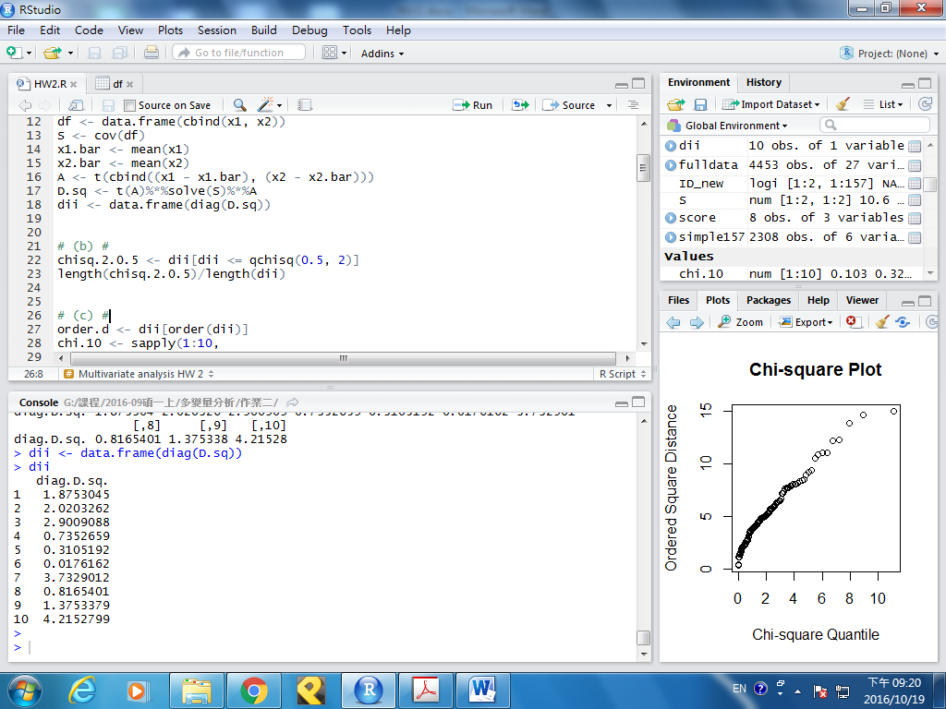

(b)

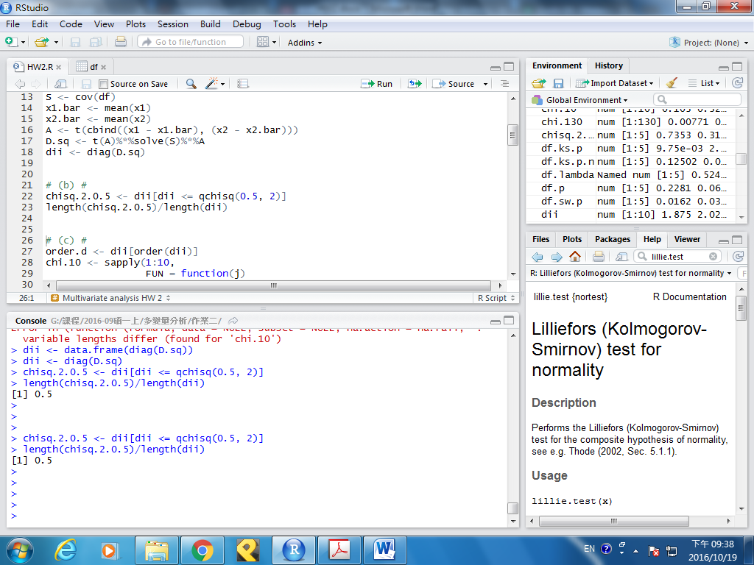

(c)

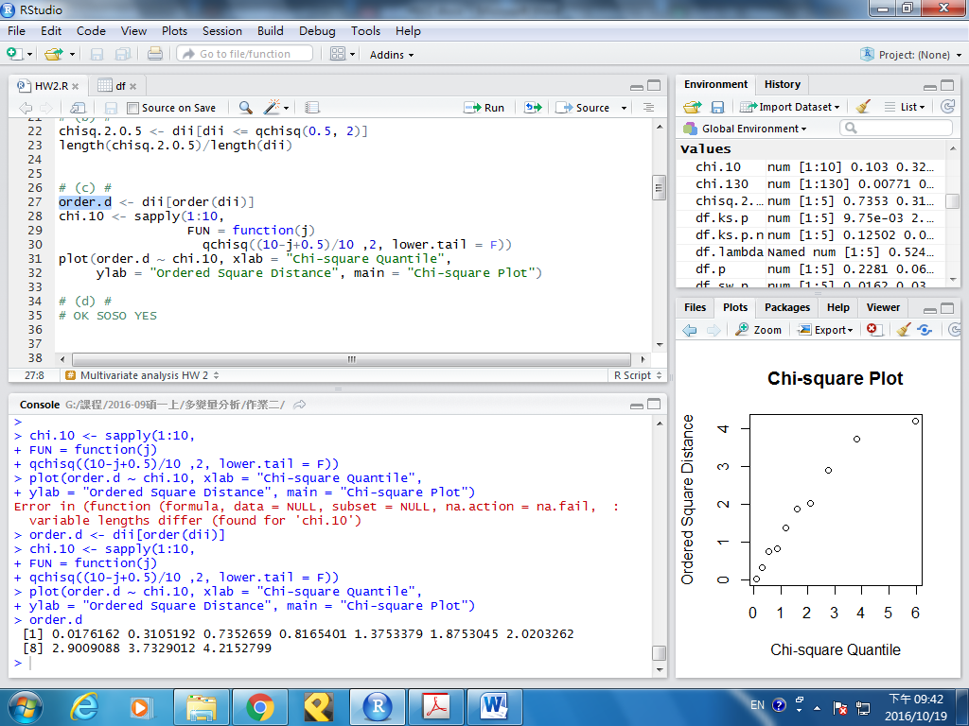

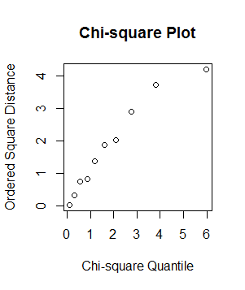

(d) 由(b)(c)結果可知，兩數據服從雙變數常態分配。

4.30. (a) ${\hat{λ}}_{1}=0.3708906$

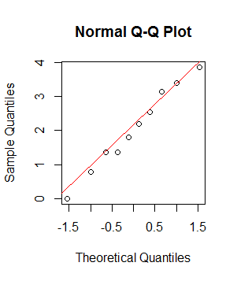

(b) ${\hat{λ}}_{2}=0.9361967$

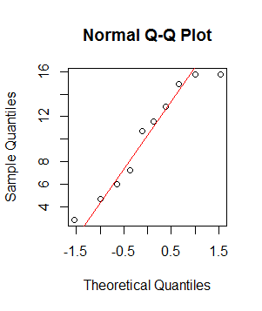

(c) $\left({\hat{λ}}_{1},{\hat{λ}}_{2}\right)=\left(1.2732157, 0.0310405\right)$

若個別計算最佳的 $\hat{λ}$，則會使兩變數個別較趨近常態分佈。若同時計 ${\hat{λ}}_{1}$ 與 ${\hat{λ}}_{2}$，則會找到最佳的 $\hat{λ}$，使得兩變數較趨近於雙變量常態分佈。

4.39.

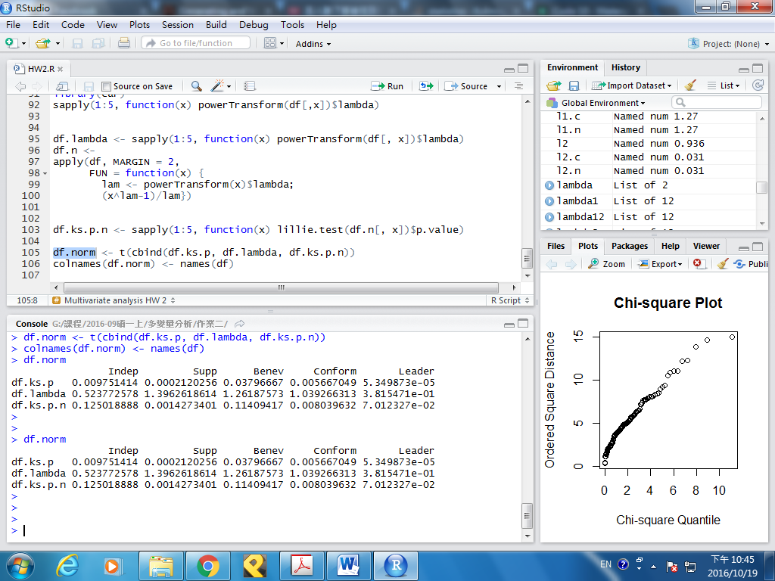

df.ks.p ：轉換前的Kolmogorov-Smirnov檢定之p-value

df.lamda ：轉換所使用的 $最佳λ$

df.ks.p ：轉換後的Kolmogorov-Smirnov檢定之p-value

(a) 由上表可知所有的p-value皆小於0.05，故拒絕常態之假設。

(b) 雖然在Chi-square圖中各點分布接近一斜直線，但是由(a)可知個變數之邊際分佈皆不符從常態分佈，故此資料不符從多變量常態分佈。

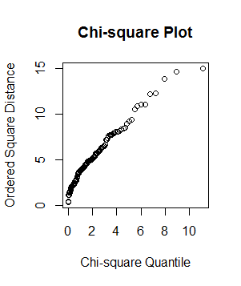

(c) 由上表可知，各變數經轉換後重新檢定之p-value皆有成長的趨勢，甚至大於0.05，即服從常態分佈，如：Indep、Benev、Leader等。

Appendix

### 4.26 ###

# (a) #

x1 <- c(1, 2, 3, 3, 4, 5, 6, 8, 9, 11)

x2 <- c(18.95, 19.00, 17.95, 15.54, 14.00,

12.95, 8.94, 7.49, 6.00, 3.99)

df <- data.frame(cbind(x1, x2))

S <- cov(df)

x1.bar <- mean(x1)

x2.bar <- mean(x2)

A <- t(cbind((x1 - x1.bar), (x2 - x2.bar)))

D.sq <- t(A)%*%solve(S)%*%A

dii <- diag(D.sq)

# (b) #

chisq.2.0.5 <- dii[dii <= qchisq(0.5, 2)]

length(chisq.2.0.5)/length(dii)

# (c) #

order.d <- dii[order(dii)]

chi.10 <- sapply(1:10,

function(j)

qchisq((10-j+0.5)/10 ,2, lower.tail = F))

plot(order.d ~ chi.10, xlab = "Chi-square Quantile",

ylab = "Ordered Square Distance", main = "Chi-square Plot")

### 4.30. ###

install.packages("MASS")

library(MASS)

library(car)

# (a) #

lambda1 <- powerTransform(x1)

l1 <- lambda1$lambda

x1.n <- (x1^l1-1)/l1

qqnorm(x1.n)

qqline(x1.n, col="red")

# (b) #

lambda2 <- powerTransform(x2)

l2 <- lambda2$lambda

x2.n <- (x2^l2-1)/l2

qqnorm(x2.n)

qqline(x2.n, col="red")

# (c) #

lambda12 <- powerTransform(cbind(x1,x2))

l1.c <- lambda12$lambda[1]

l2.c <- lambda12$lambda[2]

x1.c <- (x1^l1.c-1)/l1.c

x2.c <- (x1^l2.c-1)/l2.c

### 4.39 ###

# (a) #

#install.packages("nortest")

library(nortest)

df <- read.csv("4.39.csv", header = F, sep = ",")

names(df) <- c("Indep", "Supp", "Benev", "Conform",

"Leader", "Gender", "Socio")

df.ks.p <- sapply(1:5, FUN = function(x) lillie.test(df[,x])$p.value)

df.sw.p <- sapply(1:5, FUN = function(x) shapiro.test(df[,x])$p.value)

# (b) #

df <- df[, 1:5]

S <- cov(df)

A <- t(apply(df, MARGIN = 2, FUN = function(x) x-mean(x)))

D.sq <- t(A)%*%solve(S)%*%A

dii <- diag(D.sq)

order.d <- dii[order(dii)]

chi.130 <- sapply(1:130,

FUN = function(j)

qchisq((length(dii)-j+0.5)/length(dii) ,2, lower.tail = F))

plot(order.d~chi.130, xlab = "Chi-square Quantile",

ylab = "Ordered Square Distance", main = "Chi-square Plot")

# (c) #

library(car)

sapply(1:5, function(x) powerTransform(df[,x])$lambda)

df.lambda <- sapply(1:5, function(x) powerTransform(df[, x])$lambda)

df.n <-

apply(df, MARGIN = 2,

FUN = function(x) {

lam <- powerTransform(x)$lambda;

(x^lam-1)/lam})

df.ks.p.n <- sapply(1:5, function(x) lillie.test(df.n[, x])$p.value)

df.norm <- t(cbind(df.ks.p, df.lambda, df.ks.p.n))

colnames(df.norm) <- names(df)