M052040003 鍾冠毅

1.a.

(i)

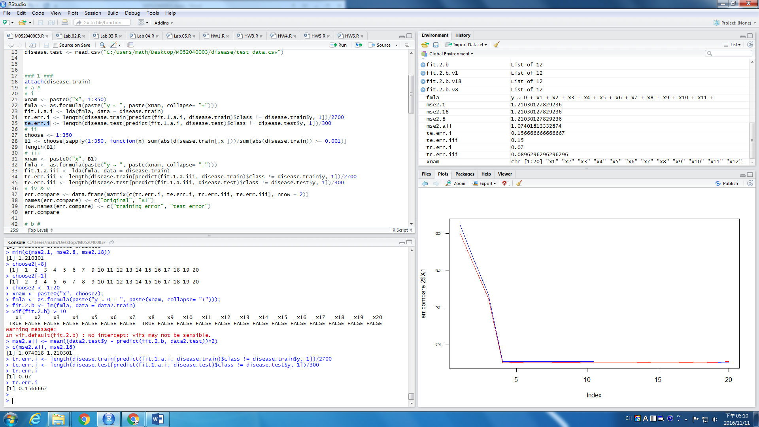

(ii)

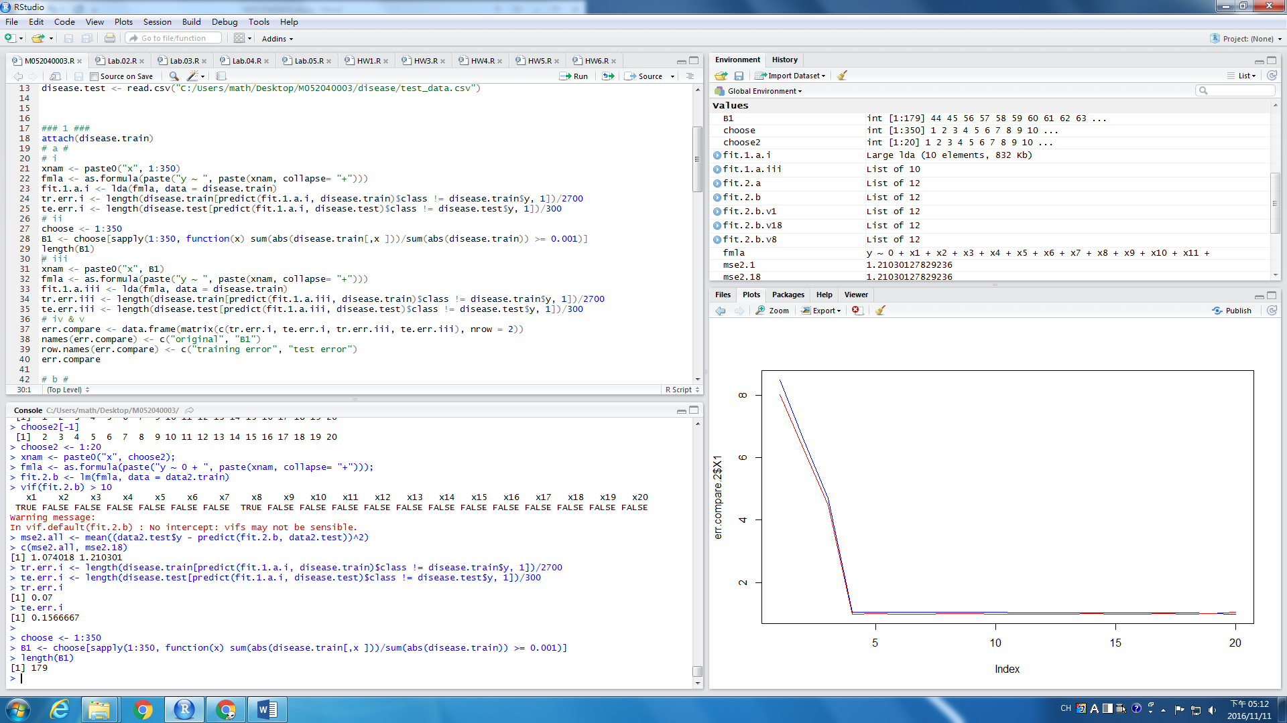

(iii)

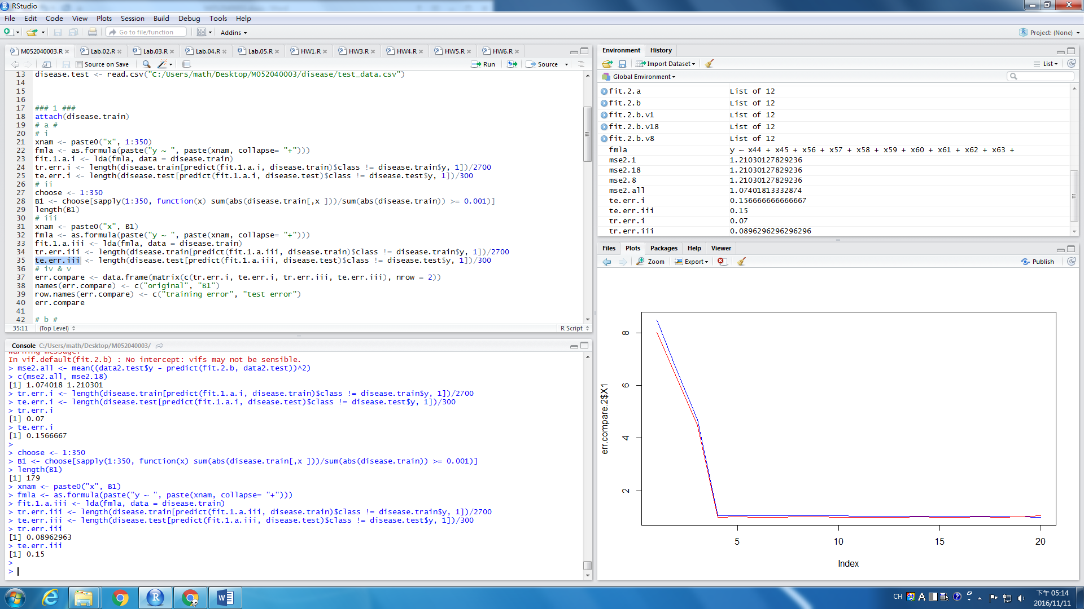

(iv) base on B1

(v) NO! the error rate is 15% which is a little bit large.

1.c.

1.d.

1.e.

2.a.

(i)

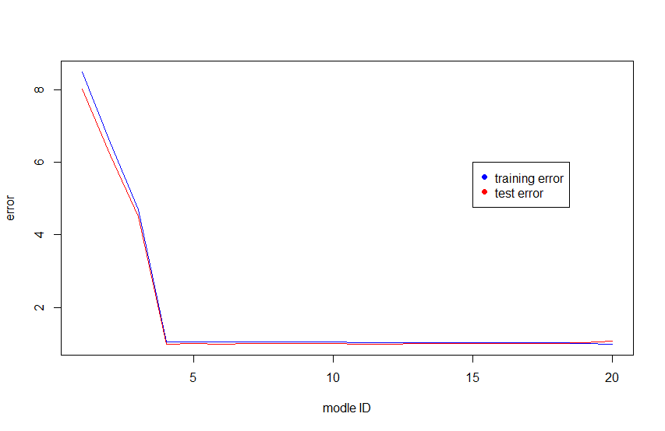

(ii) model 20 has the minimum training 合理，使用越多變數估計模型，可以得到越低的training error

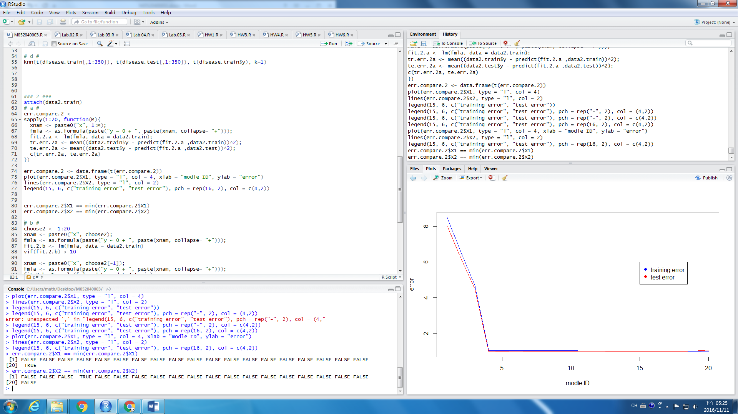

(iiI) model 3 is the best

