TAVI 事前審查
個案: 洪范鳳英04019515（女）85 歲1940/01/18, N200935271 , 病患History為Severe Aortic stenosis、Hypertension、Hyperlipidemia、Post thyroidectomy、Left ICA (internal carotid artery) 50~70% Stenosis，在門診追蹤治療；近期常發生暈眩及暈倒情形；此次於2025/11/26因Syncope 至急診求治並住入加護病房治療。於2025/11/27安排了心臟超音波檢查：Severe AS(AVA:0.67cm2, Vmax:5.61m/s, Peak PG:126mmHg, Mean PG:76mmHg)；於2025/11/27因肺積水及呼吸困難而緊急插管，於2024/10/22安排心導管檢查：Critical severe AS (AVA:0.3cm2)並施行主動脈瓣膜氣球撐開術(BAV)；嚴重主動脈瓣膜狹窄建議手術。經二位心臟外科專科醫師(謝炯昭,曾政哲)評估主動脈瓣膜傳統手術風險高(STS score >10%)；醫病共享決策與家屬討論後決定家屬希望能申請經導管主動脈瓣膜置換手術(TAVI)。病患平時日常生活在家人協助下是可以自理的，臨床上判定病人至少有一年以上之存活機率。由於主動脈瓣膜狹窄的情形(Critical AS) 隨時都有猝死的可能。需盡快行經導管主動脈瓣膜置換術(TAVI)來改善的症狀，惠請貴局同意。

1.心臟超音波檢查
高雄醫學大學附設中和紀念醫院 胸前心臟超音波報告
Trans Thoracic Echocardiography Report
病歷號碼：04019515 姓名：洪范鳳英 性別：女 出生日期：1940/01/18 年齡：85 歲
身分證號：N200935271 報告日期：2025/11/27 檢查號碼：114112703128
RVD(7~23)= mm IVSd(6~11)= 13 mm LVIDd(36~52)= 47 mm
AoRoot(20~37)= 26 mm IVSs(6~11)= 15 mm LVIDs(20~36)= 33 mm
AV opening(15~26)= 4 mm LVPWd(6~11)= 9 mm EPSS(<5)= mm
LA(19~40)= 36 mm LVPWs(9~17)= 13 mm TAPSE= 21 mm
EF(MM-Teich)= 58.4 % LVEDV= 103 ml LVESV= 43 ml
Pericardial effusion : No
<2D-Mode>
EF(Simpsons)= 57% EF(2D)= 57% EF(3D)= %
LA volume index(16~34)= ml/m2, LVMI= 128 g/m2
<Doppler Finding>
Trans-mitral inflow: E/A: 1150 / 1210 = 1 DT= 298 msec
E/E' Med= 28.5 E/E' Lat= 24.6 E/E' Avg= 26.1
Ascending AO= mm RVs= mm/s LVOT= 19
<Valve Analysis>
1. Very Severe AS(AVA:0.67cm2, Vmax:5.61m/s, Peak PG:126mmHg, Mean PG:76mmHg)
2. Mild TR(Vmax:2.29m/s, Peak PG:21mmHg)
3. Mild MR
4. Mild AR
5. MV(MVA:2.5cm2, Vmax:1.32m/s, Peak PG:7mmHg, Mean PG:2mmHg)
6. MV: calcification
<Comments>
. Adequate LV systolic function (estimated LVEF=58.4% by M-mode; 57.3% by Simpson's method)
. Impaired LV diastolic function with elevated LV filling pressure
. Adequate RV function(TAPSE=20.6mm)
. IVS hypertrophy
報告醫師：張建偉 ((108)中心專醫字013號)
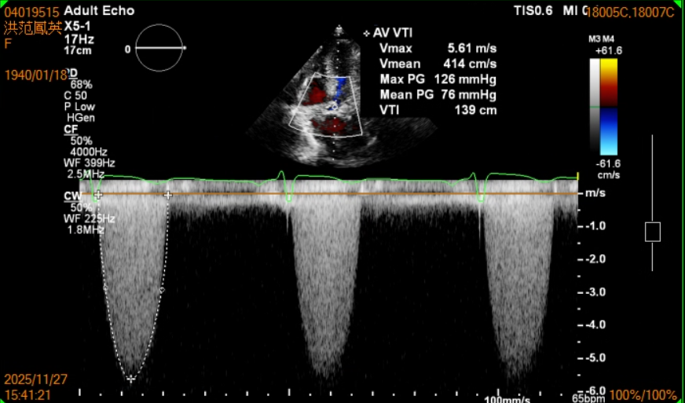
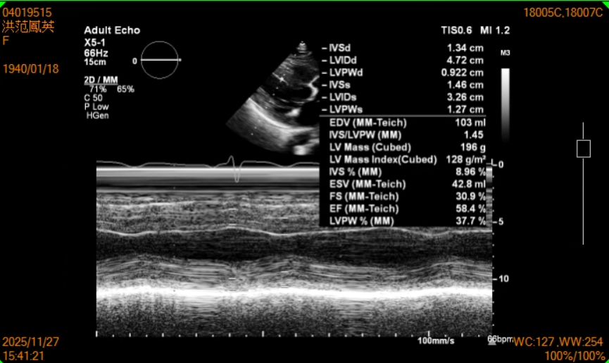
==================================================================================
2. 心導管檢查
高雄醫學大學附設中和紀念醫院 心 導 管 報 告
Cardiac Catheterization Report
病歷號碼：04019515 姓名：洪范鳳英 性別：女 出生日期：1940/01/18 年齡：85 歲
身分證號：N200935271 報告日期：2025/11/28
第一導管室 檢查項目：Diagnosis 開始時間：07:50 診斷：Normal CAG
Indication:
The patient was referred with severe aortic stenosis.The procedure was explained in detail to the patient and family.Risks, complications and alternative treatments were reviewed. Written consent was obtained.
Approach:
Percutaneous access was performed through the right radial artery where a BRAIDIN HEMOSTASIS INTRODUCER[5F 0.025'cm] was inserted. Percutaneous access was performed through the right femoral vein where a Terumo Sheath 7F 10cm[7F 10cm] was inserted. Percutaneous access was performed through the right femoral artery where a Terumo Sheath 8F 10cm[8F 10cm] was inserted.
Catheters:
Left ventriculography was performed using Angiographic Catheter[JR 4.0] catheter and Left ventriculography + Aortography was performed using Pigtail[5Fr .038 110cm PIG] catheter.
Procedure:
- 47036B-順流導管插管術 On Swan-Ganz
- 18026B LV Angio
- 18021B Cath both side
- 18029B Cardiac output
- 18027B AO Angio
- 68015B 瓣膜成形術
The contrast material used was Omnipaque 350 cc. The patient was treated with heparin (Dosage=8000). Brief Summary:Syntax Score = 0
LM : No stenosis
RCA : No stenosis
LAD : No stenosis
LCX : No stenosis
In conclusion :
. Normal CAG
---------------------------------------------------------
# Severe AS :
pre-BAV post BAV
Peak-to-peak 106.6 55.5 mmHg
Mean PG 80.03 50.58 mmHg
AVA 0.3 0.37 cm2
BAV balloon: Tyshack 18 mm * 4cm / 20mm * 4 cm
----------------------------------------------------------
Left Ventriculogram : LVEF 77 ％
Aortogram : mild AR noted (after BAV)
[Hemodynamic]
AO Pre.：109 / 36 ( 63 ) mmHg SaO2：98.6 ％
LV Pre.：222 / 14 ( 31 ) mmHg
RA ：15 / 11 ( 9 ) mmHg Mid：77.3 ％
RV ：30 / 8 ( 11 ) mmHg
PA ：33 / 14 ( 21 ) mmHg Main：73.5 ％
PCW ：38 / 17 ( 14 ) mmHg
Heart rate：Pre. 91 bpm Post 76 bpm
Thermodilution CO：2.8 L/min CI：1.83 L/min/m2
Direct Fick CO：3.96 L/min CI：2.59 L/min/m2
PVR：2.50 WU SVR：17.14 WU
主治醫師：邱正安((94)中心專醫字024號)
高宇賢((110)中心專醫字027號)
===============================================================================
3. EKG心電圖檢查
高雄醫學大學附設中和紀念醫院 心電圖
姓名：洪范鳳英 性別：F 檢查日期：20251126 檢查編號：114112602863
病歷號：04019515 生日：19400118 檢查人員：王子義-1030410 流水號：
年齡：85 開單醫師：王子義-1030410 檢查來源：急診部
報告醫師：王子義-1030410-急專醫字001829
診斷：Syncope and collapse
EKG Diagnosis: ■Non-Specific ST-T change
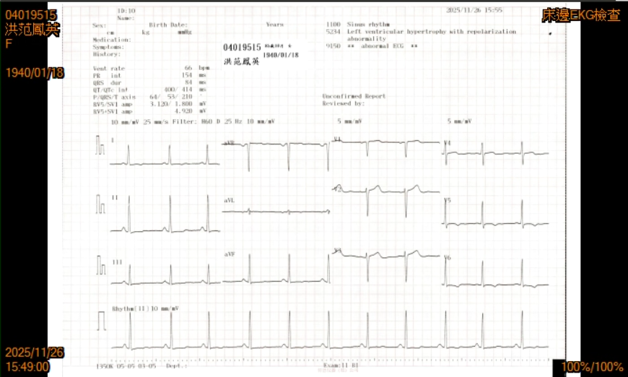
=========================================================================
4. Chst X-ray
高雄醫學大學附設中和紀念醫院 放射線科 Plain Film 報告
病歷號碼：04019515 出生日期： 19400118 科 別： 心臟血管內科
病患姓名：洪范鳳英 性 別： F 年 齡： 85
檢查日期：20251126 檢查時間： 172732 檢查單號： 114112603660
臨床醫師：張建偉 (1030420) 放 射 師： 蘇哲緯蔡蕙如周倩雯
開單日期：20251126 開單時間： 171710
Imaging findings：Chest PA
Impression：
Tortuous aorta with atherosclerosis.
Thickening of the bilateral apical pleura.
Patch opacities at the bilateral lung. Consider pneumonia. Recommend clinical correlation
and follow-up after treatment to rule out superimposed pulmonary lesion.
Spondylosis deformans of thoracolumbar spine.
Mild scoliosis of thoracolumbar spine.Left side costodiaphragmatic recess blunting,
consider pleural effusion or pleural adhesion.
Jerry Chih-Wei Chen, M.D. 陳智偉醫師(放診專醫字第0001228號)||
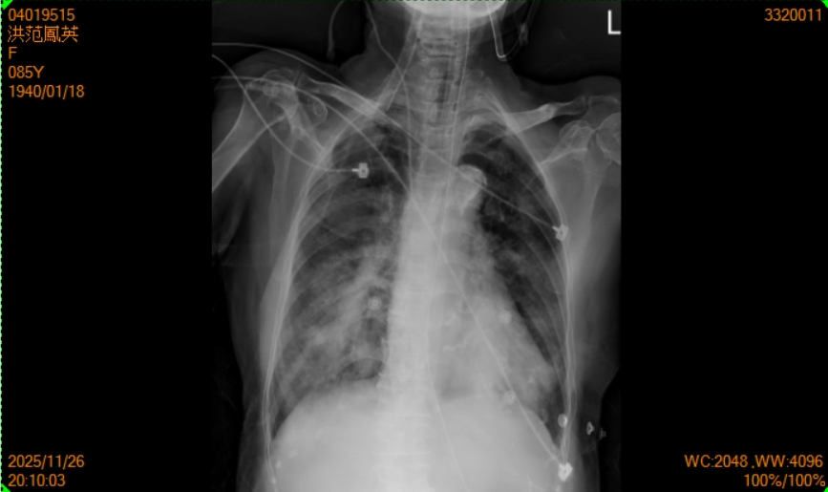
======================================================================
5. Heart CT
高雄醫學大學附設中和紀念醫院 放射線科 CT 報告
病歷號碼：04019515 出生日期： 19400118 科 別： 心臟血管內科
病患姓名：洪范鳳英 性 別： F 年 齡： 85
檢查日期：20251201 檢查時間： 092106 檢查單號： 114120101208
臨床醫師：張建偉 (1030420) 放 射 師： 陳薇婷李鴻治劉淑芬
開單日期：20251127 開單時間： 160532
Imaging findings：CT of the Heart:
Protocol
1.Enhanced axial images of heart and abdomen were obtained with reformatted coronal images.
2.Special views: Multi-Planar Reconstruction, Cruved Planar Reconstruction and Maximal
Intensitive Projection.
3.Contrast medium: 40(1:0), 50(7:3), 25(0:1).
Aortic valve/Root measurement:
Annulus daimeter: 24x17(20.7) mm
Annulus perimetry: ovoid, 67mm, area:334.5mm^2.
Sinus of Valsava diameter: Right coronary cuspid(RCC)= 29mm, Non-coronary cuspid
(NCC)= 29mm, (Left coronary cuspid)LCC= 30mmmm
Sinotubular junction diameter: 27.7x23.7(25.7)mm
Ascending Aorta diameter: 33.8x32.5(33.1) mm
LVOT diameter: 26.7x18.1(22.4)mm
LVEF:59%.
Length:
Native leaflet to sinotubular junction: Right coronary cuspid(RCC)= 18.5(15.2), Non-
coronary cuspid(NCC)=17.2mm, (Left coronary cuspid)LCC= 17.7(9.9)mm
Sinus of Valsava diameter: Right coronary cuspid(RCC)= 29mm, Non-coronary cuspid
(NCC)= 29mm, (Left coronary cuspid)LCC= 30mmmm
Angles:Annular angulation: 31degree
Peripheral A. measurement:
Common Iliac A. : left: 9.4x7.9mm ; right:6.5x8.8mm
External Iliac A. : left: 6.7x6.0mm ; right: 7.0x6.4mm
Femoral A. : left: 7.1x6.50mm ; right: 7.2x6.mm
Left ventricular end-diastolic volume(LVEDV):128ml; Left ventricular systolic volume
(LVESV):52ml; Ejection fraction of left ventricle (LVEF): 59%
Right ventricular end-diastolic volume(RVEDV):128ml; Right ventricular systolic volume
(RVESV):64.5ml; Ejection fraction of right ventricle (RVEF): 49%
Left atrial end-diastolic volume(LAEDV):110ml; Left atrial systolic volume(LAESV):131ml;
Ejection fraction of left atrium (LAEF): 17%
Right atrial end-diastolic volume(RAEDV):80ml; Right atrial systolic volume(RAESV):121ml;
Ejection fraction of right atrium(RAEF): 34%
Calcification of the aortic valves are noted.
Calcified plaques along the mitral annulus are noted.
Partial atelectasis in the left lingual and bilateral lower lobes are noted.
Fluid collection in the bilateral pleural spaces.
Status post left thyroidectomy is noted.
Distended gallbladder is noted.
Mild dilatation of common bile duct is noted.
Hyperdense nodules in the uterus are noted.
Multiple hypodense nodules are noted in the bilateral kidneys.
There are spurs of the cervical, thoracic and lumbar spine and with scoliotic alignment.
On endotracheal tube, nasogastric tube are noted.
Impression：
1) Aortic valve
- Severe calcification along all cuspids with severe restrictive movement, especially in the non-coronary cuspid (NCC>LCC>RCC). - Aortic valve opening:0.63cm^2
2) Mitral valve
- Mitral annular calcification with less excursion at the base of posterior leaflet.
- Coaptation gap at the A2-P2:7.4mm^2
3) Preserved ejection fraction of biventricles.(RVEF:49%, LVEF:59%) but mild left atrial
ejection fraction.(LAEF:17%)
Other cardiac parameters, please see on imaging finding
4) Suspicious pneumonia, partial atelectasis in the left lingual and bilateral lower lobes.
Suggest clinical correlation and follow-up.
5) Small nodules(<6mm) in the both lungs. (Se/Im:5/39,44,46,55,75,86,95,106,128)
6) Bilateral pleural effusion.
7) Atherosclerosis of the aorta and iliofemoral arteries.
8) Status post left thyroidectomy.
9) Enhanced nodules in the S4, S7. (Se/Im:12/56) Suggest clinical correlation and follow-up.
10) Distended gallbladder with mild wall thickening of gallbladder. Suspicious cholecystitis.
Suggest clinical correlation and follow-up.
11) Mild dilatation of common bile duct. - Suggest clinical correlation and follow-up.
12) Bilateral renal cysts.
13) Calcified uterine myomas.
14) Spondylosis deformans of cervical, thoracic and lumbar spine. sci
15) On endotracheal tube, nasogastric tube.
Min-Fang Chao, M.D. 趙敏芳醫師(放診專醫字第001083號)||
=============================================================================
6. 生理測量資訊：
BMI:22.9 TBSA:1.54 m2 IBW:52.9 公斤 Height:155.0 公分 Weight:55.0 公斤
======================================================================
7. 檢驗報告
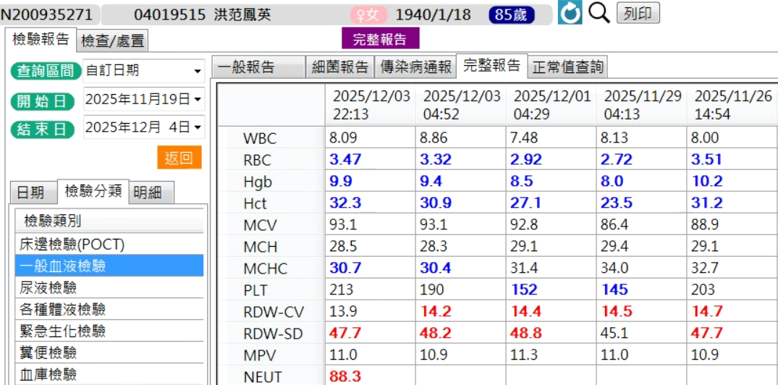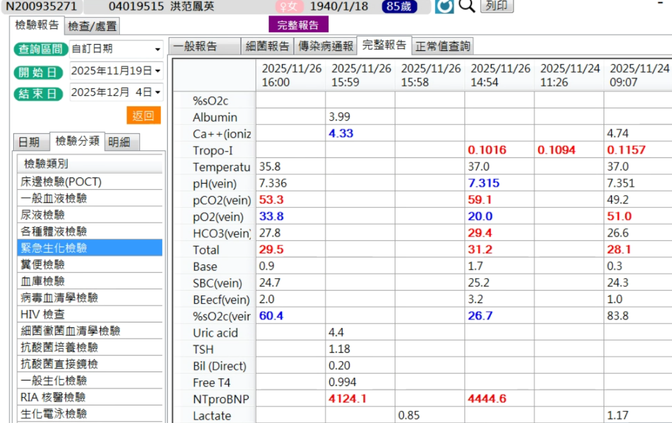
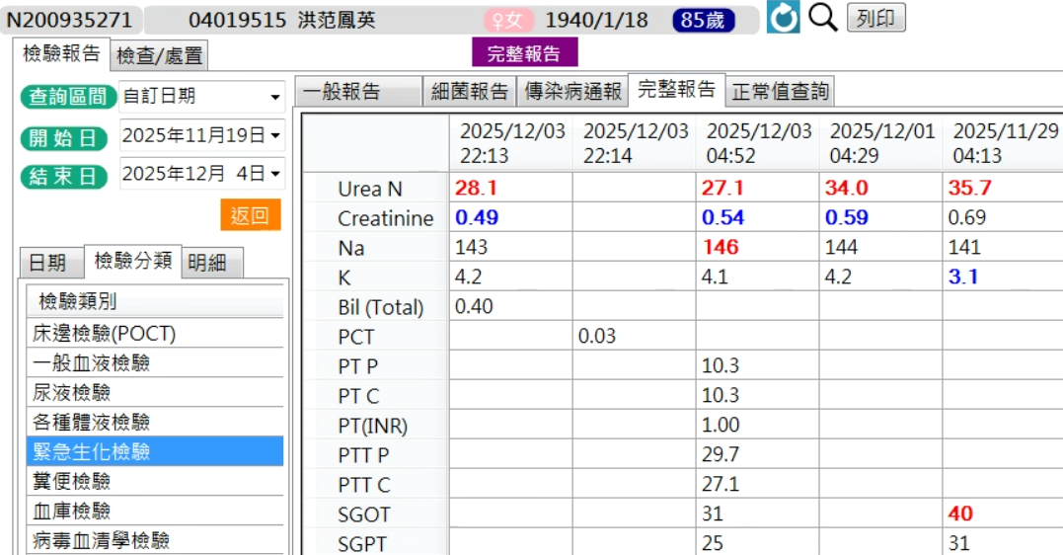
GFR: 58.5
===============================================================================
8. 就醫紀錄
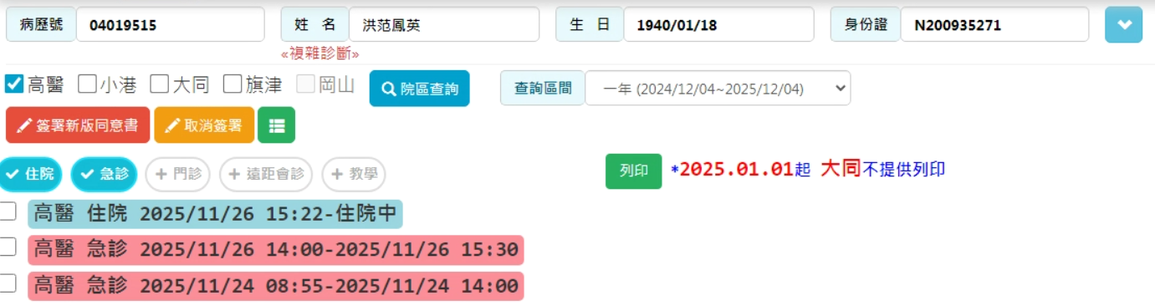

She is a 85-year-old woman with underlying disease of:
# severe aortic stenosis
- 2020/12/31 heart echo: severe AS: AVA(VTI)=0.67cm2, Max PG=61.17mmHg, Mean PG=38.73mmHg, Vmax=3.91m/s; LVEF 75%
- 2025/01/13 holter: Sinus rhythm with rate 58-127/min and mean 75/min. moderate APC+VPC
# Hypertension
# Hyperlipidemia
# Post thyroidectomy
# Left ICA (internal carotid artery) 50~70% Stenosis
# Anxiety disorder
Her ADL (activities of daily living) was totally independent without NG (nasogastric) or foley indwelled.
According to the patient's statement, she was diagnosed with severe AS (aortic stenosis) in 2020. This time, she has suffered from dizziness followed by syncope on 11/22 and 11/24 after falling off a motorcycle accidentally. Associated symptoms included consciousness change and she reported that she remembered the events before and after the syncope. She denied aura, nausea, vomiting, headache, fever, urinary incontinence, seizure, limb weakness, or other symptoms.
Due to the above problems, she came to our ED (emergency department) on 11/24. Under the concern of cardiogenic syncope, she was referred to our CV (cardiovascular) OPD (Outpatient Department) and was admitted to the CCU (cardiac care unit) for further management.

List of Diagnosis (Problem List)
# Severe aortic stenosis
- 2020/12/31 heart echo: severe AS: AVA(VTI)=0.67cm2, Max PG=61.17mmHg, Mean PG=38.73mmHg, Vmax=3.91m/s; LVEF 75%
- 2025/11/27 cardiac echo: Very Severe AS(AVA:0.67cm2, Vmax:5.61m/s, Peak PG:126mmHg, Mean PG:76mmHg)、 estimated LVEF (left ventricular ejection fraction ) =58.4% by M-mode; 57.3% by Simpson's method), Impaired LV (left ventricle) diastolic function with elevated LV (left ventricle) filling pressure
- 2025/11/28 CAG (coronary angiography): no stenosis, and severe aortic stenosis, post balloon aortic valvuloplasty
- 2025/12/01 heart CT: Aortic valve opening:0.63cm^2, Mitral valve coaptation gap at the A2-P2:7.4mm^2; RVEF:49%, LVEF:59%, LAEF:17%
# Acute respiratory failure, HF (heart failure) related
# Acute decompensated heart failure, favor Severe aortic stenosis related
- post intubation on 11/26
---------Underlying disease-------
# Hypertension
# Hyperlipidemia
# Post thyroidectomy
# Left ICA (internal carotid artery) 50~70% Stenosis

Assessment and Plan
# Severe aortic stenosis
- 2025/11/27 cardiac echo: Very Severe AS(AVA:0.67cm2, Vmax:5.61m/s, Peak PG:126mmHg, Mean PG:76mmHg)、 estimated LVEF (left ventricular ejection fraction ) =58.4% by M-mode; 57.3% by Simpson's method), Impaired LV (left ventricle) diastolic function with elevated LV (left ventricle) filling pressure
- 2025/11/28 CAG (coronary angiography): no stenosis, and severe aortic stenosis, post balloon aortic valvuloplasty
- 2025/12/01 heart CT: Aortic valve opening:0.63cm^2, Mitral valve coaptation gap at the A2-P2:7.4mm^2; RVEF:49%, LVEF:59%, LAEF:17%
# Acute respiratory failure, HF (heart failure) related
# Acute decompensated heart failure, favor Severe aortic stenosis related
- post intubation on 11/26
→ keep ventilator support
→ monitor respiratory pattern and SpO2 (pulse oximeter oxygen saturation)
→ Arranged TAVI (transcatheter aortic valve implantation) on 12/04
======================================================================
11. STS Score : Risk of Mortality：13.4%
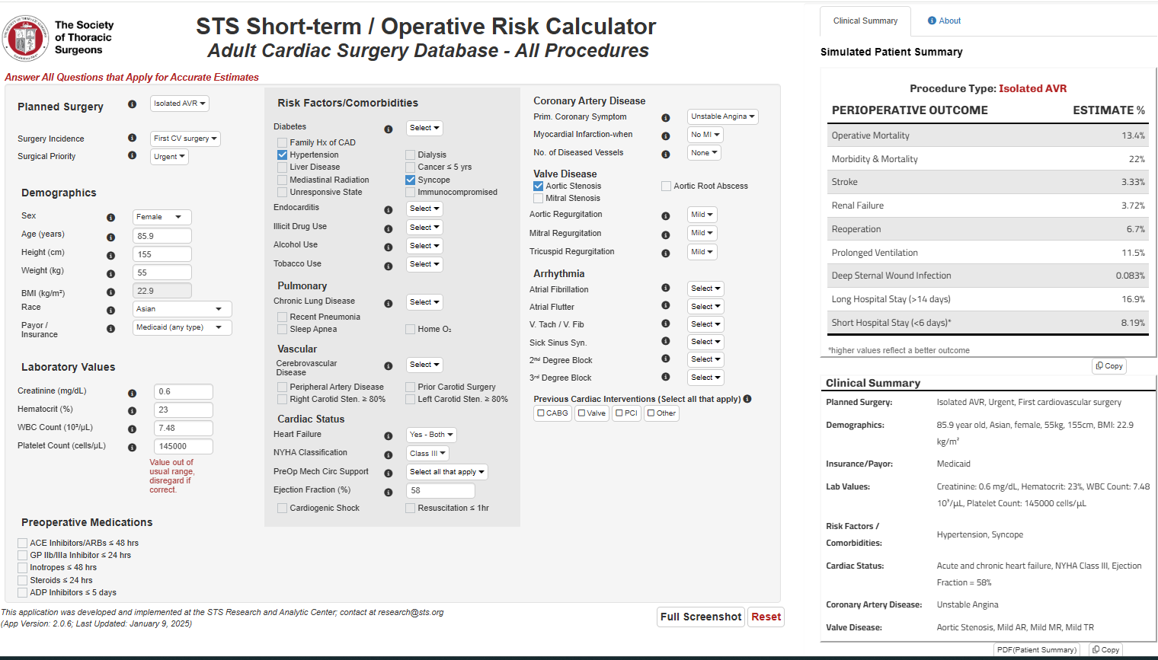
12.二位心臟外科專科醫師判定無法以傳統開心手術進行主動脈瓣膜置換或開刀危險性過高
