Expert Feedback is Does Not Always Mean High Quality Feedback

| Tricia J. Ngoon & Scott Klemmer  Design Lab, UC San Diego  {tngoon, srk}@ucsd.edu |
| --- |

# ABSTRACT

Paste the appropriate copyright/license statement here. ACM now supports three different publication options:

* ACM copyright: ACM holds the copyright on the work. This is the historical approach.
* License: The author(s) retain copyright, but ACM receives an exclusive publication license.
* Open Access: The author(s) wish to pay for the work to be open access. The additional fee must be paid to ACM.

This text field is large enough to hold the appropriate release statement assuming it is single-spaced in Times New Roman 8-point font. Please do not change or modify the size of this text box.

Each submission will be assigned a DOI string to be included here.

Good feedback is a critical part of the learning process, particularly in creative fields. Expert feedback is often hailed as the highest quality feedback due to experts’ domain knowledge and experience. However, even among experts, good feedback is rare. This short paper presents an analysis of expert feedback given to over <<x>> students from three iterations of an undergraduate design course. We found that from over <<x>> feedback comments, only <<x%>> were considered being of high quality. Our results suggest that though expert feedback is often highly valued from students, it is not always helpful and greater efforts should be made to teach instructors provide more effective and helpful feedback.

## Author Keywords

Authors’ choice; of terms; separated; by semicolons; commas, within terms only; this section is required.

## ACM Classification Keywords

H.5.m. Information interfaces and presentation (e.g., HCI): Miscellaneous; See<http://acm.org/about/class/1998> for the full list of ACM classifiers. This section is required.

# INTRODUCTION

From writing essays to developing web applications, formative, iterative feedback is critical to the success of creative projects. Both giving and receiving feedback encourage self-reflection and critical thinking upon one’s work. In educational settings, feedback is especially important for showing students where they are, where they should be, and how to get there. Unfortunately, the practice of giving good feedback is not an explicitly taught skill. Even experts are often unware that their feedback is ineffective.

While peer feedback is more easily scaled in large educational settings, expert feedback is more valued by learners. Recently, systems have emphasized the potential reuse of expert feedback to allow this feedback to better scale.

## What are the Characteristics of Good Feedback?

Effective feedback in general is specific, actionable, and justified. Specific feedback is directly related to a particular part of the work or rubric criteria. Actionable feedback provides a concrete suggested next step for learners to progress. Justified feedback provides an explanation or reasoning to help learners understand why the feedback was given.

The detection of these characteristics is of great interest to natural language processing research in the context of detecting whether feedback is actionable and how to improve this feedback.

This paper provides an analysis of feedback provided by teaching staff from three iterations of an undergraduate design course. <<x>> total feedback comments from <<x>> teaching assistants (TAs) were rated in terms of whether they were specific, actionable, and/or justified. to provide evidence that even experienced feedback givers often fail to provide effective and high-quality feedback.

# METHODS

## Feedback Dataset

Our dataset consisted of 4,077 total distinct feedback comments. These comments were provided by 20 different TAs over the course of three iterations of an undergraduate design course. TAs provided feedback comments on a total of 10 weekly assignments for each course iteration. These assignments ranged from written explanations to paper prototypes to functional web applications.

## Feedback Ratings

Two independent raters rated whether each feedback comment was specific, actionable, or justified with a binary 1 for yes or 0 for no. Each rater rated a half of the total dataset. An overlap sample consisting of 30% of the total overall sample was rated by both raters as a measure of interrater reliability. The interrater reliability between the two raters was high (<<x>>).

# results

The styles contained in this document have been modified from the default styles to reflect ACM formatting conventions. For example, content paragraphs like this one are formatted using the Normal style.

## Most Feedback is Not Specific, Actionable, & Justified

**Longer Comments Tend to be of Higher Quality**

## Key Words and Phrases May Be Indicative of Quality

# Discussion

The heading of a section should be in Arial 9-point bold, all in capitals (Heading 1 style). Sections should not be numbered.

## Subsections

Headings of subsections should be in Arial 9-point bold with initial letters capitalized (Heading 2 style). For sub-sections and sub-subsections, a word like *the* or *of* is not capitalized unless it is the first word of the heading.

### Sub-subsections

Headings for sub-subsections should be in Arial 9-point italic with initial letters capitalized (Heading 3 style).

# FIGURES/CAPTIONS

Place figures and tables at the top or bottom of the appropriate column or columns, on the same page as the relevant text (see Figure 1). A figure or table may extend across both columns to a maximum width of two columns, or 17.78 cm (7 in.).

Captions should be Times New Roman 9-point bold (Caption style). They should be numbered (e.g., “Table 1” or “Figure 2”), centered, and placed beneath the figure or table. The words “Figure” and “Table” should be spelled out (e.g., “Figure” rather than “Fig.”) wherever they occur.

All figures should also include alt text for improved accessibility. In Word, right click the figure, and select Format Picture | Layout | Alt Text). Papers and notes may use color figures, which are included in the page limit; the figures must be usable when printed in black-and-white in the proceedings.

The paper may be accompanied by a short video figure up to five minutes in length. However, the paper should stand on its own without the video figure, as the video may not be available to everyone who reads the paper.

## Inserting Images

Occasionally MS Word generates larger-than-necessary PDF files when images inserted into the document are manipulated in MS Word. To minimize this problem, use an image editing tool to resize the image at the appropriate printing resolution (usually 300 dpi), and then insert the image into Word using Insert | Picture | From File.

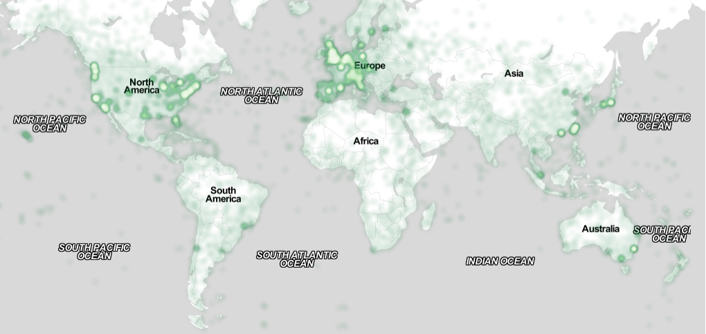

Figure . Sample of a wide figure. Be sure to place at the top or bottom of the page. Ensure that important information is legible in both black-and-white and color printing. Image: CC-BY-ND ayman on Flickr.

## Table Style

The text of tables will format better if you use the Table Text style (as in Table 1). If you do not use this style, then you may want to adjust the vertical spacing of the text in the tables. To adjust the spacing of text in a table in Word, use Home | Paragraph | Indents and Spacing. Generally, text in each field of a table will look better if it has equal amounts of spacing above and below it, as in Table 1. Table captions should be placed below the table. We recommend table lines be 1 point, 25% black. Minimize use of unnecessary table lines.

For improved accessibility, header rows of tables should be marked. In Word, right-click a header row, and select Table Properties | Row | Repeat as header…

# LANGUAGE, STYLE AND CONTENT

The written and spoken language of SIGCHI is English. Spelling and punctuation may use any dialect of English (e.g., British, Canadian, US, etc.) provided this is done consistently. Hyphenation is optional. To ensure suitability for an international audience, please:

* Write in a straightforward style.
* Try to avoid long or complex sentence structures.
* Use common and basic vocabulary (e.g., use the word “unusual” rather than the word “arcane”).
* Briefly define or explain all technical terms that may be unfamiliar to readers.
* Explain all acronyms the first time they are used in your text—e.g., “Digital Signal Processing (DSP)”.
* Explain local references (e.g., not everyone knows all city names in a particular country).
* Explain “insider” comments. Ensure that your whole audience understands any reference whose meaning you do not describe (e.g., do not assume that everyone has used an Android phone, or a particular application).
* Explain colloquial language and puns. Understanding phrases like “red herring” may require a local knowledge of English. Humor and irony are difficult to translate.
* Use unambiguous forms for culturally localized concepts, such as times, dates, currencies, and numbers (e.g., “1-5- 97” or “5/1/97” may mean 5 January or 1 May, and “seven o’clock” may mean 7:00 am or 19:00). For currencies, indicate equivalences: “Participants were paid ₩22, or roughly US$29.”
* Be careful with the use of gender-specific pronouns (*he*, *she*) and other gendered words (*chairman*, *manpower*, *man-months*). Use inclusive language that is gender-neutral (e.g., *she* *or* *he*, *they*, *s/he*, *chair*, *staff*, *staff-hours*, *person-years*). See the *Guidelines for Bias-Free Writing* for further advice and examples regarding gender and other personal attributes [9]. Be particularly aware of considerations around writing about people with disabilities.
* If possible, use the full (extended) alphabetic character set for names of persons, institutions, and places (e.g., Grønbæk, Lafreniére, Sánchez, Nguyễn, Universität, Weißenbach, Züllighoven, Århus, etc.). These characters are already included in most versions and variants of Times, Helvetica, and Arial fonts.

# Accessibility

The Executive Council of SIGCHI has committed to making SIGCHI conferences more inclusive for researchers, practitioners, and educators with disabilities. As a part of this goal, the all authors are asked to work on improving the accessibility of their submissions. Specifically, we encourage authors to carry out the following five steps:

1. Add alternative text to all figures
2. Mark table headings
3. Generate a tagged PDF
4. Verify the default language
5. Set the tab order to “Use Document Structure”

For more information and links to instructions and resources, please see: <http://chi2016.acm.org/accessibility>.

# Page Numbering, Headers, and Footers

Your final submission should not contain footer or header information at the top or bottom of each page. Specifically, your final submission should not include page numbers. Initial submissions may include page numbers, but these *must* be removed for camera-ready. Page numbers will be added to the PDF when the proceedings are assembled.

# Producing and testing PDF files

We recommend that you produce a PDF version of your submission well before the final deadline. Your PDF file must be ACM DL Compliant. The requirements for an ACM Compliant PDF are available at:

<http://sheridanprinting.com/typedept/ACM-distilling-settings.htm>

When creating your PDF from Word, ensure that you generate a tagged PDF from improved accessibility. This can be done by using the Adobe PDF add-in, also called PDFMaker. Select Acrobat | Preferences from the ribbon and ensure that “Enable Accessibility and Reflow with tagged Adobe PDF” is selected. You can then generate a tagged PDF by selecting “Create PDF” from the Acrobat ribbon. Test your PDF file by viewing or printing it with the same software the publisher will use, Adobe Acrobat Reader Version 10, which is widely available at no cost. Note that most reviewers will use a North American/European version of Acrobat Reader, so please check your PDF accordingly.

# Conclusion

It is important that you write for the SIGCHI audience. Please read previous years’ proceedings to understand the writing style and conventions that successful authors have used. State clearly what you have done, not merely what you plan to do, and explain how your work is different from previously published work, i.e., *the unique contribution that your work makes to the field*. Please consider what the reader will learn from your submission, and how they will find your work useful. If you write with these questions in mind, your work is more likely to be successful, both in being accepted into the conference, and in influencing the work of our field.

# ACKNOWLEDGMENTS

Sample text: We thank all the volunteers, and all publications support and staff, who wrote and provided helpful comments on previous versions of this document. Authors 1, 2, and 3 gratefully acknowledge the grant from NSF (#1234-2012-ABC). This is just an example.

# References format

References must be the same font size as other body text. References should be in alphabetical order by last name of first author. Example reference formatting for individual journal articles [3], articles in conference proceedings [7], books [9], theses [10], book chapters [11], an entire journal issue [6], websites [1,4], tweets [1], patents [5], and online videos [8] is given here. This formatting is a slightly edited version of the format automatically generated by the ACM Digital Library (http://dl.acm.org) as “ACM Ref”. More details of reference formatting are available at:

<http://www.acm.org/publications/submissions/latex_style>

Note that the Hyperlink style used throughout this document uses blue links; however, URLs that appear in the references section may appear in black.

# REFERENCES

1. @_CHINOSAUR. 2014. VENUE IS TOO COLD. #BINGO #CHI2016. Tweet. (1 May, 2014). Retrieved February 2, 2014 from https://twitter.com/_CHINOSAUR/status/461864317415989248
2. ACM. How to Classify Works Using ACM’s Computing Classification System. 2014. Retrieved August 22, 2014 from [http://www.acm.org/class/how_to_use.html](http://www.acm.org/class/how_to_use.html%20)
3. Ronald E. Anderson. 1992. Social impacts of computing: Codes of professional ethics. *Soc Sci Comput Rev* 10, 2: 453-469.
4. Anna Cavender, Shari Trewin, Vicki Hanson. 2014. Accessible Writing Guide. Retrieved August 22, 2014 from <http://www.sigaccess.org/welcome-to-sigaccess/resources/accessible-writing-guide/>
5. Morton L. Heilig. 1962. Sensorama Simulator, U.S. Patent 3,050,870, Filed January 10, 1961, issued August 28, 1962.
6. Jofish Kaye and Paul Dourish. 2014. Special issue on science fiction and ubiquitous computing. *Personal Ubiquitous Comput*. 18, 4 (April 2014), 765-766. <http://dx.doi.org/10.1007/s00779-014-0773-4>
7. Scott R. Klemmer, Michael Thomsen, Ethan Phelps-Goodman, Robert Lee, and James A. Landay. 2002. Where do web sites come from?: capturing and interacting with design history. In *Proceedings of the SIGCHI Conference on Human Factors in Computing Systems* (CHI '02), 1-8. <http://doi.acm.org/10.1145/503376.503378>
8. Psy. 2012. Gangnam Style. Video. (15 July 2012.). Retrieved August 22, 2014 from <https://www.youtube.com/watch?v=9bZkp7q19f0>
9. Marilyn Schwartz. 1995. *Guidelines for Bias-Free Writing.* Indiana University Press.
10. Ivan E. Sutherland. 1963. *Sketchpad, a Man-Machine Graphical Communication System*. Ph.D Dissertation. Massachusetts Institute of Technology, Cambridge, MA.
11. Langdon Winner. 1999. Do artifacts have politics? In *The Social Shaping of Technology* (2nd. ed.), Donald MacKenzie and Judy Wajcman (eds.). Open University Press, Buckingham, UK, 28-40.