**COMP1752 Object-Oriented Programming**

Student ID: GCS220690

Name: Tô Nguyễn

To design and implement a simulation of a video player app I use Visual Studio Code as a useful IDE to code and run. To begin with, I design a first interface with 4 main features: check videos, create video list, update video and filter videos by director’s name in video_player.py as below :

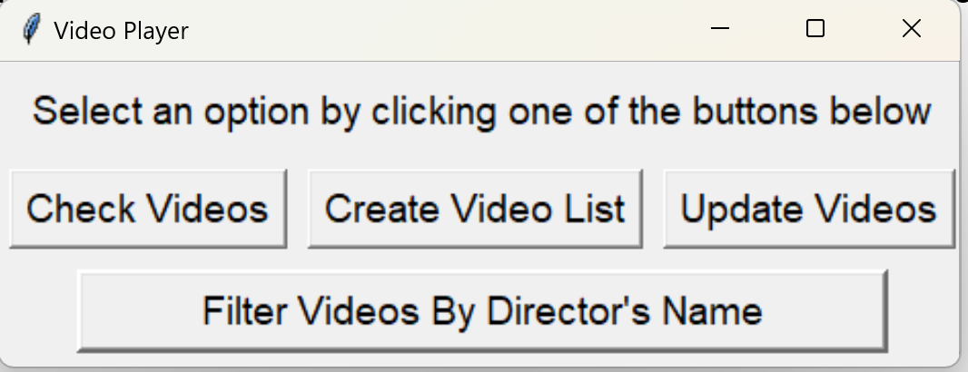

Then I will explain what each feature does. Check Videos feature is coded in check_video.py with purposes that list all videos in the database when people click List All Videos button and display them in Text area including video number, title and director and then If the user want to see more information of a specific video, they have to enter video number and click Check Video button and the information will be retrieved from csv file and display in Text area with Title, Director, Rating and Plays and create a Back button to return to the interface of video_player.py.

The interface and features of check_videos.py as below:

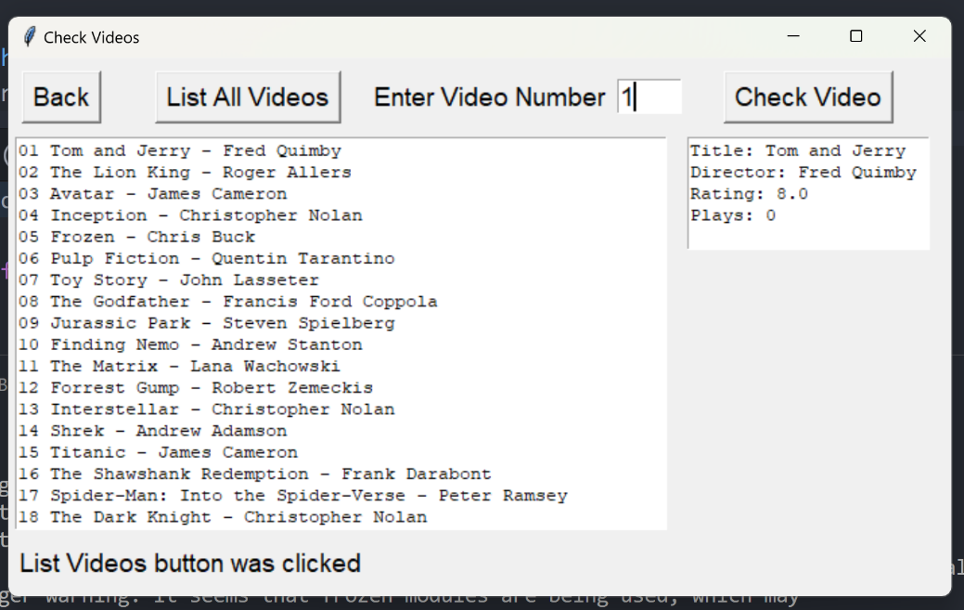

With the second function Create Videp List was designed and implemented in create_video_list.py. Firstly, The interface will display all videos in the database when use click List All Videos button and then User can add video to playlist by enter a video number to entry area and click Add to Playlist, the user can add multi videos at the same time and all of them will be displayed in text area with video number, title and played. If the use click Play button, all of videos’ Played in playlist will be incremented by 1. Otherwise, the user click Reset button all videos’ Played in playlist will reset to 0 and clear text area.Furthermore the user can export the playlist into file text when clicking Export button and enter filepath the Back button functions as check_videos.py.

The interface and features of create_video_list.py as below:

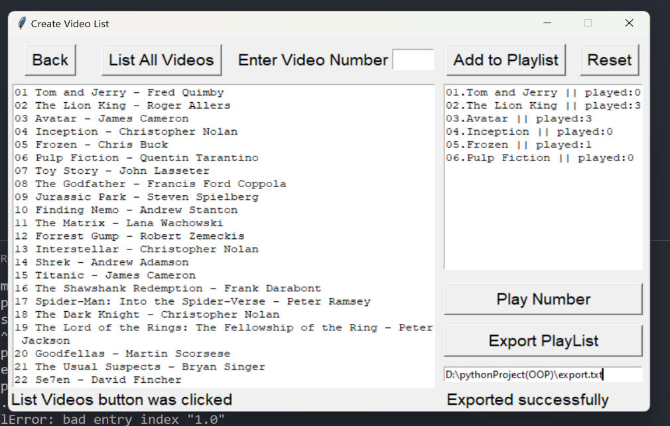

The Update Rating feature also allow users List all video and displayed in text area. The user can update rating for a specific video by entering video number into Entry and write new rating for the video after writing the user has to click Update Rating button to update new rating to the databse(file csv) and display in text area with Title, Director, Rating and Plays. The Back button functions as check_videos.py.

The interface and features of update_videos.py as below:

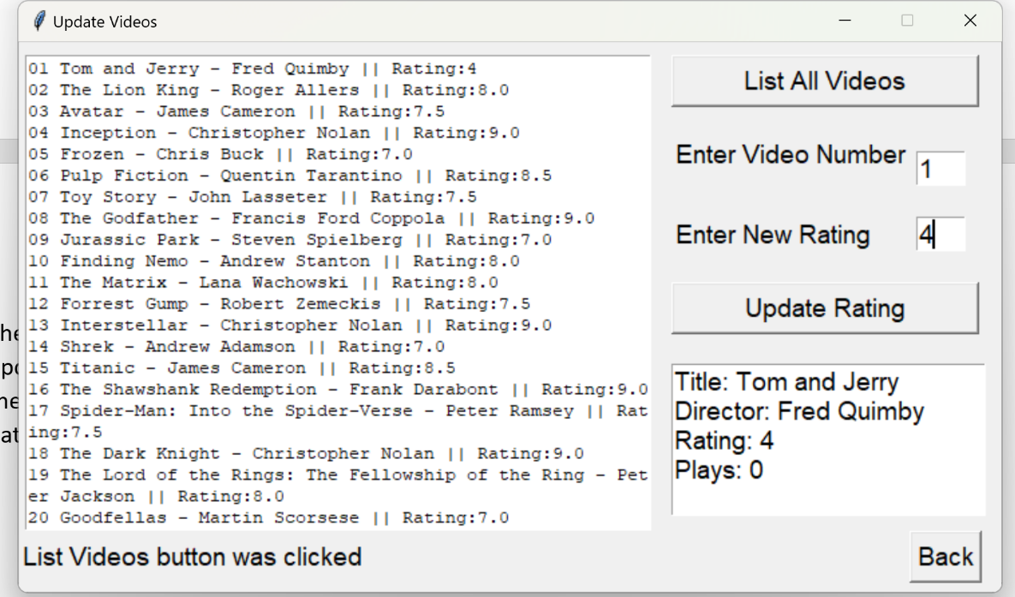

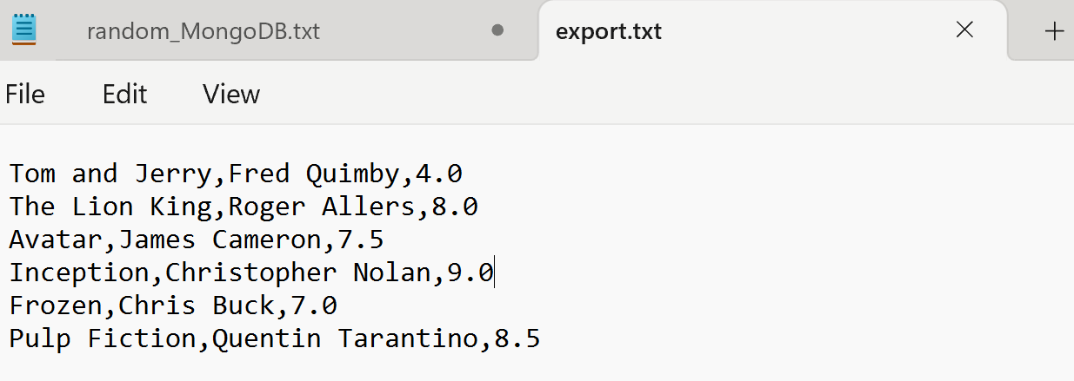

And the final feature filter videos by director’s name was coded in filter_videos.py. the interface has a comboBox that contains all director’s name for the user to choose. When the user choose a name all videos of the director will list and display in text are with title, director and rating. One top of that I also caculate total of videos that the director has . The Back button functions as check_videos.py.

The interface and features of filter_videos.py as below:

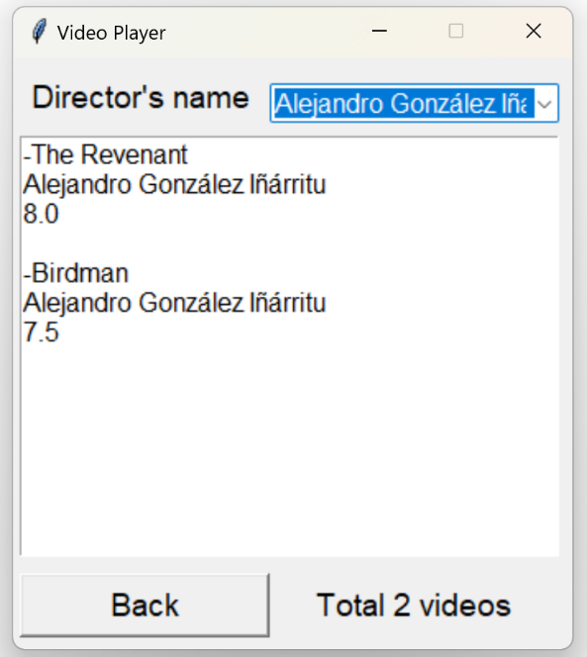

Hightlist function:

To get name, get director,get rating, get plays that all information will be read from file csv and saved to a list, so when user enter a video number. The system has to compare one by one between the number entered and the number in the List with linear search algorithm, that is why I use binary search algorithm to shorten the search time and elevate produtiviy in file video_library.py.

In testing.py I test some cases can cause errors when users enter input:

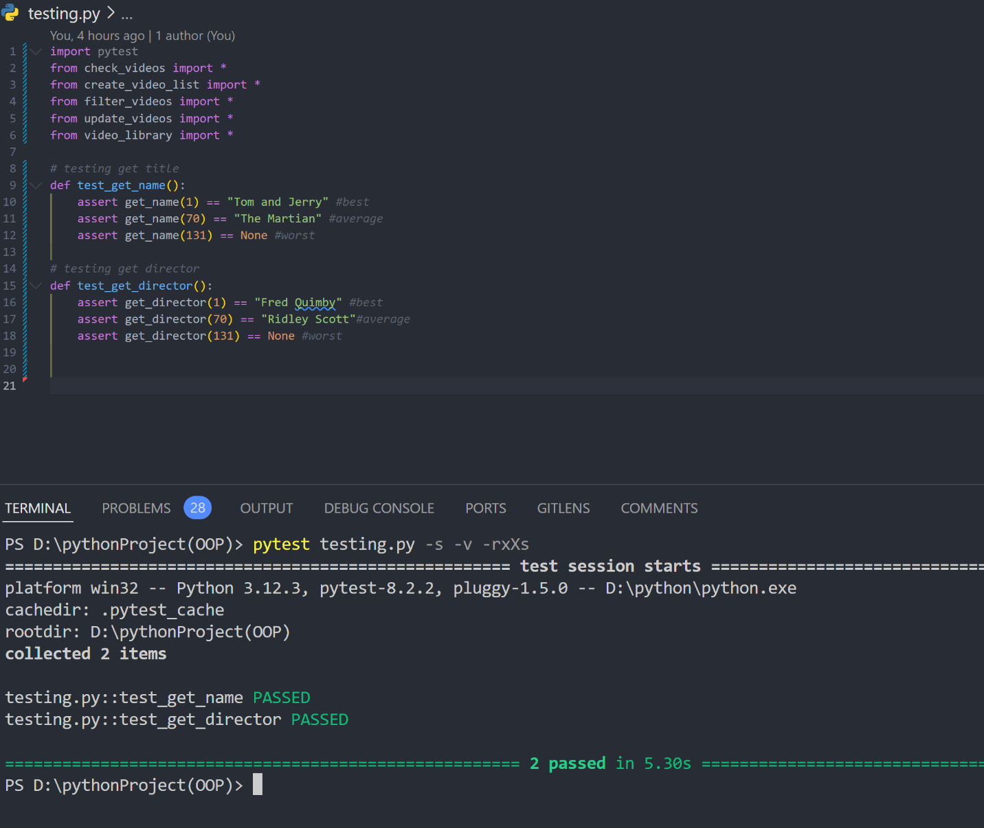

If I have more time I will learn more to develop the app with more features like instead of showing information my app will run a real video and the user can search video by its name with elastic search. I think the easy part in the course work is design interface and the hardest part is coding function add read information from database. But after learning this course and doing the coursework I absorb and use OOP in programming fluently. I think I will learn more programing languages and use the knowledge that I have learnt to create a useful app that can use in real life.