===== Hard Constraints Math - Complete Boolean / Pseudo-Boolean Constraint Encoding

C1 | hard | Activation: 1[j covered, D=1] iff ∃ (i,z,t,p) with x[i,z,t,p]=1 and TRAP_TECHNIQUES[i]=j and D=1. Detection requires zone-pinned undiscovered deployment. | c[j,a,t]

This is a rule for a trap detection system (think cybersecurity or military). It defines when a "trap technique" counts as detected in a specific zone.
- j = a trap technique (like a decoy, tripwire, or honeypot)
- D=1 = "detection happened"
- x[i,z,t,p]=1 = a specific asset i was deployed in zone z, at time t, with profile p
- TRAP_TECHNIQUES[i]=j = that asset uses trap technique j
The ∃ ("there exists") means: detection fires if you can find at least one deployed asset that (a) is in the relevant zone, (b) uses the trap technique in question, and (c) hasn't been discovered yet.
The three gates in plain terms:
- Zone pinned — the asset must be in the right zone. Traps in the wrong zone don't count toward this zone's detection score.
- Technique match — the asset must use trap technique j specifically. Different trap types are tracked separately.
- Undiscovered — the critical one. A burned/exposed trap is useless. Only a live, hidden trap can trigger detection. This prevents the formula from counting dead traps as active coverage.
The ∃ ("there exists") is the final key: you only need one qualifying asset to satisfy all three gates, and detection fires. You don't need all assets to qualify — just one.
In short: "Has the adversary entered a zone where at least one live, zone-matched trap of type j is hiding? If yes → detected."

=====

C2 | PB | Σ_{i∈K,z,p} cost[i,z,p]·x[i,z,t,p] ≤ B_t ∀t. Encoded via totalizer cardinality network. | carry bits in totalizer

This is a budget constraint — at every time step t, the total cost of all deployed assets must not exceed the budget B_t.
- i∈K = asset types (from the set K)
- z = zones, p = profiles (configurations)
- cost[i,z,p] = what it costs to deploy asset i in zone z with profile p
- x[i,z,t,p] = 1 if that asset is actually deployed (0 if not)
- B_t = budget available at time t
- ∀t = "for all time steps" — must hold every period
- The totalizer cardinality network is a SAT/hardware trick: instead of doing real arithmetic, it encodes the sum using binary carry bits through a tree of adder circuits — so a SAT solver can check the budget constraint without ever doing actual multiplication or addition.
- Two diagrams tell this story best: first the budget constraint itself, then the totalizer network that implements it.
The phrase "carry bits in totalizer" from your formula is literally pointing at those propagating carry bits between levels of the adder tree. The whole budget constraint gets compiled down to a handful of SAT clauses — no real numbers involved at solve time.
=====

C3 | PB | Σ_{i,p} x[i,z,t,p] ≤ B2[z,t] ∀z,t. Per-zone totalizer network. | per-zone carry bits

- C2 asked: "is total spend across everything ≤ budget?"
- C3 asks: "in each specific zone z, at each time t, is the count of deployed assets ≤ that zone's capacity B2[z,t]?"
Notice what dropped out of the sum: cost[i,z,p] is gone. This isn't a cost budget — it's a slot/count budget. You're just counting how many assets are deployed in zone z at time t, regardless of their cost. Each zone has its own independent cap B2[z,t], and each zone runs its own separate totalizer network to enforce it.
The ∀z,t means this must hold for every zone and every time step — so if you have 5 zones and 10 time steps, that's 50 independent constraints all running in parallel.

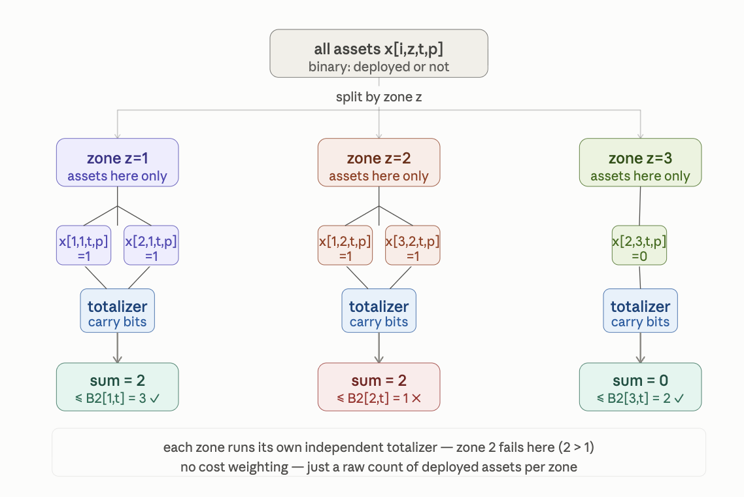

======

C4 | hard | (¬x[i,z,t,p] ∨ ¬x[i′,z,t,p′]) ∀(i,i′)∈C, all z,t,p,p′. Pairwise type conflict. | none

This is a mutual exclusion clause — the simplest possible SAT constraint. It says: for every pair of asset types (i, i′) that are known to conflict, you cannot deploy both of them in the same zone z at the same time t, regardless of which profiles p and p′ they use.
- C = the set of conflicting pairs — a pre-computed list like {(drone, radar_jammer), (decoy_A, decoy_B), ...}
- ¬x[i,z,t,p] = "asset i is NOT deployed"
- ∨ = OR
- The whole clause = "at least one of these two must be off"
The ∀(i,i′)∈C, all z,t,p,p′ part means this single clause template stamps out one clause for every combination of conflicting pair × zone × time step × profile pair — potentially thousands of clauses, but each one is trivially tiny.
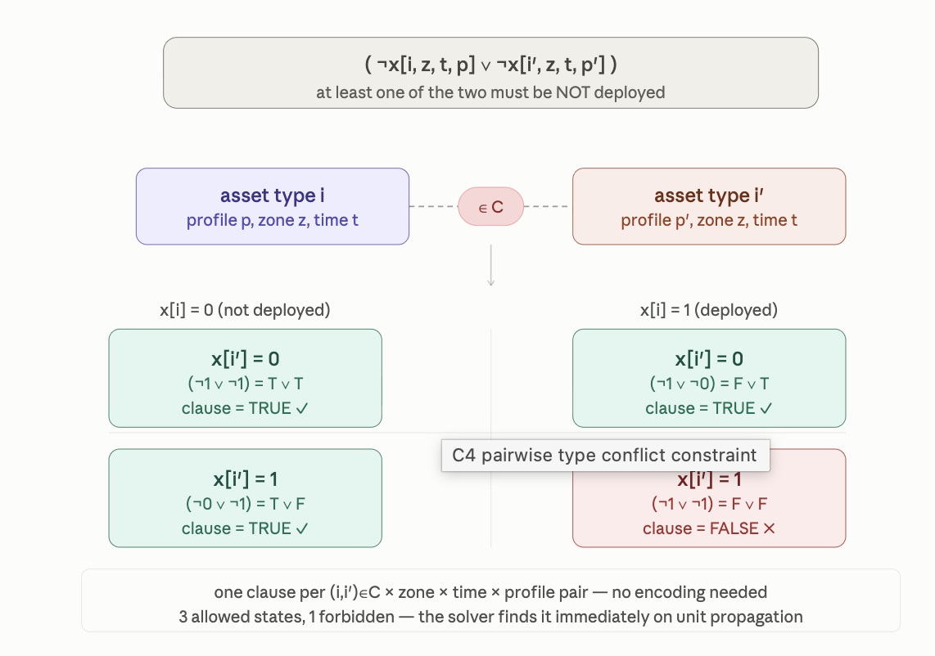

======

C5 | hard | ¬x[i,z,t,p] unit clause ∀ crossing type i, (z,z′)∈I₂, all t,p. Air-gap isolation. | none

- ¬x[i,z,t,p] alone, with no OR, no partner
- It means: "asset i is unconditionally forbidden in zone z" — not "forbidden if something else is true", just flat-out banned
- The reason: asset i is a crossing type — something that spans or bridges zones — and the pair (z,z′)∈I₂ is an air-gap pair, two zones that must never be bridged
- Deploying a crossing asset there would punch a logical hole through the isolation boundary
∀ crossing type i, (z,z′)∈I₂, all t,p means: stamp this ban out for every crossing asset, every air-gapped zone pair, every time step, every profile. No exceptions, no conditions.
======

C5b | hard | ¬x[i,z,t,p] unit clause ∀(i,p)∉GK, all z,t. Mimicry plausibility. | none

- C5b bans an asset because of what it is — specifically, because the combination (i, p) is not in the set GK of plausible mimics
GK = "good/known" mimicry pairs — a pre-vetted list of (asset type, profile) combinations that are believable as genuine decoys. If a pair (i,p) is not on that list, it means the asset-profile combination would look fake, suspicious, or physically implausible to an adversary. Deploying it would be worse than useless — it would tip off the adversary that something artificial is present.
So ∀(i,p)∉GK means: for every asset-profile pair that failed the plausibility check, ban it everywhere — every zone, every time step, no exceptions.
A mimicry system only works if the adversary cannot distinguish the decoy from the real thing. An implausible deployment — wrong signature for that profile, wrong asset type for that context — actively harms the operation by revealing that deception is occurring. It's not just unhelpful, it's counterproductive.

====

C6 | PB | ph[π,h,t] ≤ Σ_{p} x[i,zone(π,h),t,p]·D ∀π,h,t. Path-hop coverage requires active undiscovered deployment. | ph[π,h,t]

can only claim that hop h on path π is covered at time t if there is genuinely at least one active, undiscovered asset deployed in the zone that hop passes through.
- π = a path (a route an adversary might take through the system)
- h = a specific hop along that path (step 1, step 2, ...)
- zone(π,h) = the zone that hop h of path π passes through — a lookup function, not a free variable
- ph[π,h,t] = binary indicator: is hop h of path π covered at time t? (1 = yes, 0 = no)
- x[i,zone(π,h),t,p] = is asset i with profile p deployed in that zone at time t?
- D = a big scaling constant — if any asset is deployed (Σ ≥ 1), then Σ·D ≥ D ≥ 1, which is always ≥ ph[π,h,t] since ph is binary
So the logic is: ph can be 1 only if the right-hand side is ≥ 1, which only happens when at least one asset is actually deployed in zone(π,h). If no asset is there, the sum is 0, forcing ph[π,h,t] = 0 — you cannot falsely claim coverage.
D is a classical Big-M trick: it converts "at least one asset exists" (a count) into a bound that dominates the binary ph variable without needing to enumerate which asset covers it.
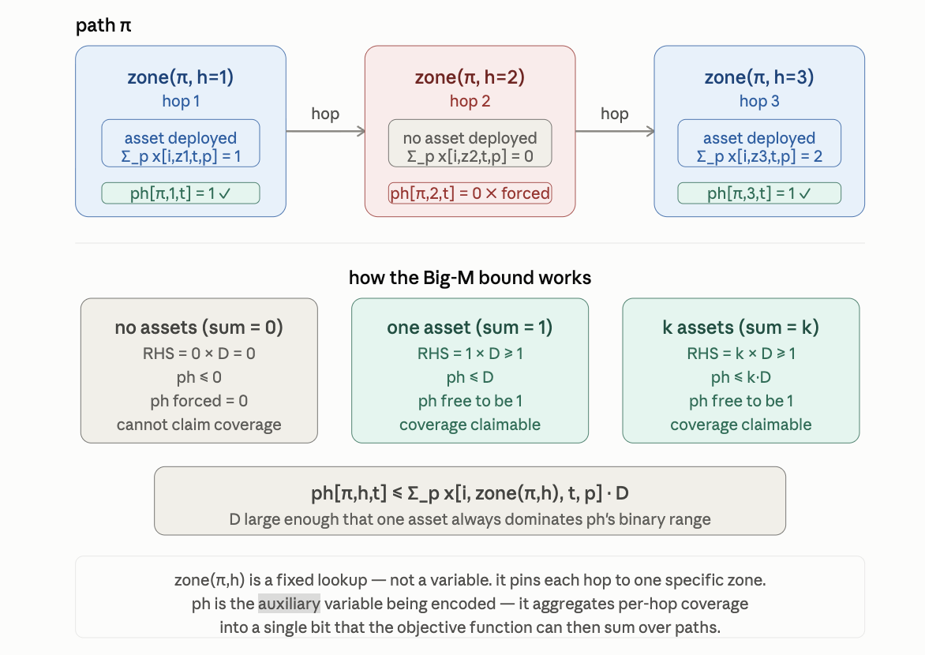

Why ph exists as a separate variable — and why D is the right tool:
The optimizer's objective ultimately wants to maximise path coverage — something like "how many paths are fully covered?" To reason about whole paths, it needs a single bit per hop saying "this hop is covered." That's ph. But ph has to be honest — it can't be set to 1 by the optimizer unless assets are actually there backing it up. C6 is the honesty constraint.
D is chosen to be large enough that even a single deployed asset (Σ = 1) makes the right-hand side ≥ 1, which is all that's needed since ph is binary and can never exceed 1. Setting D = 1 would also work here mathematically, but in practice D absorbs any scaling mismatch between the asset count and the ph range — a standard Big-M safety margin.

======

C7 | hard | e[π,t] ≤ Σ_{h<|π|} ph[π,h,t] ∀π,t. Early interception requires non-final hop covered. | e[π,t]

This constraint defines when early interception of path π at time t is claimable. e[π,t] is a binary indicator meaning "we can intercept the adversary before they reach the end of path π." But you can only claim that if at least one non-final hop along the path is covered.
- e[π,t] = 1 means "early interception is possible on path π at time t"
- |π| = the total number of hops on path π
- h < |π| = all hops except the last one — the "early" hops
- Σ_{h<|π|} ph[π,h,t] = count of how many early hops are covered
So the rule is: e[π,t] can only be 1 if at least one non-final hop is covered. Coverage of the final hop doesn't count for early interception — if you only catch them at the destination, that's not "early."
The encoded variable is e[π,t] itself — it's the auxiliary bit that the objective will later sum over paths to measure total early-interception capability.
The sum on the right is a simple count of covered hops, not weighted, not Big-M scaled — just raw ph bits adding up. Since e is binary (0 or 1), even a single covered early hop (Σ ≥ 1) is enough to free e to be 1.

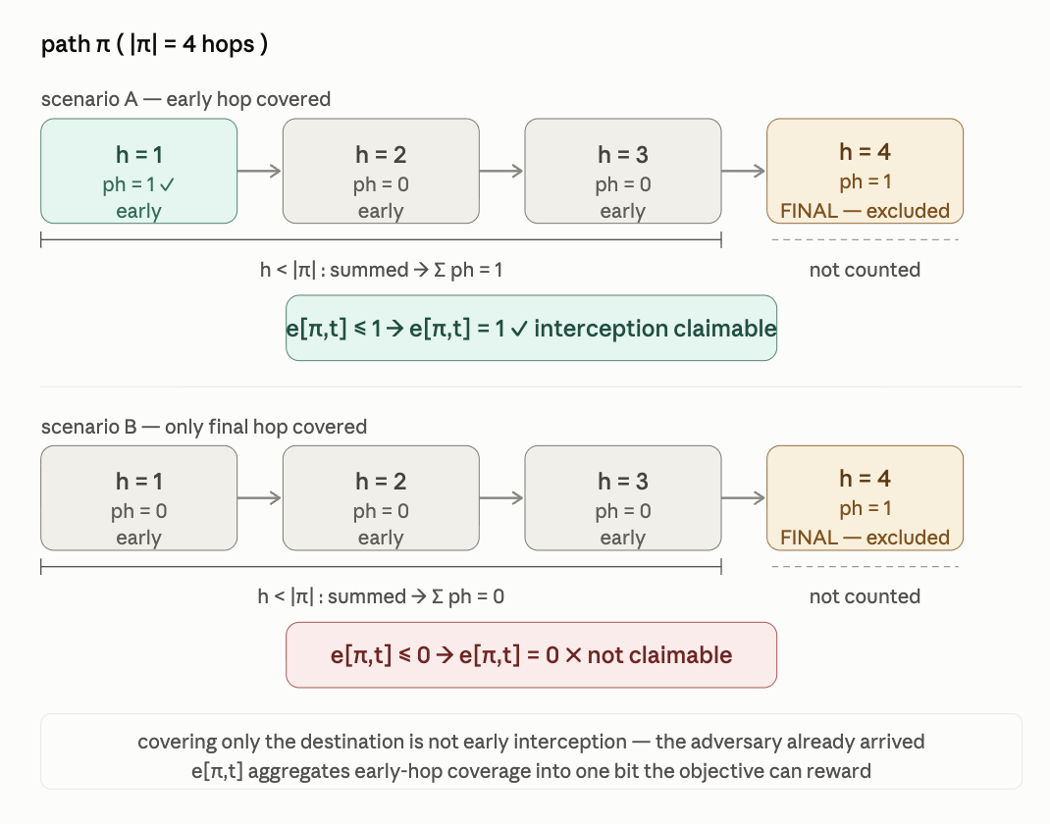

=====

C8 | PB | ch[i,z,p,t] ≥ x[i,z,t,p]−x[i,z,t-1,p]; ch[i,z,p,t] ≥ x[i,z,t-1,p]−x[i,z,t,p]; Σ_t ch[i,z,p,t] ≤ Δ ∀i,z,p. Type-churn limit. | ch[i,z,p,t]

This constraint tracks and limits how many times any asset i with profile p changes its deployment state in zone z across all time steps. "Churn" = switching between deployed and not-deployed. Each flip — whether deploying or withdrawing — costs one churn unit, and the total across all time is capped at Δ.
Three sub-clauses working together:
- Line 1 ch ≥ x[t] − x[t-1]: if the asset was just switched on (0→1), this is positive (=1), forcing ch to be at least 1 that period
- Line 2 ch ≥ x[t-1] − x[t]: if the asset was just switched off (1→0), this is positive (=1), forcing ch to be at least 1 that period
- Line 3 Σ_t ch ≤ Δ: total churn across all time steps must not exceed the churn budget Δ
Lines 1 and 2 together make ch[i,z,p,t] an absolute-difference detector — it's forced to 1 whenever the deployment status flips in either direction, and free to be 0 when the status stays the same. No single clause can do this alone because absolute value isn't directly expressible in linear arithmetic — you need two one-sided inequalities to capture both directions of change.
The encoded variable ch[i,z,p,t] is the auxiliary churn bit. The optimizer will naturally push it to 0 whenever possible (since it's consuming the Δ budget), so the two lower bounds are the honest constraints stopping it from cheating.

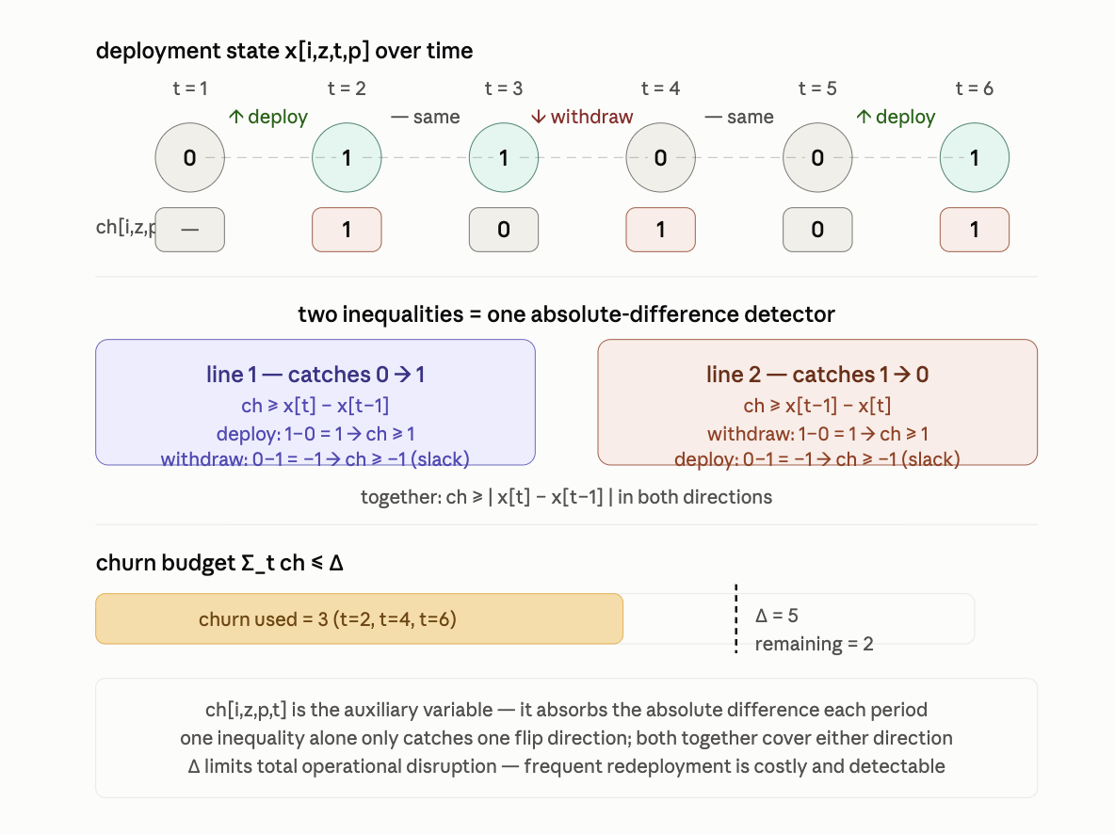

=====

C9 | PB | run_type[i,z,t] = Σ_{s=t-τd+1}^{t} x_present[i,z,s]; u_type[i,z,t]=1 iff run_type≥τ_d (unary counter); (¬u_type[i,z,t] ∨ ¬x[i,z,t+1,p]) hard block. | run_type[i,z,t], u_type[i,z,t]

¬x[i,z,t,p] it just means "asset i is NOT deployed.

This is a fatigue / dwell-time limit. An asset type i that has been continuously present in zone z for τ_d consecutive time steps becomes "burnt out" — it must be withdrawn. The constraint enforces this in three stages:
- Stage 1 — sliding window sum: run_type[i,z,t] counts how many of the last τ_d time steps asset i was present in zone z. It's a rolling window of depth τ_d, not a total-time counter.
- Stage 2 — threshold flag: u_type[i,z,t] = 1 if and only if that window sum hits τ_d — meaning the asset has been present for every single step in the window without a break. This is encoded via a unary counter (a chain of implications, not binary arithmetic).
- Stage 3 — hard block: (¬u_type ∨ ¬x[i,z,t+1,p]) is a 2-clause — if u_type = 1 (burnt out), then x[i,z,t+1,p] must be 0 for all profiles p. The asset cannot be deployed in the next step.
The unary counter in Stage 2 is the interesting encoding choice. Rather than comparing a binary number to a threshold (which needs adder circuits like C2/C3), a unary counter represents the count as a chain of bits b_1, b_2, ..., b_{τd} where b_k = 1 means "count ≥ k." Each step just propagates one more bit — cheap, no carry logic needed.

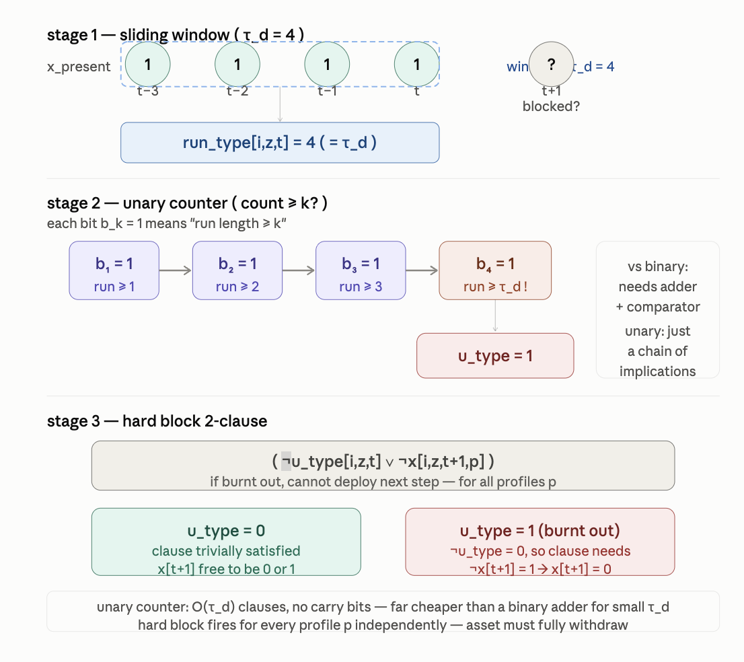

=====

C10 | PB | Σ_t ph[π,h_crit,t] ≥ ⌈ρ_π·H⌉ ∀π. Path persistence on critical hop. | reuses ph[π,h,t]

This is a minimum coverage guarantee for the most important hop on each path. Instead of blocking something (like C5, C9) or defining what a variable means (like C6, C7), C10 is a positive requirement — it demands that critical hop h_crit on path π must be covered for a minimum number of time steps across the whole horizon.
- h_crit = the single most critical hop on path π — pre-designated, not a variable
- ph[π,h_crit,t] = coverage indicator at that hop at time t (already defined by C6)
- Σ_t ph[π,h_crit,t] = total number of time steps that hop is covered across the whole horizon
- ρ_π = a per-path persistence ratio, between 0 and 1 (e.g. 0.75 = must be covered 75% of the time)
- H = total number of time steps in the horizon
- ⌈ρ_π · H⌉ = the ceiling — round up to the nearest integer, so you never get credit for a fractional time step
So the constraint says: path π's critical hop must be covered for at least ⌈ρ_π·H⌉ out of H time steps. If H=10 and ρ_π=0.7, the hop must be covered in at least 7 time steps — not necessarily consecutive, just in total.
The encoding note "reuses ph[π,h,t]" means no new auxiliary variable is introduced — C6 already defined ph, and C10 just sums over it. The solver is told the sum must clear a threshold, which is handled by the same totalizer infrastructure already built for ph.

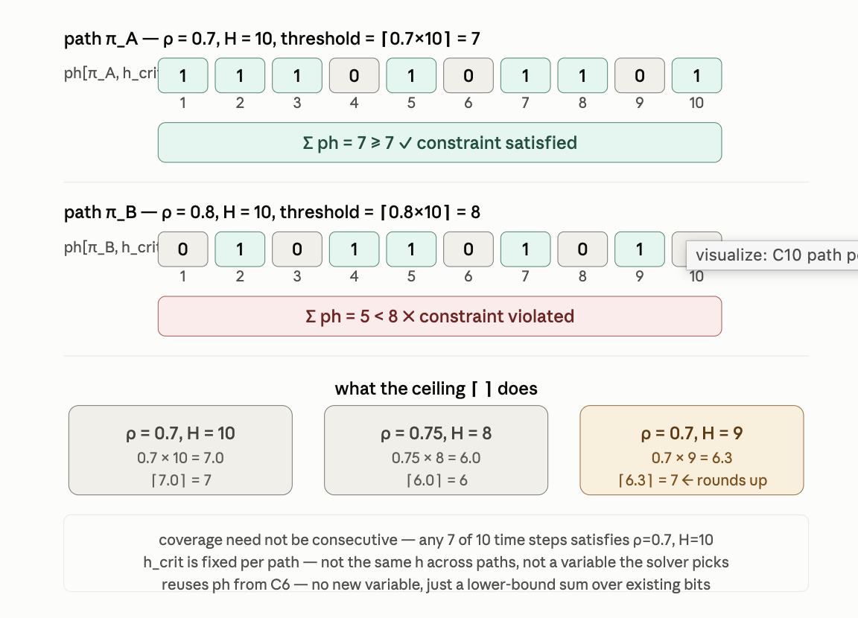

======

C11 | param | τ_d(i,z,t)=max{1, τ_d0·(1−ρ_π(t)/ρ_max)·γ^n}. WCNF regenerated each re-solve; no new clause structure, only updated τ_d thresholds in C9. | none (τ_d is a parameter)

This is not a constraint at all — it's a parameter update formula. Nothing gets added to the SAT/pseudo-boolean model. Instead, the dwell-time threshold τ_d that C9 uses gets recomputed before each re-solve, and then C9's clauses are regenerated with the new value baked in.
Breaking down the formula τ_d(i,z,t) = max{1, τ_d0 · (1 − ρ_π(t)/ρ_max) · γⁿ}:
- τ_d0 = the baseline dwell limit — how long an asset can stay before rotation under normal conditions
- ρ_π(t) = current path coverage ratio at time t — how well-covered the paths are right now
- ρ_max = the maximum possible coverage ratio — a normalising constant
- (1 − ρ_π(t)/ρ_max) = how far below maximum coverage you currently are. When coverage is poor this is close to 1; when coverage is near-perfect it shrinks toward 0
- γⁿ = a decay factor — γ < 1 raised to the power n (number of re-solves so far), so it shrinks each iteration. Assets are allowed to stay longer as the solve matures
- max{1, ...} = floor of 1 — the dwell limit can never drop below 1 time step, otherwise C9 would ban every deployment instantly
So the full behaviour is: when coverage is poor, τ_d stays large (assets must rotate quickly, keeping the trap landscape fresh). As coverage improves or re-solves accumulate, τ_d shrinks (assets are allowed to stay longer, reducing churn). It's an adaptive tightening mechanism.
The WCNF (Weighted CNF) file is simply regenerated from scratch each re-solve with the new τ_d values plugged into C9's sliding window and unary counter. No new clause structure appears — just different threshold numbers inside the same template.

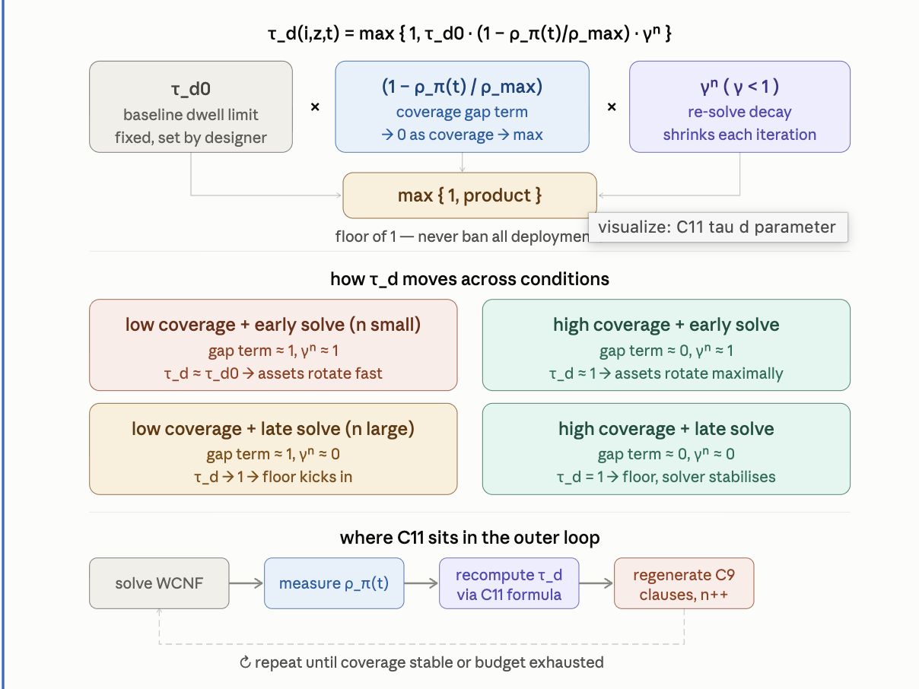

======

C12 | hard | (¬x[i,z,t,p] ∨ ¬x[i′,z,t,p]) ∀i≠i′, all z,t,p. Persona conflict within zone/slot. | none

This looks nearly identical to C4 at first glance — another pairwise 2-clause mutual exclusion. The difference is entirely in what is being conflicted:
- C4 conflicted asset types (i,i′) drawn from a pre-computed conflict set C — pairs that are known to interfere operationally, regardless of profile
- C12 conflicts any two distinct asset types i ≠ i′ that share the exact same zone, time step, and profile — the conflict is not about operational interference but about identity collision: two different things cannot occupy the same persona slot simultaneously
The profile p appears on both sides and is the same p — that is the key. This is not "asset i with profile p conflicts with asset i′ with profile p′" (which C4 handles across profile combinations). This is "two different asset types cannot both be wearing the same profile costume in the same zone at the same time."
Think of p as a disguise or persona — a specific signature, behaviour pattern, or emission profile an asset presents to the adversary. Two assets impersonating the same persona in the same zone simultaneously would be immediately detectable as duplicates. The constraint enforces that each persona slot (z,t,p) is occupied by at most one asset type.
The ∀i≠i′ means this stamps out one clause for every unordered pair of distinct asset types, for every zone, time step, and profile — potentially a very large clause count, but each clause is a trivially cheap 2-clause with no encoding needed.

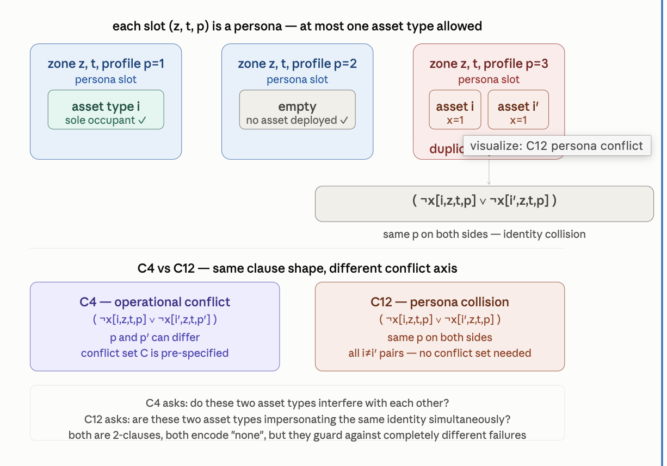

======

C13 | PB | run_pers[i,z,t,p]=Σ_{s=t-τdp+1}^{t} x[i,z,s,p]; u_pers=1 iff run_pers≥τ_dp; D=(1−u_type)·(1−u_pers)→zeroed. | run_pers[i,z,t,p], u_pers[i,z,t,p]

C13 is a profile-level dwell limit — a finer-grained version of C9 running in parallel with it. Where C9 tracked how long asset type i has been present in zone z regardless of which profile it wore, C13 tracks how long asset i has been wearing a specific profile p in zone z. An asset can potentially reset its profile-dwell counter by switching profiles, even while staying in the zone — but both clocks are running simultaneously.
Three components:
- run_pers[i,z,t,p] — sliding window sum, identical in structure to C9's run_type but now the window tracks x[i,z,s,p] with p fixed. Counts consecutive steps the specific (asset, profile) combination has been active in zone z within the last τ_dp steps
- u_pers[i,z,t,p] — unary counter flag, same mechanism as C9's u_type but fires when run_pers ≥ τ_dp. Set to 1 when the profile has been worn too long
- D = (1−u_type)·(1−u_pers) → zeroed — the combined availability gate. D=1 only when both flags are clear: the asset type hasn't overstayed (u_type=0) AND the profile hasn't overstayed (u_pers=0). If either flag fires, D collapses to 0, blocking deployment
The D term here feeds back into C6's right-hand side — recall C6 was ph[π,h,t] ≤ Σ_p x[i,zone(π,h),t,p] · D. When D=0, no asset counts toward hop coverage even if physically deployed. It's a coverage nullifier: the asset is present but invisible to the objective.

Why two separate dwell clocks are necessary:
A single type-level clock (C9 alone) would allow an adversary pattern: keep asset i in zone z indefinitely by rotating through profiles p₁, p₂, p₃..., resetting the type clock each time. But a consistent asset presence — even in different disguises — becomes recognisable over time. C13 closes that loophole by clocking each profile separately, so rotating profiles buys some relief but the type clock still accumulates.
Conversely a profile-only clock without the type clock would miss the case where an asset cycles profiles so fast it never triggers u_pers on any single one, yet is permanently present. Both clocks together are needed to cover both evasion strategies.
How C9 and C13 divide the dwell-time problem:
 | C9 | C13
Window variable | run_type[i,z,t] | run_pers[i,z,t,p]
What it counts | presence regardless of profile | presence in this specific profile
Threshold | τ_d — type dwell limit | τ_dp — profile dwell limit
Flag | u_type | u_pers
Reset by profile switch? | no | yes
Reset by zone exit? | yes | yes
The D gate is the integration point for the whole constraint hierarchy:
D = (1−u_type)·(1−u_pers) is not a new SAT clause — it's a product of two binary values, expressible as a conjunction. It feeds directly into C6's right-hand side, meaning an asset that has overstayed either its type or profile dwell limit stops contributing to path-hop coverage entirely. The optimizer therefore has a strong incentive to rotate assets proactively — letting either clock run to its limit doesn't just trigger a hard block next step (as in C9's 2-clause), it silently kills the asset's coverage contribution right now.

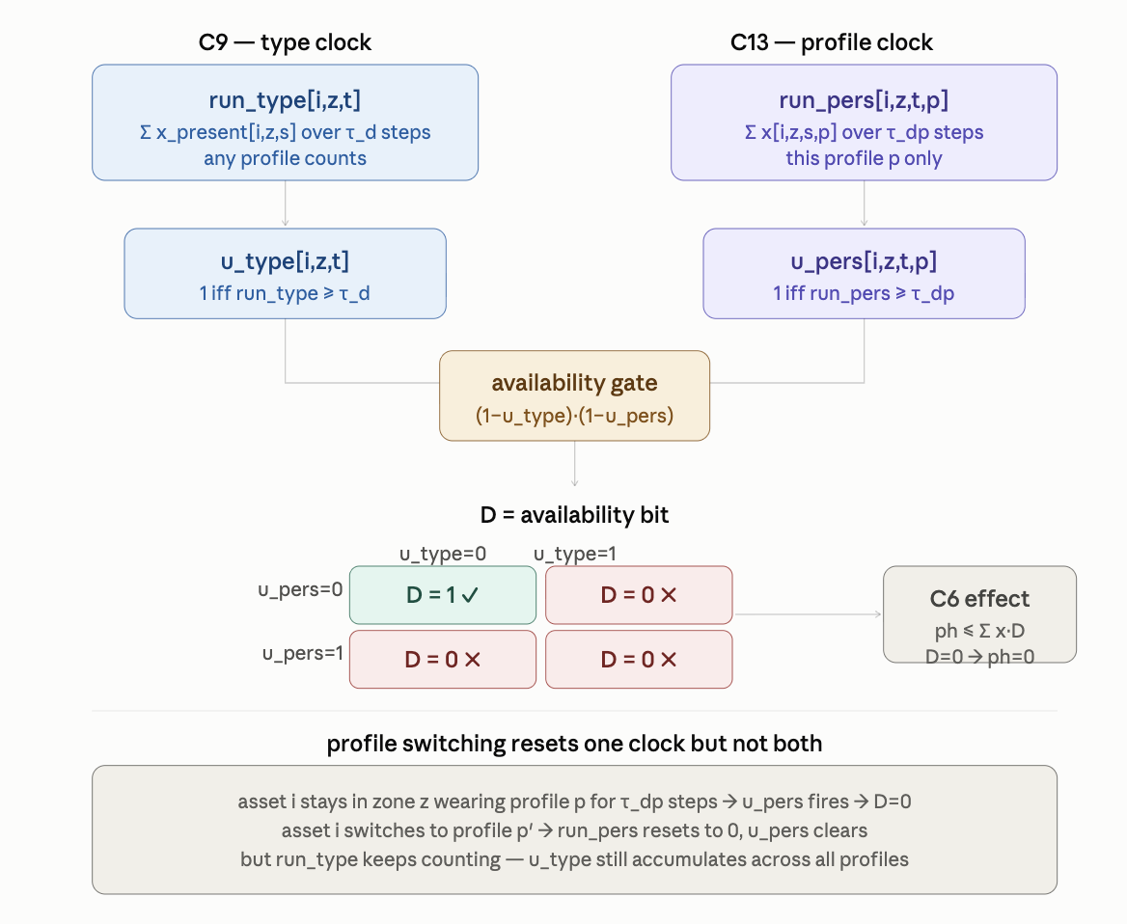

======

C14 | hard | (¬x[i,z,t,p] ∨ ¬x[i′,z′,t,p]) ∀z≠z′, all i,i′,t,p. Cross-zone persona uniqueness. | none

Another 2-clause, another dimension of persona uniqueness — but now the ban reaches across zones. Where C12 said "no two asset types can share the same profile in the same zone at the same time," C14 says "no asset deployment anywhere can share a profile with any other deployment in a different zone at the same time."
- C12: same (z, t, p), different i — within-zone identity collision
- C14: same (t, p), different z — cross-zone identity collision, any i and i′ including i = i′
The key insight: profile p must be globally unique across all zones at any given time step. If the same persona appears simultaneously in zone z and zone z′, an adversary who can observe both zones immediately knows at least one is artificial — real entities don't clone themselves across locations. The deception is broken not by what happens inside a single zone but by the cross-zone pattern.

Note that i and i′ are universally quantified with no i ≠ i′ restriction — the same asset type wearing the same profile in two different zones is also forbidden. Even identical asset types cannot share a persona across space.

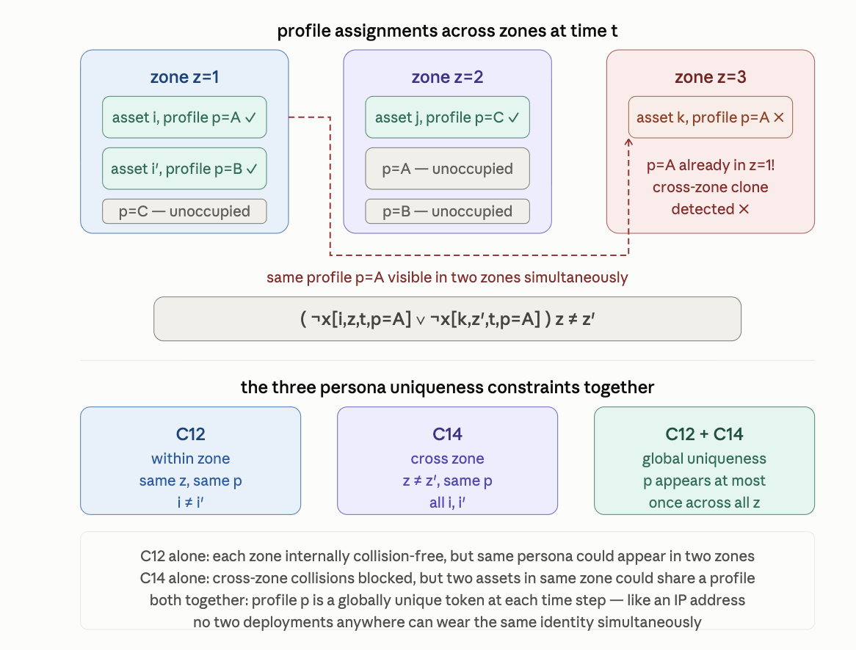

======

C15 | hard | Pre-check: if κ[t]<κ_min → ¬x[i,z,t,p] unit clause ∀i,z,p; else satisfied. Minimum slot-duration floor. | none

C15 is a global readiness gate — the simplest possible conditional in the whole system. Before any deployment is allowed at time t, a pre-check asks: is the slot duration κ[t] at least the minimum required κ_min? If not, every deployment variable at that time step is killed with a unit clause. If yes, the constraint is trivially satisfied and disappears entirely.
- κ[t] = the available slot duration at time t — how long time step t actually lasts, or how much operational window is available in that period
- κ_min = the minimum duration needed for any deployment to be meaningful — below this threshold, there is not enough time for an asset to establish its presence, emit its signature, or contribute to coverage before the window closes
- If κ[t] < κ_min: stamp ¬x[i,z,t,p] for every i, z, p — the entire time step is wiped from the search space
- If κ[t] ≥ κ_min: no clauses are generated at all — the constraint is vacuously true
This is a pre-processing filter, not a solver constraint. It runs before the WCNF is built, identifies which time steps are too short to be useful, and eliminates all their variables before the solver ever sees them. It's cheaper than any clause — it simply removes a dimension of the problem.
The "none" encoding is the most extreme case: not even a 2-clause, not even a unit clause in the running solver — just a pre-assignment that shrinks the variable set before solving begins.

κ[t] is the actual window size — determined by the real-world schedule, maintenance gaps, or operational tempo. κ_min is the minimum viable window — set by how long it physically takes for a deployed asset to do its job. Slots where reality falls short of the minimum are simply erased from the problem.

think of κ[t] as how long time slot t actually lasts, and κ_min as the shortest window in which a deployment can do anything useful.

Concrete scenario: a 24-hour operation divided into 6 slots
Time slot t | κ[t] (hours) | κ_min = 4 hrs | Result
t=1 | 6 hrs (06:00–12:00) | 4 | ✓ passes — enough time
t=2 | 2 hrs (12:00–14:00) | 4 | ✗ wiped — too short
t=3 | 8 hrs (14:00–22:00) | 4 | ✓ passes
t=4 | 1 hr (22:00–23:00) | 4 | ✗ wiped — too short
t=5 | 4 hrs (23:00–03:00) | 4 | ✓ passes — exactly at limit
t=6 | 3 hrs (03:00–06:00) | 4 | ✗ wiped — too short
Why is κ_min = 4 hours here? Because deploying a deception asset takes time to set up, emit a believable signature, and be observed by the adversary. A 2-hour window isn't enough — the asset would barely be established before the slot closes, so deploying it would waste resources and potentially reveal the operation.

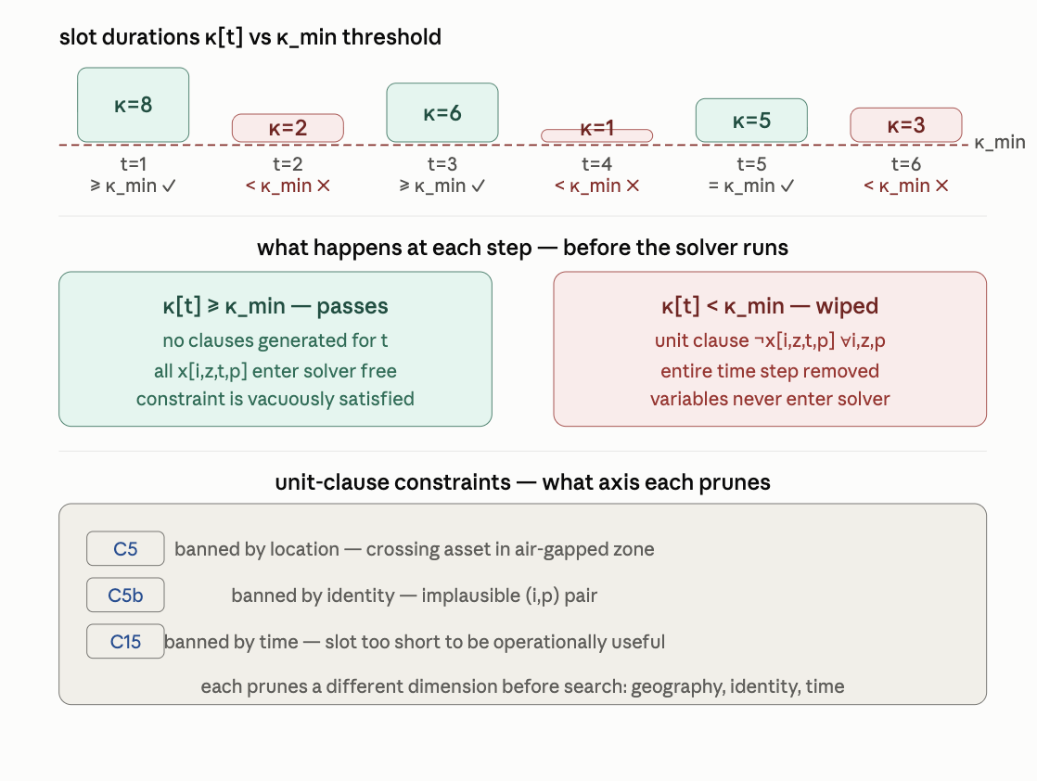

====== How Deployment Decisions Activate Each Layer

===== Robust Threshold-Chain Construction — Six Steps

=====

