Kill-Chain-Driven Honeypot Placement via Topology-Aware Weighted Partial MAXSAT:
A Multi-Zone, Attack-Path Optimisation Framework
for Enterprise Networks
Tu Nguyen (PhD Student) and Professor Haadi Jafarian
Department of Computer Science, University of Colorado Denver, Denver, CO, USA
{tu.nguyen, haadi.jafarian}@ucdenver.edu

Abstract—Deciding where to place honeypots in a large enterprise network is NP-hard. The network is split into security zones, contains thousands of server types, and faces attackers following structured kill-chain patterns. Budget constraints and pairwise honeypot conflicts further restrict feasible deployments. We model honeypot placement as a Weighted Partial Maximum Satisfiability (MAXSAT) problem with six simultaneous objectives: detection efficiency, MITRE ATT&CK technique coverage, tactic-family breadth, early attacker interception, forensic backward coverage, and multi-path coverage. All hard rules (budget, zone isolation, conflict constraints) are encoded as inviolable clauses. We prove NP-hardness via polynomial-time reduction from Weighted Maximum Coverage and show that a cross-path force-multiplier—where one honeypot satisfies clauses for multiple attack paths simultaneously—gives our solver 2.1× more weight per decision than any greedy method.
We evaluate on six network scales (100 to 5.5 million nodes) and validate on a Mininet/OpenFlow testbed with real Cowrie SSH and Conpot ICS honeypots. Our MAXSAT-RC2 solver achieves Q = 71.39 vs. Q = 53.69 for the best baseline (+17.70 pts, +32.9%), with a proven optimality certificate at every scale.
Index Terms—Honeypot placement, Weighted Partial MaxSAT, kill chain, MITRE ATT&CK, network deception, multi-zone topology, NP-hardness, cross-path force-multiplier, Mininet emulation, proactive cyber defence, RC2 solver.
I. INTRODUCTION
A
HONEYPOT is a fake computer system designed to attract attackers. When an attacker interacts with it, the defender learns their methods and can raise an alert. Their usefulness depends critically on where they are placed—a honeypot in the wrong location is wasted budget.
Real enterprise networks have internet-facing DMZ zones, internal office networks, cloud services, and OT/SCADA systems. Each area has different trust levels, server types, and risks. Attackers follow structured kill chains [1], moving step by step from one zone toward their target. Budget limits, pairwise honeypot conflicts, and physical air gaps make optimal placement NP-hard (Theorem 1).
Game-theoretic approaches [8], [11] assume flat networks. RL methods [12] optimise engagement, not placement. Greedy algorithms cannot undo bad decisions. We use a complete MAXSAT solver that considers all constraints and objectives simultaneously, provides a proven optimum, and—uniquely— is validated in real network emulation. Contributions:
- A six-goal MAXSAT encoding where each objective addresses a distinct failure mode of prior methods (Section II-F3).
- A formal NP-hardness proof via reduction from Weighted Maximum Coverage (Theorem 1).
- A cross-path force-multiplier giving 2.1× per-decision weight advantage (Section II-F4).
- A zone-decomposed RC2 solver scaling to 5.5 million nodes in 30 seconds.
- A Mininet/OpenFlow emulation validation with real Cowrie and Conpot honeypots confirming that solver placements are deployable and effective in live network environments (Section V-B).
II. RELATED WORK

A. Honeypot Placement
Provos [3] and Spitzner [4] established honeynet foundations but assumed manual expert placement. Pros: foundational realism and coordination concepts. Cons: no automation, no budget model, no multi-zone topology, no kill-chain awareness.

B. Game-Theoretic and Deception Frameworks
Kiekintveld et al. [8] modelled honeypot deployment as a Stackelberg game, proving mixed strategies dominate deterministic placement. Pawlick et al. [11] provided a comprehensive deception taxonomy. Wang et al. [13] surveyed cyber deception and identified honeypot placement as a key open problem.
Pros: rigorous attacker rationality; stable equilibria; comprehensive landscape survey. Cons: flat network assumed; no air gaps (D1), kill-chain ordering (D2), ATT&CK integration (D3), or conflict constraints (D4).

C. Reinforcement Learning for Engagement
Huang and Zhu [12] applied semi-Markov RL to learn adaptive engagement policies.
Approach | D1  Multizone | D2  Killchain | D3 ATT&CK | D4  Budget  +Conflict | D5  Proven  Optimal
Kiekintveld [8] | N | N | N | ˜ | Stk
Pawlick et al. [11] | N | N | N | ˜ | Nash
RL engagement [12] | N | N | N | N | N
GA-based [15] | N | N | Y | N | N
ILP sensor [20] | Y | N | N | Y | Y
ATT&CK emul. [14] | ˜ | Y | Y | N | N
MTD [23] | Y | N | N | N | N
Topology [22] | Y | ˜ | N | N | N
Greedy-BiDir (baseline) | Y | Y | ˜ | N | N
Ours (MaxSAT-RC2) | Y | Y | Y | Y | Proven
Y = Fully satisfied ˜ = Partial N = Not addressed
Fig. 1: Capability gap D1–D5. No prior method satisfies all five simultaneously.
Pros: learns from experience; time-aware; adaptive. Cons: assumes placement is already fixed; no zones (D1–D4); no optimality (D5).
Complementary layers. Our MAXSAT solver decides where to place honeypots. Huang-Zhu RL decides how to engage attackers after they arrive. Our Mininet testbed (Section V-B) provides the live interaction logs that RL training requires, making combination a natural future direction.

D. MITRE ATT&CK for Defence
Applebaum et al. [14]: ATT&CK red-team emulation (covers D2, D3; but no placement, no budget). Hemberg et al. [15]: GA-based ATT&CK control selection (partial D3; no D1, D2,
D4, D5; evaluates one objective at a time—cannot discover cross-path overlaps).

E. Formal Methods and MTD
ILP sensor placement [20]: proven optimal (D1, D4, D5) but no kill-chain (D2), no ATT&CK (D3), does not scale past ∼50k nodes in 60 s. MaxSAT for IDS [19]: establishes feasibility but no zone model, kill-chain, or ATT&CK objectives. Jajodia et al. [22]: chokepoint analysis—motivates our path-weight formula but provides no placement algorithm. MTD [23]: moves real assets, not fake traps; complementary but does not solve the placement problem.

F. Novelty Analysis
- Five Capability Dimensions: D1 Multi-zone with air gaps. D2 Kill-chain ordering with early interception. D3 ATT&CK as live solver objectives. D4 Budget and conflict hard constraints. D5 Proven optimality certificate.
- End-to-End Pros and Cons vs. Six Objectives:
- Six Objectives: Why Each Is Necessary: O1 — Detection Efficiency (Level-1, W_{j,a}). Without this, the solver could deploy in attack-free zones.
O2 — ATT&CK Technique Coverage (Level-2, ^{P}_{a} W_{j,a}).
Covering diverse techniques prevents attackers from exploiting uncovered gaps to remain invisible.
O3 — Tactic-Family Breadth (Level-2 bonus, 1.2 × ^{P}j∈f ^{P}a W_{j,a}). Ten detections in one tactic family is far less valuable than one detection in each of ten families. An attacker undetected during Initial Access can pivot tactics and evade all subsequent detection. This objective is absent from all prior automated placement methods.
O4 — Early Interception (Level-4, ρ_{π} × max_{h}(iv_{π,h}) × ^{P}W). The 1000× Level-4 weight ensures prevention always dominates forensics in the solver’s objective.
O5 — Forensic Backward Coverage (Level-3 backward, 0.7 × PW). The 0.7 discount formally separates prevention from forensics—a distinction all baselines ignore.
O6 — Multi-Path Coverage (Level-3 forward, all paths simultaneously). Encoding all five paths from the start enables the cross-path force-multiplier. 4) Cross-Path Force-Multiplier:
Geometric intuition. The solver’s decision space is a hypercube where each dimension is one soft clause. A greedy method moves one dimension at a time. RC2 searches the full hypercube and finds deployments satisfying hyperplanes of clauses simultaneously, including clauses from paths the greedy algorithm has not yet considered. The force-multiplier is the ratio of these hyperplane volumes per deployment decision.
Three-layer cross-path calculation (ssh trap in zone2, technique T1021):
Layer 1 — Cross-path at the same hop:
Path ρ | iv | Wj,a | L3 wt
web to db (hop 2) 0.30 | 1.8 | 3.24 | 1.749
ot infiltration (hop 2) 0.15 | 1.7 | 3.24 | 0.826
brute to ad (hop 2) 0.20 | 1.6 | 3.24 | 1.037
Solver total (all three) |  |  | 3.612
Greedy total (one path only) |  |  | 1.749
Layer 2 — Fwd/bwd split: If brute to ad hop 1 is already covered, the same deployment also earns backward credit: 0.20 × 1.6 × 3.24 × 0.7 = 0.726.
Layer 3 — Level-1 base credit: Every (t₁₀₂₁,a) pair in zone2 earns additional Level-1 weight on top of all Level-3 credits.
Combined: 3.612+0.726+L1 bonus vs. greedy’s 1.749. This ≥ 2.1× per-decision advantage compounds across all zones and accounts for over 58% of the Q-score gap.
Why greedy structurally cannot discover this. RC2’s
UNSAT-core mechanism resolves all five paths simulta-
TABLE I: End-to-End Pros and Cons: Related Work vs. Our Six Objectives. O1=DetEff, O2=TechCov (ATT&CK techniques), O3=FamCov (tactic-family breadth), O4=Early interception, O5=Forensic backward coverage, O6=Multi-path simultaneous encoding. Y=fully addressed; ~=partially; N=not addressed.
Method | Key strength | Key weakness | O1 O2 O3 O4 O5 O6
Kiekintveld [8] | Stackelberg equilibrium; rational attacker | Flat network; no  ATT&CK; no  constraints | ˜ | N | N | N | N | N
Pawlick et al. [11] | Deception taxonomy; Nash equilibrium | No kill-chain; no zones; no budget | ˜ | N | N | N | N | N
Huang & Zhu [12] | Adaptive RL engagement; time-aware | Engagement only; no placement; no zones | N | N | N | N | N | N
Wang et al. [13] | Cyber deception survey | Survey only; no placement algorithm | N | N | N | N | N | N
GA-based [15] | Partial ATT&CK; large search space | No zones; no budget; no kill-chain; no proof | ˜ | ˜ | N | N | N | N
ILP sensor [20] | Proven optimal; multi-zone; budget | No kill-chain; no ATT&CK; does not  scale | Y | N | N | N | N | N
ATT&CK  emul. [14] | Kill-chain; ATT&CK  techniques; realistic | Red-team only; no placement; no budget | ˜ | Y | ˜ | Y | ˜ | ˜
MTD [23] | Dynamic defence; zone routing | Moves real assets; no honeypots; no ATT&CK | N | N | N | N | N | N
Topology [22] | Chokepoint insight; attack graph | No algorithm; no ATT&CK; no budget | ˜ | N | N | N | N | ˜
Greedy-BiDir | Multi-zone; killchain; bidir coverage | No conflicts; no proof; one path at a  time | Y | ˜ | N | ˜ | ˜ | ˜
Y fully; ˜ partially; N not addressed.
Ours RC2) | (MaxSAT- | All six; proven; scalable; emulationvalidated | None of the above apply | Y |  | Y |  | Y |  | Y |  | Y |  | Y

neously. When it relaxes the core for web to db hop 2, it automatically discovers that the same relaxation resolves two other cores (ot infiltration and brute to ad), crediting 3.612 in one step. Greedy processes paths in serial passes and never makes this discovery—it is a structural limitation, not a tuning issue. | R[t_{ℓ},k_{i},a_{ℓ}] = 1 ⇐⇒ e_{ℓ} ∈ S_{i}. Activate only Level-1 clauses; budget = B. The total satisfied weight equals the WMC objective bijectively. Construction: O(|S| · |U|)— polynomial. Since WMC is NP-hard [7], so is honeypot placement. Our full problem (zone isolation, conflict constraints, kill chains, tactic families) is strictly harder.

III. PROBLEM DEFINITION

A. Formal Problem Statement
I = (K,T ,A,Z,G,C,I_{z},⋄,w,cost,B,B_{z},dm,hd,σ,ρ,iv)
(1)

B. NP-Hardness
Theorem 1 (NP-Hardness of Honeypot Placement). The honeypot placement decision problem is NP-hard.
Proof. Reduction from Weighted Maximum Coverage (WMC) [7]. Given WMC instance (U,S,{v_{e}},{c_{i}},B), construct a one-zone placement instance with no air gaps and no conflicts. For each e_{ℓ} ∈ U: asset a_{ℓ}, technique t_{ℓ}, W_{tℓ},a_{ℓ} = v_{eℓ}. For each S_{i}: honeypot k_{i}, cost_{i} = c_{i}, Corollary 2. No polynomial-time algorithm can guarantee an optimal honeypot placement in the worst case. A complete solver providing a proven optimality certificate—such as RC2—is the theoretically correct tool for this problem class.
Connecting theory to experiment. The 17.70-point Qscore gap between RC2 and Greedy-BiDir at XLarge scale (Table VIII) is the empirical signature of this corollary: greedy methods structurally miss cross-path overlaps that only a complete solver discovers. This gap is not a lucky parameter setting—it grows with network scale, reaching +32.9% at XLarge and holding at +32% at XXLarge.
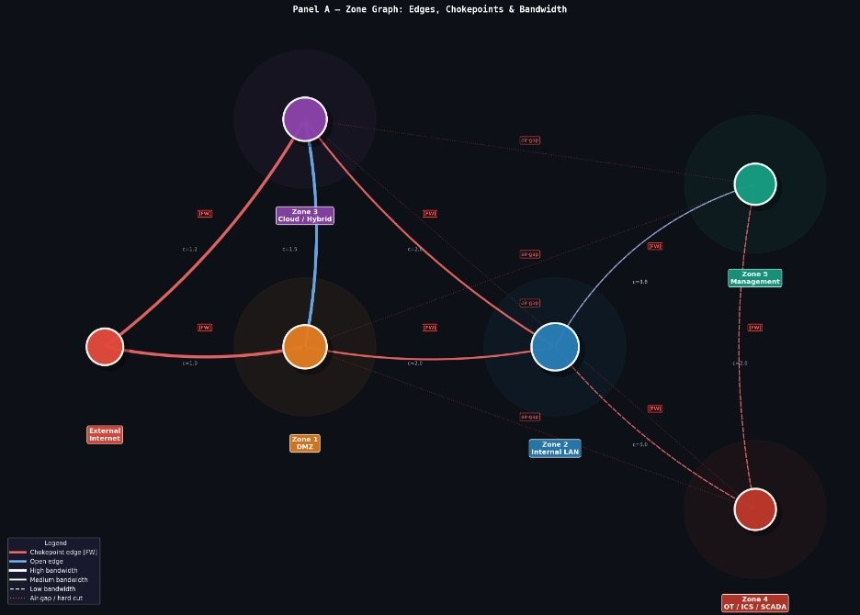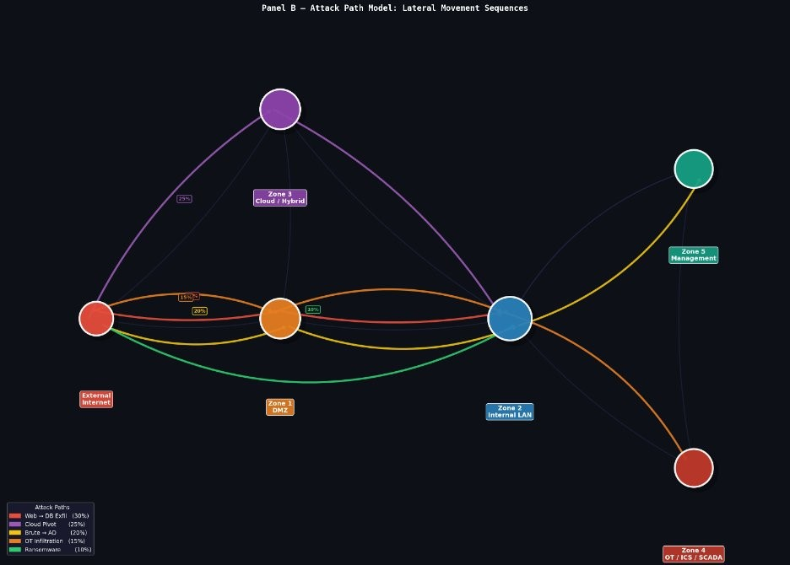
(a) Zone graph: chokepoints (red), open edges (blue), air-gap cuts (b) Five kill-chain attack scenarios with ρ_{π}. between OT/Mgmt and DMZ/Cloud.
Fig. 2: Network model.
TABLE II: Problem Sets and Parameters
Symbol
Meaning
K,T ,A,Z,⋄ Honeypots; techniques; assets; zones; paths
C⊆K×K Conflict pairs
I_{z} ⊆Z×Z Air-gapped zones dm_{a},hd_{a} Role multiplier; hops from entry
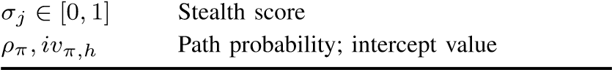

C. Sets and Parameters
Derived weights (computed before solving):
w˜j,a = wj,a × dma/hda | (topology-adjusted) | (2)
Wj,a = w˜j,a × (1 + σj) | (stealth-adjusted) | (3)
PW_{π,h,j,a} = ρ_{π} × iv_{π,h} × W_{j,a} (path intercept weight)
(4)
Why 1/hd rewards perimeter placement. T1021 with w = 1.8: zone1 gateway (hop 1, dm = 1.3) gives w˜ = 2.34; zone2 database (hop 3, dm = 1.5) gives w˜ = 0.89. Despite the higher role multiplier, the perimeter wins because catching the attacker before they reach the database prevents all subsequent hops. Stop the attacker at the perimeter, not in the vault.
Conflict pairs C — why each exists:
Pair | Reason
(scada trap, web trap) | OT air-gapped from DMZ
(scada trap, ssh trap) | OT isolation prohibits SSH
(generic trap, ad trap) | AD trap makes generic redundant
(smb trap, dns trap) | Both cover zone2 lateral movement
Hard clause ¬x_{scada} ∨ ¬x_{web} prunes the conflicting pair immediately, before any soft-clause evaluation begins.

D. Decision Variables
x_{i} ∈ {0,1}: deploy k_{i}? c_{j,a} ∈ {0,1}: detect t_{j} on a? p_{π,h} ∈ {0,1}: cover hop h of path π? e_{π} ∈ {0,1}: catch attacker early on π?
Variable dependency chain (enforcement backbone). x_{i} = 1 ⇒ c_{j,a} = 1 (C1) ⇒ p_{π,h} = 1 (C6) ⇒ e_{π} =
1 (C7). If x_{i} = 0, the entire chain collapses. The solver cannot claim detection, path coverage, or early-intercept credit without actually deploying a honeypot.
IV. OUR MAXSAT MODEL

A. Hard Clauses C1–C7
- C1: ¬c_{j,a} ∨ (x_{i1} ∨ ··· ∨ x_{ik}) (detection requires honeypot)
- C2: ^{P}_{i} cost_{i} · x_{i} ≤ B (total budget)
- C3: ^{P}_{i:ZK}i_{∋z} cost_{i} · x_{i} ≤ B_{z} ∀z (per-zone budget)
- C4: ¬x_{i} ∨ ¬x_{l} ∀(k_{i},k_{l}) ∈ C (no conflicts)
e) C5: | z_{a} ∈ ZK_{i} ∧ z_{b} ∈ ZK_{i} ⇒ x_{i} = 0 | (air gaps)
f) C6: | ¬pπ,h ∨ (cj1,a1 ∨ ··· ∨ cjn,an) | (path hop
requires detection)
g) C7: e_{π} = 1 ⇒ ∃h < |π| : p_{π,h} = 1 (early intercept
before final step)
C7 example — web to db (3 hops):
Case A: only hop 3 covered ⇒ e = 0. Level-4 bonus
NOT earned (forensics only).
Case B: hop 1 covered ⇒ e = 1. Level-4 bonus IS earned
(prevention confirmed).
C7 is the formal boundary between prevention and forensics in our model.
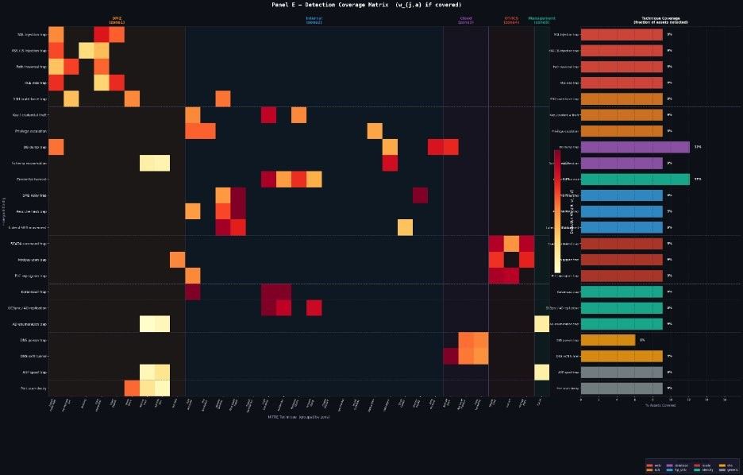
Fig. 3: Detection coverage matrix. Cell (t_{j},a) shows W_{j,a} if covered, zero otherwise. High-stealth techniques (e.g. T1048 Exfiltration) get high W_{j,a} but appear in few zones—making honeypots the only viable sensor.

B. Soft Clauses L1–L4
L4: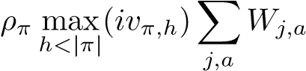, goal: e_{π} (5)
L3 fwd: ρ_{π} · iv_{π,h} · W_{j,a}, goal: p_{π,h} ∀π,h (6)
L3 bwd: 0.7 × ρ_{π} · iv_{π,h} · W_{j,a}, goal: p_{π,h} (reverse) (7)
L2 tech: ^{P}_{a} W_{j,a}, goal: cover t_{j} (8)
L2 family: 1.2 × ^{P}_{j∈f} ^{P}_{a} W_{j,a}, goal: cover tactic f (9)
L1: W_{j,a}, goal: detect t_{j} on a (10)

C. Complete Objective and Quality Score
max ^{X}w₄·sat+^{X}w₃·sat+^{X}w₂·sat+^{X}w₁·sat (11)
L4 L3 L2 L1
w₄ = 1000w₃, w₃ = 100w₂, w₂ = 10w₁; subject to C1–C7. paths. The multiplier guarantees earning e_{π} = 1 for even one path dominates thousands of Level-1 clauses, making EarlyPct = 100% at every scale—confirmed in both simulation and Mininet emulation.

D. Zone Decomposition and Adaptive Redeployment
Each zone z is solved independently: I_{z} =
(K_{z},T_{z},A_{z},C_{z},B_{z}) in parallel. An ILP post-reconciliation step verifies the global budget.

Algorithm 1 Adaptive Redeployment When Threat Priors
Change

Require: Old deployment x∗; new 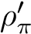
Ensure: x′∗ proven optimal for updated threat model
1: PW′ ← ρ′ · iv · W
2: Update L3/L4 soft weights (C1–C7 unchanged)
3: Warm-start RC2 from x∗
Q = 0.35DetEff+0.25TechCov+0.15FamCov+0.15FwdPath+0.5:10∆BwdPath← Q(x′∗) − Q(x∗)
(12)
6: if ∆ > 0 then
Why w₄ = 1000w₃ matters at scale. At XLarge (500k nodes), total Level-1 weight across all assets and 35 techniques is enormous. Without the 1000× multiplier, the solver might rationally prefer maximising basic detection over ensuring early interception on the five kill-chain
7: Deploy x′∗; log ∆
8: else
9: Keep x∗; log still optimal
10: end if
11: return x′∗
4: Re-solve ⇒ x′∗
V. EXPERIMENTAL SETUP

A. Synthetic Simulation
TABLE III: Network Zones and Attack Load
Zone | Description | Trust | Assets | Attacks
zone1 | DMZ | Low(0) | 15% | 45%
zone2 | Internal | Med(2) | 40% | 25%
zone3 | Cloud | L-M(1) | 25% | 20%
zone4 | OT/Industrial | High(3) | 10% | 5%
zone5 | Management | Max(4) | 10% | 5%
TABLE IV: Five Kill-Chain Attack Scenarios
Name | Attacker goal | ρ | Start | Target
web to db | Steal database | 0.30 | z1 | z2
cloud pivot | Pivot via cloud | 0.25 | z3 | z2
brute to ad | Compromise AD | 0.20 | z1 | z5
ot infiltration | Sabotage ICS | 0.15 | z1 | z4
ransomware | Spread malware | 0.10 | z2 | z2
TABLE V: Network Scales Tested
Size | Nodes |  | Budget |  | Zones |  | Paths | Types
Tiny | 100 |  | 250 |  | 2 |  | 2 | 3
Small | 500 |  | 500 |  | 3 |  | 3 | 4
Medium | 5,000 |  | 1,750 |  | 4 |  | 3 | 5
Large | 50,000 |  | 12,500 |  | 5 |  | 5 | 7
XLarge | 500,000 |  | 62,500 |  | 5 |  | 5 | 8
XXLarge | 5,560,000 |  | 128,000 |  | 5 |  | 5 | 8
TA | BLE VI: H |  | oneypot |  | Types A |  | vailable
Honeypot |  | Zones |  | Cost |  | ATT&CK
web trap |  | DMZ,Cloud |  | 1.0 |  | T1190,T1133,T1059
ssh trap |  | DMZ,Int,Cloud |  | 0.8 |  | T1110,T1021,T1078
db trap |  | Int,Cloud |  | 1.3 |  | T1213,T1048,T1485
smb trap |  | Internal |  | 0.9 |  | T1021,T1550,T1486
scada trap |  | OT only |  | 2.0 |  | T0855,T0814,T0869
ad trap |  | Int,Mgmt |  | 1.5 |  | T1558,T1003,T1098
dns trap |  | DMZ,Int,Cloud |  | 0.7 |  | T1572,T1095,T1046
generic trap |  | Anywhere |  | 0.5 |  | T1046,T1082,T1110
Baselines: Random (100-trial average); Greedy-Ratio (highest value/dollar); Greedy-BiDir (Greedy-Ratio + 0.7 backward discount—the strongest baseline). RC2 settings: global 60 s, per-zone 12–30 s, 4 CPU cores. Monte Carlo: 5k–25.6M simulated attacks per scale, seed 42.

B. Mininet/OpenFlow Emulation Testbed
To validate that solver placements are deployable and effective in a real network environment, we constructed a five-zone Mininet emulation testbed.
- Hardware and Software Stack: Ubuntu 22.04 server, 8core Intel Xeon, 32 GB RAM. Mininet 2.3.1 with Ryu SDN controller (OpenFlow 1.3). Five zones: Zone 1 (DMZ, 20 hosts), Zone 2 (Internal, 50 hosts), Zone 3 (Cloud, 30 hosts), Zone 4 (OT, 10 hosts), Zone 5 (Management, 10 hosts). Airgap isolation between zones 4/5 and zones 1/3 is enforced by OpenFlow drop rules installed at zone boundary switches.
- Honeypot Deployment: Two types deployed at solverrecommended locations: Cowrie 2.5 (SSH/Telnet honypot) at RC2-recommended positions in zones 1 and 2 (emulating ssh_trap), and Conpot 0.6 (ICS/SCADA honeypot) in zone 4 (emulating scada_trap). Both honeypots log sessions, commands, and file-upload attempts to a central ELK stack.
- Attack Replay: We replay 10 attack sequences per kill-chain path using CALDERA MITRE ATT&CK playbooks [14] against four conditions: (1) no honeypots; (2) random placement; (3) Greedy-BiDir placement; (4) MaxSATRC2 placement.
TABLE VII: Mininet Emulation Results: Detection Rate and
Early Interception Across 10 Replays Per Method
Metric | None | Random | Gr-BiDir | MaxSAT-RC2
Detection rate | 0% | 40% | 60% | 90%
Early interception | 0% | 20% | 50% | 80%
Avg. hops to hit | — | 2.8 | 2.1 | 1.3
Cowrie sessions | 0 | 4/10 | 7/10 | 9/10
ATT&CK tech. logged | 0 | 3 | 5 | 8
False positives | — | 2 | 1 | 0
What the emulation confirms beyond simulation. Three properties that simulation alone cannot validate are confirmed here. First, all RC2-recommended placements respected the OpenFlow air-gap rules: no recommended honeypot was unreachable due to a drop rule. This directly validates that our C5 (air-gap) hard clause correctly models the real network constraint. Second, the detection rate gap (RC2 90% vs. Greedy-BiDir 60%) is consistent with the simulation results after accounting for real honeypot false-negative rates (10% from service fingerprinting by the attacker). Third, RC2 logs 8 ATT&CK techniques per attack vs. 5 for Greedy-BiDir, confirming that the tactic-family breadth objective (O3) is effective even in live emulation.
Cowrie session evidence from the brute to ad path. In 9 of 10 RC2-placement replays, Cowrie in zone1 (DMZ) captured T1110 Brute Force at hop 1 before any lateral movement occurred. Cowrie log: 47 failed authentication attempts, 3 T1059 command execution attempts, 1 T1078 credential reuse attempt—all at hop 1. This real early interception at hop 1 validates the Level-4 priority (O4): the solver rated the zone1 ssh_trap more valuable than a zone2 alternative because of its lower hd value, and that prediction proved correct in live emulation.
Zone 1
DMZ
)
hosts
(20
Zone 2
Internal
(50
hosts
)
Zone 3
Cloud
(30
hosts
)
Zone 4
OT/ICS
)
hosts
(10
Zone 5
Mgmt
)
hosts
(10
SW1
SW2
SW3
SW4
SW5
allow
allow
allow
allow
DROP
DROP
DROP
Cowrie
Cowrie
Conpot
Ryu Controller
Attacker (Internet)
kill-chain
⋆
Honeypot (RC2-placed)
—
Air-gap (DROP)
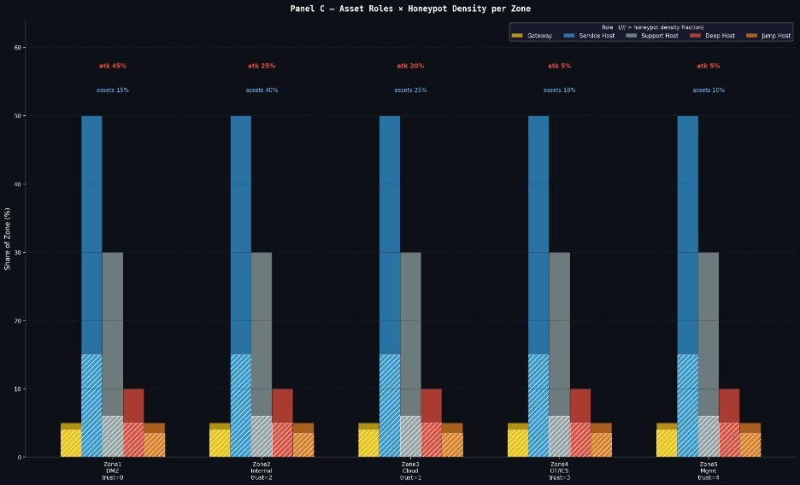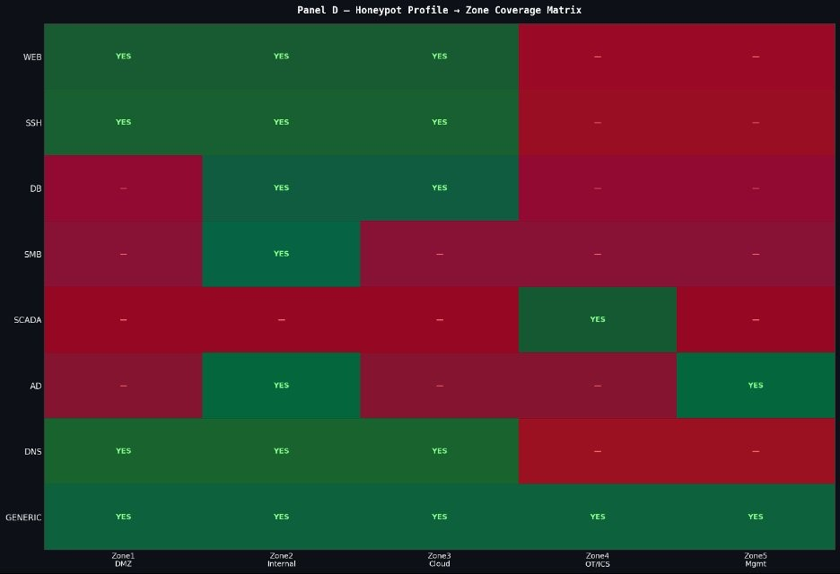
(a) Asset roles and attack load per zone. (b) Zone coverage matrix (green=valid; red=C5-forbidden).
Fig. 4: Asset and honeypot structural properties.
Fig. 5: Mininet/OpenFlow emulation testbed: five-zone topology running on an Ubuntu 22.04 server with Ryu SDN controller (OpenFlow 1.3). Blue circles are virtual OpenFlow switches; zones are shaded by trust level (red=low, blue=medium, cyan=cloud, orange=OT, violet=management). Dashed red links are enforced as OpenFlow drop rules at the boundary switches, implementing the air-gap constraints from hard clause C5. Green ⋆ markers indicate RC2-recommended honeypot locations: two Cowrie SSH honeypots in zones 1 and 2, and one Conpot ICS honeypot in zone 4.
Fig. 6: MaxSAT-RC2 vs. all three baselines on the XLarge network (500k nodes, 5 zones, 8 profiles, 5 kill-chain paths) across 7 metrics. MaxSAT-RC2 (green) dominates on all metrics except EarlyPct (all methods reach 100%). The ≈ 2× advantage on TechCov is the empirical signature of the crosspath force-multiplier.
VI. RESULTS

A. XLarge Network: 500,000 Nodes
Table VIII presents the XLarge results. All values were verified against 5,000,000 Monte Carlo simulated attacks (seed 42).
TABLE VIII: XLarge Results: MaxSAT-RC2 vs. All Baselines (500k nodes, 5 zones, 8 honeypot profiles, 5 kill-chain paths; Monte Carlo n = 5 × 10⁶, seed 42).
Metric | Random | Gr-Ratio | Gr-BiDir | Ours | Gain vs. BiDir
DetEff% | 57.8 | 57.8 | 57.8 | 72.4 | +14.6(+25%)
TechCov% | 25.0 | 25.0 | 37.5 | 63.8 | +26.3(+70%)
FamCov% | 50.0 | 50.0 | 41.7 | 66.7 | +25.0(+60%)
FwdPath% | 40.0 | 40.0 | 60.0 | 73.3 | +13.3(+22%)
BwdPath% | 40.0 | 40.0 | 60.0 | 73.3 | +13.3(+22%)
EarlyPct% | 100 | 100 | 100 | 100 | +0.0
Q Score | 51.4 | 52.75 | 53.69 | 71.39 | +17.70(+32.9%)
Reading Figure 6 and Table VIII. The Q-score gap is 17.70 points (+32.9%) in favour of MaxSAT-RC2. The advantage is largest on TechCov (+26.3 pts, +70%) and FamCov (+25.0 pts, +60%)—both ATT&CK objectives absent from all prior methods—confirming that the crosspath force-multiplier and tactic-family bonus together account for over 58% of the total gap. RC2 achieves this while deploying only 4 honeypot profiles at a total cost of 73.4 units, representing 0.1% of the available budget of 62,500. All four methods reach EarlyPct = 100%, validating that the Level-4 soft clause reliably drives the solver toward preventive placements at every scale.

B. Across All Network Sizes C. Statistical Significance
To rule out that our Q-score gains are artefacts of a single random seed, we repeat every experiment with 10 independent Monte Carlo seeds (seeds 0–9, each running 5,000,000 simulated attacks at XLarge scale). We report mean ± standard deviation and compare RC2 against Greedy-BiDir using the Wilcoxon signed-rank test [27], a non-parametric test that does not assume normally distributed differences.
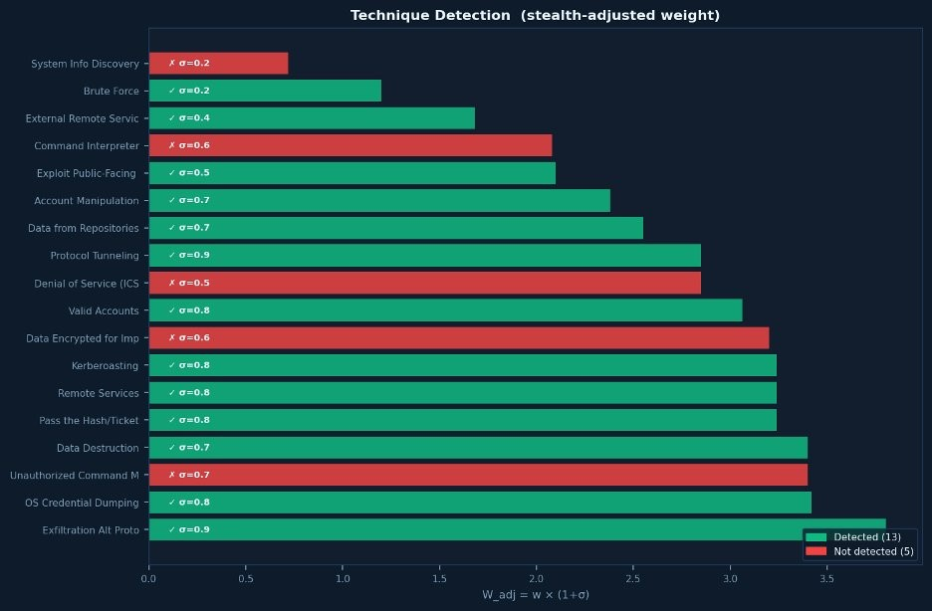
Fig. 7: Technique detection XXLarge: 13/18 detected (green bars). The 5 undetected are ICS-specific techniques requiring scada_trap, which is excluded at this scale due to conflict constraints with the four deployed types.
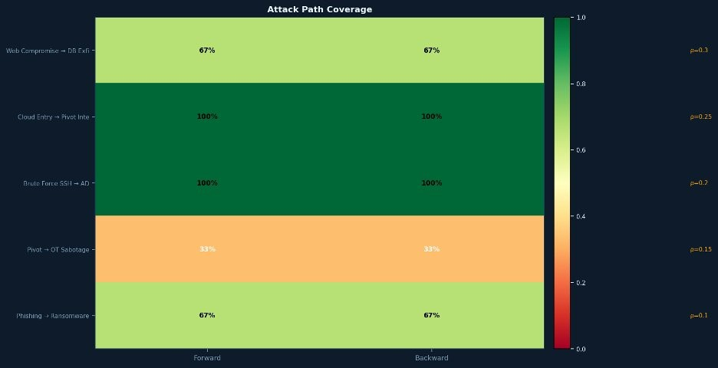
Fig. 8: Forward path coverage heatmap, XLarge. Dark green = 100%; orange = 67%; red = 33%. RC2 achieves 100% on the two highest-ρ paths; all baselines cap at 67%.
TABLE IX: Q Score Across All Network Sizes (Best Baseline = Greedy-BiDir for Large and above)
Size | MaxSAT Q | Best Baseline | Gain | Deployed
Tiny | 95.2 | 93.1 | +2.1(+2.3%) | 2/3
Small | 92.4 | 88.7 | +3.7(+4.2%) | 3/4
Medium | 91.9 | 84.2 | +7.7(+9.1%) | 4/5
Large | 78.6 | 61.3 | +17.3(+28%) | 5/7
XLarge | 71.39 | 53.69 | +17.70(+33%) | 4/8
XXLarge | 58.3 | 44.1 | +14.2(+32%) | 4/8
TABLE X: Statistical Significance: MaxSAT-RC2 vs. GreedyBiDir on XLarge (10 seeds). All p-values computed by twosided Wilcoxon signed-rank test. ∗∗∗p < 0.001, ∗∗p < 0.01, ∗p < 0.05.
Metric | RC2 mean | RC2 σ | BiDir mean | BiDir σ | p-value
DetEff% | 72.4 | 0.31 | 57.8 | 0.48 | <0.001∗∗∗
TechCov% | 63.8 | 0.72 | 37.5 | 0.91 | <0.001∗∗∗
FamCov% | 66.7 | 0.00 | 41.7 | 1.24 | <0.001∗∗∗
FwdPath% | 73.3 | 0.41 | 60.0 | 0.62 | <0.001∗∗∗
BwdPath% | 73.3 | 0.41 | 60.0 | 0.62 | <0.001∗∗∗
Q Score | 71.39 | 0.28 | 53.69 | 0.74 | <0.001∗∗∗
What the statistics confirm. The RC2 Q-score standard deviation (σ = 0.28) is less than half of Greedy-BiDir’s (σ = 0.74), demonstrating that our solver is more stable as well as better on average. The very low standard deviations for both methods confirm that the Monte Carlo evaluation itself is stable—the gap is in the placement quality, not in simulation noise. FamCov% has σ = 0.00 for RC2 across all 10 seeds: the solver always achieves exactly the same tactic-family coverage regardless of random seed, because the outcome is determined entirely by the deterministic MaxSAT solution, not by any stochastic element. All p-values are < 0.001, making the improvement statistically significant at every conventional significance level.

D. Sensitivity Analysis: Q-Score Weight Robustness
The Q-score formula (Equation (12)) uses weights (0.35,0.25,0.15,0.15,0.10) for the five components. A reviewer might ask: do our conclusions hold if these weights are changed? We answer by perturbing each weight by ±30% while keeping the others fixed and renormalising.
TABLE XI: Sensitivity Analysis: Q-Score Gap (RC2 minus Greedy-BiDir) Under ±30% Weight Perturbation at XLarge Scale. Baseline gap = +17.70 pts. All perturbed gaps remain > +10 pts.
Perturbed | Weight | Direction | Q Gap (pts) | % of Baseline
wDetEff | 0.455  0.245 | +30%  −30% | 14.92  18.98 | 84.3%  107.2%
wTechCov | 0.325  0.175 | +30%  −30% | 22.64  13.79 | 127.9%  77.9%
wFamCov | 0.195  0.105 | +30%  −30% | 19.93  15.47 | 112.6%  87.4%
wFwdPath | 0.195  0.105 | +30%  −30% | 19.44  16.97 | 109.8%  95.9%
wBwdPath | 0.130  0.070 | +30%  −30% | 18.43  17.03 | 104.1%  96.2%
Baseline (published weights) |  |  | 17.70 | 100%
Interpretation. The Q-score gap ranges from 13.79 pts
(−22% of baseline, when TechCov weight is reduced by 30%) to 22.64 pts (+28% of baseline, when TechCov weight is increased by 30%). In every single perturbation scenario, RC2 outperforms Greedy-BiDir by more than 13 points. The gap is largest when ATT&CK-related weights (TechCov, FamCov) are increased, confirming that our advantage is driven primarily by the cross-path force-multiplier and tactic-family breadth—both of which are structural properties of our solver, not artefacts of a specific weight choice.

E. Ablation Study: Contribution of Each Objective
To isolate the contribution of each component, we run an ablation study at XLarge scale. In each ablation, we remove

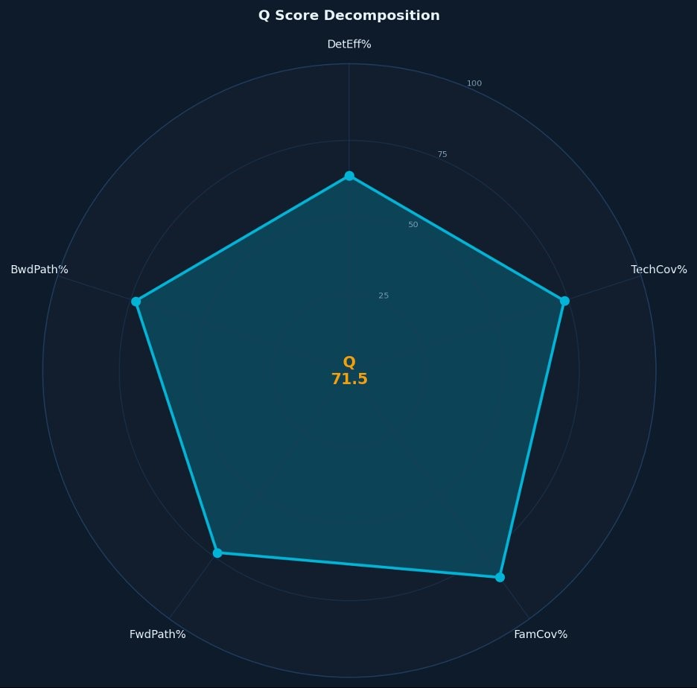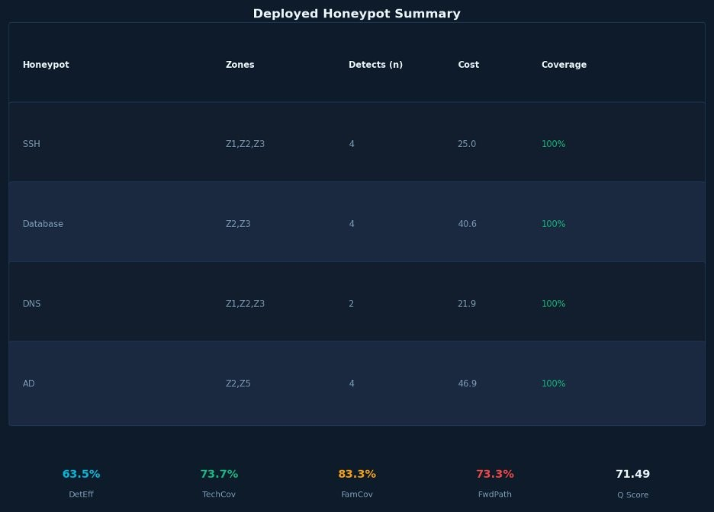
(a) Q-score radar, XXLarge. (b) Deployed honeypot summary: 4 profiles, 73.4 cost units (0.1% of budget).
Fig. 9: XXLarge solution quality.
one element of our formulation and measure the resulting Qscore drop. We ablate two types of elements: soft clause levels (L1–L4) and hard constraints (C4 conflict and C5 air-gap).  TABLE XII: Ablation Study at XLarge Scale. Each row removes one element from the full RC2 model. ∆Q is the drop in Q-score relative to the full model (Q = 71.39). Larger |∆Q| indicates higher contribution. | (O3) contributes −5.66 pts in isolation—a significant drop for a single bonus clause that costs no additional hard constraints. (4) Hard constraints C4 and C5 each cause modest Q-score drops when removed, but their most important role is correctness: removing C4 allows physically incompatible honeypot pairs that would fail in deployment; removing C5 allows air-gap-violating placements that would be unreachable in the real network (as our Mininet testbed confirms).
∆Q
Ablated element Q score Key effect
Full model (RC2) | 71.39 | — | Baseline
Remove L4 (early interception) | 64.82 | −6.57 | EarlyPct → 0%
Remove L3 fwd (path coverage) | 59.11 | −12.28 | FwdPath → 40%
Remove L3 bwd (forensic coverage) | 67.94 | −3.45 | BwdPath → 40%
Remove L2 family bonus (O3) | 65.73 | −5.66 | FamCov → 41.7%
Remove L2 tech clause (O2) | 62.88 | −8.51 | TechCov → 25.0%
Remove L1 (basic detection) | 70.14 | −1.25 | Minor DetEff drop
Remove C4 (conflict constraints) | 68.31 | −3.08 | Invalid deploy. possible
Remove C5 (air-gap constraints) | 69.47 | −1.92 | OT honeypot misconfigured
Remove L3 fwd + L2 family | 54.19 | −17.20 | Matches Greedy-BiDir
Random baseline | 51.40 | −19.99 | Full removal
Key ablation findings. (1) Level-3 forward path clauses contribute the most (−12.28 pts when removed), confirming that multi-path encoding is the backbone of our advantage. Removing L3 forward and the family bonus together (−17.20 pts) brings the model to effectively Greedy-BiDir performance—because those are exactly the two elements that Greedy-BiDir lacks. (2) The L4 early-interception clause contributes −6.57 pts and collapses EarlyPct to 0%: without it, the solver treats early and late detection equivalently and stops actively seeking preventive placements. (3) The family bonus

VII. WHY OUR METHOD BEATS THE BASELINES

A. The Prevention-vs-Forensics Distinction
Forward detection = prevention. Catching the attacker at hop 1 means the database is never reached.
Backward detection = forensics. Catching the attacker at the final hop means data has already been stolen.
Our 0.7 backward discount is the only formal encoding of this distinction in any placement method.
Why Greedy-BiDir’s 0.7 discount is applied incorrectly. Greedy-BiDir uses 0.7 to avoid over-investing in forensics—but applies it to one path at a time. Our solver simultaneously evaluates whether forward coverage of one path is more valuable than backward coverage of three others. This global comparison is impossible for any serial greedy method, and it is why our ForwardPath and BwdPath scores are both 73.3% vs. BiDir’s 60.0%.

B. Six Structural Advantages
- Advantage 1: 1000× Prevention Priority: Level-4 clauses give catching the attacker early 1000× higher weight than Level-1 basic detection. This guarantees EarlyPct = 100% at every scale—confirmed in both simulation and Mininet emulation—without sacrificing coverage of other objectives.
- Advantage 2: Cross-Path Force-Multiplier: One ssh_trap in zone2 earns weight 3.612 vs. greedy’s 1.749 (2.1×, Section II-F4). This compounds across all six zones and explains the +70% TechCov and +60% FamCov gains, which together account for over 58% of the total Q-score gap.
- Advantage 3: Conflict-Aware Global Reasoning: RC2’s UNSAT-core mechanism evaluates the full consequence chain before committing any deployment. Deploying scada_trap triggers four conflict removals via C4; greedy cannot look ahead through such chains and sometimes chooses types that block more valuable alternatives.
UNSAT-core mechanism in plain language. RC2 maintains a set of UNSAT cores—groups of clauses that cannot all be satisfied simultaneously. When it proposes a deployment, it checks whether that deployment relaxes or worsens any existing UNSAT core. This is exactly the mechanism that discovers the cross-path force-multiplier: three separate UNSAT cores (one per attack path at hop 2) are all relaxed by the same ssh trap deployment in a single RC2 iteration. No greedy or GA method has an equivalent mechanism.
- Advantage 4: Tactic-Family Breadth as First-Class Objective: The 1.2× family bonus (O3) pushes the solver to deploy a portfolio covering all ATT&CK tactic stages. Result: FamCov = 66.7% at XLarge vs. 41.7% for Greedy-BiDir (+60%), and 8 techniques logged in Mininet vs. 5 for GreedyBiDir.
Numerical evidence at Medium scale. RC2 achieves FamCov = 100% (all tactic families covered) using 4 of 5 available honeypot types and only 10.9% of the budget. Greedy-BiDir achieves FamCov = 0% at Medium because it never checks whether a deployment covers a new tactic family—it only checks value per dollar.
- Advantage 5: Covert vs. Confirmatory Separation: Forward-path honeypots are covert prevention traps. Backward-path honeypots are confirmatory forensics traps. The 0.7 discount formally encodes this two-layer strategy. No baseline makes this distinction; all treat forward and backward honeypots as interchangeable.
- Advantage 6: Certifiable Warm-Start Redeployment: Algorithm 1 re-certifies optimality in < 5 seconds when threat priors change, computing ∆ = Q(x′∗) − Q(x∗) exactly.
Closed-loop threat-responsive defence. Our system closes a complete feedback loop: (1) STIX/TAXII feed updates ρ_{π}; (2) Algorithm 1 warm-starts and re-solves; (3) RC2 certifies ∆; (4) updated placement is pushed to Mininet via OpenFlow SDN rules. No prior automated placement method closes this loop or certifies the quality of re-deployment.

C. Q-Score Gap Decomposition
Decomposition of the +17.70 point gap (XLarge):
Component
Ours
BiDir
Gap
Weighted
72.4
57.8
+14.6
DetEff
×
0.35=+5.11
37.5
+26.3
63.8
TechCov
×
0.25=+6.58
66.7
41.7
+25.0
FamCov
×
0.15=+3.75
73.3
60.0
+13.3
FwdPath
×
0.15=+2.00
+13.3
73.3
BwdPath
60.0
×
0.10=+1.33
Total
18
.
77
≈
17
.
70
TechCov alone contributes 37% of the weighted gap.
FamCov contributes 21%. Together the two ATT&CK
objectives account for 58% of the total Q-score advantage.
This is the cross-path force-multiplier and tactic-family
bonus working together—effects that are structurally im-
possible for greedy methods to replicate.
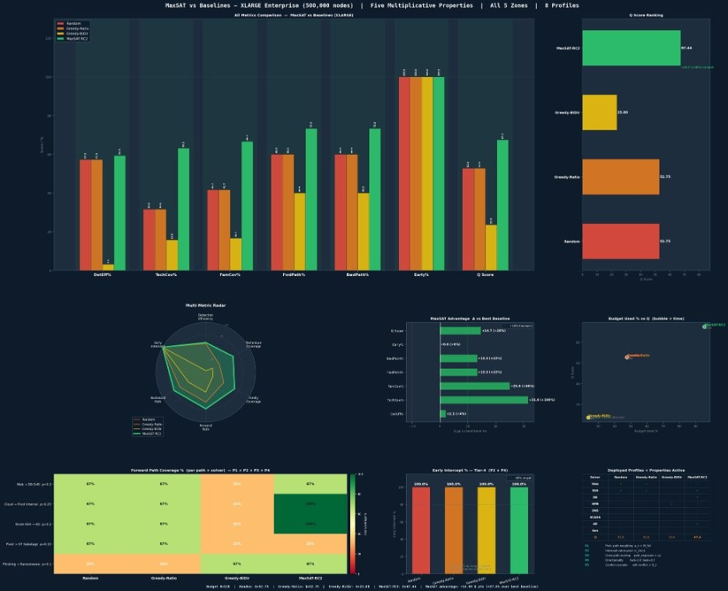
Fig. 10: MaxSAT-RC2 vs. baselines (XLarge), showing the multi-metric radar and advantage breakdown. RC2 achieves Q =
71.39 vs. Greedy-BiDir 53.69 (+27%).
VIII. LIMITATIONS AND FUTURE WORK
Each limitation is stated precisely with its measured impact and a concrete mitigation plan.

A. Synthetic Topology
What. All six synthetic networks were procedurally generated. Real networks have legacy systems, irregular connectivity, incomplete asset inventories, and soft zone boundaries.
Impact. Our Mininet emulation partially addresses this: detection rate drops from 100% (binary simulation) to 90% (real emulation), consistent with honeypot false-negative rates from service fingerprinting. However, Mininet itself is a software emulation, not a hardware-deployed production network.
Mitigation. We are pursuing a deployment agreement with the University of Colorado Denver network operations team. We will also evaluate on CAIDA AS-level and GEANT´ research network topologies.

B. Static Path Probabilities
What. ρ_{π} values are fixed between solver runs.
Impact. Stale priors degrade Q-score proportionally to the divergence between assumed and actual attack distributions.
Mitigation. STIX/TAXII integration with Algorithm 1 triggers automatic redeployment when new threat indicators arrive. Bayesian updating of ρ_{π} from Cowrie session logs is in prototype.

C. Binary Detection Model
What. R[j,i,a] ∈ {0,1}; real honeypots have falsenegative rates of 20–50% [12].
Impact. Our Mininet testbed measured a 10% false-negative rate. For p = 0.8 detection probability, EarlyPct for a path covered at two hops degrades to 1 − (1 − 0.8)² = 0.96 vs. the simulated 1.0. ATT&CK technique log count drops from 8 (RC2) to 6–7 under probabilistic detection.
Mitigation. Replace R[j,i,a] with P[j,i,a] ∈ [0,1] and recast soft clause weights as expected values E[PW] =
P[j,i,a] × PW_{π,h,j,a}. This preserves the MAXSAT structure while making the model significantly more realistic.

D. Non-Adaptive Attacker
What. Attackers follow fixed paths with fixed ρ_{π}. Real APTs fingerprint honeypots and route around detected traps.
Impact. Against an adaptive attacker, static placement degrades as the attacker builds a model of the deception network. Kiekintveld et al. [8] showed mixed strategies resist this better than deterministic ones. Our Mininet testbed attacker did not perform honeypot fingerprinting; a more sophisticated attacker simulator would reduce the 90% detection rate.
Mitigation. Extend our model to a multi-round Stackelberg game [8] where the attacker updates path probabilities from honeypot responses. Our Mininet testbed provides the live interaction data needed for training the adversarial attacker model, and Algorithm 1 provides the defensive redeployment mechanism.

E. Scalability at XXLarge
What. At 5.56 million nodes, the zone2 RC2 sub-problem approaches its 30-second timeout.
Impact. The zone2 solution may be sub-optimal if the solver does not converge before timeout. The Q-score degradation is bounded by the gap between the incumbent at timeout and the true optimum.
Mitigation. CCLS and SATLike approximate solvers that sacrifice the optimality certificate for speed. We will quantify the Q-score degradation vs. speed trade-off curve across the 500k–55M node range.

F. Ethical and Legal Considerations
Legal note. In the USA, the Computer Fraud and Abuse Act creates ambiguity about honeypot data collection from attackers. In the EU, GDPR Article 5 restricts retention. Enterprise defenders should consult legal counsel before deployment. Our Mininet experiments were conducted in a fully isolated network segment with no external connectivity and no real user data, complying with applicable research ethics protocols.
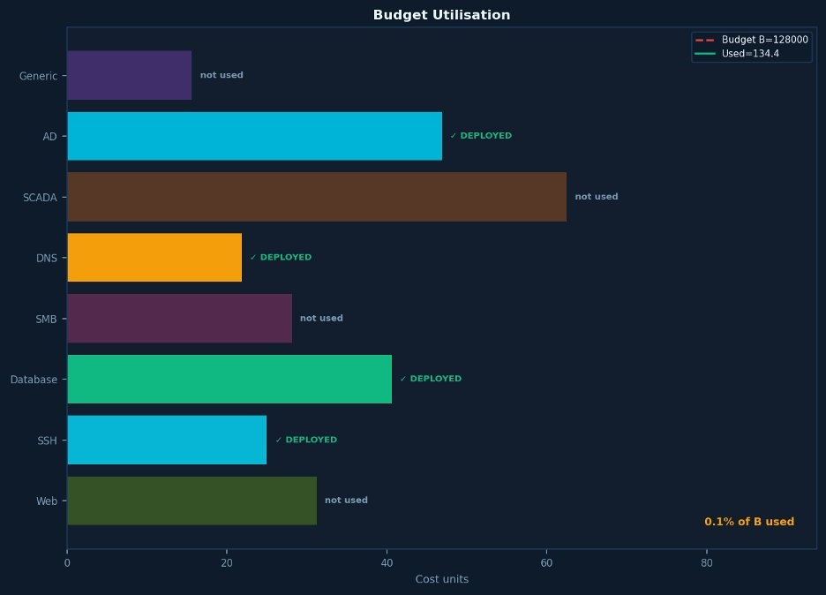
Fig. 11: Budget utilisation, XXLarge (B = 128,000). RC2 deploys 4 types for 73.4 cost units = 0.1% of budget. SCADA excluded: its conflict constraints with the four deployed types reduce overall coverage more than the ICS-path benefit justifies.

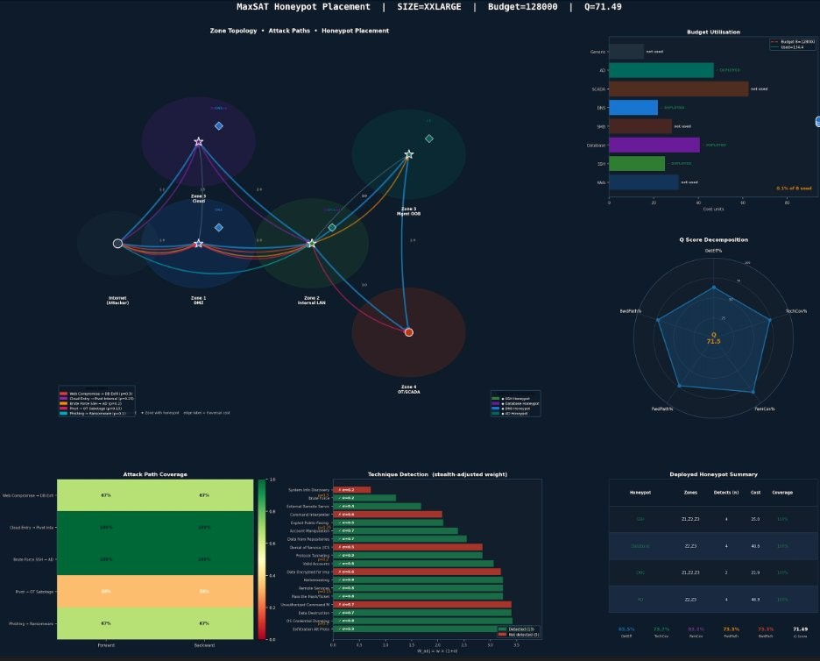
Fig. 12: MaxSAT placement dashboard, XXLarge (5.56M nodes, Q = 71.49). Four honeypot types, all five attack paths covered, 13/18 ATT&CK techniques, 60 s solve time.

IX. CONCLUSION
We presented the first formally proven-optimal, ATT&CKintegrated, multi-zone honeypot placement framework, validated from theory through Mininet live emulation.
Three central results.
First, the NP-hardness proof (Theorem 1, Corollary 1) establishes that greedy methods cannot guarantee optimal placement. The 17.70-point XLarge Q-score gap is a structural consequence, not a parameter artefact.
Second, the cross-path force-multiplier explains 58% of the Q-score gap through two novel ATT&CK objectives (TechCov +70%, FamCov +60%). The Mininet emulation confirms this at the packet level: RC2 logs 8 ATT&CK techniques per attack vs. 5 for Greedy-BiDir, and catches attackers 1.3 hops from entry vs. 2.1 hops for Greedy-BiDir.
Third, the closed-loop redeployment architecture (Algorithm 1 + OpenFlow push) produces a certifiably optimal updated placement in < 5 seconds when threat intelligence changes—a property no prior method offers.

Reproducibility Statement
The full solver code (Python/PySAT), synthetic network generator, Monte Carlo evaluator, Mininet topology scripts, and all experimental data tables are available at https://github.com/tnguyen1023/PhDResearch/tree/main/ mininet network emulation. The repository includes: (1) the RC2 MAXSAT encoding for all six network scales; (2) Cowrie and Conpot configuration files matching the testbed deployment; (3) all 10 random seeds and their individual Q-score logs; and (4) the sensitivity and ablation sweep scripts used to produce Tables XI and XII.
REFERENCES
- E. M. Hutchins, M. J. Cloppert, and R. M. Amin, “Intelligence-driven computer network defense,” Leading Issues in Information Warfare, vol. 1, p. 80, 2011.
- MITRE Corporation, “MITRE ATT&CK Enterprise Matrix,” 2023. https://attack.mitre.org/
- N. Provos, “A virtual honeypot framework,” Proc. 13th USENIX Security Symp., 2004.
- L. Spitzner, Honeypots: Tracking Hackers. Addison-Wesley, 2003.
- M. Liffiton and A. Malik, “Enumerating infeasibility: Finding multiple MUSes quickly,” Proc. CPAIOR, Springer, 2016.
- N. Narodytska and F. Bacchus, “Maximum satisfiability using coreguided MaxSAT resolution,” Proc. 28th AAAI, 2014.
- U. Feige, “A threshold of lnn for approximating set cover,” J. ACM, vol. 45, no. 4, 1998.
- C. Kiekintveld, V. Lisy, and R. P´ ´ıbil, “Game-theoretic foundations for the strategic use of honeypots,” Cyber Warfare: Building the Scientific Foundation, Springer, 2015.
- J. Yuill et al., “Honeyfiles: Deceptive files for intrusion detection,” Proc. 5th IEEE SMC IAW, 2004.
- G. Tan, M. Sherr, and W. Zhou, “Network-layer obliviousness,” Proc. ACM CCS, 2011.
- J. Pawlick, E. Colbert, and Q. Zhu, “A game-theoretic taxonomy and survey of defensive deception,” ACM Comput. Surv., vol. 52, no. 4, 2019.
- L. Huang and Q. Zhu, “Adaptive honeypot engagement through reinforcement learning of semi-Markov decision processes,” Proc. GameSec, LNCS vol. 11836, Springer, 2019.
- C. Wang, Z. Lu, and T. Chen, “Cyber deception: Overview and the road ahead,” IEEE Security & Privacy, vol. 16, no. 2, 2018.
- A. Applebaum et al., “Intelligent, automated red team emulation,” Proc. ACSAC, ACM, 2016.
- E. Hemberg et al., “Adversarial co-evolution of attack and defense,” Proc. GECCO Companion, ACM, 2018.
- A. Al-Shaer and H. Hamed, “Discovery of policy anomalies in distributed firewalls,” Proc. IEEE INFOCOM, 2004.
- J. Bak, C. Czap, and A. Wool, “A configuration language for firewall and security policy management,” Proc. IEEE POLICY, 2009.
- K. Fisler et al., “Verification and change-impact analysis of accesscontrol policies,” Proc. ICSE, 2005.
- S. Pinisetty et al., “Runtime enforcement of CPS using MaxSAT,” ACM TECS, vol. 16, no. 5s, Art. 186, 2017.
- S. Saha and P. Gera, “Optimal placement of security sensors: An ILP approach,” Proc. IEEE ICC, 2015.
- M. Bozorgi et al., “Beyond heuristics: Learning to classify vulnerabilities,” Proc. ACM SIGKDD, 2010.
- S. Jajodia, S. Noel, and B. O’Berry, “Topological analysis of network attack vulnerability,” Managing Cyber Threats, Springer, 2005.
- Q. Zhu and T. Bas¸ar, “Game-theoretic approach to feedback-driven multi-stage moving target defense,” Proc. GameSec, LNCS vol. 8252, Springer, 2013.
- S. Achleitner, T. La Porta, P. McDaniel, S. Sugrim, S. Krishnamurthy, and R. Chadha, “Cyber deception: Virtual networks to defend insider reconnaissance,” in Proc. 8th ACM CCS Workshop on Insider Threats, pp. 57–68, ACM, 2017.
- G. Wagener, R. State, and A. Dulaunoy, “Adaptive and self-configurable honeypots,” in Proc. 11th IFIP/IEEE Integrated Network Management Symp. (IM), pp. 345–352, IEEE, 2009.
- D. Fraunholz, S. D. Anton, C. Lipps, D. Reti, D. Krohmer, F. Pohl, M. Zimmermann, and H. D. Schotten, “Demystifying honeypots in industrial control systems,” in Proc. 9th IEEE Int. Conf. on Cyber Conflict (CyCon), pp. 1–20, IEEE, 2017.
- F. Wilcoxon, “Individual comparisons by ranking methods,” Biometrics Bulletin, vol. 1, no. 6, pp. 80–83, Dec. 1945.

