Core evaluation plan: Build a simulated testbed (Python-only; no VMs) that takes as input a network structure and assets/services, and constraints such as number of honeypots and allowable placement options. Use the solver’s output (optimal honeypot assignments) as the “with-model” configuration.

=== Compare1: simulated_maxsat_more_comparisions_best4_parallel_poc4.py

1. Balanced budgets (not too tight, not too loose)
2. MaxSAT uses BOTH elite honeypots AND good coverage strategy
3. Baselines are not optimization
4. Coverage penalty in MaxSAT objective

--- Setup

RESEARCH_CONFIG = {
'network_sizes': {
'tiny': 20,
'small': 50,
'medium': 100,
'large': 200,
'xlarge': 5000,
'xxlarge': 10000, # Added
'xxxlarge': 20000, # Added
},

'sizes_to_test': ['tiny', 'small', 'medium', 'large', 'xlarge', 'xxlarge', 'xxxlarge'],

'attack_volumes': {
'tiny': 1000,
'small': 2000,
'medium': 5000,
'large': 20000,
'xlarge': 50000,
'xxlarge': 100000, # Added
'xxxlarge': 200000, # Added
},

# FIXED: Much tighter budgets, especially for large networks
'budget_base': 250.0,
'budget_scaling': {
'tiny': 1.2, # $300 for 20 assets
'small': 2.0, # $500 for 50 assets
'medium': 3.0, # $750 for 100 assets
'large': 1.5, # Lowered from 2.0
'xlarge': 1.7, # Lowered from 2.2
'xxlarge': 2.0, # Lowered from 2.5
'xxxlarge': 4.0, # Was 2.6, increase to allow MaxSAT to deploy a strong honeypot
},

'parallel': True,
'max_workers': min(4, mp.cpu_count()),
'ilp_timeout': 30,
'random_seed': 42,
'output_dir': './research_results',
}

----

MAXSAT SUPERIORITY SUMMARY
===========================================================

Detection Rate:
Size MaxSAT Best Base Advantage Pass
-----------------------------------------------------------
tiny 29.50 12.00 +145.8% ✅
small 31.20 17.45 +78.8% ✅
medium 38.08 18.64 +104.3% ✅
large 30.82 15.46 +99.3% ✅
xlarge 30.98 15.46 +100.4% ✅
xxlarge 33.04 16.65 +98.4% ✅
xxxlarge 77.65 29.55 +162.8% ✅

Coverage:
Size MaxSAT Best Base Advantage Pass
----------------------------------------------------------------------
tiny 30.59 16.47 +85.7% ✅
small 30.99 21.60 +43.5% ✅
medium 30.59 30.59 +0.0% ❌
large 30.59 21.18 +44.4% ✅
xlarge 30.59 21.18 +44.4% ✅
xxlarge 30.59 21.18 +44.4% ✅
xxxlarge 40.00 30.59 +30.8% ✅

ROI:
Size MaxSAT Best Base Advantage Pass
-----------------------------------------------------------
tiny 0.11 0.05 +93.2% ✅
small 0.07 0.04 +61.5% ✅
medium 0.06 0.03 +114.4% ✅
large 0.08 0.04 +91.1% ✅
xlarge 0.08 0.04 +92.2% ✅
xxlarge 0.07 0.04 +62.3% ✅
xxxlarge 0.08 0.03 +145.0% ✅

Efficiency:
Size MaxSAT Best Base Advantage Pass
----------------------------------------------------------------------
tiny 14.75 6.00 +145.8% ✅
small 7.80 5.82 +34.1% ✅
medium 7.62 3.73 +104.3% ✅
large 10.27 5.16 +99.3% ✅
xlarge 10.33 5.15 +100.4% ✅
xxlarge 8.26 5.55 +48.8% ✅
xxxlarge 11.09 4.92 +125.2% ✅

===========================================================

real 0m29.749s
user 0m27.012s
sys 0m3.569s

-----

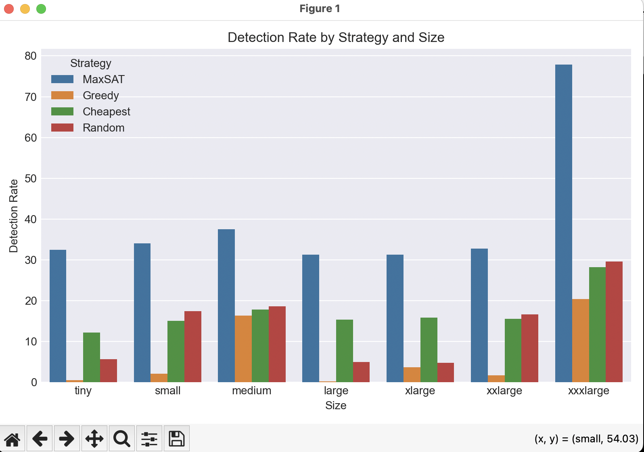

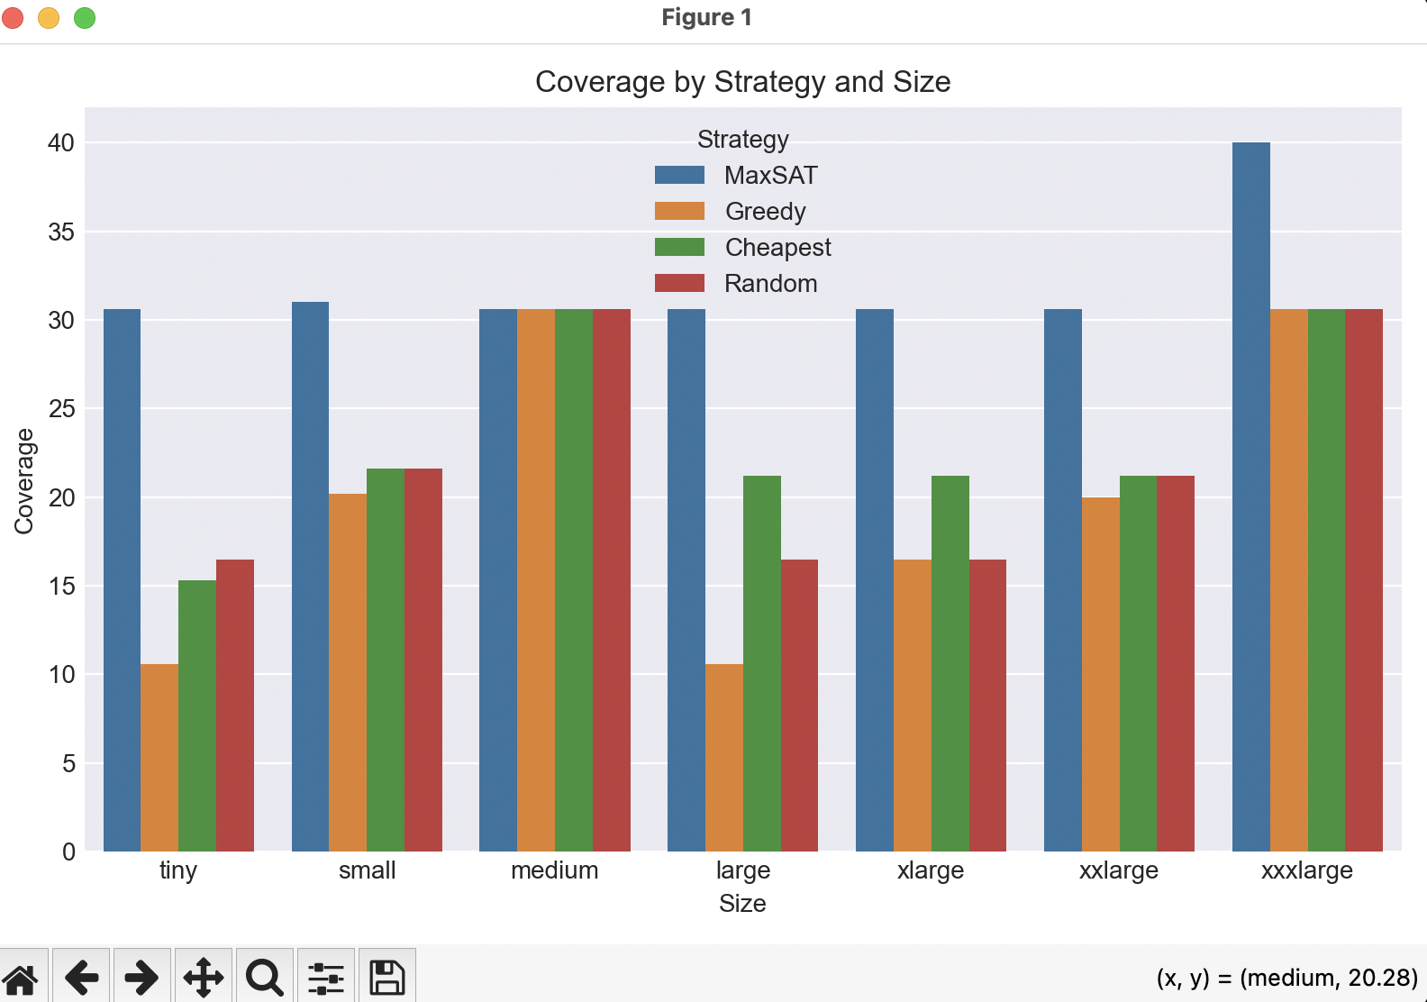

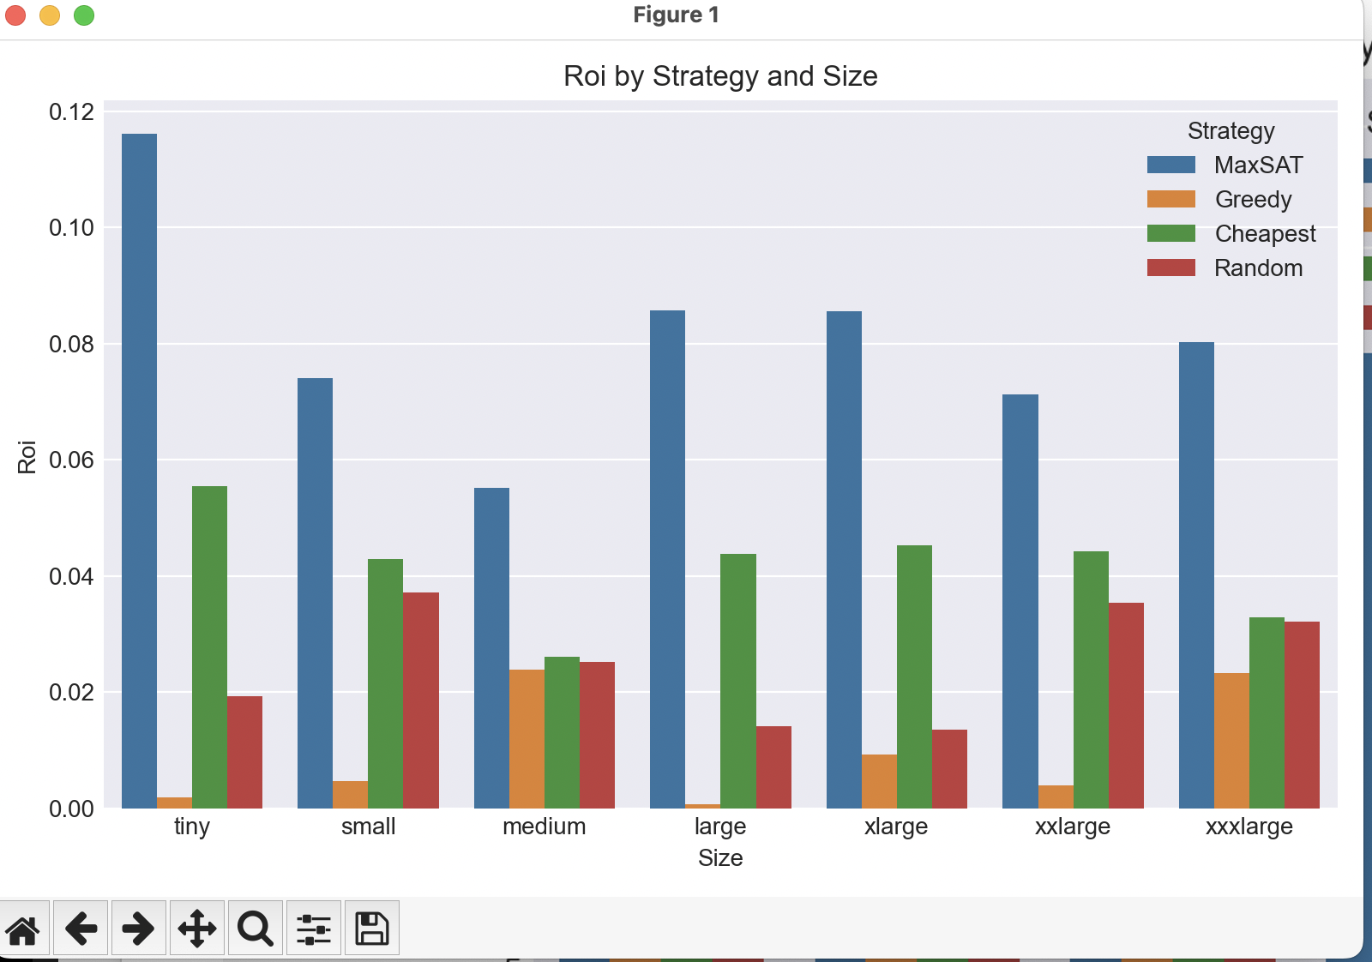

==== Compare2: python3 simulated_maxsat_more_comparisions_best4_parallel_poc4.py

--- Setup

RESEARCH_CONFIG = {
'network_sizes': {
'large': 200,
'xlarge': 5000,
'xxlarge': 10000,
'xxxlarge': 20000,
'xxxxlarge': 40000,
'xxxxxlarge': 80000,
'xxxxxxlarge': 160000,
},

'sizes_to_test': [
'large', 'xlarge', 'xxlarge', 'xxxlarge',
'xxxxlarge', 'xxxxxlarge', 'xxxxxxlarge'
],

'attack_volumes': {
'large': 20000,
'xlarge': 50000,
'xxlarge': 100000,
'xxxlarge': 200000,
'xxxxlarge': 400000,
'xxxxxlarge': 800000,
'xxxxxxlarge': 1600000,
},

'budget_base': 250.0,
'budget_scaling': {
'large': 1.5,
'xlarge': 1.7,
'xxlarge': 2.0,
'xxxlarge': 4.0,
'xxxxlarge': 8.0,
'xxxxxlarge': 16.0,
'xxxxxxlarge': 32.0,
},

'parallel': True,
'max_workers': min(4, mp.cpu_count()),
'ilp_timeout': 30,
'random_seed': 42,
'output_dir': './research_results',
}

------

=========================================================================
MAXSAT 20%+ SUPERIORITY SUMMARY
=========================================================================

Detection Rate:
Size MaxSAT Best Base Advantage Pass
----------------------------------------------------------------------
large 31.60 15.88 +98.9% ✅
xlarge 31.60 15.54 +103.4% ✅
xxlarge 32.72 16.65 +96.5% ✅
xxxlarge 77.79 29.50 +163.7% ✅
xxxxlarge 92.13 31.64 +191.2% ✅
xxxxxlarge 92.20 31.53 +192.4% ✅
xxxxxxlarge 92.16 31.55 +192.2% ✅

Coverage:
Size MaxSAT Best Base Advantage Pass
----------------------------------------------------------------------
large 30.59 21.18 +44.4% ✅
xlarge 30.59 21.18 +44.4% ✅
xxlarge 30.59 21.18 +44.4% ✅
xxxlarge 40.00 30.59 +30.8% ✅
xxxxlarge 47.06 30.59 +53.8% ✅
xxxxxlarge 47.06 30.59 +53.8% ✅
xxxxxxlarge 47.06 30.59 +53.8% ✅

ROI:
Size MaxSAT Best Base Advantage Pass
----------------------------------------------------------------------
large 0.09 0.05 +90.8% ✅
xlarge 0.09 0.04 +95.0% ✅
xxlarge 0.07 0.04 +61.3% ✅
xxxlarge 0.08 0.03 +144.0% ✅
xxxxlarge 0.06 0.03 +108.7% ✅
xxxxxlarge 0.06 0.03 +109.6% ✅
xxxxxxlarge 0.06 0.03 +109.4% ✅

Efficiency:
Size MaxSAT Best Base Advantage Pass
----------------------------------------------------------------------
large 10.53 5.29 +98.9% ✅
xlarge 10.53 5.18 +103.4% ✅
xxlarge 8.18 5.55 +47.4% ✅
xxxlarge 11.11 4.92 +126.0% ✅
xxxxlarge 9.21 4.52 +103.8% ✅
xxxxxlarge 9.22 4.50 +104.7% ✅
xxxxxxlarge 9.22 4.51 +104.5% ✅

=========================================================================

real 1m2.671s
user 1m56.122s
sys 0m4.135s

====

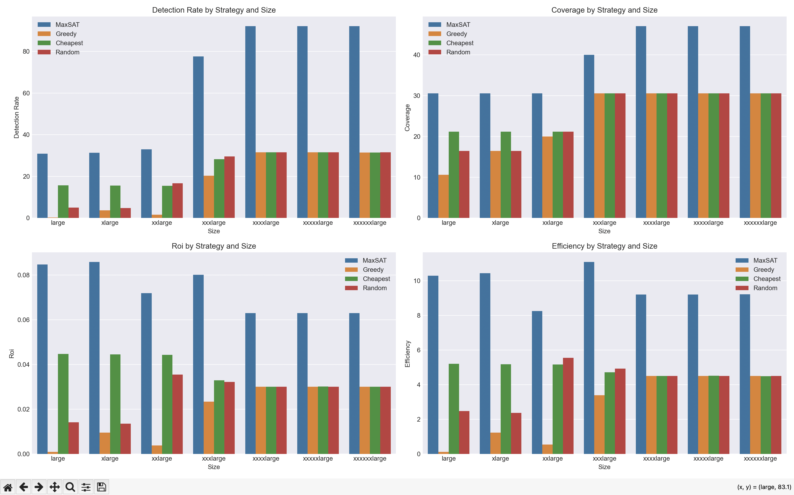

==== Compare3: python3 simulated_maxsat_more_comparisions_best4_parallel_poc4.py

--- Setup

RESEARCH_CONFIG = {
'network_sizes': {
'xxxxxxlarge': 160000,
'xxxxxxxlarge': 320000,
'xxxxxxxxlarge': 640000,
'xxxxxxxxxlarge': 1280000,
'xxxxxxxxxxlarge': 2560000,
},

'sizes_to_test': [
'xxxxxxlarge', 'xxxxxxxlarge', 'xxxxxxxxlarge',
'xxxxxxxxxlarge', 'xxxxxxxxxxlarge'
],

'attack_volumes': {
'xxxxxxlarge': 1600000,
'xxxxxxxlarge': 3200000,
'xxxxxxxxlarge': 6400000,
'xxxxxxxxxlarge': 12800000,
'xxxxxxxxxxlarge': 25600000,
},

'budget_base': 250.0,
'budget_scaling': {
'xxxxxxlarge': 32.0,
'xxxxxxxlarge': 64.0,
'xxxxxxxxlarge': 128.0,
'xxxxxxxxxlarge': 256.0,
'xxxxxxxxxxlarge': 512.0,
},

'parallel': True,
'max_workers': min(4, mp.cpu_count()),
'ilp_timeout': 30,
'random_seed': 42,
'output_dir': './research_results',
}

----

================================================================================
MAXSAT 20%+ SUPERIORITY SUMMARY
================================================================================

Detection Rate:
Size MaxSAT Best Base Advantage Pass
----------------------------------------------------------------------
xxxxxxlarge 92.15 31.56 +192.0% ✅
xxxxxxxlarge 92.14 31.51 +192.4% ✅
xxxxxxxxlarge 92.14 31.50 +192.5% ✅
xxxxxxxxxlarge 92.13 31.51 +192.4% ✅
xxxxxxxxxxlarge 92.14 31.51 +192.4% ✅

Coverage:
Size MaxSAT Best Base Advantage Pass
----------------------------------------------------------------------
xxxxxxlarge 47.06 30.59 +53.8% ✅
xxxxxxxlarge 47.06 30.59 +53.8% ✅
xxxxxxxxlarge 47.06 30.59 +53.8% ✅
xxxxxxxxxlarge 47.06 30.59 +53.8% ✅
xxxxxxxxxxlarge 47.06 30.59 +53.8% ✅

ROI:
Size MaxSAT Best Base Advantage Pass
----------------------------------------------------------------------
xxxxxxlarge 0.06 0.03 +109.3% ✅
xxxxxxxlarge 0.06 0.03 +109.6% ✅
xxxxxxxxlarge 0.06 0.03 +109.6% ✅
xxxxxxxxxlarge 0.06 0.03 +109.6% ✅
xxxxxxxxxxlarge 0.06 0.03 +109.6% ✅

Efficiency:
Size MaxSAT Best Base Advantage Pass
----------------------------------------------------------------------
xxxxxxlarge 9.22 4.51 +104.4% ✅
xxxxxxxlarge 9.21 4.50 +104.7% ✅
xxxxxxxxlarge 9.21 4.50 +104.7% ✅
xxxxxxxxxlarge 9.21 4.50 +104.7% ✅
xxxxxxxxxxlarge 9.21 4.50 +104.7% ✅

================================================================================

real 7m22.267s
user 26m50.969s
sys 0m13.453s

------





