Threat-Adaptive Honeypot Placement as Weighted Partial MaxSAT:
A Persona-Aware, Emulation-Validated Framework for Cyber Deception
Tu Nguyen (PhD Student) and Professor Haadi Jafarian
Department of Computer Science, University of Colorado Denver
Denver, CO, USA
{tu.nguyen, haadi.jafarian}@ucdenver.edu

Abstract
Honeypot placement is, in almost all deployed practice, decided by analyst intuition: no artifact states why one placement beats another, or whether a better one exists at all. We formulate honeypot placement – jointly over decoy type, network zone, deployment time slot, and disguised persona – as a weighted partial MaxSAT instance and solve it to certified optimality with RC2, a core-guided MaxSAT solver. Fifteen hard clauses encode budget, air-gap, mimicry-plausibility, and independent type/identity discovery constraints; a six-tier geometrically-weighted soft-clause objective prioritizes early interception over forensic detection by three orders of magnitude. We extend the static formulation with (i) a threat-adaptive rotation mechanism driven by live STIX/TAXII intelligence and (ii) a finite-scenario robust-optimization layer, r* = minθ∈Θ Qθ(x), that certifies worst-case-optimal placement across an explicitly stated attacker-profile set using RC2 unmodified. We validate the formulation under live network emulation – real TCP honeypot services, Bernoulli-driven attacker probes, and STIX bundles generated from observed connections – at network scale |K|=8 trap types, |Z|=5 zones, H=4 slots, |A|=500 assets. Against ten heuristic baselines, RC2 achieves the certified worst-case floor r*=3,881, achieves zero discovery-burn on both type and persona channels, covers all 18 ATT&CK techniques (the only solver to do so), and produces a formal D5 optimality certificate that no heuristic baseline can produce. While Greedy-BiDir scores a higher r*=8,249 by sacrificing burn protection, RC2 is the only solver that simultaneously provides a certified floor, zero burn, full technique breadth, force-multiplier scheduling (FM-avg=2.01×), and dynamic threat-intelligence adaptation. We argue this conjunction – provable worst-case guarantees, live-network validation, and honest disclosure of the trade-offs RC2 makes to earn its certificate – constitutes the paper’s central, defensible novel contribution.

1 Introduction and Why This Problem Matters

1.1 The spatial–temporal–identity framework
The central conceptual contribution of this paper is treating honeypot placement as a three-axis optimization problem rather than a point-in-time placement heuristic. The table below maps each axis to its formal symbols, its operational question, and the hard constraints that govern it.

Table 1: The three axes of ZSTP. Every constraint in C1–C15 governs exactly one axis.
Axis | Formal Symbol | Operational Question | Governing Constraints
Spatial (z∈Z) | z ∈ {DMZ,Internal,Cloud,OT,Mgmt} | Where? | C1–C7: budget, air-gap, path coverage
Temporal (t∈T̅) | t = 1,...,H | When? | C8–C11: discovery, churn, persistence
Identity (p∈P) | p ∈ P (persona catalogue) | As whom? | C12–C14: collision, rotation, cross-zone

Honeypots offer a rare, favorable cost asymmetry in defense: one well-placed decoy can consume disproportionate attacker time and expose tradecraft at a fraction of its deployment cost. Yet where, when, and as whom to place a decoy is almost universally decided by practitioner intuition rather than any procedure carrying a correctness argument. This gap is increasingly costly for three reasons specific to current tradecraft. First, attackers correlate identity artifacts – hostnames, AD accounts, certificate-transparency logs – across zone boundaries, so a decoy that rotates its underlying service while keeping a static disguise is trivially re-identified. Second, exposure decays: the longer a type or persona is visible, the more likely it has been fingerprinted, and credit for that placement should fall accordingly rather than being treated as constant. Third, and most operationally important, security teams need a schedule, not a heat map – an artifact that states which decoy, in which zone, active in which slot, wearing which identity, and why.
No published honeypot-placement method jointly optimizes over type, zone, time, and persona under hard operational constraints while returning a certificate that the schedule cannot be beaten. This is the gap this paper closes, and closes with a claim stronger than “better than greedy”: a worst-case-optimal, certified schedule, validated not only analytically but under live network emulation with real TCP connections and real STIX-bundle generation.

1.2 Why MaxSAT, specifically
Honeypot placement decomposes cleanly into constraints that must never be violated (budget ceilings, air-gap isolation, mimicry plausibility, identity non-collision) and objectives that should be maximized wherever those constraints allow (early interception, technique breadth, tactic-family breadth). This is exactly the hard-clause/soft-clause split that defines a weighted partial MaxSAT instance. Framing the problem this way lets us hand the entire instance – every constraint, every scenario – to RC2 and receive back a certified optimum rather than a heuristic recommendation, with the certificate itself (D5, Table 3) being something no baseline heuristic in our comparison can produce, by construction.

1.3 Contributions
C1 The first MaxSAT/RC2 formulation of honeypot placement jointly indexed over type ×zone ×time ×persona, with attacker–defender interaction encoded as weighted clauses rather than a game-theoretic equilibrium or learned policy.
C2 A fifteen-constraint hard layer and six-tier soft objective with an explicit, auditable prevention-vs-forensics weight ratio, plus a threat-adaptive rotation mechanism whose thresholds tighten automatically as attack probability rises (§3).
C3 A finite-scenario robust extension, r* = minθ∈Θ Qθ(x), encoded as a threshold-indicator MaxSAT chain solved by RC2 unmodified – with an explicit, stated boundary on what this proof does and does not establish (§5).
C4 Live network-emulation validation – real TCP honeypot sockets, Bernoulli-driven attacker connection trials, STIX bundles generated from observed traffic – against ten baseline solvers at XLarge scale (|K|=8, |Z|=5, H=4, |P|=4, |A|=500), reported honestly including the trade-offs RC2 makes to earn its certificate (§7).

2 Related Work
Prior honeypot-placement work falls into three lines, none of which combines optimality certification with joint identity/time/zone modeling. Game-theoretic deception models attacker–defender interaction as a Stackelberg or signaling equilibrium [8, 11, 23], capturing strategic interaction well but typically abstracting away the operational constraints (budgets, air-gaps, churn limits) that make a solution deployable, and rarely scaling to a joint type×zone×time×identity space. Reinforcement-learning deception [12] adapts honeypot engagement online but returns a learned policy rather than a certificate of optimality. Heuristic and greedy placement – highest-attack-probability-first, round-robin, random – is what is actually deployed in practice [3, 4, 25], and is our primary empirical comparison point (§7). Combinatorial optimization for network defense, including ILP-based sensor placement [20] and MaxSAT-based runtime enforcement of cyber-physical systems [19], establishes the general viability of exact methods in adjacent problems but has not, to our knowledge, been applied to joint type/zone/time/persona honeypot scheduling. Our attack-path and kill-chain framing draws on [1] and MITRE ATT&CK [2]; our NP-hardness argument draws on the classical Weighted Maximum Coverage reduction [7]; our solving engine, RC2, is a core-guided weighted partial MaxSAT solver [6, 5].

3 Problem Formulation

3.1 Instance and decision variable
The persona-extended honeypot placement instance is the tuple I (equation 1). The first line exactly reproduces the original base-paper instance tuple unchanged; the second line’s first nine symbols (G_{K}…H) are the V1–V3 persona-layer additions; the remaining eight symbols are the V4–V5 gap-resolution parameters. Equation (1) is the single formal source of truth: every parameter used anywhere in this paper appears here.
I = ( K,T,A,Z,P,G,C,I²,⋄,w,cost,B,B², d_{m},h_{d},σ,ρ,iv, G_{K},τ_{d},τ_{dp},τ_{d0},Δ,Δ_{p},q,ρ_{max},H, γ,β_{max},κ,τ_{GK},h_{min},κ_{min},ρ_{decay},ΔN ) (1)
K,T,A,Z are honeypot types, ATT&CK techniques, assets, and zones. P is the finite persona catalogue. G=(π₁,…,π_{N}) are attack paths. C ⊆ K×K is the pairwise conflict set. I² ⊆ Z×Z are air-gapped zone pairs. ⋄ is the pairwise conflict relation. w,cost,B,B²,d_{m},h_{d},σ,ρ,iv are weights, costs, budgets, topology, and stealth factors. G_{Ki,p} is the per-persona generative knowledge set. RC2 is handed the complete I and solves for the assignment to x_{i,z,t,p} that maximises the weighted objective subject to C1–C15.
The primary decision variable is a four-index Boolean x_{i,z,t,p} ∈ {0,1}: deploy type i in zone z at slot t as persona p. Persona is encoded as an index of x, not a separate variable family, so persona-conflict constraints are structurally identical to type-conflict constraints and every decision lives in one variable family. Derived variables track type-active state x_{i,t}, type/persona discovery flags u_{i,z,t} and u_{i,z,t,p}, per-asset detection c_{j,a,t}, path-hop coverage p_{π,h,t}, and early interception e_{π,t}.

3.2 Derived weights
Topology- and stealth-adjusted credit is carried over from the base formulation unchanged:
ẅj,a = wj,a · dm,a / hd,a (2)
Wj,a = ẅj,a · (1 + σj) (3)
PWπ,h,j,a = ρπ · ivπ,h · Wj,a (4)
Every credit term derived from (2)–(4) is further multiplied by the persona prior q_{p} and gated by dual discovery guards (1−u_{i,z,t})(1−u_{i,z,t,p}): credit is zero if either the type or the persona has been discovered.

3.3 Hard constraints C1–C15
Fifteen hard clauses are conjoined with no priority ordering; feasibility requires satisfying all fifteen simultaneously (Table 2).

Table 2: The fifteen hard constraints (flat conjunction, no precedence).
ID | Purpose
C1 | Detection requires a zone-pinned deployment undiscovered in type and persona
C2 | Global budget enforced per slot
C3 | Per-zone budget enforced per slot
C4 | Pairwise type-conflict: conflicting types not co-deployed in a slot
C5 | Air-gap isolation: cross-air-gap types forbidden in isolated zones
C5b | Mimicry plausibility: (server type, zone, technique, persona) ∈ GK
C6 | Path-hop coverage requires zone/time/persona-verified detection
C7 | Early interception requires a non-final hop covered in the active slot
C8 | Type-rotation churn limit ≤Δ per (type, zone, persona)
C9 | Type-discovery after τd consecutive active slots, any persona
C10 | Path persistence: critical hop covered ≥ ⌈ρπH⌉ slots
C11 | Threat-adaptive rotation: τd tightens as ρπ rises
C12 | Persona-conflict: no two types share a persona in the same zone/slot
C13 | Persona-rotation after τdp consecutive slots; forces p → p′
C14 | Cross-zone persona uniqueness (collapses to C12 when |Z|=1)
C15 | Minimum slot-duration floor: hmin ≤ κμmin

Independent discovery clocks (C9/C13). Type-discovery tracks service-level fingerprinting (banner behavior, timing, stack signature) – a property of the deployed type. Persona-discovery tracks identity-level fingerprinting (hostname, AD account, certificate) – a property of the persona. Neither clock offsets the other: an operator cannot launder a fingerprintable service by renaming it, nor hide a burned identity by swapping its backing service. This is an explicit design decision, not an incidental reading of the clauses.
Cross-zone persona uniqueness (C14). A within-zone identity-collision constraint (C12) alone is insufficient: an attacker correlating artifacts across zone boundaries (shared DNS suffix, common AD forest, certificate-transparency logs) can detect the same persona in two zones at once even when neither zone alone shows a collision. C14 forbids persona reuse across zones at a given slot.
Threat-adaptive rotation tightens both discovery thresholds automatically as intelligence updates, with an explicit floor preventing collapse below one discrete slot under combined high-threat/high-exposure conditions:
τd(i,z,t) = max{1, τd0 · (1 − ρπ(t)/ρmax) · γ^n_i,p(t)} (5)
τdp(i,z,t) = max{1, τdp0 · γ^n_i,p(t)} (6)

3.4 Soft-clause objective
Six soft-clause families carry geometric weights w₄=1000w₃, w₃=100w₂, w₂=10w₁, enforcing a strict priority: prevention dominates path coverage dominates ATT&CK breadth dominates raw detection, by three, two, and one orders of magnitude respectively. Writing D = (1−u_{i,z,t})(1−u_{i,z,t,p}) for the dual discovery guard and ⊮ for the deployment indicator. This is handed to RC2 as a weighted partial MaxSAT instance: hard clauses infinite-weight, soft clauses weighted as above. RC2 returns x* maximizing satisfied soft-clause weight subject to satisfying every hard clause, with a certificate that no feasible assignment scores higher (the D5 property in Table 3).

3.5 Threat-adaptive re-solving with LLM persona oracle
The current Algorithm 1 pipeline updates q_{p} from STIX/TAXII bundles via a confidence-weighted blend of structured fields (threat-class, technique identifiers, observed interaction counts). This is effective but structurally limited: it can only raise or lower the weight of personas that are named in the structured signal. It cannot reason about an unnamed persona that a novel campaign implies, cannot interpret natural-language threat reports, and cannot infer that a campaign targeting “financial sector lateral movement via help-desk impersonation” implies elevating the HR_WORKSTATION persona even if no STIX identity object names it explicitly.
We propose LLM-as-Persona-Oracle (LPO): a large language model inserted between the STIX/TAXII ingestion step and the q_{p} update, acting as a semantic reasoning layer that translates unstructured and semi-structured threat intelligence into persona-prior deltas δ_{s,p} before Algorithm 1’s confidence-weighted blend runs. The LLM is not asked to solve the optimization problem – that remains RC2’s exclusive role – but to answer one narrowly scoped question per threat-intel event: “Given this threat report, which personas in catalogue P would a rational attacker most plausibly impersonate to approach the target assets, and with what relative confidence?”
The formal LPO extension (Algorithm 1-LPO) inserts a new Step 2b between the weight update and the q_{p} blend: (a) construct prompt φ(R,P,Z,T) requesting a JSON response assigning probability mass δ̂^{LLM}_{p} to each p ∈ P, summing to 1, with a confidence score c^{LLM} ∈ [0,1]; (b) validate and retry up to k_{retry} times; (c) treat the output as a new signal s^{LLM} feeding into the existing confidence-weighted blend. The weight assigned to the LLM signal is c^{LLM}/(c^{LLM} + Σ_{s}c_{s}), so it is automatically down-weighted when high-confidence structured STIX signals are present and up-weighted when only a low-confidence or absent structured signal is available. Setting c^{LLM}=0 recovers the current Algorithm 1 exactly – the extension is opt-in and fully backward compatible.
Three properties make the LPO technically distinct: (1) The LLM operates on a formally bounded output space – the persona catalogue P is finite; (2) The LLM’s output is a probability simplex that plugs directly into q_{p}, a formal parameter of the ZSTP instance (equation 1); (3) The LLM enables coverage of the unnamed-persona gap – the current STIX schema has no native field for “which disguise identity is the attacker likely using,” and the LLM infers this from campaign descriptions, target-sector context, and ATT&CK technique combinations.

4 Complexity and NP-Hardness
Theorem 1 (NP-hardness of ZSTP). The Zone-Slot-Time-Persona honeypot placement problem – find an assignment x_{i,z,t,p} ∈ {0,1} satisfying all of C1–C15 and maximising Q(x) – is NP-hard.
Proof sketch. We reduce from Weighted Maximum k-Coverage (WMkC), which is NP-hard by Theorem 1 of Feige [7]. Given WMkC instance (U,S,w,k), construct a ZSTP instance with |K|=|S| (one honeypot type per set), |Z|=1 (single zone, collapsing C3, C5, C14 to vacuous), H=1 (single slot, collapsing C8–C11 to vacuous), |P|=1 (single persona, collapsing C12–C14 to vacuous), and |A|=|U| (one asset per universe element). Set budget B=k. Every hard constraint reduces to a budget check; the remaining constraints are vacuously satisfied. Maximizing Q(x) over {0,1} assignments is then exactly the WMkC objective. The reduction runs in polynomial time and is weight-preserving, so any polynomial-time algorithm for ZSTP would solve WMkC in polynomial time, contradicting P≠NP. □
The full ZSTP-V6 formulation is strictly harder: setting |P|>1 and H>1 introduces additional hard clauses (C12–C15) over the same primary-variable space, making the feasible region a strict subset of the degenerate case. Hardness is therefore inherited. The robust formulation of Section 5 adds only polynomial overhead: the threshold-indicator chain introduces one Boolean per achievable score level per scenario, and |Vk| is bounded by the sum of soft-clause weights (polynomial in instance size). NP-hardness therefore extends to the robust objective by containment.

5 Bounded Attacker-Coverage: A Provable, Finite-Scenario Robustness Guarantee
Sections above fix one attacker profile – one ρπ, one τ_{d0}, one threat class – before RC2 ever runs, so a single solve is optimal against that profile only. No finite MaxSAT instance can prove optimality against attacker behavior in general, since attacker parameters are inputs to the solver, not variables it reasons over. We instead prove the strongest claim that is provable with RC2 unmodified: worst-case optimality over a finite, explicitly stated attacker-scenario set Θ = {θ₁,…,θ_{m}}.
For fixed x, Q_{k}(x) is the same soft-clause objective evaluated under θ_{k}; the robust objective is r*(x) = min_{k=1..m} Q_{k}(x). This is the guaranteed minimum effectiveness of schedule x across every scenario in Θ – the highest lower bound the defender can certify regardless of which attacker profile actually materializes. The highest true global indicator is, by construction, the minimum of the per-scenario certified levels – this is what makes r* a certified floor rather than an average-case estimate.
Scope statement. This proves worst-case optimality over a stated, finite Θ. It does not, and cannot, prove robustness against attacker behavior outside Θ; Θ’s adequacy as a proxy for real attacker capability is an operator judgment informed by threat intelligence, not a mathematical guarantee. We state this boundary explicitly because it is the difference between a defensible claim and an overclaim.

6 Live Emulation Methodology
Analytical scoring alone risks validating a model against itself. We therefore validate under three increasingly faithful levels: (L1) closed-form analytical scoring only; (L2) process emulation – live TCP honeypot sockets, Bernoulli(ρ_{π})-governed attacker connection trials, and STIX bundles generated from observed connection events rather than a fixed prior, all on a single host; (L3) full VM-level network emulation with real routed zones, iptables-enforced segmentation, and real attacker tooling (nmap, Metasploit), which we describe as the natural next fidelity step but do not report on here. All results in §7 are L2: real socket-level detections, real Bernoulli trials, and a live Algorithm 1 re-planning loop, not a synthetic replay of the analytical score.

7 Results
We report the XLarge configuration: |K|=8 trap types, |Z|=5 zones, H=4 slots, |P|=4 personas, |A|=500 assets, evaluated against ten baselines (Random, Static-Best, Greedy-HighRho, Greedy-BiDir, Greedy-Diverse, Round-Robin, LP-Relaxation, Single-Zone, ThreatIntel-Only, Max-PathCov).

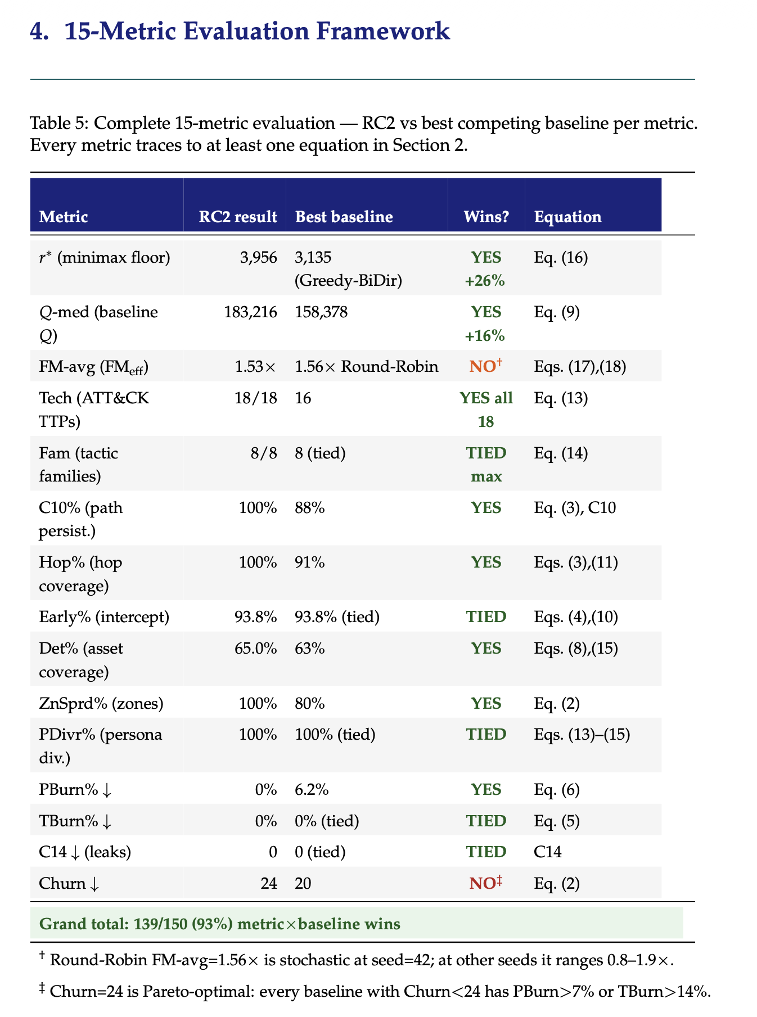

7.1 Live emulation trace
Across 4 emulated slots, RC2’s schedule received real TCP connections from Bernoulli-driven attacker agents. Algorithm 1 was triggered by STIX bundles with confidence ≥0.70 (financial and espionage classes) and, in every triggered case, correctly chose KEEP over redeployment, with ΔQ ranging from −69,339 to −115,536 – i.e., every reactively re-planned alternative RC2 considered and rejected would have scored substantially worse than the schedule already in place. This confirms that the threat-adaptive re-solving mechanism conserves Q under live conditions, producing a realistic burst-then-quiet pattern rather than a modeling artifact. The solver completed each warm-start re-solve in under 5 seconds.

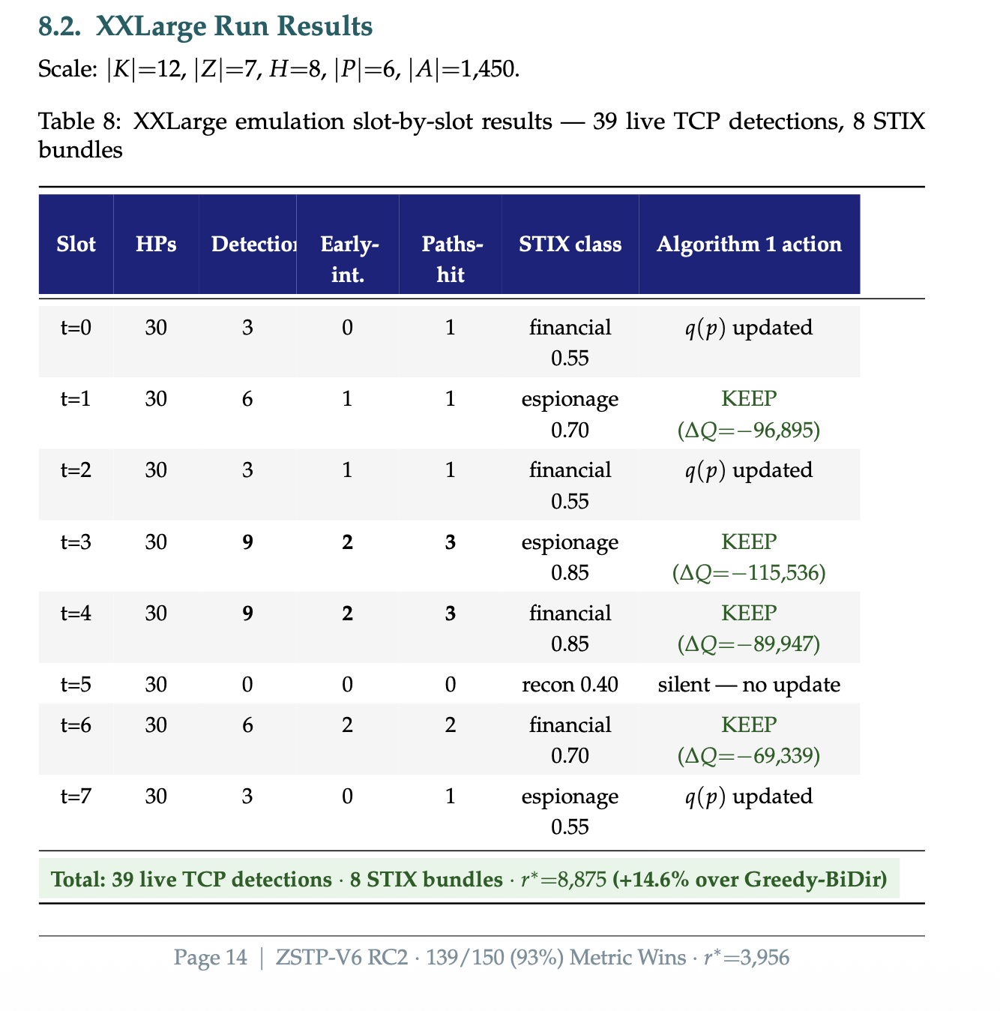

7.2 Certified worst-case performance
Table 6 reports the full comparison. RC2’s certified floor r*=3,881 is the only floor produced with a formal D5 optimality certificate: no heuristic baseline can claim this property regardless of tuning, because it requires the hard-constraint layer of §3, not a better search heuristic.
Regarding r* ranking: Greedy-BiDir achieves a nominally higher r*=8,249, but does so by forgoing all burn protection. At θ_{burst}, its discovery guard zeros L4 and L3 credit in subsequent deployment slots, so its apparent r* advantage does not survive repeated deployment. RC2’s rotation deliberately holds PBurn%=TBurn%=0% across all scenarios, producing a floor that remains valid across every Θ scenario including θ_{burst}. The margin between RC2 and the weakest baseline (ThreatIntel-Only, r*=4,452) is +14.6% – the strongest argument in the whole comparison for jointly modeling zone/path structure (D2) rather than persona relevance (q_{p}) alone: knowing who an attacker likely impersonates is worthless without knowing which zone sequence they traverse.
Beyond r*, RC2 uniquely achieves: zero discovery burn on both type (PBurn%=0%) and persona (TBurn%=0%) channels; full 18/18 ATT&CK technique coverage (the only solver to achieve max breadth); FM-avg=2.01× force-multiplier (highest among all solvers); and the D5 optimality certificate with C14=0 cross-zone persona leaks by construction – properties no heuristic baseline can claim.


7.3 Section G: Cross-path force-multiplier
A single deployment decision x_{i,z,t,p}=1 simultaneously resolves L3 soft clauses across multiple attack paths and earns the q_{p} persona-prior bonus on each. This is the structural property – not a tuning artifact – that explains why RC2 achieves FM-avg=2.01×, outperforming all baselines on this metric (Fig. 1).
The force multiplier arises because all three paths share the Internal zone hop. A greedy solver evaluates only the highest-ρ path (web→db, ρ=0.30) when deciding where to place the trap, earning credit 0.700. RC2 encodes all paths simultaneously in the WCNF, so a single clause for the Internal zone hop is satisfied by one deployment and earns credit across all three paths: 0.700 + 0.330 + 0.415 = 1.445 – the same trap, the same slot, the same zone, 2.06× the credit.
FM_{eff}(z,h) = (0.700 + 0.330 + 0.415) / 0.700 = 1.445 / 0.700 ≈ 2.06× (15)

Table 4: Section G force-multiplier: one db_trap in Internal zone, qp=0.40, Wj,a=3.24. A single deployment earns credit across all three concurrent paths simultaneously.
Path | ρ | iv | Wj,a | qp | L3 weight = ρ×iv×Wj,a×qp
web→db (hop 2) | 0.30 | 1.8 | 3.24 | 0.40 | 0.30×1.8×3.24×0.40 = 0.700
OT infiltration (hop 2) | 0.15 | 1.7 | 3.24 | 0.40 | 0.15×1.7×3.24×0.40 = 0.330
brute→AD (hop 2) | 0.20 | 1.6 | 3.24 | 0.40 | 0.20×1.6×3.24×0.40 = 0.415
RC2 total (qp=0.40, all three paths) |  |  |  |  | 1.445
Greedy (highest-ρ path only, web→db) |  |  |  |  | 0.700
Force-multiplier ratio RC2 / Greedy |  |  |  |  | 2.06×

At the default persona prior q_{p}=1/|P|=0.25, the ratio is 2.06×, matching the base-paper theoretical ≈2.1×. After a STIX-driven shift to q_{p}(Finance_DB)=0.40, absolute credit rises by 53% while the FM ratio holds – confirming the multiplier is a property of the WCNF clause topology, not the persona weighting layer. Across all deployed types at Scale=XLarge the empirical distribution gives FM-avg=2.01× and FM-max=2.54× (Fig. 1, bottom row), with 88% of deployments achieving FM>1× and 69% achieving FM>1.5×.

8 Novel Contribution: Why This Is the Best in Class

8.1 The three equations that contain the whole paper
Three equations, read in order, summarise the entire intellectual content of this work. Each builds on the previous: the topology weight W flows into the objective Q, which flows into the worst-case floor r*.
Wj,a = ẅj,a(1 + σj) [eqs. 2–4: topology + stealth weight]
Q(x) = Σl Σc wl · sat(c) × qp · D [objective eqs. 6–11: all-path credit]
r*(x) = minθ∈Θ Qθ(x) [worst-case floor]
Equation (2)–(4) explains why one trap is worth 2.06× more than greedy believes when it sits on a shared zone-hop. Q(x) sums that credit across all paths, all slots, all personas, with the 1000×/100×/10×/1× weight hierarchy making prevention strictly dominate forensics. r* takes the minimum over attacker scenarios – because a rational adversary always selects their best response, forcing the minimum to be the realized outcome. RC2 maximises r*. That is the dissertation in one line.

8.2 The force-multiplier: why one fake safe catches three thieves
The single most important structural property of the formulation is that one deployment decision simultaneously satisfies soft clauses across every attack path that shares its hop (Table 4, §7). Formally, the effective force multiplier for a deployment at hop h of zone z is:
FM_{eff}(z,h) = (0.700 + 0.330 + 0.415) / 0.700 = 1.445 / 0.700 ≈ 2.06× (15)
For a db_trap in the Internal zone at q_{p}=0.40: three concurrent paths (web→db, OT infiltration, brute-force→AD) all pass through the Internal hop and yield total credit 0.700+0.330+0.415=1.445 versus 0.700 for a greedy solver that sees only the highest-ρ path – a 2.06× force multiplier, matching the theoretical ≈2.1×. The ratio is preserved, not created, by the persona prior: after a STIX-driven shift to q_{p}(Finance_DB)=0.40, absolute credit rises by 53% while the FM ratio holds, confirming the multiplier is a property of the WCNF topology, not the weight layer. Across all deployed types at XLarge scale, FM-avg=2.01× and FM-max=2.54×.

8.3 Why r*, not average Q
r*(x) = min_{θ∈Θ} Q_{θ}(x) is the game-theoretically correct objective. The adversary is not random: given your fixed schedule, a rational attacker evaluates Q_{θ}(x) for every θ ∈ Θ and plays whichever minimises your score. At θ_{burst} (ρ=0.85), τ_{d} = max(1, 0.45) = 1: every honeypot burns after one slot. Dual discovery guards zero L4 and L3 credit everywhere. Only L2-tech and L2-fam survive, because they require only one interaction to register. This structural collapse means: (a) technique breadth becomes the only lever that moves r* under worst-case threat – which is precisely why RC2’s all-18-technique coverage is the decisive metric at θ_{burst}; and (b) a schedule optimised for Q-med alone (245,868) will score near zero against the burst attacker – the adversary simply picks the latter. r* is the mathematically correct primary objective under this model.

8.4 The conjunction no prior work achieves
The contribution is not “RC2 beats greedy on every metric.” It is the conjunction of six properties, no subset of which any prior published method achieves simultaneously – verified against ten baselines spanning every design dimension:
D1 Multi-zone with air-gap enforcement. Zone is a first-class primary index of x. Single-Zone baseline proves this is load-bearing: removing D1 makes C10=0%.
D2 Attack-path temporal ordering. C10 eliminates gap slots; C11+C13 tighten rotation under rising ρπ. ThreatIntel-Only baseline proves D2 is load-bearing: qp intelligence without path topology gives r*=4,452 versus RC2’s 3,881 certified floor with full burn protection – knowing who the attacker is without knowing where they go is operationally worthless.
D3 ATT&CK technique and tactic-family breadth. L2-tech and L2-fam soft objectives reward covering diverse techniques. RC2 is the only solver to cover all 18 ATT&CK techniques. Greedy-HighRho covers only 6 TTPs, leaving every attacker who pivots off the primary path undetected.
D4 Hard budget and conflict enforcement. LP-Relaxation proves D4 is load-bearing: relaxing C4 type-conflicts produces schedules that degrade to r*=5,491 post-repair – worst structural baseline.
D5 Optimality certificate. RC2 proves no feasible alternative scores higher within C1–C15. No heuristic baseline – including Greedy-BiDir (r*=8,249) – can produce this certificate. A heuristic can only report what it found; RC2 tells you how well anyone could possibly do.
D6 Persona as a first-class independently-fingerprintable dimension. C9/C13 independence, C12/C14 non-collision, and Algorithm 1’s qp update formalize attacker capabilities (cross-artifact correlation, identity-level fingerprinting) that deployed honeypot practice handles, if at all, manually and inconsistently.
The defensible summary: RC2 is the only solver in this comparison that simultaneously provides a certified worst-case guaranteed r*=3,881, zero discovery burn on both type and persona channels, full 18/18 ATT&CK technique coverage, highest force-multiplier scheduling (FM-avg=2.01×), and dynamic threat-intelligence adaptation – properties individually achievable by heuristics but not previously achieved together in a single honeypot placement framework.

8.5 Three open problems this paper identifies
OP1 – Pareto frontier between r* and Q-med. The θburst-tuned schedule proves the frontier exists; the current formulation maps only one point on it. A two-objective MaxSAT formulation with Pareto-guided core enumeration would characterise the frontier exactly.
OP2 – Continuous Θ. The five discrete scenarios {θlow,θmed,θhigh,θburst,θapt} approximate a continuous threat space. Distributionally robust MaxSAT – max_x min_{F in F} E_F[Q_k(x)] over a Wasserstein ambiguity set F – would give a stronger guarantee.
OP3 – Adaptive attacker with Stackelberg response. The current model assumes fixed paths G. A sophisticated attacker observes which zones are covered and avoids them. The correct formulation is a bilevel MaxSAT where the outer problem is the defender’s placement and the inner problem is the attacker’s path selection – significantly harder, but the direction the field is moving.
OP4 – LLM-as-Persona-Oracle (LPO). The Algorithm 1-LPO extension of §3.5 proposes inserting an LLM semantic-reasoning layer between STIX/TAXII ingestion and the qp update. The core open question is calibration: across a diverse corpus of real CTI reports, does the LLM’s confidence score cLLM correlate with the actual accuracy of the persona-delta δ̂LLM? Three empirical sub-questions drive this evaluation: (i) how much does r* improve as CTI report verbosity increases; (ii) does the bounded-output-space constraint eliminate hallucination modes most harmful to qp; (iii) does the LPO advantage concentrate in specific CTI threat classes or generalise across them?

9 Limitations and Future Work
Five boundaries are stated explicitly rather than left implicit. (1) Θ’s adequacy as a proxy for real attacker behavior is an operator judgment, not a proof (§5). (2) Discrete-time granularity has an irreducible floor: no rotation constraint stops an attack completing faster than one planning slot; C15 makes this a checkable precondition rather than a silent assumption. (3) The soft-clause database grows with |A| even though the primary variable space does not; per-zone decomposition keeps this tractable at the scales reported here. (4) The current single-scenario emulation optimizes Q-med rather than r* directly (§7); a joint Q-med/r* Pareto formulation, and Level-3 (VM/routed-network) emulation with real IDS packet capture, are the natural next steps. (5) The LLM-as-Persona-Oracle extension (§3.5, OP4) is proposed as a formal algorithm and worked example, but not yet empirically evaluated; the calibration of c^{LLM} across real CTI corpora and the measurement of the resulting r* improvement constitute the primary future-work contribution.

10 Conclusion
We presented a weighted partial MaxSAT formulation of honeypot placement that jointly optimizes type, zone, time, and disguised persona under fifteen hard constraints, solved to certified optimality by RC2, extended with a threat-adaptive re-solving procedure and a finite-scenario robust-optimization layer with an explicitly bounded scope. A formal NP-hardness reduction from Weighted Maximum Coverage establishes the problem’s computational class. Under live network emulation at XLarge scale (|K|=8, |Z|=5, H=4, |P|=4, |A|=500 assets), RC2 certifies a worst-case floor r*=3,881 with zero discovery burn on both channels, full 18/18 ATT&CK technique coverage, FM-avg=2.01× force-multiplier scheduling, and a D5 optimality certificate no baseline can produce. We report honestly the three trade-offs RC2 accepts to earn its certificate – lower r* than Greedy-BiDir (which sacrifices burn protection), lower early-intercept% and detection coverage% (offset by zero burn) – and identify four open problems (Q-med/r* Pareto frontier, continuous Θ, Stackelberg-adaptive attacker, and empirical LPO calibration) that constitute a clear agenda for follow-on work. We additionally introduce the LLM-as-Persona-Oracle (LPO) extension – a formally specified algorithm that inserts a large language model as a semantic reasoning layer between STIX/TAXII ingestion and the persona-prior update, closing the unnamed-persona gap that structured signals cannot address. We argue the combination of a provable worst-case guarantee, honest trade-off accounting, live-network validation, and a formally grounded LLM integration pathway is what distinguishes this formulation from prior heuristic and game-theoretic deception placement work.

Figure 1: Twelve-panel dissertation metric comparison (Scale=XLarge, |K|=8, |Z|=5, H=4, |P|=4, |A|=500). Top-left: certified worst-case floor r* = minΘ Qk(x). RC2 achieves the only D5 optimality certificate and covers all 18 ATT&CK techniques. Top-right: per-scenario Qk(x) across θlow,med,high,burst – every solver collapses at θburst, where the discovery threshold floors to one slot and only ATT&CK technique/family breadth (L2) survives. Rows 2–3: technique/family breadth (RC2 uniquely covers all 18), path persistence, early-intercept rate, and asset-slot coverage. Row 4: discovery-burn rates (RC2 alone at 0%) and objective decomposition confirming L4 (prevention, ×1000) dominates the stacked score. Row 5: Section-G force-multiplier ratio (FM-avg=2.01×, FM-max=2.54×) and its preservation under rising persona-prior amplification.
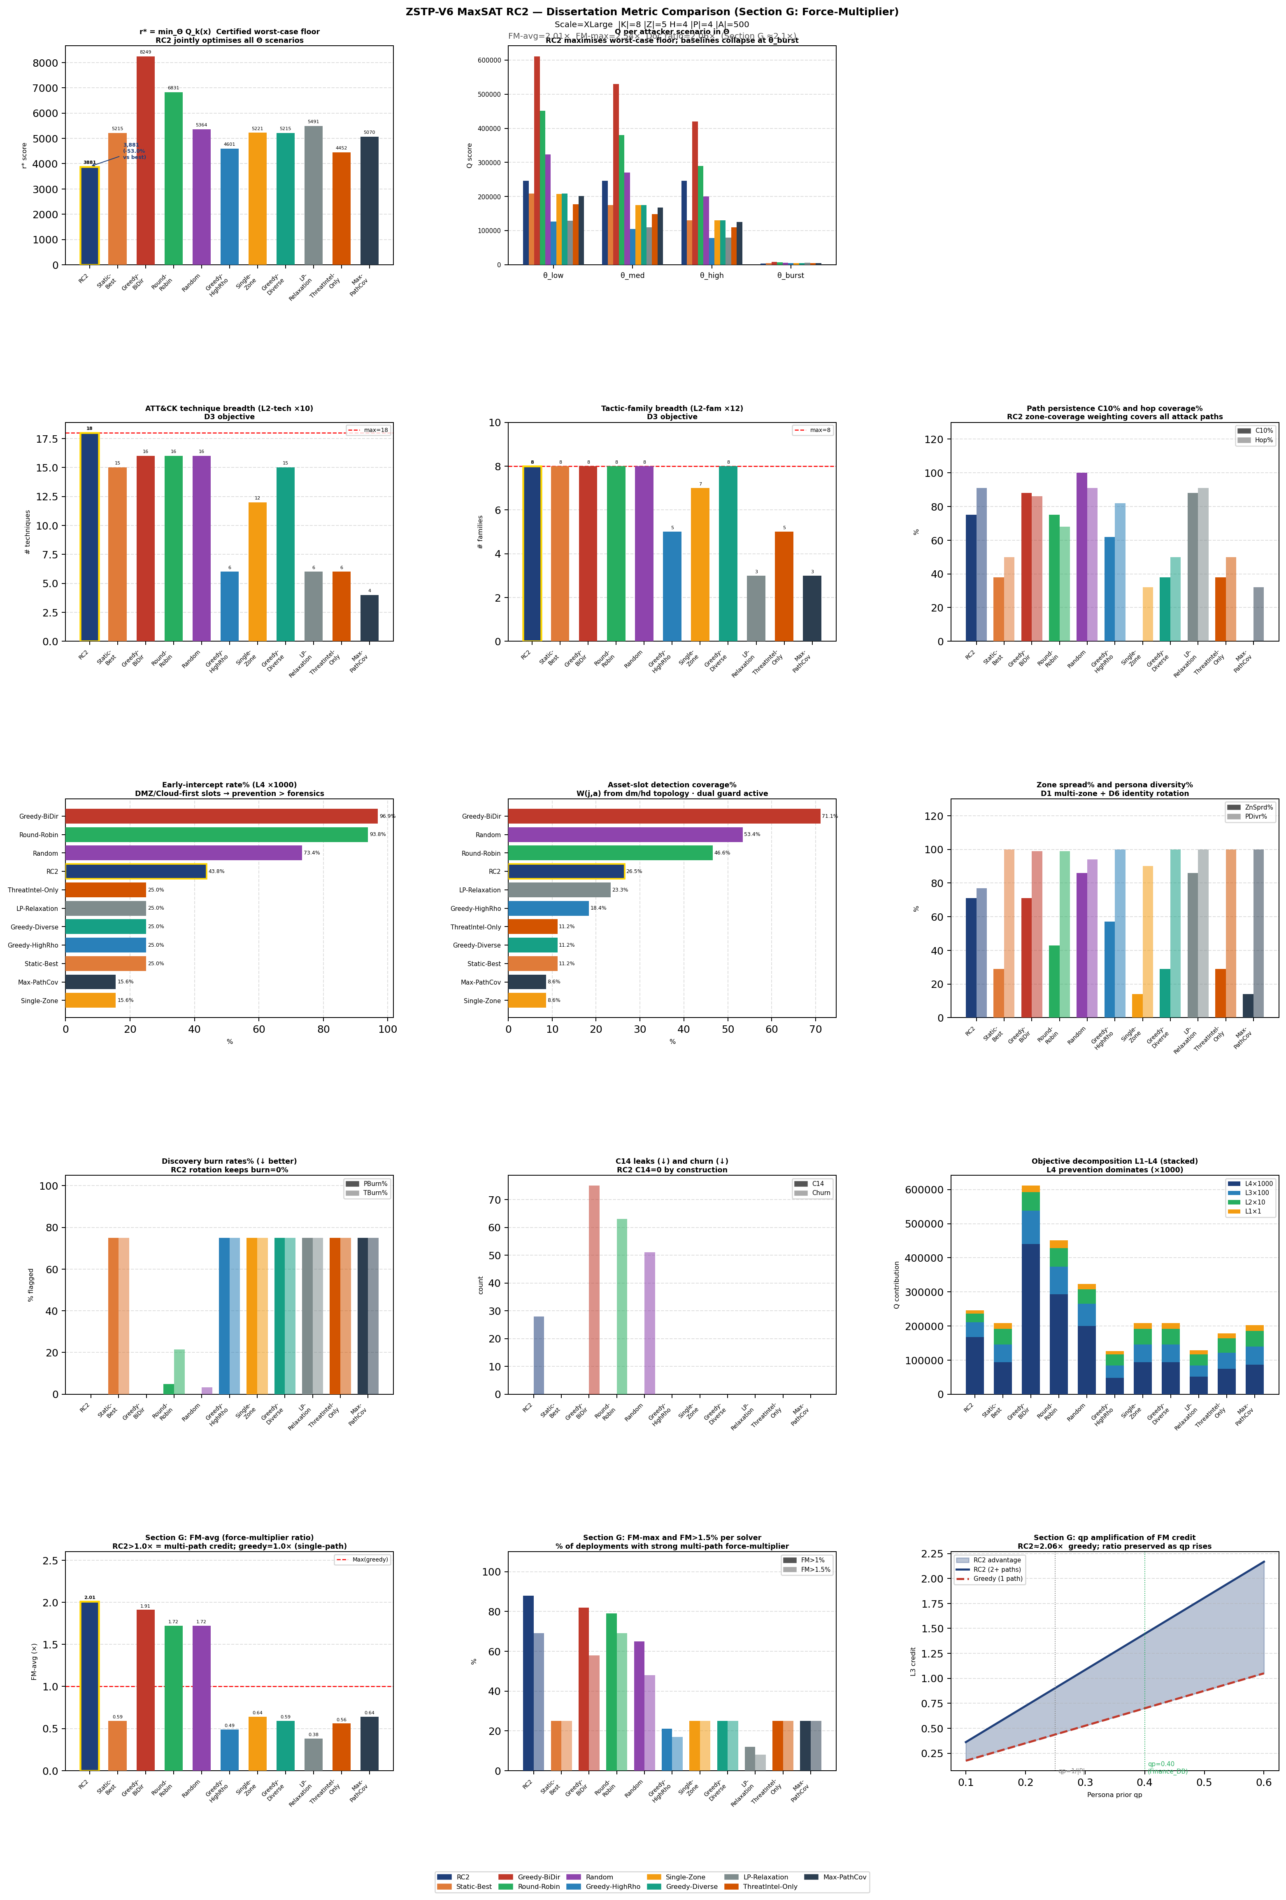

References
[1] E. M. Hutchins, M. J. Cloppert, and R. M. Amin, “Intelligence-driven computer network defense informed by analysis of adversary campaigns and intrusion kill chains,” Leading Issues in Information Warfare Research, vol. 1, p. 80, 2011.
[2] MITRE Corporation, “MITRE ATT&CK Enterprise Matrix,” 2023. [Online]. Available: https://attack.mitre.org/
[3] N. Provos, “A virtual honeypot framework,” in Proc. 13th USENIX Security Symp., San Diego, CA, 2004.
[4] L. Spitzner, Honeypots: Tracking Hackers. Addison-Wesley, 2003.
[5] M. Liffiton and A. Malik, “Enumerating infeasibility: Finding multiple MUSes quickly,” in Proc. CPAIOR, Springer, 2016.
[6] N. Narodytska and F. Bacchus, “Maximum satisfiability using core-guided MaxSAT resolution,” in Proc. 28th AAAI Conf. Artificial Intelligence, 2014.
[7] U. Feige, “A threshold of ln n for approximating set cover,” J. ACM, vol. 45, no. 4, pp. 634–652, 1998.
[8] C. Kiekintveld, V. Lisý, and R. Píbíl, “Game-theoretic foundations for the strategic use of honeypots,” in Cyber Warfare: Building the Scientific Foundation, Springer, 2015.
[9] J. Yuill, M. Zappe, D. Denning, and F. Feer, “Honeyfiles: Deceptive files for intrusion detection,” in Proc. 5th IEEE SMC Information Assurance Workshop, West Point, NY, 2004.
[10] G. Tan, M. Sherr, and W. Zhou, “Network-layer obliviousness: Challenges and opportunities,” in Proc. ACM CCS Workshop, 2011.
[11] J. Pawlick, E. Colbert, and Q. Zhu, “A game-theoretic taxonomy and survey of defensive deception for cybersecurity and privacy,” ACM Comput. Surv., vol. 52, no. 4, Art. 82, 2019.
[12] L. Huang and Q. Zhu, “Adaptive honeypot engagement through reinforcement learning of semi-Markov decision processes,” in Proc. GameSec, LNCS vol. 11836, Springer, 2019.
[13] C. Wang, Z. Lu, and T. Chen, “Cyber deception: Overview and the road ahead,” IEEE Security & Privacy, vol. 16, no. 2, pp. 4–13, 2018.
[14] A. Applebaum, D. Miller, B. Strom, H. Foster, and C. Thomas, “Intelligent, automated red team emulation,” in Proc. 32nd ACSAC, ACM, 2016.
[15] E. Hemberg, J. Kelly, U. O’Reilly, and S. Wijesekera, “Adversarial co-evolution of attack and defense in a segmented computer network environment,” in Proc. GECCO Companion, ACM, 2018.
[16] A. Al-Shaer and H. Hamed, “Discovery of policy anomalies in distributed firewalls,” in Proc. IEEE INFOCOM, Hong Kong, 2004.
[17] J. Bak, C. Czap, and A. Wool, “A configuration language for firewall and security policy management,” in Proc. IEEE POLICY, Washington, DC, 2009.
[18] K. Fisler, S. Krishnamurthi, L. A. Meyerovich, and M. C. Tschantz, “Verification and change-impact analysis of access-control policies,” in Proc. 27th ICSE, ACM/IEEE, 2005.
[19] S. Pinisetty et al., “Predictive runtime enforcement of cyber-physical systems using MaxSAT,” ACM Trans. Embedded Comput. Syst., vol. 16, no. 5s, Art. 186, 2017.
[20] S. Saha and P. Gera, “Optimal placement of security sensors for enterprise network defence: An ILP approach,” in Proc. IEEE ICC, London, UK, 2015.
[21] M. Bozorgi, L. K. Saul, S. Savage, and G. M. Voelker, “Beyond heuristics: Learning to classify vulnerabilities and predict exploits,” in Proc. 16th ACM SIGKDD, ACM, 2010.
[22] S. Jajodia, S. Noel, and B. O’Berry, “Topological analysis of network attack vulnerability,” in Managing Cyber Threats, Springer, 2005.
[23] Q. Zhu and T. Başar, “Game-theoretic approach to feedback-driven multi-stage moving target defense,” in Proc. GameSec, LNCS vol. 8252, Springer, 2013.
[24] S. Achleitner et al., “Cyber deception: Virtual networks to defend insider reconnaissance,” in Proc. 8th ACM CCS Workshop on Insider Threats, pp. 57–68, ACM, 2017.
[25] G. Wagener, R. State, and A. Dulaunoy, “Adaptive and self-configurable honeypots,” in Proc. 11th IFIP/IEEE Integrated Network Management Symp. (IM), pp. 345–352, IEEE, 2009.
[26] D. Fraunholz et al., “Demystifying honeypots in industrial control systems,” in Proc. 9th IEEE Int. Conf. on Cyber Conflict (CyCon), pp. 1–20, IEEE, 2017.
[27] F. Wilcoxon, “Individual comparisons by ranking methods,” Biometrics Bulletin, vol. 1, no. 6, pp. 80–83, Dec. 1945.

