ZSTP: A MaxSAT Framework for Certified Adversarially Robust Honeypot Scheduling
Keywords: honeypot scheduling, MaxSAT, RC2, adversarial robustness, WCNF, persona fingerprint, burn constraint, NP-hardness, force multiplier

Abstract
Honeypot schedules must satisfy operational rules while staying useful against attackers who recognize decoys they have seen before. An attacker who flags a trap type repeated in the same zone, or an identity reused across consecutive observation slots, can discount those decoys, and a schedule evaluated without this discovery burn overstates its value. Recent (2026) work already places honeypots on attack graphs and attack paths, using mixed-integer programs, Bayesian Stackelberg games over several attacker types and deep reinforcement learning, and re-optimizes when alerts arrive; attack-path coverage, early interception and multiple attacker types are therefore not claimed as new here. That work, however, does not model a placed decoy losing its value once the attacker has recognized it, and it optimizes an expected or learned payoff rather than a certified worst case. We identify four gaps in that work — recognition, decoy identity, multi-slot planning and assurance — and, to our knowledge, ZSTP is the first approach to close all four: it enforces the operational hard constraints, models per-decoy type and identity burn for several attacker profiles, and certifies the worst case over those profiles with an independently checkable proof.
We present ZSTP, a honeypot scheduling framework over five dimensions — four deployment decisions and the attacker profile — that encodes the deployment decisions — trap type, network zone, time slot, and persona — together with a hard constraint layer governing budget, air-gap, mimicry plausibility, and identity non-collision, and four attacker profiles, in a single weighted partial MaxSAT (WCNF) instance. Hard clauses carry the rules and weight soft clauses the detection objective. ZSTP uses two exact procedures: a four-pass tier-lexicographic RC2 procedure for the medium-attacker objective (Q-med), and a SAT-based max–min search for the worst-case objective r*, which emits a machine-checkable optimality certificate that is verified independently (Table 9). Three architectural refinements support this: a persona decomposition P ⊆ R̂ × F decoupling role plausibility from fingerprint uniqueness; a path-frequency constraint split separating minimum coverage frequency from maximum coverage gap; and strict tier priority enforced by pass-wise hard floors.
On a 640-decision XLarge instance, the max–min schedule attains r* = 7,052.62 and follows every hard rule; an independent CP-SAT model reaches the same value. Ten baselines, scored by the same rule checker and evaluator, each break at least one hard rule. None collapses to zero, but their worst-case scores range from 1,341.25 to 4,822.52, and the burst attacker recognizes 50–75% of their honeypots, against 27.3% for the max–min schedule, which in the model scores higher than every baseline under all four profiles (1.46× the best baseline's worst case as produced and 1.80× after the baselines are repaired to follow every rule). Heuristics that optimize the worst case directly come closer but cannot certify it: a robust local search reaches r* in 1 of 11 restarts with no way to tell which, and giving each role two fingerprints lets the schedule rotate identities and raises r* by 28.8%. Under L2 process emulation with real TCP sockets and STIX 2.1 bundles, a deterministic replay reproduces every model score exactly, and with common random numbers the max–min schedule has a significantly higher emulated worst-profile score than 20 of the 22 other schedules (paired bootstrap, 95%). A validation suite — an exhaustive test of the adder encoding, a two-directional encoding-versus-checker test on 1,635 independently drawn schedules, CP-SAT cross-checks, exhaustive enumeration of a small instance, and independent verification of four optimality certificates — finds no disagreement. Per-gap ablations, each re-solved and emulated with the same attacker episodes, show that planning without recognition, identity or multi-slot rules cuts the worst case to 42.0–55.5% of r* and the emulated worst-profile score by 583–787 points (all significant at 95%), and that an expected-payoff objective matches r* only when its prior favours the binding profile, losing up to 33.1% otherwise. The certificate proves optimality for the encoded model and the four modeled attacker profiles on this instance; it is not a claim of real-world security.

1. Introduction
Honeypot scheduling is a combinatorial problem in which the value of a decoy depends on whether the attacker has already recognized it. A practitioner who deploys decoys with a greedy, game-theoretic, or learned method implicitly assumes that the attacker will not correlate the decoy’s identity artifacts across time slots and zone boundaries. Against a casual adversary this assumption may hold. Against an attacker who flags a repeated trap type or a reused identity after one observation slot, it does not: in our evaluation, the burst attacker recognizes 50–75% of the honeypots placed by ten baseline heuristics. This paper addresses that gap for a set of modeled attacker profiles.
The problem decomposes into two layers. A hard constraint layer governs decisions that must never be violated: budget ceilings, air-gap isolation [10], mimicry plausibility, and identity non-collision. A soft objective layer governs decisions that should be maximized wherever constraints allow early interception [1], attack-path coverage, ATT&CK technique breadth, and tactic-family coverage [2]. The layers interact: a placement that scores well against a slow attacker can be recognized quickly by a fast one. A method that optimizes one layer, or evaluates one attacker profile, can therefore produce a schedule that is weak against the profile that matters most: on our test instance, the schedule that is best for the medium attacker loses 33.1% of the attainable worst-case score.
Honeypot placement has recently moved onto attack graphs, and the peer-reviewed 2026 placement literature addresses parts of this challenge. TrapManager ranks critical attack paths with a graph attention network and places decoys with a budget-constrained mixed-integer program that is re-solved when a trap fires [23]; a weighted core attack graph prunes attack paths for honeypot allocation against lateral movement [24]; Bayesian Stackelberg formulations allocate honeypots against several attacker types and update beliefs from intrusion-detection observations [21, 22]; and a Stackelberg game combined with deep reinforcement learning adjusts software-defined honeypot deployments under a budget [25]. These works establish attack-path coverage, early interception, exact mixed-integer placement, multiple attacker types and alert-driven re-optimization, and we do not claim these as contributions. To our knowledge, what they do not provide is a model in which an individual decoy loses its value once the attacker has recognized its trap type or its identity, hard rules on how a decoy identity may be reused across zones and slots, and a worst-case optimum with a proof that can be checked independently of the solver. Section 2 names these as four gaps, G1–G4 (recognition, identity, temporal planning and assurance), and maps each to the ZSTP element that closes it (Table 2b); Section 7.8 reports the model and emulation evidence for each gap (Table 14) and isolates each gap with a per-gap ablation (Table 15). In our unified evaluation, which applies the same rule checker and burn semantics to every method and scores all four attacker profiles, all ten baselines break at least one hard rule, and their worst-case scores (1,341.25–4,822.52) remain below the certified optimum.
We address the gap by formulating honeypot scheduling as a weighted partial MaxSAT instance. The hard-clause/soft-clause structure maps onto the must-never-violate/should-maximize structure of the scheduling problem without relaxing hard constraints. The medium-attacker objective is solved by RC2 [6, 9], a core-guided exact MaxSAT solver, in four tier passes. The worst-case objective r* is computed by a separate SAT-based max–min search that returns an optimal schedule and an optimality certificate: an unsatisfiability proof, checked by an independent proof checker (Table 9), showing that no schedule within the stated constraints achieves a higher worst-case score. The certificate is a proof about the worst case of the encoded model, not a claim about average performance.
Stated precisely: under the modeled discovery dynamics and four evaluated attacker profiles, ZSTP jointly enforces deployment constraints and optimizes worst-case detection utility, with a checkable optimality certificate for the encoded model; we evaluate its schedules against ten specified baselines using a common feasibility check and scoring procedure. This paper makes five contributions:
- A joint type × zone × time × persona MaxSAT/RC2 formulation with per-decoy burn state. Each Boolean fixes what is deployed, where, when and under which identity, and derived variables record, for each attacker profile, whether that decoy's trap type or fingerprint has already been recognized; NP-hardness is established by reduction from Maximum k-Coverage [7]. Exact attack-graph placement by mixed-integer programming [21, 23] is not new; what is new is that recognition is decided per decoy and per profile inside the optimization, rather than assumed away [23] or left unmodeled [21].
- A hard constraint layer covering budgets, isolation, plausibility, churn, path persistence and identity, and six-tier soft objective with an auditable prevention-vs-forensics weight ratio, and a threat-adaptive threshold update (U11), applied before each solve, whose burn thresholds tighten as attack frequency rises. Budget limits are standard [21, 23, 25]; the identity rules (C12, C14) and churn rule (C8) have, to our knowledge, no counterpart in the 2026 placement models, and the minimum-frequency and maximum-gap rules (C10a, C10b) extend the single-placement critical-path coverage requirement of [23] to a multi-slot horizon.
- A certified robust objective r* = max_x min_{θ∈Θ} Q_θ(x), computed exactly by a SAT-based threshold search over adder-encoded scores, with an independently verified optimality certificate; on the test instance r* = 7,052.62. Unlike Bayesian Stackelberg allocation [21, 22], which maximizes the defender's expected payoff under a prior over attacker types, r* is the value guaranteed against every modeled profile, and its optimality rests on a refutation proof accepted by an independent checker rather than on trust in the solver.
- L2 process-emulation validation — real TCP honeypot sockets, Bernoulli-driven attacker connection trials, STIX 2.1 bundles from observed traffic — against ten baseline solvers and two worst-case-optimizing heuristics, with a scaling study, per-gap ablations (Section 7.8), with every reported number traced to a run ID in one results file, an independent CP-SAT cross-check, exhaustive enumeration of a small instance, a reproducible validation test suite with paired statistics for the emulation, and full transparency on the trade-offs the robust schedule accepts.
- Three architectural refinements that each resolve a specific limitation of prior methods: the persona decomposition P ⊆ R̂ × F, with at most |F| simultaneous honeypots per slot, which lets a role rotate fingerprints (+28.8% in r* with two fingerprints per role) and which, to our knowledge, has no counterpart in the 2026 placement models, where a decoy is a location without a separate identity [21, 23]; the C10a/C10b path-constraint split; and the four-pass tier-lexicographic MaxSAT procedure with hard floors.
How the contributions fit together. The five contributions form a layered hierarchy (Figure 1, Table 1), and Section 3.5 maps each of them onto a concrete utility network. C1 defines the decision space: one Boolean per (trap type, zone, slot, persona), together with derived burn and credit variables for each attacker profile. C2 populates that space with the hard constraint layer — rules that may never be violated — and the soft objective that defines what a schedule is worth and specifies how threat intelligence updates both before each solve (U11). C3 is the solution concept built on C1 and C2: the schedule whose worst score over the modeled attacker profiles is highest, returned with a checkable optimality certificate. C4 validates C3’s output against an independent rule checker, an independent solver, exhaustive enumeration of a small instance and a process-level emulation. C5 collects three refinements on which the other layers rely: the persona decomposition refines the identity axis of C1 and raises r*; the C10a/C10b split belongs to the rule layer of C2 and is central to the zero-burn infeasibility result of Section 4.2; and the four-pass procedure enforces the tier order of C2.
The two ways a decoy is recognized. A decoy is useful only until the attacker recognizes it, and recognition has a spatial and a temporal side. Spatially, an attacker compares what it observes in different zones at the same time: an identity that answers in two zones at once, or a role that does not belong in the zone where it appears. Temporally, it compares what it observes in consecutive slots: the same trap type left in the same zone, or the same identity reused. Figure 2 illustrates both. ZSTP therefore decides where (zone), when (slot) and as whom (persona) jointly rather than one axis at a time. Table 1 gives, for each contribution, a plain-language statement, what it builds on and feeds, and its spatial and temporal role; a small running example (Section 3.5) applies each contribution to one corridor of the network and is revisited at the end of Sections 4–7.
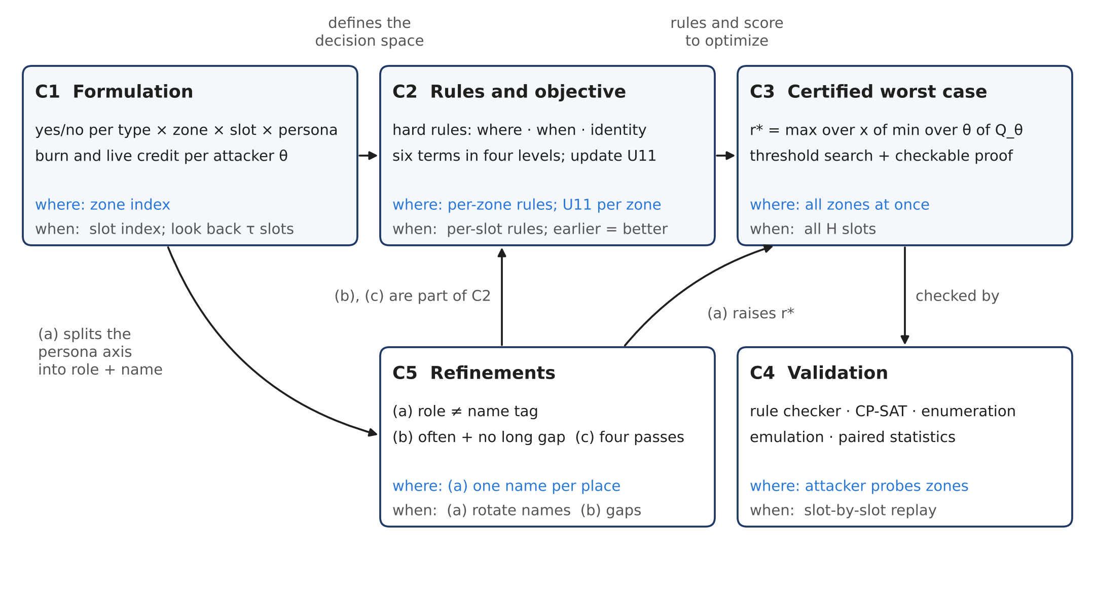
Figure 1. Structure of ZSTP. Solid arrows show dependencies between the contributions: C1 defines the decision space, C2 the rules and objective over it, and C3 the certified worst-case solution, which C4 validates; the refinements of C5 act on C1–C3. Each box lists its spatial (where) and temporal (when) role. The dashed arrow is the threat-adaptive loop of Section 6.
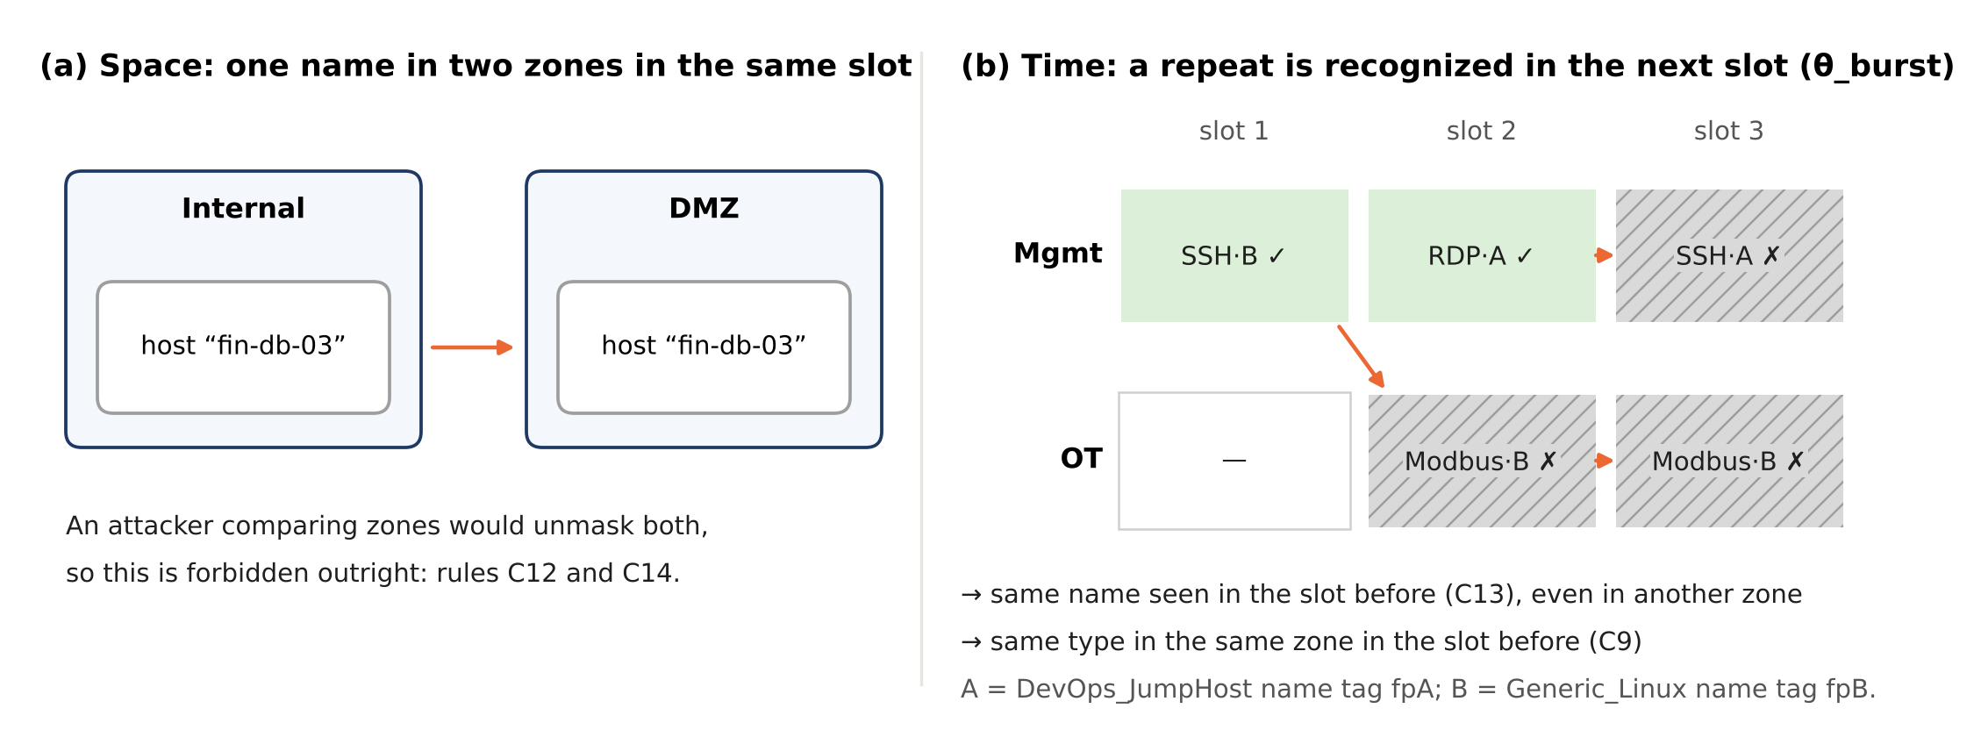
Figure 2. How an attacker recognizes a decoy. (a) Space: the same identity in two zones in the same slot would unmask both decoys, so rules C12 and C14 forbid it outright. (b) Time: on the running example (Section 3.5), a deployment is recognized by θ_burst when the same type stood in the same zone in the slot before (C9) or when its fingerprint was seen in the slot before, in any zone (C13); green cells marked ✓ still earn credit, grey hatched cells marked ✗ do not. In plain terms: a decoy is unmasked by being seen in two places at once, or in the same place or under the same name again
Table 1. The contributions briefly: plain-language summary, dependencies, and spatial and temporal role.
Contribution | In plain terms | Builds on → feeds | Spatial role (where) | Temporal role (when)
C1 Formulation | Writes every deployment choice — what, where, when, as whom — as one Boolean, so that rules, burn and scores are evaluated jointly rather than one axis at a time. | — → C2, C3, C5(a) | Zone index z; budgets, air gap and attack paths are indexed by zone | Slot index t; burn looks back τ_d or τ_dp slots
C2 Constraint and objective layer | Separates what may never happen (hard rules) from what should be maximized (six weighted terms in four priority levels) and shortens recognition thresholds as attack frequency rises (U11). | C1 → C3; contains C5(b), C5(c) | C3–C5b, C12, C14 restrict where; U11 is set per zone | C2, C8, C10a, C10b, F15 restrict when; L4 rewards earlier interception
C3 Certified robust objective | Selects the schedule whose lowest score across the attacker profiles is highest and proves that no rule-compliant schedule does better in the encoded model. | C1, C2 → Algorithm 1, C4 | Worst case taken over all zones jointly | Q_θ summed over all H slots; profiles differ in recognition speed
C4 Validation | Checks that the encoding, an independent rule checker, an independent solver and a socket-level emulation agree, with paired statistics and one-command reproducibility. | C2, C3 → evidence for C3 | Attacker probes each zone and walks paths across zones | Slot-by-slot observe-then-burn replay; horizon scaled to H = 8
C5 Refinements | (a) Separate the role a decoy plays from the fingerprint it shows; (b) require both a minimum coverage frequency and a maximum coverage gap; (c) enforce the tier order with hard floors. | C1, C2 → C3 | (a) one fingerprint per zone and slot; (b) the critical hop is a location | (a) fingerprints rotate across slots; (b) how often vs. how long uncovered; (c) earlier before wider

2. Related Work
This section first credits the foundational honeypot literature in a short background paragraph and then compares ZSTP with the peer-reviewed honeypot-placement literature published in 2026, the most recent and most closely related work. Five such papers place honeypots or decoys on attack graphs or networks with exact, game-theoretic or learned optimization [21]–[25]. Table 2a summarizes how each addresses the dimensions that ZSTP combines; the text after it states which of these dimensions already exist, Table 2b maps each remaining gap to the ZSTP element that closes it, and Table 2c compares ZSTP with each paper individually.
Background. Honeypots originated as standalone decoy systems and virtual honeypot frameworks [3, 4], later extended to adaptive honeypots that change their interaction with the attacker [20]. Game-theoretic work models honeypot allocation as a strategic game between defender and attacker [8], surveys defensive-deception games [11] and studies feedback-driven multi-stage moving-target defense [19]; reinforcement learning has been used to learn honeypot engagement policies [12] and intrusion-prevention strategies through self-play [13]; and attack graphs have been used for optimal intrusion-detection sensor placement [18]. These works established the problem and its main modeling tools. The 2026 placement papers are more recent and closer to ZSTP, so the detailed comparison below, including Tables 2a and 2b, is made against the 2026 work only.
Attack-graph honeypot placement (2026). Four of the 2026 papers place honeypots on attack graphs. Liu et al. [23] (TrapManager) build a vulnerability-based attack graph, rank critical attack paths with a graph attention network, and place traps with a binary mixed-integer program that maximizes path-weighted interception under a budget and requires at least one trap on each of the top-K critical paths; when a trap fires, node embeddings are updated and the program is re-solved. Their attacker model assumes that traps are not recognized before interaction, and adversaries that adapt to repeated alerts are left out of scope. Lacmou Zeutouo et al. [24] reduce the attack graph to a weighted core that ranks and preserves attack paths by exploit difficulty and asset criticality, so that honeypot allocation against lateral movement remains tractable on networks of more than 300 nodes. Park and Dagher [21] allocate honeypots on a directed attack graph against several concurrent attackers, each with its own exploits, costs and targets, in a multi-follower Bayesian Stackelberg game; the defender updates its beliefs about attacker types from intrusion-detection and honeypot observations and re-solves a DOBSS-style mixed-integer program each round. Voznyi et al. [22] likewise formulate honeypot placement as a Bayesian Stackelberg game, coupling detection with inference of the attacker's type.
Learning-based honeypot deployment (2026). Zhang et al. [25] combine a Stackelberg game with deep Q-learning for software-defined honeypots: binary deployment vectors are chosen under a budget on the number of honeypots, and the defense benefit of the Stackelberg optimum serves as a threshold that decides whether the current deployment should be adjusted. The deployment is learned rather than proven optimal.
Table 2a. Positioning of ZSTP relative to the peer-reviewed 2026 honeypot-placement papers, characterized from each paper's published description (✓ addressed; ◐ partly; ✗ not addressed; · not discussed). ◐ means that only a path-coverage rule is imposed beyond the budget [23]. “Burn per decoy” means that a placed decoy loses its value once the attacker recognizes it; “Several types” means several attacker types or profiles; “Worst case + proof” means a worst-case objective over attacker types with an independently checkable optimality proof; “Joint 4-axis plan” means type, zone, time and persona are chosen together over a multi-slot horizon. The attack-path column shows that ZSTP does not claim attack-path modeling as new.
2026 placement paper | Attack paths | Exact solver | Rules beyond budget | Burn per decoy | Several types | Worst case + proof | Joint 4-axis plan
Park & Dagher [21]: Bayesian Stackelberg, multi-attacker | ✓ | ✓ | ✗ | ✗ | ✓ | ✗ | ✗
Voznyi et al. [22]: Bayesian Stackelberg, type inference | · | · | · | · | ✓ | ✗ | ·
Liu et al. [23]: TrapManager, GAT + MIP | ✓ | ✓ | ◐ | ✗ | ✗ | ✗ | ✗
Lacmou Zeutouo et al. [24]: weighted core attack graph | ✓ | · | · | · | · | · | ·
Zhang et al. [25]: Stackelberg + deep RL | ✓ | ✗ | · | · | · | ✗ | ·
ZSTP (this paper) | ✓ (input, not new) | ✓ | ✓ | ✓ | ✓ | ✓ | ✓
What already exists and what is new. Read against the 2026 placement papers, the elements of ZSTP fall into two groups. The following are already established and are not claimed as contributions:
- Attack-path and critical-path coverage, and early interception before the target (layers L3 and L4) [21, 23, 24].
- Exact optimization of honeypot placement by mixed-integer programming [21, 23]; the use of MaxSAT instead of a mixed-integer program is a modeling choice, not by itself a contribution.
- Several attacker types or profiles [21, 22].
- Re-optimization when alerts or threat intelligence arrive [21, 23, 25]; Algorithm 1 follows this pattern.
- Budget constraints [21, 23, 25] and a requirement to cover critical attack paths in a single placement [23].
What the 2026 placement papers do not provide forms four gaps. Table 2b states each gap, where it appears in the 2026 work, the ZSTP element that closes it, and where the evidence is reported; to our knowledge, no 2026 placement paper closes any of the four.
Table 2b. Gaps in the peer-reviewed 2026 honeypot-placement literature, the ZSTP element that closes each, and where the evidence is reported.
Gap | Where it appears in 2026 work | ZSTP element that closes it | Evidence
G1 Recognition | A placed decoy is treated as unrecognized until engaged: traps are assumed unrecognized [23]; entering a honeypot counts as detection, with no recognition model [21]. | Per-decoy, per-profile burn inside the optimization: type burn (C9) and fingerprint burn (C13) gate every credit term (Section 4.2). | Tables 14–15, G1
G2 Identity | A decoy is a location without a separate identity [21, 23]; nothing limits reuse of an identity across zones or slots. | Persona p = (r, f) separating role from fingerprint, with hard rules C12 and C14 and fingerprint rotation (Sections 3.3, 7.7). | Tables 14–15, G2
G3 Temporal planning | Placement is re-solved per round or per alert [21, 23]; critical-path coverage is required only within a single placement [23]. | Multi-slot horizon with churn (C8) and critical-hop minimum-frequency and maximum-gap rules (C10a, C10b); certified re-solve in Algorithm 1 (Sections 4.1, 6). | Tables 14–15, G3
G4 Assurance | Expected payoff under a prior over attacker types [21, 22], a learned deployment [25] or a single-attacker program [23]; no checkable optimality proof. | Max–min objective r* over four attacker profiles with a refutation proof verified by an independent checker [5] (Sections 3.4, 5.2, 7.5). | Tables 14–15, G4

Results that follow only from closing the gaps together. The zero-burn infeasibility result (Section 4.2) requires G1 and G3 at once; the +28.8% gain in r* from fingerprint rotation (Section 7.7) requires G1, G2 and G4; and the 33.1% worst-case loss of the medium-profile optimum (Section 1) is visible only under G1 and G4.
Table 2c. ZSTP compared with each peer-reviewed 2026 honeypot-placement paper: what the paper already does (not claimed by ZSTP) and what ZSTP adds. Characterizations follow each paper's published description; rule identifiers refer to Table 5.
2026 placement paper | Already does (not claimed by ZSTP) | What ZSTP adds (novel)
Park and Dagher [21] | Attack-graph placement against several attacker types; Bayesian Stackelberg game solved as a DOBSS-style MILP each round, with beliefs updated from IDS observations. | Per-decoy recognition (C9, C13); identity rules (C12, C14); inter-slot rules (C8, C10a, C10b) over a planning horizon; worst case over profiles with an independently checked proof instead of expected payoff under a prior.
Voznyi et al. [22] | Bayesian Stackelberg honeypot placement coupled with attacker-type inference. | Worst case over profiles instead of expected payoff; per-decoy burn; decoy identity as a decision axis.
Liu et al. [23] (TrapManager) | Critical attack paths ranked by a graph attention network; budgeted MIP placement with mandatory top-K path coverage; re-solve when a trap fires; early interception. | Recognition per decoy and profile (TrapManager assumes traps are not recognized); identity rules; minimum-frequency and maximum-gap coverage over several slots instead of single-placement coverage; several attacker profiles; optimality proof.
Lacmou Zeutouo et al. [24] | Weighted core attack graph that ranks and preserves attack paths for honeypot allocation against lateral movement. | Complementary: its reduced paths could populate Π; ZSTP adds the time, identity and burn structure and the certified schedule over those paths.
Zhang et al. [25] | Stackelberg game plus deep Q-learning to adjust software-defined honeypots under a budget. | Exact, certified optimum rather than a learned deployment decision; per-decoy burn; identity rules; inter-slot rules over a planning horizon.

Positioning. ZSTP therefore does not compete with the 2026 attack-graph methods on attack-path modeling: it takes the attack paths Π as input and adds the recognition, identity and temporal structure, and the worst-case certificate, that those methods omit. The two are complementary — critical paths ranked by [23] or reduced by [24] could populate Π, and the per-round re-solve of [21] could be replaced by the certified re-solve of Algorithm 1. A direct experimental comparison with re-implementations of [21] and [23] is left to future work; the Max-PathCov baseline of Section 7, which maximizes attack-path coverage without burn, is closest to them in objective but is not a re-implementation of either method.

3. Problem Formulation

3.1 Why Weighted Partial MaxSAT?
Before stating the formal instance, we motivate the problem encoding. Honeypot scheduling has a natural two-layer structure: some constraints must never be violated (budget limits, air-gap isolation, identity collision rules), while others represent objectives that should be maximized wherever constraints allow (detection breadth, early interception, ATT&CK coverage). Weighted Partial MaxSAT captures this structure directly: infinite-weight hard clauses encode must-never-violate constraints that RC2 never relaxes, while finite-weight soft clauses encode should-maximize objectives that RC2 optimizes within the hard constraint boundary. This encoding requires no relaxation of hard constraints and no approximation of the objective — properties that LP relaxation, greedy search, and RL policies cannot simultaneously guarantee. Figure 3 illustrates this mapping.
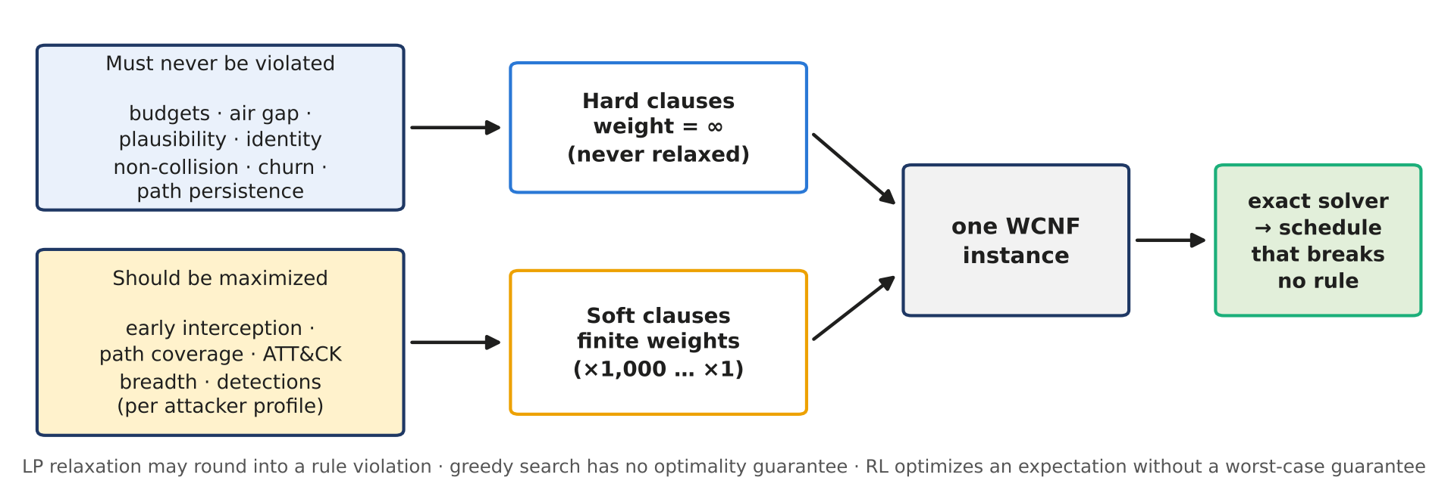
Figure 3. From scheduling rules to one weighted partial MaxSAT instance. In plain terms: rules that must never break become hard clauses the solver may not violate; goals to maximize become soft clauses with weights ×1,000 … ×1; an exact solver then returns a schedule that breaks no rule. The bottom-line names why LP rounding, greedy search and RL fall short.

3.2 Instance and Decision Variables
The ZSTP instance is defined by the tuple I = (K, Z, H, R̂, F, P, Θ, Π, J, G_K, C, Z_air, W, B_t, B_z, c_max, τ_d0, τ_dp0, ρ_max, α, κ, κ_min, λ), where K is the set of trap types, Z the set of network zones, H the planning horizon (slots T = {1, …, H}), R̂ the role templates, F the fingerprint bundles, P ⊆ R̂ × F the persona catalogue with priors q_p, Θ the set of attacker profiles (each with attack strength ρ_θ and path emphasis ω_θ,π), Π the attack paths (each with frequency ρ_π, a critical hop, and a zone, technique and interception value per hop), J the ATT&CK techniques with their tactic families, weights w_j and the trap types that detect them, G_K the plausibility table over (type, zone, role), C the conflicting type pairs, Z_air the air-gapped zones with the trap types forbidden there, W the gap window, B_t and B_z the slot and zone budgets, c_max the churn limit, τ_d0 and τ_dp0 the base recognition thresholds, ρ_max the strength normalizer of U11, α the prior update rate, κ and κ_min the slot lengths and their minimum, and λ the layer weights. Every rule and objective term, and the emulator, reads its parameters from I.
The decision variable is x_{i,z,t,p} ∈ {0,1} — deploy trap type i ∈ K in zone z ∈ Z at time slot t ∈ T as persona p ∈ P. For the XLarge instance (|K| = 8, |Z| = 5, H = 4, |P| = 4), this yields 640 binary decisions. Derived variables, each defined by a full equivalence so that it is fixed by x, include type-burn indicators u^θ_{i,z,t}, persona-burn indicators v^θ_{f,t}, live-credit indicators d^θ_{i,z,t,p}, path-hop coverage indicators cov^θ_{π,h,t}, and early-interception flags e^θ_{π,t}, with one copy per attacker profile θ; all feed the soft objective. The encoding has 8,340 variables and 33,011 hard clauses.
Attack paths, hops and the force multiplier in plain terms. An attack path π is the route an intruder takes toward a target, written as a chain of hops. Each hop is one step taken in one zone with one ATT&CK technique, for example using remote services (T1021) on the administrators’ jump hosts in the Mgmt zone, or sending an unauthorized command (T0855) to the plant controls in OT. A decoy covers a hop when it is live in that zone in that slot and its trap type detects that technique. Each path has a frequency ρ_π, how often attackers use it, and a critical hop, the step into the target zone, which C10a and C10b keep watched. Catching the intruder on a hop before the target is early interception (L4); covering hops at all is path coverage (L3). Because paths share zones, one well-placed decoy can cover hops of several paths at once. The force multiplier (Section 7.4) measures this: with equally valued hops, a decoy that earns credit on two hops has FM = 2, a decoy on one hop has FM = 1, and a recognized decoy has FM = 0. Figure 4 shows the three ideas on the utility network and on the running example of Section 3.5.
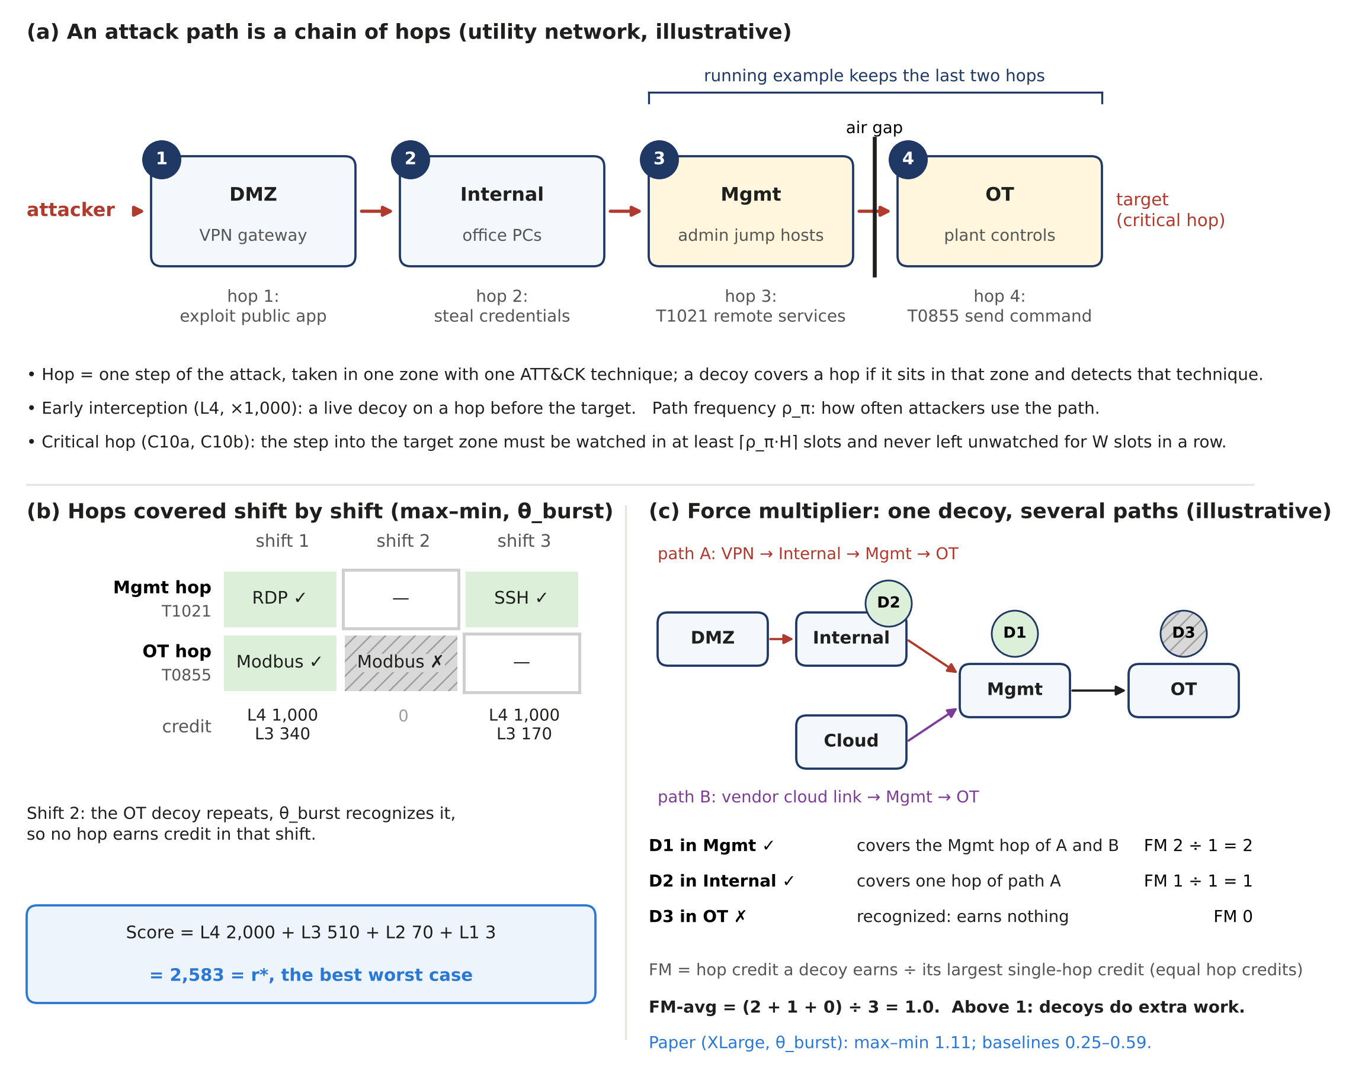
Figure 4. Attack paths, hops and the force multiplier in plain terms. (a) A four-hop path through an illustrative utility network; the running example keeps the last two hops (Mgmt and OT), and the step into OT is the critical hop. (b) The max–min schedule of the running example under θ_burst, hop by hop and shift by shift: the credits add up to r* = 2,583, and the OT decoy repeated in shift 2 is recognized and earns nothing. (c) An illustrative two-path network with equal hop credits: a decoy at a shared hop serves both paths (FM = 2), a decoy on one path has FM = 1, and a recognized decoy has FM = 0. On the XLarge instance FM-avg at θ_burst is 1.11 for max–min against 0.25–0.59 for the baselines (Section 7.4).
ZSTP treats placement as a three-axis optimization problem, summarized in Table 3. Each rule governs one axis; the threshold update U11 and the slot check F15 are applied before solving (Section 4.1). Table 4 restates the key symbols in plain words, with their values in the running example of Section 3.5.
Table 3. The three axes of ZSTP and their governing constraints.
Axis | Symbol | Question | Governing Constraints
Spatial (zone z ∈ Z) | z ∈ {DMZ, Internal, Cloud, OT, Mgmt} | Where? | C2–C5b: budget, type conflict, air-gap, plausibility; C1, C6, C7 define credit, coverage, interception
Temporal (slot t ∈ T) | t = 1, ..., H | When? | C8 churn; C9 type burn (definition); C10a/C10b path persistence; U11 and F15 before solving
Identity (persona p ∈ P) | p ∈ P ⊆ R̂ × F | As whom? | C12, C14: fingerprint collision and cross-zone uniqueness; C13 persona burn (definition)
Table 4. Key symbols in plain words, with their values in the running example (Section 3.5).
Symbol | Meaning in plain words | Running example
K, i | Trap types: the kinds of decoy service that can be deployed | SSH, RDP, Modbus
Z, z | Zones: the parts of the network a decoy can be placed in | Mgmt, OT
H, t | Slots: the planning periods (here 8-hour shifts) | H = 3
R̂, F, p = (r, f) | Role (what the decoy pretends to be), fingerprint (the name tag an attacker sees), persona (a role wearing a fingerprint) | DevOps_JumpHost as fpA; Generic_Linux as fpB
x_{i,z,t,p} | Yes/no decision: deploy type i in zone z in slot t as persona p | 36 decisions, 12 free
Θ, θ | Attacker profiles: the kinds of attacker planned for | θ_low, θ_med, θ_burst
τ_d, τ_dp | How many consecutive slots of repetition an attacker needs to recognize a repeated type in a zone, or a reused fingerprint | (2, 3), (2, 2), (1, 1)
Burn (u, v) | The attacker has recognized the decoy; it no longer earns credit | static schedule: 4 of 6 recognized by θ_burst
Q_θ(x) | Score of schedule x against attacker θ: six weighted terms counting only unrecognized decoys | max–min schedule: 2,754 / 2,754 / 2,583
r* | The best worst-case score that any rule-following schedule can guarantee | 2,583
Certificate | A machine-checkable proof, verified by a separate program, that no rule-following schedule beats r* | small enough to enumerate instead: no schedule reaches 2,584
U11 | The update that shortens τ when threat intelligence reports more frequent attacks | τ_d from 2 to 1 after the OT bulletin

3.3 Persona Space: Product-Space Decomposition P = R̂ × F
A key architectural refinement is the product-space persona decomposition, which separates two orthogonal axes:
- R̂: a finite set of role templates (e.g., HR_Workstation, DevOps_JumpHost, Finance_DB_Server). Governs mimicry plausibility only (C5b).
- F: a finite set of fingerprint bundles. Each f ∈ F is a tuple (hostname, account, certificate, banners, OS_sig) — the artifacts an attacker actually observes and correlates.
- p = (r, f) ∈ P ⊆ R̂ × F. Because C12 and C14 forbid using a fingerprint twice within one slot, at most |F| honeypots can run simultaneously, not |R̂| × |F|. In the experiments each of the four roles is bound to its own fingerprint (HR_Workstation fp1, DevOps_JumpHost fp2, Finance_DB_Server fp3, Generic_Linux fp4), so |P| = |F| = 4, which is also the slot budget.
Under this decomposition, C5b checks only r = π₁(p) (role plausibility), while C12–C14 check only f = π₂(p) (fingerprint identity). Persona burn attaches to f; retiring a fingerprint does not retire the role template, enabling sustained role coverage with rotated fingerprints. On the test instance the max–min schedule has 0% persona burn under θ_low and θ_med and 27.3% under θ_high and θ_burst while satisfying C12–C14; zero burn under all four profiles is infeasible (Section 4.2).

3.4 Attacker Scenarios and Certified Robust Objective
ZSTP models four discrete attacker profiles Θ = {θ_low, θ_med, θ_high, θ_burst} with attack strength ρ = 0.10, 0.30, 0.60, and 0.85. Profiles differ in recognition thresholds (from U11: τ_d = 2, 2, 1, 1 slot for a repeated trap type and τ_dp = 3, 2, 1, 1 slot for a reused fingerprint) and in path emphasis ω_{θ,π}. The strongest profile, θ_burst, recognizes a trap type repeated in the same zone, or a reused fingerprint, in the next slot; a honeypot still earns credit in the first slot in which it is seen (Section 4.2).
The certified robust objective is r* = max_x min_{θ∈Θ} Q_θ(x) over feasible x ∈ {0,1}^640. A rational adversary selects the profile that minimizes Q, so r* is the worst-case value the defender can guarantee within the model. ZSTP computes r* exactly with a SAT-based threshold search (Section 5.2) and certifies it with an independently verified unsatisfiability proof that no feasible schedule reaches r* + 0.01. On the test instance r* = 7,052.62; an independent CP-SAT model gives the same value, and the binding profile is θ_high.
Reading the objective. For each feasible schedule, Q_θ is evaluated under every profile and only the lowest value is kept; r* is the largest such value over all feasible schedules. This differs from maximizing the mean score: a schedule scoring 9,000 under three profiles and 2,000 under the fourth has a higher mean than one scoring 7,000 under all four but guarantees less. Because the binding profile depends on the schedule — θ_high binds for 10 of the 13 schedules in Table 7 and θ_burst for 3 — no single profile can be chosen in advance as the one to optimize, which is why both the Q-med and the burst-first schedules fall below r* (Section 7.2).
NP-hardness. The ZSTP placement problem is NP-hard by polynomial reduction from Maximum k-Coverage (Feige [7]): given items U, sets S_1, …, S_m, and k, construct a ZSTP instance with one zone, one slot, one role, and k distinct fingerprints, slot and zone budget k, one trap type per set S_i, and one ATT&CK technique per item, where trap type i detects exactly the techniques in S_i. There are no type conflicts and no air gap, every type is plausible for the role, every path frequency is 0 (so C10a requires nothing), with one slot (H = 1 < W) C10b has no window, the slot is valid, and no churn or burn rule applies. With unit technique weights and every layer weight except technique breadth set to 0, a schedule of score v selects at most k distinct trap types whose sets cover v items, and conversely; each chosen type receives its own fingerprint, so C12 and C14 hold. Because this is a special case of the full problem, the full problem is NP-hard.

3.5 Running Example: One Corridor, Three Slots
To make the formulation concrete, we use a deliberately small instance in the remainder of the paper. It keeps one corridor of the XLarge network — the Mgmt zone, where administrators’ jump hosts bridge IT and the plant, and the OT zone that controls physical equipment — over H = 3 slots of 8 h. There are three trap types: SSH and RDP services, plausible only in Mgmt, and a Modbus/TCP controller, plausible only in OT and only as Generic_Linux; C5 forbids SSH and RDP in OT. There are two personas, DevOps_JumpHost with fingerprint fpA and Generic_Linux with fpB; budgets B_t = 2 and B_z = 1; c_max = 2 and W = 2; one attack path Mgmt (T1021) → OT (T0855) whose OT hop is critical (ρ_π = 0.5); and three profiles θ_low, θ_med and θ_burst with the U11 thresholds of Section 3.4, (τ_d, τ_dp) = (2, 3), (2, 2) and (1, 1). The objective uses the layer weights of Table 6, with L3_fwd and L3_bwd applied together as 170 per covered hop and L2 computed from technique weights only. The instance is small enough that every assignment of its free variables can be enumerated, so each number reported for it was also checked exhaustively. It illustrates the mechanisms; the results of the paper are those of Section 7.
Real-world reading. Figure 5 places the instance in context: a regional water and power utility whose attack path runs DMZ → Internal → Mgmt → OT, with an air gap in front of the plant controls. The corridor modeled here is the last hop of that path, and each contribution acts at a definite place and time: C1 turns every (decoy type, zone, shift, identity) choice into one decision; C2 forbids, for example, IT-type decoys behind the air gap and ranks an interception at Mgmt above one at OT; C3 judges a plan by the attacker type it handles worst; C4 replays the plan against an emulated attacker before deployment; and C5 lets the jump-host decoy keep its role while its identity rotates, and keeps the Mgmt → OT hop both frequently covered and never uncovered for long.
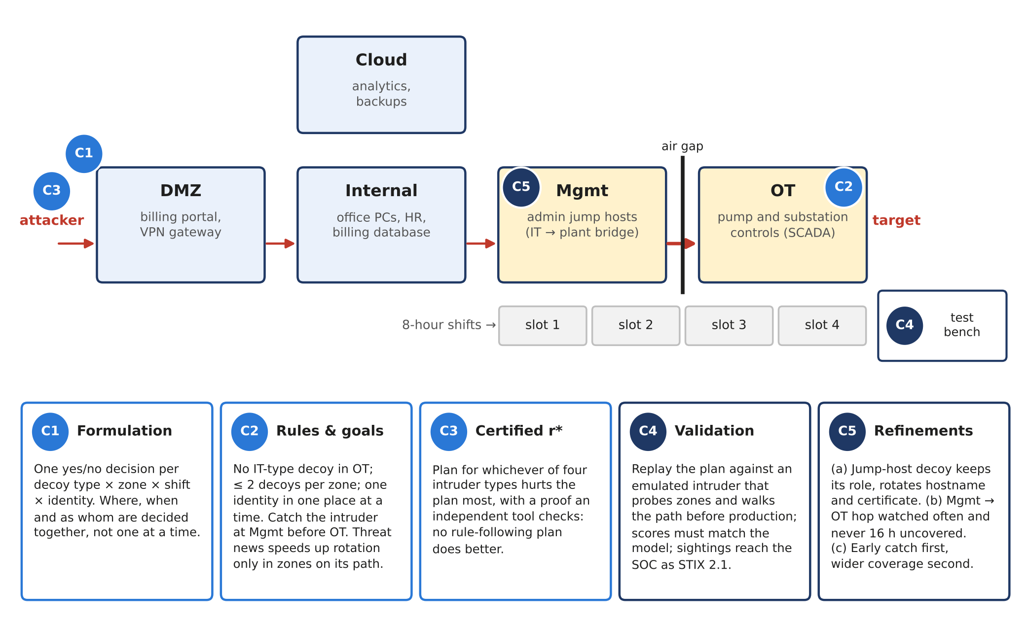
Figure 5. Real-world reading of the five contributions on a regional water and power utility (illustrative). The attack path runs DMZ → Internal → Mgmt → OT across an air gap, with 8-hour shifts as time slots; badges C1–C5 show where each contribution acts, and the highlighted Mgmt and OT zones are the corridor of the running example. In plain terms: the cards below the network state what each contribution does for the operator.
C1 on the example. The decision space has 3 × 2 × 3 × 2 = 36 variables. C5 (air gap) and C5b (plausibility) fix 24 of them to 0, leaving 12 — per slot: SSH in Mgmt as fpA or as fpB, RDP in Mgmt as fpA, and Modbus in OT as fpB — and the hard rules admit 87 of the 2^12 = 4,096 assignments. Burn couples the slots: a Modbus deployment in OT in slots 1 and 2 earns credit in slot 1 under every profile, but its slot-2 copy is recognized by θ_burst (τ_d = 1) and not by θ_med (τ_d = 2). Figure 2(b) shows how burn couples cells in time (same zone, next slot) and across zones (same fingerprint, next slot). C1 is therefore the layer on which every later contribution operates: C2 writes its rules over these cells, C3 searches them, and C5(a) refines their identity axis.
The whole scenario briefly. Figure 6 follows the running example from start to finish in six steps, each drawn as the same zone × shift timetable so that the reader can compare them directly. (1) The setting: the Mgmt → OT corridor, three shifts, two decoys at a time and three attacker types. (2) The habitual static schedule, which the fast attacker unmasks from the second shift on. (3) The max–min schedule (C3), which changes the decoy type and rests the identity in Mgmt; with the two available fingerprints no rule-following schedule scores higher. (4) A threat bulletin that tightens the rules (U11, Algorithm 1) and forces a redeployment. (5) A different setup in which the defender has one more fingerprint for the same role (C5(a)): max–min is solved again, and the new certified schedule keeps the Mgmt decoy live in every shift. (6) The worst-case scores, grouped by setup. Step 5 does not beat max–min; it shows that max–min, applied to a setup with more identities, certifies a higher optimum — the same effect as the +28.8% reported for XLarge in Section 7.7. Sections 4–7 return to these steps when they introduce each contribution formally.
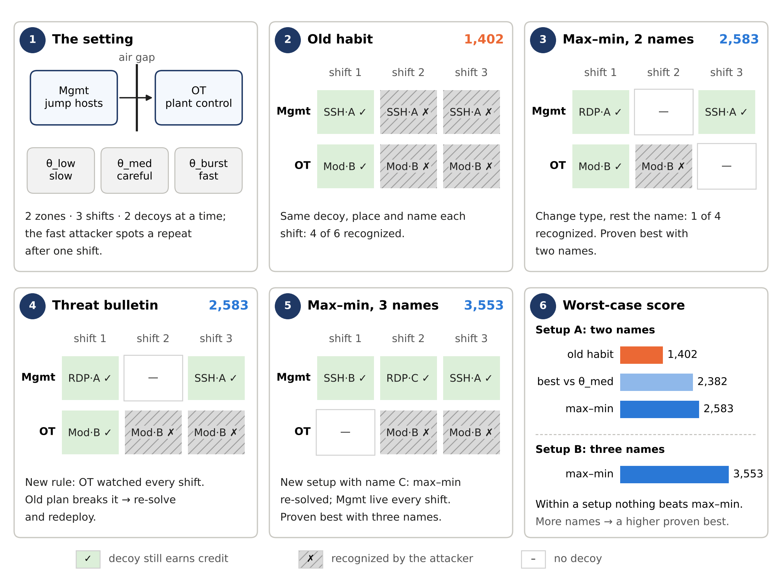
Figure 6. The running example end to end. Each timetable shows two zones (rows) over three 8-hour shifts (columns); green cells marked ✓ are decoys that still earn credit, grey hatched cells marked ✗ are decoys the fast attacker θ_burst has recognized, and white cells are empty; A, B and C abbreviate the fingerprints fpA, fpB and fpC. The number at the top right of each step is the worst-case score over the attacker profiles. Steps 2–3 share one setup (two fingerprints); step 5 is a second setup with a third fingerprint, solved again by max–min. For this small example, optimality is proven by enumerating every schedule; on XLarge it is proven by the certificate of Section 7.5. In plain terms: within a given setup nothing beats the max–min plan; giving the defender more identities to rotate raises the best achievable score, and max–min finds that new best.
Spatio-temporal view. Steps 2 and 3 of Figure 6 draw two schedules as zone × shift timetables under θ_burst. The static schedule — the same decoys under the same identities in every slot — loses four of its six deployments to recognition from slot 2 onward and scores 1,402 under θ_burst (2,744 under θ_low and θ_med). The max–min schedule changes the type of the Mgmt decoy between slots 1 and 3 and rests fpA in slot 2, so nothing in Mgmt repeats; in OT, the path rules force the only plausible decoy into two adjacent slots, so exactly one deployment is recognized. Its worst case is r* = 2,583 (2,754 under θ_low and θ_med), 1.84× that of the static schedule.

4. Constraint Encoding and Burn Mechanics

4.1 Hard Constraint Layer and Pre-Solve Updates
All hard rules — C2–C5b, C8, C10a, C10b, C12, and C14 — are encoded as hard WCNF clauses (cardinality rules through sequential-counter encodings); RC2 and the SAT search never return a schedule that violates one, and an independent rule checker re-tests every reported schedule. C1, C6, C7, C9, and C13 are not restrictions: they define detection credit, coverage, interception, and burn inside the objective. The threat update U11 (formerly C11) recomputes recognition thresholds, and the slot check F15 (formerly C15) switches off placements in invalid slots; both run before the encoding is built. Table 5 lists every rule with its real-world meaning and how often the ten baselines break it.
Table 5. ZSTP rules and pre-solve updates. Baseline failure: number of the ten baselines that break each hard rule (independent rule checker), or the burn observed under θ_burst.
ID | Constraint | Real-World Rule | Baseline Failure
C1 | Detection requires an unrecognized deployment (definition) | A recognized decoy no longer intercepts | θ_burst recognizes 50–75% of baseline deployments
C2 | Global budget per slot (≤ 4 honeypots) | Maximum concurrent deployments | 0 of 10 baselines
C3 | Per-zone budget per slot (≤ 2) | Zone capacity ceiling | 2 of 10 baselines
C4 | Pairwise type conflict (dns+generic, web+generic) | Conflicting cover stories expose both | 1 of 10 baselines
C5 | Air-gap isolation (IT-crossing types forbidden in OT) | No crossing of the isolated OT segment | 0 of 10 baselines (plausibility table given to all)
C5b | Mimicry plausibility: (type, zone, role) ∈ G_K | Server honeypot in the wrong zone breaks cover | 0 of 10 baselines (plausibility table given to all)
C8 | Churn: each (type, zone, persona) switches on/off at most twice | Limits reconfiguration effort | 2 of 10 baselines
C9 | Type burn after τ_d consecutive slots (definition) | Same honeypot recognized after τ_d slots | TBurn at θ_burst: 0–75%
C10a | Min-frequency: critical hop covered in ≥ ⌈ρ_π H⌉ slots | High-traffic corridor covered most slots | 6 of 10 baselines
C10b | Max-gap: critical hop never uncovered for W = 2 consecutive slots | No extended unguarded window | 7 of 10 baselines
U11 | Threshold update before solving: τ_d, τ_dp tighten as ρ rises | Intelligence-driven rotation speed | Applied identically to all methods
C12 | No fingerprint used twice in the same zone and slot | Two honeypots cannot share a cover identity | 4 of 10 baselines
C13 | Persona burn after τ_dp slots (definition) | Cover identity must change periodically | PBurn at θ_burst: 44–75%
C14 | Cross-zone fingerprint uniqueness per slot | Same identity cannot appear in two zones at once | 6 of 10 baselines
F15 | Slot validity before solving: κ_t ≥ κ_min (8 h ≥ 2 h) | Placements only in valid slots | All slots valid
Hard rules on the running example. Figure 7(a) checks every hard rule against one concrete timetable, the max–min schedule of Section 3.5. Each rule restricts a cell (where), a row over time (when) or the name tags used in a shift (identity), and the timetable passes all of them. Of the 4,096 possible timetables only 87 pass, and the solver chooses among these only: a hard rule is never traded for score. Figure 7(b) counts, for each rule, how many of the ten baselines of Section 7 break it on the XLarge instance. The critical-hop rules C10a and C10b and the identity rules C12 and C14 are broken most often; no ZSTP schedule breaks any rule.
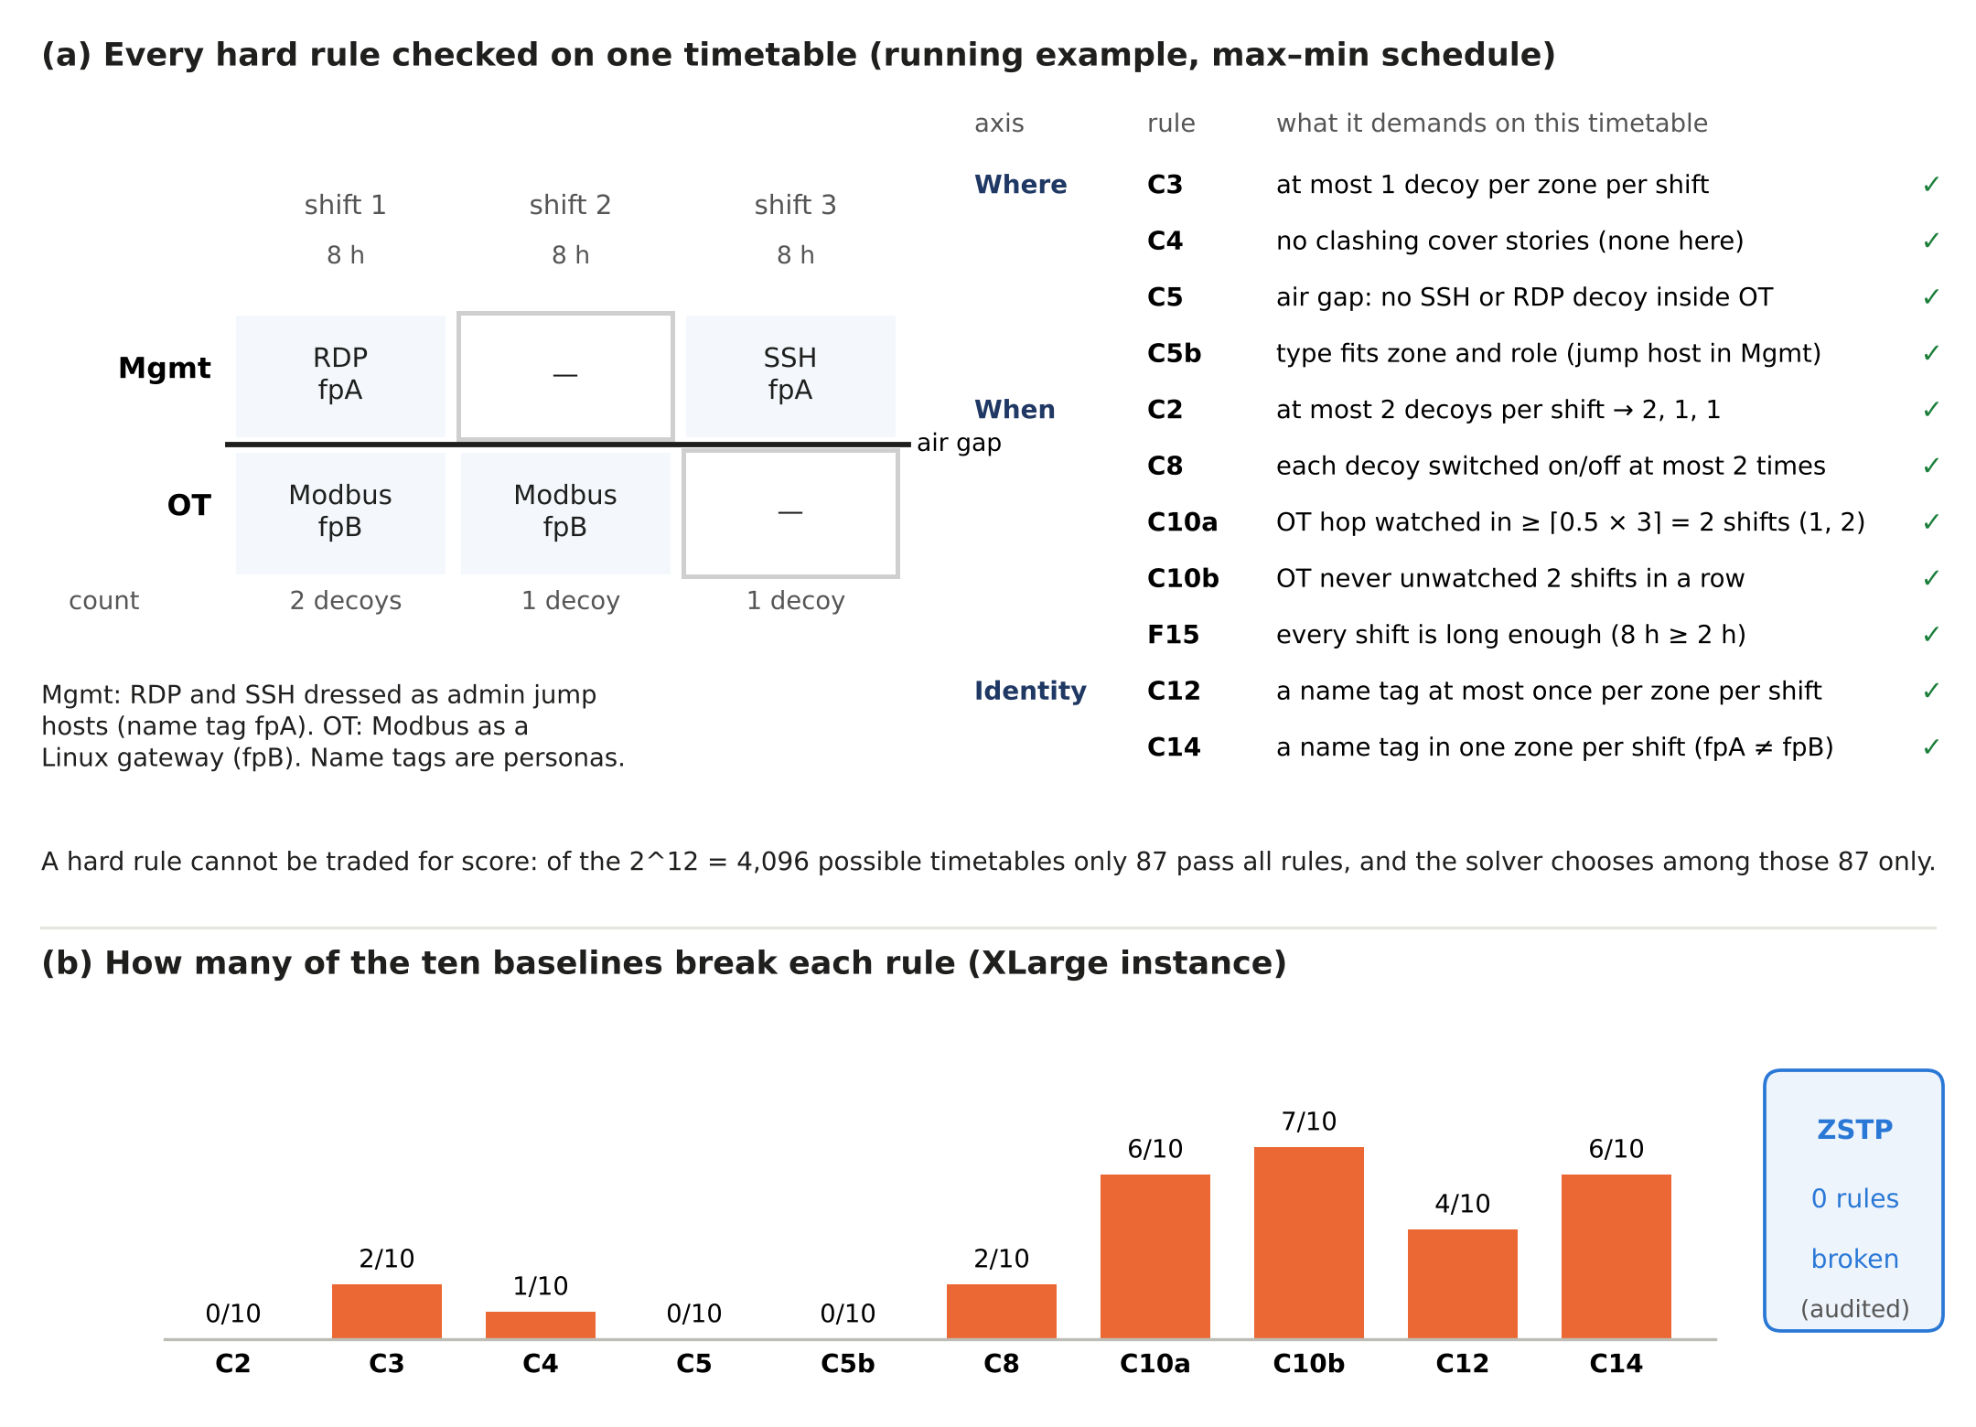
Figure 7. Hard rules made concrete. (a) The rules of Table 5 checked on the max–min timetable of the running example, grouped by the axis they restrict. (b) Number of the ten baselines that break each rule on the XLarge instance, as produced (Table 5, last column); every ZSTP schedule passes the hard-rule audit (Table 9).
Running example (C2, C5b). Each rule becomes a short clause over the twelve free variables; for example, C14 for fpB in slot 1 is ¬x_{SSH,Mgmt,1,Generic_Linux} ∨ ¬x_{Modbus,OT,1,Generic_Linux}, and C8 forbids the on–off–on pattern x_1 ∧ ¬x_2 ∧ x_3 of any deployment. With ρ_π = 0.5 and H = 3, C10a requires the OT hop to be covered in at least two slots, while C10b forbids two consecutive uncovered slots. The two rules are not redundant: with ρ_π = 0.3, coverage in slot 1 only satisfies C10a but violates C10b, and with ρ_π = 0.5, coverage in slot 2 only satisfies C10b but violates C10a. With ρ_π = 0.5, the only coverage patterns that C10a, C10b and C8 allow together are slots {1, 2}, {2, 3} and {1, 2, 3}; each places the single plausible OT deployment in adjacent slots, so θ_burst must recognize it once — the mechanism behind the zero-burn infeasibility shown for XLarge in Section 4.2 (see also Figure 19(b)).

4.2 Burn Mechanics and Dual Detection Credit
The live-credit indicator d^θ_{i,z,t,p} = x_{i,z,t,p} ∧ ¬u^θ_{i,z,t} ∧ ¬v^θ_{f(p),t} is 1 only when neither the type-burn indicator (C9) nor the persona-burn indicator (C13) has fired; all soft objective layers (L1–L4) are gated on d^θ. Burn follows an observe-then-burn order within each slot: honeypots are deployed; recognition is decided only from earlier slots; the attacker probes and every unrecognized honeypot earns credit; the attacker records what it saw; the defender rotates. Type burn u^θ_{i,z,t} = 1 when the same trap type was in the same zone in each of the previous τ_d slots; persona burn v^θ_{f,t} = 1 when fingerprint f was used in each of the previous τ_dp slots. At θ_burst (τ_d = τ_dp = 1), a honeypot earns credit in its first slot and is recognized only if the same placement or fingerprint is repeated in the next slot. The evaluator, the encoding, and the L2 emulation all use this order. Figure 8 shows this order across two consecutive slots.
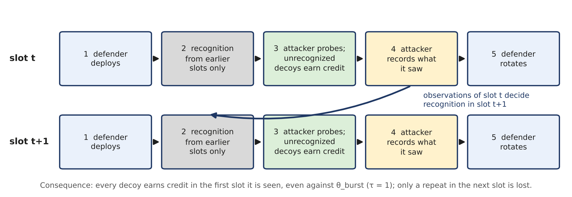
Figure 8. Observe-then-burn order within each slot, shared by the encoding, the evaluator and the emulation. In plain terms: what the attacker sees in one slot can only unmask a repeat in the next slot, so every decoy earns credit the first time it is seen, even against θ_burst (τ = 1).
Baselines receive no credit from recognized honeypots under this common evaluation, but they do not score zero, because each still earns credit in the slot where it first places each honeypot. Under θ_burst the baselines lose 50–75% of their deployments to recognition, and their worst-case scores range from 1,341.25 to 4,822.52. The max–min schedule loses 3 of its 11 deployments (27.3%) under θ_high and θ_burst and none under θ_low and θ_med. Zero burn under all four profiles is infeasible (exact CP-SAT check): the OT critical hop can be covered by only one type-and-identity combination, C10b forces that placement into adjacent slots, the churn limit C8 rules out alternating it, and a one-slot threshold then recognizes the repeat. Zero burn under θ_low and θ_med alone costs nothing (best worst case 7,052.62 = r*).

5. Soft Objective and Four-Pass Lexicographic Strategy

5.1 Six-Tier Weighted Objective
The soft objective Q_θ(x) is stratified across six detection layers whose weights embed an explicit prevention-vs-forensics trade-off: early interception outweighs basic detection by three orders of magnitude. The weight ratio is an auditable design parameter, not a tuned hyperparameter; operators who value early interception and forensic breadth differently can adjust the weights and re-run the solvers to obtain a new certified schedule. Each term is scaled by the path frequency ρ_π, the profile's path emphasis ω_{θ,π}, hop interception values, and ATT&CK technique weights; all coefficients are multiplied by 100 and rounded to integers, so every score is exact to 0.01 for the rounded model. The weights alone do not enforce strict tier priority: on the test instance one unit of L4 is worth 433.50, while the lower tiers together can add up to 5,985.68. Strict priority is therefore enforced by the pass procedure of Section 5.2.
Table 6. Soft objective layers and their weights.
Layer | Weight | Operational Meaning
L4 (Early interception) | × 1,000 | Detection before the target asset; dominant term via non-final hop coverage
L3_fwd (Path forward) | × 100 | Path-hop coverage across attack path π; L3_fwd and L3_bwd are summed, so each covered hop earns weight 170
L3_bwd (Path backward) | × 70 | Backward component of the same hop-coverage term (0.7× L3_fwd rate)
L2_fam (Tactic family) | × 12 | Distinct ATT&CK tactic families covered, each weighted by the sum of its technique weights
L2_tech (ATT&CK breadth) | × 10 | Distinct ATT&CK techniques covered, each weighted by its weight w_j
L1 (Basic detection) | × 1 | Raw detection credit at baseline weight
Soft objective on the running example. Figure 9(a) builds the worst-case score of the max–min schedule of Section 3.5 from its parts: the Mgmt hop is caught early in shifts 1 and 3 (L4: 2 × 1,000); three hop-shifts are covered (L3: 3 × 170, the forward and backward weights 100 + 70 combined); four techniques with weights 2, 1, 1 and 3 are seen (L2: 7 × 10); and three decoy-shifts are live (L1: 3 × 1), for a total of 2,583. Figure 9(b) splits the θ_burst scores of three timetables the same way. The habitual static schedule loses an early catch because θ_burst recognizes its repeated decoys; the schedule that is best for θ_med loses hop coverage and technique breadth for the same reason.
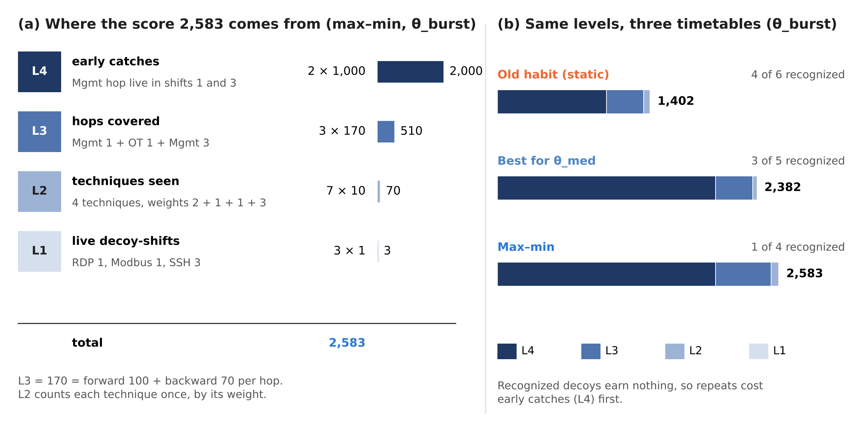
Figure 9. The soft objective made concrete on the running example (θ_burst). (a) The score 2,583 of the max–min schedule, level by level. (b) The same levels for the habitual static schedule, the schedule that is best for θ_med, and the max–min schedule. Weights follow Table 6 (L3 = 100 + 70 per covered hop); the running example has a single L2 term.
The six terms form four priority levels: L4; L3 = L3_fwd + L3_bwd, which score the same covered hop; L2 = L2_fam + L2_tech, which both measure ATT&CK breadth; and L1. Strict priority is enforced between these four levels (Section 5.2), while terms within a level are added with their weights. Running example. For the static schedule of Figure 6 (step 2) under θ_burst, only slot 1 earns credit: L4 = 1,000 (the Mgmt hop is intercepted once before the target), L3 = 2 × 170 = 340, L2 = 10 × (2 + 1 + 3) = 60 for techniques T1021, T1021.004 and T0855, and L1 = 2, so Q_burst = 1,402. Under θ_low and θ_med nothing is yet recognized and the same schedule scores 2,744: the burn profile, not the placement, separates the scores. Figure 10 summarizes this layer: the hard rules grouped by the axis they restrict, and the six terms grouped into the four levels that the passes of Section 5.2 enforce. In the hierarchy of Figure 1, C2 is what C3 optimizes over, and refinements C5(b) and C5(c) belong to it.
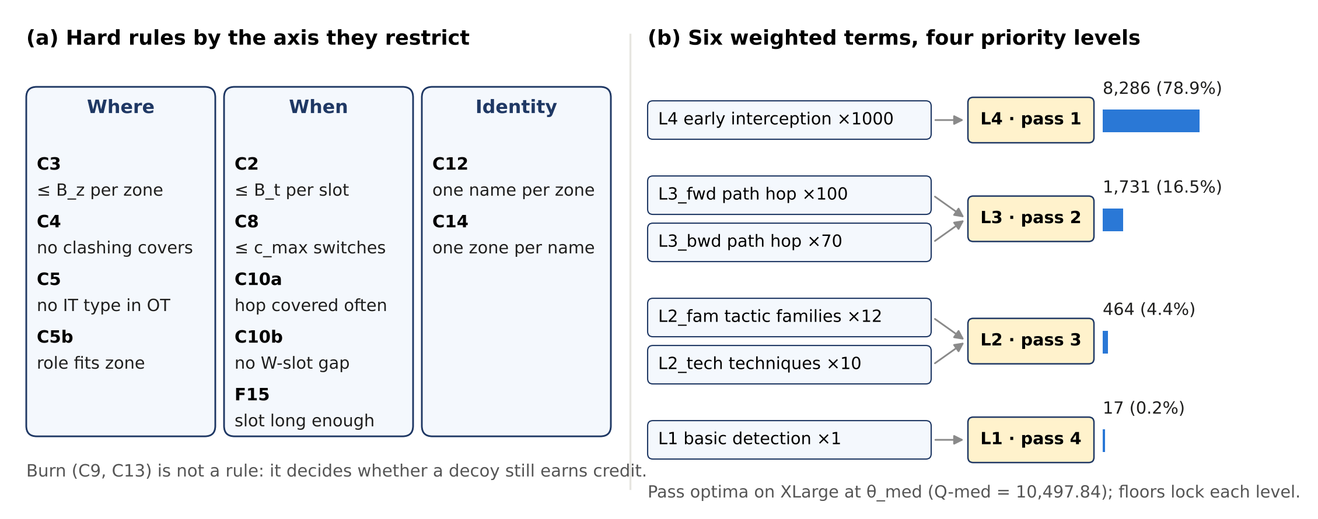
Figure 10. C2 at a glance. (a) The hard rules grouped by the axis they restrict: where (spatial), when (temporal) and identity. (b) The six weighted terms of Table 6 grouped into the four priority levels enforced by the four passes, with the XLarge pass optima at θ_med and their share of Q-med. Real-world reading: the operator states what must never happen (left) and what matters most, in order (right).

5.2 Four-Pass Lexicographic MaxSAT
A single weighted MaxSAT pass cannot guarantee tier ordering, because enough lower-tier gains can outweigh a higher-tier loss (Section 5.1). ZSTP therefore builds the Q-med schedule with a four-pass tier-lexicographic strategy at θ_med, executed as four sequential RC2 invocations; each earlier tier optimum is locked as a pseudo-Boolean hard floor (adder encoding [17]):
- Pass 1: Maximize L4 (early interception) at θ_med. Optimum on the test instance: 8,285.68.
- Pass 2: Maximize L3 (path coverage), with L4 ≥ 8,285.68 as a hard floor. Optimum: 1,730.84.
- Pass 3: Maximize L2 (ATT&CK breadth), with the L4 and L3 floors. Optimum: 464.20.
- Pass 4: Maximize L1 (basic detection), with all three floors. Optimum: 17.12 (Q-med = 10,497.84).
Because each earlier optimum is a hard floor, no lower-tier gain can reduce a higher tier; an independent CP-SAT model running the same four passes reaches the same four values, and the passes take 0.79 s in total. The worst-case objective r* is not taken from these passes. It is computed separately by an exact max–min search: for each profile an adder network computes Q_θ(x) in binary with a comparator literal for Q_θ(x) ≥ T, and a SAT solver (Glucose via PySAT [14]) finds the largest T that all four profiles reach at once (17 solver calls, 21.2 s). The optimality certificate is the exported CNF with the claim Q_θ(x) ≥ r* + 0.01 for every θ together with its refutation proof; its size and verification are reported in Table 9. A burst-first procedure (maximize Q_burst, then Q_high, Q_med, and Q_low with floors) is not equivalent: its worst case is 6,610.37, 6.3% below r*, because θ_burst is not the worst profile for every schedule (Section 7.2). The four-pass construction adds polynomial WCNF overhead and requires no modification to the RC2 solver itself.
Running example (C3, C5c). At θ_med the four passes give L4 = 3,000, L3 = 680, L2 = 70 and L1 = 4 (Q-med = 3,754). Here the levels never conflict, so a single weighted pass gives the same value; on XLarge they can (Section 5.1), which is why the floors are needed. The resulting Q-med schedule scores only 2,382 under θ_burst, because it shows fpB in Mgmt in slot 1 and in OT in slot 2 — a reuse that θ_med (τ_dp = 2) tolerates and θ_burst (τ_dp = 1) recognizes. The max–min threshold search over the three profiles needs 12 feasibility calls (T = 2,051 feasible, 3,077 infeasible, 2,564 feasible, …, 2,584 infeasible, 2,583 feasible); the infeasible call at T = 2,584 is the kind of statement that the certificate proves on XLarge (Section 7.5); for this small instance it is confirmed directly by enumerating all 87 feasible schedules, which gives r* = 2,583. Figure 11(a) plots those schedules: the one that is best for a single profile is not the one with the best worst case, which is the relationship between the objective of C2 and the certified solution of C3; Figure 11(b) shows the threshold search converging to r*.
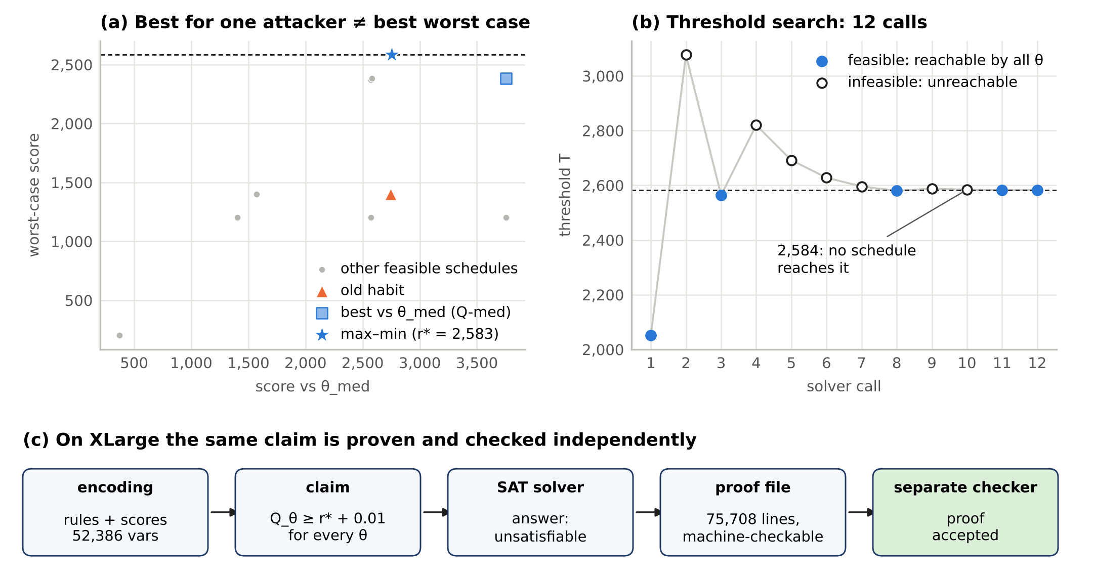
Figure 11. C3. (a) All 87 feasible schedules of the running example by their score under θ_med and their worst case (several coincide): the schedule that is best for θ_med is not the one with the best worst case, and only the max–min schedule reaches r*. (b) The threshold search on the running example: filled markers are thresholds some schedule reaches under every profile, hollow markers are thresholds none reaches; 2,584 is unreachable (confirmed by enumeration). (c) On XLarge the corresponding claim is proven by a SAT solver and its proof is accepted by a separate checker (Section 7.5, Table 9). In plain terms: a plan is judged by its weakest match-up, and the result comes with a proof that no rule-following plan does better

6. Threat-Adaptive Loop

6.1 Algorithm 1
Algorithm 1 implements the threat-adaptive loop. It responds to STIX 2.1 intelligence bundles [16] by updating persona priors and recognition thresholds, rebuilding the WCNF, re-running the max–min search, and applying an acceptance decision. Alert-driven re-optimization itself follows recent work [21, 23]; what Algorithm 1 adds is that every re-solve returns the certified max–min schedule and passes an independent audit before deployment. The deployed schedule is the max–min schedule, so the certificate is renewed for the updated inputs after every update. The critical safety property is that Step 5 — the audit of every hard rule by the independent rule checker and independent verification of the new certificate — executes before any schedule change reaches the deployment controller. No proposed schedule update bypasses this gate. Figure 12 shows the loop together with the two outcomes reported in Section 6.2.
Algorithm 1 (Threat-Adaptive Honeypot Re-scheduling).
Input: deployed schedule x_dep; STIX bundle B = {campaign_class, ρ_π (optional), confidence c}.
- Update persona priors: q_p := normalize(q_p + α · c · [p = p(B)]), where p(B) is the persona associated with the campaign and α ∈ (0,1] (default 0.3).
- Update thresholds (U11) and slots (F15): set ρ_π from B if given; τ_d(θ,z) := max(1, ⌊τ_d0 (1 − ρ_eff/ρ_max)⌋) with ρ_eff = max(ρ_θ, max ρ_π over paths through z), and τ_dp(θ) := max(1, ⌊τ_dp0 (1 − ρ_θ/ρ_max)⌋), with τ_d0 = 3, τ_dp0 = 4, ρ_max = 1; re-check slot validity; rebuild the WCNF.
- Robust re-solve compute the new optimum r*′ and a schedule x*′ by the max–min search, with a new certificate.
- Acceptance: if x_dep follows every hard rule under the updated inputs and min_θ Q′_θ(x_dep) ≥ r*′ → KEEP; else → REDEPLOY x*′. Q-med is reported but does not decide.
- Before deployment: re-test the schedule to be deployed against every hard rule with the independent checker and verify its certificate with an independent proof checker before pushing it to the deployment controller.
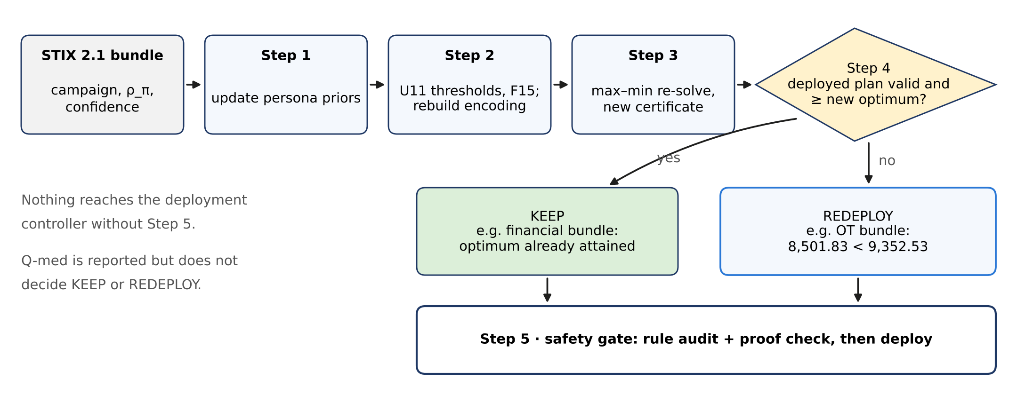
Figure 12. The threat-adaptive loop of Algorithm 1, annotated with the REDEPLOY and KEEP outcomes of Section 6.2. In plain terms: new intelligence triggers a fresh certified plan, and nothing is deployed before an independent audit.

6.2 Controlled REDEPLOY Scenario
A controlled scenario exercises the REDEPLOY branch. On receipt of a high-confidence OT infiltration bundle (campaign_class = OT_infiltration, confidence = 0.92, ρ_π = 0.72 on the OT path, previously 0.15), Step 1 raises the prior of Generic_Linux, the only persona plausible in the OT zone, from 0.25 to 0.412 (the other three fall to 0.196). U11 lowers τ_d from 2 to 1 in DMZ, Mgmt, and OT for θ_low and θ_med, and C10a now requires ⌈0.72 × 4⌉ = 3 covered slots for the OT critical hop. Under the updated inputs the deployed max–min schedule reaches a worst-case score of 8,501.83, below the new optimum r*′ = 9,352.53, so Algorithm 1 chooses REDEPLOY. The new schedule attains 9,352.53 (Q-med 15,771.50, the highest Q-med among all schedules that attain r*′), passes the audit of every hard rule, and its certificate is verified (Table 9). For comparison, the earlier acceptance rule (REDEPLOY when Q-med rises), applied to the Q-med schedule with old and new schedules scored on the same updated inputs, raises Q-med from 16,346.88 to 17,398.53 (+1,051.65, +6.4%) but lowers the worst-case score by 17.2% (8,597.26 → 7,118.58); the robust re-solve's worst case is 31.4% higher. Comparing against the old schedule's Q-med on the original inputs (10,497.84) would mix the model change with the schedule change. In a KEEP check, a financial-campaign bundle (confidence 0.7, no path change) gives a new optimum of 7,052.66, which the deployed schedule already attains, so it is kept.
An LLM-as-Persona-Oracle (LPO) extension is architecturally specified — its output would be a bounded prior adjustment feeding into Step 1, with the max–min re-solve and the rule audit serving as a mandatory safety gate — but it is not implemented or evaluated and is not part of any reported result.
Running example (U11, Algorithm 1). Suppose a bundle with confidence 0.92 raises the corridor’s path frequency from 0.50 to 0.72. Step 1 raises the prior of Generic_Linux from 0.5 to 0.608. Step 2 sets ρ_eff = 0.72 in both zones, because both lie on the updated path, so τ_d falls to 1 for all three profiles — recognition becomes faster in exactly the zones the campaign traverses — and C10a now requires ⌈0.72 × 3⌉ = 3 covered slots for the OT hop. The deployed max–min schedule covers OT in slots 1–2 only, so it fails the updated hard rules and Algorithm 1 chooses REDEPLOY. The re-solve (23 feasible schedules) returns a schedule that adds the OT deployment in slot 3 and attains the new optimum of 2,583. Figure 13 plots the thresholds U11 assigns: the update links the temporal axis (how many slots a deployment may repeat before recognition) to the spatial one (which zones lie on the reported path), and it feeds C3, which re-solves and re-certifies.
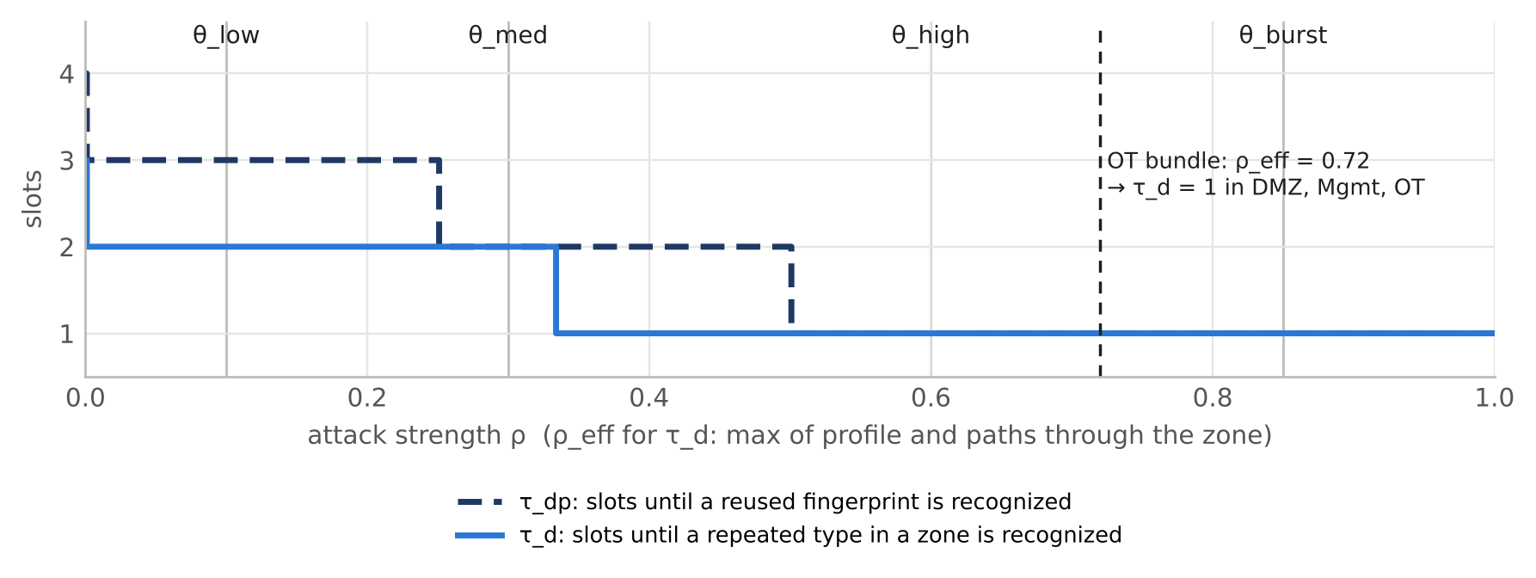
Figure 13. U11 thresholds as a function of attack strength ρ: slots before a repeated type in a zone (τ_d, solid) or a reused fingerprint (τ_dp, dashed) is recognized; vertical lines mark the four profiles. In plain terms: after the OT bundle of Section 6.2 (ρ_eff = 0.72), any repeat in DMZ, Mgmt or OT is spotted after one slot.

7. Experimental Evaluation

7.1 Setup and Evaluation Protocol
All experiments use the XLarge instance (|K| = 8, |Z| = 5, H = 4, |P| = 4; 640 binary decisions; 4 attacker profiles) and come from one pipeline run (code version 32d54d7e7d96, instance hash 5cb2c5f369c5; Python 3.13, PySAT 1.9 with RC2 [9, 14], OR-Tools CP-SAT 9.15 [15]; 2 CPU cores, under 2 GB of memory, 6.7 minutes). Every schedule carries a run ID derived from the instance, the method, and the code version, and every table is generated from one results file, provided with the certificates, STIX bundles, and scripts as supplementary material (see Data and Code Availability). Validation is at L2: real TCP honeypot sockets, Bernoulli-governed attacker connection trials, and STIX bundles generated from observed connections. The attacker's random stream depends only on the instance, the profile and the episode, so every schedule faces the same attacker episodes (common random numbers) and schedules can be compared pairwise. In each slot the attacker probes each zone with probability ρ_θ, observing every honeypot there, and traverses each attack path with probability min(1, ρ_π ω_θ,π), contacting at each hop every unrecognized honeypot that detects the hop's technique; recognition uses only the attacker's own observations and the thresholds τ_d and τ_dp of Section 3.4, and credit follows the layer definitions of Section 5.1. The emulator reads only the schedule and instance parameters (Θ, Π, J, F and the U11 thresholds); the budget, plausibility, churn, path and identity rules act through the schedule. The rule checker tests every schedule before emulation and reports its violations, and baselines are emulated as produced, violations included, so that they can be compared (Table 10). The emulator gives a broken rule no direct attacker-visible effect (for example, a conflicting cover story or an identity shown in two zones at once is not itself recognized), which favours the rule-breaking baselines and makes the comparison conservative. We evaluate three RC2 procedures — the max–min schedule (r*), the four-pass Q-med schedule, and a burst-first comparison — and ten baselines. All are scored through the same unified evaluation pipeline: (i) an independent rule checker tests every hard rule; (ii) burn is applied with identical observe-then-burn semantics to every method; (iii) Q_θ is scored under all four θ using identical equations; and (iv) the worst-case score min_θ Q_θ is computed identically for all methods. Baselines are reported as produced, and feasibility and optimality are reported as separate properties. Certificates are not available for heuristic baselines; the comparison is framed as certified versus uncertified, not as a claim that heuristics were poorly implemented. Naming convention: in the tables and figures, “RC2 max–min” denotes the schedule returned by the SAT-based max–min search of Section 5.2 on the same encoding (RC2 itself computes the Q-med and burst-first schedules), and “burst-first (V3)” denotes the burst-first procedure of Section 5.2.

7.2 Main Results: Per-Scenario Scores
Table 7. Per-scenario scores for all solvers (XLarge instance, common evaluator; run IDs are in the results file). Worst-case = min_θ Q_θ, with the binding profile in parentheses. Hard rules: rules broken (× number of violations) according to the independent rule checker.
Solver | Q θ_low | Q θ_med | Q θ_high | Q θ_burst | Worst-case | Certificate | Hard rules
★ RC2 max–min (r*) | 7,247.03 | 9,513.64 | 7,052.62 | 7,950.30 | 7,052.62 (high) | YES | all pass
RC2 Q-med (4 passes) | 7,675.36 | 10,497.84 | 4,715.04 | 6,227.11 | 4,715.04 (high) | NO | all pass
RC2 burst-first | 6,737.95 | 9,606.13 | 6,610.37 | 8,379.09 | 6,610.37 (high) | NO | all pass
Greedy-Diverse | 6,093.44 | 7,951.23 | 4,822.52 | 5,388.61 | 4,822.52 (high) | NO | C12×2, C14×3
Random | 5,289.77 | 4,910.11 | 3,888.75 | 3,770.69 | 3,770.69 (burst) | NO | C3×2, C4×1, C8×1, C10a×1, C10b×6, C12×1, C14×4
Greedy-BiDir | 5,326.49 | 6,366.29 | 3,093.19 | 3,344.40 | 3,093.19 (high) | NO | C14×4
Static-Best | 4,757.12 | 6,330.84 | 3,093.19 | 3,344.40 | 3,093.19 (high) | NO | C14×4
LP-Relaxation | 3,996.62 | 5,570.34 | 2,849.21 | 3,186.49 | 2,849.21 (high) | NO | C10a×1, C10b×3
Max-PathCov | 3,791.56 | 5,456.40 | 2,782.72 | 3,167.77 | 2,782.72 (high) | NO | C10a×1, C10b×3
Round-Robin | 4,506.63 | 5,357.27 | 2,776.85 | 2,901.22 | 2,776.85 (high) | NO | C8×3, C10b×2, C12×1, C14×3
Single-Zone | 3,487.41 | 4,072.55 | 3,067.59 | 2,376.09 | 2,376.09 (burst) | NO | C3×4, C10a×2, C10b×6, C12×2
ThreatIntel-Only | 2,994.06 | 4,196.92 | 2,090.52 | 2,331.56 | 2,090.52 (high) | NO | C10a×3, C10b×9
Greedy-HighRho | 3,538.24 | 3,538.24 | 1,654.33 | 1,341.25 | 1,341.25 (burst) | NO | C10a×2, C10b×6, C14×4
Reading Table 7. Each RC2 procedure is best at its own objective: the Q-med schedule has the highest Q at θ_med (10,497.84), burst-first the highest Q at θ_burst (8,379.09), and the max–min schedule the highest worst-case score (7,052.62), 1.46× that of the best baseline (Greedy-Diverse, 4,822.52). The max–min schedule scores higher than every baseline under each of the four profiles, including θ_low. No baseline collapses to zero, because each still earns credit in the slot where it first places a honeypot; all ten break at least one hard rule, and their worst-case scores range from 1,341.25 (Greedy-HighRho) to 4,822.52. The Q-med schedule's worst case (4,715.04) is below that of Greedy-Diverse, which breaks C12 and C14: optimizing the medium profile alone does not protect the worst case. θ_burst is the binding profile for only 3 of the 13 schedules. Figure 14 shows the worst case of every schedule, with each baseline both as produced and after repair to the nearest feasible schedule, and Table 11 (Section 7.6) summarizes each baseline in one row.
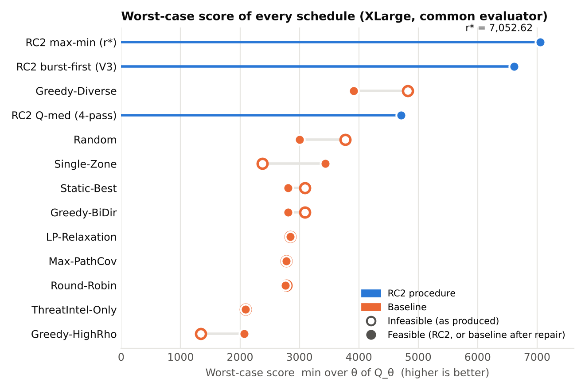
Figure 14. Worst-case score min_θ Q_θ of every schedule (common evaluator). Hollow: baseline as produced (breaks at least one hard rule); filled orange: the same baseline after minimum-change repair; blue: RC2 procedures. Every repaired baseline stays below r*. “RC2 max–min” is the schedule of the exact max–min search and “burst-first (V3)” the burst-first procedure (Section 5.2).

7.3 15-Metric Head-to-Head Comparison
Table 8. 15-metric comparison (RC2 = max–min schedule). ATT&CK techniques, tactic families, hop coverage, and early interception count live honeypots at θ_med; PBurn, TBurn, and FM-avg are at θ_burst. Bold marks the best value in each row. Lower is better for PBurn, TBurn, rule violations, and C14 leaks; higher is better otherwise.
Metric | RC2 | G-BiDir | R-Robin | S-Best | LP | Rnd | S-Zone | G-Div | ThrI | MaxPC | G-HiRho
Worst-case | 7,052.62 | 3,093.19 | 2,776.85 | 3,093.19 | 2,849.21 | 3,770.69 | 2,376.09 | 4,822.52 | 2,090.52 | 2,782.72 | 1,341.25
Q-med | 9,513.64 | 6,366.29 | 5,357.27 | 6,330.84 | 5,570.34 | 4,910.11 | 4,072.55 | 7,951.23 | 4,196.92 | 5,456.40 | 3,538.24
ATT&CK Tech | 11/18 | 11/18 | 18/18 | 9/18 | 12/18 | 15/18 | 14/18 | 18/18 | 6/18 | 11/18 | 10/18
Tactic Families | 6/8 | 7/8 | 8/8 | 6/8 | 8/8 | 7/8 | 6/8 | 8/8 | 4/8 | 6/8 | 6/8
Path Persist C10% | 100% | 100% | 75% | 100% | 75% | 25% | 50% | 100% | 25% | 75% | 50%
Hop Coverage% | 34.6% | 26.9% | 19.2% | 26.9% | 26.9% | 13.5% | 15.4% | 26.9% | 11.5% | 30.8% | 15.4%
Early-Intercept% | 81.2% | 50.0% | 43.8% | 50.0% | 37.5% | 43.8% | 25.0% | 68.8% | 37.5% | 37.5% | 25.0%
Rule violations | 0 | 4 | 9 | 4 | 4 | 16 | 14 | 5 | 12 | 4 | 12
Zone Spread% | 80% | 60% | 100% | 60% | 60% | 80% | 20% | 80% | 40% | 60% | 60%
Persona Div% | 100% | 75% | 100% | 75% | 100% | 100% | 100% | 100% | 100% | 100% | 75%
PBurn% (lower↓) | 27.3% | 75.0% | 62.5% | 75.0% | 75.0% | 43.8% | 62.5% | 56.2% | 75.0% | 75.0% | 75.0%
TBurn% (lower↓) | 27.3% | 62.5% | 0.0% | 75.0% | 75.0% | 18.8% | 62.5% | 50.0% | 75.0% | 75.0% | 75.0%
C14 X-Zone Leaks | 0 | 4 | 3 | 4 | 0 | 6 | 0 | 3 | 0 | 0 | 4
FM-avg | 1.11 | 0.41 | 0.29 | 0.41 | 0.41 | 0.37 | 0.36 | 0.59 | 0.34 | 0.45 | 0.25
Optimality certificate | YES | NO | NO | NO | NO | NO | NO | NO | NO | NO | NO
Worst profile | high | high | high | high | high | burst | burst | high | high | high | burst
The max–min schedule is best, or tied for best, on 10 of the 14 measured metrics: the worst-case score, Q-med among baselines, hop coverage (34.6%), early interception (81.2%), persona burn and force multiplier, and (tied) path persistence, persona diversity, rule violations (none) and C14 leaks; it is also the only schedule with an optimality certificate. Its ATT&CK breadth is lower: 11/18 techniques and 6/8 tactic families, while Round-Robin and Greedy-Diverse reach 18/18 and 8/8 while breaking hard rules. This is a trade-off the robust objective accepts: breadth (L2) contributes less to the worst case than interception (L4) and coverage (L3). Its Q-med (9,513.64) is also below that of the Q-med schedule (Table 7), which is the price of protecting the worst case.
Figure 15 gathers the main results in one view: (a) the percentage metrics of Table 8, max–min against each baseline; (b) the emulated advantage of max–min with 95% confidence intervals (Table 10); (c) the worst case reached by methods that target it without a proof (Table 12); and (d) the solve time of the certified search as the instance grows (Table 13).
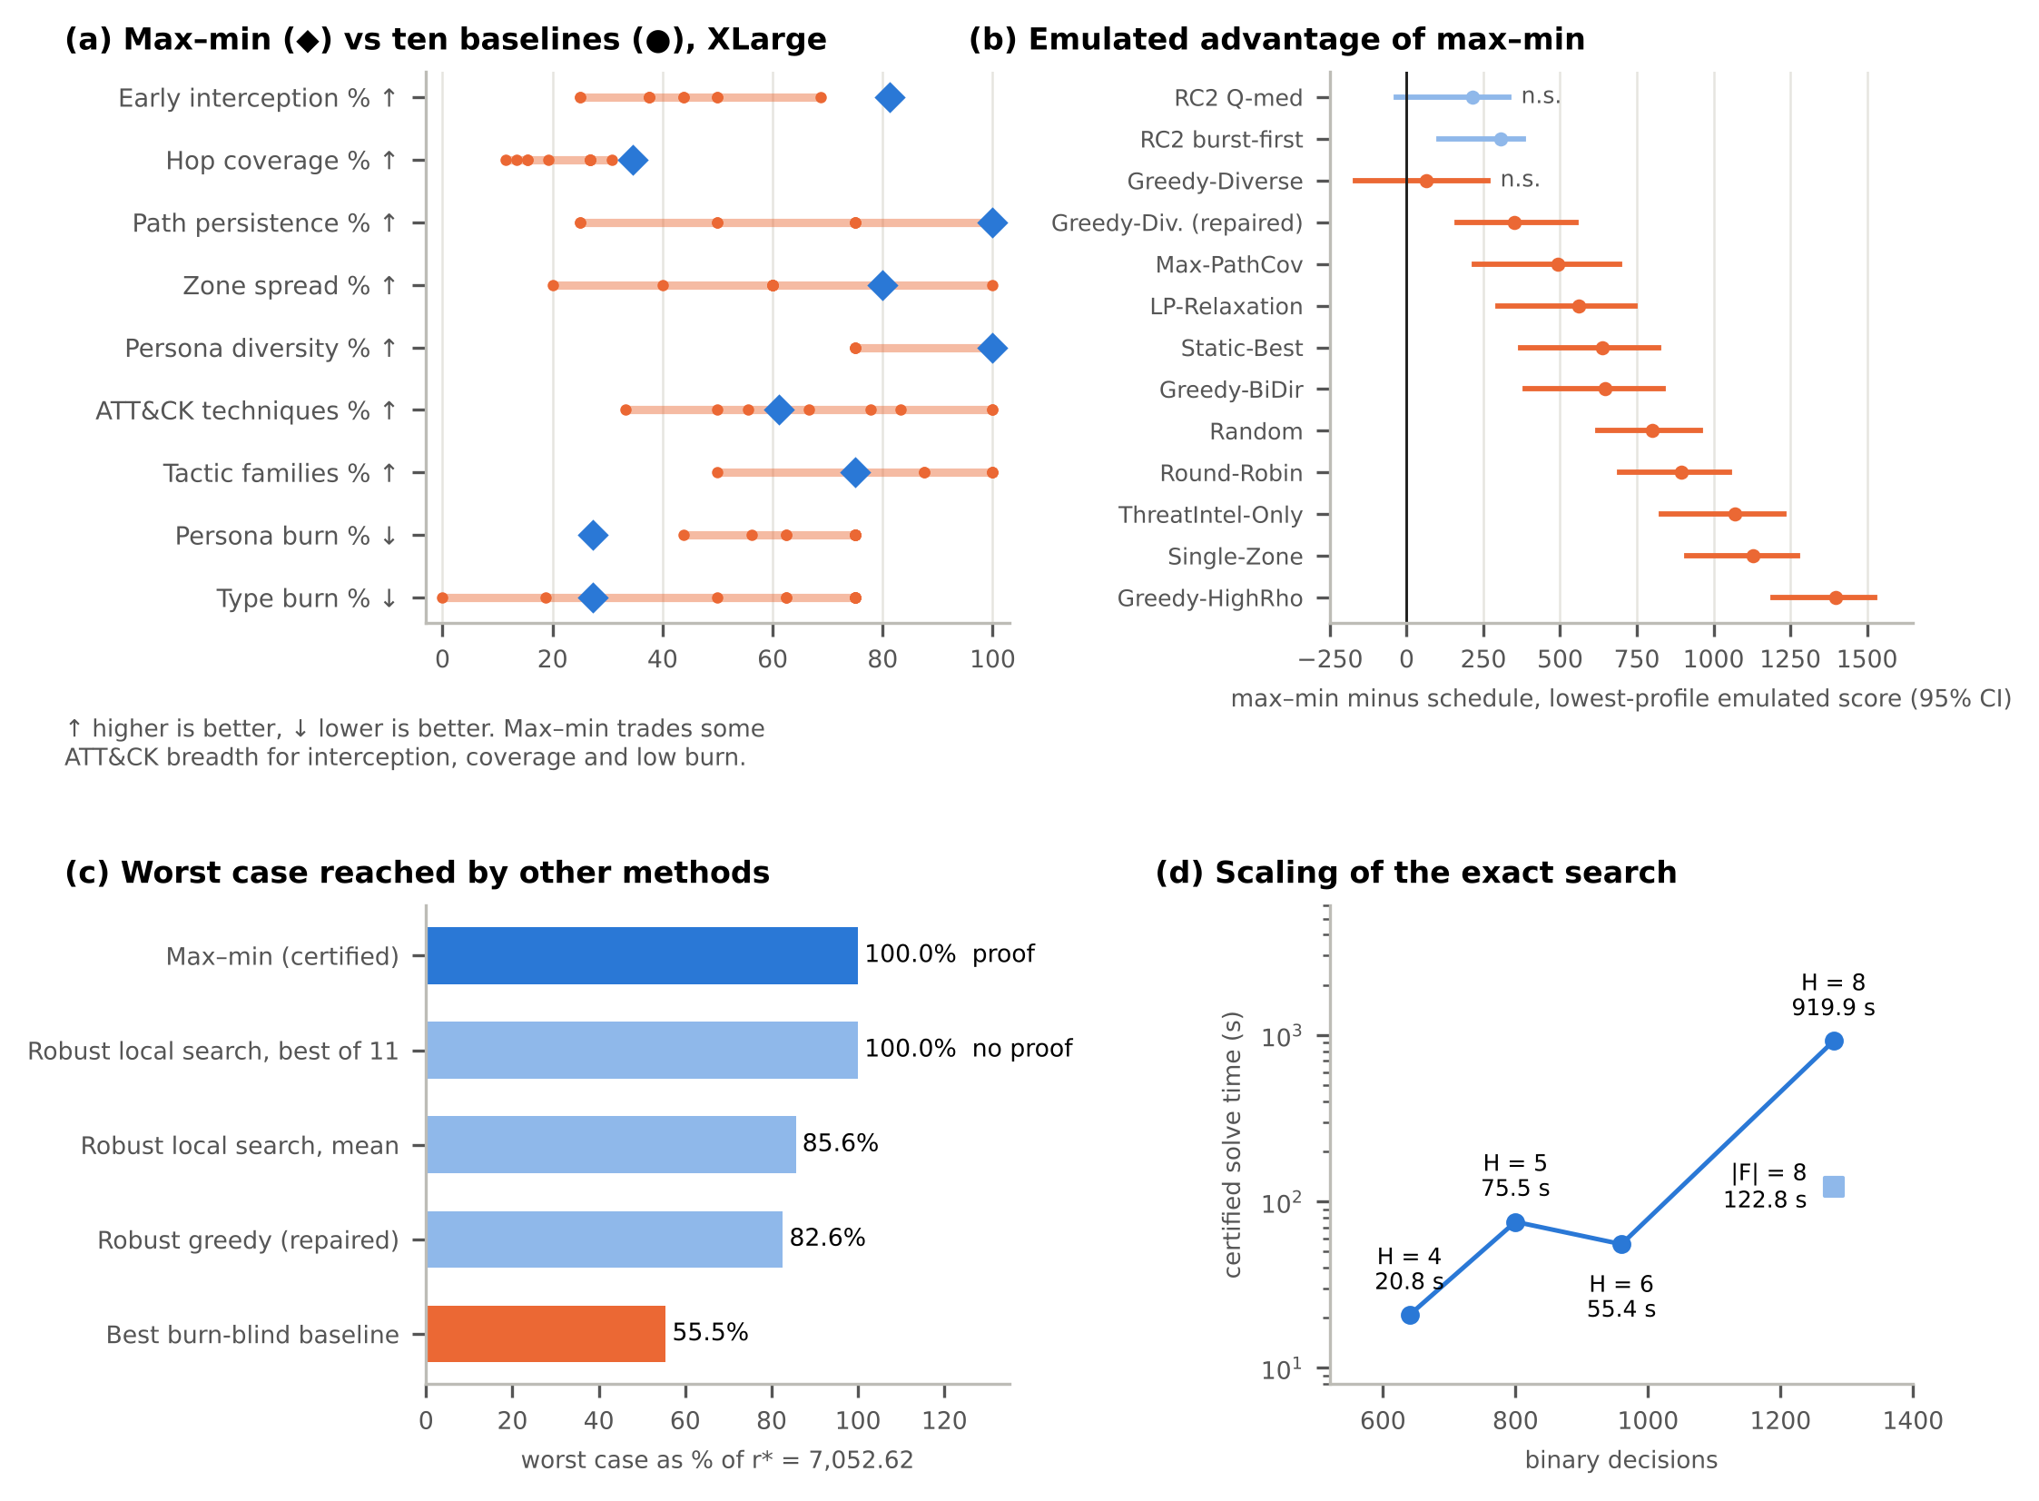
Figure 15. The main results briefly (XLarge instance). (a) Percentage metrics of Table 8: max–min (◆) against each of the ten baselines (●); arrows mark the better direction. (b) Max–min minus each schedule in lowest-profile emulated score, with paired-bootstrap 95% confidence intervals; n.s., the interval includes 0 (Table 10). (c) Worst case as a share of r* = 7,052.62 (Table 12). (d) Certified solve time against the number of binary decisions, log scale (Table 13).
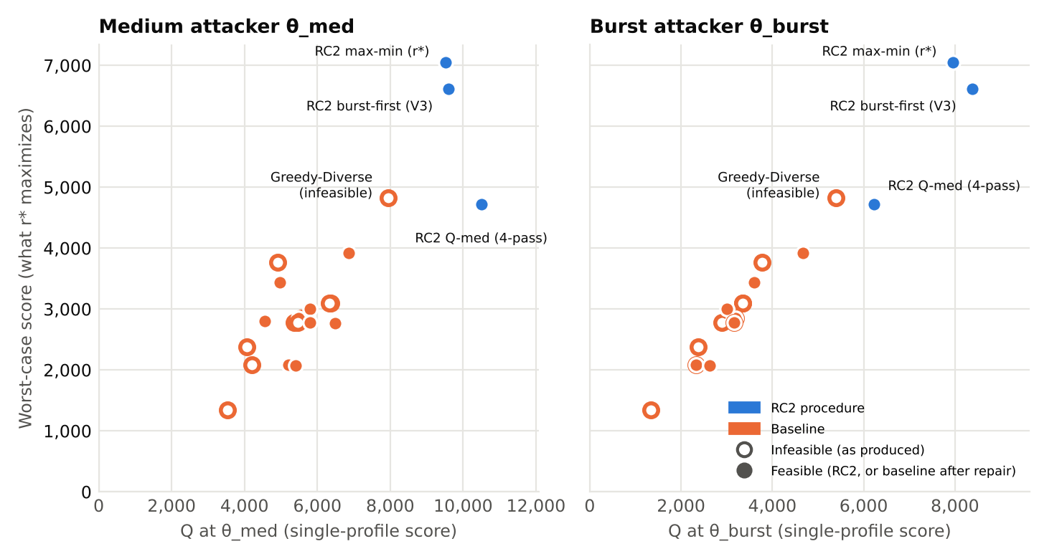
Figure 16. Single-profile score against the worst-case score for every schedule: medium attacker (left) and burst attacker (right). Each single-profile objective picks a different schedule from the robust objective: the Q-med schedule leads at θ_med and the burst-first schedule at θ_burst, but both have a lower worst case, because θ_high, not θ_burst, is the binding profile for most schedules. No baseline, as produced or repaired, exceeds the max–min schedule on any axis. Labels as in Figure 14.

7.4 Force-Multiplier Analysis
The force multiplier of a deployment is the total L3 credit of the attack-path hops it covers divided by its largest single-hop credit; it is 0 for a burned deployment or one that covers no hop, and FM-avg is its mean over all deployments. A value above 1 means that a single decoy serves several attack paths at once. At θ_burst, FM-avg is 1.11 for the max–min schedule (1.11 for burst-first and 0.84 for the Q-med schedule), against 0.25–0.59 for the baselines. Across ±25% perturbations of path frequencies, hop interception values, technique weights, and the L4 weight, the original max–min schedule stays within 0.19% of the re-solved optimum in seven of eight cases and within 10.18% when all path frequencies rise by 25%; after a shift to q_p(Finance_DB) = 0.40 it remains optimal.
The baselines fall below FM = 1.0 at θ_burst for the same reason their worst-case scores are lower: 50–75% of their deployments are recognized, which zeroes credit that was structurally available. The highest baseline FM-avg is 0.59 (Greedy-Diverse). Figure 17 compares FM-avg across all schedules. On the running example there is a single path, so every live decoy that covers a hop has FM = 1, and FM-avg at θ_burst is simply the share of deployments still live: 0.75 for max–min, 0.40 for the schedule that is best for θ_med and 0.33 for the static schedule (Figure 4).
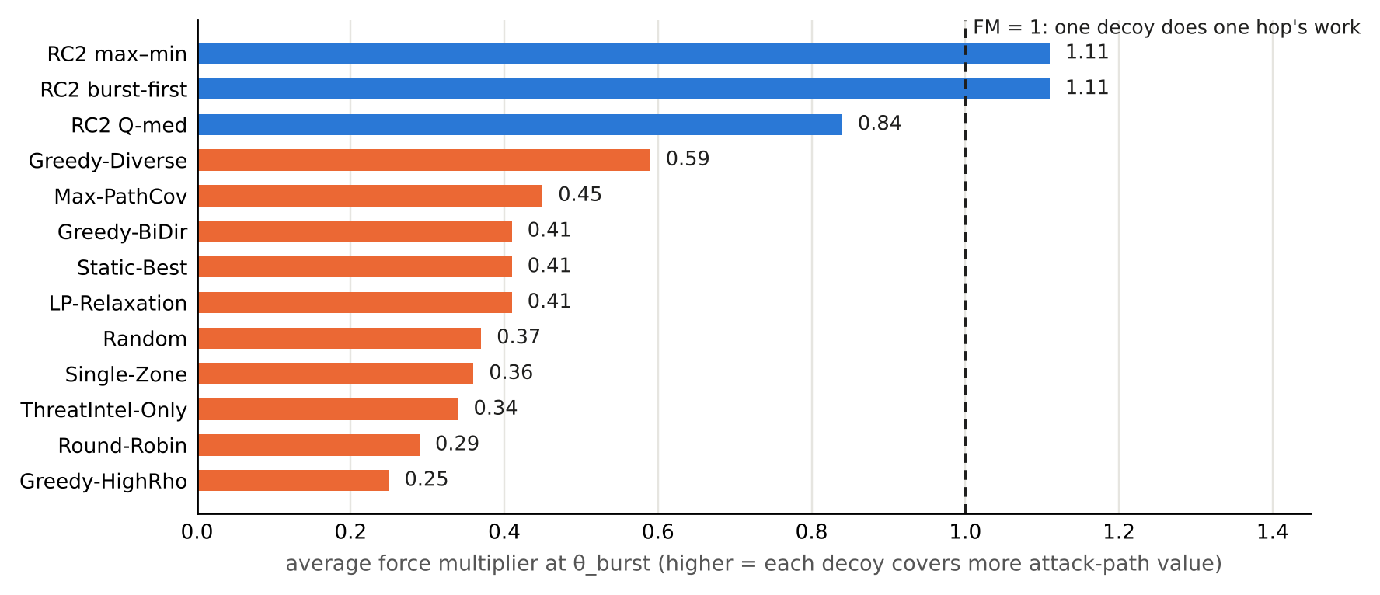
Figure 17. Average force multiplier at θ_burst (Table 8 and Section 7.4); blue, RC2 procedures; orange, baselines. In plain terms: a value above 1 means a single decoy does more than one attack-path hop's work; only the RC2 schedules exceed 1.

7.5 Optimality Certificate and Comparability
The value r* = 7,052.62 returned by the exact max–min search of Section 5.2 is the certified result for the encoded model. The certificate proves that no x ∈ {0,1}^640 satisfying every hard rule reaches min_θ Q_θ(x) ≥ 7,052.63, and it was verified independently (Table 9). Three further checks support that the encoding matches the model: an independent CP-SAT model gives the same r* and the same four Q-med tier values; the encoding, the rule checker and the evaluator agree on every schedule tested (Section 7.6); and on a small instance (|K| = 3, |Z| = 2, H = 3, |P| = 2; 262,144 schedules enumerated, 131 feasible), enumeration, SAT, and CP-SAT all give r* = 2,249.09, with a verified certificate. At L2, a deterministic replay reproduces every model score for all 13 schedules (1,334 connections); over 100 stochastic episodes per profile, the max–min schedule has the highest lowest-profile mean score (2,030), with a widespread between episodes (standard deviation 943–1,124); Section 7.6 reports which differences are statistically significant. Because of the certificate, any schedule with a higher worst-case score must break at least one hard rule; no baseline in this evaluation exceeds r*. Figure 11(c) traces the certificate from encoding to independent verification.

7.6 Validation Test Suite and Statistics
The certificate proves optimality of the CNF, so its value depends on the CNF encoding the model correctly. Table 9 lists the tests that check this and the other claims, all run on the final code. Two tests go beyond Section 7.5. The adder encoding of Q_θ(x) ≥ T, on which the max–min search, the tier floors and every certificate rest, is checked exhaustively against arithmetic. The hard-clause layer is compared with the independent rule checker in both directions, on schedules drawn without the solver, so an encoding that wrongly excluded a valid schedule would be detected as well as one that admitted an invalid schedule.
Table 9. Validation tests (final code; every value is written to a results file by the single reproduce command, see Data and Code Availability).
Test | Scope | Result
Adder pseudo-Boolean encoding | 120 random weighted sums (1–8 literals, weights up to 90,000); every input assignment × every threshold 0…max+1 | 0 errors
Encoding vs. rule checker, both directions | 1,635 schedules drawn independently of the solver (805 small-instance, 830 XLarge; 328 feasible): random subsets, one-step mutations of feasible schedules, the ten raw baselines | 0 feasibility mismatches; 0 score mismatches (4 profiles)
Encoding vs. evaluator on solver-completed schedules | 64 feasible schedules (30 XLarge, 34 small-instance), 4 profiles | 0 mismatches
Independent CP-SAT model | r*, the four Q-med tier optima, weighted Q-med optimum | all OPTIMAL and equal
Exhaustive enumeration (small instance) | 262,144 subsets, 131 feasible | r* = 2,249.09 by enumeration, SAT and CP-SAT; tier-lex and weighted optima equal
Optimality proofs (no schedule beats r*) | A machine-readable proof that no rule-compliant schedule reaches r* + 0.01, checked by a separate program. XLarge r* (52,386 variables, 277,714 clauses; proof 75,708 lines), small-instance r*, both Algorithm 1 re-solves | 4 of 4 proofs accepted by an independent, standard proof checker for SAT solvers [5]
L2 deterministic replay | 24 schedules (13 reported, 10 repaired baselines, 1 tie-break check) × 4 profiles, 2,349 connections | log score = evaluator score in 96 of 96 cases
Hard-rule audit | every RC2 and repaired schedule, both Algorithm 1 outcomes | 0 violations
Uniqueness of the reported optimum | maximize Q-med subject to Q_θ ≥ r* for every θ | returns the reported max–min schedule
Reproducibility | two complete runs of the main pipeline (code 32d54d7e7d96) | identical results apart from timing fields
Emulator vs. independent reference simulator | every recorded stochastic episode (9,600 = 24 schedules × 4 profiles × 100) replayed from the same seeds by a simulator written from the stated attacker model | 0 score mismatches; deterministic burn set and hop coverage equal the evaluator's
Attackers draw frequencies | 20 binomial tests of observed probe and attack rates against ρ_θ and min(1, ρ_π ω_θ,π) | max |z| = 2.24 (Bonferroni bound 3.02)
STIX 2.1 bundles | 4 bundles, 92 objects: required properties, unique ids, sighting references | 0 errors
Values stated in the paper | U11 thresholds, Algorithm 1 inputs and decisions, F15, layer-weight figures | 10 of 10 match
Four-pass floors | each pass optimum kept as a floor; final tiers vs. pass optima | all floors hold; final tiers equal the pass optima
NP-hardness reduction (Section 3.4) | 30 random Maximum k-Coverage instances encoded as described and solved | ZSTP optimum = brute-force coverage in 30 of 30
Several schedules attain r*, so a schedule's secondary scores could depend on which optimum the solver returns. Maximizing Q-med subject to Q_θ ≥ r* for every θ returns exactly the reported max–min schedule, so its scores in Tables 7 and 8 are those of the best-Q-med optimum. The same tie-break is applied to the Algorithm 1 re-solves (Section 6.2).
Table 10 reports the L2 stochastic emulation with paired statistics. Each profile column is the mean emulated score over 100 episodes (95% confidence half-width at most 243); an asterisk marks the schedule's lowest profile. The difference column compares these lowest-profile means: the max–min schedule's value minus the schedule's value, with a 95% paired-bootstrap interval (10,000 replicates, episodes resampled jointly). The max–min schedule is significantly higher than 20 of the 22 other schedules, including every feasible baseline after repair. Two differences are not significant: Greedy-Diverse as produced (+64, interval -166 to +265), which breaks C12 and C14, and the RC2 Q-med schedule (+214, interval -33 to +333). Under the Bernoulli attacker the max–min schedule's weakest profile is θ_low rather than θ_high, because a low-rate attacker probes few honeypots per episode; the emulation therefore complements the model rather than reproducing its worst case.
Profile by profile the picture is mixed, as expected of a max–min objective, which protects the weakest profile rather than each profile. Under θ_high only Greedy-Diverse as produced and under θ_burst only RC2 burst-first have a higher emulated mean than the max–min schedule, but under θ_low 11 and under θ_med 8 of the 22 other schedules do. In the model scores of Table 7 the max–min schedule leads every baseline under all four profiles; the emulation, in which a probe or attack happens only with the profile's probability, does not reproduce that per-profile lead under the low-rate profiles.
Table 10. L2 stochastic emulation: mean emulated score under θ_low, θ_med, θ_high and θ_burst over 100 episodes (common random numbers; * = lowest profile), and the paired difference of lowest-profile means from the max–min schedule. † = breaks at least one hard rule as produced.
Schedule | Low | Med | High | Burst | Max–min minus schedule [95% CI] | Max–min higher (95%)
★ RC2 max–min (r*) | 2,030* | 2,614 | 2,075 | 2,282 | — | —
RC2 Q-med (4 passes) | 2,088 | 2,773 | 1,817* | 2,131 | +214 [-33, +333] | no
RC2 burst-first | 1,724* | 2,484 | 2,054 | 2,588 | +306 [+104, +379] | yes
Greedy-Diverse † | 2,418 | 2,976 | 2,097 | 1,966* | +64 [-166, +265] | no
Greedy-Diverse (repaired) | 1,842 | 2,402 | 1,746 | 1,678* | +352 [+163, +553] | yes
Max-PathCov † | 1,987 | 2,589 | 1,949 | 1,538* | +492 [+220, +694] | yes
LP-Relaxation † | 2,136 | 2,658 | 1,776 | 1,469* | +561 [+298, +745] | yes
Static-Best † | 2,471 | 2,886 | 1,713 | 1,393* | +638 [+372, +822] | yes
Greedy-BiDir † | 2,493 | 2,888 | 1,664 | 1,384* | +646 [+387, +836] | yes
Random † | 1,547 | 1,777 | 1,236 | 1,229* | +801 [+622, +958] | yes
Round-Robin † | 1,286 | 1,771 | 1,212 | 1,136* | +894 [+693, +1,053] | yes
ThreatIntel-Only † | 1,609 | 2,027 | 1,323 | 961* | +1,070 [+831, +1,229] | yes
Single-Zone † | 1,936 | 2,132 | 1,634 | 900* | +1,130 [+912, +1,274] | yes
Greedy-HighRho † | 2,185 | 2,214 | 1,024 | 631* | +1,399 [+1,195, +1,525] | yes
Baselines repaired to the nearest feasible schedule (RC2 minimizing the number of changed deployments; 4–13 changes) follow every hard rule, and their worst-case scores range from 2,070.51 to 3,915.24 (Greedy-Diverse); r* is 1.80× the best of them, against 1.46× the best baseline as produced.
Table 11. Baselines at a glance: rules broken as produced, worst-case score as produced and after minimum-change repair (number of changed deployments), r* divided by the repaired worst case, and the paired L2 difference (max–min minus the repaired schedule, lowest-profile means, 95% CI). Sorted by repaired worst case.
Baseline | Rules broken (as produced) | Worst case as produced | Worst case repaired (changes) | r* ÷ repaired | L2: max–min minus repaired [95% CI]
★ RC2 max–min (r*) | none | 7,052.62 | — (feasible) | 1.00× | —
Greedy-Diverse | C12×2, C14×3 | 4,822.52 | 3,915.24 (5) | 1.80× | +352 [+163, +553]
Single-Zone | C10a×2, C10b×6, C12×2, C3×4 | 2,376.09 | 3,432.89 (12) | 2.05× | +681 [+422, +862]
Random | C10a×1, C10b×6, C12×1, C14×4, C3×2, C4×1, C8×1 | 3,770.69 | 3,002.83 (13) | 2.35× | +942 [+706, +1,092]
LP-Relaxation | C10a×1, C10b×3 | 2,849.21 | 2,849.21 (4) | 2.48× | +590 [+331, +772]
Greedy-BiDir | C14×4 | 3,093.19 | 2,806.43 (4) | 2.51× | +700 [+463, +885]
Static-Best | C14×4 | 3,093.19 | 2,806.43 (4) | 2.51× | +672 [+408, +857]
Max-PathCov | C10a×1, C10b×3 | 2,782.72 | 2,782.72 (4) | 2.53× | +523 [+249, +722]
Round-Robin | C10b×2, C12×1, C14×3, C8×3 | 2,776.85 | 2,764.98 (10) | 2.55× | +763 [+569, +941]
ThreatIntel-Only | C10a×3, C10b×9 | 2,090.52 | 2,090.52 (12) | 3.37× | +884 [+625, +1,056]
Greedy-HighRho | C10a×2, C10b×6, C14×4 | 1,341.25 | 2,070.51 (10) | 3.41× | +779 [+537, +958]
Running example (C4). With every probe forced (deterministic replay), the emulated score equals the model score for the static, max–min and Q-med schedules under all three profiles (nine of nine pairs). Over 1,000 stochastic episodes per profile with common random numbers, run with a scripted emulator of the same attacker model, the max–min schedule’s lowest-profile mean (1,305.9, under θ_burst) exceeds the static schedule’s by +481.9 (95% paired-bootstrap interval [442.8, 520.3]) and the Q-med schedule’s by +19.5 ([−29.2, 69.6], not significant) — the same pattern as in Table 10, where the comparison with the Q-med schedule is also one of the two that are not significant. Figure 18 shows both checks; C4 thus tests the output of C3 under the rules of C2, without changing either.
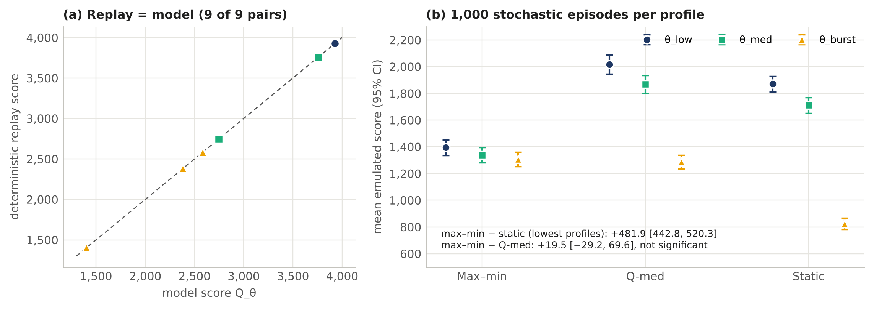
Figure 18. C4 on the running example. (a) Deterministic replay reproduces the model score in all nine schedule–profile pairs. (b) Mean emulated score over 1,000 stochastic episodes per profile with 95% confidence intervals: max–min beats the static plan on its lowest profile by +481.9 [442.8, 520.3]; its difference from Q-med (+19.5 [−29.2, 69.6]) is not statistically significant on this small instance.

7.7 Robust Heuristics, Scaling and Persona Rotation
The ten baselines optimize a burn-blind, single-profile score, so they do not show how close a heuristic can get when it targets the same objective. We therefore add two burn-aware, rule-aware heuristics that maximize min_θ Q_θ directly (Table 12). Robust greedy adds the deployment with the largest worst-case gain while every rule that additions can break holds, and is then repaired for C10a/C10b (4 changes). Robust local search climbs over rule-compliant schedules by adding, removing or replacing one deployment (4,000 moves per restart) from 11 starting points: the robust-greedy schedule and the ten repaired baselines.
Robust greedy reaches 5,821.95 (82.6% of r*), well above every burn-blind baseline, which confirms that burn awareness, not only rule compliance, drives the worst case. Robust local search reaches r* = 7,052.62 in 1 of 11 restarts; the other 10 stop between 5,262.00 and 6,744.70. Nothing in the heuristic's output distinguishes the optimal run from the others: only the certificate establishes that 7,052.62 cannot be exceeded, and the exact search returns that value and its proof in a single run. The contribution of ZSTP is therefore the certified optimum, not a score that no heuristic could ever find.
Table 12. Heuristics that optimize the worst case directly, against the certified optimum (XLarge, common evaluator; all schedules follow every hard rule).
Method | Optimizes | Worst case | % of r* | Time | Proven optimal
★ RC2 max–min (certified) | worst case, exact | 7,052.62 | 100.0% | 21.2 s | yes
Robust local search, best of 11 restarts | worst case | 7,052.62 | 100.0% | 11.9 s (all restarts) | no
Robust local search, mean of 11 | worst case | 6,039.21 | 85.6% |  | no
Robust greedy (repaired) | worst case | 5,821.95 | 82.6% | 0.7 s | no
Best burn-blind baseline (repaired: Greedy-Diverse) | θ_med, burn-blind | 3,915.24 | 55.5% |  | no
Table 13 extends the instance. Lengthening the horizon to H = 4, 5, 6, 8 keeps the exact search and its certificate tractable on two cores (every certificate verified): up to 76 s for H ≤ 6, rising to 15 minutes at H = 8, so solve time grows steeply with the horizon; r* grows with H because more slots carry credit, so values are not comparable across rows. Solve time is not monotone in H because the number of SAT calls and their difficulty vary.
The persona decomposition is exercised by giving each role two fingerprints (|F| = 8), so a role can switch identity between slots. The optimum rises from 7,052.62 to 9,082.56 (+28.8%), and persona burn at θ_high and θ_burst falls from 27.3% to 18.8% of deployments while every hard rule still holds. Decoupling the role (C5b) from the fingerprint (C12–C14) is what makes this rotation expressible.
Running example (C5a). Adding a third fingerprint fpC to DevOps_JumpHost changes no rule but raises the max–min optimum of the running example, re-solved for this enlarged setup, from 2,583 to 3,553 (+37.6%; 377 of 262,144 assignments are feasible). The new schedule does not outperform max–min; it is the max–min schedule of a setup with more identities. Under θ_burst the Mgmt hop is now covered by a live deployment in all three slots, because the identity shown there rotates fpB → fpC → fpA while the roles stay plausible; the two OT deployments are still recognized, as the path rules require. Figure 19 shows the rotation and, for C5(b), every OT coverage pattern checked against C10a, C10b and C8; C5(a) acts on the identity axis of C1 and raises the r* of C3, while C5(b) belongs to the rule layer of C2.
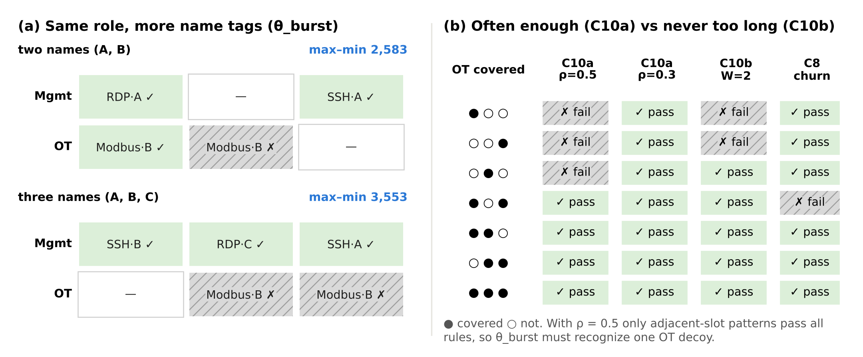
Figure 19. C5 on the running example. (a) Persona decomposition: adding a third fingerprint to the same role lets the Mgmt decoy stay live in every slot under θ_burst; the max–min optimum of this enlarged setup is 37.6% higher. (b) Minimum frequency (C10a) and maximum gap (C10b) disagree in both directions; with ρ_π = 0.5 only adjacent-slot patterns satisfy all rules, so one OT deployment is necessarily recognized. Real-world reading: rotate the name, not the role; cover a critical hop both often enough and without long gaps.
Table 13. Scaling of the exact max–min search and persona rotation (two CPU cores; one SAT solver thread).
Instance | Decisions | Variables / clauses | r* | SAT calls | Time (s) | Proof lines | Verified
H = 4, |F| = 4 | 640 | 62,518 / 33,011 | 7,052.62 | 17 | 20.8 | 75,708 | yes
H = 5, |F| = 4 | 800 | 77,874 / 43,611 | 7,738.61 | 18 | 75.5 | 128,923 | yes
H = 6, |F| = 4 | 960 | 93,108 / 53,897 | 9,071.80 | 19 | 55.4 | 148,635 | yes
H = 8, |F| = 4 | 1,280 | 123,155 / 74,476 | 9,809.98 | 20 | 919.9 | 671,793 | yes
H = 4, |F| = 8 (2 per role) | 1,280 | 111,848 / 65,119 | 9,082.56 | 19 | 122.8 | 413,425 | yes

7.8 Evidence for Each Gap
Table 14 gathers, for each gap of Table 2b, the model evidence and the L2 emulation evidence already reported in Sections 4–7, so that every novelty claim of Section 2 can be checked against a measured result. Model evidence is deterministic; emulation evidence uses common random numbers and paired bootstrap intervals.
Table 14. Evidence for each gap of Table 2b. Model evidence is deterministic and uses the common evaluator and rule checker; L2 emulation evidence uses 100 episodes per profile with common random numbers, and intervals are 95% paired-bootstrap intervals of the max–min schedule minus the compared schedule. Every value is taken from the tables and sections cited.
Gap | ZSTP element | Model evidence (deterministic) | L2 emulation evidence (paired, 95%)
G1 Recognition | Burn C9, C13 | θ_burst recognizes 27.3% of max–min deployments against 50–75% of baseline deployments (Section 4.2); persona burn 27.3% against 43.8–75.0% (Table 8). A burn-aware robust greedy reaches 82.6% of r*, the best burn-blind repaired baseline 55.5% (Table 12). FM-avg at θ_burst 1.11 against 0.25–0.59 (Table 8). | Under θ_burst the max–min emulated mean (2,282) exceeds every other schedule in Table 10 except burst-first (2,588), as produced or repaired (at most 1,966). Against all ten repaired baselines the lowest-profile difference is +352 to +942, every 95% interval above 0 (Table 11).
G2 Identity | Persona P ⊆ R̂ × F; C12, C14 | C14 is broken by 6 and C12 by 4 of the 10 baselines (Table 5); cross-zone leaks 0 against up to 6 (Table 8). Two fingerprints per role raise r* by 28.8% (7,052.62 → 9,082.56) and cut persona burn from 27.3% to 18.8% (Table 13). | The emulator does not penalize identity violations, which favours rule-breaking schedules: Greedy-Diverse as produced (C12×2, C14×3) is one of only two non-significant comparisons (+64 [−166, +265]); repaired to satisfy the identity rules (5 changes), the max–min advantage becomes +352 [+163, +553] (Tables 10, 11).
G3 Temporal planning | C8, C10a, C10b; Algorithm 1 | C10b is broken by 7, C10a by 6 and C8 by 2 of the 10 baselines (Table 5). Path persistence 100% against 25–100%, hop coverage 34.6% against 11.5–30.8%, early interception 81.2% against 25.0–68.8% (Table 8). Zero burn under all four profiles is proven infeasible (Section 4.2). After the OT bulletin, the robust re-solve has a 31.4% higher worst case than Q-med-based acceptance (Section 6.2). | The four baselines with six or more C10b violations (Random, Single-Zone, ThreatIntel-Only, Greedy-HighRho) trail the max–min schedule by +801 to +1,399 in lowest-profile emulated mean, every 95% interval above 0 (Table 10).
G4 Assurance | Max–min r*; DRAT proof | r* = 7,052.62, certified by a 75,708-line proof accepted by an independent checker; 4 of 4 proofs verified (Table 9). Objectives that do not target the worst case fall 33.1% (Q-med) and 6.3% (burst-first) below r*. Robust local search reaches r* in 1 of 11 restarts (mean 85.6%) and cannot recognize it (Table 12). Certification remains tractable up to H = 8 (919.9 s, Table 13). r* is 1.46× the best baseline as produced and 1.80× after repair. | The max–min schedule has the highest lowest-profile emulated mean (2,030) and is significantly higher than 20 of the 22 other schedules, including burst-first (+306 [+104, +379]); the difference from the Q-med schedule (+214 [−33, +333]) is not significant (Table 10).
Reading Table 14. Each gap is supported by both kinds of evidence, with two limits stated in the table. For G2, the emulator gives a broken identity rule no attacker-visible effect, so the identity evidence is conservative: the one rule-breaking baseline that the max–min schedule does not significantly beat in emulation becomes significantly worse once it is made to follow the identity rules. For G4, the emulated advantage over the Q-med schedule is not significant, because under the Bernoulli attacker the max–min schedule's weakest profile is θ_low rather than θ_high (Section 7.6); the certified worst case is a property of the model, and the emulation complements it rather than reproducing it. Table 15 isolates each gap with a per-gap ablation.
Per-gap ablations. Table 14 collects evidence that already exists in Sections 4–7; Table 15 isolates each gap. Each ablation removes one capability and re-solves with the procedure used for r* (exact max–min search, ties broken by the highest Q-med): A1 plans without recognition (no type or fingerprint burn in the model); A2 plans without identity (no C12, C14 and no fingerprint burn); A3 re-solves one slot at a time, as the 2026 placement papers re-solve per round or per alert, without the inter-slot rules C8, C10a and C10b; and A4 replaces the worst case by the expected payoff Σ_θ π_θ Q_θ, solved exactly by the same SAT search under a uniform prior and under four priors that put 0.7 on one profile (the uniform-prior optimum is confirmed by CP-SAT). With nothing removed, the ablation encoder produces exactly the 33,011 hard clauses of the main encoding, so each ablation differs from ZSTP only in the capability removed. Every resulting schedule is then judged on the full model like the baselines: rule checker, common evaluator, minimum-change repair if a rule is broken, and the L2 emulation with the same attacker episodes.
Table 15. Per-gap ablations. Each row removes the capability that closes one gap of Table 2b and re-solves; every schedule is then checked, scored and emulated on the full model exactly like the baselines. Rules broken: independent rule checker (as produced). Worst case: min_θ Q_θ on the full model, with its share of r*. Burst burn: share of deployments recognized under θ_burst. Emulation: worst-profile mean over 100 episodes per profile with common random numbers; difference = max–min schedule minus the ablation, 95% paired-bootstrap interval (10,000 replicates). All values are written to out/ablation.json by ablation.py.
Gap | Ablation | Rules broken | Worst case (% of r*) | Burst burn | Emul. worst mean | Max–min minus ablation [95% CI]
— | ZSTP max–min (full model) | none | 7,052.62 (100.0%) | 27.3% | 2,030 | —
G1 | A1 recognition-blind planner | none | 2,964.92 (42.0%) | 75.0% | 1,243 | +787 [+532, +957]
G2 | A2 identity-blind planner | C14×4 | 3,915.09 (55.5%) | 68.8% | 1,416 | +614 [+357, +790]
G2 | A2 after repair (7 changes) | none | 3,546.53 (50.3%) | 63.6% | 1,447 | +583 [+347, +766]
G3 | A3 per-slot re-solve, no inter-slot rules | C10b×3 | 3,133.91 (44.4%) | 66.7% | 1,325 | +705 [+483, +876]
G3 | A3 after repair (4 changes) | none | 3,133.91 (44.4%) | 71.4% | 1,367 | +663 [+400, +844]
G3 | A3h full horizon, no inter-slot rules (supplementary) | C10b×2, C8×3 | 7,752.55 (109.9%) | 27.3% | 2,161 | −130 [−284, −94]
G3 | A3h after repair (6 changes) | none | 4,681.42 (66.4%) | 61.5% | 1,916 | +114 [−77, +317]
G4 | A4 expected payoff, uniform prior | none | 7,052.62 (100.0%) | 27.3% | 2,022 | +8 [−47, +64]
G4 | A4 expected payoff, prior 0.7 on θ_low | none | 5,982.84 (84.8%) | 53.8% | 2,012 | +18 [−214, +210]
G4 | A4 expected payoff, prior 0.7 on θ_med | none | 4,715.04 (66.9%) | 50.0% | 1,934 | +96 [−122, +243]
G4 | A4 expected payoff, prior 0.7 on θ_high | none | 7,052.62 (100.0%) | 27.3% | 2,022 | +8 [−47, +64]
G4 | A4 expected payoff, prior 0.7 on θ_burst | none | 6,610.37 (93.7%) | 27.3% | 1,724 | +306 [+101, +379]
Reading Table 15. Removing recognition (A1), identity (A2) or multi-slot planning (A3) cuts the worst case to 42.0–55.5% of r* and lowers the emulated worst-profile mean by 583–787 points, every 95% interval above zero, as produced and after repair. A1 shows the mechanism of G1: a planner that ignores recognition deploys 16 decoys instead of 11 and repeats them, so θ_burst recognizes 75.0% of its deployments in the model and 53.7% in emulation, against 27.3% and 18.8% for ZSTP. A2 shows that identity is not cosmetic: the identity-blind plan shows a fingerprint in two zones at once 4 times (C14), and because fingerprints repeat, 68.8% of its deployments are recognized under θ_burst. A3 leaves a critical hop uncovered for too long (C10b×3; path persistence 25% against 100%). The supplementary A3h shows the other side of the inter-slot rules: with the full horizon but without C8, C10a and C10b, the schedule scores above r* (109.9%) and above ZSTP in emulation (−130 [−284, −94]) because it breaks churn and gap rules that operators impose; repaired to follow them, it falls to 66.4% of r*, and its emulated difference from ZSTP (+114 [−77, +317]) is not significant. The rules therefore cost score, and ZSTP is the best schedule that respects them.
G4 behaves differently. The expected-payoff optimum reaches r* under the uniform prior and under the prior weighted toward θ_high, the profile that binds for the max–min schedule, and its emulated difference from ZSTP is then not significant (+8 [−47, +64]). Under priors weighted toward θ_low, θ_med and θ_burst it loses 15.2%, 33.1% and 6.3% of the worst case; in emulation the loss is significant only for the θ_burst-weighted prior (+306 [+101, +379]). An expected-payoff schedule therefore matches the worst case only when the prior happens to favour the binding profile, which cannot be known without computing r*; the max–min objective needs no prior, and its certificate establishes that no rule-compliant schedule does better.

7.9 Threats to Validity
Internal validity. A certificate is only as sound as the encoding it certifies. The encoding is checked against an independently written rule checker and evaluator in both directions, against an independent CP-SAT model, against exhaustive enumeration, and its adder arithmetic is tested exhaustively (Table 9); none of these checks found a disagreement.
Construct validity. The score is a model: the technique map, attack-path steps, plausibility tables, path emphasis ω and the layer weights are documented defaults rather than measured values, and coefficients are rounded to 0.01. Under ±25% changes to path frequencies, interception values, technique weights and the L4 weight, the original max–min schedule stays within 0.19% of the re-solved optimum in 7 of 8 cases and within 10.18% in the remaining one (Section 7.4).
Baseline fairness. The heuristic baselines optimize a single, burn-blind profile and are not given every hard rule, which is how such heuristics are normally used; this favours the certified method. We therefore report every baseline both as produced and after minimum-change repair by the same solver, and the max–min schedule keeps a 1.80× worst-case advantage over the best repaired baseline. Two burn-aware, rule-aware heuristics that optimize the worst case directly are evaluated in Section 7.7. The 2026 attack-graph methods [21, 23] are not re-implemented as baselines, because their objectives (expected payoff over attacker types, path-weighted interception without recognition) differ from the worst case under burn; Section 2 states this difference, and a direct comparison is future work. The expected-payoff objective of [21, 22] is, however, evaluated as ablation A4 in Section 7.8, under a uniform prior and four skewed priors.
External validity. The main results come from one instance with four discrete attacker profiles; Section 7.7 extends the horizon and the fingerprint catalogue, but the zones, paths and technique map stay fixed. Validation is at L2: the attacker is a Bernoulli process on loopback sockets, not real attacker tooling.
Statistical validity. Emulation comparisons use common random numbers and paired bootstrap intervals over 100 episodes per profile; two of the 22 comparisons (Greedy-Diverse as produced and the RC2 Q-med schedule) are not significant at 95% and are reported as such. Model scores, the certificate and all rule checks are deterministic, and two complete runs give identical results.

8. Conclusion
Certified worst-case honeypot scheduling is achievable at the evaluated problem size. By encoding the scheduling problem — four deployment decisions evaluated over attacker profiles — as a single weighted partial MaxSAT instance, ZSTP computes an exact worst-case optimum r* = 7,052.62 for four modeled attacker profiles, with an independently verified certificate, while following every hard rule. The max–min schedule scores higher than each of ten baselines under every modeled profile, keeps burn at 0% under θ_low and θ_med and 27.3% under θ_high and θ_burst, and has the highest force multiplier of all compared methods (1.11 at θ_burst). A validation suite finds no disagreement between the encoding, the independent rule checker, the evaluator and an independent CP-SAT model, and the emulated advantage is significant against every feasible baseline. A robust local search finds the optimum only in 1 of 11 restarts and cannot recognize it, the exact search remains certified up to H = 8, and fingerprint rotation raises r* by 28.8%. Three architectural refinements — the persona decomposition P ⊆ R̂ × F, the C10a/C10b path-constraint split, and the four-pass tier-lexicographic strategy — enable this result within polynomial WCNF overhead and without modifying the underlying MaxSAT solver.
The burn result deserves emphasis. The baselines do not collapse to zero, but 50–75% of their honeypots are recognized by the burst attacker, and each break at least one hard rule. This is not a consequence of poor implementation but of optimizing without burn state or hard rules. Across greedy, LP, threat-intelligence-guided, and random methods alike, the worst case stays below the certified optimum, which implies a necessary condition for robust deployment: a schedule is only as strong as its weakest attacker profile.
ZSTP's broader contribution is to show that MaxSAT provides a principled bridge between the formal guarantees of combinatorial optimization and the operational constraints of network deception. Attack-path coverage, exact placement and multiple attacker types were already present in 2026 work [21, 23, 24]; the new element is a certified worst case under per-decoy type and identity burn, with identity and inter-slot rules enforced as hard constraints. Measured gap by gap (Table 14): closing the recognition gap cuts the burst attacker's recognition of deployments from 50–75% to 27.3%; closing the identity gap removes all cross-zone identity leaks and, with fingerprint rotation, raises r* by 28.8%; closing the temporal gap satisfies the critical-hop frequency and gap rules on every path (path persistence 100%), while 7 of 10 baselines leave a critical hop uncovered for too long; and closing the assurance gap yields a proven optimum that a robust local search finds in only 1 of 11 restarts. The per-gap ablations of Table 15 confirm that each of the first three gaps costs at least 44% of the worst case and a significant emulated loss when left open, and that an expected-payoff objective reaches r* only under priors that favour the binding profile. The hard/soft clause split fits this problem class, and the optimality certificate provides machine-checkable accountability for the encoded model. The guarantee covers the four modeled attacker profiles and the evaluated instance; it says nothing about attackers outside this set, and several instance values (attack-path steps, technique maps, plausibility tables, path emphasis) are documented defaults whose change alters the optimum. The scaling study varies the horizon and the fingerprint catalogue but keeps the network fixed; instances with more zones, paths and personas are the natural next test.
Three immediate directions extend this work. First, L3 VM-level validation with iptables-segmented zones and real attacker tooling (nmap, Metasploit) is the natural next fidelity step, testing whether the certified schedule holds under attacker behaviors that the Bernoulli model does not capture; all current results are at L2. Second, a two-objective Q-med/r* Pareto analysis would characterize the trade-off between medium-profile and worst-case performance (on the test instance the max–min schedule gives up 9.4% of Q-med for a 49.6% higher worst case). Third, distributionally robust MaxSAT over an ambiguity set on the attacker prior would replace the discrete Θ. Together, these directions build toward a deployable, certified honeypot scheduling system.

Data and Code Availability
The implementation (instance construction, encoder, solvers, CP-SAT cross-check, baselines, robust heuristics, evaluator, L2 emulator, the independent reference simulator, the scaling experiments, the per-gap ablations (ablation.py) and the validation tests), the results file, the optimality certificates (CNF and proof files) and the STIX bundles are provided as supplementary material. The main pipeline (run_all.py) produces the core results file. A single command, python3 reproduce.py, runs it together with the validation, the additional experiments, the test suite and a second, compared run, writing every number, table and figure in this paper to results files from which the manuscript's tables and values are generated (code version 32d54d7e7d96, instance hash 5cb2c5f369c5). The running example of Section 3.5 is reproduced by separate scripts (mini_ot.yaml, toy.py, scenario.py), which enumerate every schedule of that instance and recompute each number reported for it.

References
[1] E. M. Hutchins, M. J. Cloppert, and R. M. Amin, “Intelligence-driven computer network defense,” Leading Issues in Information Warfare Research, vol. 1, p. 80, 2011.
[2] MITRE Corporation, “MITRE ATT&CK Enterprise Matrix,” 2024. https://attack.mitre.org/
[3] N. Provos, “A virtual honeypot framework,” in Proc. 13th USENIX Security Symp., 2004.
[4] L. Spitzner, Honeypots: Tracking Hackers. Addison-Wesley, 2003.
[5] N. Wetzler, M. J. H. Heule, and W. A. Hunt Jr., “DRAT-trim: Efficient checking and trimming using expressive clausal proofs,” in Theory and Applications of Satisfiability Testing (SAT 2014), LNCS 8561, pp. 422–429, 2014, doi:10.1007/978-3-319-09284-3_31.
[6] N. Narodytska and F. Bacchus, “Maximum satisfiability using core-guided MaxSAT resolution,” in Proc. 28th AAAI, 2014.
[7] U. Feige, “A threshold of ln n for approximating set cover,” J. ACM, vol. 45, no. 4, pp. 634–652, 1998.
[8] C. Kiekintveld, V. Lisý, and R. Píbil, “Game-theoretic foundations for the strategic use of honeypots in network security,” in Cyber Warfare: Building the Scientific Foundation, Advances in Information Security, vol. 56, Springer, 2015, doi:10.1007/978-3-319-14039-1_5.
[9] A. Ignatiev, A. Morgado, and J. Marques-Silva, “RC2: An efficient MaxSAT solver,” J. Satisfiability, Boolean Modeling and Computation, vol. 11, no. 1, pp. 53–64, 2019, doi:10.3233/SAT190116.
[10] T. M. Chen and S. Abu-Nimeh, “Lessons from Stuxnet,” IEEE Computer, vol. 44, no. 4, pp. 91–93, 2011.
[11] J. Pawlick, E. Colbert, and Q. Zhu, “A game-theoretic taxonomy and survey of defensive deception for cybersecurity and privacy,” ACM Computing Surveys, vol. 52, no. 4, Article 82, 2019, doi:10.1145/3337772.
[12] L. Huang and Q. Zhu, “Adaptive honeypot engagement through reinforcement learning of semi-Markov decision processes,” in Decision and Game Theory for Security (GameSec 2019), LNCS 11836, pp. 196–216, 2019, doi:10.1007/978-3-030-32430-8_13.
[13] K. Hammar and R. Stadler, “Finding effective security strategies through reinforcement learning and self-play,” in Proc. 16th Int. Conf. Network and Service Management (CNSM), 2020, doi:10.23919/CNSM50824.2020.9269092.
[14] A. Ignatiev, A. Morgado, and J. Marques-Silva, “PySAT: A Python toolkit for prototyping with SAT oracles,” in Theory and Applications of Satisfiability Testing (SAT 2018), LNCS 10929, pp. 428–437, 2018, doi:10.1007/978-3-319-94144-8_26.
[15] L. Perron and F. Didier, “CP-SAT,” Google OR-Tools, version 9.15. https://developers.google.com/optimization/
[16] OASIS, “STIX Version 2.1,” OASIS Standard, 2021.
[17] N. Eén and N. Sörensson, “Translating pseudo-Boolean constraints into SAT,” J. Satisfiability, Boolean Modeling and Computation, vol. 2, pp. 1–26, 2006.
[18] S. Noel and S. Jajodia, “Optimal IDS sensor placement and alert prioritization using attack graphs,” J. Network and Systems Management, vol. 16, no. 3, pp. 259–275, 2008, doi:10.1007/s10922-008-9109-x.
[19] Q. Zhu and T. Başar, “Game-theoretic approach to feedback-driven multi-stage moving target defense,” in Decision and Game Theory for Security (GameSec 2013), LNCS 8252, Springer, 2013, doi:10.1007/978-3-319-02786-9_15.
[20] G. Wagener, R. State, T. Engel, and A. Dulaunoy, “Adaptive and self-configurable honeypots,” in Proc. 12th IFIP/IEEE Int. Symp. Integrated Network Management (IM), pp. 345–352, 2011, doi:10.1109/INM.2011.5990710.
[21] D. Park and G. G. Dagher, “Adaptive honeypot allocation in multi-attacker networks via Bayesian Stackelberg games,” Computers & Security, vol. 168, Art. no. 104949, 2026, doi:10.1016/j.cose.2026.104949.
[22] K. Voznyi, A. Kashtalian, B. Savenko, and V. Lysak, “Honeypot placement for joint detection and attacker-type inference: A Bayesian Stackelberg formulation,” in Proc. 16th Int. Conf. Advanced Computer Information Technologies (ACIT), Zlín, Czech Republic, 2026, pp. 846–851, doi:10.1109/ACIT69831.2026.11700210.
[23] R. Liu, G. Xu, and Z. Hu, “Graph neural network-guided TrapManager for critical path identification and decoy deployment,” Mathematics, vol. 14, no. 4, Art. no. 683, 2026, doi:10.3390/math14040683.
[24] J. Lacmou Zeutouo, H. S. Kenmeugne Djouko, Y. F. Yankam, A. L. Nguemkam, and V. Kengne Tchendji, “Weighted core attack graph for honeypot allocation against lateral movement in advanced persistent threats,” in Proc. 3rd Int. Conf. Artificial Intelligence and Smart Applications (AISA’25), Vol. 2, Lecture Notes in Networks and Systems, vol. 1851, Springer, Cham, 2026, pp. 49–58, doi:10.1007/978-3-032-18860-1_5.
[25] M. Zhang, Y. Yu, S. Li, Y. Liu, Y. Zhang, R. Zhang, and S. Shao, “Adaptive software-defined honeypot strategy using Stackelberg game and deep reinforcement learning with DPU acceleration,” Modelling, vol. 7, no. 1, Art. no. 23, 2026, doi:10.3390/modelling7010023.

