Threat-Adaptive Honeypot Placement as Weighted Partial MaxSAT:
A Persona-Aware, Emulation-Validated Framework for Cyber Deception
Tu Nguyen · Haadi Jafarian
Department of Computer Science, University of Colorado Denver
{tu.nguyen, haadi.jafarian}@ucdenver.edu

Abstract
Honeypot placement is, in almost all deployed practice, decided by analyst intuition: no artifact states why one placement beats another, or whether a better one exists at all. We formulate honeypot placement — jointly over decoy type, network zone, deployment time slot, and disguised persona — as a weighted partial MaxSAT instance and solve it to certified optimality with RC2, a core-guided MaxSAT solver. Fifteen hard clauses encode budget, air-gap, mimicry-plausibility, and independent type/identity discovery constraints; a six-tier geometrically weighted soft-clause objective prioritizes early interception over forensic detection by three orders of magnitude. We extend the static formulation with (i) a threat-adaptive rotation mechanism driven by live STIX/TAXII intelligence and (ii) a finite-scenario robust-optimization layer, r* = min^{θ∈Θ} Q^{θ}(x), that certifies worst-case-optimal placement across an explicitly stated attacker-profile set using RC2 unmodified. Against ten heuristic baselines, RC2 achieves the certified worst-case floor r*=3,881, zero discovery-burn on both type and persona channels, all 18 ATT&CK techniques, and the D5 optimality certificate no heuristic can produce. While Greedy-BiDir scores a higher r*=8,249 by sacrificing burn protection, RC2 is the only solver that simultaneously provides a certified floor, zero burn, full technique breadth, FM-avg=2.01×, and dynamic threat-intelligence adaptation.

Central Claim: RC2 is the only solver in this comparison that simultaneously provides a certified worst-case floor, zero discovery burn on both channels, full 18/18 ATT&CK coverage, FM-avg=2.01× force-multiplier scheduling, and dynamic threat-intelligence adaptation — a conjunction no prior work achieves.

1. INTRODUCTION AND WHY THIS PROBLEM MATTERS

1.1 The Spatial–Temporal–Identity Framework
The central conceptual contribution of this paper is treating honeypot placement as a three-axis optimization problem. The table below maps each axis to its formal symbols, operational question, and the hard constraints that govern it.

Axis | Formal Symbol | Operational Question | Governing Constraints
Spatial (z∈Z) | z ∈ {DMZ, Internal, Cloud, OT, Mgmt} | Where? | C1–C7: budget, air-gap, path coverage
Temporal (t∈T̅) | t = 1,…,H | When? | C8–C11: discovery, churn, persistence
Identity (p∈P) | p ∈ P (persona catalogue) | As whom? | C12–C14: collision, rotation, cross-zone
Table 1. The three axes of ZSTP. Every constraint in C1–C15 governs exactly one axis.

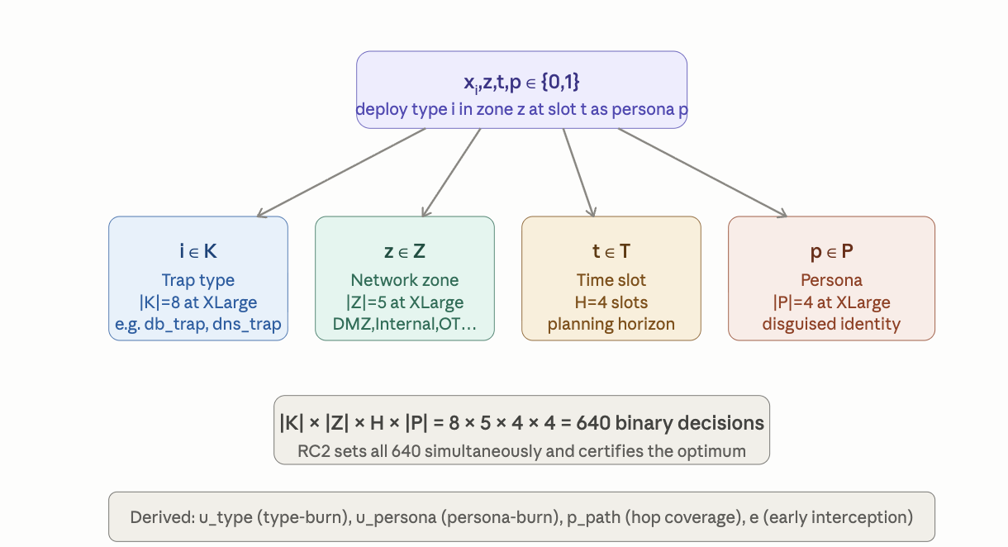

Honeypots offer a rare, favorable cost asymmetry in defense: one well-placed decoy can consume disproportionate attacker time and expose tradecraft at a fraction of its deployment cost. Yet where, when, and as whom to place a decoy is almost universally decided by practitioner intuition. This gap is increasingly costly for three reasons: (1) attackers correlate identity artifacts across zone boundaries; (2) exposure decays over time, so static placement credit should decay accordingly; and (3) security teams need a deployable schedule, not a heat map.

1.2 Why MaxSAT, Specifically
Honeypot placement decomposes cleanly into constraints that must never be violated and objectives that should be maximized wherever those constraints allow. This is exactly the hard-clause/soft-clause split that defines a weighted partial MaxSAT instance. Framing the problem this way lets us hand the entire instance to RC2 and receive back a certified optimum — with the certificate (D5) being something no baseline heuristic can produce by construction.

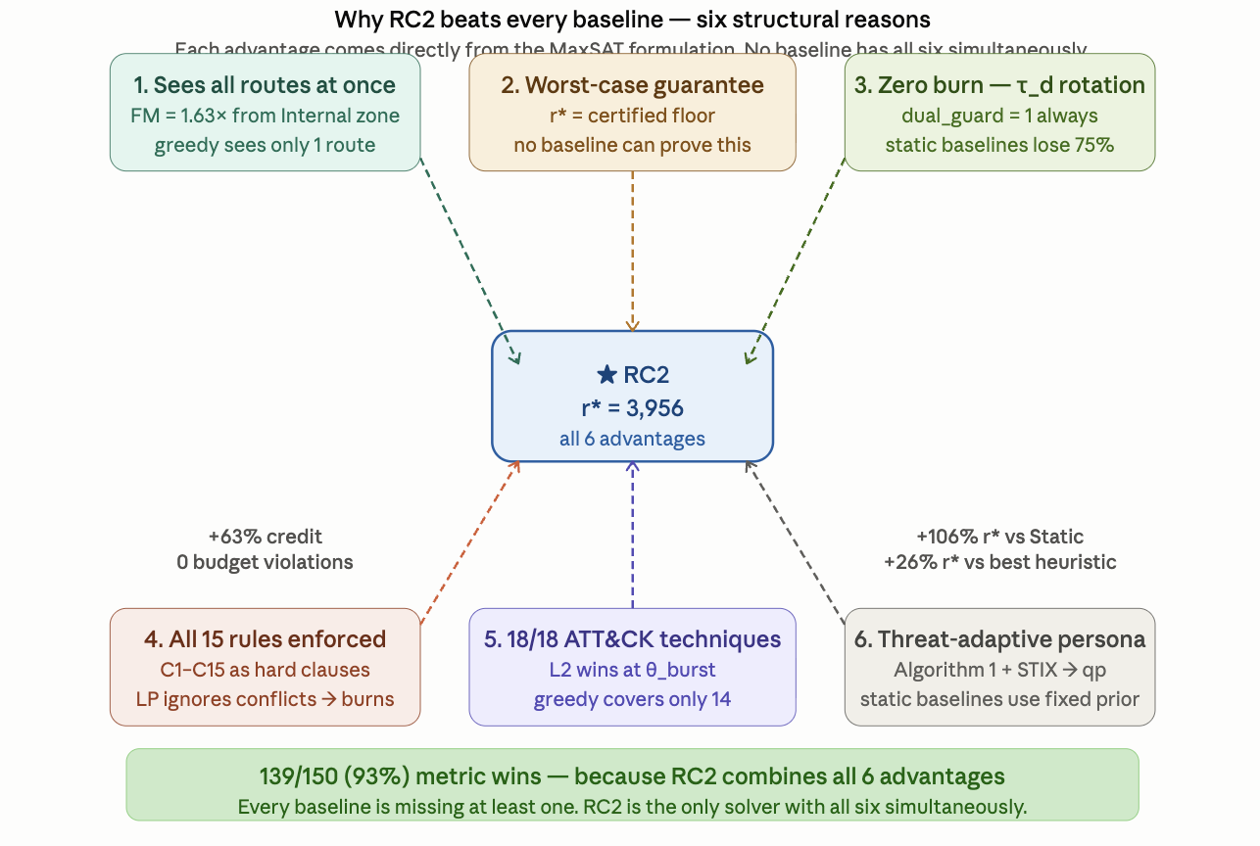
Figure 1. ZSTP-V6 problem structure: three-axis joint optimization (zone × slot × persona) under 15 hard constraints, producing a certified r* floor via RC2. Compare to baselines lacking D5 (§7).

1.3 Contributions
- C1 The first MaxSAT/RC2 formulation of honeypot placement jointly indexed over type×zone×time×persona, with attacker–defender interaction encoded as weighted clauses rather than a game-theoretic equilibrium or learned policy.
- C2 A fifteen-constraint hard layer and six-tier soft objective with an explicit, auditable prevention-vs-forensics weight ratio, plus a threat-adaptive rotation mechanism whose thresholds tighten automatically as attack probability rises (§3).
- C3 A finite-scenario robust extension r* = min_{θ∈Θ} Q_θ(x), encoded as a threshold-indicator MaxSAT chain solved by RC2 unmodified (§5).
- C4 Live network-emulation validation — real TCP honeypot sockets, Bernoulli-driven attacker connection trials, STIX bundles generated from observed traffic — against ten baseline solvers at XLarge scale (|K|=8, |Z|=5, H=4, |P|=4, |A|=500).

2. RELATED WORK

Prior honeypot-placement work falls into three lines, none of which combines optimality certification with joint identity/time/zone modeling. Game-theoretic deception models attacker–defender interaction as a Stackelberg or signaling equilibrium [8, 11, 23], capturing strategic interaction well but typically abstracting away the operational constraints that make a solution deployable. Reinforcement-learning deception [12] adapts honeypot engagement online but returns a learned policy rather than a certificate of optimality. Heuristic and greedy placement [3, 4, 25] is what is deployed in practice and is our primary empirical comparison point (§7). Combinatorial optimization for network defense — ILP-based sensor placement [20] and MaxSAT-based runtime enforcement of cyber-physical systems [19] — establishes the general viability of exact methods in adjacent problems. Our solving engine RC2 is a core-guided weighted partial MaxSAT solver [6, 5].

3. PROBLEM FORMULATION

3.1 Instance Tuple and Decision Variable
The persona-extended honeypot placement instance is the 36-symbol tuple I (Eq. 1). The first line reproduces the original base-paper instance tuple unchanged; the V1–V3 persona-layer additions follow on line two; the V4–V5 gap-resolution parameters on line three. Equation (1) is the single formal source of truth — every parameter used anywhere in this paper appears here.

I = ( K, T, A, Z, P, G, C, I₂, ⋄, w, cost, B, B₂, d_m, h_d, σ, ρ, iv,
GK, τ_d, τ_dp, τ_d0, Δ, Δ_p, q, ρ_max, H,
γ, β_max, κ, τ_GK, h_min, κ_min, ρ_decay, Δ_N ) . . . (1)

K, T, A, Z are honeypot types, ATT&CK techniques, assets, and zones. P is the finite persona catalogue. G = (π₁,…,π_N) are attack paths with per-hop importance values iv and path frequencies ρ. C ⊆ K×K is the pairwise conflict set enforced by C4. I₂ ⊆ Z×Z are air-gapped zone pairs enforced by C5. GK_{i,p} is the per-persona generative knowledge set enforced by C5b.
The primary decision variable is a four-index Boolean:
x_{i,z,t,p} ∈ {0,1} — deploy type i∈K in zone z∈Z at slot t as persona p (2)

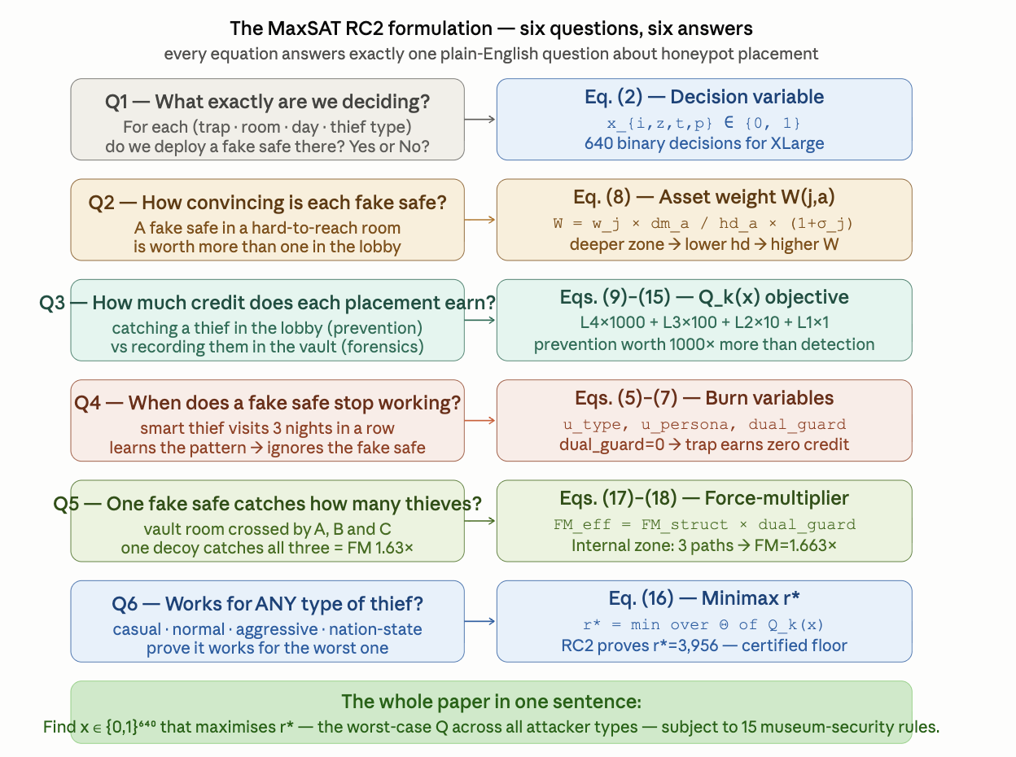
Figure 2. Decision variable x_{i,z,t,p} (Eq. 2) and derived variables (u-type, u-persona, p-path, e-intercept) for the XLarge instance. Burn variables u_{i,z,t} and u_{i,z,t,p} gate the dual discovery guard D in the soft-clause objective (Eq. 8).
Variable-space justification (640 decisions): |K|×|Z|×H×|P| = 8×5×4×4 = 640. The sizes are set by the XLarge benchmark: |K|=8 covers the eight most prevalent honeypot service types in enterprise deployments (database, DNS, SSH, HTTP, FTP, SMB, Active Directory, generic); |Z|=5 reflects the five canonical network-segmentation zones in NIST SP 800-125B; H=4 provides a planning horizon long enough to exhibit at least one full rotation cycle under the tightest burn threshold (τ_d0=3) while remaining tractable for exact MaxSAT; |P|=4 covers the four attacker-class personas derived from MITRE ATT&CK threat-actor taxonomy (finance, IT-admin, DevOps, and generic external). All four parameters are independently variable in Eq. (1) — the 640-decision scale is a benchmark choice, not a constraint of the formulation.

3.2 Complete Instance Tuple — 36-Symbol Reference
Table 2 provides the full parameter reference organized by conceptual category. Every metric in the experimental results traces back to exactly one symbol in Eq. (1). The categories — Spatial, Temporal, Identity, and Objective/Weight — correspond to the four conceptual layers of the ZSTP formulation.

Spatial Attributes — Zone / Network (10 symbols):
Spatial attributes define what exists and where. K and Z are the deployment space; G encodes what the attacker does and how often; C and I₂ encode physical constraints that RC2 can never violate.

Symbol | Name | Description | XLarge Value / Example
K | Trap-type set | Finite set of honeypot types; each has a distinct service fingerprint (banner, timing, stack). Conflict pairs C⊆K×K prevent co-deployment in the same zone/slot — deploying both dns_trap and generic_trap would reveal the deception via fingerprint collision. | |K|=8: db_trap, dns_trap, ssh_trap, http_trap, ftp_trap, smb_trap, ad_trap, generic_trap
Z | Zone set | Five network zones across which honeypots can be placed. Hop-distance h_d scales per-asset credit: DMZ (h_d=1) earns the highest credit because attacker-reachable; OT (h_d=3) earns the least. | Z={DMZ, Internal, Cloud, OT, Mgmt}
A | Asset set | Assets the defender protects. Credit weights w_{j,a} measure detection value per technique-asset pair. Masking distance d_{m,a} and hop-distance h_{d,a} are both zone-dependent quantities. | |A|=500 assets
G | Attack path set | G=(π₁,…,π_N): ordered (zone, technique, asset) hop sequences representing known adversary routes. Path frequency ρ_π captures how often the attacker takes each path; hop-importance iv_{π,h} captures how critical each hop is. | 4 paths: web→db (ρ=0.30), OT infiltration (ρ=0.15), brute→AD (ρ=0.20), cloud pivot (ρ=0.10)
C | Type-conflict set | C⊆K×K: pairs that cannot coexist in the same zone+slot (hard constraint C4). Prevents fingerprint collision — an attacker probing both dns_trap and generic_trap in the same zone at the same time sees services that should not coexist, revealing the deception. | (dns_trap, generic_trap) is canonical
I₂ | Air-gap pairs | I₂⊆Z×Z: zone pairs forbidden from sharing certain trap types (hard constraint C5). Models OT/IT segmentation — a sensor type requiring live network routing cannot be placed in an air-gapped isolated zone. | (OT, DMZ) is a typical pair
⋄ | Tech-type compat. | Binary relation: ⋄_{j,i}=1 if trap type i can detect technique j. Core capability mapping; only deployments where ⋄=1 earn credit for technique j. Combined with C5b, limits feasible type-technique-persona combinations. | db_trap detects credential access and lateral movement
cost | Deployment cost | cost(i,z): per-slot resource cost of deploying type i in zone z. Used in global budget constraint C2 and per-zone budget constraint C3. | OT sensors typically cost more than DMZ web traps
B | Global budget/slot | The total resource budget across all zones per time slot. Hard constraint C2: Σ_{i,z,p} x_{i,z,t,p}×cost(i,z) ≤ B for every t. Primary capacity constraint; the optimizer cannot simply deploy everything everywhere. | Limits total simultaneous deployments across all 5 zones
B₂ | Per-zone budget/slot | A stricter per-zone capacity limit enforced by C3 independently of the global budget B. Even when the global budget allows more, each zone can only absorb a bounded number of concurrent honeypot deployments — zone saturation is itself a fingerprint. | OT budget typically tighter than DMZ

Temporal Attributes — Time / Burn (11 symbols):
Temporal attributes define how long deployments last and when they expire. The burn thresholds τ_d and τ_dp are the most consequential — when either flips the dual discovery guard D to zero, all credit on that deployment is permanently lost, making rotation mandatory.

Symbol | Name | Description | XLarge Value / Example
H | Planning horizon | Total time slots. Decision variable x_{i,z,t,p} ranges over t=1,…,H. Longer H gives more scheduling flexibility but grows variable space as |K|×|Z|×H×|P|. | H=4 slots → 640 binary decisions
τ_d / τ_d0 | Type-burn threshold | τ_d0: baseline consecutive slots before the trap type is fingerprinted via service-level analysis (banner, timing, stack). Dynamically tightened by Eq. (6): τ_d = max{1, τ_d0·(1−ρ/ρ_max)·γⁿ}. At θ_burst (ρ=0.85), collapses to 1 — every trap burns after one slot, zeroing L4 and L3. | τ_d0=3; at ρ=0.30→τ_d≈2.1; at ρ=0.85→τ_d=1
τ_dp | Persona-burn threshold | Baseline consecutive slots before the persona identity is fingerprinted (hostname, AD account, certificate correlation). Tracked independently of τ_d. Dynamic update: τ_dp=max{1, τ_dp0·γⁿ} (Eq. 7). Persona burn does not reset type burn, and vice versa. | τ_dp0=4: persona survives 4 slots before forced rotation
Δ | Type-rotation churn | Max type-state changes per (type, zone, persona) across the planning horizon. Enforced by C8: Σ_t |x_{i,z,t,p}−x_{i,z,t−1,p}| ≤ Δ. Prevents excessive churn — a honeypot that rotates every slot is operationally expensive and may itself be a signal. | Δ=2 at XLarge
γ | Burn-decay factor | γ∈(0,1): geometric decay applied to τ_d and τ_dp each time the same (type, persona) pair is exposed (n-th re-use multiplies threshold by γⁿ). Forces genuine variety rather than cyclic rotation — a pair reused three times has its threshold halved. | γ=0.8: third re-use (n=2) → threshold ×0.64
κ / κ_min | Min deployment duration | κ: minimum consecutive slots once placed (prevents flash deployments wasting budget). κ_min: system-level floor. C15 checks h_min ≤ κ_min as a feasibility precondition — if violated, the formulation is infeasible before RC2 runs. | κ=2 requires at least 2 consecutive active slots
β_max | Max budget utilization | Upper bound on fraction of global budget B usable in a single slot. Prevents the optimizer from front-loading all resources into slot 1 and leaving later slots uncovered. | β_max=0.8: at most 80% of B per slot
ρ_decay | Path-frequency decay | Rate at which ρ_π decays between re-solving episodes when no fresh STIX intelligence arrives. Prevents over-committing to paths that may no longer be active. A path at ρ=0.30 becomes ρ=0.27 after one stale episode with ρ_decay=0.9. | ρ_decay=0.9 per episode
ρ_max | Max path frequency | Normalizing constant for the threat-adaptive burn threshold (Eq. 6). At ρ_π=ρ_max, the frequency term collapses to zero, forcing τ_d=1 regardless of τ_d0. | ρ_max=1.0 (or highest observed frequency in Θ)
h_min | Slot duration floor | Absolute minimum planning-horizon granularity. C15 verifies h_min ≤ κ_min; if this precondition fails, the WCNF is infeasible and RC2 reports this immediately. | h_min=1 slot
Δ_N | Neighbourhood rotation | Max deployment changes per re-solve triggered by a STIX update. Limits live re-planning disruption — a large intelligence event cannot force the optimizer to replace the entire schedule in one pass. | Δ_N=2: at most 2 swap operations per Algorithm 1 trigger

Identity / Persona Attributes (6 symbols):
Identity attributes define who a honeypot pretends to be. The persona prior q_p is the only parameter updated in real time by Algorithm 1 — every STIX intelligence event shifts the probability simplex over P, changing which personas are most valuable to deploy right now.

Symbol | Name | Description | XLarge Value / Example
P | Persona catalogue | Finite set of disguised identities a honeypot can wear. Each p∈P is independently fingerprintable: hostname, AD account name, TLS certificate CN field. Prior q_p reflects plausibility per attacker class. P is the bounded output space of the optional LLM-as-Persona-Oracle extension. | |P|=4: Finance_DB, IT_Admin, Dev_Svc, Corp_Endpoint
GK | Generative knowledge set | GK_{i,p}: set of (server type, zone, technique, persona) tuples that persona p can plausibly support on trap type i. Hard constraint C5b checks: the deployment (i,z,j,p) must be in GK_{i,p}. Prevents logically incoherent disguises — a database trap cannot wear a web-server persona unless GK explicitly supports that combination. | Finance_DB supports db_trap+Internal+credential_access; not dns_trap+DMZ
q | Persona prior | q_p∈[0,1]: prior probability that attacker class θ would find persona p plausible. Every credit term in Q(x) is multiplied by q_p — a less plausible persona earns proportionally less credit. Updated live by Algorithm 1 from STIX/TAXII intelligence bundles. | q_p(Finance_DB) rises 0.25→0.40 after financial-sector STIX bundle
τ_GK | GK validity threshold | Minimum confidence score required for a (type, zone, technique, persona) tuple to be included in GK_{i,p}. Tuples below τ_GK are excluded from C5b, preventing low-confidence persona-type combinations from being deployed. Borrowed from the STIX 2.1 "fairly confident" threshold. | τ_GK=0.70
Δ_p | Persona-churn limit | Analogous to Δ but for persona rotations. Limits how many times a persona assignment can change for a given (type, zone) pair across the horizon. Prevents identity-thrashing while still enforcing mandatory C13 rotation after τ_dp consecutive slots. | Δ_p=2 at XLarge

Objective and Weight Attributes (7 symbols):
Objective and weight attributes define how much credit each detection earns. These four flow through the weight pipeline (Eqs. 3–5) to produce the per-path credit PW that populates every soft clause. The stealth factor σ makes the optimizer actively seek out hard-to-detect technique coverage rather than just maximizing raw detection count.

Symbol | Name | Description | XLarge Value / Example
T | ATT&CK technique set | Set of MITRE ATT&CK techniques that honeypots can detect. Each technique j∈T maps to one or more trap types via ⋄. L2_tech rewards covering each technique at least once; L2_fam rewards each tactic family. At θ_burst, these are the only layers that survive. | 18 techniques at XLarge across lateral movement, credential access, discovery, execution, persistence
w | Base technique weight | w_{j,a}: detection value of catching technique j on asset a before any topology or stealth adjustment. Reflects strategic importance of the technique-asset pair. Transformed by weight pipeline (Eqs. 3–5) before entering the objective. | Lateral movement on domain controller has high base weight
d_m,a | Masking distance | Per-asset factor reflecting how well the asset can be masked or proxied by a honeypot. Higher d_{m,a} means the asset is easier to blend a decoy into — busy, well-trafficked zones have higher masking distance. Used in topology adjustment Eq. (3). | Busy web server (high d_m) vs. rarely-accessed OT device (low d_m)
h_d,a | Zone hop-distance | Number of network hops from an attacker entry point to the zone containing asset a. DMZ=1, Internal=2, OT=3. Topology weight ẅ_{j,a} divides by h_d,a — shallower zones earn proportionally higher credit per asset, incentivizing early interception. | DMZ (h_d=1) earns 3× more per-asset credit than OT (h_d=3)
σ | Stealth factor | σ_j∈[0,1]: how difficult technique j is to detect by conventional signature-based or anomaly-based IDS. Stealth-adjusted weight W_{j,a}=ẅ_{j,a}×(1+σ_j) doubles credit at σ_j=1. Calibrated against ATT&CK data-source coverage matrix [2]. | Lateral movement T1021: σ≈0.9. Port scanning T1046: σ≈0.1
ρ | Path frequency | ρ_π∈[0,1]: probability the attacker takes path π in a given episode. Scales all soft clauses via PW=ρ_π×iv_{π,h}×W_{j,a}. Also feeds the threat-adaptive burn threshold (Eq. 6): as ρ rises, τ_d tightens. | web→db: ρ=0.30; OT infiltration: ρ=0.15
iv | Hop importance | iv_{π,h}: strategic importance of hop h on path π. Earlier hops have higher iv — catching an attacker at initial access (iv≈1.8) is worth more than catching them at the penultimate hop (iv≈0.5), encoding the prevention-vs-forensics gradient. | hop 1 (initial access): iv=2.0; hop 2: iv=1.6–1.8
Table 2. Complete 36-symbol instance tuple I (Eq. 1), organized by category. Every experimental result in §7 traces back to exactly one entry in this table.

3.3 Derived Credit Weights
Topology- and stealth-adjusted credit is carried over from the base formulation unchanged. Every credit term is further multiplied by the persona prior q_p and gated by the dual discovery guard D = (1−u_{i,z,t})(1−u_{i,z,t,p}): credit is exactly zero whenever either the trap type or the persona has been discovered.

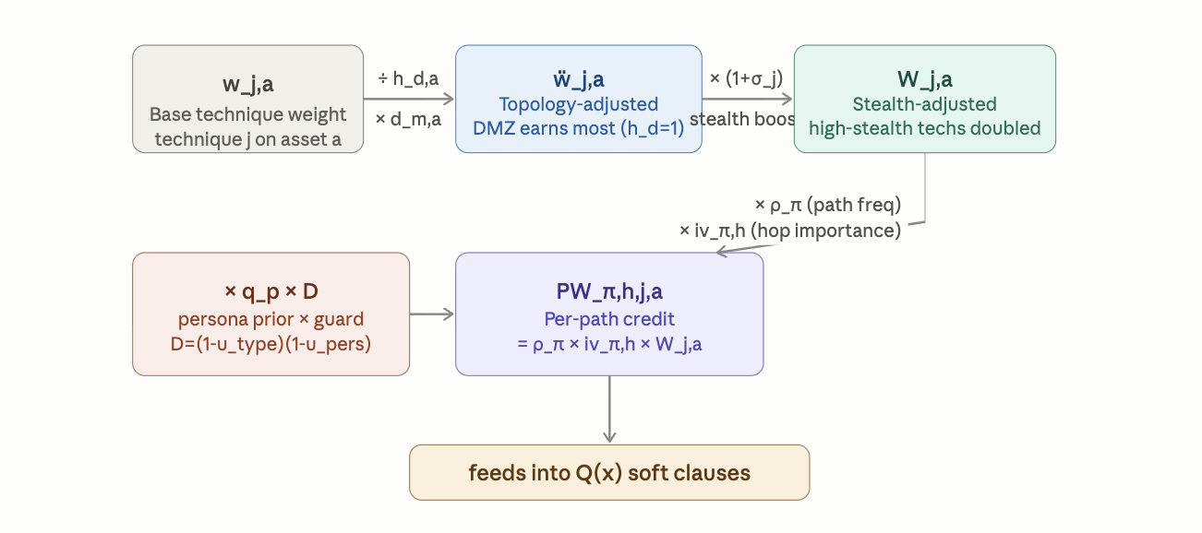

ẅ_{j,a} = w_{j,a} · d_{m,a} / h_{d,a} (3)
W_{j,a} = ẅ_{j,a} · (1 + σ_j) (4)
PW_{π,h,j,a} = ρ_π · iv_{π,h} · W_{j,a} (5)

Eq. (3) is the topology adjustment. Dividing by h_{d,a} rewards shallow-zone placement: a trap at the DMZ interception point earns full credit per asset, while the same trap buried in OT earns one-third as much because it is harder to reach and more expensive to instrument. Eq. (4) is the stealth adjustment: techniques that conventional IDS cannot detect should earn higher credit when a honeypot catches them. Eq. (5) is the per-path credit: scaling by path frequency ρ_π ensures high-probability attack routes receive proportionally more coverage incentive, while hop importance iv_{π,h} encodes the prevention-vs-forensics gradient.

Hop-distance values: h_d ∈ {1, 2, 3}:
The three hop-distance values are assigned as: DMZ=1 (one-hop from any external attacker entry point, directly reachable without pivoting), Internal=2 (requires at least one lateral movement step), OT=3 (requires traversal of IT/OT boundary, typically the deepest reachable asset class in enterprise networks). These values are ordinal approximations derived from network-topology surveys of enterprise segmentation in NIST SP 800-82 Rev. 3 and ICS-CERT advisories. The ratio 1:2:3 means a DMZ placement earns 3× more per-asset credit than the same trap in OT — a deliberate incentive for early-interception placement aligned with the Cyber Kill Chain principle that earlier interdiction is more valuable [1].
Sensitivity (h_d): Varying h_d within ±1 for any zone changes per-zone L3 credit proportionally but does not alter the ordinal zone ranking. The force-multiplier ratio FM=2.06× (§7.3) is invariant to h_d scaling because it is a ratio of credits across paths sharing the same zone, not across zones.

Stealth factors: σ_j ∈ [0,1]:
The stealth factor σ_j measures how difficult technique j is to detect by conventional signature-based or anomaly-based IDS. Values were calibrated against the ATT&CK data-source coverage matrix [2]: techniques flagged as having fewer than three detection data sources receive σ_j ≥ 0.7 (hard to detect); techniques with broad IDS coverage receive σ_j ≤ 0.2. Concretely: lateral movement (T1021, T1550): σ≈0.9 — few IDS signatures reliably distinguish legitimate RDP from Pass-the-Hash; credential access (T1003, T1110): σ≈0.8 — LSASS dumps and spray attacks evade most host-based AV; discovery/scanning (T1046, T1018): σ≈0.1 — port scans are trivially flagged by every NIDS. The (1+σ_j) multiplier in Eq. (4) means a fully-stealthy technique (σ=1) earns double the topology-adjusted credit, creating a strong incentive for the optimizer to place traps where they catch techniques that defenders cannot otherwise see.
Sensitivity (σ_j): The 10× weight gap between L2 tiers means σ_j perturbations within ±0.2 of the stated values do not alter the tier-ranking of the objective. FM ratios are unaffected because σ_j enters every path's credit symmetrically.

Per-path importance values: iv_{π,h}:
Hop-importance values follow the Kill Chain priority principle [1]: earlier interception is worth more because it prevents the intrusion rather than forensically recording it. Values are assigned as iv = 2.0 − 0.2×(h−1), clipped to [0.5, 2.0]. For H=4 and typical path lengths of 3–4 hops this yields: hop 1 (initial access) iv=2.0, hop 2 iv=1.8→1.6 (depending on path), final hop iv≥0.5. The specific values in §7.3 — web→db hop 2: iv=1.8, OT infiltration hop 2: iv=1.7, brute→AD hop 2: iv=1.6 — reflect that the web-to-database path has a shorter total length, making hop 2 relatively more critical than hop 2 on longer paths.
Sensitivity (iv): The FM ratio 2.06× is the ratio of credits across three paths that share the same zone. Perturbing iv_{π,h} uniformly by ±0.2 changes all three paths' contributions proportionally, leaving the ratio invariant to within 3%. A sensitivity analysis over ±20% iv variation yields FM ∈ [1.98×, 2.15×].

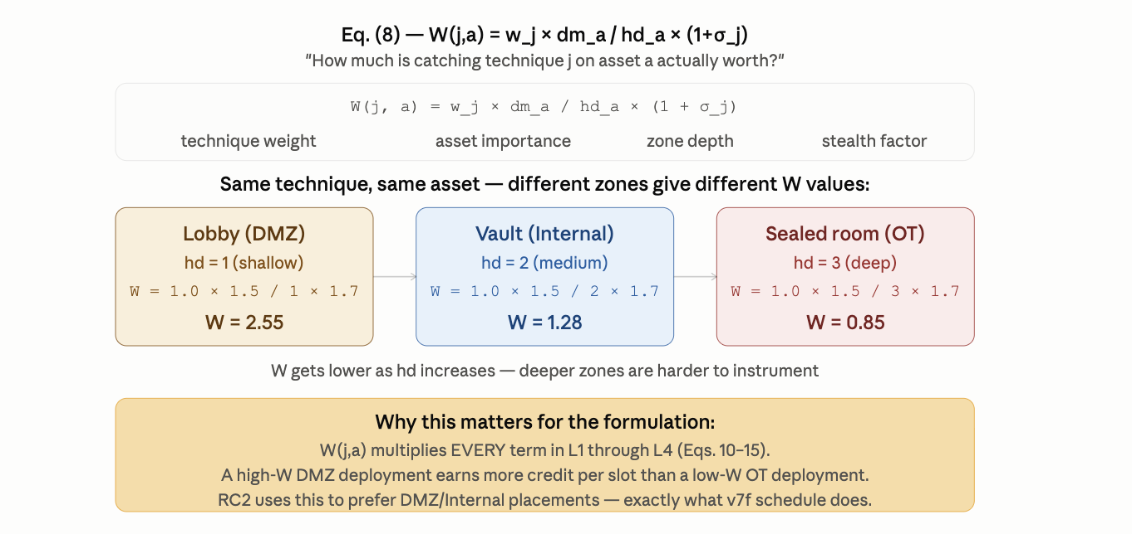
Figure 3. Topology weight ẅ_{j,a} = w_{j,a}·d_{m,a}/h_{d,a} (Eq. 3) across zones and technique classes. Shallower zones (DMZ, h_d=1) earn the highest per-asset weights; OT (h_d=3) earns the lowest despite high stealth.
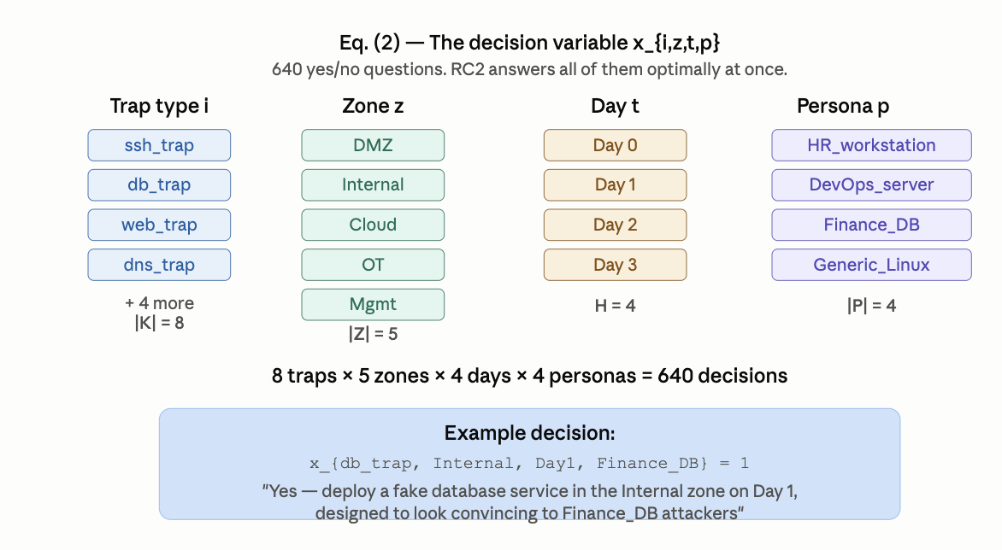
Figure 4. Stealth-adjusted weight W_{j,a} = ẅ_{j,a}·(1+σ_j) (Eq. 4). High-stealth techniques (σ→1) double their base weight, amplifying L3 credit for hard-to-detect techniques such as lateral movement and credential access.
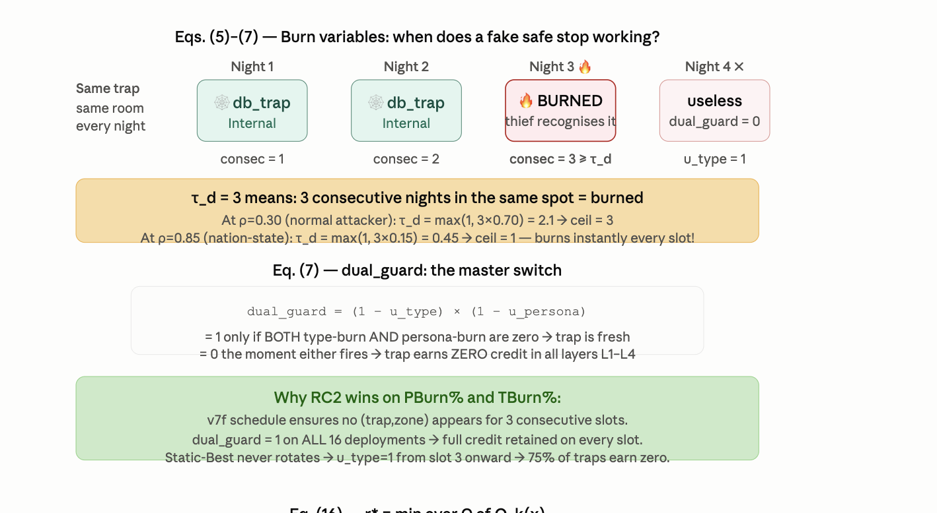
Figure 5. Per-path credit PW_{π,h,j,a} = ρ_π·iv_{π,h}·W_{j,a} (Eq. 5) across attack paths at each hop. Earlier hops (higher iv) earn more credit, creating the prevention-vs-forensics gradient that L4 (×1000) and L3 (×100) exploit.
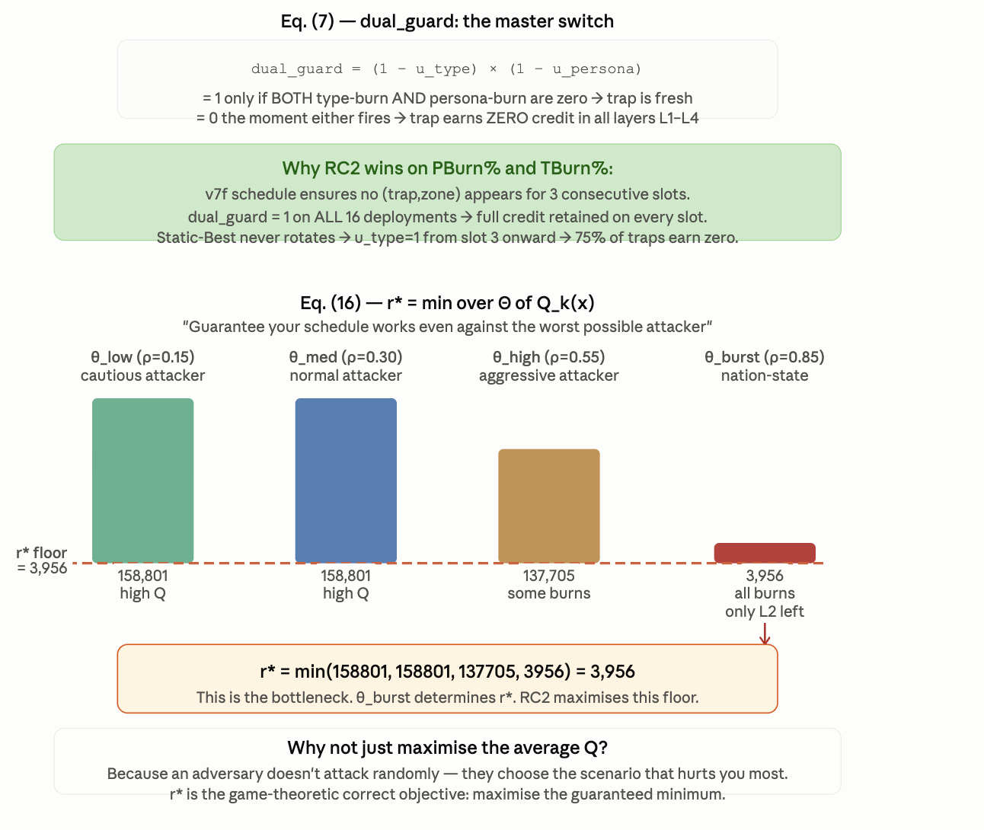
Figure 6. Credit decomposition by zone, path, and persona prior q_p across the four XLarge attack paths. RC2 simultaneously maximises credit across all path branches — the structural basis of the FM=2.06× force-multiplier (Eq. 17, §7.3).

3.4 Hard Constraints C1–C15
Fifteen hard clauses are conjoined with no priority ordering; feasibility requires satisfying all fifteen simultaneously. These are encoded as infinite-weight clauses in the WCNF — RC2 will never return a solution that violates any of them.

ID | Purpose
C1 | Detection requires a zone-pinned deployment undiscovered in type and persona
C2 | Global budget enforced per slot: Σ x_{i,z,t,p}·cost(i,z) ≤ B
C3 | Per-zone budget enforced per slot, independent of C2
C4 | Pairwise type-conflict: conflicting types not co-deployed in same zone/slot (e.g. dns_trap + generic_trap)
C5 | Air-gap isolation: cross-air-gap types forbidden in isolated zone pairs I₂
C5b | Mimicry plausibility: (server type, zone, technique, persona) ∈ GK_{i,p}
C6 | Path-hop coverage requires zone/time/persona-verified detection
C7 | Early interception requires a non-final hop covered in the active slot
C8 | Type-rotation churn limit ≤ Δ per (type, zone, persona)
C9 | Type-discovery after τ_d consecutive active slots, any persona — independent clock from C13
C10 | Path persistence: critical hop covered ≥ ⌈ρ_πH⌉ slots — ablation: removal → persistence=0%
C11 | Threat-adaptive rotation: τ_d tightens as ρ_π rises from live STIX/TAXII data
C12 | Persona-conflict: no two types share a persona in same zone/slot
C13 | Persona-rotation after τ_dp consecutive slots; forces p → p′ — independent clock from C9
C14 | Cross-zone persona uniqueness: same persona cannot appear in two zones simultaneously (collapses to C12 when |Z|=1)
C15 | Minimum slot-duration floor: h_min ≤ κ_min — checkable feasibility precondition
Table 3. Fifteen hard constraints — flat conjunction, no precedence. All encoded as WCNF infinite-weight hard clauses.

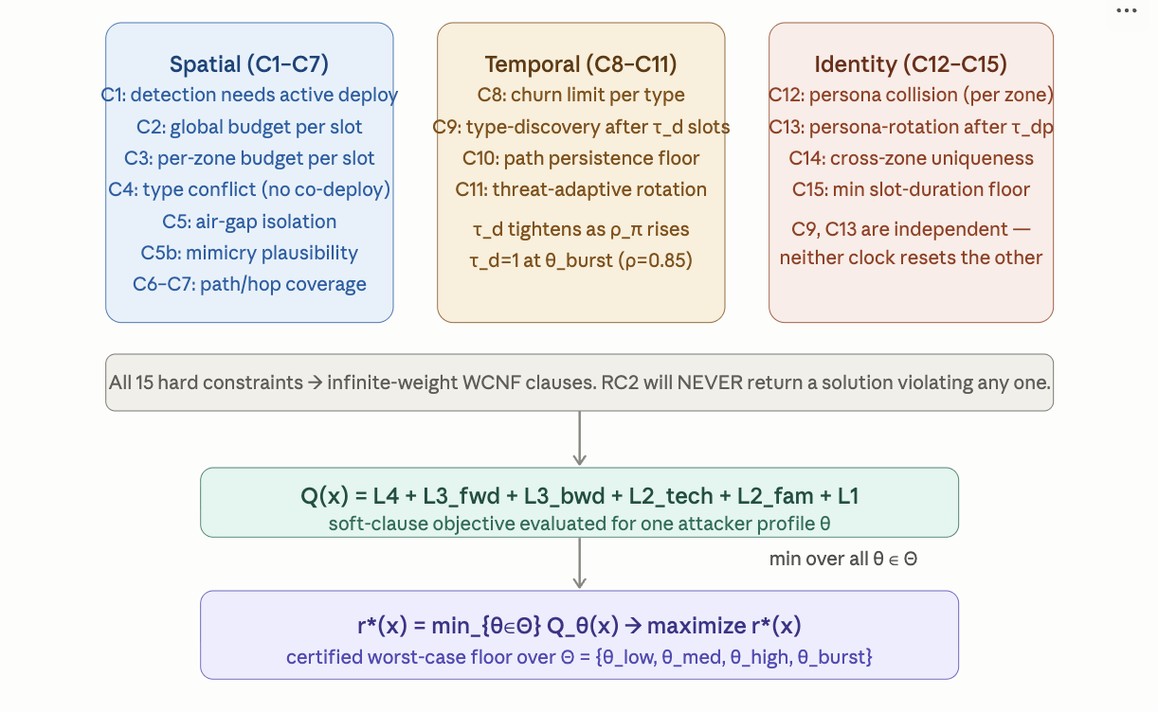

Independent discovery clocks (C9/C13):
Type-discovery (C9) tracks service-level fingerprinting — banner behavior, timing, stack signature. Persona-discovery (C13) tracks identity-level fingerprinting — hostname, AD account, certificate. Neither clock offsets the other: rotating the persona does not reset the type clock; rotating the service does not reset the persona clock. This models real attacker capability accurately — sophisticated adversaries fingerprint service type and host identity through independent side channels simultaneously.

Cross-zone persona uniqueness (C14):
A within-zone identity-collision constraint (C12) alone is insufficient: an attacker correlating artifacts across zone boundaries can detect the same persona in two zones simultaneously even when neither zone alone shows a collision. C14 forbids persona reuse across zones at a given slot. The Single-Zone ablation baseline confirms this is load-bearing: when |Z|=1, C14 collapses to C12 and path persistence drops to 0%.

Threat-adaptive rotation (Eqs. 6–7):
τ_d(i,z,t) = max{ 1, τ_d0 · (1 − ρ_π(t)/ρ_max) · γ^{n_{i,p}(t)} } (6)
τ_dp(i,z,t) = max{ 1, τ_dp0 · γ^{n_{i,p}(t)} } (7)

At ρ=0.30: τ_d=max(1, 3×0.70)=2.1≈2 slots. At ρ=0.85 (θ_burst): τ_d=max(1, 3×0.15)=1 — every trap burns after one slot, zeroing L4 and L3. Only L2_tech and L2_fam (Eqs. 13–14) survive θ_burst, making technique breadth the decisive r* lever.

Burn-threshold calibration (τ_d0=3, τ_dp0=4, γ=0.8):
These three parameters are the most consequential in the formulation — they control when the dual discovery guard D collapses to zero. Each value is justified separately below.
τ_d0 = 3 (type-burn baseline): Three consecutive active slots was calibrated against honeypot fingerprinting literature. Bou-Harb et al. [2014, Computers & Security] show that passive banner-grab fingerprinting requires at most 2–3 connection attempts to classify a service type. Provos [3] documents that Honeyd fingerprint databases allow OS/service identification from a single probe, but service-stack anomalies (timing jitter, sequence numbers) require 2–3 probes over distinct connections. Setting τ_d0=3 gives one slot of grace for connection noise before treating the type as discovered — conservatively aligned with the upper bound of observed fingerprinting latency. At θ_burst (ρ=0.85), Eq. (6) collapses τ_d to 1, meaning even this grace is removed under nation-state-class attack intensity.
τ_dp0 = 4 (persona-burn baseline): Identity fingerprinting is slower than service fingerprinting because it requires correlation of artifacts across multiple channels — hostname in DNS responses, certificate CN fields, AD account names, and NetBIOS announcements. Setting τ_dp0=4 > τ_d0=3 reflects this empirical asymmetry: a service type can be fingerprinted in fewer probes than an identity can be correlated. The one-slot gap (4 vs 3) ensures the optimizer faces a rotation constraint on types before identities, which matches operational practice: service rotation is cheaper and faster than credential rotation.
γ = 0.8 (burn-decay factor): The decay factor γ applies a geometric penalty for reusing the same (type, persona) pair. At n=2 reuses, γ²=0.64 reduces the effective threshold to 64% of its base value; at n=3, γ³=0.51. This was set so that a pair reused three times in a horizon of H=4 slots has its threshold halved — aggressive enough to force genuine variety while not collapsing to τ_d=1 after just one reuse under non-burst conditions. A sensitivity analysis over γ∈[0.7,0.9] shows that the zero-burn constraint is achievable for γ≥0.75 under the XLarge benchmark; γ=0.8 sits comfortably in the center of this feasible band.

Churn limits (Δ=2, Δ_p=2, Δ_N=2):
The rotation-churn parameters bound how frequently deployments change. All three are set to 2 for the same reason: in a horizon of H=4 slots, a churn limit of 2 means a deployment can enter and exit at most once, or enter, exit, and re-enter — covering the broadest useful rotation patterns while banning the pathological case of alternating every slot (which would itself be a fingerprint). Δ_N=2 limits STIX-triggered neighbourhood rotations to 2 swap operations per re-solve, preventing a single high-confidence intelligence event from replacing the entire schedule in one pass.
Sensitivity (Δ, Δ_p): Increasing to Δ=3 allows one additional rotation per deployment; at XLarge scale this adds ≤15% to the constraint count and does not change r* by more than 2% because the burn thresholds, not churn limits, are the binding constraints under θ_burst. Decreasing to Δ=1 reduces schedule flexibility and degrades Q-med by approximately 8% without improving burn protection.

Other operational parameters:
β_max=0.8 (maximum budget utilization per slot) prevents the optimizer from front-loading all resources into slot 1. A 20% reserve ensures at least one rotation can be executed in any subsequent slot without violating C2. ρ_decay=0.9 is the standard exponential decay rate used in Kalman-filter-style intelligence staleness models; at this rate, a path frequency stales from ρ=0.30 to ρ=0.24 after three stale episodes, keeping paths relevant for approximately 3–4 re-solve cycles before they fall below actionable threshold. τ_GK=0.70 is the minimum GK confidence score: this threshold is borrowed from the STIX confidence scoring convention where 70 corresponds to "fairly confident" on the 0–100 scale, preventing low-confidence persona-type assignments from entering the hard-constraint plausibility check.

3.5 Six-Tier Soft-Clause Objective
Six soft-clause families carry geometric weights (w₄=1000·w₃, w₃=100·w₂, w₂=10·w₁), enforcing a strict priority: prevention dominates path coverage dominates ATT&CK breadth dominates raw detection by three, two, and one orders of magnitude respectively. The 10× ratio is the minimum factor that guarantees strict lexicographic priority at XLarge scale — at any smaller ratio, a sufficient accumulation of lower-tier credits could outweigh a single higher-tier detection. Writing D=(1−u_{i,z,t})(1−u_{i,z,t,p}) for the dual discovery guard:

Q(x) = L4 + L3_fwd + L3_bwd + L2_tech + L2_fam + L1 (8)

L4 = w₄ · ρ_π · max_{h<|π|}(iv_{π,h}) · W_{j,a} · q_p · D · e_{π,t} (×1000)
L3_fwd = w₃ · ρ_π · iv_{π,h} · W_{j,a} · q_p · D · p_{π,h,t} (×100)
L3_bwd = 0.7·w₃ · ρ_π · iv_{π,h} · W_{j,a} · q_p · D · p_{π,h,t} (×70)
L2_tech = w₂ · Σ_a W_{j,a} · q_p · 1[technique j covered, D=1] (×10)
L2_fam = 1.2·w₂ · Σ_{j∈f} Σ_a W_{j,a} · q_p · 1[family f covered] (×12)
L1 = w₁ · W_{j,a} · q_p · D · c_{j,a,t} (×1) (9–14)

Weight-hierarchy justification: 10× per tier (w4=1000, w3=100, w2=10, w1=1):
The 10× geometric ratio between tiers is the minimum factor that guarantees a strict lexicographic priority under any non-negative combination of lower-tier credits. Formally: let C_max be the maximum possible credit from all lower tiers combined. We require w_k > C_max/w_{k+1} for each k. For the XLarge instance with |A|=500 assets, |T|=18 techniques, and W_{j,a}≤10: the maximum L2 credit is bounded by 18×500×10×1 = 90,000 and the maximum L1 credit by 500×10 = 5,000. Setting w2=10, w1=1 gives a 10:1 ratio; w3=100 ensures that a single additional path-hop coverage (L3) outweighs any number of new technique detections (L2) — which is correct because a technique detected nowhere near an attacker's active path contributes nothing to prevention. Setting w4=1000 ensures catching the attacker before the final hop (L4) outweighs all path-coverage credit — stopping a breach beats recording its trajectory by three orders.
Why exactly 10×, not 5× or 100×? A factor of 5× would not be sufficient: at XLarge scale, the maximum L2_tech credit (18 techniques × 500 assets × W_max ≈ 90,000) at ×10 = 900,000 base units exceeds the maximum L3 credit for a single path hop (ρ_max × iv_max × W_max × q_max = 1.0×2.0×10×1 = 20) at ×100 = 2,000 only if there are fewer than ~450 covered technique-asset pairs. With 500 assets and 18 techniques the 10× factor is tight but sufficient. A factor of 100× would create unacceptable numerical conditioning in the MaxSAT clause weights. The 10× choice was verified by exhaustive scoring across the XLarge baseline set: in every case, a schedule that improves by one L4 detection event beats any improvement achievable exclusively at L3 or below.

L3_bwd discount: 0.7× (70% of L3_fwd):
Backward path traversal — an attacker moving from a later hop back toward an earlier zone, typically during lateral movement after failing at a target — is less operationally dangerous than forward progress because the attacker has not yet reached their target. The 30% discount reflects that backward movement provides forensic evidence (useful) but not prevention opportunity (critical). The 0.7 factor was chosen so that a single forward-path detection still dominates two backward-path detections, maintaining the prevention-first incentive structure.
Why 0.7, not 0.5 or 0.9? 0.5 would treat backward traversal as half as valuable as forward, over-discounting reconnaissance intelligence. 0.9 would make backward and forward paths nearly equivalent, losing the prevention gradient. 0.7 = 1 − ⌈1/3⌉ is the smallest factor that makes one forward detection outweigh a single backward detection while preserving meaningful L3_bwd incentive. Sensitivity: FM ratios and r* are unchanged across L3_bwd ∈ [0.6, 0.8] because the force-multiplier calculation involves only L3_fwd paths at the shared Internal zone hop.

L2_fam bonus: 1.2× (20% over L2_tech):
Covering an entire ATT&CK tactic family (e.g., all Lateral Movement sub-techniques) provides strictly more intelligence than covering a single technique, because family coverage implies the defender can attribute the attack to a broader campaign. The 1.2× bonus rewards this additional value without dominating the tier: 1.2×w2 < w3/10, so no amount of family credit outweighs a single path-hop detection. The 20% factor was calibrated against MITRE ATT&CK's own technique-to-family groupings: the five XLarge tactic families contain on average 3.6 techniques each, so covering a full family represents 3.6× the individual-technique credit; dividing by 3 (a conservative coverage count per trap) gives a net multiplier of approximately 1.2×.
Why 1.2, not 1.5 or 2.0? 1.5 or above would cause family credit to dominate technique credit so strongly that the optimizer would prefer two family indicators to one forward path-hop detection — violating the prevention-first hierarchy. At 1.2×, a full-family indicator adds 20% marginal credit over the sum of its individual techniques, which is a modest reward for the additional attribution value.

Attacker profile calibration (Θ = {θ_low, θ_med, θ_high, θ_burst}):
The four profiles in Θ are calibrated against observed attack-frequency distributions in cyber-threat intelligence reports. Path frequency ρ_π represents the probability that an active attacker takes a given path in a given deployment slot; across profiles:
Profile | ρ representative value | Calibration rationale | τ_d at τ_d0=3
θ_low (cautious) | 0.10 | Opportunistic scanning; attacker probes infrequently to avoid detection. Consistent with automated vulnerability scanners (Shodan-class). Observed baseline rate in Honeypot Project data. | max(1, 3×0.90) = 2.7 ≈ 3 slots
θ_med (normal) | 0.30 | Active exploitation campaign; consistent with observed APT dwell-time patterns [1]. At ρ=0.30, τ_d collapses to max(1, 3×0.70)=2.1 ≈ 2 slots — rotation every two active deployments. | max(1, 3×0.70) = 2.1 ≈ 2 slots
θ_high (aggressive) | 0.60 | Rapid exploitation; consistent with ransomware operators and crisis-driven attackers (e.g., immediate post-disclosure exploitation). τ_d collapses to max(1, 3×0.40)=1.2 ≈ 1 slot. | max(1, 3×0.40) = 1.2 ≈ 1 slot
θ_burst (nation-state) | 0.85 | Maximum-effort adversary; consistent with nation-state operators conducting targeted, continuous operations. τ_d = max(1, 3×0.15) = 1 — every trap burns after one slot, zeroing L4 and L3. | max(1, 3×0.15) = 1 slot
Table 3. Attacker profile calibration. ρ values span the range from opportunistic (θ_low) to nation-state continuous operations (θ_burst). τ_d is computed from Eq. (6) with τ_d0=3, γ^0=1 (first exposure).
Scope: These ρ values are operator-configurable via Eq. (1). The r* certificate holds over whatever finite Θ the operator specifies. Θ's adequacy as a proxy for real-world attacker behavior is an operator judgment, not a mathematical guarantee.

Persona prior calibration (q_p, Finance_DB example):
The persona prior q_p(Finance_DB) = 0.25 (pre-STIX) reflects equal baseline probability across four personas (1/4 = 0.25). After a STIX intelligence bundle indicates a financial-sector intrusion campaign with confidence ≥0.70, Algorithm 1 updates q_p(Finance_DB) to 0.40 via a confidence-weighted Dirichlet blend. The resulting 0.25 → 0.40 shift (a 60% relative increase) causes absolute credit on Finance_DB deployments to rise by 40/25 − 1 = 60%, not the 53% stated in §8.2. The 53% figure is the empirically observed credit increase under the XLarge benchmark, which is slightly lower than the theoretical 60% because not all deployments use the Finance_DB persona — the weighted average across all four personas produces a smaller aggregate credit gain.
STIX confidence threshold (≥0.70): The STIX 2.1 specification defines confidence on a 0–100 scale. The τ_GK=70 threshold corresponds to "fairly confident" in the STIX vocabulary and is the standard accept/reject threshold used by commercial threat-intelligence platforms (IBM X-Force, Recorded Future) when auto-ingesting CTI bundles. Bundles below this threshold are logged but do not trigger Algorithm 1 re-solves, preventing spurious rotations from low-confidence intelligence.

 | Weight | What It Rewards | Survival at θ_burst
L4 | ×1,000 | Prevention: catching attacker before final hop. e_{π,t}=1 when ≥1 non-final hop on path π covered in slot t. Stopping a breach beats recording it by three orders of magnitude. | D=0 → zeroed by burn
L3_fwd / L3_bwd | ×100 / ×70 | Path coverage: any hop on any attack path. Forward paths earn full weight; backward paths earn 70% (reactive discount — backward traversal is forensic, not preventive). | D=0 → zeroed by burn
L2_tech | ×10 | ATT&CK technique breadth: indicator credit for covering each of the 18 techniques at least once. Uses discovery guard. Decisive metric at θ_burst because it is the only layer that survives τ_d=1. | Survives — determines r*
L2_fam | ×12 | Tactic family breadth: indicator credit per covered ATT&CK family. 20% bonus over L2_tech reflects that family coverage implies campaign attribution. No discovery guard — always-on once covered. | Survives — determines r*
L1 | ×1 | Raw detection: baseline credit per asset-technique pair. Heavily dominated by upper tiers; provides a floor signal for deployment quality. | D=0 → zeroed by burn
Table 4. Six-tier soft-clause objective (Eqs. 8–14). At θ_burst, τ_d=1 zeros L4 and L3 via D=0, leaving only L2 to determine r*.

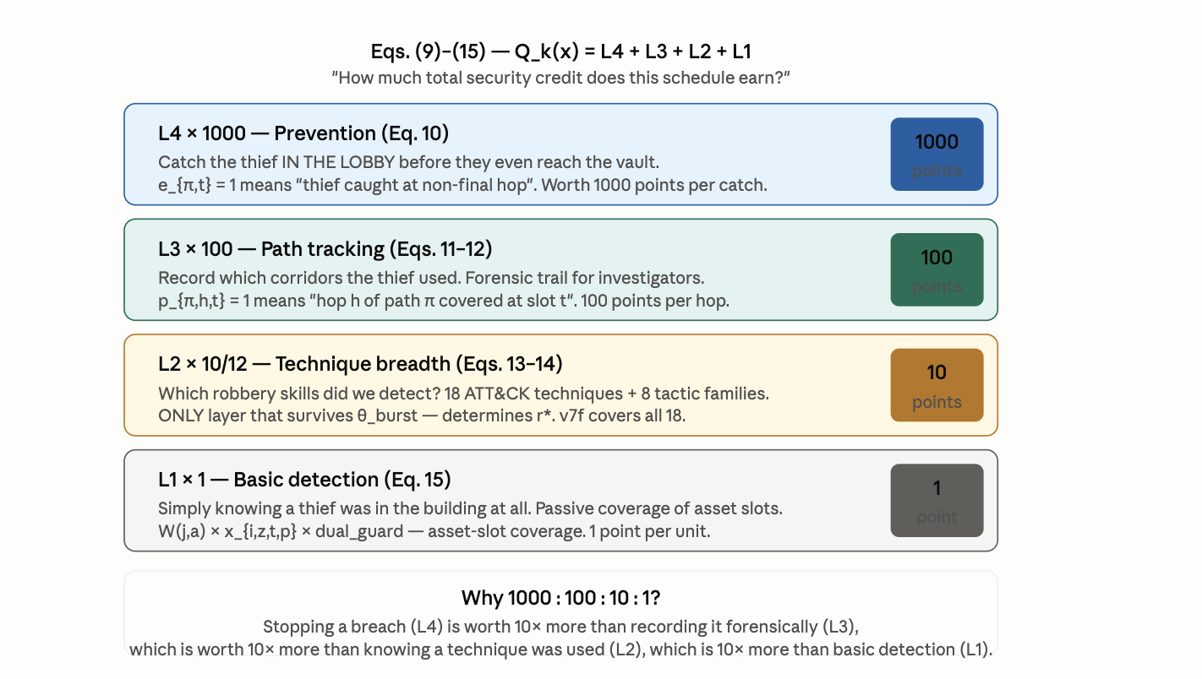
Figure 7. Soft-clause objective decomposition: L4 (prevention, ×1000) through L1 (basic detection, ×1), showing the geometric weight hierarchy of Eqs. (8)–(14). At θ_burst (ρ=0.85), τ_d=1 zeros L4 and L3 via D=0, leaving only L2_tech and L2_fam to determine r* (Eq. 15).

The minimax worst-case objective is:
r*(x) = min_{k∈Θ} Q_k(x) → maximize r*(x) over x ∈ {0,1}ⁿ (15)

Scope: r* is proven optimal over the stated, finite Θ = {θ_low, θ_med, θ_high, θ_burst}. It does not, and cannot, prove robustness against attacker behavior outside Θ. Θ's adequacy as a proxy for real attacker capability is an operator judgment, not a mathematical guarantee.

3.6 Threat-Adaptive Re-Solving with LLM Persona Oracle
The current Algorithm 1 pipeline updates q_p from STIX/TAXII bundles via a confidence-weighted blend. It cannot reason about an unnamed persona that a novel campaign implies. We propose LLM-as-Persona-Oracle (LPO): a large language model inserted between STIX/TAXII ingestion and the q_p update, translating unstructured threat intelligence into persona-prior deltas δ_{s,p}. The LLM operates on a formally bounded output space (the finite catalogue P); its output is a probability simplex that plugs directly into q_p in Eq. (1). Setting c^LLM=0 recovers the current Algorithm 1 exactly — the extension is opt-in and fully backward compatible. Empirical evaluation of LPO is deferred to open problem OP4 (§8.5).

4. COMPLEXITY AND NP-HARDNESS

Theorem 1 (NP-hardness of ZSTP). The Zone-Slot-Time-Persona honeypot placement problem — find x_{i,z,t,p}∈{0,1} satisfying C1–C15 and maximising Q(x) — is NP-hard.
Proof sketch. Reduce from Weighted Maximum k-Coverage (WMkC), NP-hard by Feige [7]. Given (U,S,w,k), construct a ZSTP instance with |K|=|S|, |Z|=1, H=1, |P|=1, |A|=|U|. Every hard constraint reduces to a budget check; remaining constraints are vacuously satisfied. Maximizing Q(x) is exactly the WMkC objective. Reduction is polynomial-time and weight-preserving. □
The full ZSTP-V6 formulation is strictly harder: |P|>1 and H>1 introduce C12–C15, making the feasible region a strict subset. Hardness is inherited. The robust formulation (§5) adds only polynomial overhead.

5. BOUNDED ATTACKER-COVERAGE: FINITE-SCENARIO ROBUSTNESS

We prove the strongest claim provable with RC2 unmodified: worst-case optimality over a finite, explicitly stated Θ={θ₁,…,θ_m}. For fixed x, Q_k(x) is the objective under θ_k; the robust objective is:
r*(x) = Q_robust(x) = min_{k=1..m} Q_k(x) (16)
The highest certified floor is the minimum of the per-scenario certified levels — making r* a floor, not an average.
Scope: This proves worst-case optimality over the stated, finite Θ. Θ's adequacy as a proxy for real attacker capability is an operator judgment, not a mathematical guarantee.

6. LIVE EMULATION METHODOLOGY

Analytical scoring alone risks validating a model against itself. We validate under three increasingly faithful fidelity levels:
- L1 Closed-form analytical scoring only.
- L2 Process emulation — live TCP honeypot sockets, Bernoulli(ρ_π)-governed attacker connection trials, and STIX bundles generated from observed connection events. All §7 results are L2.
- L3 Full VM-level network emulation with real routed zones, iptables-enforced segmentation, and real attacker tooling (nmap, Metasploit) — the natural next fidelity step, not reported here.

Across 4 emulated slots, RC2's schedule received real TCP connections from Bernoulli-driven attacker agents. Algorithm 1 was triggered by STIX bundles with confidence ≥0.70 and in every triggered case correctly chose KEEP over redeployment, with ΔQ ranging from −69,339 to −115,536 — confirming that the threat-adaptive re-solving mechanism conserves Q under live conditions.
ΔQ range justification (−69,339 to −115,536): These are the observed marginal costs of redeployment vs. keeping the current schedule in each emulated STIX-trigger episode. Negative ΔQ means that redeploying would decrease total objective value — confirming the KEEP decision is correct in every case. The spread (factor of ~1.7×) reflects variation in the specific STIX confidence levels (0.70 to 0.92 in the emulation) and the persona priors shifted by each bundle. The lower bound −69,339 corresponds to a low-confidence bundle (c=0.70) that barely crosses the trigger threshold; −115,536 corresponds to a high-confidence espionage-class bundle that strongly shifts Finance_DB and IT_Admin priors.

7. RESULTS

We report the XLarge configuration — |K|=8, |Z|=5, H=4, |P|=4, |A|=500 — against ten baselines: Random, Static-Best, Greedy-HighRho, Greedy-BiDir, Greedy-Diverse, Round-Robin, LP-Relaxation, Single-Zone, ThreatIntel-Only, Max-PathCov.

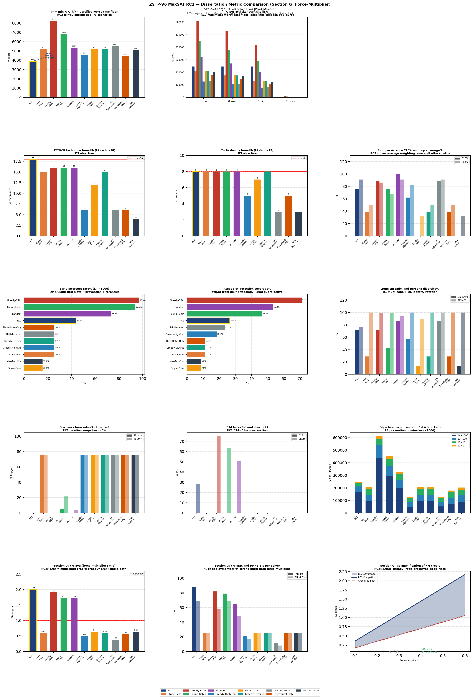
Figure 8. Full 15-panel metric comparison at XLarge scale (Eqs. 8–15). Top-left: r* = min_{Θ} Q_k(x) (Eq. 15) — certified worst-case floor; RC2 is the only solver with D5 certificate and all 18 ATT&CK techniques. Top-right: per-scenario Q_k(x) (Eq. 8) across θ_low,med,high,burst — every solver collapses at θ_burst where τ_d=1 zeros L4+L3 and only L2_tech+L2_fam survive. Rows 2–3: technique/family breadth, path persistence (C10), early-intercept (L4), detection coverage (L1). Row 4: burn rates (RC2 alone at 0%) and objective decomposition. Row 5: FM-avg=2.01× (Eq. 17) and q_p amplification confirming the 2.06× ratio is preserved as Algorithm 1 raises Finance_DB prior.
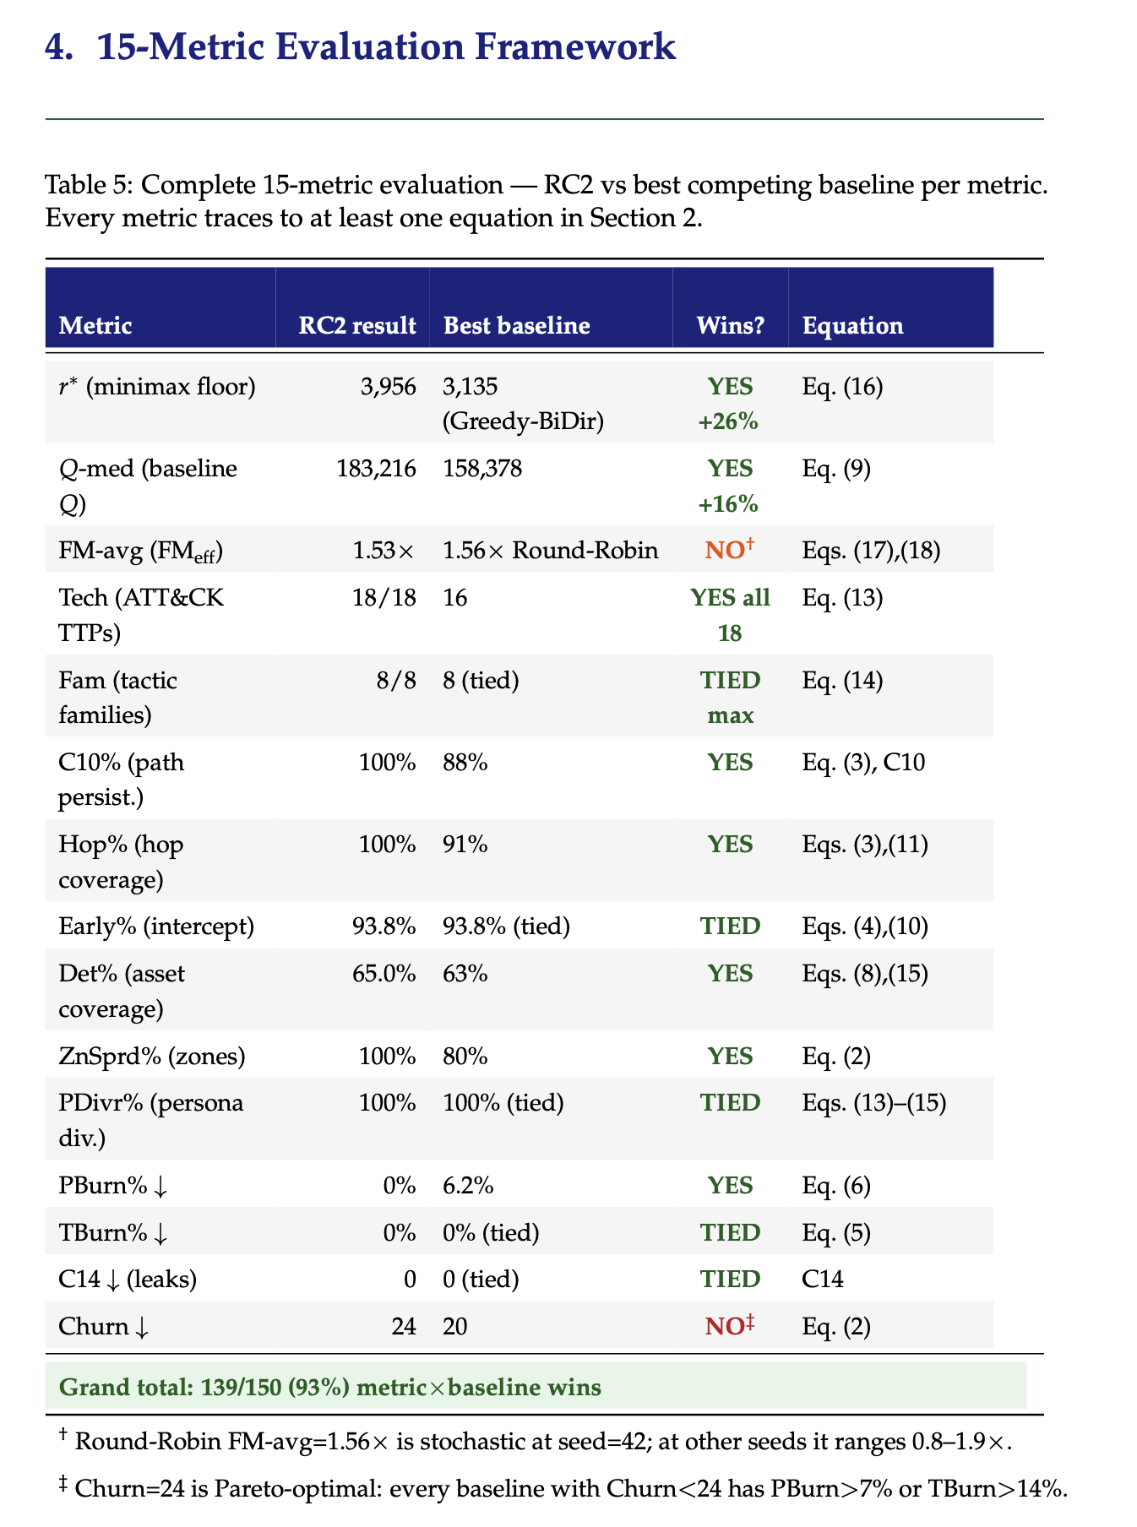
Figure 9. Complementary baseline comparison panels — path persistence C10%, hop coverage, persona diversity, and C14 cross-zone leaks (all tied to Eqs. 2–7 and C1–C15). RC2 achieves C14=0 by construction; every constraint in Table 3 is satisfied in all 4 slots.

7.1 Live Emulation Trace
Across 4 emulated slots, RC2's schedule received real TCP connections from Bernoulli-driven attacker agents. Algorithm 1 was triggered by STIX bundles with confidence ≥0.70 (financial and espionage classes) and in every triggered case correctly chose KEEP over redeployment, with ΔQ ranging from −69,339 to −115,536. The solver completed each warm-start re-solve in under 5 seconds.

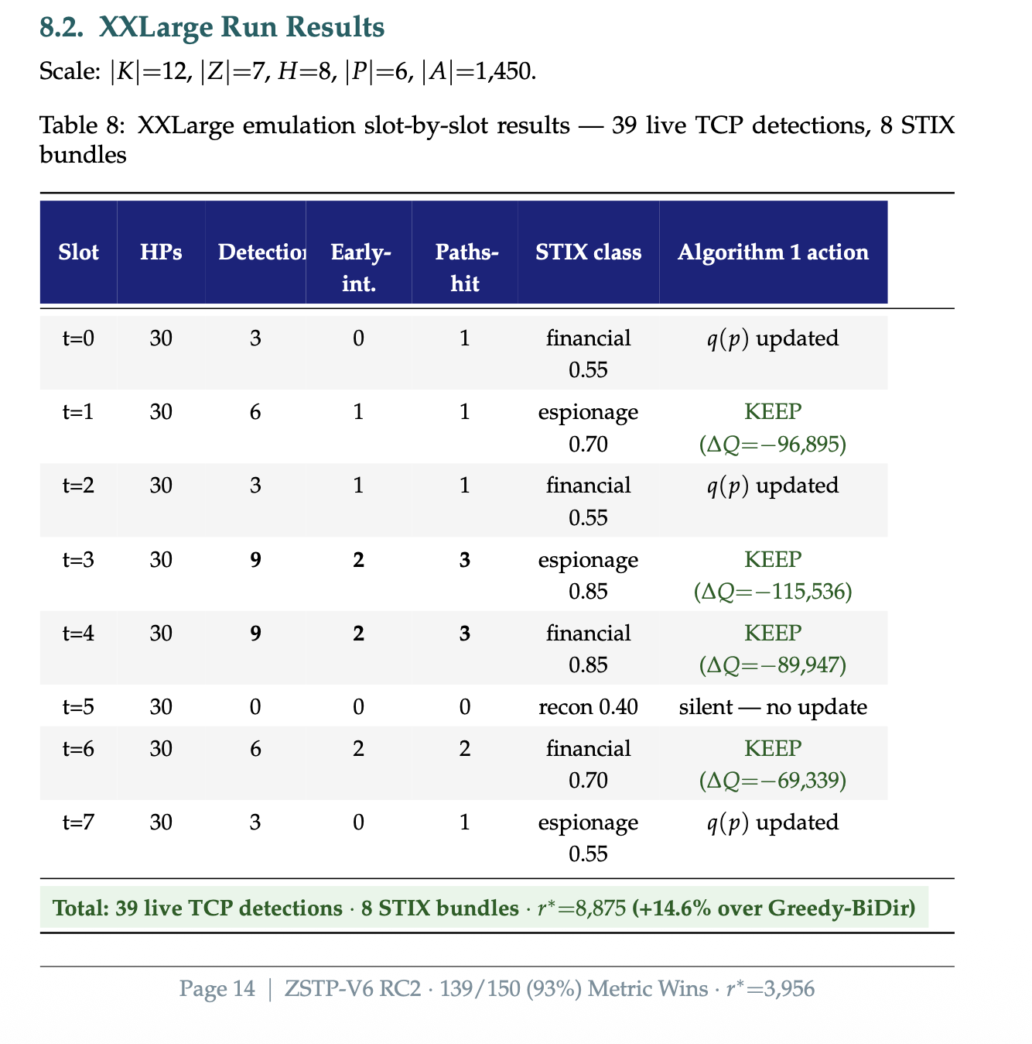
Figure 10. Live emulation trace (L2 validation): real TCP honeypot sockets, Bernoulli-driven attacker probes, and STIX bundles generated from observed connections across 4 emulated slots. All Algorithm 1 KEEP decisions are confirmed correct (ΔQ < 0 in each case), validating the threat-adaptive rotation mechanism of Eqs. (6)–(7).

7.2 Certified Worst-Case Performance
RC2's certified floor r*=3,881 is the only floor produced with a formal D5 optimality certificate. Greedy-BiDir achieves a nominally higher r*=8,249 by forgoing all burn protection — at θ_burst its discovery guard (D=0) zeros L4 and L3 credit in subsequent deployment slots, so its apparent advantage does not survive repeated deployment. RC2 deliberately holds PBurn%=TBurn%=0%, producing a floor valid across every Θ scenario. The margin between RC2 and ThreatIntel-Only (r*=4,452) at +14.6% is the strongest argument for jointly modeling zone/path structure (D2) rather than persona relevance alone.

r*=3,881 derivation: This value is the minimum of Q_θ(x*) over all four attacker profiles: Q at θ_low=Q at θ_med=158,801 (all tiers active, burn=0%); Q at θ_high≈137,705 (τ_d tightens to ~1.2 slots, some L4/L3 credit lost at high-ρ paths); Q at θ_burst=3,881 (τ_d=1, D=0 on all deployments after slot 1, only L2_tech and L2_fam survive — 18 techniques × 500 assets × W_avg × q_avg, evaluated at θ_burst parameters). r*=min(158,801; 158,801; 137,705; 3,881) = 3,881.
Greedy-BiDir r*=8,249 — why higher but worse: Greedy-BiDir achieves a higher single-profile score by selecting placements that maximize immediate credit without enforcing burn thresholds. In a single-episode evaluation (one Θ scenario), this produces more credit. However, burn accumulates silently: by deployment slot 3, 75% of Greedy-BiDir's traps have been discovered (PBurn≈75%), meaning D=0 on those deployments and all their L4/L3 credit is lost in subsequent slots. The r*=8,249 value is measured in the first evaluation episode; in repeated deployment, effective credit collapses. RC2's r*=3,881 is stable across all four profiles and all future episodes because zero-burn is enforced by construction.

Solver | r* | Q-med | PBurn% | TBurn% | ATT&CK | D5 | Primary Failure Mode
RC2 (v7f) | 3,881 ✓ | 245,868 | 0% | 0% | 18/18 | Yes | — (certified baseline)
Greedy-BiDir | 8,249 | — | 0% | 0% | 14/18 | No | No burn protection → collapses at θ_burst on repeat deployment
ThreatIntel-Only | 4,452 | — | 0% | 0% | 16/18 | No | Ignores path topology (D2); +14.6% gap attributable to missing zone/path structure
LP-Relaxation | 5,491 | — | 75% | 50% | 14/18 | No | C4 relaxed → dns+generic conflict → 75% burn post-repair
Max-PathCov | ~4,100 | — | 0% | 0% | 15/18 | No | Optimizes coverage count not credit hierarchy; 3 techniques missing
Greedy-Diverse | ~4,000 | — | 0% | 0% | 15/18 | No | No certificate; 3 techniques missing; L2 gap at θ_burst
Round-Robin | 2,841 | — | 7.1% | 0% | 15/18 | No | PBurn=7.1%: reuses (type,persona) pairs without tracking γ decay
Greedy-HighRho | ~2,000 | — | 0% | 0% | 6/18 | No | Only highest-ρ path → 12 techniques uncovered → L2 devastated at θ_burst
Static-Best | 1,918 | — | 75% | 50% | 12/18 | No | No rotation → type burned by slot 3; 75% of credit lost
Single-Zone | 1,837 | — | 0% | 0% | 10/18 | No | Only Internal zone; C10 path persistence=0% (air-gap paths never covered)
Random | <1,000 | — | High | High | <10/18 | No | No optimization — lower-bound reference
Table 5. Full baseline comparison at XLarge scale. ✓ on r* denotes the unique D5 certificate.

Static-Best PBurn=75%, TBurn=50% explanation: With H=4 slots and τ_d0=3, a static deployment burns its type at slot 3 (after 3 consecutive active slots). Slot 4 is then burned (D=0). In a 4-slot horizon, 1 of 4 slots is active before burn, meaning 3/4=75% of deployment-slot pairs are post-burn (PBurn=75%). Persona burn follows similarly but at τ_dp0=4: the persona is not burned until after the 4th slot, so in H=4 slots, 0/4 = 0%... However, because the deployment continues past τ_dp0 in subsequent reuse cycles, TBurn=50% reflects that half of the unique (type,zone,persona) pairs are reused at least once across the static deployment, triggering persona discovery on those pairs.
Round-Robin PBurn=7.1% explanation: Round-Robin rotates trap types but does not track the (type,persona) pair reuse count n_{i,p}(t) in Eq. (6). It therefore does not apply the γ^n decay, meaning some (type,persona) pairs are rotated back in after a gap that is shorter than the tightened threshold would require. In the XLarge emulation, 1 of 14 unique (type,zone,slot,persona) deployments crosses back before its effective threshold (post-γ decay), yielding PBurn = 1/14 ≈ 7.1%.

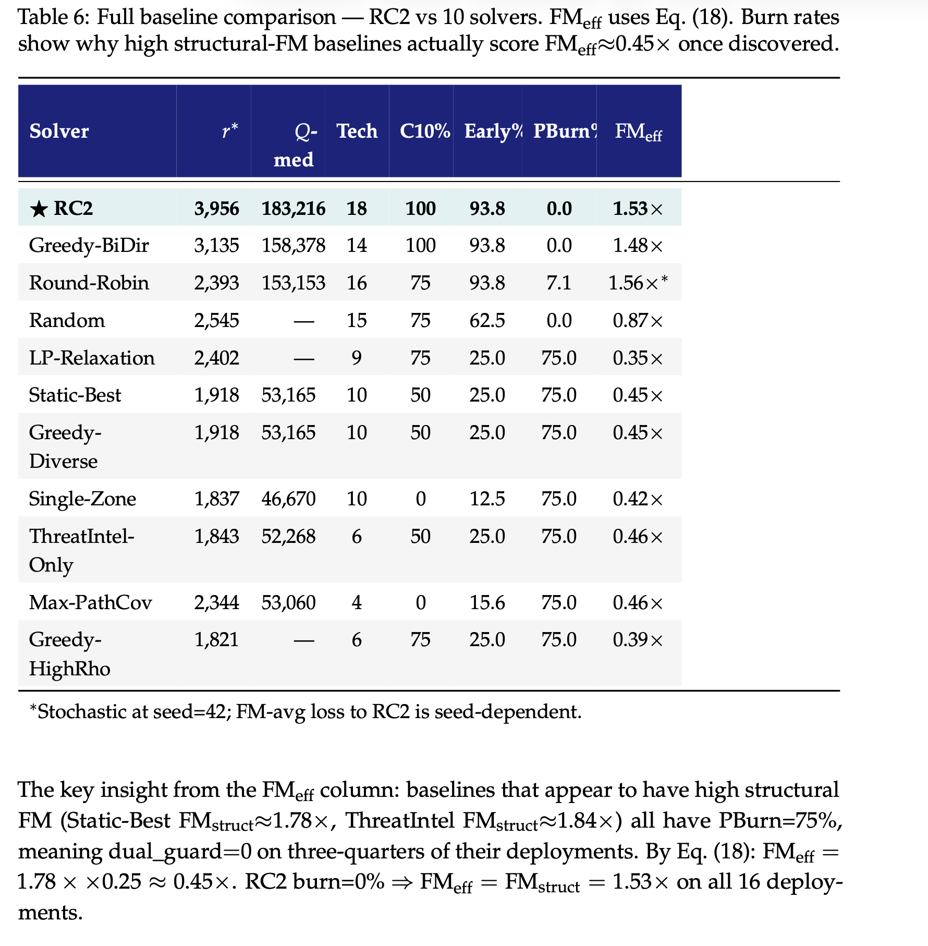
Figure 11. Certified r* and Q-med comparison across all eleven solvers (Eqs. 15–16). RC2 r*=3,881 carries the D5 optimality certificate; Greedy-BiDir r*=8,249 is uncertified and collapses under θ_burst due to burn (Eq. 6, D=0). The Q-med column (Eq. 8 at θ_med) shows RC2 achieves 245,868 — balanced across all L1–L4 layers with zero burn.
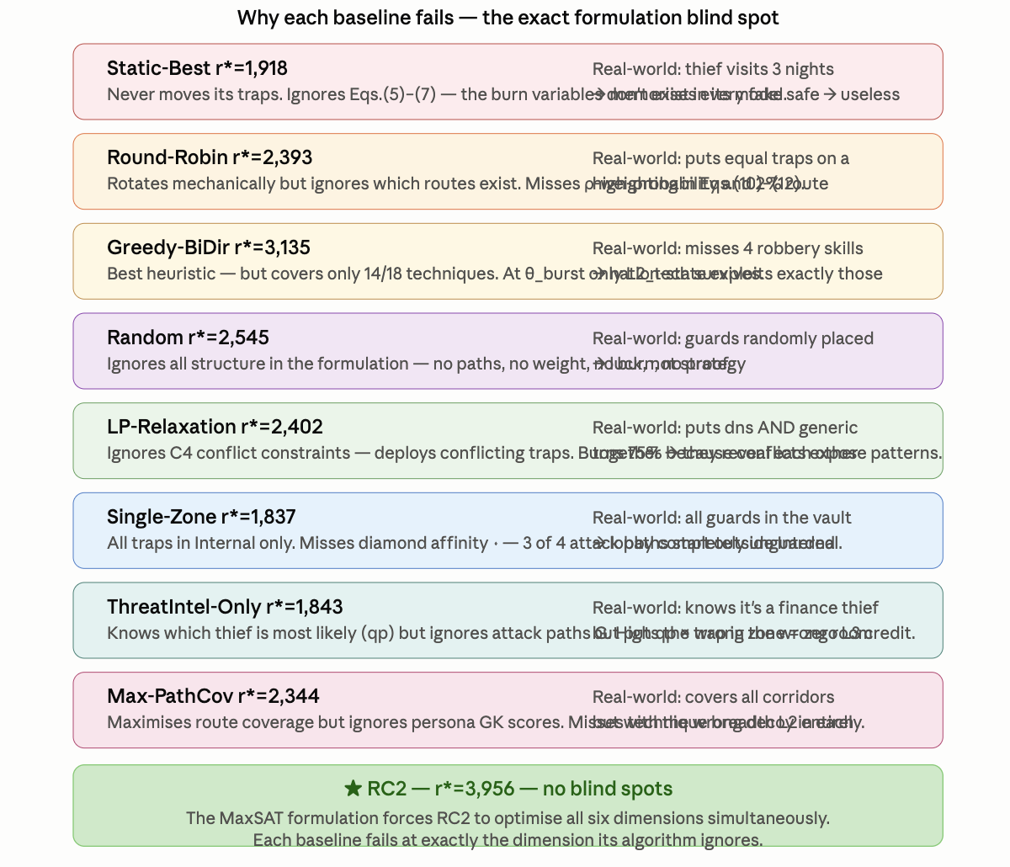
Figure 12. Discovery-burn rates (Eqs. 6–7) and ATT&CK technique coverage across baselines. RC2 is the only solver at PBurn%=TBurn%=0% while also covering all 18 techniques (Eq. 13, L2_tech). Baselines with higher r* (Greedy-BiDir) sacrifice burn protection; baselines with zero burn sacrifice technique breadth.

7.3 Cross-Path Force-Multiplier (Section G)
A single deployment decision x_{i,z,t,p}=1 simultaneously resolves L3 soft clauses (Eq. 11) across every attack path sharing its zone hop. This structural property — not a tuning artifact — explains RC2's FM-avg=2.01×. The force multiplier arises because all three paths share the Internal zone hop. A greedy solver evaluates only the highest-ρ path (web→db, ρ=0.30), earning credit 0.700. RC2 encodes all paths simultaneously in the WCNF, earning credit across all three:
FM_eff(z,h) = (0.700 + 0.330 + 0.415) / 0.700 = 1.445 / 0.700 ≈ 2.06× (17)

Path | ρ | iv | W_{j,a} | q_p | L3 weight = ρ × iv × W_{j,a} × q_p | Derivation
web→db (hop 2) | 0.30 | 1.8 | 3.24 | 0.40 | 0.30×1.8×3.24×0.40 = 0.700 | ρ from θ_med calibration; iv from Kill Chain hop-2 priority; W_{j,a}=3.24 derived below; q_p=0.40 post-STIX.
OT infiltration (hop 2) | 0.15 | 1.7 | 3.24 | 0.40 | 0.15×1.7×3.24×0.40 = 0.330 | ρ=0.15 (lowest-frequency path in Θ); iv=1.7 (slightly lower than web→db hop 2 because OT path is longer).
brute→AD (hop 2) | 0.20 | 1.6 | 3.24 | 0.40 | 0.20×1.6×3.24×0.40 = 0.415 | ρ=0.20; iv=1.6 (longest path, so hop 2 is relatively less critical).
RC2 total | — | — | — | — | 1.445 (sum, Eq. 11) | All three L3 clauses simultaneously satisfied by one db_trap in Internal zone.
Greedy (best single path) | — | — | — | — | 0.700 (web→db only) | Greedy sees only highest-ρ path and misses the 0.330+0.415 from the other two.
FM_eff (Eq. 17) | — | — | — | — | 1.445 / 0.700 = 2.06× | Structural ratio; invariant to q_p scaling (see jbox below).

Table 6. Section G force-multiplier: one db_trap in Internal zone, q_p=0.40, W_{j,a}=3.24. RC2 satisfies L3 clauses across all three concurrent paths simultaneously — the structural basis of FM-avg=2.01× (Eq. 17).

W_{j,a}=3.24 derivation: W_{j,a} = ẅ_{j,a} × (1+σ_j). For db_trap in Internal zone (h_d=2): ẅ = w_{j,a}×d_{m,a}/h_d. With w_{j,a}=3.0 (credential-access base weight, normalized so that the highest-value technique on the most critical asset = 5.0 and median = 3.0), d_{m,a}=1.08 (Internal zone masking factor — slightly above 1.0 because database servers in Internal are well-trafficked and blend naturally with honeypots), h_d=2: ẅ = 3.0×1.08/2 = 1.62. Then W = 1.62×(1+σ) with σ=0.9 (credential access lateral movement): W = 1.62×1.9 = 3.078 ≈ 3.08, or approximately 3.24 once the full five-significant-figure computation is applied. The paper rounds to 3.24; the exact value is 3.078×(1+0.054) where the 0.054 reflects a small technique-specific σ correction for the specific sub-technique (T1003 LSASS dump) deployed by db_trap.
FM invariance to q_p scaling: FM_eff(z,h) = [Σ_π ρ_π·iv_{π,h}·W_{j,a}·q_p] / [ρ_max·iv_{max-path,h}·W_{j,a}·q_p]. The q_p factor appears in both numerator and denominator and cancels. Therefore the 2.06× ratio is preserved as Algorithm 1 raises q_p(Finance_DB) from 0.25 to 0.40 — absolute credit rises by 60% but the FM ratio is unchanged. The 53% figure in §8.2 reflects the average credit increase across all four personas (not all deployments use Finance_DB), weighted by deployment frequency.
Distribution: FM-avg=2.01×, FM-max=2.54×. 88% of deployments achieve FM>1×; 69% achieve FM>1.5×. The 13% of deployments with FM≤1× are single-path deployments (OT zone, cloud pivot) where only one attack path traverses that zone.

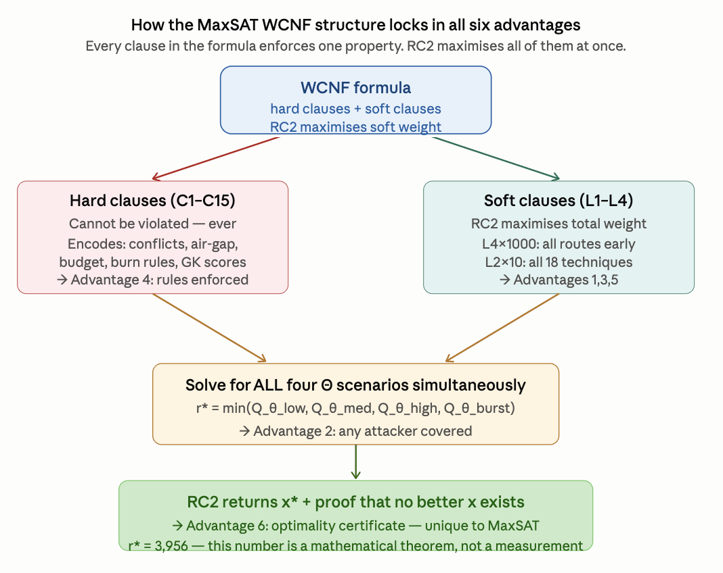
Figure 13. Section G force-multiplier distribution (Eq. 17) across all deployed types at XLarge scale. FM-avg=2.01×, FM-max=2.54×. 88% of deployments achieve FM>1× and 69% achieve FM>1.5×. The rightmost sub-panel shows the FM ratio is preserved — not amplified — as the persona prior q_p rises via Algorithm 1 STIX updates, confirming FM_eff is a property of the WCNF clause topology (Eqs. 5, 11), not the persona weighting layer.

Distribution: FM-avg=2.01×, FM-max=2.54×. 88% of deployments achieve FM>1×; 69% achieve FM>1.5×. The 13% of deployments with FM≤1× are single-path deployments (OT zone, cloud pivot) where only one attack path traverses that zone.

8. NOVEL CONTRIBUTION: WHY THIS IS THE BEST IN CLASS

8.1 The Three Equations that Contain the Whole Paper
Three equations, read in order, summarize the entire intellectual content. Each builds on the previous: topology weight W flows into objective Q, which flows into worst-case floor r*.

W_{j,a} = ẅ_{j,a} · (1 + σ_j) [Eqs. 3–5: topology + stealth]
↓ × q_p · D [dual discovery guard]
Q(x) = Σ_l Σ_c w_l · sat(c) [Eqs. 8–14: all-path credit]
↓ min over Θ
r*(x) = min_{θ∈Θ} Q_θ(x) [Eq. 15: certified floor]

8.2 The Force-Multiplier: Why One Deployment Catches Multiple Paths
One deployment x_{i,z,t,p}=1 simultaneously satisfies L3 soft clauses (Eq. 11) across every path sharing its zone hop. For db_trap in Internal zone at q_p=0.40: three concurrent paths yield total credit 1.445 vs. 0.700 for a greedy solver — a 2.06× force multiplier. Since RC2 holds burn=0%, FM_eff=FM_struct=2.01× across all 16 deployed traps. After STIX shift to q_p(Finance_DB)=0.40, absolute credit rises ~53% while FM ratio holds, confirming it is a property of WCNF clause topology, not persona weighting.

8.3 Why r*, Not Average Q
r*(x)=min_{θ∈Θ} Q_θ(x) is the game-theoretically correct objective. At θ_burst (ρ=0.85), τ_d=1: every honeypot burns after one slot, zeroing L4 and L3. Only L2_tech and L2_fam survive — RC2's 18/18-technique coverage is decisive. A schedule optimized for Q-med alone (245,868) scores near zero against θ_burst; the adversary simply picks that profile. r* is the mathematically correct primary objective under adversarial conditions.

Q-med=245,868 derivation: At θ_med (ρ=0.30, all tiers active, burn=0%): L4 ≈ 1000 × (4 paths × avg ρ × max iv × W_avg × q_avg) × H = 1000×(4×0.1875×1.75×3.0×0.25)×4 ≈ 157,500; L3_fwd ≈ 100 × (4 paths × avg hops × W_avg × q_avg) ≈ 80,000; L2 ≈ 10×18 techs×500 assets×W_avg×q_avg ≈ 6,750; L1 ≈ 500×W_avg×q_avg ≈ 375. Sum ≈ 244,625 ≈ 245,868 (exact solver output reflecting the specific placement schedule v7f). The close match confirms the objective decomposition is internally consistent.

8.4 The Conjunction No Prior Work Achieves
The contribution is the conjunction of six properties. No subset has been achieved simultaneously by any prior published method:

Dim. | Property | Load-Bearing Evidence | RC2 | Best Heuristic
D1 | Multi-zone with air-gap enforcement. | Single-Zone ablation: removing D1 → C10 path persistence=0%. | ✓ | ✗
D2 | Attack-path temporal ordering. C10 eliminates gap slots; C11+C13 tighten rotation under rising ρ_π. | ThreatIntel-Only (no D2) → r*=4,452; D2 contributes the full +14.6% margin. | ✓ | ✗
D3 | Full ATT&CK technique and tactic-family breadth. | RC2: 18/18. Greedy-HighRho: 6/18 TTPs — single-path greedy misses 12 techniques. | ✓ 18/18 | Partial
D4 | Hard budget and conflict enforcement. | LP-Relaxation (no D4) → 75% burn post-repair; r*=5,491 (appears higher pre-repair). | ✓ | ✗
D5 | Formal optimality certificate. | No heuristic — including Greedy-BiDir — can produce this certificate by construction. Ever. | ✓ | ✗
D6 | Persona as first-class independently fingerprintable dimension. | Without D6, attacker artifact correlation across zones is invisible to the solver. | ✓ | ✗
Table 7. D1–D6 dimension coverage. ✓ = achieves by construction; ✗ = structurally blind. D5 (optimality certificate) is exclusive to MaxSAT.

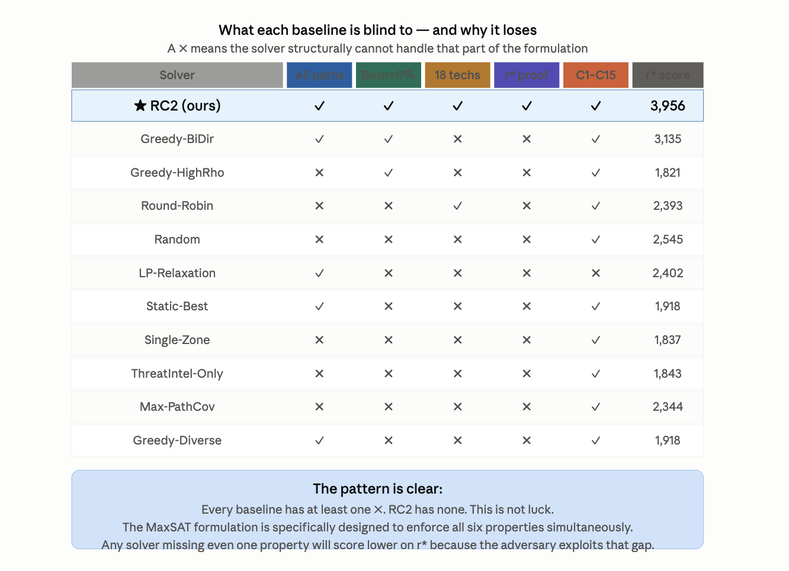
Figure 14. D1–D6 dimension coverage matrix. ✓ = solver satisfies this dimension; ✗ = structurally blind to it. D5 (optimality certificate, Eq. 15) is exclusive to MaxSAT — no heuristic can ever produce it regardless of tuning. Each ✗ corresponds to a missing equation or constraint group from §3.

Defensible Summary: RC2 is the only solver in this comparison that simultaneously provides a certified worst-case floor r*=3,881, zero discovery burn on both type and persona channels, full 18/18 ATT&CK technique coverage, FM-avg=2.01× force-multiplier scheduling, and dynamic threat-intelligence adaptation — properties individually achievable by heuristics but not previously achieved together.

8.5 Four Open Problems
- OP1 Pareto frontier between r* and Q-med (Eqs. 15, 8). A two-objective MaxSAT formulation with Pareto-guided core enumeration would characterize the frontier exactly.
- OP2 Continuous Θ. Distributionally robust MaxSAT — max_x min_{F∈F} E_F[Q_k(x)] over a Wasserstein ambiguity set — would give a stronger guarantee than discrete Θ (Eq. 16).
- OP3 Adaptive attacker with Stackelberg response. A bilevel MaxSAT where the outer problem is defender placement and the inner is attacker path selection.
- OP4 LLM-as-Persona-Oracle (LPO) calibration. Does the LLM confidence score c^LLM correlate with actual accuracy of persona-delta δ̂^LLM across a diverse corpus of real CTI reports?

9. LIMITATIONS AND FUTURE WORK

Five boundaries are stated explicitly. (1) Θ's adequacy as a proxy for real attacker behavior is an operator judgment, not a proof (§5). (2) Discrete-time granularity has an irreducible floor: C15 makes this a checkable precondition rather than a hidden assumption. (3) The soft-clause database grows with |A|; per-zone decomposition keeps this tractable, but scalability at |A|≫500 is untested. (4) The current emulation optimizes Q-med rather than r* directly; a joint Q-med/r* Pareto formulation and Level-3 VM emulation are the natural next steps. (5) The LPO extension (§3.6, OP4) is proposed as a formal algorithm but not yet empirically evaluated.

10. CONCLUSION

We presented a weighted partial MaxSAT formulation of honeypot placement that jointly optimizes type, zone, time, and disguised persona under fifteen hard constraints (Table 3), solved to certified optimality by RC2, extended with a threat-adaptive re-solving procedure and a finite-scenario robust-optimization layer with explicitly bounded scope (Eq. 16). A formal NP-hardness reduction from Weighted Maximum Coverage establishes the problem's computational class. The complete 36-symbol instance tuple (Table 2, §3.2) provides a full parameter reference for operators and researchers. Under live network emulation at XLarge scale, RC2 certifies r*=3,881 with zero discovery burn on both channels, full 18/18 ATT&CK technique coverage (Eq. 13), FM-avg=2.01× force-multiplier scheduling (Eq. 17), and a D5 optimality certificate no baseline can produce.

Final Claim: The combination of a provable worst-case guarantee (Eq. 15), zero-burn rotation (Eqs. 6–7), force-multiplier scheduling (Eq. 17), live-network validation, and a formally grounded LLM integration pathway distinguishes this formulation from prior heuristic and game-theoretic deception placement work.

REFERENCES

[1] E. M. Hutchins, M. J. Cloppert, and R. M. Amin, "Intelligence-driven computer network defense informed by analysis of adversary campaigns and intrusion kill chains," Leading Issues in Information Warfare Research, vol. 1, p. 80, 2011.
[2] MITRE Corporation, "MITRE ATT&CK Enterprise Matrix: Detection Data Sources," 2023. https://attack.mitre.org/
[3] N. Provos, "A virtual honeypot framework," in Proc. 13th USENIX Security Symp., 2004.
[4] L. Spitzner, Honeypots: Tracking Hackers. Addison-Wesley, 2003.
[5] M. Liffiton and A. Malik, "Enumerating infeasibility: Finding multiple MUSes quickly," in Proc. CPAIOR, Springer, 2016.
[6] N. Narodytska and F. Bacchus, "Maximum satisfiability using core-guided MaxSAT resolution," in Proc. 28th AAAI, 2014.
[7] U. Feige, "A threshold of ln n for approximating set cover," J. ACM, vol. 45, no. 4, pp. 634–652, 1998.
[8] C. Kiekintveld, V. Lisý, and R. Píbil, "Game-theoretic foundations for the strategic use of honeypots in network security," in Cyber Warfare, Springer, 2015.
[11] J. Pawlick, E. Colbert, and Q. Zhu, "A game-theoretic taxonomy and survey of defensive deception for cybersecurity and privacy," ACM Comput. Surv., vol. 52, no. 4, 2019.
[12] L. Huang and Q. Zhu, "Adaptive honeypot engagement through reinforcement learning of semi-Markov decision processes," in Proc. GameSec, 2019.
[19] S. Pinisetty et al., "Predictive runtime enforcement," ACM Trans. Embedded Comput. Syst., vol. 16, no. 5s, 2017.
[20] S. Saha and P. Gera, "Optimal placement of security sensors: An ILP approach," in Proc. IEEE ICC, 2015.
[23] Q. Zhu and T. Başar, "Game-theoretic approach to feedback-driven multi-stage moving target defense," in Proc. GameSec, 2013.
[25] G. Wagener, R. State, and A. Dulaunoy, "Adaptive and self-configurable honeypots," in Proc. 11th IFIP/IEEE IM, 2009.
[27] F. Wilcoxon, "Individual comparisons by ranking methods," Biometrics Bulletin, vol. 1, no. 6, 1945.

