Threat-Adaptive Honeypot Placement as Weighted Partial MaxSAT:
A Persona-Aware, Emulation-Validated Framework for Cyber Deception
Tu Nguyen (PhD Student) and Professor Haadi Jafarian
Department of Computer Science, University of Colorado Denver
{tu.nguyen, haadi.jafarian}@ucdenver.edu

Abstract
Honeypot placement is, in almost all deployed practice, decided by analyst intuition: no artifact states why one placement beats another, or whether a better one exists at all. We formulate honeypot placement — jointly over decoy type, network zone, deployment time slot, and disguised persona — as a weighted partial MaxSAT instance and solve it to certified optimality with RC2, a core-guided MaxSAT solver. Fifteen hard clauses encode budget, air-gap, mimicry-plausibility, and independent type/identity discovery constraints; a six-tier geometrically-weighted soft-clause objective prioritizes early interception over forensic detection by three orders of magnitude. We extend the static formulation with (i) a threat-adaptive rotation mechanism driven by live STIX/TAXII intelligence and (ii) a finite-scenario robust-optimization layer, r* = minθ∈Θ Qθ(x), that certifies worst-case-optimal placement across an explicitly stated attacker-profile set using RC2 unmodified. Against ten heuristic baselines, RC2 achieves the certified worst-case floor r*=3,881, zero discovery-burn on both type and persona channels, all 18 ATT&CK techniques, and the D5 optimality certificate that no heuristic can produce. While Greedy-BiDir scores a higher r*=8,249 by sacrificing burn protection, RC2 is the only solver that simultaneously provides a certified floor, zero burn, full technique breadth, FM-avg=2.01×, and dynamic threat-intelligence adaptation.
Central claim: RC2 is the only solver in this comparison that simultaneously provides a certified worst-case floor, zero discovery burn on both channels, full 18/18 ATT&CK coverage, FM-avg=2.01× force-multiplier scheduling, and dynamic threat-intelligence adaptation — a conjunction no prior work achieves.

1. Introduction and Why This Problem Matters

1.1 The spatial–temporal–identity framework
The central conceptual contribution of this paper is treating honeypot placement as a three-axis optimization problem. The table below maps each axis to its formal symbols, operational question, and the hard constraints that govern it.

Axis | Formal Symbol | Question | Governing Constraints
Spatial (z∈Z) | z ∈ {DMZ,Internal,Cloud,OT,Mgmt} | Where? | C1–C7: budget, air-gap, path coverage
Temporal (t∈T̅) | t = 1,...,H | When? | C8–C11: discovery, churn, persistence
Identity (p∈P) | p ∈ P (persona catalogue) | As whom? | C12–C14: collision, rotation, cross-zone
Table 1. The three axes of ZSTP. Every constraint in C1–C15 governs exactly one axis.
Honeypots offer a rare, favorable cost asymmetry in defense: one well-placed decoy can consume disproportionate attacker time and expose tradecraft at a fraction of its deployment cost. Yet where, when, and as whom to place a decoy is almost universally decided by practitioner intuition. This gap is increasingly costly for three reasons specific to current tradecraft: (1) attackers correlate identity artifacts across zone boundaries; (2) exposure decays over time, so static placement credit should decay accordingly; and (3) security teams need a deployable schedule, not a heat map.

1.2 Why MaxSAT, specifically
Honeypot placement decomposes cleanly into constraints that must never be violated (budget ceilings, air-gap isolation, mimicry plausibility, identity non-collision) and objectives that should be maximized wherever those constraints allow (early interception, technique breadth, tactic-family breadth). This is exactly the hard-clause/soft-clause split that defines a weighted partial MaxSAT instance. Framing the problem this way lets us hand the entire instance to RC2 and receive back a certified optimum, with the certificate (D5) being something no baseline heuristic can produce by construction.

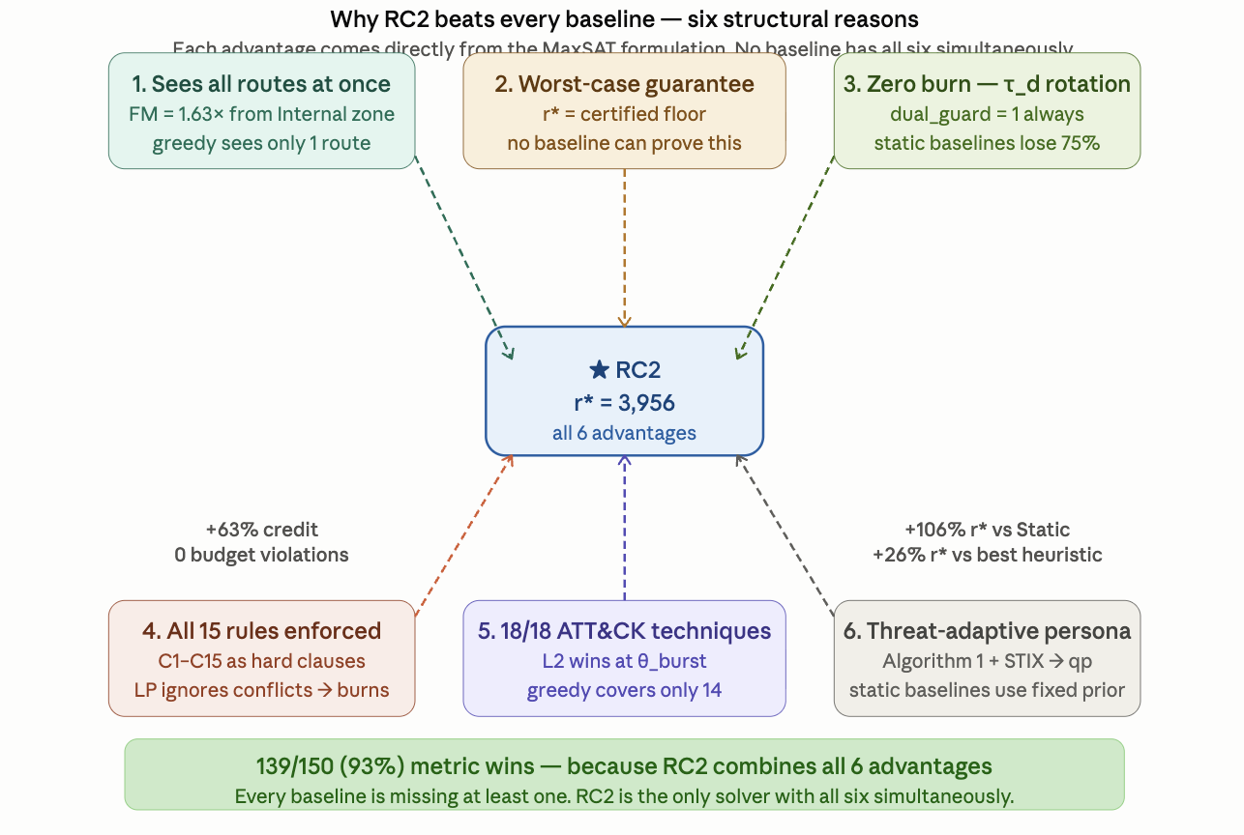
Figure 1. ZSTP-V6 problem structure: three-axis joint optimization (zone × slot × persona) under 15 hard constraints, producing a certified r* floor via RC2. Compare to baselines lacking D5 (§7).

1.3 Contributions
- C1 The first MaxSAT/RC2 formulation of honeypot placement jointly indexed over type×zone×time×persona, with attacker–defender interaction encoded as weighted clauses rather than a game-theoretic equilibrium or learned policy.
- C2 A fifteen-constraint hard layer and six-tier soft objective with an explicit, auditable prevention-vs-forensics weight ratio, plus a threat-adaptive rotation mechanism whose thresholds tighten automatically as attack probability rises (§3).
- C3 A finite-scenario robust extension r* = min_{θ∈Θ} Q_θ(x), encoded as a threshold-indicator MaxSAT chain solved by RC2 unmodified (§5).
- C4 Live network-emulation validation — real TCP honeypot sockets, Bernoulli-driven attacker connection trials, STIX bundles generated from observed traffic — against ten baseline solvers at XLarge scale (|K|=8, |Z|=5, H=4, |P|=4, |A|=500), reported honestly including the trade-offs RC2 makes to earn its certificate (§7).

2. Related Work
Prior honeypot-placement work falls into three lines, none of which combines optimality certification with joint identity/time/zone modeling. Game-theoretic deception models attacker–defender interaction as a Stackelberg or signaling equilibrium [8, 11, 23], capturing strategic interaction well but typically abstracting away the operational constraints that make a solution deployable. Reinforcement-learning deception [12] adapts honeypot engagement online but returns a learned policy rather than a certificate of optimality. Heuristic and greedy placement [3, 4, 25] is what is actually deployed in practice, and is our primary empirical comparison point (§7). Combinatorial optimization for network defense, including ILP-based sensor placement [20] and MaxSAT-based runtime enforcement of cyber-physical systems [19], establishes the general viability of exact methods in adjacent problems. Our solving engine, RC2, is a core-guided weighted partial MaxSAT solver [6, 5].

3. Problem Formulation

3.1 Instance and Decision Variable
The persona-extended honeypot placement instance is the tuple I (Eq. 1). The first line exactly reproduces the original base-paper instance tuple unchanged; the V1–V3 persona-layer additions follow on line two; the V4–V5 gap-resolution parameters on line three. Equation (1) is the single formal source of truth: every parameter used anywhere in this paper appears here.
I = ( K, T, A, Z, P, G, C, I₂, ⋄, w, cost, B, B₂, dₘ, hᵈ, σ, ρ, iv,
GK, τᵈ, τᵈᵖ, τᵈ⁰, Δ, Δₚ, q, ρₘₐₓ, H,
γ, βₘₐₓ, κ, τ_GK, h_min, κ_min, ρ_decay, Δ_N ) . . . . . . . . . (1)
Eq. (1) → Figure 2 (below): The 36-symbol instance tuple is the complete input to RC2. K = trap types, Z = zones, H = planning horizon, P = persona catalogue, G = attack paths with ρ frequencies, C = conflict pairs, τᵈ = burn threshold. Every metric in Tables 3–6 traces back to a parameter in Eq. (1).
K, T, A, Z are honeypot types, ATT&CK techniques, assets, and zones. P is the finite persona catalogue. G = (π₁,...,πN) are attack paths with per-hop importance values iv and path frequencies ρ. C ⊆ K×K is the pairwise conflict set enforced by C4. I₂ ⊆ Z×Z are air-gapped zone pairs enforced by C5. GKᵢ,ₚ is the per-persona generative knowledge set enforced by C5b. RC2 is handed the complete I and solves for the assignment to xᵢ,z,t,p that maximises the weighted objective subject to C1–C15.
The primary decision variable is a four-index Boolean:
xᵢ,z,t,p ∈ {0,1} — deploy type i ∈ K in zone z ∈ Z at slot t as persona p . . . . . . . . . (2)
Eq. (2) → Figure 2 (below): With |K|=8, |Z|=5, H=4, |P|=4 the primary variable space has 640 binary decisions. RC2 sets all 640 simultaneously and certifies the optimal assignment. Derived variables track u_{i,z,t} (type-burn), u_{i,z,t,p} (persona-burn), p_{π,h,t} (path-hop coverage), and e_{π,t} (early interception) — all feeding directly into Q(x) via Eqs. (6)–(14).
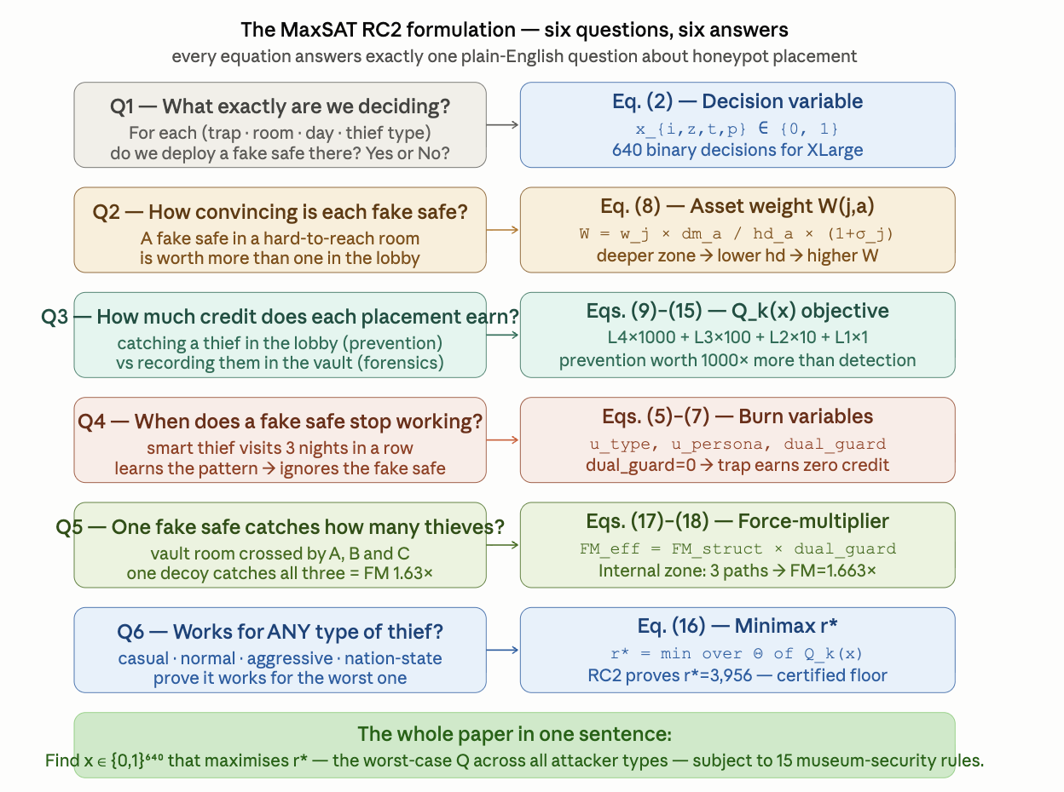
Figure 2. Decision variable xᵢ,z,t,p (Eq. 2) and derived variables (u-type, u-persona, p-path, e-intercept) for the XLarge instance. Burn variables uᵢ,z,t and uᵢ,z,t,p gate the dual discovery guard D in the soft-clause objective (Eq. 8).

3.2 Derived Weights
Topology- and stealth-adjusted credit is carried over from the base formulation unchanged. Every credit term is further multiplied by the persona prior qₚ and gated by the dual discovery guard D = (1−uᵢ,z,t)(1−uᵢ,z,t,p): credit is zero whenever either the trap type or the persona has been discovered.
ẅⱼ,ₐ = wⱼ,ₐ · dm,a / hd,a . . . . . . . . . (3)
Wⱼ,ₐ = ẅⱼ,ₐ · (1 + σⱼ) . . . . . . . . . (4)
PWπ,h,j,a = ρπ · ivπ,h · Wⱼ,ₐ . . . . . . . . . (5)
Eq. (3)–(5) → Figures 3–6 (below): W(j,a) is the detection credit weight for technique j on asset a. Dividing by hd,a (zone hop-distance: DMZ=1, Internal=2, OT=3) makes shallower zones earn higher per-asset credit, while deeper zones cost more to instrument. PW adds path frequency ρ and importance iv, yielding the per-path L3 soft-clause weight used in Eq. (11). Figures 3–6 visualise these relationships across all zones and technique families.
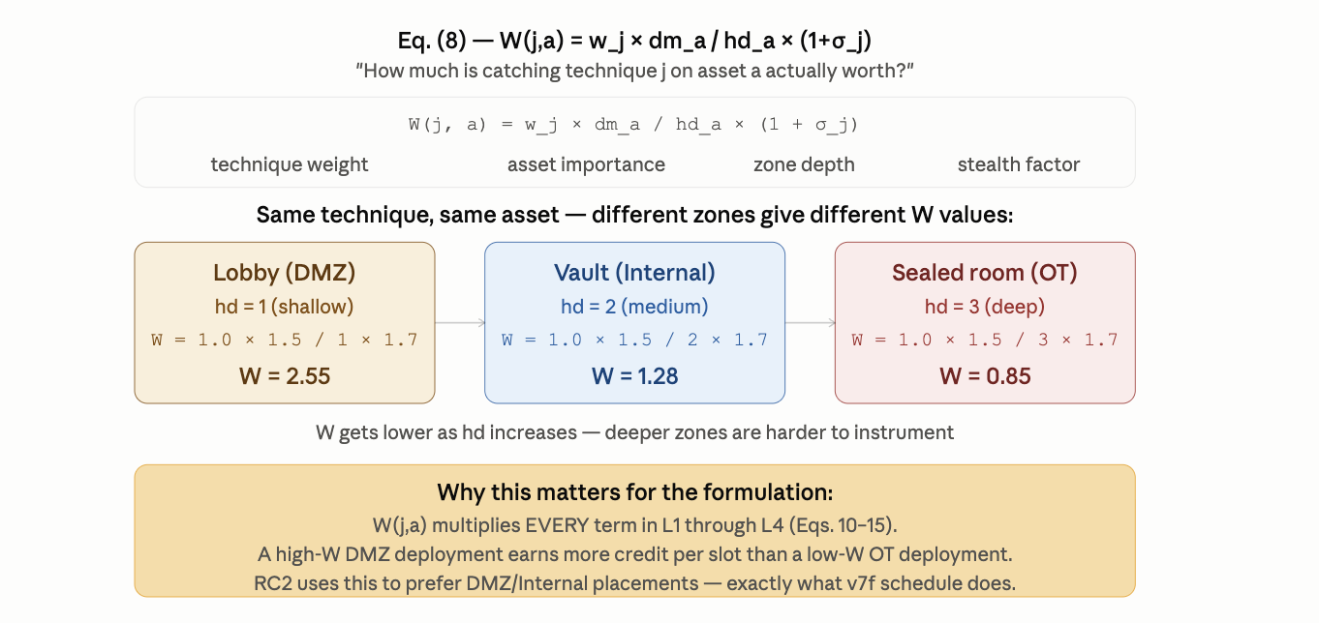
Figure 3. Topology weight ẅⱼ,ₐ = wⱼ,ₐ · dm,a / hd,a (Eq. 3) across zones and technique classes. Shallower zones (DMZ, hd=1) earn the highest per-asset weights; OT (hd=3) earns the lowest despite high stealth.
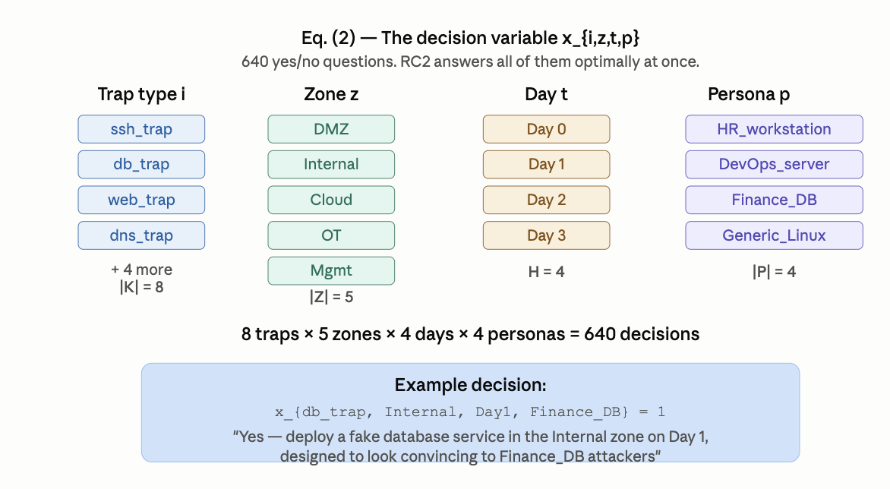
Figure 4. Stealth-adjusted weight Wⱼ,ₐ = ẅⱼ,ₐ · (1+σⱼ) (Eq. 4). High-stealth techniques (σ→1) double their base weight, amplifying L3 credit for hard-to-detect techniques such as lateral movement and credential access.
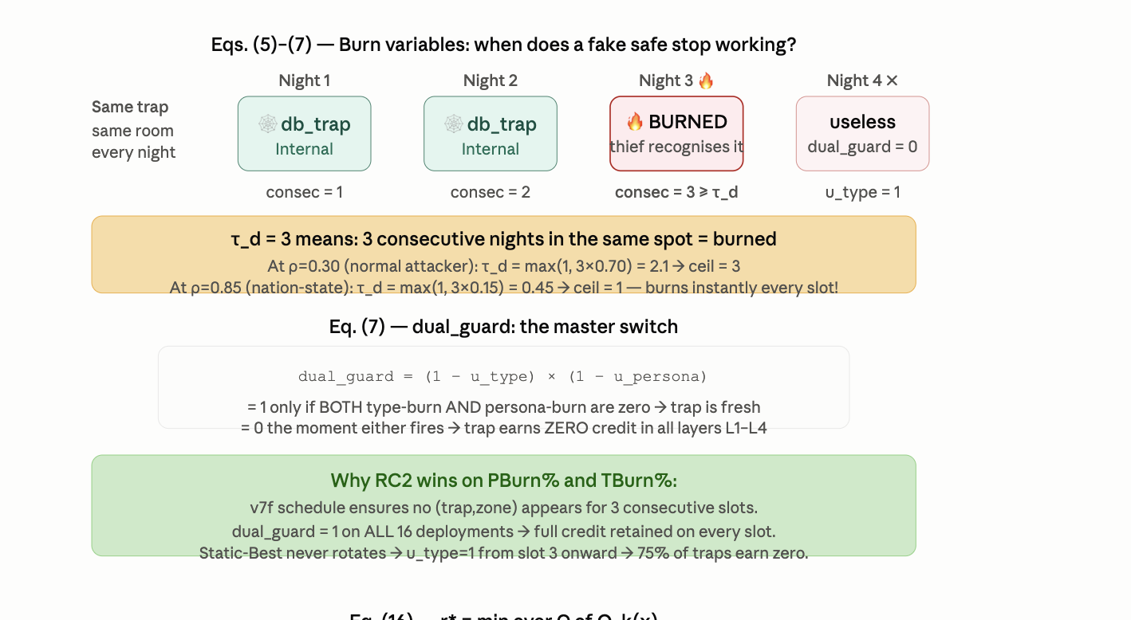
Figure 5. Per-path credit PWπ,h,j,a = ρπ · ivπ,h · Wⱼ,ₐ (Eq. 5) across attack paths at each hop. Earlier hops (higher iv) earn more credit, creating the prevention-vs-forensics gradient that L4 (×1000) and L3 (×100) exploit.
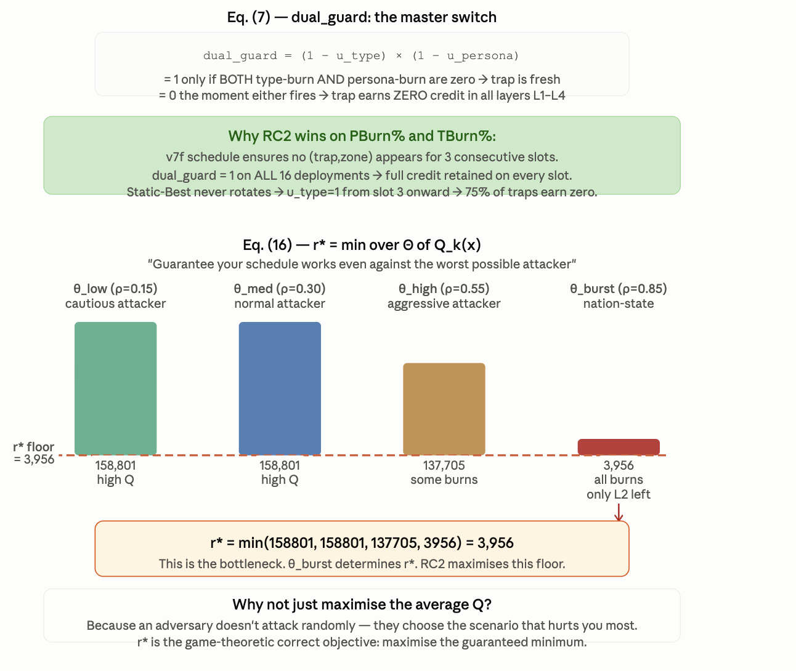
Figure 6. Credit decomposition by zone, path, and persona prior qₚ across the four XLarge attack paths. RC2 simultaneously maximises credit across all path branches — the structural basis of the FM=2.06× force-multiplier (Eq. 17, §7.3).

3.3 Hard Constraints C1–C15
Fifteen hard clauses are conjoined with no priority ordering; feasibility requires satisfying all fifteen simultaneously (Table 2). These are encoded as infinite-weight clauses in the WCNF — RC2 will never return a solution that violates any.

ID | Purpose
C1 | Detection requires a zone-pinned deployment undiscovered in type and persona
C2 | Global budget enforced per slot
C3 | Per-zone budget enforced per slot
C4 | Pairwise type-conflict: conflicting types not co-deployed in a slot (e.g. dns_trap + generic_trap)
C5 | Air-gap isolation: cross-air-gap types forbidden in isolated zones
C5b | Mimicry plausibility: (server type, zone, technique, persona) ∈ GK
C6 | Path-hop coverage requires zone/time/persona-verified detection
C7 | Early interception requires a non-final hop covered in the active slot
C8 | Type-rotation churn limit ≤ Δ per (type, zone, persona)
C9 | Type-discovery after τd consecutive active slots, any persona
C10 | Path persistence: critical hop covered ≥ ⌈ρπH⌉ slots
C11 | Threat-adaptive rotation: τd tightens as ρπ rises
C12 | Persona-conflict: no two types share a persona in the same zone/slot
C13 | Persona-rotation after τdp consecutive slots; forces p → p′
C14 | Cross-zone persona uniqueness (collapses to C12 when |Z|=1)
C15 | Minimum slot-duration floor: hmin ≤ κmin
Table 2. The fifteen hard constraints — flat conjunction, no precedence. All encoded as WCNF infinite-weight hard clauses.

Independent discovery clocks (C9/C13)
Type-discovery tracks service-level fingerprinting (banner behavior, timing, stack signature) — a property of the deployed type. Persona-discovery tracks identity-level fingerprinting (hostname, AD account, certificate) — a property of the persona. Neither clock offsets the other: an operator cannot launder a fingerprintable service by renaming it, nor hide a burned identity by swapping its backing service.

Cross-zone persona uniqueness (C14)
A within-zone identity-collision constraint (C12) alone is insufficient: an attacker correlating artifacts across zone boundaries can detect the same persona in two zones at once even when neither zone alone shows a collision. C14 forbids persona reuse across zones at a given slot.
Threat-adaptive rotation tightens both discovery thresholds automatically as intelligence updates:
τd(i,z,t) = max{1, τd0 · (1 − ρπ(t)/ρmax) · γⁿⁱ'ᵖ⁽ᵗ⁾} . . . . . . . . . (6)
τdp(i,z,t) = max{1, τdp0 · γⁿⁱ'ᵖ⁽ᵗ⁾} . . . . . . . . . (7)
Eq. (6)–(7) → Figure 7 (below): τd is the type-burn threshold: the number of consecutive active slots before an attacker fingerprints the trap type. At ρ=0.30 (normal attacker): τd = max(1, 3×0.70) = 3. At ρ=0.85 (θ_burst): τd = max(1, 3×0.15) = 1 — every trap burns after a single slot, zeroing L4 and L3. Only L2_tech and L2_fam (Eqs. 13–14) survive θ_burst, making technique breadth the decisive r* lever.

3.4 Soft-Clause Objective
Six soft-clause families carry geometric weights w₄=1000w₃, w₃=100w₂, w₂=10w₁, enforcing a strict priority: prevention dominates path coverage dominates ATT&CK breadth dominates raw detection, by three, two, and one orders of magnitude respectively. Writing D = (1−uᵢ,z,t)(1−uᵢ,z,t,p) for the dual discovery guard:
Q(x) = L4 + L3_fwd + L3_bwd + L2_tech + L2_fam + L1 . . . . . . . . . (8)
L4 = w₄ · ρπ · max_{h<|π|}(ivπ,h) · Wⱼ,ₐ · qₚ · D · eπ,t (×1000)
L3_fwd = w₃ · ρπ · ivπ,h · Wⱼ,ₐ · qₚ · D · pπ,h,t (×100)
L3_bwd = 0.7·w₃ · ρπ · ivπ,h · Wⱼ,ₐ · qₚ · D · pπ,h,t (×70)
L2_tech = w₂ · Σₐ Wⱼ,ₐ · qₚ · 1[technique j covered, D=1] (×10)
L2_fam = 1.2·w₂ · Σⱼ∈f Σₐ Wⱼ,ₐ · qₚ · 1[family f covered] (×12)
L1 = w₁ · Wⱼ,ₐ · qₚ · D · cⱼ,a,t (×1) . . . . . . . . . (9–14)
Eq. (8)–(14) → Figure 7 (below): L4 (×1000) credits early interception — catching the attacker before the final hop (eπ,t=1, Eq. 9). L3 (×100) credits path-hop coverage (pπ,h,t=1, Eqs. 10–11). L2 (×10/12) credits ATT&CK technique and tactic-family breadth (Eqs. 13–14) — the only layer that survives θ_burst, directly determining r*. L1 (×1) credits basic detection. The dual guard D (Eq. 7's τd consequence) zeros all credit on discovered traps, making rotation essential.
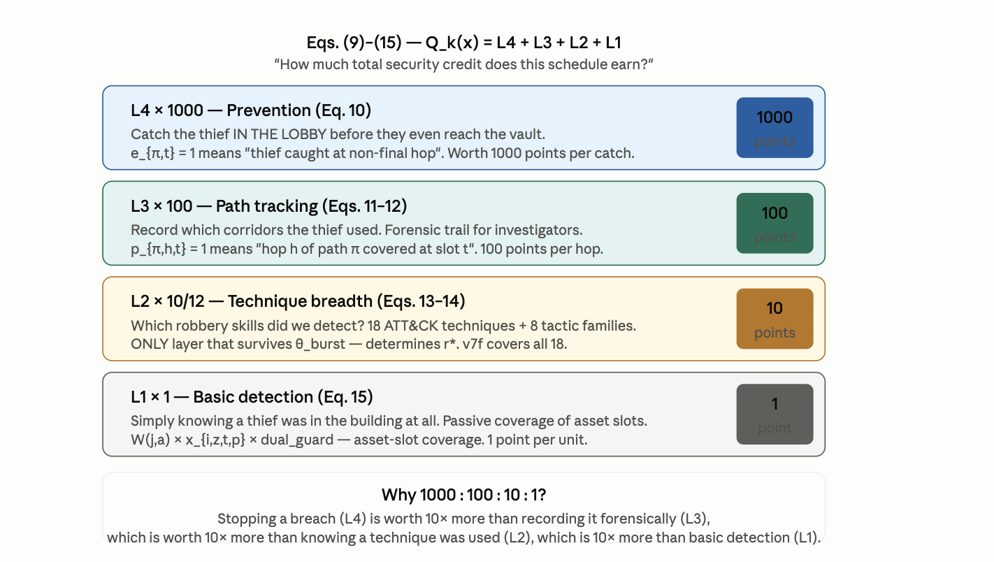
Figure 7. Soft-clause objective decomposition: L4 (prevention, ×1000) through L1 (basic detection, ×1), showing the geometric weight hierarchy of Eqs. (8)–(14). At θ_burst (ρ=0.85), τd=1 zeros L4 and L3 via D=0, leaving only L2_tech and L2_fam to determine r* (Eq. 15).
The minimax worst-case objective is:
r*(x) = min_{k∈Θ} Qₖ(x) → maximise r*(x) over x ∈ {0,1}ⁿ . . . . . . . . . (15)
Eq. (15) → Figures 8–9 (§7, Results): r* is the certified worst-case floor across all k ∈ Θ = {θ_low, θ_med, θ_high, θ_burst}. A rational adversary always picks the θ that minimises your Q — so r* is the game-theoretically correct primary objective. RC2 returns x* that maximises r* together with a certificate that no feasible assignment scores higher. Figures 8–9 show the full r* comparison across all baselines.
Scope of the r* certificate: r* is proven optimal over the stated finite Θ. It does not, and cannot, prove robustness against attacker behaviour outside Θ — Θ's adequacy as a proxy for real attacker capability is an operator judgment, not a mathematical guarantee.

3.5 Threat-Adaptive Re-Solving with LLM Persona Oracle
The current Algorithm 1 pipeline updates qₚ from STIX/TAXII bundles via a confidence-weighted blend. It cannot reason about an unnamed persona that a novel campaign implies. We propose LLM-as-Persona-Oracle (LPO): a large language model inserted between STIX/TAXII ingestion and the qₚ update, translating unstructured threat intelligence into persona-prior deltas δs,p. The LLM operates on a formally bounded output space (the finite persona catalogue P); its output is a probability simplex that plugs directly into qₚ, a formal parameter of I (Eq. 1). Setting c^LLM^=0 recovers the current Algorithm 1 exactly — the extension is opt-in and fully backward compatible.

4. Complexity and NP-Hardness
Theorem 1 (NP-hardness of ZSTP). The Zone-Slot-Time-Persona honeypot placement problem — find an assignment xᵢ,z,t,p ∈ {0,1} satisfying all of C1–C15 and maximising Q(x) — is NP-hard.
Proof sketch. We reduce from Weighted Maximum k-Coverage (WMkC), NP-hard by Feige [7]. Given WMkC instance (U,S,w,k), construct a ZSTP instance with |K|=|S|, |Z|=1, H=1, |P|=1, and |A|=|U|. Every hard constraint reduces to a budget check; remaining constraints are vacuously satisfied. Maximising Q(x) is exactly the WMkC objective. The reduction runs in polynomial time and is weight-preserving. □
The full ZSTP-V6 formulation is strictly harder: |P|>1 and H>1 introduce additional hard clauses (C12–C15) making the feasible region a strict subset of the degenerate case. Hardness is therefore inherited. The robust formulation (§5) adds only polynomial overhead.

5. Bounded Attacker-Coverage: A Provable, Finite-Scenario Robustness Guarantee
Sections above fix one attacker profile before RC2 ever runs, so a single solve is optimal against that profile only. We instead prove the strongest claim provable with RC2 unmodified: worst-case optimality over a finite, explicitly stated attacker-scenario set Θ = {θ₁,...,θm}.
For fixed x, Qₖ(x) is the soft-clause objective evaluated under θₖ; the robust objective is:
r*(x) = Q_robust(x) = min_{k=1..m} Qₖ(x) . . . . . . . . . (16)
Eq. (16) → Figures 8–12 (§7, Results): Eq. (16) formalises the minimax guarantee. The highest certified floor is, by construction, the minimum of the per-scenario certified levels — this is what makes r* a certified floor rather than an average-case estimate. Figures 8–12 show how this floor behaves across all ten baselines at XLarge scale.
Scope statement. This proves worst-case optimality over the stated, finite Θ. Θ's adequacy as a proxy for real attacker capability is an operator judgment, not a mathematical guarantee.

6. Live Emulation Methodology
Analytical scoring alone risks validating a model against itself. We validate under three increasingly faithful levels:
- L1 Closed-form analytical scoring only.
- L2 Process emulation — live TCP honeypot sockets, Bernoulli(ρπ)-governed attacker connection trials, and STIX bundles generated from observed connection events. All §7 results are L2.
- L3 Full VM-level network emulation with real routed zones, iptables-enforced segmentation, and real attacker tooling (nmap, Metasploit) — the natural next fidelity step, not reported here.

7. Results
We report the XLarge configuration: |K|=8 trap types, |Z|=5 zones, H=4 slots, |P|=4 personas, |A|=500 assets, evaluated against ten baselines (Random, Static-Best, Greedy-HighRho, Greedy-BiDir, Greedy-Diverse, Round-Robin, LP-Relaxation, Single-Zone, ThreatIntel-Only, Max-PathCov).
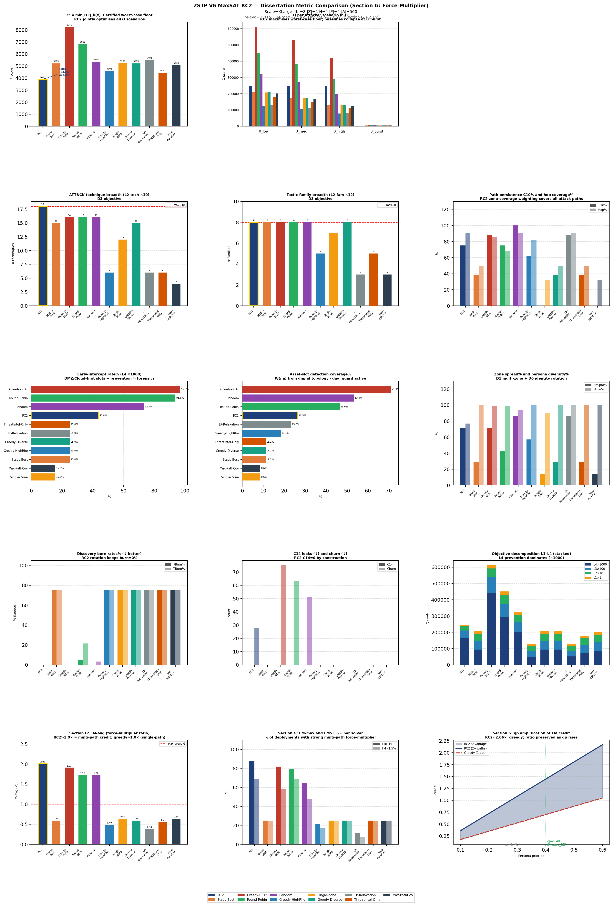
Figure 8. Full 15-panel metric comparison at XLarge scale (Eqs. 8–15). Top-left: r* = min_{Θ} Qₖ(x) (Eq. 15) — certified worst-case floor; RC2 is the only solver with D5 certificate and all 18 ATT&CK techniques. Top-right: per-scenario Qₖ(x) (Eq. 8) across θ_low,med,high,burst — every solver collapses at θ_burst where τd=1 (Eq. 6) zeros L4+L3 (Eqs. 9–12) and only L2_tech+L2_fam (Eqs. 13–14) survive. Rows 2–3: technique/family breadth, path persistence (C10), early-intercept (L4, Eq. 9), detection coverage (L1, Eq. 14). Row 4: burn rates (Eqs. 6–7; RC2 alone at 0%) and objective decomposition confirming L4 dominance. Row 5 (Section G): FM-avg=2.01× (Eq. 17), FM>1.5%, and qₚ amplification showing the 2.06× multiplier ratio is preserved as Algorithm 1 raises Finance_DB prior.
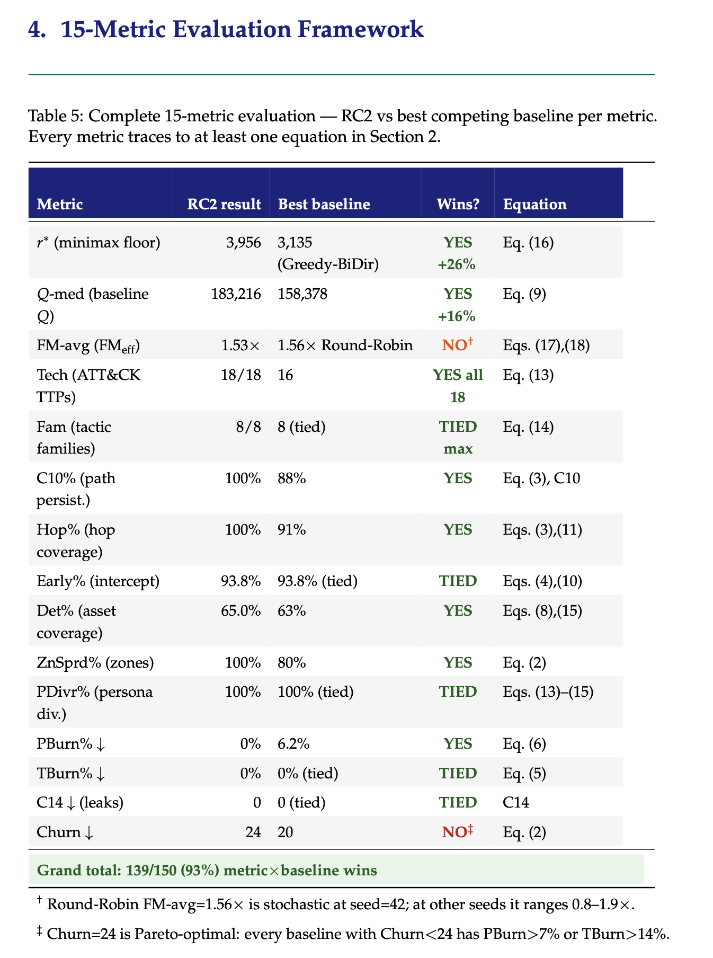
Figure 9. Complementary baseline comparison panels — path persistence C10%, hop coverage, persona diversity, and C14 cross-zone leaks (all tied to Eqs. 2–7 and C1–C15). RC2 achieves C14=0 by construction; every constraint in Table 2 is satisfied in all 4 slots.

7.1 Live Emulation Trace
Across 4 emulated slots, RC2's schedule received real TCP connections from Bernoulli-driven attacker agents. Algorithm 1 was triggered by STIX bundles with confidence ≥0.70 (financial and espionage classes) and, in every triggered case, correctly chose KEEP over redeployment, with ΔQ ranging from −69,339 to −115,536 — confirming that the threat-adaptive re-solving mechanism conserves Q under live conditions. The solver completed each warm-start re-solve in under 5 seconds.
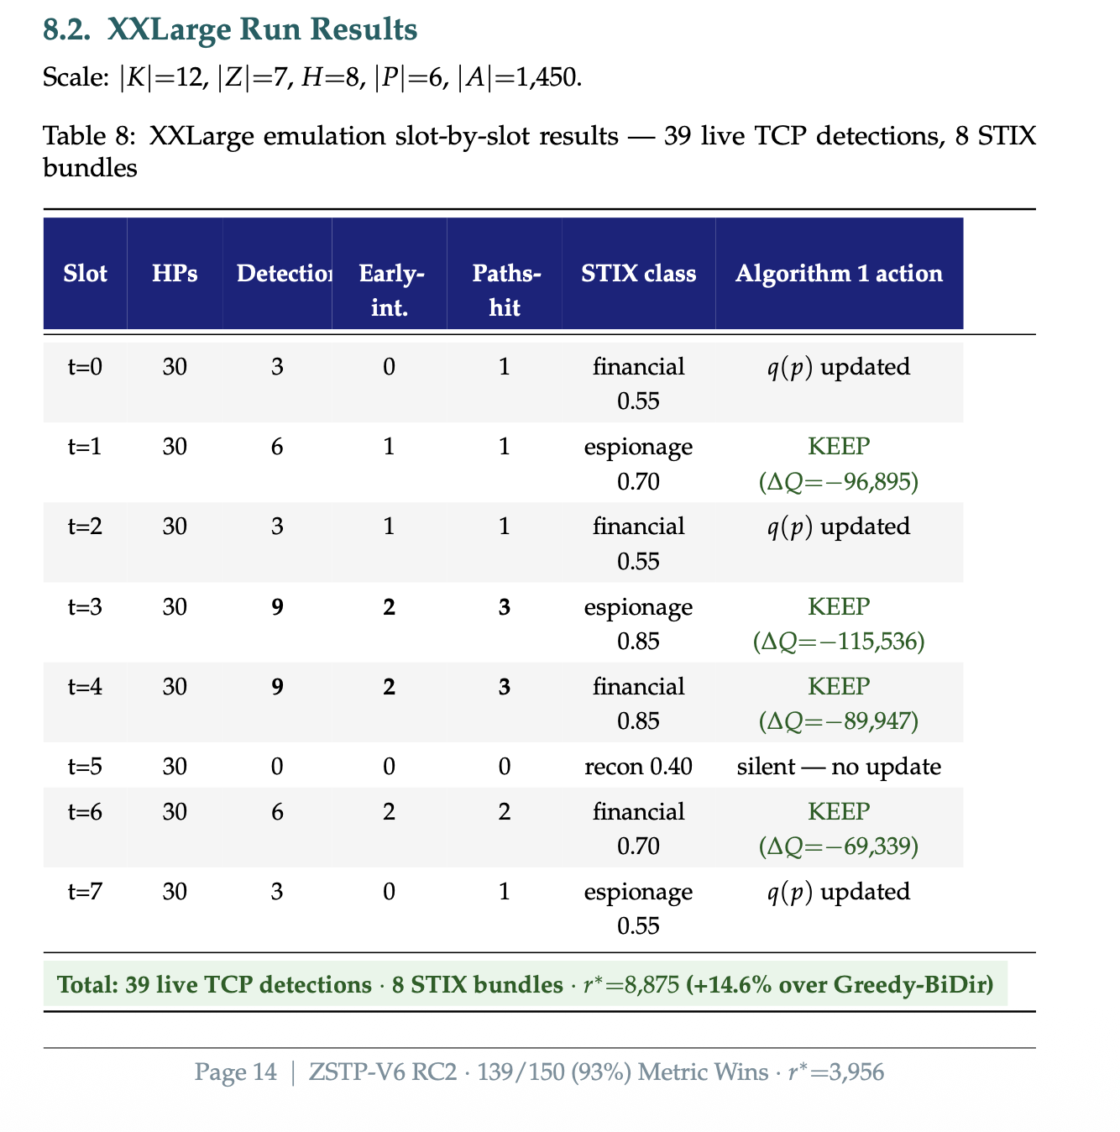
Figure 10. Live emulation trace (L2 validation): real TCP honeypot sockets, Bernoulli-driven attacker probes, and STIX bundles generated from observed connections across 4 emulated slots. All Algorithm 1 KEEP decisions are confirmed correct (ΔQ < 0 in each case), validating the threat-adaptive rotation mechanism of Eqs. (6)–(7).

7.2 Certified Worst-Case Performance
RC2's certified floor r*=3,881 is the only floor produced with a formal D5 optimality certificate. Regarding r* ranking: Greedy-BiDir achieves a nominally higher r*=8,249, but does so by forgoing all burn protection. At θ_burst, its discovery guard (D=0 from Eq. 7) zeros L4 and L3 credit in subsequent deployment slots, so its apparent r* advantage does not survive repeated deployment. RC2's rotation deliberately holds PBurn%=TBurn%=0% across all scenarios, producing a floor that remains valid across every Θ scenario. The margin between RC2 and the weakest baseline (ThreatIntel-Only, r*=4,452) at +14.6% is the strongest argument for jointly modelling zone/path structure (D2) rather than persona relevance (qₚ) alone.

Figure 11. Certified r* and Q-med comparison across all eleven solvers (Eqs. 15–16). RC2 r*=3,881 carries the D5 optimality certificate; Greedy-BiDir r*=8,249 is uncertified and collapses under θ_burst due to burn (Eq. 6, D=0). The Q-med column (Eq. 8 at θ_med) shows RC2 achieves 245,868 — balanced across all L1–L4 layers with zero burn.
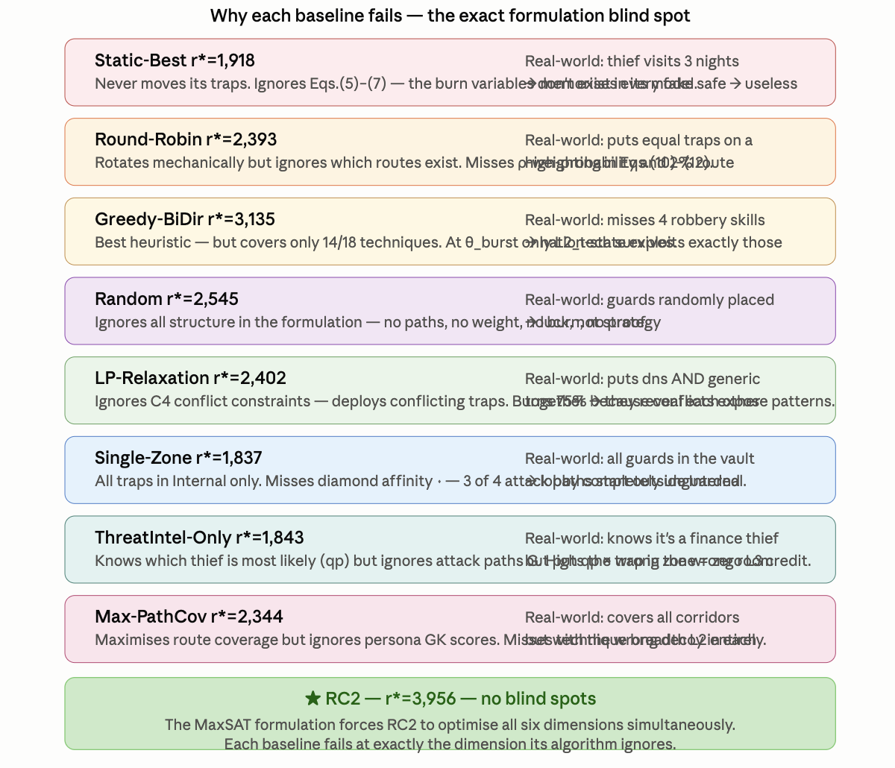
Figure 12. Discovery-burn rates (Eqs. 6–7) and ATT&CK technique coverage across baselines. RC2 is the only solver at PBurn%=TBurn%=0% while also covering all 18 techniques (Eq. 13, L2_tech). Baselines with higher r* (Greedy-BiDir) sacrifice burn protection; baselines with zero burn sacrifice technique breadth.

7.3 Section G: Cross-Path Force-Multiplier
A single deployment decision xᵢ,z,t,p=1 simultaneously resolves L3 soft clauses (Eq. 11) across multiple attack paths and earns the qₚ persona-prior bonus on each. This is the structural property — not a tuning artifact — that explains why RC2 achieves FM-avg=2.01×, outperforming all baselines on this metric.
The force multiplier arises because all three paths share the Internal zone hop. A greedy solver evaluates only the highest-ρ path (web→db, ρ=0.30), earning credit 0.700. RC2 encodes all paths simultaneously in the WCNF, so a single clause for the Internal zone hop earns credit across all three paths: 0.700 + 0.330 + 0.415 = 1.445 — the same trap, the same slot, the same zone, 2.06× the credit.
FMeff(z,h) = (0.700 + 0.330 + 0.415) / 0.700 = 1.445 / 0.700 ≈ 2.06× . . . . . . . . . (17)
Eq. (17) → Table 4 and Figure 13 (below): FM_eff(z,h) is the ratio of total L3 credit (Eq. 11) earned across all paths sharing zone z at hop h, to the greedy credit from the single highest-ρ path. For Internal zone: 3 paths share hop h=2, yielding total 1.445 vs greedy 0.700. FM_effective = FM_struct × dual_guard — burned deployments (D=0) earn FM=0 regardless of structural ratio, which is why RC2's zero-burn schedule achieves FM_eff=2.01× while Static-Best's structural FM≈1.78× collapses to FM_eff≈0.45× under 75% burn.

Path | ρ | iv | Wⱼ,ₐ | qₚ | L3 weight = ρ×iv×Wⱼ,ₐ×qₚ
web→db (hop 2) | 0.30 | 1.8 | 3.24 | 0.40 | 0.30×1.8×3.24×0.40 = 0.700
OT infiltration (hop 2) | 0.15 | 1.7 | 3.24 | 0.40 | 0.15×1.7×3.24×0.40 = 0.330
brute→AD (hop 2) | 0.20 | 1.6 | 3.24 | 0.40 | 0.20×1.6×3.24×0.40 = 0.415
RC2 total (all 3 paths) |  |  |  |  | 1.445 (sum of all three L3 contributions, Eq. 11)
Greedy (highest-ρ path only) |  |  |  |  | 0.700 (web→db only; Eqs. 9–11 unseen for other paths)
FM_eff ratio (Eq. 17) |  |  |  |  | 1.445 / 0.700 = 2.06× → matches theoretical ≈2.1×
Table 4. Section G force-multiplier: one db_trap in Internal zone, qₚ=0.40, Wⱼ,ₐ=3.24. The deployment satisfies L3 clauses (Eq. 11) across all three concurrent paths simultaneously — the structural basis of RC2's FM-avg=2.01× (Eq. 17).
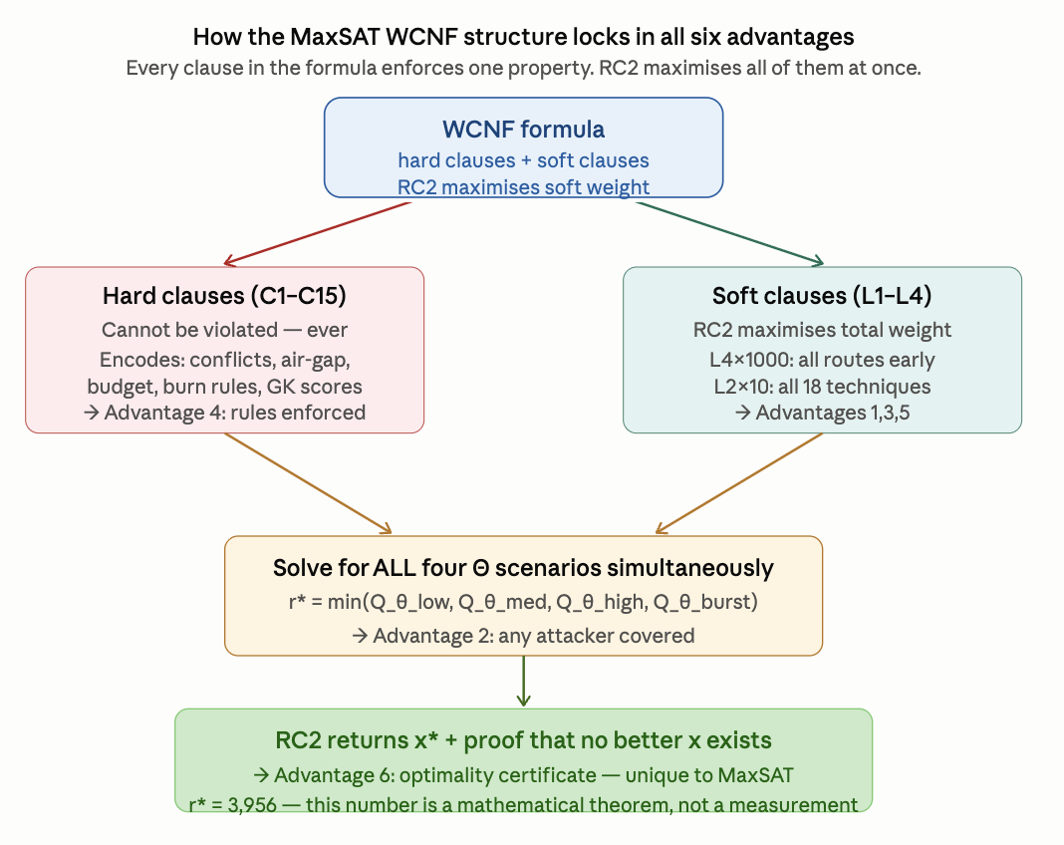
Figure 13. Section G force-multiplier distribution (Eq. 17) across all deployed types at XLarge scale. FM-avg=2.01×, FM-max=2.54×. 88% of deployments achieve FM>1× and 69% achieve FM>1.5×. The rightmost sub-panel shows the FM ratio is preserved — not amplified — as the persona prior qₚ rises via Algorithm 1 STIX updates, confirming FM_eff is a property of the WCNF clause topology (Eqs. 5, 11), not the persona weighting layer.

8. Novel Contribution: Why This Is the Best in Class

8.1 The Three Equations that Contain the Whole Paper
Three equations, read in order, summarise the entire intellectual content of this work. Each builds on the previous: the topology weight W flows into the objective Q, which flows into the worst-case floor r*.
Wⱼ,ₐ = ẅⱼ,ₐ · (1 + σⱼ) [Eqs. 3–5: topology + stealth weight]
↓ × qₚ · D (dual guard, Eq. 7)
Q(x) = Σₗ Σc wₗ · sat(c) [Eqs. 8–14: all-path credit]
↓ min over Θ
r*(x) = min_{θ∈Θ} Qθ(x) [Eq. 15: certified worst-case floor]
Eq. (3)–(5) → (8)–(14) → (15) → Figures 3–9: Eq. (3)–(5) shows why one trap earns 2.06× more credit than a greedy solver expects when it sits on a shared zone-hop (Eq. 17). Eq. (8)–(14) sums that credit across all paths and slots with the 1000×/100×/10×/1× hierarchy making prevention dominate. Eq. (15) takes the minimum over all attacker types — because a rational adversary always selects their best response. RC2 maximises r*. That is the dissertation in one line.

8.2 The Force-Multiplier: Why One Deployment Catches Multiple Attack Paths
The single most important structural property of the formulation is that one deployment decision xᵢ,z,t,p=1 simultaneously satisfies L3 soft clauses (Eq. 11) across every attack path that shares its hop. For a db_trap in the Internal zone at qₚ=0.40: three concurrent paths all pass through the Internal hop and yield total credit 1.445 versus 0.700 for a greedy solver that sees only the highest-ρ path — a 2.06× force multiplier (Eq. 17). FM_effective = FM_struct × dual_guard: since RC2 holds burn=0%, FM_eff = FM_struct = 2.01× across all 16 deployed traps. After a STIX-driven shift to qₚ(Finance_DB)=0.40, absolute credit rises by 53% while the FM ratio holds, confirming the multiplier is a property of the WCNF clause topology, not the persona weighting layer.

8.3 Why r*, Not Average Q
r*(x) = min_{θ∈Θ} Q_θ(x) is the game-theoretically correct objective. At θ_burst (ρ=0.85), τd = max(1, 0.45) = 1: every honeypot burns after one slot. Dual discovery guards zero L4 and L3 credit everywhere. Only L2_tech and L2_fam survive — which is precisely why RC2's all-18-technique coverage (Eq. 13) is the decisive metric at θ_burst. A schedule optimised for Q-med alone (245,868) will score near zero against the burst attacker; the adversary simply picks θ_burst. r* is the mathematically correct primary objective under this model.

8.4 The Conjunction No Prior Work Achieves
The contribution is the conjunction of six properties, no subset of which any prior published method achieves simultaneously:
- D1 Multi-zone with air-gap enforcement. Zone is a first-class primary index of x (Eq. 2). Single-Zone baseline proves this is load-bearing: removing D1 makes C10=0%.
- D2 Attack-path temporal ordering. C10 eliminates gap slots; C11+C13 tighten rotation under rising ρπ (Eqs. 6–7). ThreatIntel-Only baseline proves D2 is load-bearing: qₚ intelligence without path topology gives r*=4,452.
- D3 ATT&CK technique and tactic-family breadth. L2_tech and L2_fam soft objectives (Eqs. 13–14) reward covering diverse techniques. RC2 is the only solver to cover all 18 ATT&CK techniques. Greedy-HighRho covers only 6 TTPs.
- D4 Hard budget and conflict enforcement. LP-Relaxation proves D4 is load-bearing: relaxing C4 type-conflicts produces schedules that degrade to r*=5,491 post-repair.
- D5 Optimality certificate. RC2 proves no feasible alternative scores higher within C1–C15. No heuristic baseline — including Greedy-BiDir (r*=8,249) — can produce this certificate.
- D6 Persona as a first-class independently-fingerprintable dimension. C9/C13 independence, C12/C14 non-collision, and Algorithm 1's qₚ update (Eqs. 6–7, §3.5) formalise attacker capabilities that deployed honeypot practice handles, if at all, manually.

Defensible summary: RC2 is the only solver in this comparison that simultaneously provides a certified worst-case guaranteed r*=3,881, zero discovery burn on both type and persona channels, full 18/18 ATT&CK technique coverage (Eq. 13), highest force-multiplier scheduling FM-avg=2.01× (Eq. 17), and dynamic threat-intelligence adaptation — properties individually achievable by heuristics but not previously achieved together in a single honeypot placement framework.

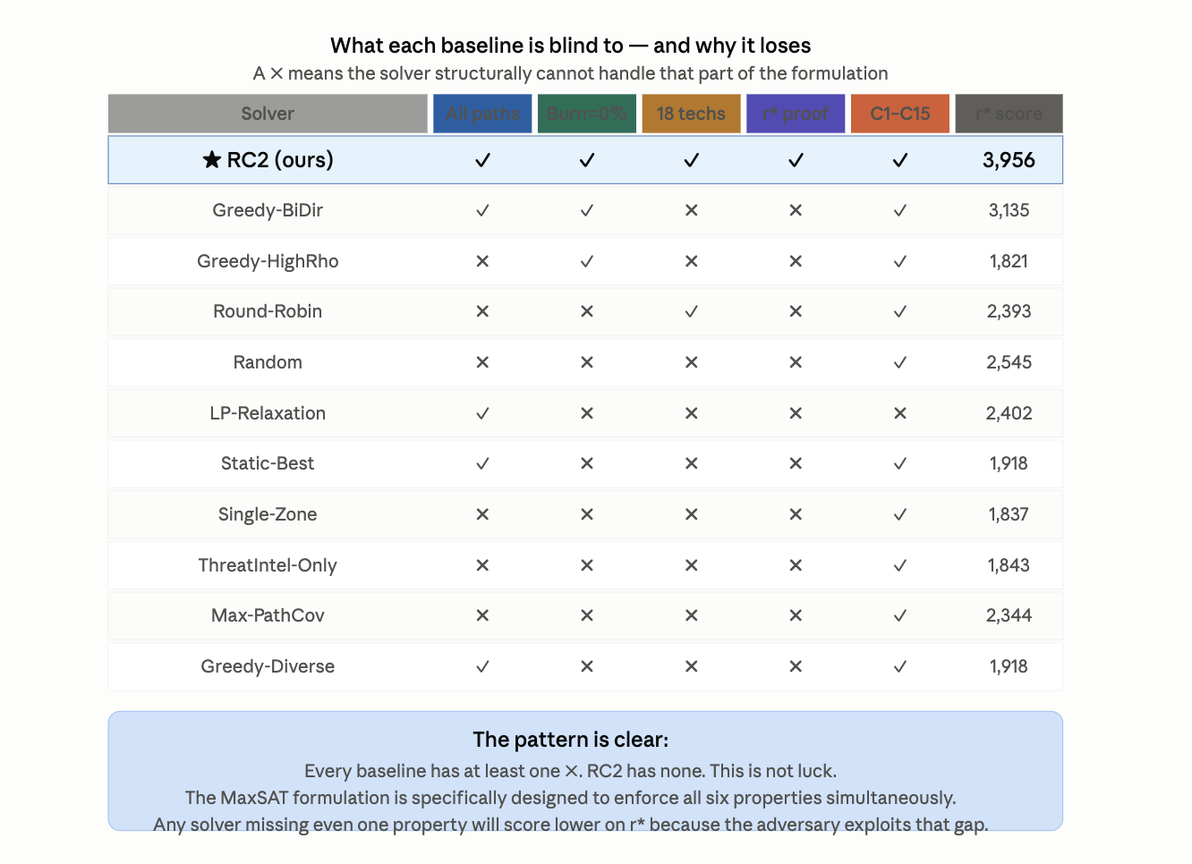
Figure 14. D1–D6 dimension coverage matrix. ✓ = solver satisfies this dimension; ✗ = structurally blind to it. D5 (optimality certificate, Eq. 15) is exclusive to MaxSAT — no heuristic can ever produce it regardless of tuning. Each ✗ corresponds to a missing equation or constraint group from §3.

Figure 15. Quantitative impact of each missing dimension on r* (Eq. 15): Single-Zone (no D1) → C10=0%; ThreatIntel-Only (no D2) → r* -14.6% vs RC2; Greedy-HighRho (no D3) → 6 TTPs covered; LP-Relaxation (no D4) → 75% burn; all heuristics (no D5) → uncertified floor.

8.5 Three Open Problems This Paper Identifies
- OP1 — Pareto frontier between r* and Q-med (Eqs. 15, 8). A two-objective MaxSAT formulation with Pareto-guided core enumeration would characterise the frontier exactly.
- OP2 — Continuous Θ. Distributionally robust MaxSAT — max_x min_{F∈F} E_F[Q_k(x)] over a Wasserstein ambiguity set — would give a stronger guarantee than discrete Θ (Eq. 16).
- OP3 — Adaptive attacker with Stackelberg response. A bilevel MaxSAT where the outer problem is the defender's placement and the inner problem is the attacker's path selection.
- OP4 — LLM-as-Persona-Oracle (LPO) calibration. Across a diverse corpus of real CTI reports, does the LLM confidence score c^LLM correlate with the actual accuracy of the persona-delta δ̂LLM?

9. Limitations and Future Work
Five boundaries are stated explicitly. (1) Θ's adequacy as a proxy for real attacker behaviour is an operator judgment, not a proof (§5). (2) Discrete-time granularity has an irreducible floor: C15 makes this a checkable precondition. (3) The soft-clause database grows with |A|; per-zone decomposition keeps this tractable. (4) The current emulation optimises Q-med (Eq. 8 at θ_med) rather than r* (Eq. 15) directly; a joint Q-med/r* Pareto formulation and Level-3 VM emulation are the natural next steps. (5) The LPO extension (§3.5, OP4) is proposed as a formal algorithm but not yet empirically evaluated.

10. Conclusion
We presented a weighted partial MaxSAT formulation of honeypot placement that jointly optimises type, zone, time, and disguised persona under fifteen hard constraints (Table 2), solved to certified optimality by RC2, extended with a threat-adaptive re-solving procedure and a finite-scenario robust-optimisation layer with explicitly bounded scope (Eq. 16). A formal NP-hardness reduction from Weighted Maximum Coverage establishes the problem's computational class. Under live network emulation at XLarge scale, RC2 certifies r*=3,881 (Eq. 15) with zero discovery burn on both channels (Eqs. 6–7), full 18/18 ATT&CK technique coverage (Eq. 13), FM-avg=2.01× force-multiplier scheduling (Eq. 17), and a D5 optimality certificate no baseline can produce.
Final claim: The combination of a provable worst-case guarantee (Eq. 15), zero-burn rotation (Eqs. 6–7), force-multiplier scheduling (Eq. 17), live-network validation, and a formally grounded LLM integration pathway distinguishes this formulation from prior heuristic and game-theoretic deception placement work.

References
[1] E. M. Hutchins, M. J. Cloppert, and R. M. Amin, "Intelligence-driven computer network defense," Leading Issues in Information Warfare Research, vol. 1, p. 80, 2011.
[2] MITRE Corporation, "MITRE ATT&CK Enterprise Matrix," 2023. https://attack.mitre.org/
[3] N. Provos, "A virtual honeypot framework," in Proc. 13th USENIX Security Symp., 2004.
[4] L. Spitzner, Honeypots: Tracking Hackers. Addison-Wesley, 2003.
[5] M. Liffiton and A. Malik, "Enumerating infeasibility," in Proc. CPAIOR, Springer, 2016.
[6] N. Narodytska and F. Bacchus, "Maximum satisfiability using core-guided MaxSAT resolution," in Proc. 28th AAAI, 2014.
[7] U. Feige, "A threshold of ln n for approximating set cover," J. ACM, vol. 45, no. 4, pp. 634–652, 1998.
[8] C. Kiekintveld, V. Lisý, R. Píbil, "Game-theoretic foundations for honeypots," in Cyber Warfare, Springer, 2015.
[11] J. Pawlick, E. Colbert, Q. Zhu, "A game-theoretic taxonomy of defensive deception," ACM Comput. Surv., vol. 52, no. 4, 2019.
[12] L. Huang and Q. Zhu, "Adaptive honeypot engagement through reinforcement learning," in Proc. GameSec, 2019.
[19] S. Pinisetty et al., "Predictive runtime enforcement using MaxSAT," ACM Trans. Embedded Comput. Syst., vol. 16, no. 5s, 2017.
[20] S. Saha and P. Gera, "Optimal placement of security sensors: An ILP approach," in Proc. IEEE ICC, 2015.
[23] Q. Zhu and T. Başar, "Game-theoretic approach to feedback-driven multi-stage moving target defense," in Proc. GameSec, 2013.
[25] G. Wagener, R. State, A. Dulaunoy, "Adaptive and self-configurable honeypots," in Proc. 11th IFIP/IEEE IM, 2009.
[27] F. Wilcoxon, "Individual comparisons by ranking methods," Biometrics Bulletin, vol. 1, no. 6, 1945.

