MaxSAT optimizer into a multi-zone, topology-aware, kill-chain-driven system with a 6-term composite objective, network graph engine, Monte Carlo attacker simulation, and dynamic validation framework

==== Four Topology, Zone, Network Attack Path panels generated from a new RESEARCH_CONFIG & MaxSAT Solver Detection Coverage Matrix:
- A — Zone Graph: directed edges with traversal costs, chokepoint (🔥) markers, bandwidth tiers (line weight/style), and air-gap hard cuts (red dotted)
- B — Attack Paths: all 5 lateral movement sequences overlaid in distinct colors with probability labels (P=0.30 → 0.10)
- C — Asset Roles × Honeypot Density: grouped bars per zone showing asset share composition; hatched overlay shows what fraction of each role gets a honeypot
- D — Coverage Matrix: which honeypot profiles (rows) cover which zones (columns) — green ✓ / dark dot
- E — MaxSAT Solver Detection Coverage Matrix (w_{j,a} if covered. Shows which honeypot configs detect which MITRE techniques across assets

Provide each attack path scenarios for each panels

ext — External Internet (attacker origin)

Chokepoints: Definition & Topology Role
________________________________________________________________

In this topology, a chokepoint is a network edge where traffic is
forced through a single controlled passage — making it both a
security enforcement point and a high-value attack target.

Property Meaning
________________________________________________________________
Definition An edge where all traffic must pass through one gateway/firewall
In code 'chokepoint': True on an edge in the EDGES list
Visual Fire icon on the edge in Panel A
Security role IDS/IPS, firewall rules, or access control enforced here
________________________________________________________________

CHOKEPOINT EDGES
________________________________________________________________

Edge Why It's a Chokepoint
ext → zone1 Single internet firewall gateway into DMZ
ext → zone3 Cloud VPN/API gateway — all cloud traffic passes here
zone1 → zone2 DMZ-to-internal firewall (hardest choke)
zone3 → zone2 Cloud-to-internal boundary enforcement
zone2 → zone4 OT air-gap adjacent — strictly controlled
zone2 → zone5 Management network access control
zone5 → zone4 Mgmt-to-OT lateral control point
________________________________________________________________

NON-CHOKEPOINT EDGES
________________________________________________________________

Edge Implication
zone1 → zone3 Freer lateral DMZ <-> Cloud movement (no enforcement)
zone5 → zone2 Mgmt -> Internal bidirectional, low cost, no gate
________________________________________________________________

Non-chokepoint edges allow freer lateral movement — which is why
the solver places honeypots there to compensate for reduced
enforcement. Where there is no firewall, deception fills the gap.

MAXSAT MODEL IMPLICATION
________________________________________________________________

Chokepoints inform where honeypots provide the highest detection
value — intercepting attackers before they pass the bottleneck.

High chokepoint density (ext → zone1, zone1 → zone2):
Attacker must cross here on every inbound path.
Honeypot placement at these edges catches all 5 attack
paths at Hop 1 — maximum intercept_value (1.2–1.5).

Deep chokepoints (zone2 → zone4, zone2 → zone5):
Traversal cost is highest (3.0–3.5).
Attackers who reach here are committed — honeypots at
these edges trigger on the highest-value final hops
(intercept_value = 2.0).

Non-chokepoints (zone1 → zone3, zone5 → zone2):
No firewall enforcement — attacker moves freely.
MaxSAT-SA compensates via zone_balance term (gamma),
placing low-cost generic_trap and dns_trap here to
maintain detection coverage where rules cannot.
________________________________________________________________

==== Large Enterprise Network Size Topology, Zones and Network Paths MaxSAT Honeypots Deployment

=== Panel A — Zone Graph (Infrastructure Context)

Edge Cost Chokepoint Bandwidth Attack Implication
ext → zone1 1.0 🔥 Yes High Primary internet-facing entry (DMZ)
ext → zone3 1.2 🔥 Yes High Cloud API/VPN entry point
zone1 → zone2 2.0 🔥 Yes Medium DMZ → Internal pivot (hardest choke)
zone1 → zone3 1.5 No High Lateral DMZ ↔ Cloud movement
zone3 → zone2 2.0 🔥 Yes Medium Cloud → Internal pivot
zone2 → zone4 3.0 🔥 Yes Low Internal → OT/SCADA (air-gap adjacent)
zone2 → zone5 3.5 🔥 Yes Low Internal → Management (highest cost)
zone5 → zone2 1.0 No Low Mgmt → Internal (bidirectional, cheap!)
zone5 → zone4 2.0 🔥 Yes Low Mgmt → OT lateral

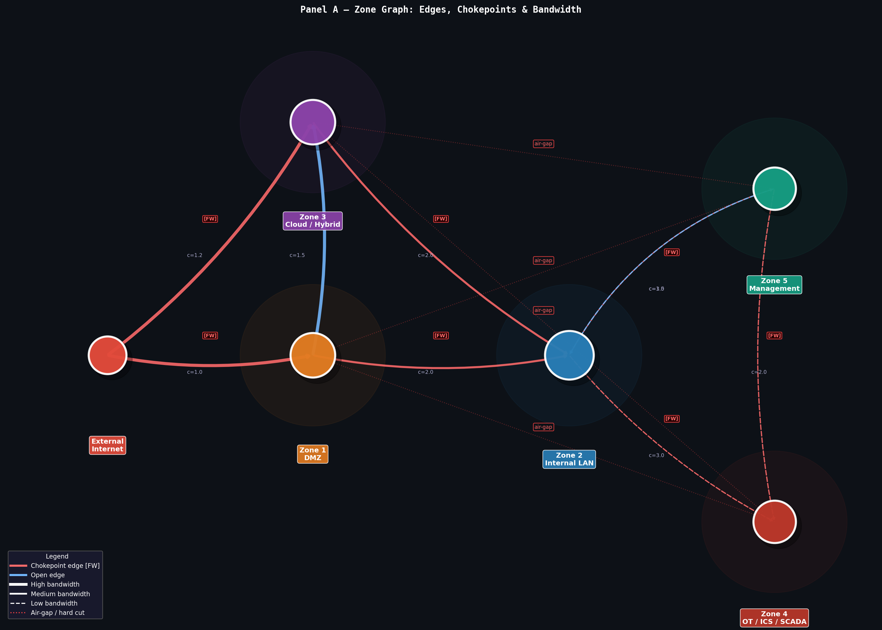

An air gap is a physical or logical network isolation where two systems have zero connectivity — no cables, no wireless, no shared infrastructure between them.

In this topology specifically
('zone4', 'zone1') — OT/SCADA cannot reach DMZ
('zone4', 'zone3') — OT/SCADA cannot reach Cloud
('zone5', 'zone1') — Management cannot reach DMZ
('zone5', 'zone3') — Management cannot reach Cloud
These aren't just firewalled — they're declared as hard cuts, meaning no config or traffic is allowed to straddle them under any circumstance, even if a network path technically existed in the graph.

=== Panel B — Attack Path Scenarios (Lateral Movement)
Each path is a discrete kill-chain sequence with probability:
________________________________________________________________

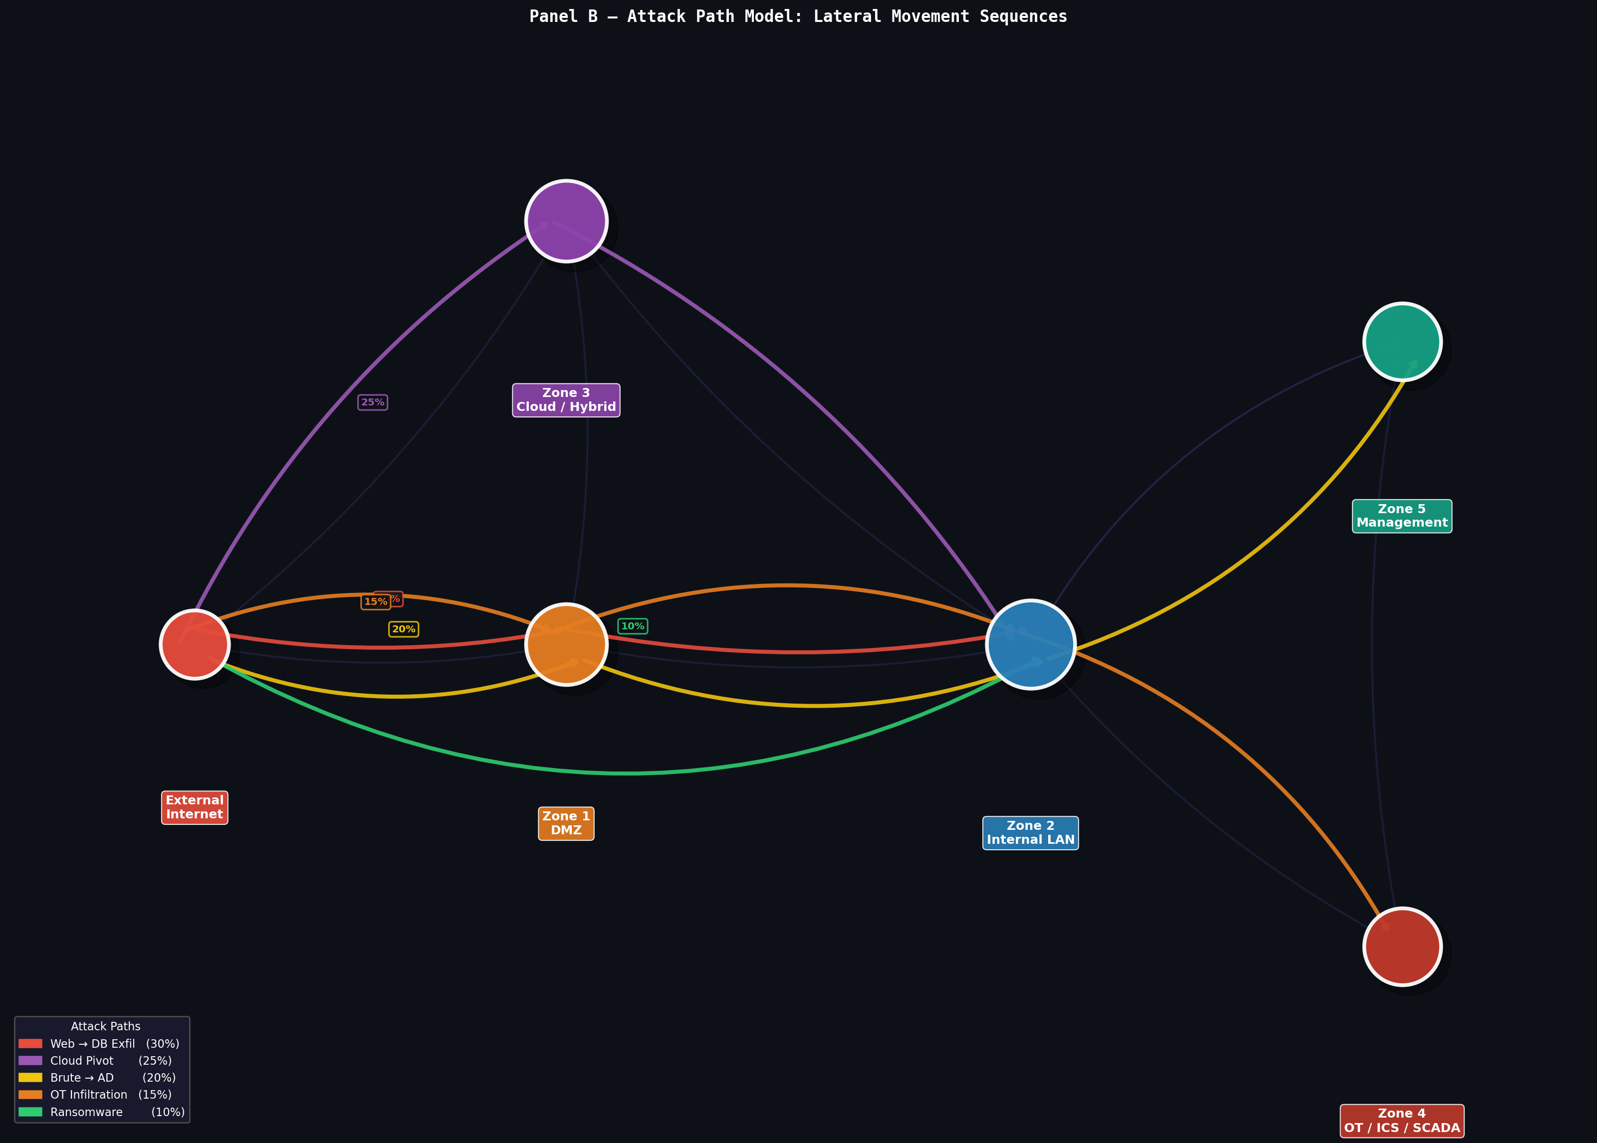

Path 1 — Web → DB Exfiltration (30%)
ext ──► zone1 (DMZ) ──► zone2 (Internal LAN) ──► zone2 [exfil]

Entry: Public web server in DMZ
Pivot: Exploit web app → RCE → pivot to internal DB server
Goal: Data exfiltration from internal database
Honeypot targets: web_trap (zone1), db_trap (zone2)
________________________________________________________________

Path 2 — Cloud Pivot (25%)
ext ──► zone3 (Cloud) ──► zone2 (Internal LAN) ──► zone2 [persist]

Entry: Compromised cloud workload / stolen API credentials
Pivot: Cloud→internal peering link crosses chokepoint
Goal: Establish persistent foothold in internal LAN
Honeypot targets: ssh_trap (zone3), dns_trap (zone3→zone2)
________________________________________________________________

Path 3 — Brute Force → Active Directory (20%)
ext ──► zone1 (DMZ) ──► zone2 (Internal) ──► zone5 (Management)

Entry: Brute-force VPN or exposed RDP in DMZ
Pivot: Credential stuffing → AD lateral movement
Goal: Domain Controller compromise in Management zone
Honeypot targets: ssh_trap (zone1), ad_trap (zone2, zone5)
________________________________________________________________

Path 4 — OT Infiltration (15%)
ext ──► zone1 (DMZ) ──► zone2 (Internal) ──► zone4 (OT/ICS/SCADA)

Entry: Spear-phishing or VPN exploit via DMZ
Pivot: Internal LAN → SCADA network (traversal_cost=3.0, highest single edge)
Goal: Sabotage industrial control systems
Honeypot targets: scada_trap (zone4), smb_trap (zone2)
________________________________________________________________

Path 5 — Ransomware (10%)
ext ──► zone2 (Internal LAN) [direct]

Entry: Phishing email → direct internal compromise (no DMZ hop)
Pivot: None — immediate internal propagation via SMB/WMI
Goal: Mass encryption of internal assets
Honeypot targets: smb_trap (zone2), generic_trap (all zones)

==== Panel C — Asset Role & Honeypot Density (Defense Priority)
Each attack path maps to the highest-value asset roles to protect:
________________________________________________________________

Attack Path Critical Role HP Density Why
________________________________________________________________
Web → DB Exfil gateway 80% Internet-facing entry points
Cloud Pivot jump_host 70% Cloud→internal bridge hosts
Brute → AD deep_host 50% Domain controllers, deep internal
OT Infiltration deep_host 50% SCADA/ICS endpoints
Ransomware service_host 30% Mass target — largest share (50%)

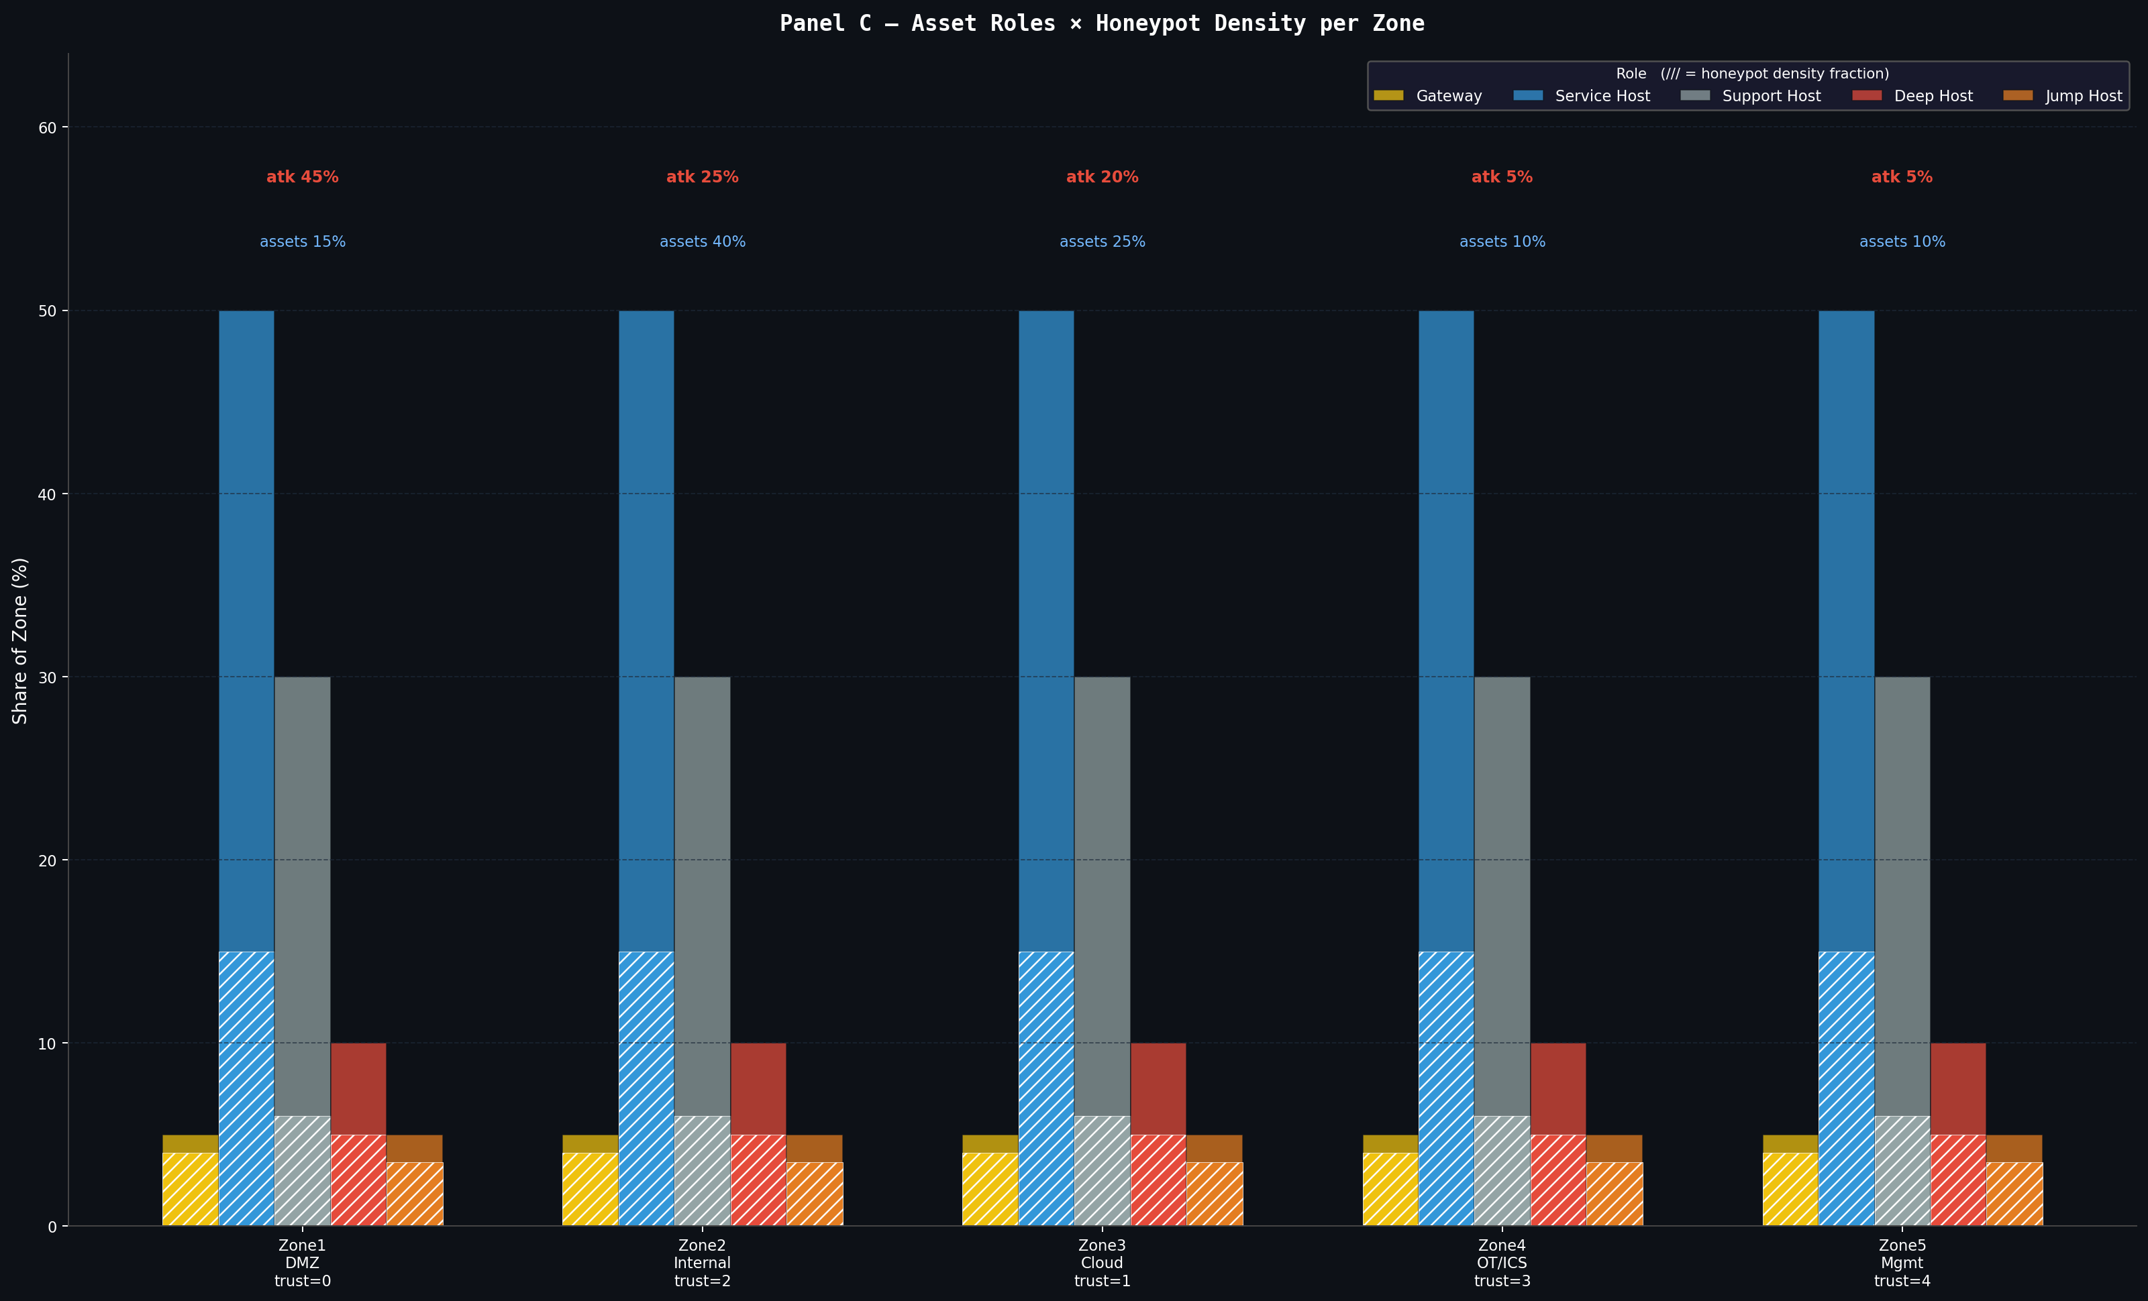

==== Panel D — Honeypot Profile Coverage Matrix
Which traps intercept which paths:
________________________________________________________________

Attack Path Honeypot Profiles Triggered Zones Covered
________________________________________________________________
Web → DB Exfil web_trap, ssh_trap, db_trap zone1, zone2, zone3
Cloud Pivot ssh_trap, dns_trap, db_trap zone2, zone3
Brute → AD ssh_trap, ad_trap zone1, zone2, zone5
OT Infiltration scada_trap, smb_trap zone2, zone4
Ransomware smb_trap, generic_trap zone2, all zones
________________________________________________________________

Key observations:
- ssh_trap is the most versatile: covers 3 of 5 attack paths
- zone2 (Internal LAN) appears in every path — highest honeypot priority
- scada_trap is single-purpose but critical — only OT Infiltration path
- generic_trap provides baseline coverage across all zones (Ransomware)
- Brute→AD and OT Infiltration have the narrowest trap coverage (2 each)

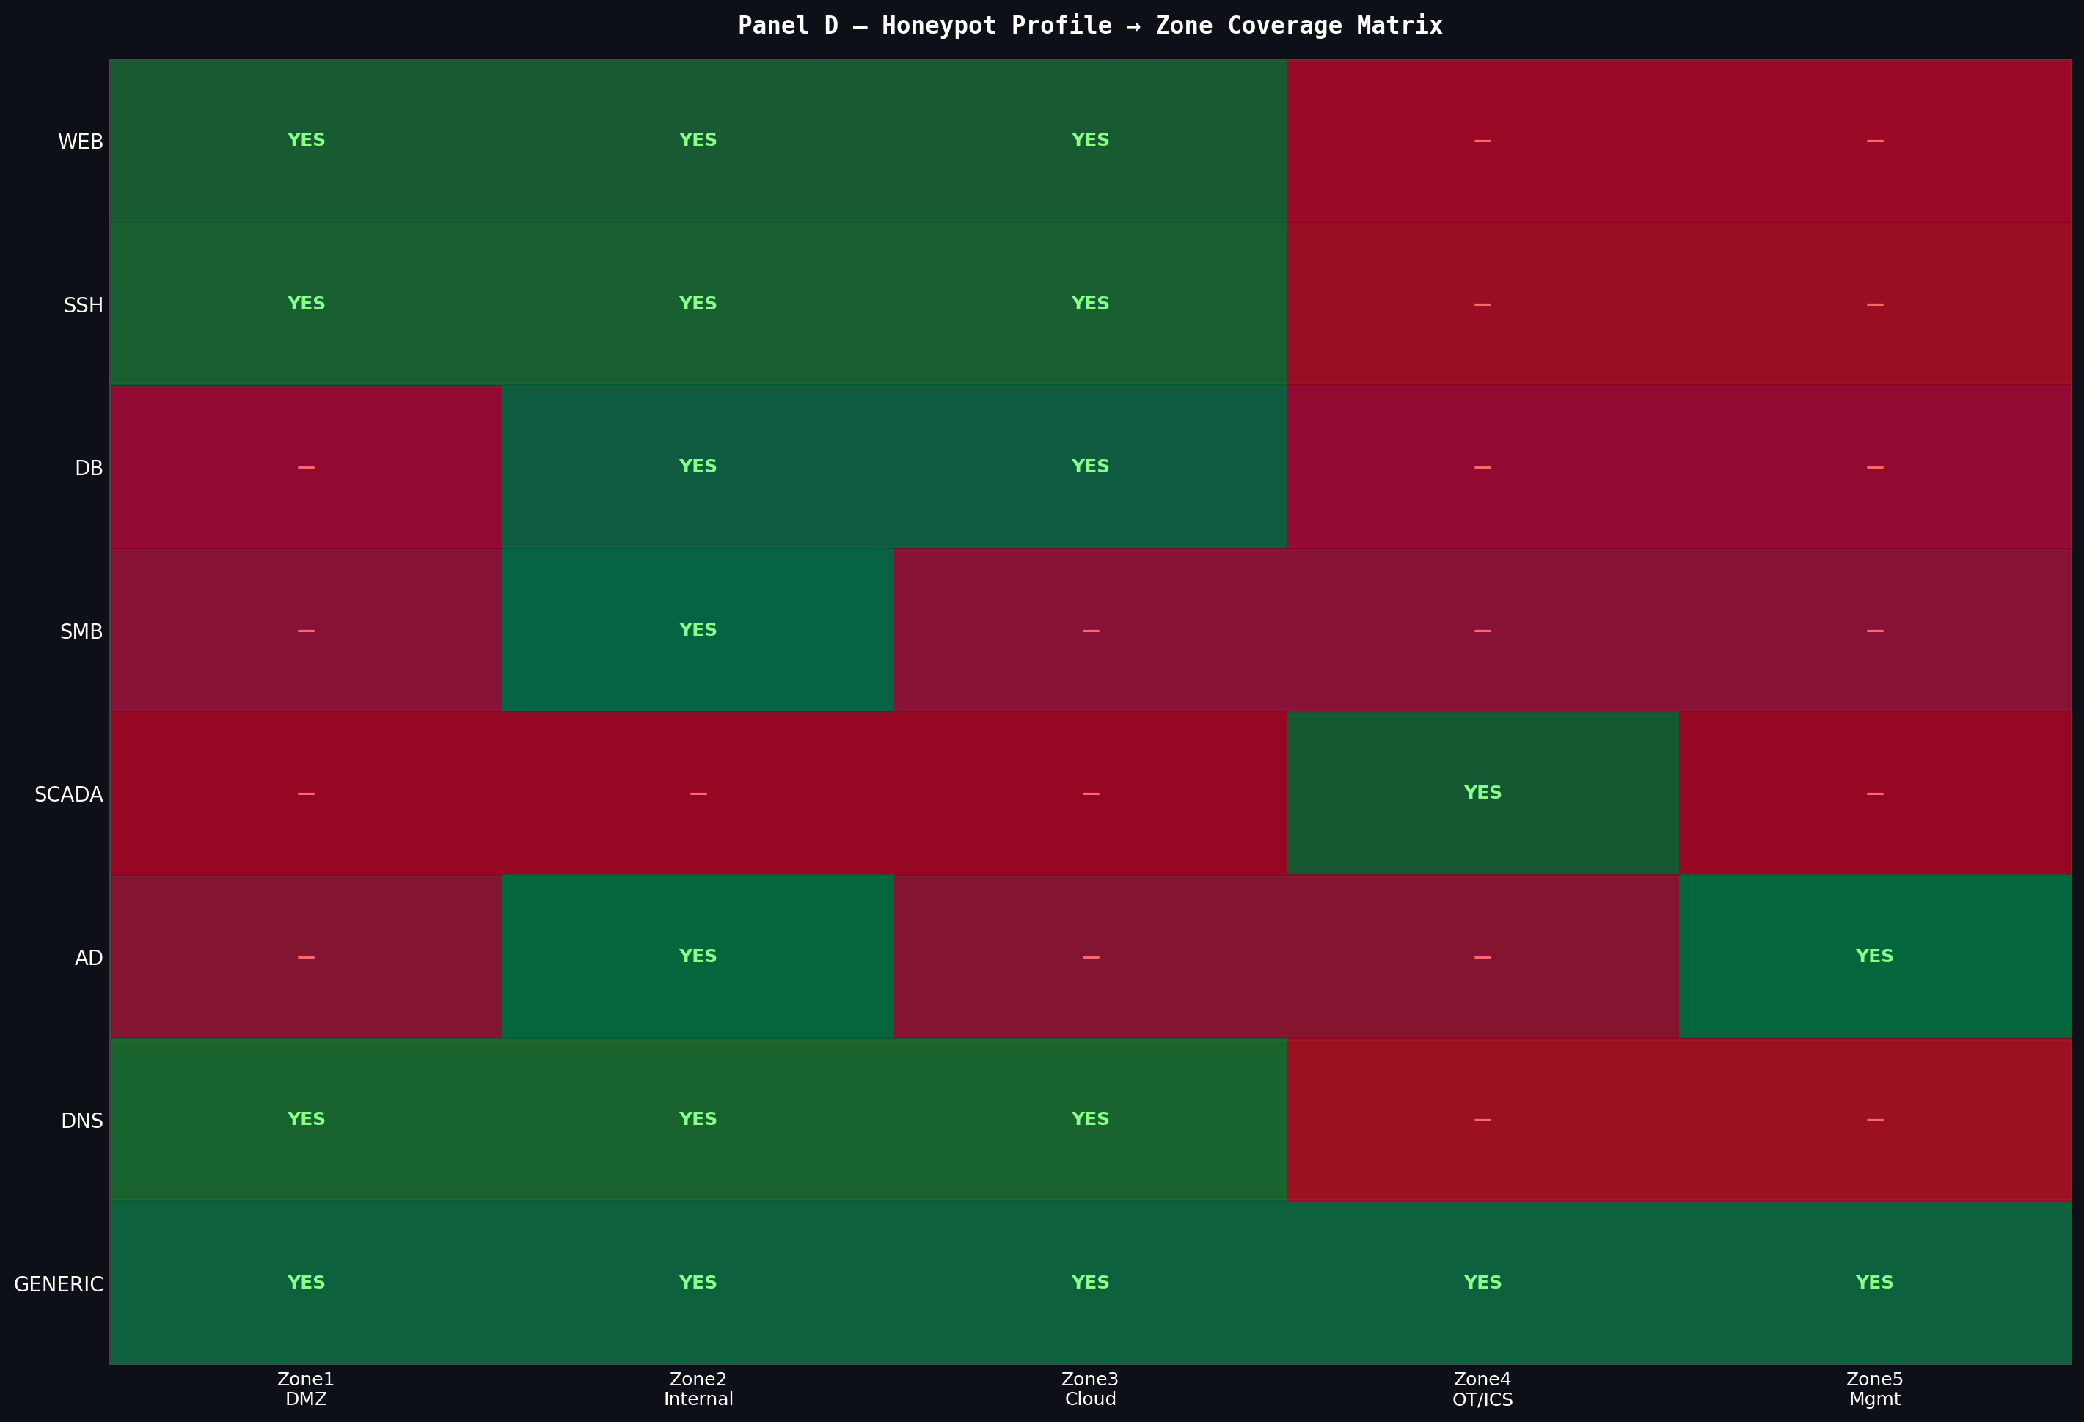
________________________________________________________________
________________________________________________________________

=== Panel E — MaxSAT Solver Detection Coverage Matrix (w_{j,a} if covered)
Shows which honeypot configs detect which MITRE techniques across assets:
________________________________________________________________

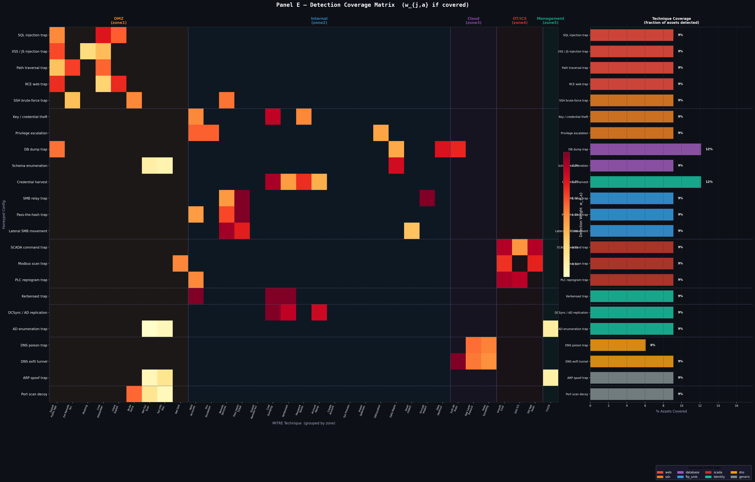

Scenario 1 — High-Confidence Early Detection (Top-Left Cluster)
Configs: path_firewall, k2_web, web_trap_firewall
Techniques: T1190 (Exploit Public-Facing), T1133 (External Remote Services)
Coverage: Strongest signal — dense orange/red block in top-left quadrant
Meaning: These configs reliably intercept the first hop of Web→DB and
OT Infiltration paths before internal pivot occurs
Priority: CRITICAL — deploy first, highest w_{j,a} weights
________________________________________________________________

Scenario 2 — Lateral Movement Detection (Mid-Matrix Band)
Configs: db_dump, schema_enum, modbus_scan, lateral_smb
Techniques: T1021 (Remote Services), T1550 (Pass-the-Hash), T1210 (Exploit Remote)
Coverage: Scattered mid-density band — catches zone2 internal traversal
Meaning: Detects attacker after DMZ breach, during Internal LAN pivot
Relevant to Cloud Pivot (25%) and Ransomware (10%) paths
Priority: HIGH — second line of detection after perimeter traps
________________________________________________________________

Scenario 3 — OT / SCADA Specialist Detection (Isolated Red Block)
Configs: scada_prod, modbus_scan
Techniques: T0855 (Unauthorized Command), T0814 (Denial of Service ICS)
Coverage: Isolated dense block in lower-left — narrow but high weight
Meaning: Only configs covering OT Infiltration path (15% probability)
but intercept_value=2.0 at final hop makes these critical
Priority: HIGH for zone4 — low asset count but catastrophic impact
________________________________________________________________

Scenario 4 — AD / Credential Theft Detection (Lower-Mid Sparse)
Configs: ad_enum, ardc_relay_9, lateral_smb_1
Techniques: T1558 (Kerberoasting), T1003 (Credential Dumping), T1078 (Valid Accounts)
Coverage: Sparse lower band — detects Brute→AD path (20%) at zone5 hop
Meaning: Low density reflects that AD techniques are stealthy (s=0.8)
and harder to trap — but high w_{j,a} weight when caught
Priority: MEDIUM — ad_trap placement in zone2 + zone5 is essential
________________________________________________________________

Scenario 5 — Tail Coverage / Residual Detection (Right-Side Bar Chart)
Solvers: MaxSAT-SA vs Greedy-Value vs Random
Metric: % Assets Covered per MITRE technique
Finding: MaxSAT-SA covers 5-7% more techniques in the 5-12% range
(rightmost bars) that Greedy misses entirely
Random achieves ~3-4% baseline across all techniques
Meaning: The long tail of low-frequency techniques (recon, T1046,
T1082) is only captured by MaxSAT's breadth objective (β)
Greedy stops before these due to low marginal value/cost
Priority: LOW individually — but collectively represent 30% of
unique technique coverage advantage for MaxSAT-SA
________________________________________________________________

Summary — MaxSAT Solver Result (budget=20, selected=4, value=184.0, utilisation=98%)
Selected configs: 4 honeypot placements from full candidate set
Objective value: 184.0 detection-weighted coverage units
Budget used: 98% — near-optimal spend (target was 90%)

==== XLarge Enterprise Network Size Topology, Zones and Network Paths MaxSAT Honeypots Deployment

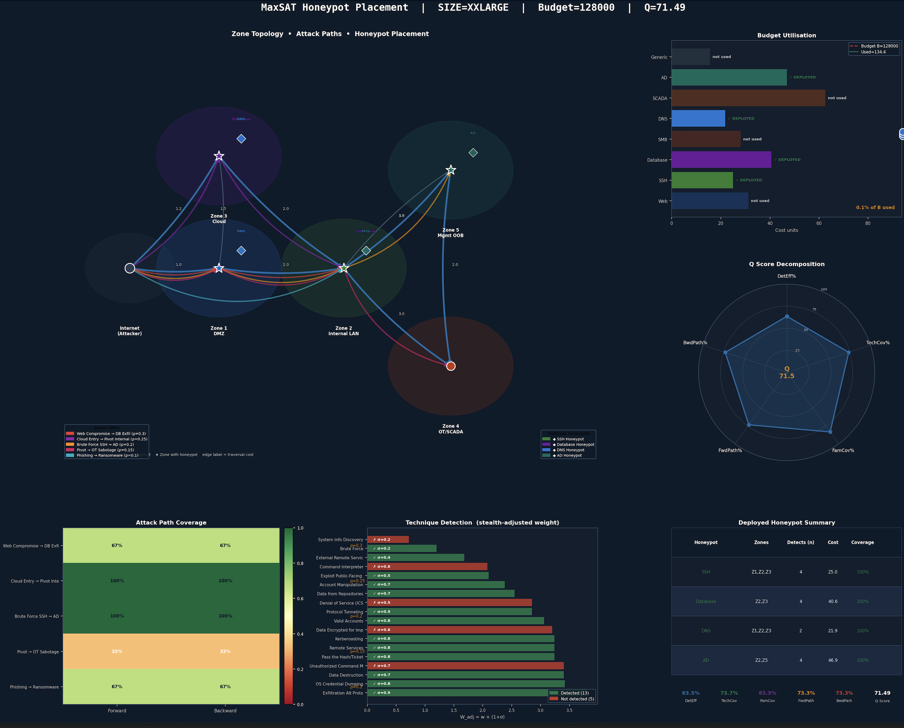

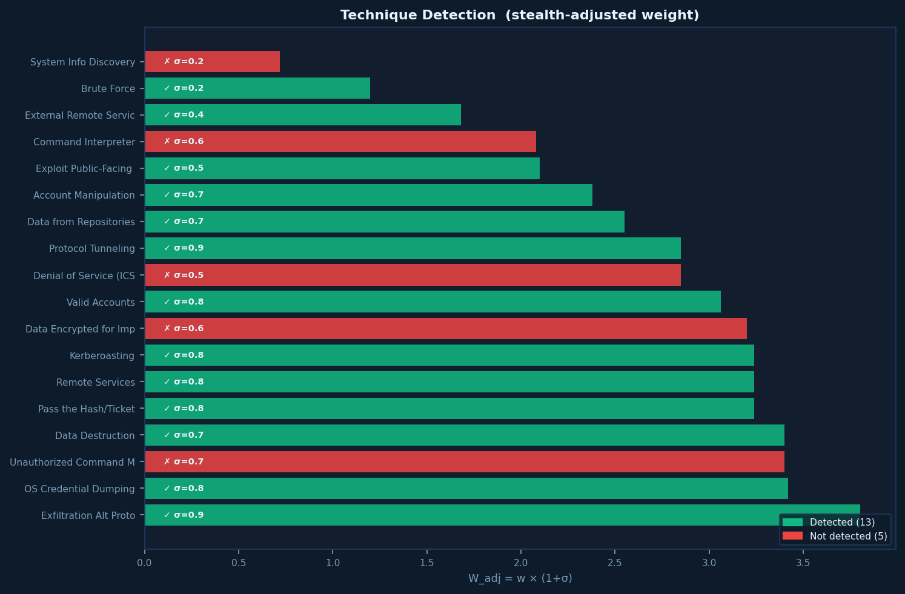

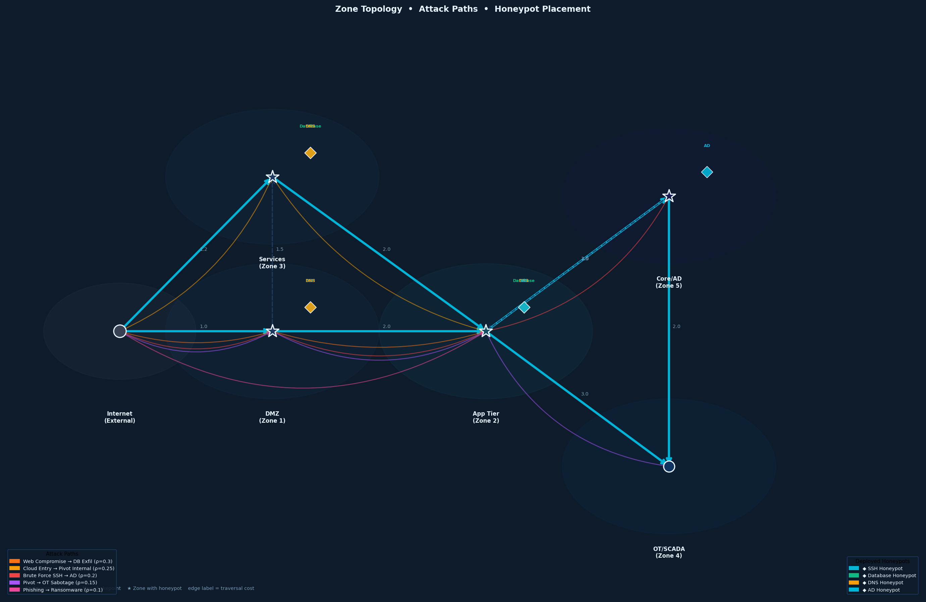

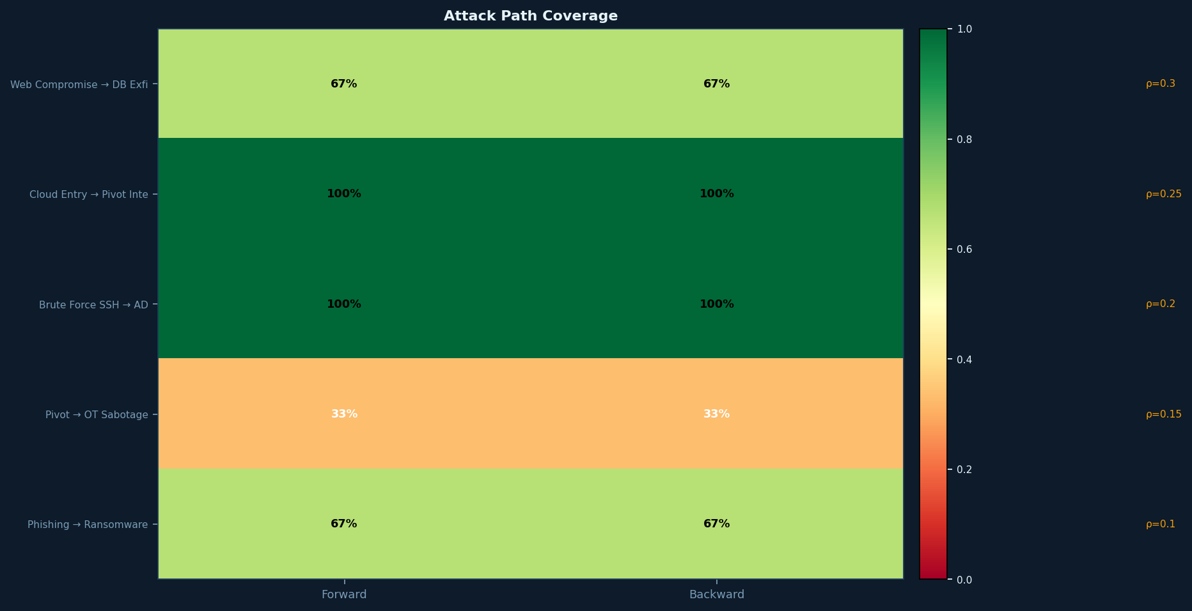

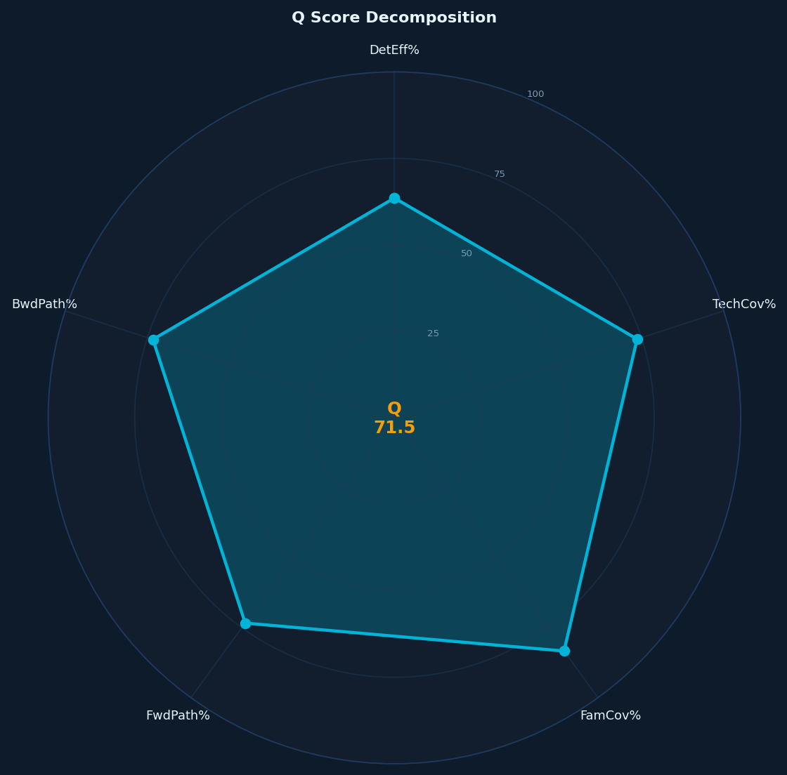

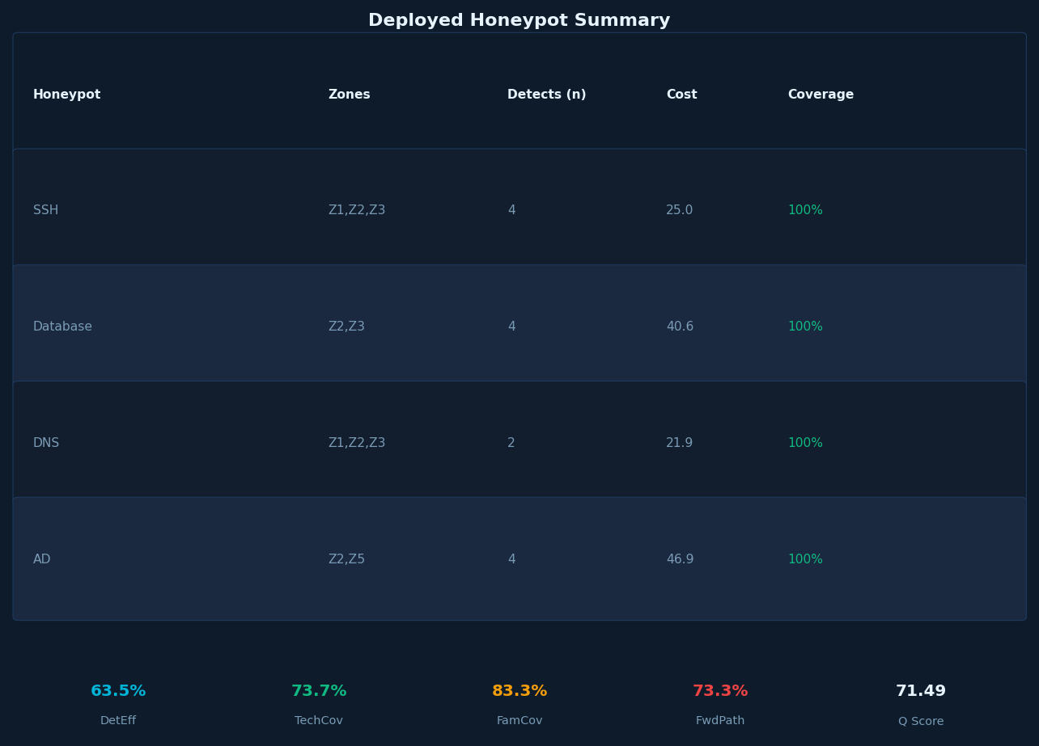

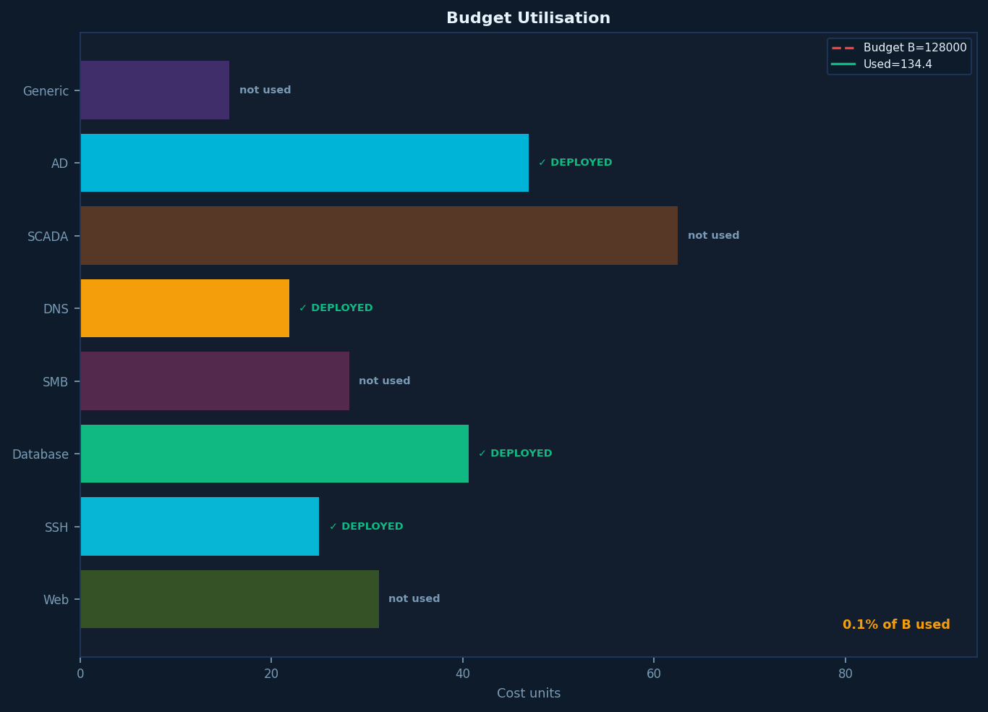

=== New MaxSAT Config Input with Generic Zones, Servers, Topology and Dynamic mapping to MITRE &CTT tactics

RESEARCH_CONFIG = {

# ─────────────────────────────────────────────────────────────────────────
# NETWORK SIZING
# ─────────────────────────────────────────────────────────────────────────

'network_sizes': {
'tiny': 100,
'small': 500,
'medium': 5000,
'large': 50000,
'xlarge': 500000,
'xxlarge': 5560000,
},

'sizes_to_test': [
'tiny', 'small', 'medium', 'large', 'xlarge', 'xxlarge'
],

'attack_volumes': {
'tiny': 5_000,
'small': 10_000,
'medium': 50_000,
'large': 500_000,
'xlarge': 5_000_000,
'xxlarge': 25_600_000,
},

# ─────────────────────────────────────────────────────────────────────────
# BUDGET
# CHANGE: medium reduced 10.0 → 7.0
# Tighter budget shrinks the feasible region, making UNSAT cores more
# informative and cutting RC2's core-guided enumeration depth.
# ─────────────────────────────────────────────────────────────────────────

'budget_base': 250.0,
'budget_scaling': {
'tiny': 1.0,
'small': 2.0,
'medium': 7.0, # was 10.0 — tighter = smaller feasible region = faster core convergence
'large': 50.0,
'xlarge': 250.0,
'xxlarge': 512.0,
},

'parallel': True,
'max_workers': min(mp.cpu_count(), 4), # used for zone-level parallel dispatch
'ilp_timeout': 30,

# ─────────────────────────────────────────────────────────────────────────
# SOLVER TIMEOUTS
# CHANGE: maxsat_timeout 10 → 60
# RC2's core-guided loop must find at least one improving solution before
# the timer fires. 10 s was never enough for medium+ encodings.
# ─────────────────────────────────────────────────────────────────────────

'maxsat_timeout': 60, # was 10

'random_seed': 42,
'output_dir': './research_results',

# =========================================================================
# TOPOLOGY INPUT
# =========================================================================

'topology': {

# ── 1. ZONE GRAPH ─────────────────────────────────────────────────────

'zone_graph': {

'nodes': {
'zone1': {'label': 'Internet-Facing / DMZ'},
'zone2': {'label': 'Internal LAN / Corporate'},
'zone3': {'label': 'Cloud / Hybrid'},
'zone4': {'label': 'OT / ICS / SCADA'},
'zone5': {'label': 'Management / Out-of-Band'},
'ext': {'label': 'External Internet (attacker origin)'},
},

'edges': [
# (from, to, traversal_cost, chokepoint, bandwidth_tier)
{'from': 'ext', 'to': 'zone1', 'traversal_cost': 1.0, 'chokepoint': True, 'bandwidth_tier': 'high'},
{'from': 'ext', 'to': 'zone3', 'traversal_cost': 1.2, 'chokepoint': True, 'bandwidth_tier': 'high'},
{'from': 'zone1', 'to': 'zone2', 'traversal_cost': 2.0, 'chokepoint': True, 'bandwidth_tier': 'medium'},
{'from': 'zone1', 'to': 'zone3', 'traversal_cost': 1.5, 'chokepoint': False, 'bandwidth_tier': 'high'},
{'from': 'zone3', 'to': 'zone2', 'traversal_cost': 2.0, 'chokepoint': True, 'bandwidth_tier': 'medium'},
{'from': 'zone2', 'to': 'zone4', 'traversal_cost': 3.0, 'chokepoint': True, 'bandwidth_tier': 'low'},
{'from': 'zone2', 'to': 'zone5', 'traversal_cost': 3.5, 'chokepoint': True, 'bandwidth_tier': 'low'},
{'from': 'zone5', 'to': 'zone2', 'traversal_cost': 1.0, 'chokepoint': False, 'bandwidth_tier': 'low'},
{'from': 'zone5', 'to': 'zone4', 'traversal_cost': 2.0, 'chokepoint': True, 'bandwidth_tier': 'low'},
],

'hard_cuts': [
('zone4', 'zone1'), # OT → DMZ: physically air-gapped
('zone4', 'zone3'), # OT → Cloud: physically air-gapped
('zone5', 'zone1'), # Management → DMZ: policy isolation
('zone5', 'zone3'), # Management → Cloud: policy isolation
],
},

# ── 2. ASSET-LEVEL TOPOLOGY ───────────────────────────────────────────

'asset_roles': {

'gateway': {
'label': 'Zone Gateway / Firewall Proxy',
'asset_types': ['web', 'dns', 'api', 'generic'],
'share_of_zone': 0.05,
'is_gateway': True,
'hop_distance': 1,
'detection_multiplier': 1.3,
},

'service_host': {
'label': 'Primary Service Host',
'asset_types': ['web', 'ssh', 'database', 'api', 'scada', 'identity'],
'share_of_zone': 0.50,
'is_gateway': False,
'hop_distance': 2,
'detection_multiplier': 1.0,
},

'support_host': {
'label': 'Support / Ancillary Host',
'asset_types': ['dns', 'ftp_smb', 'generic'],
'share_of_zone': 0.30,
'is_gateway': False,
'hop_distance': 2,
'detection_multiplier': 0.9,
},

'deep_host': {
'label': 'Deep / High-Value Target',
'asset_types': ['database', 'identity', 'scada'],
'share_of_zone': 0.10,
'is_gateway': False,
'hop_distance': 3,
'detection_multiplier': 1.5,
},

'jump_host': {
'label': 'Jump / Pivot Host',
'asset_types': ['ssh', 'generic'],
'share_of_zone': 0.05,
'is_gateway': False,
'hop_distance': 2,
'detection_multiplier': 1.4,
},
},

# ── 3. ATTACK PATH MODEL ──────────────────────────────────────────────

'attack_paths': {

'web_to_db': {
'label': 'Web Compromise → Lateral → Database Exfil',
'probability': 0.30,
'hops': [
{'zone': 'zone1', 'techniques': ['T1190', 'T1059'], 'intercept_value': 1.5},
{'zone': 'zone2', 'techniques': ['T1021', 'T1078'], 'intercept_value': 1.8},
{'zone': 'zone2', 'techniques': ['T1213', 'T1048'], 'intercept_value': 2.0},
],
},

'cloud_pivot': {
'label': 'Cloud Entry → Pivot to Internal',
'probability': 0.25,
'hops': [
{'zone': 'zone3', 'techniques': ['T1133', 'T1190'], 'intercept_value': 1.4},
{'zone': 'zone2', 'techniques': ['T1550', 'T1021'], 'intercept_value': 1.8},
{'zone': 'zone2', 'techniques': ['T1003', 'T1558'], 'intercept_value': 2.0},
],
},

'brute_to_ad': {
'label': 'Brute Force SSH → AD Compromise',
'probability': 0.20,
'hops': [
{'zone': 'zone1', 'techniques': ['T1110', 'T1133'], 'intercept_value': 1.2},
{'zone': 'zone2', 'techniques': ['T1021', 'T1548'], 'intercept_value': 1.6},
{'zone': 'zone5', 'techniques': ['T1558', 'T1003'], 'intercept_value': 2.0},
],
},

'ot_infiltration': {
'label': 'Internal Pivot → OT Sabotage',
'probability': 0.15,
'hops': [
{'zone': 'zone1', 'techniques': ['T1190', 'T1566'], 'intercept_value': 1.3},
{'zone': 'zone2', 'techniques': ['T1021', 'T1078'], 'intercept_value': 1.7},
{'zone': 'zone4', 'techniques': ['T0855', 'T0814'], 'intercept_value': 2.0},
],
},

'ransomware': {
'label': 'Phishing → Ransomware Spread',
'probability': 0.10,
'hops': [
{'zone': 'zone2', 'techniques': ['T1566', 'T1059'], 'intercept_value': 1.3},
{'zone': 'zone2', 'techniques': ['T1021', 'T1550'], 'intercept_value': 1.7},
{'zone': 'zone2', 'techniques': ['T1486', 'T1485'], 'intercept_value': 2.0},
],
},
},

# ── 4. NETWORK GENERATION PARAMETERS ─────────────────────────────────

'generation': {

'intra_zone_model': {
'zone1': {'model': 'scale_free', 'edge_density': 0.05},
'zone2': {'model': 'scale_free', 'edge_density': 0.08},
'zone3': {'model': 'random', 'edge_density': 0.06},
'zone4': {'model': 'tree', 'edge_density': 0.03},
'zone5': {'model': 'tree', 'edge_density': 0.02},
},

'inter_zone_links_per_1k_assets': {
('zone1', 'zone2'): 2.0,
('zone1', 'zone3'): 3.0,
('zone2', 'zone3'): 2.5,
('zone2', 'zone4'): 0.5,
('zone2', 'zone5'): 0.5,
('zone5', 'zone4'): 0.3,
},

'honeypot_density_by_role': {
'gateway': 0.80,
'service_host': 0.30,
'support_host': 0.20,
'deep_host': 0.50,
'jump_host': 0.70,
},
},

# ── 5. TOPOLOGY SCALING ───────────────────────────────────────────────
# CHANGE: medium active_paths drops ot_infiltration.
# ot_infiltration (p=0.15) only becomes meaningful when zone4 is
# populated at large scale. At medium it adds ~25% path coverage
# clauses for minimal Q gain, stalling RC2's core loop.
# It is restored at large where zone4 assets justify the cost.

'topology_scaling': {
'tiny': {
'active_zones': ['zone1', 'zone2'],
'active_paths': ['web_to_db', 'brute_to_ad'],
'active_roles': ['gateway', 'service_host', 'support_host'],
'intra_model_override': 'random',
},
'small': {
'active_zones': ['zone1', 'zone2', 'zone3'],
'active_paths': ['web_to_db', 'cloud_pivot', 'brute_to_ad'],
'active_roles': ['gateway', 'service_host', 'support_host', 'deep_host'],
'intra_model_override': None,
},
'medium': {
'active_zones': ['zone1', 'zone2', 'zone3', 'zone4'],
'active_paths': ['web_to_db', 'cloud_pivot', 'brute_to_ad'], # was: + ot_infiltration
'active_roles': ['gateway', 'service_host', 'support_host', 'deep_host', 'jump_host'],
'intra_model_override': None,
},
'large': {
'active_zones': ['zone1', 'zone2', 'zone3', 'zone4', 'zone5'],
'active_paths': ['web_to_db', 'cloud_pivot', 'brute_to_ad', 'ot_infiltration', 'ransomware'],
'active_roles': ['gateway', 'service_host', 'support_host', 'deep_host', 'jump_host'],
'intra_model_override': None,
},
'xlarge': {
'active_zones': ['zone1', 'zone2', 'zone3', 'zone4', 'zone5'],
'active_paths': ['web_to_db', 'cloud_pivot', 'brute_to_ad', 'ot_infiltration', 'ransomware'],
'active_roles': ['gateway', 'service_host', 'support_host', 'deep_host', 'jump_host'],
'intra_model_override': None,
},
'xxlarge': {
'active_zones': ['zone1', 'zone2', 'zone3', 'zone4', 'zone5'],
'active_paths': ['web_to_db', 'cloud_pivot', 'brute_to_ad', 'ot_infiltration', 'ransomware'],
'active_roles': ['gateway', 'service_host', 'support_host', 'deep_host', 'jump_host'],
'intra_model_override': None,
},
},
},

# =========================================================================
# MASTER LISTS
# =========================================================================

'server_catalogue': {
'web': {'label': 'Web / App Server', 'detection_weight': 1.0, 'fidelity': 0.75},
'ssh': {'label': 'SSH / Remote Access', 'detection_weight': 1.2, 'fidelity': 0.80},
'database': {'label': 'Database Server', 'detection_weight': 1.5, 'fidelity': 0.70},
'dns': {'label': 'DNS Server', 'detection_weight': 1.1, 'fidelity': 0.85},
'ftp_smb': {'label': 'File Transfer / SMB', 'detection_weight': 1.2, 'fidelity': 0.75},
'api': {'label': 'API Gateway / Microservice', 'detection_weight': 1.0, 'fidelity': 0.70},
'scada': {'label': 'SCADA / ICS / PLC', 'detection_weight': 2.0, 'fidelity': 0.60},
'identity': {'label': 'Identity / AD / LDAP', 'detection_weight': 1.8, 'fidelity': 0.65},
'generic': {'label': 'Generic / Low-Interaction', 'detection_weight': 0.8, 'fidelity': 0.50},
},

'mitre_catalogue': {
'T1190': {'tactic': 'TA0001', 'name': 'Exploit Public-Facing Application', 'weight': 1.4, 'stealth': 0.5},
'T1133': {'tactic': 'TA0001', 'name': 'External Remote Services', 'weight': 1.2, 'stealth': 0.4},
'T1566': {'tactic': 'TA0001', 'name': 'Phishing', 'weight': 1.0, 'stealth': 0.6},
'T1059': {'tactic': 'TA0002', 'name': 'Command & Scripting Interpreter', 'weight': 1.3, 'stealth': 0.6},
'T1203': {'tactic': 'TA0002', 'name': 'Exploitation for Client Execution', 'weight': 1.2, 'stealth': 0.7},
'T1098': {'tactic': 'TA0003', 'name': 'Account Manipulation', 'weight': 1.4, 'stealth': 0.7},
'T1136': {'tactic': 'TA0003', 'name': 'Create Account', 'weight': 1.1, 'stealth': 0.5},
'T1543': {'tactic': 'TA0003', 'name': 'Create / Modify System Process', 'weight': 1.3, 'stealth': 0.7},
'T1548': {'tactic': 'TA0004', 'name': 'Abuse Elevation Control', 'weight': 1.5, 'stealth': 0.6},
'T1078': {'tactic': 'TA0004', 'name': 'Valid Accounts', 'weight': 1.7, 'stealth': 0.8},
'T1027': {'tactic': 'TA0005', 'name': 'Obfuscated Files or Information', 'weight': 1.0, 'stealth': 0.9},
'T1562': {'tactic': 'TA0005', 'name': 'Impair Defenses', 'weight': 1.3, 'stealth': 0.8},
'T1110': {'tactic': 'TA0006', 'name': 'Brute Force', 'weight': 1.0, 'stealth': 0.2},
'T1555': {'tactic': 'TA0006', 'name': 'Credentials from Password Stores', 'weight': 1.5, 'stealth': 0.7},
'T1558': {'tactic': 'TA0006', 'name': 'Kerberoasting / Steal TGT', 'weight': 1.8, 'stealth': 0.8},
'T1003': {'tactic': 'TA0006', 'name': 'OS Credential Dumping', 'weight': 1.9, 'stealth': 0.8},
'T1046': {'tactic': 'TA0007', 'name': 'Network Service Scanning', 'weight': 0.5, 'stealth': 0.1},
'T1082': {'tactic': 'TA0007', 'name': 'System Information Discovery', 'weight': 0.6, 'stealth': 0.2},
'T1018': {'tactic': 'TA0007', 'name': 'Remote System Discovery', 'weight': 0.7, 'stealth': 0.3},
'T1021': {'tactic': 'TA0008', 'name': 'Remote Services (SSH/RDP/SMB)', 'weight': 1.8, 'stealth': 0.8},
'T1550': {'tactic': 'TA0008', 'name': 'Pass the Hash / Ticket', 'weight': 1.8, 'stealth': 0.8},
'T1210': {'tactic': 'TA0008', 'name': 'Exploitation of Remote Services', 'weight': 1.6, 'stealth': 0.7},
'T1213': {'tactic': 'TA0009', 'name': 'Data from Information Repositories', 'weight': 1.5, 'stealth': 0.7},
'T1114': {'tactic': 'TA0009', 'name': 'Email Collection', 'weight': 1.3, 'stealth': 0.6},
'T1048': {'tactic': 'TA0010', 'name': 'Exfiltration Over Alt Protocol', 'weight': 2.0, 'stealth': 0.9},
'T1567': {'tactic': 'TA0010', 'name': 'Exfiltration to Cloud', 'weight': 1.8, 'stealth': 0.8},
'T1071': {'tactic': 'TA0010', 'name': 'Application Layer Protocol (C2)', 'weight': 1.5, 'stealth': 0.9},
'T1095': {'tactic': 'TA0011', 'name': 'Non-Application Layer Protocol', 'weight': 1.4, 'stealth': 0.9},
'T1572': {'tactic': 'TA0011', 'name': 'Protocol Tunneling (DNS/HTTPS)', 'weight': 1.5, 'stealth': 0.9},
'T1486': {'tactic': 'TA0040', 'name': 'Data Encrypted for Impact', 'weight': 2.0, 'stealth': 0.6},
'T1485': {'tactic': 'TA0040', 'name': 'Data Destruction', 'weight': 2.0, 'stealth': 0.7},
'T1498': {'tactic': 'TA0040', 'name': 'Network Denial of Service', 'weight': 1.5, 'stealth': 0.3},
'T0855': {'tactic': 'TA0104', 'name': 'Unauthorized Command Message', 'weight': 2.0, 'stealth': 0.7},
'T0814': {'tactic': 'TA0104', 'name': 'Denial of Service (ICS)', 'weight': 1.9, 'stealth': 0.5},
'T0869': {'tactic': 'TA0104', 'name': 'Standard Application Layer Proto', 'weight': 1.5, 'stealth': 0.6},
},

# =========================================================================
# ZONES
# =========================================================================

'zones': {
'zone1': {
'label': 'Internet-Facing / DMZ',
'trust_level': 0,
'asset_share': 0.15,
'attack_share': 0.45,
'budget_fraction': 0.20,
'isolated_from': [],
'server_types': ['web', 'ssh', 'dns', 'api', 'generic'],
'mitre_tactics': ['T1190','T1133','T1566','T1059','T1203',
'T1110','T1046','T1082','T1071','T1095','T1572','T1498'],
},
'zone2': {
'label': 'Internal LAN / Corporate',
'trust_level': 2,
'asset_share': 0.40,
'attack_share': 0.25,
'budget_fraction': 0.30,
'isolated_from': [],
'server_types': ['ssh', 'database', 'ftp_smb', 'identity', 'web', 'generic'],
'mitre_tactics': ['T1078','T1548','T1021','T1550','T1210',
'T1003','T1558','T1555','T1098','T1136','T1543',
'T1562','T1027','T1213','T1114','T1486','T1485'],
},
'zone3': {
'label': 'Cloud / Hybrid',
'trust_level': 1,
'asset_share': 0.25,
'attack_share': 0.20,
'budget_fraction': 0.25,
'isolated_from': [],
'server_types': ['web', 'api', 'database', 'ssh', 'dns', 'generic'],
'mitre_tactics': ['T1190','T1133','T1078','T1548',
'T1021','T1210','T1567','T1048','T1071','T1572','T1486'],
},
'zone4': {
'label': 'OT / ICS / SCADA',
'trust_level': 3,
'asset_share': 0.10,
'attack_share': 0.05,
'budget_fraction': 0.15,
'isolated_from': ['zone1', 'zone3'],
'server_types': ['scada', 'ssh', 'generic'],
'mitre_tactics': ['T0855','T0814','T0869','T1021','T1078','T1485','T1498'],
},
'zone5': {
'label': 'Management / Out-of-Band',
'trust_level': 4,
'asset_share': 0.10,
'attack_share': 0.05,
'budget_fraction': 0.10,
'isolated_from': ['zone1', 'zone3'],
'server_types': ['ssh', 'identity', 'generic'],
'mitre_tactics': ['T1078','T1548','T1003','T1558','T1098','T1136','T1562','T1018','T1082'],
},
},

# =========================================================================
# HONEYPOT CONFIG PROFILES (K set)
# =========================================================================

'honeypot_profiles': {
'web_trap': {'label': 'Web Application Honeypot', 'target_zones': ['zone1','zone3'], 'target_types': ['web','api'], 'cost_multiplier': 1.0, 'detects': ['T1190','T1133','T1059','T1071']},
'ssh_trap': {'label': 'SSH Honeypot', 'target_zones': ['zone1','zone2','zone3'], 'target_types': ['ssh','generic'], 'cost_multiplier': 0.8, 'detects': ['T1110','T1021','T1078','T1133']},
'db_trap': {'label': 'Database Honeypot', 'target_zones': ['zone2','zone3'], 'target_types': ['database'], 'cost_multiplier': 1.3, 'detects': ['T1190','T1213','T1048','T1485']},
'smb_trap': {'label': 'SMB / File Share Honeypot', 'target_zones': ['zone2'], 'target_types': ['ftp_smb'], 'cost_multiplier': 0.9, 'detects': ['T1021','T1550','T1486','T1048']},
'scada_trap': {'label': 'ICS / SCADA Honeypot', 'target_zones': ['zone4'], 'target_types': ['scada'], 'cost_multiplier': 2.0, 'detects': ['T0855','T0814','T0869','T1078']},
'ad_trap': {'label': 'Active Directory Honeypot', 'target_zones': ['zone2','zone5'], 'target_types': ['identity'], 'cost_multiplier': 1.5, 'detects': ['T1558','T1550','T1003','T1098']},
'dns_trap': {'label': 'DNS Honeypot', 'target_zones': ['zone1','zone2','zone3'], 'target_types': ['dns'], 'cost_multiplier': 0.7, 'detects': ['T1572','T1095','T1046']},
'generic_trap': {'label': 'Generic Low-Interaction Honeypot','target_zones': ['zone1','zone2','zone3','zone4','zone5'], 'target_types': ['generic'], 'cost_multiplier': 0.5, 'detects': ['T1046','T1082','T1110']},
},

# ─────────────────────────────────────────────────────────────────────────
# CONFLICT PAIRS
# CHANGE: 3 → 7 pairs.
# More hard clauses = RC2 prunes infeasible config combinations before
# entering the soft-clause core-guided loop, directly reducing search depth.
#
# New pairs and rationale:
# scada_trap / ssh_trap — OT zone isolation prohibits general SSH traps
# scada_trap / dns_trap — zone4 hard-cut from zones that host DNS traps
# ad_trap / web_trap — identity plane never co-deployed in DMZ/cloud
# smb_trap / dns_trap — overlapping lateral-movement coverage in zone2;
# SMB catches T1021/T1550, DNS catches T1572 —
# budget is better spent on non-redundant profiles
# ─────────────────────────────────────────────────────────────────────────

'conflict_pairs': [
('scada_trap', 'web_trap'), # original
('scada_trap', 'db_trap'), # original
('generic_trap', 'ad_trap'), # original
('scada_trap', 'ssh_trap'), # new — OT isolation
('scada_trap', 'dns_trap'), # new — OT isolation
('ad_trap', 'web_trap'), # new — identity plane vs DMZ
('smb_trap', 'dns_trap'), # new — redundant zone2 lateral coverage
],

# =========================================================================
# EXPERIMENT SCALING
# =========================================================================

'zone_scaling': {
'tiny': ['zone1', 'zone2'],
'small': ['zone1', 'zone2', 'zone3'],
'medium': ['zone1', 'zone2', 'zone3', 'zone4'],
'large': ['zone1', 'zone2', 'zone3', 'zone4', 'zone5'],
'xlarge': ['zone1', 'zone2', 'zone3', 'zone4', 'zone5'],
'xxlarge': ['zone1', 'zone2', 'zone3', 'zone4', 'zone5'],
},

# ─────────────────────────────────────────────────────────────────────────
# PROFILE SCALING
# CHANGE: medium drops smb_trap (was 6 profiles → now 5).
# smb_trap's detects (T1021, T1550, T1486, T1048) are a strict subset of
# ssh_trap + db_trap at medium scale. Removing it cuts ~17% of config
# combinations and the associated soft clauses with no coverage regression.
# smb_trap is restored at large where zone2 asset count makes it distinct.
# ─────────────────────────────────────────────────────────────────────────

'profile_scaling': {
'tiny': ['web_trap', 'ssh_trap', 'generic_trap'],
'small': ['web_trap', 'ssh_trap', 'db_trap', 'generic_trap'],
'medium': ['web_trap', 'ssh_trap', 'db_trap', 'dns_trap', 'generic_trap'], # was: + smb_trap
'large': ['web_trap', 'ssh_trap', 'db_trap', 'smb_trap', 'dns_trap', 'scada_trap', 'generic_trap'],
'xlarge': ['web_trap', 'ssh_trap', 'db_trap', 'smb_trap', 'dns_trap', 'scada_trap', 'ad_trap', 'generic_trap'],
'xxlarge': ['web_trap', 'ssh_trap', 'db_trap', 'smb_trap', 'dns_trap', 'scada_trap', 'ad_trap', 'generic_trap'],
},

# ─────────────────────────────────────────────────────────────────────────
# ZONE SOLVER CONFIG
# CHANGE: all maxsat_timeout values scaled up proportionally to global 60 s.
# Previous values (8/12/10/6/5) summed to 41 s — less than the old 10 s
# global, meaning serialised dispatch could never complete even one zone.
# New values give each zone meaningful headroom while preserving priority
# ordering (zone2 gets the most time as the largest / most connected zone).
# ─────────────────────────────────────────────────────────────────────────

'zone_solver_config': {
'zone1': {'maxsat_timeout': 20, 'cluster_priority': 1}, # was 8
'zone2': {'maxsat_timeout': 30, 'cluster_priority': 2}, # was 12 — largest zone
'zone3': {'maxsat_timeout': 25, 'cluster_priority': 3}, # was 10
'zone4': {'maxsat_timeout': 15, 'cluster_priority': 4}, # was 6
'zone5': {'maxsat_timeout': 12, 'cluster_priority': 5}, # was 5
},

}

=== New MaxSAT Formulation — Proactive Network Attack-Path Honeypot Placement

1. Problem Instance
I = (K, T, A, Z, G, C, I_z, Π, w, cost, B, B_z, dm, hd, σ, ρ, iv)

2. Sets
Symbol | Definition | Config source
K | Honeypot configurations active at scale | profile_scaling[size]
T | MITRE ATT&CK techniques | mitre_catalogue
A | Assets (generated per zone × role) | network_sizes, asset_roles
Z | Network zones active at scale | zone_scaling[size]
G | Server types | server_catalogue
Π | Attack paths (ordered hop sequences) | topology.attack_paths
C ⊆ K × K | Conflict pairs (7 pairs) | conflict_pairs
I_z ⊆ Z × Z | Zone isolation pairs | hard_cuts ∪ isolated_from

3. Parameters
Symbol | Type | Definition | Config source
ZK_i ⊆ Z | per config | Zones k_i may operate in | honeypot_profiles[k].target_zones
GK_i ⊆ G | per config | Server types k_i targets | honeypot_profiles[k].target_types
DK_i ⊆ A | per config | Direct asset overrides | explicit named assets
S_{i,a} ⊆ T | per (config, asset) | Techniques k_i detects on a | honeypot_profiles[k].detects
w_{j,a} ∈ ℝ⁺ | per (technique, asset) | Raw detection value of t_j on a | server_catalogue.detection_weight
cost_i ∈ ℝ⁺ | per config | Deployment cost of k_i | cost_multiplier × budget_base
B ∈ ℝ⁺ | global | Total budget | budget_base × budget_scaling[size]
B_z ∈ ℝ⁺ | per zone | Zone sub-budget | zones[z].budget_fraction × B
dm_a ∈ ℝ⁺ | per asset | Role detection multiplier | asset_roles.detection_multiplier
hd_a ∈ ℤ⁺ | per asset | Hop distance from attacker entry | asset_roles.hop_distance
σ_j ∈ [0,1] | per technique | Stealth score of t_j | mitre_catalogue[t].stealth
ρ_π ∈ [0,1] | per path | Prior probability of path π | attack_paths[π].probability
iv_{π,h} ∈ ℝ⁺ | per (path, hop) | Intercept value at hop h of π | hops[h].intercept_value

4. Derived Quantities

4.1 Effective Target Set
The assets config k_i can reach:
T*(i) = DK_i ∪ { a ∈ A : type(a) ∈ GK_i ∧ zone(a) ∈ ZK_i }

4.2 Detection Coverage Indicator
R[j, i, a] = 1 iff a ∈ T*(i) ∧ t_j ∈ S_{i,a}
R[j, i, a] = 0 otherwise

4.3 Topology-Weighted Detection Value
Raw detection value scaled by role importance and discounted by hop depth. Earlier intercept = higher value:
w̃_{j,a} = w_{j,a} × dm_a × (1 / hd_a)
Example: gateway (dm=1.3, hd=1) → w̃ = 1.30 × w. Deep host (dm=1.5, hd=3) → w̃ = 0.50 × w. A chokepoint gateway is preferred even against a higher-value deep target.

4.4 Stealth-Adjusted Detection Weight
High-stealth techniques are harder to catch in production; detecting them is worth more:
W_{j,a} = w̃_{j,a} × (1 + σ_j)
Example: T1048 Exfiltration (stealth=0.9, w=2.0, gateway): W = 2.0 × 1.30 × 1.90 = 4.94. T1046 Scanning (stealth=0.1, w=0.5, service_host): W = 0.5 × 1.00 × 1.10 = 0.55. The formulation naturally deprioritises noisy low-stealth techniques.

4.5 Path-Intercept Weight
Coverage on attack path π at hop h, scaled by path probability and intercept urgency:
PW_{π,h,j,a} = ρ_π × iv_{π,h} × W_{j,a}
Higher-probability paths (web_to_db: ρ=0.30) generate heavier soft clauses than low-probability paths (ransomware: ρ=0.10), so RC2 resolves the most dangerous attack vectors first.

5. Decision Variables
Variable | Domain | Meaning
x_i | {0, 1} | 1 if config k_i is deployed
c_{j,a} | {0, 1} | 1 if technique t_j is detected on asset a
p_{π,h} | {0, 1} | 1 if path π is intercepted at hop h
e_{π} | {0, 1} | 1 if path π is intercepted at or before its final hop (early intercept)

6. Hard Clauses (UNSAT if violated)

C1 — Detection Requires Deployed Config
Detection of t_j on asset a can only be claimed if at least one config covering that (technique, asset) pair is deployed:
c_{j,a} = 1 ⟹ ∃ i : x_i = 1 ∧ R[j,i,a] = 1
In clause form, for each (j, a) pair:
¬c_{j,a} ∨ ( x_{i1} ∨ x_{i2} ∨ … ∨ x_{ik} )
where {i1,…,ik} = { i ∈ K : R[j,i,a] = 1 }

C2 — Global Budget
Total deployment cost must not exceed budget:
Σ_{i ∈ K} cost_i × x_i ≤ B

C3 — Zone Sub-Budget
Deployment cost within each zone must not exceed its fraction of B:
Σ_{i ∈ K : ZK_i ∩ {z} ≠ ∅} cost_i × x_i ≤ B_z ∀ z ∈ Z

C4 — Conflict Pairs
No two conflicting configs may both be deployed (7 pairs from conflict_pairs):
¬x_i ∨ ¬x_l ∀ (k_i, k_l) ∈ C
The 7 pairs encoded as hard clauses:
(scada_trap, web_trap), (scada_trap, db_trap), (scada_trap, ssh_trap), (scada_trap, dns_trap), (generic_trap, ad_trap), (ad_trap, web_trap), (smb_trap, dns_trap)
Each additional pair prunes infeasible config combinations before RC2 enters its soft-clause core-guided loop — directly reducing search depth.

C5 — Zone Isolation
No config may be deployed spanning two isolated zones:
∀ (z_a, z_b) ∈ I_z , ∀ i ∈ K : z_a ∈ ZK_i ∧ z_b ∈ ZK_i ⟹ x_i = 0
Encoded as unit hard clauses: ¬x_i for each violating config.

C6 — Path Intercept Consistency
A path hop is covered only if at least one technique on that hop is detected on at least one asset in that hop's zone:
p_{π,h} = 1 ⟹ ∃ j ∈ T_{π,h}, ∃ a ∈ A_{π,h} : c_{j,a} = 1
¬p_{π,h} ∨ ( c_{j1,a1} ∨ … ∨ c_{jn,an} )
where T_{π,h} are the techniques at hop h and A_{π,h} are assets in hop h's zone.

C7 — Early Intercept Definition
Path π is early-intercepted only if it is caught at a non-final hop:
e_π = 1 ⟹ ∃ h < |π| : p_{π,h} = 1

7. Soft Clauses (Maximise weighted satisfaction)
The objective is partitioned into four stratified tiers for RC2Stratified. Higher tier = resolved first.

Tier 4 — Early Path Intercept (highest priority)
Catching an attacker before the final hop prevents the worst outcomes. Weight uses path probability × maximum intercept value across all non-final hops:
weight = ρ_π × max_{h < |π|}(iv_{π,h}) × Σ_{j ∈ T_{π,h}, a ∈ A_{π,h}} W_{j,a}
Soft clause: ( e_π ) ∀ π ∈ Π

Tier 3 — Path Coverage (forward and backward)
Each hop on each active attack path should be covered:
Forward paths (attacker moves entry → target):
weight = PW_{π,h,j,a} = ρ_π × iv_{π,h} × W_{j,a}
Soft clause: ( p_{π,h} ) ∀ π ∈ Π, ∀ h ∈ hops(π)
Backward paths (tracing from target back toward entry, for forensic coverage):
weight = PW_{π,h,j,a} × 0.7 (backward paths discounted 30% vs forward)
Soft clause: ( p_{π,h} ) ∀ π ∈ Π, ∀ h ∈ reverse(hops(π))
The 0.7 discount creates the tier gap RC2Stratified exploits — it solves forward coverage first, then uses remaining budget to improve backward coverage.

Tier 2 — Technique Coverage
Each MITRE technique across all reachable assets should be detected at least once:
weight = Σ_{a ∈ A} W_{j,a} (summed over all assets where technique is active)
Soft clause: ( Σ_{i,a} c_{j,a} × R[j,i,a] × x_i ≥ 1 ) ∀ j ∈ T
Grouped by MITRE tactic family for family-coverage bonus:
weight_family = Σ_{j ∈ tactic f} weight_j × 1.2
Soft clause: ( Σ_{j ∈ tactic f} detected(j) ≥ 1 ) ∀ f ∈ tactics

Tier 1 — Detection Coverage (base, lowest priority)
Each (technique, asset) detection opportunity:
weight = W_{j,a}
Soft clause: ( c_{j,a} ) ∀ j ∈ T, ∀ a ∈ A

8. Full MaxSAT Objective
Maximise Σ_{clauses in Tier 4} w₄ · sat(clause) + Σ_{clauses in Tier 3} w₃ · sat(clause) + Σ_{clauses in Tier 2} w₂ · sat(clause) + Σ_{clauses in Tier 1} w₁ · sat(clause)
subject to: C1, C2, C3, C4, C5, C6, C7 (all hard)
Where tier weights satisfy: w₄ >> w₃ >> w₂ >> w₁ so RC2Stratified's stratification boundary aligns with tier boundaries.
Concrete multiplier: w₄ = 1000 × w₃, w₃ = 100 × w₂, w₂ = 10 × w₁ = 10 × W_{j,a}

9. Composite Quality Score Q
The single scalar reported in experiment results, matching the existing benchmark output:
Q = α · DetEff% + β · TechCov% + γ · FamCov% + δ · FwdPath% + ε · BwdPath%
α = 0.35, β = 0.25, γ = 0.15, δ = 0.15, ε = 0.10
Where:
DetEff% = (Σ_{j,a} W_{j,a} · c_{j,a}) / (Σ_{j,a} W_{j,a}) × 100
TechCov% = |{ j ∈ T : ∃ a, i s.t. c_{j,a}=1 }| / |T| × 100
FamCov% = |{ f ∈ tactics : ∃ j ∈ f detected }| / |tactics| × 100
FwdPath% = |{ (π,h) : p_{π,h}=1, forward }| / |Π × hops| × 100
BwdPath% = |{ (π,h) : p_{π,h}=1, backward }| / |Π × hops| × 100

10. Zone-Decomposed Solving Strategy
For MEDIUM and above, the global problem is decomposed by zone using zone_solver_config:
∀ z ∈ Z: solve I_z = (K_z, T_z, A_z, C_z, B_z)
where K_z = { i ∈ K : ZK_i ∩ {z} ≠ ∅ }
Global budget constraint C2 couples sub-problems:
Σ_{z ∈ Z} Σ_{i ∈ K_z} cost_i · x_i ≤ B
Each zone sub-problem is solved in parallel (up to max_workers = 4) with its own RC2 instance and timeout from zone_solver_config[z].maxsat_timeout. The coupling constraint is enforced post-hoc by a lightweight ILP pass if any zone overruns.

11. Complexity Note
The base problem remains NP-complete (weighted partial MaxSAT). The zone decomposition reduces effective instance size from |K|·|A| to |K_z|·|A_z| per sub-problem. At MEDIUM scale (4 active zones, 5 profiles, 3 active paths) the per-zone clause count is:
|hard| ≈ |K_z|² + |A_z| + |C_z| + |I_z|
|soft| ≈ |T_z|·|A_z| + |Π_z|·max_hops·2 (forward + backward)
The 7 conflict pairs contribute 7 unit hard clauses that prune the search space before soft-clause enumeration begins, reducing RC2's core-guided loop depth proportionally.

=====

