Walmart Project
Tien V Nguyen

Quarto
Quarto enables you to weave together content and executable code into a finished document. To learn more about Quarto see https://quarto.org.

Running Code
In the following code chunk, load all the libraries you will need:
library(tidyverse)
Warning: package 'tidyverse' was built under R version 4.5.1
Warning: package 'ggplot2' was built under R version 4.5.1
Warning: package 'tibble' was built under R version 4.5.1
Warning: package 'tidyr' was built under R version 4.5.1
Warning: package 'readr' was built under R version 4.5.1
Warning: package 'purrr' was built under R version 4.5.1
Warning: package 'dplyr' was built under R version 4.5.1
Warning: package 'stringr' was built under R version 4.5.1
Warning: package 'forcats' was built under R version 4.5.1
Warning: package 'lubridate' was built under R version 4.5.1
── Attaching core tidyverse packages ──────────────────────── tidyverse 2.0.0 ──
✔ dplyr 1.1.4 ✔ readr 2.1.5
✔ forcats 1.0.1 ✔ stringr 1.5.2
✔ ggplot2 4.0.0 ✔ tibble 3.3.0
✔ lubridate 1.9.4 ✔ tidyr 1.3.1
✔ purrr 1.1.0
── Conflicts ────────────────────────────────────────── tidyverse_conflicts() ──
✖ dplyr::filter() masks stats::filter()
✖ dplyr::lag() masks stats::lag()
ℹ Use the conflicted package (<http://conflicted.r-lib.org/>) to force all conflicts to become errors
library(fixest)
Warning: package 'fixest' was built under R version 4.5.2
library (rio)
Warning: package 'rio' was built under R version 4.5.2
library(vtable)
Warning: package 'vtable' was built under R version 4.5.2
Loading required package: kableExtra
Warning: package 'kableExtra' was built under R version 4.5.2
Attaching package: 'kableExtra'
The following object is masked from 'package:dplyr':
group_rows
library(dplyr)
Linking to data sheet.
project1 <- read.csv("~/ECON 5300/Project1/Walmart_Sales.csv")
Running correlation matrix.
numeric_cols<- c('Weekly_Sales','Temperature','CPI','Unemployment')
cor_matrix <- round(cor(project1[ , numeric_cols], use = "complete.obs"),2)
print(cor_matrix)
Weekly_Sales Temperature CPI Unemployment
Weekly_Sales 1.00 -0.06 -0.07 -0.11
Temperature -0.06 1.00 0.18 0.10
CPI -0.07 0.18 1.00 -0.30
Unemployment -0.11 0.10 -0.30 1.00
Doing demeaned for each variables.
project1 <- project1 %>%
group_by(Store) %>%
mutate(Temperature_poly = Temperature^2,
Temperature_log= log(Temperature),
Weekly_Sales_log= log(Weekly_Sales),
Temperature_dm=Temperature- mean(Temperature),
Temperature_poly_dm=Temperature_poly- mean(Temperature_poly),
Temperature_log_dm=Temperature_log- mean(Temperature_log),
Weekly_Sales_log_dm=Weekly_Sales_log-mean(Weekly_Sales_log),
Weekly_Sales_dm= Weekly_Sales - mean(Weekly_Sales),
CPI_dm=CPI-mean(CPI),
Unemployment_dm=Unemployment -mean(Unemployment))
Warning: There was 1 warning in `mutate()`.
ℹ In argument: `Temperature_log = log(Temperature)`.
ℹ In group 7: `Store = 7`.
Caused by warning in `log()`:
! NaNs produced
Plotting to check best model for model 1.
ggplot(project1, aes(x = Temperature_poly_dm, y = Weekly_Sales_dm)) +geom_point() +labs(x = "Temperature^2 (fixed effect)", y = "Weekly Sale")
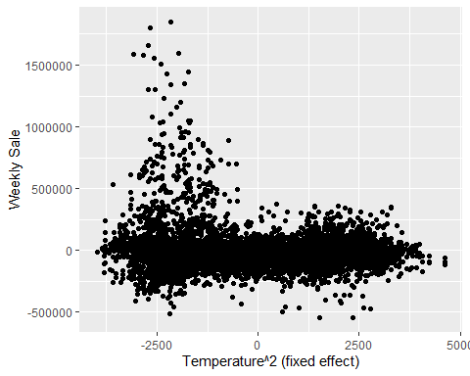
ggplot(project1, aes(x = Temperature_dm, y = Weekly_Sales_dm)) +geom_point() +labs(x = "Temperature (fixed effect)", y = "Weekly Sale")
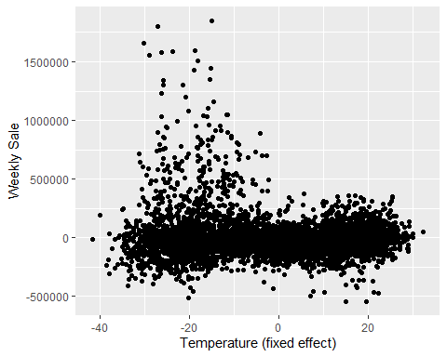
ggplot(project1, aes(x = Temperature_log_dm, y = Weekly_Sales_dm)) +geom_point() +labs(x = "log(Temperature) (demeaned by fixed effect)", y = "Weekly Sale")
Warning: Removed 143 rows containing missing values or values outside the scale range
(`geom_point()`).
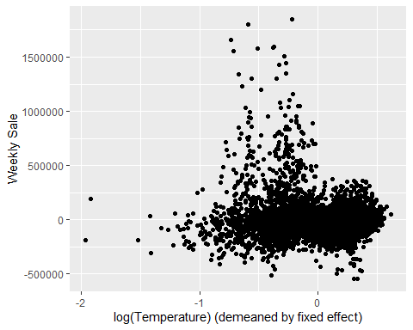
ggplot(project1, aes(x =
Temperature_dm, y = Weekly_Sales_log_dm)) +geom_point() +labs(x = "Temperature (fixed effect)", y = " log(Weekly Sale)")
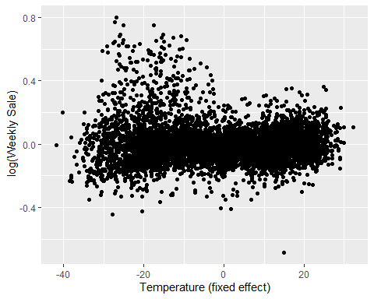
Double check for model 2.
ggplot(project1, aes(x = Temperature_dm+ CPI_dm+ Unemployment_dm, y = Weekly_Sales_log_dm)) +geom_point() +labs(x = "Temperatue,CPI, and Unemployment (fixed effect)", y = " log(Weekly Sale)")
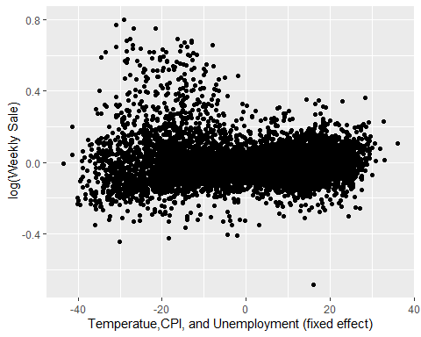
Combining month and assigning them for different seasons. Also, making season becomes factor variables.
project1 <- project1 %>%mutate(Date = dmy(Date), month = month(Date),
season = case_when(month %in% 1:3 ~ "Winter",
month %in% 4:6 ~ "Spring",
month %in% 7:9 ~ "Summer",
month %in% 10:12 ~ "Fall"))
project1 <- project1 %>%mutate(season = factor(season))
Ruuning regression for model 1 and model 2
model1<-feols(log(Weekly_Sales)~ Temperature|Store,vcov=~Store, data= project1 )
model2<-feols(log(Weekly_Sales)~ season+ Temperature+ CPI+ Unemployment | Store, vcov=~Store, data= project1 )
etable(model1,model2)
model1 model2
Dependent Var.: log(Weekly_Sales) log(Weekly_Sales)
Temperature -0.0005* (0.0002) -0.0011*** (0.0002)
seasonSpring -0.0397*** (0.0074)
seasonSummer -0.0435*** (0.0055)
seasonWinter -0.0977*** (0.0113)
CPI -0.0005 (0.0022)
Unemployment -0.0166 (0.0103)
Fixed-Effects: ----------------- -------------------
Store Yes Yes
_______________ _________________ ___________________
S.E.: Clustered by: Store by: Store
Observations 6,435 6,435
R2 0.95726 0.96043
Within R2 0.00375 0.07760
---
Signif. codes: 0 '***' 0.001 '**' 0.01 '*' 0.05 '.' 0.1 ' ' 1
summary(model1)
OLS estimation, Dep. Var.: log(Weekly_Sales)
Observations: 6,435
Fixed-effects: Store: 45
Standard-errors: Clustered (Store)
Estimate Std. Error t value Pr(>|t|)
Temperature -0.000475 0.000216 -2.20041 0.033073 *
---
Signif. codes: 0 '***' 0.001 '**' 0.01 '*' 0.05 '.' 0.1 ' ' 1
RMSE: 0.121612 Adj. R2: 0.95696
Within R2: 0.003748
summary(model2)
OLS estimation, Dep. Var.: log(Weekly_Sales)
Observations: 6,435
Fixed-effects: Store: 45
Standard-errors: Clustered (Store)
Estimate Std. Error t value Pr(>|t|)
seasonSpring -0.039718 0.007434 -5.343007 3.0830e-06 ***
seasonSummer -0.043483 0.005470 -7.949624 4.7657e-10 ***
seasonWinter -0.097740 0.011275 -8.668467 4.5183e-11 ***
Temperature -0.001122 0.000238 -4.707371 2.5182e-05 ***
CPI -0.000482 0.002210 -0.218144 8.2833e-01
Unemployment -0.016614 0.010348 -1.605606 1.1551e-01
---
Signif. codes: 0 '***' 0.001 '**' 0.01 '*' 0.05 '.' 0.1 ' ' 1
RMSE: 0.117017 Adj. R2: 0.96012
Within R2: 0.077604

