# Create Google Meeting using Google Calendar API in Python

This guideline shows how to programmatically schedule meetings using Google Calendar API using Python language. At the moment, this one only schedules a meeting without a meeting link.

**Step 1. Create a Google Cloud Platform project and enable the Google Calendar API.**

* Open Google Cloud Console https://console.cloud.google.com/
* Create a project

* Select project

* Search and select google calendar api

* Click “Enable” to enable Google Calendar API for your project

**Step 2. Create an API key and download the JSON file.**

* Go back to welcome page: <https://console.cloud.google.com/>
* Select API&Services

* Configure the OAuth consent screen. Please refer to the <https://developers.google.com/docs/api/quickstart/python#configure_the_oauth_consent_screen>

* Authorize credentials for a desktop application. Please refer to the <https://developers.google.com/docs/api/quickstart/python#authorize_credentials_for_a_desktop_application>

*Desktop app for now trying with the api

**Step 3. Add the JSON file to your project.**

* Create a python project folder
* Setup a virtual environment to install all required packages locally



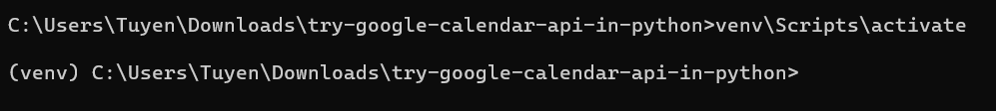

* python -m pip install --upgrade google-api-python-client
* pip install --upgrade google-api-python-client google-auth-httplib2 google-auth-oauthlib
* Create a python file main.py and adding the following lines of code
* Place the JSON credentials file into the project folder. Change the name of the json file into credentials.json

**Step 4. Write code to create a meeting.**

Reference code: <https://github.com/tnguyen7s/research-google-meet-api>

What’s next?

* Create google meet with a link and return the link: (Kiet)
  + Dựa vào cái guiline này, làm lại
  + Thêm code để tạo meeting với meeting link
* Schedule meeting using Javascript, deliverables: (Khai)
  + Code phải chạy
  + Documentation

This reference should be helpful: <https://developers.google.com/docs/api/quickstart/js>