**Step 1. Create a Google Cloud Platform project and enable the Google Calendar API.**

* Open Google Cloud Console https://console.cloud.google.com/
* Create a project

* Select project

* Search and select google calendar api

* Click “Enable” to enable Google Calendar API for your project

**Step 2. Create an API key and download the JSON file.**

* Go back to welcome page: <https://console.cloud.google.com/>
* Select API&Services

* Configure the OAuth consent screen. Please refer to the <https://developers.google.com/docs/api/quickstart/python#configure_the_oauth_consent_screen>

* Authorize credentials for a desktop application. Please refer to the <https://developers.google.com/docs/api/quickstart/python#authorize_credentials_for_a_desktop_application>

*Desktop app for now trying with the api

**Step 3. Add the JSON file to your project.**

* Create a python project folder
* Setup a virtual environment to install all required packages locally



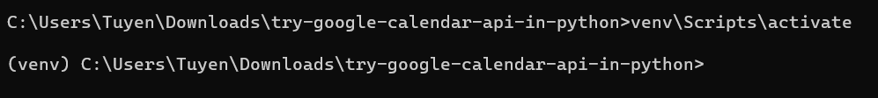

* python -m pip install --upgrade google-api-python-client
* pip install --upgrade google-api-python-client google-auth-httplib2 google-auth-oauthlib
* Create a python file main.py and adding the following lines of code
* Place the JSON credentials file into the project folder. Change the name of the json file into credentials.json

**Step 4. Write code to create a meeting.**

Reference code: <https://github.com/tnguyen7s/research-google-meet-api>

What’s next?

* Create google meet with a link and return the link
* Schedule meeting using JS
  + create a separate documentation for this