AI-Assisted Software Development
Working Process
Spec-Driven Vibe Coding Standard for Enterprise Agentic Systems

Author: Aperium Engineering Team — Hillspire / Merops Automation
Version: 1.0
Date: March 2026

Table of Contents

[Right-click and select 'Update Field' to populate TOC]

Executive Summary
This document defines the standard working process for the Aperium AI Agent Platform engineering team. The process is designed for a team that builds enterprise agentic systems using Python, AI/ML, and ReactJS, and that relies heavily on AI coding assistants — a practice widely known as vibe coding.
Purpose: Establish a repeatable, quality-focused workflow that harnesses AI code generation at every stage of the software development lifecycle while maintaining the discipline required for enterprise-grade software.
Key principles:
- Spec-first, not prompt-first — every feature begins with a lightweight specification before any AI-generated code is written.
- Context engineering over prompt engineering — the team invests in CLAUDE.md, AGENTS.md, and skill files that give AI agents persistent, accurate project knowledge.
- Automate everything that can be automated — linting, type-checking, security scanning, test generation, and even first-pass code review run automatically on every commit.
- Human judgment where it matters — architecture decisions, business logic validation, and security review remain human responsibilities.
- Adapt quickly — the process includes an explicit fast-track path for urgent client feedback and ad-hoc requests.
The workflow integrates the team's primary tools — Augment Code, Claude (Code & Chat), OpenAI Codex, and GitHub Copilot — alongside supplementary tools such as Speckit and Superpower Kit, into a cohesive development lifecycle that moves from ticket to deployment in a controlled, auditable manner.

Process Overview
The development process follows three macro-phases, each with clearly defined inputs, outputs, and responsibilities. The diagram below illustrates the end-to-end flow.
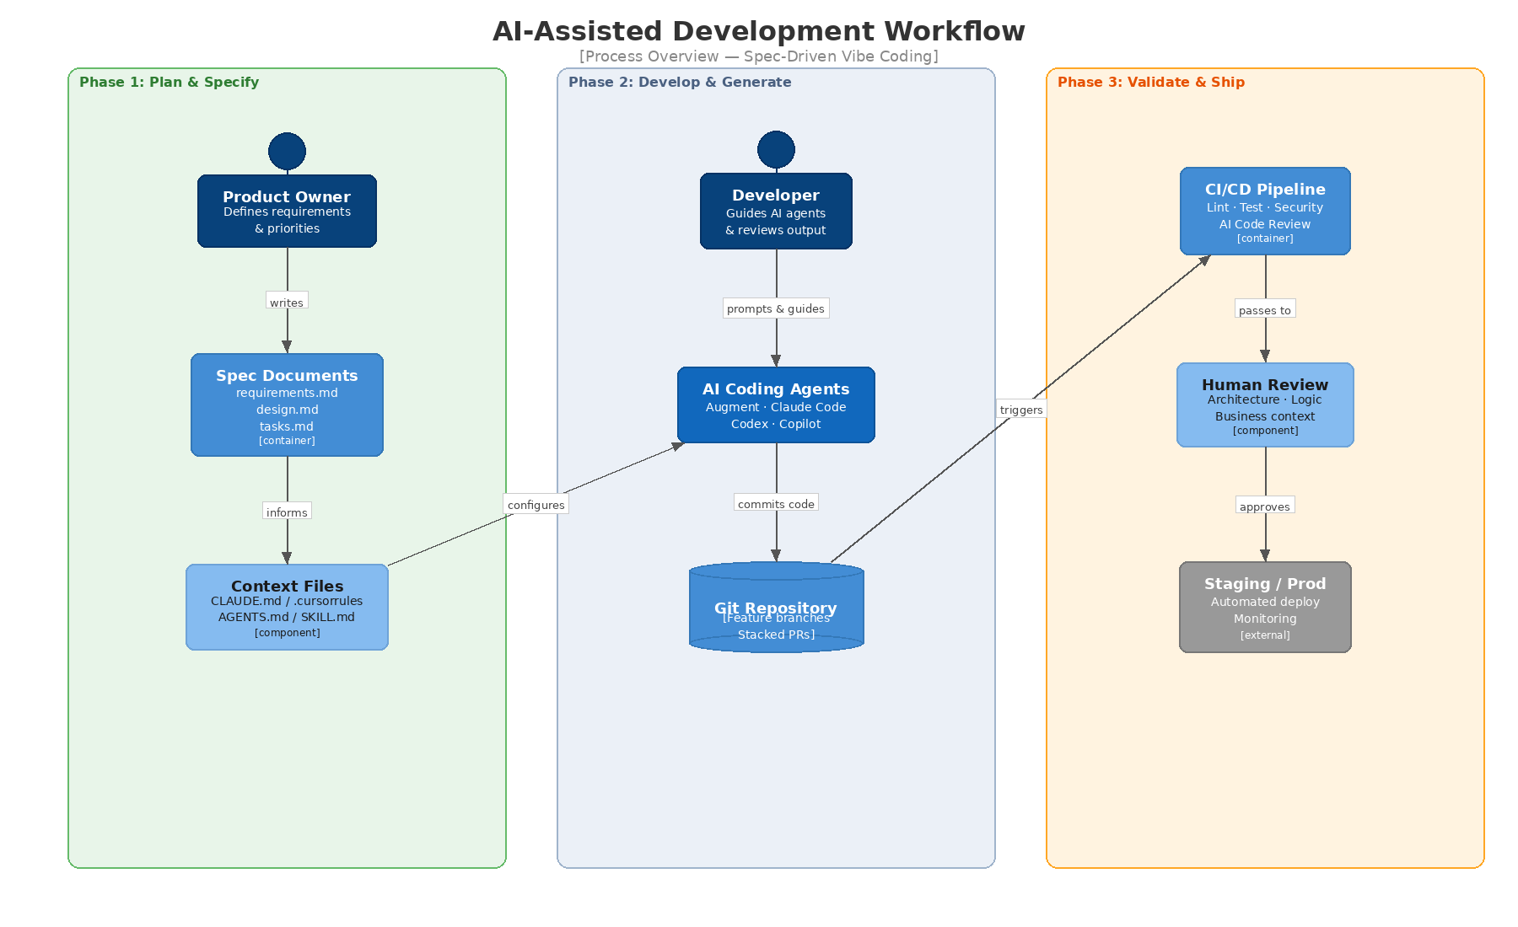
Figure 1: AI-Assisted Development Workflow — Three-Phase Overview

Phase Summary
Phase 1 — Plan & Specify:
The Product Owner (or developer for technical tasks) writes a lightweight spec consisting of three Markdown files: requirements.md, design.md, and tasks.md. AI assistants help generate and refine these specs, but a human reviews and approves them before any implementation begins. Context files (CLAUDE.md, .cursorrules, AGENTS.md) are maintained as living documents that encode the project's architecture, conventions, and known pitfalls.
Phase 2 — Develop & Generate:
Developers use AI coding agents to implement the task breakdown from the spec. Each task is implemented on a feature branch, validated locally (lint, type-check, tests), and committed. The developer acts as a director — providing intent, reviewing each AI output, and course-correcting — rather than writing every line by hand.
Phase 3 — Validate & Ship:
Every push triggers the CI/CD pipeline, which runs automated linting, testing, security scanning, and AI-assisted code review. A human reviewer inspects architecture, business logic, and edge cases. Once approved, the change is merged and deployed through staging to production with feature flags where appropriate.

Tool Ecosystem & Roles
The team uses multiple AI tools, each chosen for a distinct strength. Standardizing which tool to use when prevents duplication and ensures consistency across the team.
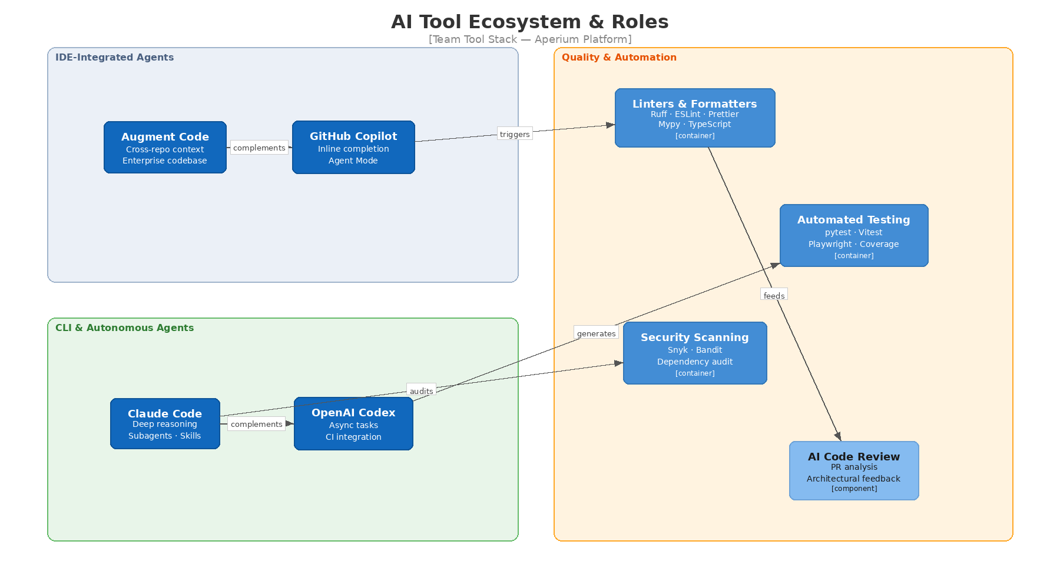
Figure 2: AI Tool Ecosystem — Roles and Responsibilities

Primary AI Coding Agents
Augment Code — the team's primary IDE-integrated assistant for enterprise codebase work. Its 200K-token context engine understands cross-repository architectural patterns, making it ideal for Aperium's multi-service architecture (FastAPI backend, React frontend, MCP servers). Use Augment for everyday coding, refactoring, and feature work where broad codebase awareness is needed.
Claude (Chat & Claude Code) — used for deep reasoning, architectural design, complex debugging, and spec generation. Claude Code's subagent and skill systems make it powerful for spec-driven development: a main agent orchestrates requirement analysis, design, and implementation subagents. Use Claude for design documents, security assessments, and tasks requiring long-chain reasoning.
OpenAI Codex — used as an asynchronous coding agent through GitHub's Agent HQ integration. Ideal for background tasks such as scaffolding boilerplate, generating test suites, documentation updates, and CI-triggered fixes. Assign Codex to issues for parallel, fire-and-forget work.
GitHub Copilot — the baseline IDE assistant available to all developers. Use for inline code completion, quick chat queries, and agent mode for smaller, well-scoped tasks. Copilot's deep GitHub integration makes it the natural choice for PR-related workflows.

Supplementary Tools
Speckit — used by some team members for structured specification generation. Speckit enforces a requirements → design → tasks workflow and produces Markdown specs compatible with any AI coding agent. Teams using Speckit should output specs to the project's docs/specs/ directory.
Superpower Kit — a productivity toolkit that augments IDE capabilities with code snippets, templates, and workflow shortcuts. Useful for standardized patterns specific to the Aperium stack (FastAPI route scaffolding, React component boilerplate, MCP tool templates).
Quality & Automation Layer:
- Linters & Formatters: Ruff (Python), ESLint + Prettier (TypeScript/React), mypy (type checking)
- Testing: pytest (backend), Vitest (frontend), Playwright (E2E)
- Security: Snyk or Bandit (vulnerability scanning), dependency auditing
- AI Code Review: Automated PR analysis via Claude or Codex in CI pipeline

Tool Selection Matrix
The following matrix guides developers in choosing the right tool for each task type:
- Feature implementation (complex): Augment Code in IDE + Claude Code for architecture
- Feature implementation (simple): Copilot Agent Mode or Augment Code
- Spec generation: Claude Chat or Speckit
- Bug fixing / debugging: Claude Code (deep reasoning) or Augment (cross-repo context)
- Test generation: Codex (async) or Copilot (inline)
- Documentation: Codex (async) or Claude Chat
- Code review (first pass): AI review bot in CI
- Security audit: Claude Code with security skill
- Refactoring: Augment Code (multi-file awareness)
- Urgent hotfix: Copilot Agent Mode (fastest) + express human review

Spec-Driven Development Process
The single most important practice for high-quality vibe coding is writing a specification before writing code. Research from Thoughtworks, MIT Technology Review, and industry practitioners consistently shows that AI agents produce dramatically better output when given well-structured context and clear requirements up front.
The team adopts a lightweight spec-driven development (SDD) approach — not heavyweight waterfall documentation, but focused Markdown files that serve as both human communication and AI prompts.

The Three Spec Documents
Every non-trivial task (anything beyond a one-line fix) produces three Markdown files stored in docs/specs/<feature-name>/:
1. `requirements.md` — What to Build
Written by the Product Owner or developer, optionally with AI assistance. Contains:
- User story or problem statement
- Acceptance criteria (testable conditions)
- Edge cases and constraints identified through AI-assisted analysis
- Out of scope items to prevent scope creep
2. `design.md` — How to Build It
Generated collaboratively with AI (Claude or Speckit), reviewed by a senior developer. Contains:
- Architecture decisions with rationale
- Component interactions (which services, APIs, and data stores are involved)
- Data model changes (if any)
- Security considerations
- Technology choices with trade-offs
3. `tasks.md` — Step-by-Step Implementation Plan
Broken down by AI into small, testable chunks with dependency ordering. Contains:
- Numbered task list with estimated complexity (S/M/L)
- Dependencies between tasks
- Test criteria for each task
- Suggested AI tool for each task (e.g., "Use Codex for boilerplate scaffolding, Claude Code for auth logic")
The spec phase typically takes 30–90 minutes for a medium feature. This investment saves hours of rework that occurs when AI agents work without clear direction.

Spec Workflow Step-by-Step
Step 1 — Ticket arrives (from Jira, client feedback, or internal backlog)
The developer reads the ticket and gathers context.
Step 2 — Generate initial spec
Using Claude Chat, Speckit, or Claude Code's subagent system:
- Prompt: "Analyze this requirement and generate requirements.md, design.md, and tasks.md for the Aperium platform. Consider our stack: FastAPI, React, PostgreSQL, Redis, MCP servers."
- The AI drafts all three files.
Step 3 — Human review and refinement
The developer and/or tech lead reviews the spec for:
- Correctness of architecture decisions
- Completeness of edge cases
- Realistic task breakdown
- Security implications
Feedback is given conversationally to the AI until the spec is approved.
Step 4 — Commit spec to repository
Specs are committed to docs/specs/<feature-name>/ on the feature branch. This creates an audit trail and gives all AI agents access to the spec as context.
Step 5 — Implement against spec
The developer feeds the tasks.md to their chosen AI agent(s) and implements task by task, validating each step before moving to the next.

Context Engineering — The Foundation
Context engineering is the discipline of curating the information that AI agents receive so they produce accurate, consistent, project-aligned output. Research shows that the presence of well-maintained context files (such as CLAUDE.md or AGENTS.md) is associated with a 29% reduction in median agent runtime and 17% reduction in output tokens — meaning the AI gets things right faster and with less waste.
The team maintains a hierarchy of context files:

Context File Hierarchy
1. Project-Level: `CLAUDE.md` (or `AGENTS.md`)
Lives in the repository root. Contains:
- Project purpose and architecture overview — what the system does, how services connect
- Tech stack and conventions — framework versions, naming conventions, code style rules
- Common patterns — how to create a new API endpoint, how to add an MCP tool, how to write a React component in the Aperium style
- Known pitfalls — things that break, anti-patterns to avoid, previous bugs and their fixes
- Testing requirements — minimum coverage, required test types
- Security rules — authentication patterns, PII handling, RBAC conventions
2. Directory-Level: `.claude/` or `.cursor/` rules
Specific instructions for subsystems (e.g., backend/.claude/rules for FastAPI conventions, frontend/.cursorrules for React patterns).
3. Task-Level: Spec files
The requirements.md / design.md / tasks.md files provide task-specific context that overrides or supplements project-level guidance.
4. Skill Files: `SKILL.md`
Reusable, codified instructions for common workflows (e.g., "how to add a new MCP server", "how to run a security assessment"). Skills encode team knowledge that would otherwise live only in senior developers' heads.
Maintenance rule: Context files are living documents. After every sprint retrospective, the team updates CLAUDE.md with any new patterns, pitfalls, or conventions discovered. This takes 15–30 minutes and pays for itself many times over.

Development Workflow — Standard Path
This section describes the day-to-day workflow for implementing a feature or task using AI-assisted development.
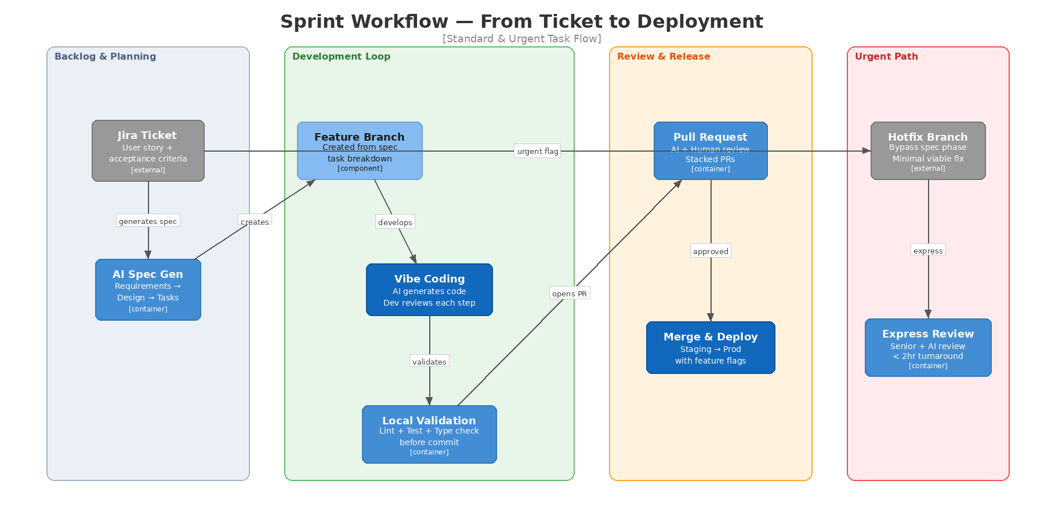
Figure 3: Sprint Workflow — Standard and Urgent Paths

Step 1: Branch & Context Setup
Action: Create a feature branch from develop (or main depending on branching strategy).
- Branch naming: feature/<ticket-id>-<short-description> or fix/<ticket-id>-<short-description>
- Ensure the spec files are committed to the branch before coding begins
- Verify that CLAUDE.md and relevant skill files are up to date
Automation opportunity: A git hook or CI step can validate that every feature branch contains spec files before allowing the first code commit.

Step 2: AI-Assisted Implementation
The developer works through tasks.md sequentially (or in dependency order), using AI agents to generate code for each task.
Best practices for effective vibe coding:
- One task at a time — don't ask the AI to build everything at once. Small, focused prompts produce better code.
- Provide full context — reference the spec files, the relevant source files, and any error messages. The more context the AI has, the better the output.
- Review every output — read each AI-generated block before accepting it. Check for logic errors, security issues, and alignment with the spec.
- Use the feedback loop — if the AI produces incorrect code, feed the error back: "This fails with [error]. The expected behavior is [X]. Fix it."
- Commit frequently — after each task or logical chunk, commit with a descriptive message. This creates save points and makes code review easier.
- Run local checks between commits — execute ruff check ., mypy ., and pytest (or their frontend equivalents) before committing.
Cross-model verification: For critical logic (authentication, payment processing, data integrity), use a second AI model to review the first model's output. For example, have Claude write the code and Copilot review it, or vice versa.

Step 3: Local Validation Gate
Before pushing to the remote repository, the developer runs the local validation suite:
- ruff check . && ruff format --check . — Python linting and formatting
- mypy . — Python type checking
- pytest --cov — Python tests with coverage
- npm run lint && npm run typecheck — Frontend linting and TypeScript
- npm run test — Frontend unit tests
Automation: These checks should be enforced via a pre-push git hook using husky (frontend) or pre-commit (Python). The hook prevents pushing code that fails any check.
Coverage threshold: The team maintains a minimum of 80% line coverage for new code. AI agents are excellent at generating test cases — use Codex or Copilot to generate tests immediately after implementing each task.

Step 4: Pull Request & Automated Review
When the feature is ready, the developer opens a Pull Request targeting the develop branch.
Automated CI pipeline runs:
- Lint & format check (fail-fast)
- Type checking (mypy / TypeScript)
- Unit & integration tests with coverage report
- Security scan (Snyk / Bandit)
- AI code review — an automated GitHub Action sends the PR diff to Claude or Codex for first-pass review, posting comments directly on the PR
AI code review configuration:
The CI workflow extracts the PR diff, sends it to the AI API with the project's CLAUDE.md as system context, and requests feedback on:
- Logic errors and potential bugs
- Security vulnerabilities (OWASP Top 10 for agentic systems)
- Adherence to project conventions
- Test coverage gaps
- Performance concerns
Quality gate: The PR cannot be merged until all automated checks pass and the AI review has no critical findings.

Step 5: Human Code Review
After automated checks pass, a human reviewer (senior developer or tech lead) reviews the PR with a focus on:
- Architecture alignment — does this change fit the system's design?
- Business logic correctness — does it fulfill the acceptance criteria from the spec?
- Edge cases — are there scenarios the AI might have missed?
- Maintainability — will this code be understandable in six months?
- Security implications — especially for MCP tool integrations, RBAC, and PII handling
Review SLA:
- Standard PRs: reviewed within 4 business hours
- Urgent/hotfix PRs: reviewed within 2 hours by an assigned senior reviewer
Stacked PRs: For large features, use stacked PRs (smaller, dependent PRs that are reviewed and merged incrementally). This reduces review fatigue and keeps the feedback loop tight.

Step 6: Merge & Deploy
Once approved, the PR is squash-merged into develop. The CI/CD pipeline automatically:
- Deploys to the staging environment
- Runs E2E tests (Playwright) against staging
- If E2E passes and a release is scheduled, promotes to production via feature flag or direct deployment
Feature flags: For significant changes, use feature flags (LaunchDarkly, Unleash, or a simple config toggle) to control rollout. This allows instant rollback without a code revert.
Post-deployment monitoring: The team monitors error rates, latency, and key business metrics for 24 hours after deployment to catch regressions.

Handling Urgent & Ad-Hoc Tasks
Enterprise clients regularly surface urgent issues and last-minute requests. The process must accommodate these without abandoning quality controls. The team uses an express path that shortens — but does not skip — critical quality gates.

Severity Classification
When an urgent request arrives, the team classifies it:
- P0 — Production Down: System is unavailable or data is at risk. Response target: < 1 hour.
- P1 — Critical Bug: Core functionality broken for users. Response target: < 4 hours.
- P2 — Important Client Request: Feature change or non-critical bug needed urgently. Response target: < 1 business day.
- P3 — Normal Backlog: Standard priority. Follows the full spec-driven process.

Express Path (P0 & P1)
Step 1 — Triage (< 15 min): Senior developer assesses the issue, identifies root cause, and decides on minimal fix scope.
Step 2 — Hotfix branch: Create a hotfix/<ticket-id> branch directly from main (production).
Step 3 — Fast implementation: Use the fastest AI tool available (typically Copilot Agent Mode or Claude Code) to implement the minimal fix. Skip the full spec phase but write a one-paragraph description of the problem and fix in the PR description.
Step 4 — Express validation: Run only the most critical subset of tests:
- Lint check (must pass)
- Directly relevant unit tests (must pass)
- Manual smoke test of the affected feature
Step 5 — Express review: A designated senior reviewer (on-call or assigned) reviews within 2 hours. AI code review still runs automatically.
Step 6 — Deploy to production: Once approved, merge and deploy immediately.
Step 7 — Follow-up: Within 48 hours, create a proper spec for the fix, add comprehensive tests, and refactor if needed. The hotfix is retroactively brought up to full quality standards.
Key rule: Express path does not mean no review. It means faster review by a pre-assigned senior reviewer and a reduced but mandatory set of automated checks.

Ad-Hoc Client Requests (P2)
For important but non-critical client requests:
- Abbreviated spec: Write a condensed requirements.md only (skip design.md and tasks.md if the change is small and well-understood)
- Same development and review process as standard path but with a prioritized review SLA (same business day)
- Communication: Acknowledge the client request within 2 hours with an estimated delivery time

Automation Strategy
The team automates every repeatable step to minimize manual overhead and ensure consistency. The following table maps each development activity to its automation approach.
Activity | Automation Approach | Tool / Config
Code formatting | Pre-commit hook + CI check | Ruff (Python), Prettier (JS/TS)
Linting | Pre-commit hook + CI check | Ruff, ESLint
Type checking | Pre-push hook + CI check | mypy, TypeScript compiler
Unit tests | Pre-push hook + CI check | pytest, Vitest
Test generation | AI-assisted after each task | Codex (async) or Copilot
Security scanning | CI pipeline stage | Snyk, Bandit, dependency audit
AI code review | CI pipeline (on PR) | Claude API / Codex via GitHub Actions
E2E tests | CI pipeline (on staging deploy) | Playwright
Spec validation | Git hook (feature branches) | Script checks for spec files
Documentation gen | Async AI task | Codex or Claude Code
Context file update | Sprint retrospective checklist | Manual with AI assistance
Deployment | CI/CD pipeline | GitHub Actions / Cloud Deploy
Post-deploy monitoring | Automated alerting | Cloud Monitoring / Sentry

CI/CD Pipeline Configuration
The CI/CD pipeline is the team's automated quality backbone. It runs on every push to a PR branch and on merge to develop and main.
Pipeline stages (in order):
- Install & Cache — install dependencies, cache node_modules and Python virtualenv
- Lint & Format — fail fast on style issues (ruff check, eslint, prettier --check)
- Type Check — mypy for Python, tsc --noEmit for TypeScript
- Unit Tests — pytest --cov and vitest --coverage with coverage thresholds
- Security Scan — snyk test or bandit -r src/ for vulnerability detection
- AI Code Review — send PR diff to Claude/Codex API, post findings as PR comments
- Build — build Docker images or frontend bundles
- Deploy to Staging — automatic on merge to develop
- E2E Tests — run Playwright suite against staging
- Deploy to Production — manual trigger or automatic on merge to main (with feature flags)
Failure policy: Any failure in stages 1–6 blocks the PR from merging. E2E failures block production deployment but not the merge to develop (to allow investigation on staging).

Git Hooks Setup
The team uses pre-commit (Python) and husky (JavaScript) to enforce local quality checks.
Pre-commit hooks (Python backend):
- ruff check --fix — auto-fix linting issues
- ruff format — auto-format code
- mypy --incremental — type checking
Pre-push hooks:
- Run affected tests only (using pytest --last-failed or test file detection)
- Block push if tests fail
Commit message format:
All commit messages follow conventional commits: type(scope): description
Examples: feat(mcp): add Malbek contract search tool, fix(auth): resolve OIDC token refresh race condition
This enables automated changelog generation and clear git history.

Code Quality Standards
AI-generated code requires extra scrutiny, not less. Research from CodeRabbit found that AI-co-authored code contains approximately 1.7x more major issues than human-written code, with 2.74x higher security vulnerability rates. The following standards are designed to counteract these risks.

Coding Standards
Python (Backend — FastAPI):
- Follow PEP 8 enforced by Ruff
- Type hints on all function signatures (enforced by mypy in strict mode)
- Docstrings on all public functions and classes (Google style)
- No Any types except where genuinely unavoidable
- Async-first: use async def for all I/O-bound operations
- Dependency injection via FastAPI's Depends() pattern
TypeScript / React (Frontend):
- Strict TypeScript mode enabled ("strict": true)
- Functional components with hooks only (no class components)
- Zustand for state management, TanStack Query for server state
- Component files: one component per file, co-located tests
- No any types; use unknown and type narrowing instead
MCP Server Development:
- Follow FastMCP patterns for tool definitions
- All tools must have input validation, error handling, and timeout configuration
- PII masking middleware must be applied to all MCP tools handling user data
- Each MCP server must have its own integration test suite

Testing Standards
Coverage requirements:
- New code: minimum 80% line coverage
- Critical paths (auth, payment, data integrity): 95% coverage
- MCP tools: every tool must have at least one happy-path and one error-path test
Test types:
- Unit tests: test individual functions and methods in isolation
- Integration tests: test API endpoints with a test database, test MCP tool execution
- E2E tests: test critical user flows through the UI (Playwright)
- Security tests: test for OWASP Top 10 vulnerabilities in agentic systems
AI test generation: After implementing a feature, use Codex or Copilot to generate test cases. The AI is excellent at producing comprehensive test matrices, but the developer must review edge cases and verify that assertions are meaningful (not just checking that the function "doesn't throw").

Security Standards for Agentic Systems
Because Aperium is an agentic platform that orchestrates actions across enterprise systems (Odoo, Arena PLM, Malbek CLM), security is paramount.
Mandatory security practices:
- Zero Trust architecture — every request is authenticated and authorized, including inter-service calls
- PII masking — all MCP tool inputs/outputs are scanned for PII and masked before logging or LLM processing
- RBAC enforcement — tool-level permissions checked before execution
- Input validation — all user inputs and LLM outputs are validated and sanitized before acting on enterprise systems
- Audit logging — every tool invocation is logged with user identity, timestamp, inputs, and outputs
- Token management — OAuth tokens stored in HashiCorp Vault, never in environment variables or code
- Guardrails — AI agent actions are bounded by the six-layer defense model (input validation → prompt injection detection → tool permission check → output validation → human approval for destructive actions → audit log)
Security review trigger: Any PR that touches authentication, authorization, MCP tool permissions, or data access patterns requires a mandatory security review by a senior developer, in addition to standard code review.

Team Practices & Ceremonies
The process is embedded in the team's regular cadence of meetings and practices.

Sprint Cadence
The team operates in two-week sprints with the following ceremonies:
Sprint Planning (2 hours):
- Review prioritized backlog
- For each selected ticket, assign it and decide: full spec path or abbreviated path
- Identify any tickets that can be assigned to AI agents (Codex) for async execution
Daily Standup (15 min):
- What I completed yesterday (link to PR)
- What I'm working on today (which spec/task)
- Blockers (including AI tool issues — model limits, context window problems, incorrect outputs)
Mid-Sprint Review (30 min):
- Demo completed features on staging
- Surface any specs that need revision based on implementation learnings
- Adjust remaining sprint scope if needed
Sprint Retrospective (1 hour):
- Review what went well / what didn't
- Update `CLAUDE.md` and skill files with new patterns and pitfalls discovered during the sprint
- Review AI tool effectiveness: which tools worked best for which tasks?
- Discuss any quality issues that escaped automated checks

Knowledge Sharing
Prompt Library:
The team maintains a shared docs/prompts/ directory with proven prompts for common tasks:
- new-api-endpoint.md — prompt template for generating a new FastAPI endpoint
- new-mcp-tool.md — prompt template for creating a new MCP server tool
- new-react-component.md — prompt template for React component with tests
- debug-template.md — structured debugging prompt
- security-review.md — prompt for AI-assisted security review
Skill Files:
Complex, reusable workflows are codified as SKILL.md files that can be loaded by Claude Code or referenced by other agents. Examples:
- skills/mcp-server-creation/ — step-by-step MCP server creation workflow
- skills/security-assessment/ — zero-trust security assessment procedure
- skills/database-migration/ — safe database migration workflow
Weekly AI Tools Sync (30 min):
A weekly informal session where team members share:
- New techniques they discovered with AI tools
- Tools or plugins they tried
- Patterns that worked or failed
- Updates to shared prompts or skills

Onboarding New Team Members
New developers are onboarded with:
- Read `CLAUDE.md` — understand the project architecture and conventions
- Read this process document — understand the workflow
- Complete a guided first task — a small ticket with a pre-written spec, paired with a senior developer
- Review the prompt library — familiarize with standard prompts
- Set up all AI tools — Augment Code, Copilot, Claude Code access, git hooks
- Shadow a PR review — observe how the team reviews AI-generated code
Expected time to productivity: 1 week for experienced developers, 2 weeks for junior developers (compared to the industry average of 4–6 weeks, accelerated by AI tools and well-maintained context files).

Metrics & Continuous Improvement
The team tracks the following metrics to measure and improve the process:
Metric | Target | Measurement Method
Spec-to-PR time | < 3 days (medium feature) | Jira timestamps
PR review turnaround | < 4 hours (standard) | GitHub PR metrics
CI pipeline duration | < 15 minutes | GitHub Actions logs
Test coverage (new code) | > 80% | Coverage reports in CI
AI code review findings | 0 critical, < 3 high per PR | AI review bot output
Post-deploy incidents | < 1 per sprint | Incident tracker
Context file freshness | Updated every sprint | Sprint retrospective checklist
Developer satisfaction | > 4/5 | Monthly anonymous survey

Process Improvement Cycle
Every month, the tech lead reviews the metrics and identifies one or two areas for improvement. These improvements are tracked as regular tickets and implemented in the following sprint.
Examples of past improvements:
- Added AI code review to CI after noticing recurring security issues in manually-reviewed PRs
- Created skill file for MCP server creation after the third developer asked "how do I add a new MCP tool?"
- Increased test coverage threshold from 70% to 80% after post-deploy incidents correlated with low-coverage PRs
- Added cross-model verification step for authentication code after a subtle OIDC bug escaped single-model review
The process itself is a living document. When something isn't working, change it. When something works well, codify it into a context file or skill so the entire team (and their AI agents) benefit.

Quick Reference — Workflow Cheat Sheet
Standard Feature Flow:
- Ticket arrives → classify priority
- Generate spec (requirements.md + design.md + tasks.md)
- Human review spec → iterate with AI until approved
- Create feature branch, commit spec files
- Implement task-by-task with AI agents
- Run local validation (lint, type-check, tests) before each push
- Open PR → automated CI runs (lint, test, security, AI review)
- Human review → approval
- Squash-merge → deploy to staging → E2E tests → production
Urgent Hotfix Flow (P0/P1):
- Triage (< 15 min) → identify minimal fix
- Hotfix branch from main
- Fast implementation with AI
- Express validation (lint + relevant tests + smoke test)
- Express human review (< 2 hours)
- Deploy to production
- Follow-up: full spec + tests within 48 hours
Context File Updates:
- CLAUDE.md — updated every sprint at retrospective
- SKILL.md files — created when a workflow is repeated 3+ times
- Prompt library — expanded whenever a developer discovers an effective prompt
Commit Message Format:
type(scope): description
Types: feat, fix, refactor, test, docs, chore, perf, security

