Cross-Agent Consistency &
MCP-Driven Development Lifecycle
CTO Advisory — Building a Unified Vibe Coding Process
Across Augment, Claude, Codex, Copilot, Speckit & Superpowers

Author: Aperium Engineering — Hillspire / Merops Automation
Version: 1.0
Date: March 2026

Table of Contents

[Right-click and select 'Update Field' to populate TOC]

CTO Perspective: The Real Problem
Let me be direct about what I see when a team uses five different AI coding agents without a unification layer: you get five different codebases inside one repository. Each agent has its own style biases, naming preferences, error handling patterns, and architectural assumptions. Augment writes code differently from Claude Code. Copilot's suggestions diverge from Codex's async output. Multiply this by a team of developers, each with their own prompting habits, and within two sprints you have a maintenance nightmare.
The problem is not that your team uses multiple agents — that's actually a strength. The problem is the absence of a shared contract that every agent reads before it writes a single line of code, and the absence of a unified workflow that enforces consistency regardless of which agent or developer is executing.
This document proposes a concrete architecture to solve three things:
- Consistency — how to make Augment, Claude Code, Codex, and Copilot all produce code that looks like it came from one senior developer
- Workflow unification — how to integrate Speckit, Superpowers, and custom skills into a single spec-driven lifecycle that works with any agent
- MCP-driven automation — how to wire Jira, Odoo, Malbek, and your internal systems into the development lifecycle so tickets, specs, and tasks flow automatically from idea to deployment
My recommendation in one sentence: Adopt AGENTS.md as your single source of truth, symlink it to every agent-specific config file, wire Jira MCP into the spec phase, and build three custom Aperium skills that encode your team's patterns.

The Consistency Problem — And How to Solve It
Research from ETH Zurich (March 2026) found that human-written context files improve agent task success rates by ~4%, while LLM-generated context files actually degrade performance by 3%. The key finding: what matters is encoding non-inferable information — your specific conventions, build commands, architectural decisions, and known pitfalls that no AI can guess from reading the code alone.
Meanwhile, a study of 2,303 context files across Claude Code, Codex, and Copilot found that 72.6% of Claude Code projects specify application architecture in their CLAUDE.md. The presence of AGENTS.md files was associated with a 29% reduction in median agent runtime and 17% reduction in output tokens — agents get things right faster when given clear instructions.
The fragmentation problem is real: Claude wants CLAUDE.md, Cursor/Augment want .cursorrules, Copilot wants .github/copilot-instructions.md, Codex reads AGENTS.md. The industry is converging on AGENTS.md as the universal standard (backed by the Linux Foundation, OpenAI, and broad tool support), but tool-specific files aren't going away.
The solution is simple: one file, many symlinks.
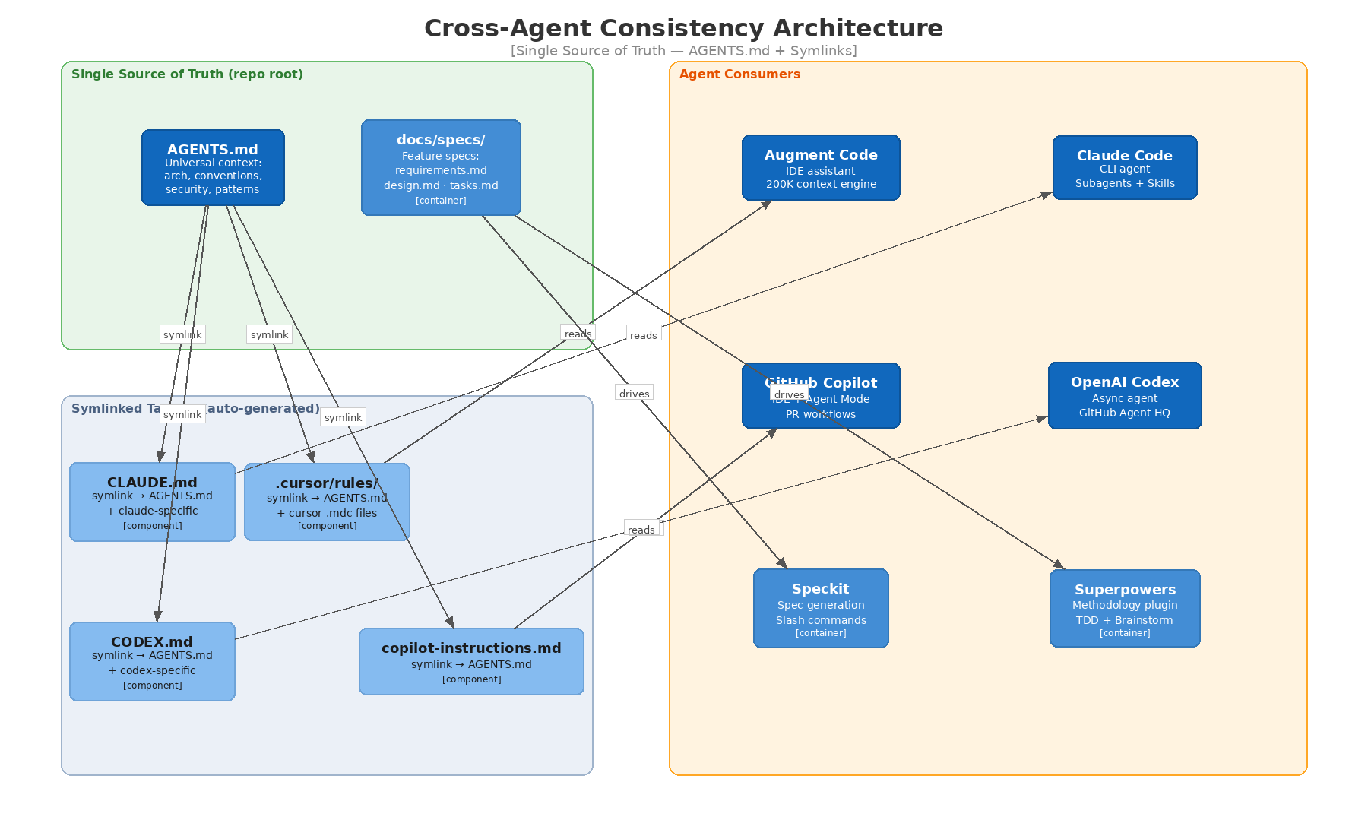
Figure 1: Cross-Agent Consistency Architecture — Single Source of Truth

Implementation: The Symlink Strategy
Create AGENTS.md in your repository root as the single source of truth. Then symlink every agent-specific config to it:
ln -sfn AGENTS.md CLAUDE.md
ln -sfn AGENTS.md CODEX.md
mkdir -p .github && ln -sfn ../AGENTS.md .github/copilot-instructions.md
mkdir -p .cursor/rules && ln -sfn ../../AGENTS.md .cursor/rules/main.mdc
Add this to your repo setup script so every developer gets the symlinks on clone. The .gitignore should track AGENTS.md and ignore the symlinked files (or track them as symlinks).
For tool-specific overrides, use the tool's native mechanism in addition to the symlink:
- Claude Code: CLAUDE.local.md for personal preferences (auto-gitignored)
- Cursor: Additional .cursor/rules/*.mdc files with YAML frontmatter for granular rules
- Augment: Its 200K context engine indexes the full repo, so AGENTS.md is automatically consumed

What Goes in AGENTS.md — The Aperium Template
Based on research and your specific stack, here is the structure I recommend for Aperium's AGENTS.md:
Section 1 — Project Identity (3-5 lines)
What is Aperium, what does it do, who are the users. This orients the agent immediately.
Section 2 — Architecture Overview (10-15 lines)
Services map: FastAPI backend, React frontend, MCP servers (Odoo, Arena, Malbek), PostgreSQL + Redis + Neo4j. Explain how they connect. This is the non-inferable context that ETH Zurich says matters most.
Section 3 — Coding Conventions (20-30 lines)
The rules every agent MUST follow:
- Python: async-first, type hints everywhere, Ruff formatting, Google-style docstrings
- TypeScript: strict mode, functional components, Zustand + TanStack Query
- MCP tools: FastMCP patterns, PII masking middleware, input validation
- Naming: snake_case for Python, camelCase for TS, kebab-case for files
- Error handling: custom exception classes, structured error responses
Section 4 — Forbidden Patterns (5-10 lines)
Things that break the codebase: Any types, synchronous I/O in async paths, inline SQL, secrets in code, class components in React, localStorage usage.
Section 5 — Build & Test Commands (5-10 lines)
Exact commands: ruff check ., mypy ., pytest --cov, npm run lint, npm run test. The agent should run these after generating code.
Section 6 — Security Requirements (10-15 lines)
Zero Trust patterns, RBAC, token management via Vault, audit logging requirements.
Total: ~80-100 lines of dense, human-written, non-inferable context. Not a novel — a sharp reference card.

The Unified Workflow — MCP-Driven Development Lifecycle
Now I want to lay out the end-to-end flow you described: from ticket creation to spec generation to task decomposition to implementation — all connected via MCP and consistent across any agent a developer chooses.
This is what I call the MCP-Driven Development Lifecycle (MCP-DLC).
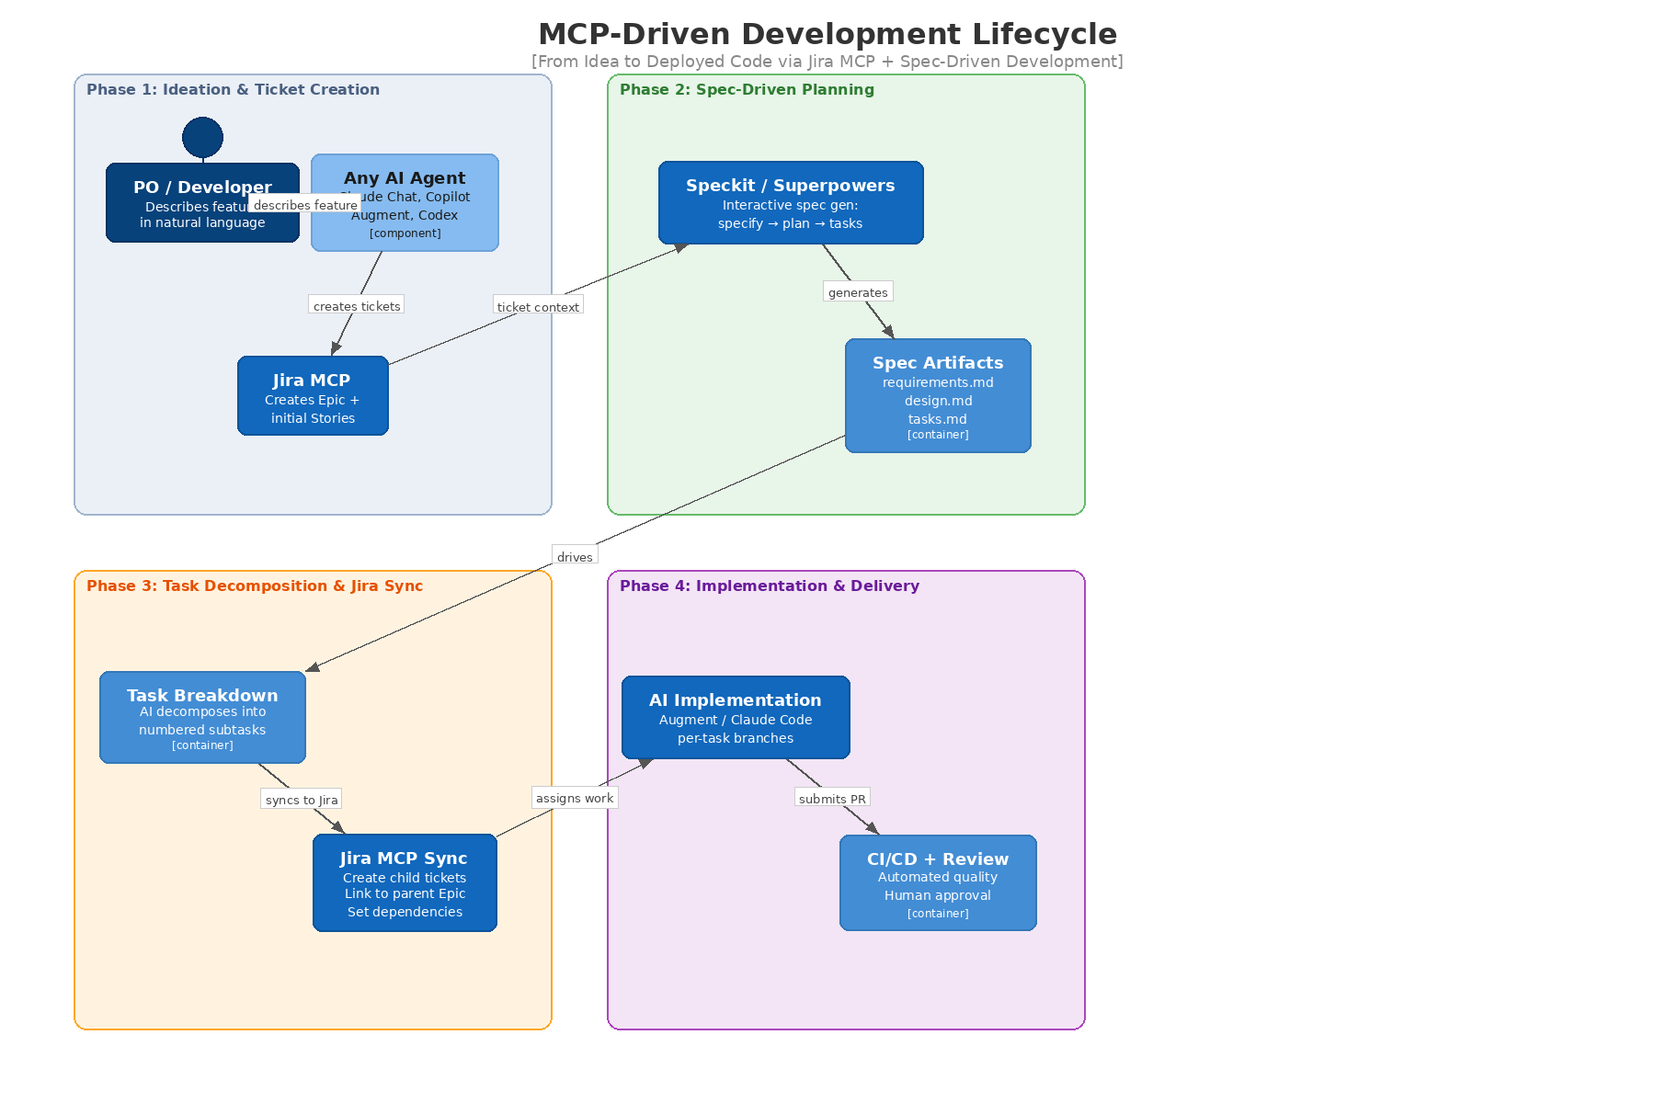
Figure 2: MCP-Driven Development Lifecycle — Four Phases

Phase 1: Ideation & Ticket Creation
Who: PO or Developer, using any AI agent (Claude Chat, Copilot Chat, Augment, or even a Slack bot)
What happens:
The PO/dev describes a feature in natural language. The AI agent helps refine it into a structured format: user story, acceptance criteria, initial scope. Then — and this is the automation win — the agent uses the Atlassian Jira MCP to create the Epic and initial Stories directly in Jira.
How it works technically:
You already have the Atlassian MCP connected (https://mcp.atlassian.com/v1/sse in your Claude.ai connectors). For Claude Code, the Atlassian Rovo MCP server provides OAuth 2.1 authentication and supports: creating issues (Epic, Story, Task, Bug), setting fields (priority, assignee, story points, sprint), creating parent/child hierarchies, and adding subtasks.
The prompt pattern:
"Based on this feature description, create a Jira Epic titled '[Feature Name]' in project APER with the following stories as children: [Story 1], [Story 2], [Story 3]. Set priority to Medium, assign to [dev], and add to Sprint [current]."
Critical design decision: intermediate review.
I strongly recommend a draft-first pattern where the AI generates ticket content as local Markdown files first, the developer reviews and edits, and then the MCP pushes to Jira. This prevents garbage tickets from cluttering your board. One practitioner reported that this intermediate step reduces ticket rework by ~80% while still cutting creation time from 1 hour to 10-15 minutes.
MCP reliability note: The Atlassian SSE MCP has known session stability issues (frequent re-authentication). Consider the alternative pattern used by experienced teams: install acli (Atlassian CLI), authenticate once, create a wrapper script, and build a Claude Code skill that calls it. This is faster and more reliable than the SSE endpoint.

Phase 2: Spec-Driven Planning (Speckit / Superpowers)
Who: Developer, using their preferred AI agent + Speckit or Superpowers
What happens:
The developer pulls context from the Jira ticket (via MCP) and generates a formal specification using either Speckit or Superpowers. Both tools follow the same fundamental pattern: specify → plan → tasks. The output is a set of Markdown files committed to the repo.
Speckit vs. Superpowers — when to use which:
Speckit (GitHub's official toolkit, 72K+ stars, v0.1.4) is best for:
- Teams that want a lightweight, structured process with slash commands (/speckit.specify, /speckit.plan, /speckit.tasks, /speckit.implement)
- Cross-agent compatibility: supports 22+ AI agent platforms (Claude Code, Copilot, Cursor, Gemini, Codex, Windsurf)
- Projects where the spec should survive as a living artifact anchored to the code
- The constitution concept — project-level principles that constrain all specs
Superpowers (obra's framework, 75K+ stars, Anthropic marketplace official) is best for:
- Teams that want a methodology-first approach with full TDD enforcement
- Claude Code users specifically (it's a Claude Code plugin with deep integration)
- The subagent-driven development model: brainstorm → plan → execute in isolated worktrees with built-in code review between tasks
- Teams that value the Socratic brainstorming phase (the AI asks YOU questions before writing anything)
My recommendation: Use both. They're complementary, not competing.
- Use Speckit as the specification format standard — its /speckit.specify and /speckit.plan commands produce clean, agent-agnostic specs that any tool can consume
- Use Superpowers as the implementation methodology — its TDD enforcement, subagent orchestration, and code review skills kick in during the development phase
- For developers using Augment or Copilot (non-Claude Code), they use Speckit commands directly
- For developers using Claude Code, they get Superpowers as an additional layer on top
The spec format standard (team-wide):
Regardless of which tool generates it, every spec must produce these artifacts in docs/specs/<feature-name>/:
- constitution.md — project principles (inherited from Speckit constitution, one per project)
- requirements.md — functional requirements with acceptance criteria
- design.md — technical design with architecture decisions
- tasks.md — numbered, dependency-ordered, parallelism-marked task breakdown
- review-checklist.md — acceptance checklist for implementation verification

Phase 3: Task Decomposition & Jira Sync
Who: AI agent (any), with developer approval
What happens:
The tasks.md file contains a numbered list of implementation tasks. The AI agent reads this file and creates corresponding child tickets in Jira under the parent Epic/Story created in Phase 1. Each Jira ticket includes:
- Summary from the task title
- Description from the task detail (acceptance criteria, test criteria)
- Story points estimate (S=1, M=3, L=5)
- Dependencies linked via Jira "blocked by" relationships
- Labels for parallelism ([P] tasks get a parallel-safe label)
The automation flow:
- AI reads tasks.md
- AI generates a batch of Markdown ticket files (one per task) in docs/specs/<feature>/tickets/
- Developer reviews the ticket files (intermediate checkpoint)
- Developer approves: "Push these to Jira under APER-123"
- AI uses Jira MCP to create all tickets, link them to the parent, and set dependencies
- AI updates tasks.md with the Jira ticket IDs for traceability
This is the point where the spec and the project management tool are synchronized. From here on, progress on tasks in code maps directly to ticket status in Jira.

Phase 4: Implementation & Delivery
Who: Developer + AI agents, following the spec
What happens:
The developer works through the task list using their preferred AI agent. Each task is implemented on a branch (or worktree for parallel execution with Claude Code/Superpowers), validated locally, and submitted as a PR.
Agent-specific implementation patterns:
Augment Code users:
- Open the spec files as context (@docs/specs/feature/tasks.md)
- Work through tasks in IDE with Augment's cross-repo awareness
- Augment auto-reads AGENTS.md (via .cursorrules symlink)
Claude Code users:
- Superpowers activates automatically, enforcing TDD cycle
- Each task runs in an isolated git worktree (no conflicts)
- Subagents handle implementation; main agent reviews between tasks
- Use: implement @docs/specs/feature/tasks.md — use task tool, each task via subagent, commit after each
Copilot Agent Mode users:
- Assign tasks as GitHub issues (via Jira→GitHub sync or manual)
- Copilot agent works asynchronously, creates draft PRs
- Review in GitHub web UI
Codex users:
- Assign tasks via GitHub Agent HQ
- Codex works async in cloud environment
- Good for boilerplate, tests, documentation tasks
Status sync back to Jira:
When a task's PR is merged, a GitHub Action (or a post-merge hook) uses the Jira MCP to transition the corresponding ticket to "Done." This closes the loop: spec → Jira ticket → code → PR → merge → Jira status update.

Skills, Plugins & Custom Extensions
The skill ecosystem is where the team's institutional knowledge becomes executable. Instead of relying on tribal knowledge ("ask Thanh how to create an MCP server"), you codify the knowledge into a SKILL.md file that any agent can follow.
As of March 2026, the skill ecosystem has matured significantly: 1,234+ community skills exist in the Antigravity library, Superpowers is in the official Anthropic marketplace, and Speckit supports 22+ agent platforms. But the real value comes from custom team skills that encode your specific patterns.
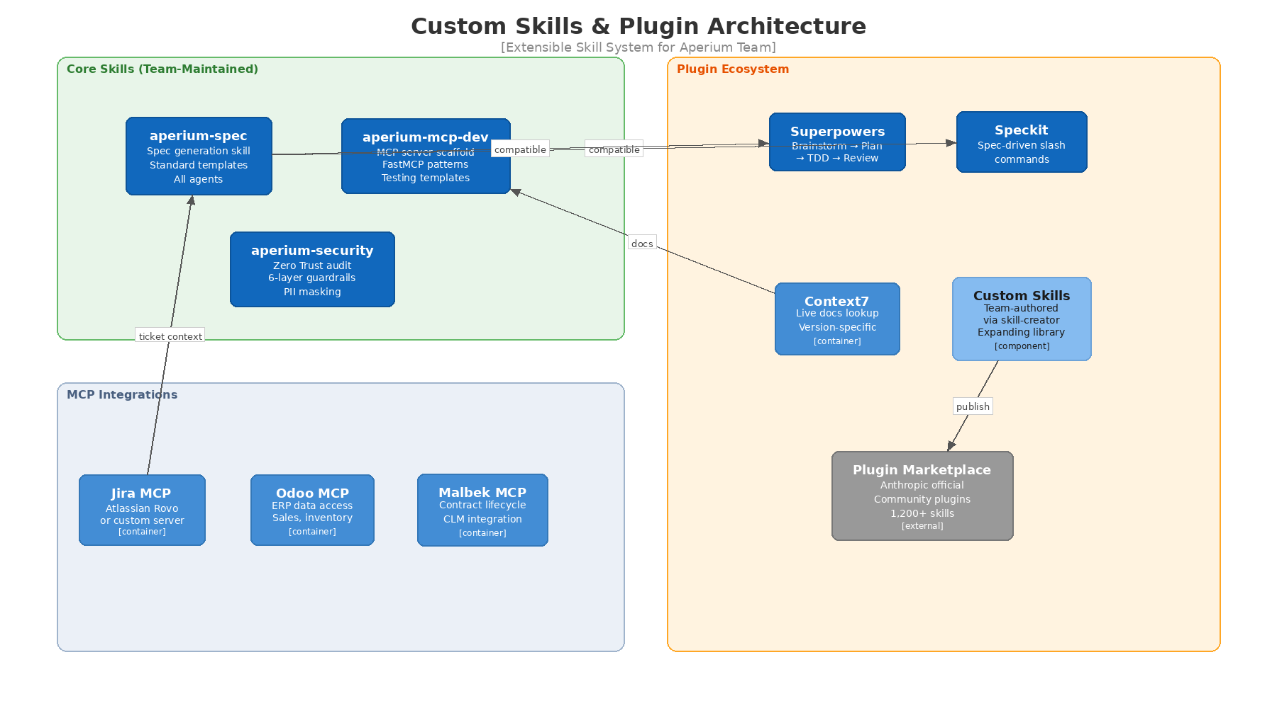
Figure 3: Custom Skills & Plugin Architecture — Extensible System

Recommended Plugin Stack
Tier 1 — Install Immediately (All Team Members):
- Superpowers (obra/superpowers) — The methodology backbone. Provides brainstorming, TDD, subagent development, code review, and systematic debugging. Install via the Anthropic marketplace for Claude Code; for Codex/OpenCode, follow the manual setup in the repo.
- Speckit (github/spec-kit) — The specification standard. Initialize per-project with specify init . --ai claude (or --ai copilot). Provides /speckit.specify, /speckit.plan, /speckit.tasks, /speckit.implement commands.
- Context7 (context7@claude-plugins-official) — Live documentation lookup. Pulls version-specific docs and code examples from source repos into LLM context. Essential for keeping agents current on FastAPI, React, pgvector, etc.
- Frontend Design (frontend-design@claude-plugins-official) — Generates polished UI code that avoids generic AI aesthetics. Important for Aperium's React frontend work.
- Playwright (playwright@claude-plugins-official) — E2E test generation and execution. Integrates with Superpowers' TDD cycle.
Tier 2 — Install for Specific Roles:
- Atlassian Rovo MCP (Jira + Confluence) — For the ticket automation workflow described above. Consider the acli wrapper pattern if the SSE endpoint is unreliable.
- Commit Commands (commit-commands@claude-plugins-official) — Enforces conventional commit messages. Pairs with your CI changelog generation.
- Feature Dev (feature-dev@claude-plugins-official) — End-to-end feature development workflow.
Tier 3 — Custom Aperium Skills (Build These):

Custom Skills to Build
I recommend the team builds three custom skills that encode Aperium-specific knowledge. These should be stored in .agent/skills/ in the repo and installed via npx skills add or the Claude Code skill directory.
1. `aperium-spec` — Aperium Specification Skill
Purpose: Standardize spec generation across all agents with Aperium-specific patterns.
What it does:
- Provides a slash command /aperium:spec <feature-name> that triggers the full spec workflow
- Templates are pre-filled with Aperium's architecture (FastAPI, React, MCP servers, PostgreSQL, Redis)
- Automatically includes security considerations section (Zero Trust, PII, RBAC)
- Outputs to the standard docs/specs/<feature>/ directory structure
- Compatible with both Speckit and Superpowers (it generates the same Markdown format)
- Includes Jira MCP integration: after spec approval, offers to create/link Jira tickets
Why custom vs. using Speckit directly:
Speckit is generic. Your skill wraps Speckit with Aperium-specific templates, architecture context, and MCP integration points. A developer types /aperium:spec user-behavior-analytics and gets a spec that already knows about your BigQuery pipeline, Cloud Functions, and Vertex AI models.
2. `aperium-mcp-dev` — MCP Server Development Skill
Purpose: Codify the patterns for creating new MCP servers in the Aperium ecosystem.
What it does:
- Scaffolds a new FastMCP server with the team's standard structure
- Includes PII masking middleware template
- Includes RBAC permission check boilerplate
- Generates integration test suite template
- Sets up Docker configuration
- Adds the server to the MCP registry documentation
- Follows FastMCP 3.0 HTTP transport patterns the team has established
This replaces: The current process where a developer asks "how do we create a new MCP server?" and gets pointed to an old Confluence page or has to reverse-engineer an existing server.
3. `aperium-security` — Security Assessment Skill
Purpose: Run zero-trust security assessments on new features, especially MCP integrations.
What it does:
- Implements the 6-layer defense model the team designed (input validation → prompt injection detection → tool permission check → output validation → human approval → audit log)
- Checks for OWASP Agentic Top 10 compliance
- Verifies PII handling in MCP tool chains
- Generates a security assessment report
- Integrates with the existing agentic-security-assessment skill but adds Aperium-specific checks
4. (Future) `aperium-jira-sync` — Jira Synchronization Skill
Purpose: Automate the bidirectional sync between specs and Jira tickets.
What it does:
- Reads tasks.md and creates/updates Jira child tickets
- Reads Jira ticket status and updates local tasks.md checkboxes
- On PR merge, transitions corresponding Jira ticket to "Done"
- On sprint planning, generates a sprint summary from completed specs
Building custom skills is straightforward. Each skill is a directory with a SKILL.md file (natural language instructions), optional reference files, and optional scripts. The Superpowers plugin even includes a writing-skills skill that teaches the agent how to author new skills using TDD principles.

Multi-Agent Orchestration Strategy
For large features, the team can run multiple agents in parallel using git worktree isolation. Here's the pattern:
Orchestrator approach (Claude Code + Superpowers):
- Claude Code acts as the lead agent, reading the full spec and creating the task plan
- For each independent task (marked [P] in tasks.md), it spawns a subagent in an isolated git worktree
- Each subagent implements one task, runs tests, and commits
- The lead agent reviews each subagent's output (Superpowers' requesting-code-review skill)
- Approved work is merged back to the feature branch
Multi-tool approach (mixing agents):
For teams where different developers use different tools:
- Assign Claude Code to deep reasoning tasks (auth, MCP integrations, complex business logic)
- Assign Codex to boilerplate tasks (CRUD endpoints, test generation, documentation)
- Assign Copilot to UI tasks (React components, styling, accessibility)
- All agents read the same AGENTS.md and the same spec files
- All work converges via PRs to the same feature branch
Coordination tools:
- Claude Squad (5.8K stars) — Multi-tool agent session manager with git worktree isolation
- Claude Flow (12.9K stars) — Enterprise-grade orchestrator for 60+ agents
- ccswarm — Rust-native high-performance multi-agent coordination
For Aperium's team size, start with Superpowers' built-in subagent orchestration. Move to Claude Squad or Flow only if you're regularly running 5+ agents in parallel.

Handling Ad-Hoc & Urgent Requests in This Workflow
The spec-driven lifecycle has overhead. For P0/P1 urgencies, the flow adapts:
Urgent path (bypass spec phase):
- PO/dev creates Jira ticket with crisis: Yes via MCP (or manually)
- Developer creates hotfix branch directly — no spec required
- The ONLY mandatory context: a one-paragraph problem description in the PR body
- Implementation with fastest available agent (Copilot Agent Mode for inline, Claude Code for debugging)
- Express review (< 2 hours, pre-assigned senior reviewer)
- Deploy to production
- Post-mortem spec: within 48 hours, retroactively create the spec, add proper tests, and refactor if needed. The Jira ticket is updated with the spec link.
Ad-hoc client requests (P2):
- Abbreviated spec: requirements.md only (skip design.md and tasks.md if the change is < 1 day of work)
- Jira ticket created via MCP with proper parent linkage
- Standard review process, prioritized SLA (same business day)
The key principle: Even urgent work eventually gets a spec. The spec is the team's memory. Without it, the next developer (or AI agent) to touch that code has no context for why it exists or how it should behave.

Implementation Roadmap
Here's a phased plan to roll this out without disrupting current velocity:

Week 1-2: Foundation
- Create `AGENTS.md` — write the Aperium-specific content (architecture, conventions, security rules, build commands). Estimated effort: 2-3 hours by a senior developer. Do not generate this with AI. Human-written context files outperform LLM-generated ones.
- Set up symlinks — create the symlink script, add to repo README and onboarding docs
- Install Superpowers + Speckit — on all team members' Claude Code instances
- Install Context7 + Playwright — for documentation lookup and E2E testing
- Configure Atlassian MCP — for Jira integration (SSE or acli wrapper)
- Define the spec directory structure — docs/specs/ with README explaining the format

Week 3-4: Pilot
- Pick 2-3 medium features from the backlog as pilot candidates
- Run the full MCP-DLC workflow — ticket creation → spec → task decomposition → Jira sync → implementation → PR
- Document friction points — what broke, what was slow, what was confusing
- Iterate on `AGENTS.md` — add conventions discovered during pilot
- Build `aperium-spec` skill — the first custom skill, based on patterns from the pilot

Week 5-8: Rollout & Custom Skills
- Full team adoption — all new features follow the MCP-DLC workflow
- Build `aperium-mcp-dev` skill — codify MCP server creation patterns
- Build `aperium-security` skill — codify security assessment patterns
- Set up CI AI code review — GitHub Action that sends PR diffs to Claude API
- Establish sprint retro → `AGENTS.md` update cadence
- Create prompt library — docs/prompts/ with proven prompt templates

Week 9-12: Optimization
- Build `aperium-jira-sync` skill — bidirectional spec↔Jira sync
- Measure metrics — spec-to-PR time, review turnaround, defect rates, developer satisfaction
- Evaluate multi-agent orchestration — pilot Claude Squad or Superpowers subagents for parallel work
- Publish team skills — to internal skill registry (or Anthropic marketplace if appropriate)
- Train on skill authoring — teach team members to write their own skills using Superpowers' writing-skills module

Summary of Recommendations
Area | Recommendation | Why
Context standard | AGENTS.md + symlinks | One file, all agents read it. 29% faster runtime.
Spec tool (format) | Speckit | 22+ agent support, cross-team standard, slash commands
Spec tool (methodology) | Superpowers | TDD enforcement, subagent orchestration, code review
Jira integration | Atlassian MCP (or acli wrapper) | Ticket creation, task sync, status updates
IDE agent (primary) | Augment Code | 200K context, cross-repo awareness, enterprise scale
CLI agent (deep work) | Claude Code + Superpowers | Reasoning, subagents, worktree isolation
Async agent | Codex via GitHub Agent HQ | Fire-and-forget tasks, test generation
Inline completion | GitHub Copilot | Fast suggestions, PR workflows, universal
Custom skill 1 | aperium-spec | Aperium-specific spec templates + Jira integration
Custom skill 2 | aperium-mcp-dev | MCP server scaffold with PII/RBAC/test patterns
Custom skill 3 | aperium-security | Zero Trust assessment, OWASP Agentic Top 10
Docs lookup | Context7 plugin | Live version-specific documentation for all dependencies
E2E testing | Playwright plugin | AI-generated E2E tests in TDD cycle
Multi-agent orchestration | Superpowers subagents (start) | Built-in, no extra tooling needed

Final Thought
The teams that win with vibe coding in 2026 are not the ones using the most AI tools. They're the ones with the tightest feedback loop between spec, code, test, and review — and the most precise context given to every agent on every task.
Your competitive advantage is not that you use Augment and Claude and Codex. It's that you've built a system where any developer with any agent can produce code that is indistinguishable from what your best senior engineer would write — because the spec is clear, the conventions are encoded, the quality gates are automated, and the institutional knowledge is captured in skills.
Build the system. Then the tools become interchangeable.

