AI-Assisted Software Development
Working Process v3
Spec-Driven Vibe Coding Standard for Enterprise Agentic Systems
Specs in Git — Confluence as Presentation Layer via CI

Author: Thanh Nguyen
Version: 3.0
Date: March 2026

Executive Summary
This document defines the standard working process for the Aperium AI Agent Platform engineering team. It is designed for a team building enterprise agentic systems with Python, AI/ML, and ReactJS, using AI coding assistants (vibe coding) as the primary development method.
Architectural principle: Specifications live in Git alongside code as committed Markdown files in specs/APER-123/. Confluence serves as a read-only presentation layer — CI workflows sync specs to Confluence on PR merge so stakeholders (POs, QA, designers) can view them without Git access. Developers never fetch from or write to Confluence directly during the development loop.
Why this design: AI coding agents iterate on specs using native file tools — reading, editing, and referencing local Markdown files is faster, more reliable, and has zero network dependency. Specs travel with the code in the same branch, the same PR, and the same Git history. No stale caches, no MCP failures mid-session, no Confluence downtime blocking development.
Key principles:
- Specs + code in Git, Confluence for presentation — clean separation of authoring (developer + AI) from viewing (stakeholders)
- Three-layer context model — AGENTS.md (code conventions) + specs/ (feature context) + .agents/skills/ (workflow knowledge)
- AGENTS.md as universal standard — one file, two symlinks (CLAUDE.md, copilot-instructions.md). Augment and Codex read AGENTS.md natively.
- CI handles all Confluence sync — confluence-sync.yml pushes specs on merge, close-the-loop.yml transitions Jira tickets, archive-if-completed moves completed epics
- Any agent, same result — every agent reads the same AGENTS.md and specs/ files directly from the working tree
- Automate everything possible — linting, testing, security scanning, AI code review, Jira/Confluence sync all automated
- Adapt quickly — explicit fast-track path for urgent tasks that skips spec creation, with mandatory retro-spec within 48 hours

Process Overview
The development process follows three macro-phases. Specs are committed to Git and synced to Confluence by CI — never the reverse.
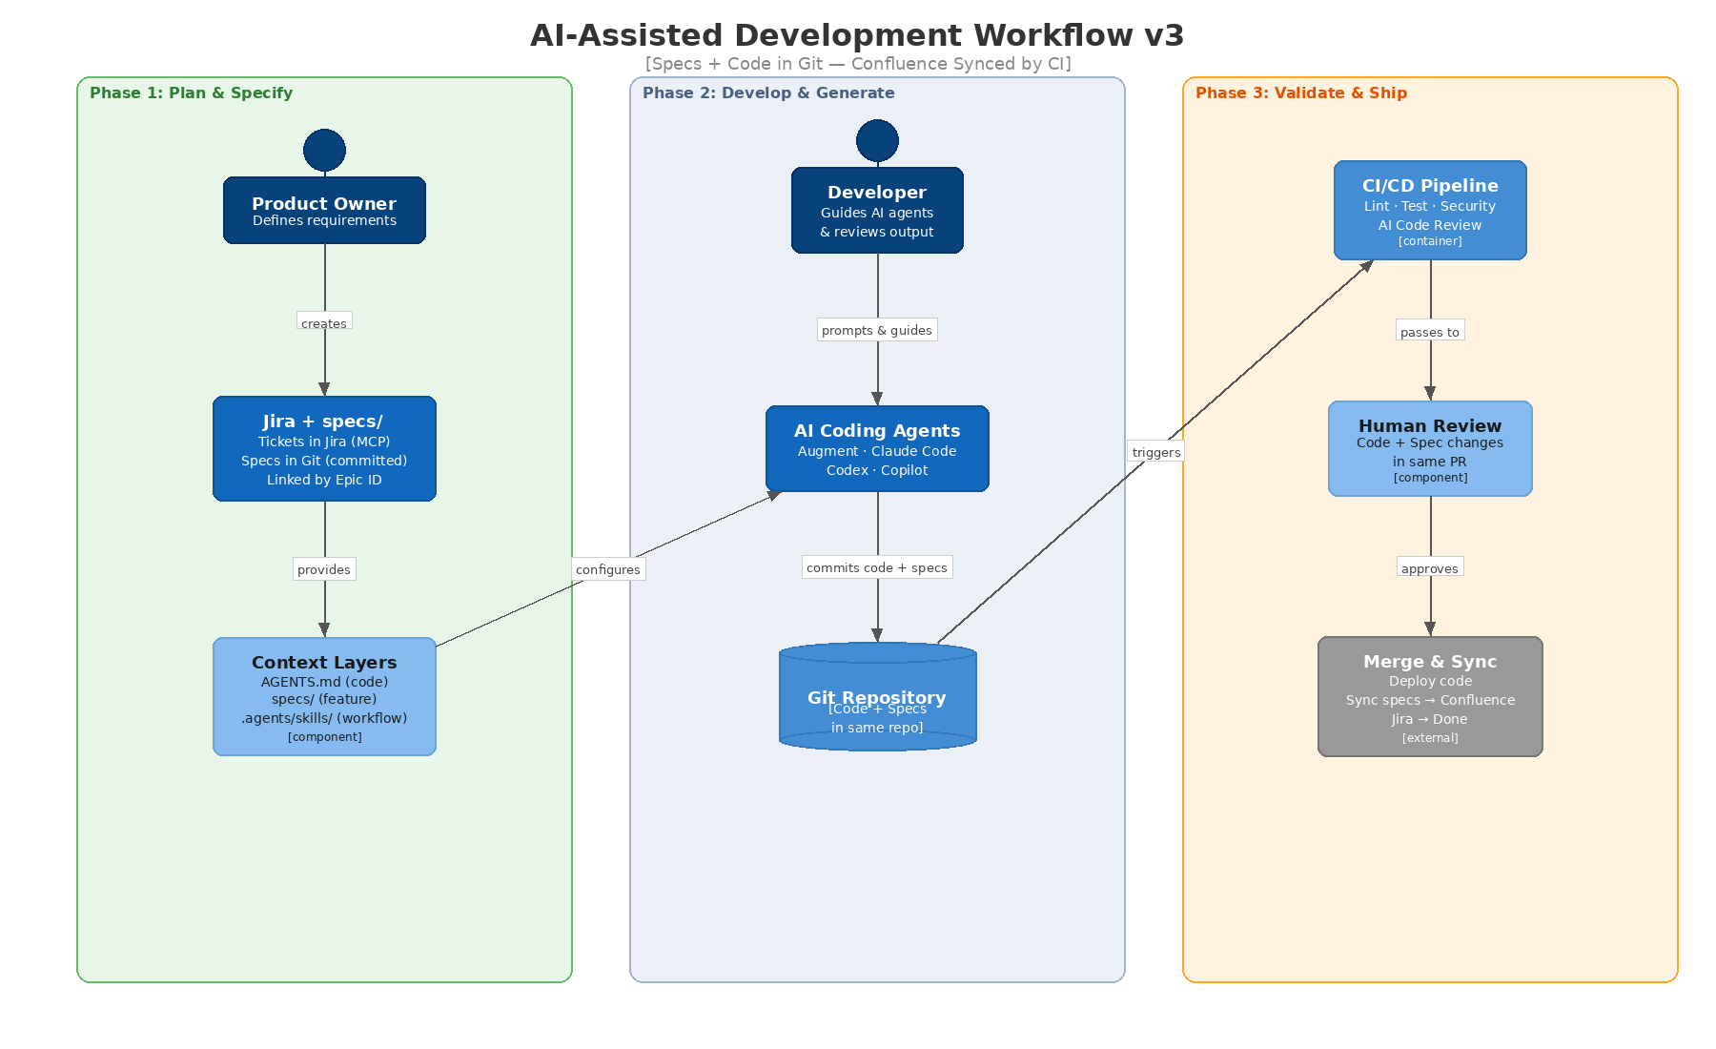
Figure 1: AI-Assisted Development Workflow — Specs + Code in Git

Phase Summary
Phase 1 — Plan & Specify (Jira MCP + Git):
The PO or developer creates Jira tickets via MCP. Then, using AI agents (Speckit or Superpowers), they generate specs as five Markdown files committed to `specs/APER-123/` in the feature branch. Context files (AGENTS.md and two symlinks) encode coding conventions. Skills live in .agents/skills/.
Phase 2 — Develop & Generate (Git-native):
Developers work with AI agents that read AGENTS.md and specs/APER-123/ directly from the file system — no MCP, no fetch, no network dependency. Code, tests, and spec updates are all committed to the same branch and reviewed in the same PR.
Phase 3 — Validate & Ship (CI/CD + Confluence sync):
Every push triggers the CI/CD pipeline with automated quality gates. On PR merge, CI workflows handle all external sync: confluence-sync.yml pushes spec pages to Confluence for stakeholder viewing, close-the-loop.yml transitions Jira tickets to Done, and archive-if-completed moves finished epics to the Completed Specs area.

Tool Ecosystem & Roles
The team uses multiple AI tools. Because all agents read specs from local files, they are fully interchangeable — no agent-specific MCP configuration is needed for spec access.
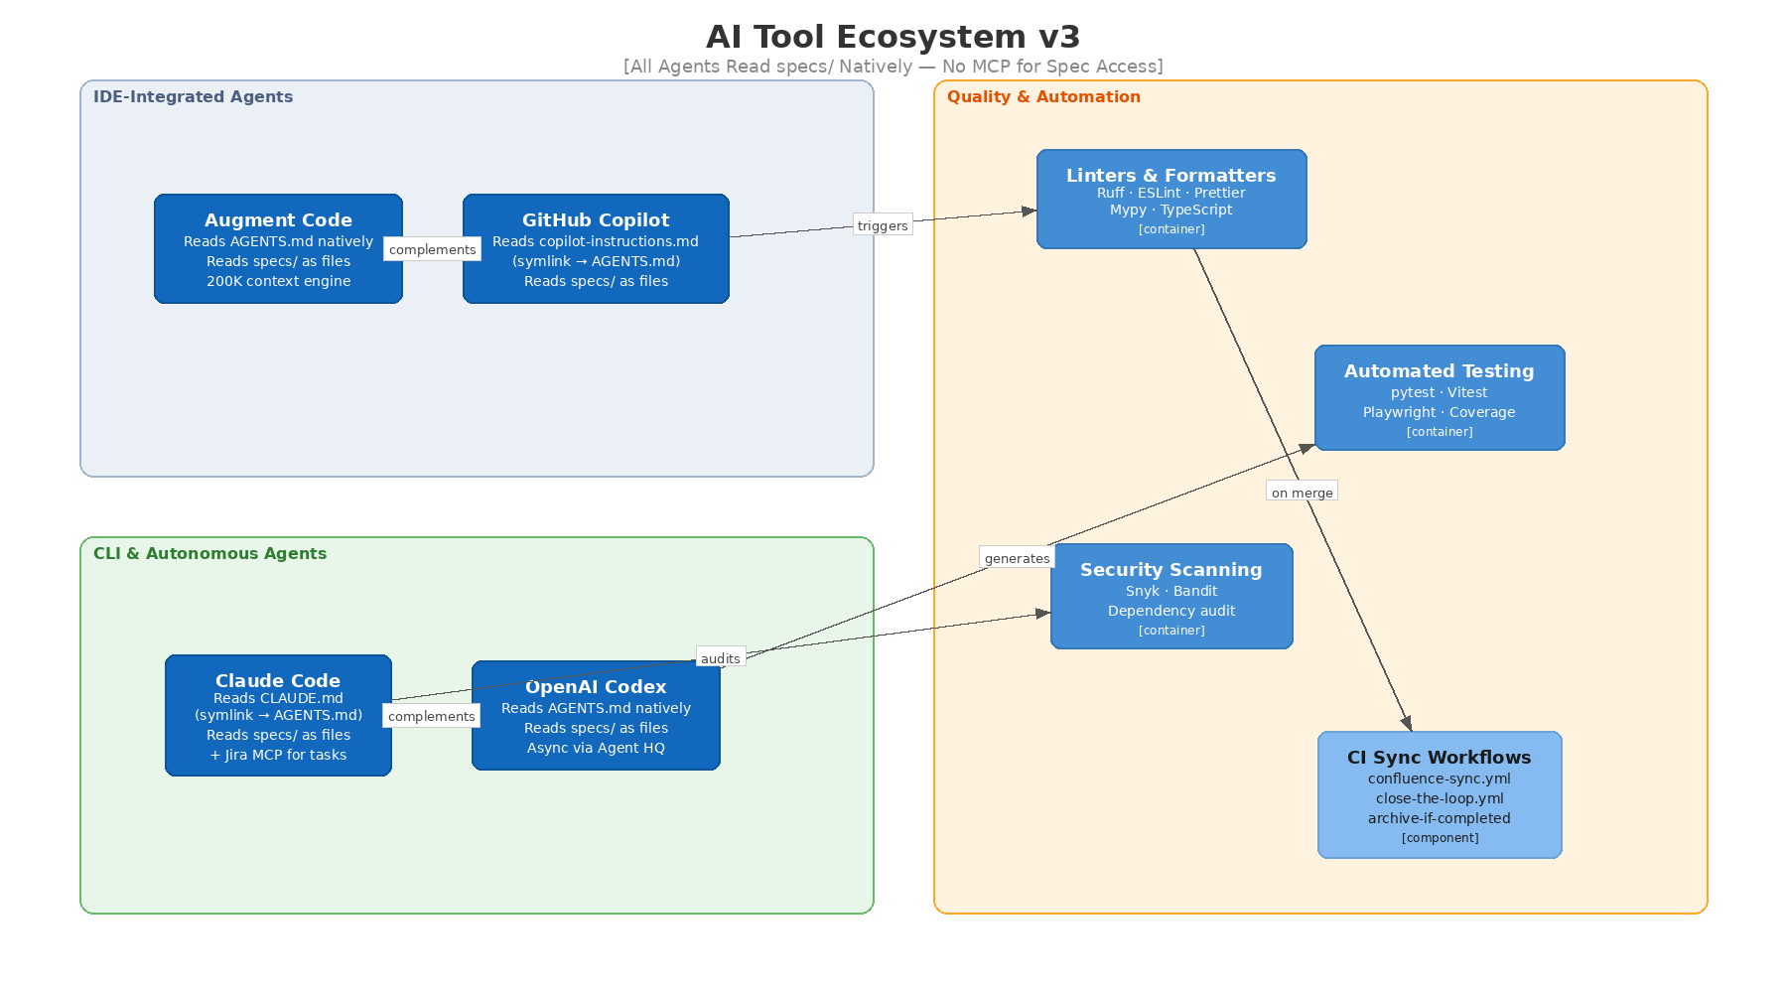
Figure 2: AI Tool Ecosystem — All Agents Read specs/ Natively

Primary AI Coding Agents
Augment Code — primary IDE assistant. Reads AGENTS.md natively (no symlink needed). Reads specs/ as regular workspace files within its 200K-token context engine. Best for everyday coding, refactoring, and feature work with cross-repo awareness.
Claude Code — CLI agent for deep reasoning, spec generation, and complex debugging. Reads CLAUDE.md (symlink to AGENTS.md). Reads specs/ as local files. Uses Jira MCP for ticket creation via aperium-sync-tasks skill. Superpowers plugin provides TDD, brainstorming, and subagent orchestration.
OpenAI Codex — async agent via GitHub Agent HQ. Reads AGENTS.md natively (no symlink needed). Reads specs/ as workspace files. Best for fire-and-forget tasks: test generation, documentation, boilerplate scaffolding.
GitHub Copilot — baseline IDE completion and agent mode. Reads copilot-instructions.md (symlink to AGENTS.md). Reads specs/ as regular files. Best for inline completion, small tasks, and PR workflows.

Supplementary Tools
Speckit — spec structure standard (22+ agent platforms). Generates structured specs that are saved directly to `specs/` in Git. The /speckit.specify → /speckit.plan → /speckit.tasks commands produce Markdown files locally.
Superpowers — methodology plugin for Claude Code. Provides brainstorm → plan → TDD → review workflow. The brainstorm and planning phases output to specs/; the implementation phase reads them back.
Quality & Automation Layer:
- Linters & Formatters: Ruff (Python), ESLint + Prettier (TypeScript/React), mypy
- Testing: pytest (backend), Vitest (frontend), Playwright (E2E)
- Security: Snyk or Bandit, dependency auditing
- AI Code Review: Automated PR analysis with spec compliance check (reads specs/ from the PR branch)
- CI Sync: confluence-sync.yml, close-the-loop.yml, archive-if-completed (post-merge)

Tool Selection Matrix
Guidance on which tool to use for each task type:
- Spec generation: Claude Code + Speckit/Superpowers → outputs to specs/
- Feature implementation (complex): Augment Code + Claude Code for architecture
- Feature implementation (simple): Copilot Agent Mode or Augment Code
- Bug fixing / debugging: Claude Code (deep reasoning) or Augment (cross-repo)
- Test generation: Codex (async) or Copilot (inline)
- Documentation: Claude Code → commit to docs/
- Code review (first pass): AI review bot in CI (reads specs from PR branch)
- Security audit: Claude Code with aperium-security skill
- Jira task sync: Claude Code with aperium-sync-tasks skill + Jira MCP
- Urgent hotfix: Copilot Agent Mode (fastest) + express human review

Specification Management in Git
Specs are committed Markdown files in the repository, organized by Epic ID. Confluence is a read-only mirror synced by CI on merge.
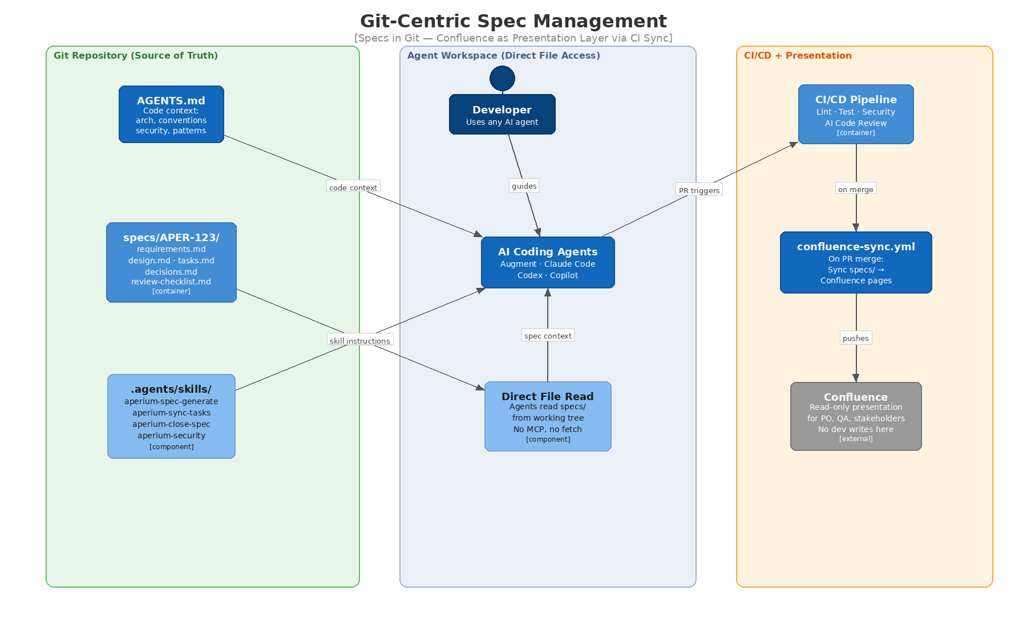
Figure 3: Git-Centric Spec Management — Confluence as Presentation Layer

Why Specs in Git (Not Confluence)
The v2 design proposed Confluence as spec source of truth. After team review, this was inverted. The decisive insight: don't make Confluence a dependency during the development loop.
Benefits of specs in Git:
- Agents read specs via native file tools — faster, more reliable, no MCP failure risk during development
- Specs travel with the code — same branch, same PR, same version history. No out-of-sync risk.
- Zero network dependency — works offline, on planes, in cafes, when Confluence is down
- Atomic commits — spec changes and code changes are reviewed together in the same PR
- Git branching works naturally — feature branches contain both the spec and its implementation
- No merge conflict surprise — spec Markdown conflicts are visible in the same PR as code conflicts
- Git handles versioning natively — no need for schema_version JSON or freshness tracking
Role of Confluence:
Confluence is the presentation layer for non-developer stakeholders. POs, QA, designers, and managers view specs in Confluence with rich formatting, comments, and status indicators. But they never author there — CI syncs Git → Confluence on every merge to develop or main.

Spec Directory Structure
Every non-trivial feature generates five Markdown files in specs/<EPIC-ID>/:
specs/APER-123/
- requirements.md — user stories, acceptance criteria, edge cases, out-of-scope
- design.md — architecture decisions, component interactions, data model, security
- tasks.md — numbered tasks with dependencies, test criteria, suggested AI tool, Jira ticket IDs
- decisions.md — architectural decision records made during planning and implementation
- review-checklist.md — acceptance verification checklist (checked off during review)
Naming convention: The directory name matches the Jira Epic key. This enables CI to auto-discover the corresponding Confluence page for sync.
Lifecycle: Specs are created on the feature branch during Phase 2, committed alongside code, reviewed in the same PR, and merged to develop. On merge, CI syncs to Confluence. When the Epic is fully completed, close-the-loop.yml archives the Confluence page.

How Agents Access Specs
All agents access specs the same way: direct file read from the working tree.
There is no MCP, no fetch script, no .specs/ temporary directory, and no network dependency. The agent simply reads specs/APER-123/requirements.md (or any other spec file) as a regular file in the repository.
Augment Code: Indexes specs/ as part of the full repo. Reference with @specs/APER-123/tasks.md.
Claude Code: Reads files natively. Reference with @specs/APER-123/design.md or let Superpowers auto-discover.
Copilot: Reads files in the workspace. Can be prompted with "read specs/APER-123/tasks.md and implement task 3."
Codex: Reads files in the repo when assigned via GitHub Agent HQ.
CI/CD: Reads spec files directly from the PR branch. The AI code review step checks whether the code implements the acceptance criteria from specs/APER-123/requirements.md.

Spec-Driven Development Process
The spec-driven process generates five Markdown files locally using the aperium-spec-generate skill, then commits them to Git. Confluence is updated automatically by CI after merge.

Spec Workflow Step-by-Step
Step 1 — Ticket arrives. Developer reads the Jira ticket and gathers context.
Step 2 — Generate specs using AI:
Developer triggers the aperium-spec-generate skill (or Speckit/Superpowers directly):
- AI asks clarifying questions (Superpowers' Socratic brainstorming)
- AI generates all five spec files interactively
- Files are written to specs/APER-123/ in the feature branch
Step 3 — Review specs in PR:
The developer commits the spec files and opens (or updates) the PR. The tech lead and PO review the spec files in the PR diff — GitHub/GitLab renders Markdown natively. Comments and suggestions use the standard PR review workflow.
For POs who prefer Confluence: they can wait until merge, when CI syncs the specs to Confluence, and review there. Or a draft CI sync can be triggered on PR creation.
Step 4 — Task decomposition & Jira sync:
Developer runs the aperium-sync-tasks skill, which reads specs/APER-123/tasks.md and creates child tickets in Jira via MCP. If the MCP fails, the skill falls back to generating a jira-draft.md file that can be manually imported.
Step 5 — Implementation:
Developer implements task-by-task. Agents read AGENTS.md + specs/APER-123/ directly. Only code, tests, and config changes are added; spec files are already committed.
Step 6 — Close the loop (automated by CI on merge):
- confluence-sync.yml syncs specs/APER-123/ to Confluence pages
- close-the-loop.yml transitions Jira tickets to Done
- archive-if-completed moves the Confluence page to Completed Specs if all tasks are done
- aperium-close-spec skill (optional, run by developer) adds implementation notes to specs/APER-123/decisions.md

Context Engineering — Three-Layer Model
The context model has three layers, all in Git:
Layer 1: Code Context — `AGENTS.md`
Contains everything an agent needs to write correct code: architecture overview, coding conventions, forbidden patterns, build/test commands, security rules. ~80-100 lines, human-written.
Two symlinks only:
- CLAUDE.md → AGENTS.md (for Claude Code)
- .github/copilot-instructions.md → AGENTS.md (for Copilot)
Augment and Codex read AGENTS.md natively — no symlinks needed. Cursor auto-discovers AGENTS.md — no .cursor/rules/ symlink needed.
AGENTS.md uses FIXED vs CUSTOMIZABLE section markers. FIXED sections contain team-wide standards that should not be modified per-developer. CUSTOMIZABLE sections allow personal preferences. The --update mode refreshes only FIXED sections.
Layer 2: Feature Context — `specs/APER-123/`
Contains everything an agent needs to know what to build: requirements, design, tasks, decisions, review checklist. Per-feature, committed, versioned.
Layer 3: Skill Context — `.agents/skills/`
Contains reusable workflow instructions as SKILL.md files. Industry-standard directory (native support in Augment and Codex). Key skills: aperium-spec-generate, aperium-sync-tasks, aperium-close-spec, aperium-security.

Development Workflow — Standard Path
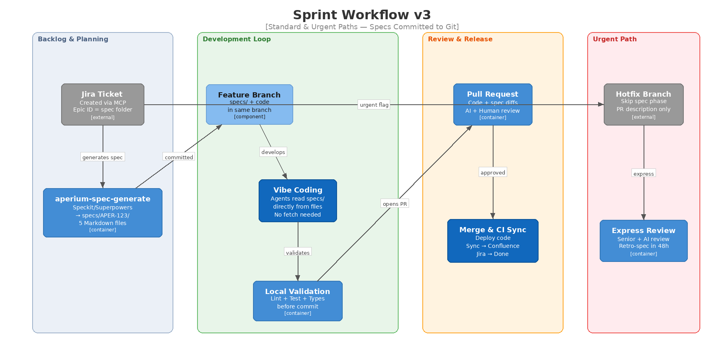
Figure 4: Sprint Workflow — Standard and Urgent Paths

Step 1: Branch & Spec Generation
Create a feature branch: feature/APER-123-feature-name. Generate specs using aperium-spec-generate skill or Speckit/Superpowers. Commit the five spec files to specs/APER-123/. Push and open a draft PR so spec review can begin in parallel.

Step 2: AI-Assisted Implementation
Work through tasks.md sequentially. Best practices:
- One task at a time — small, focused prompts
- Reference specs explicitly — @specs/APER-123/design.md
- Review every AI output — check logic, security, spec alignment
- Commit frequently — after each task
- Run local checks between commits — ruff check ., mypy ., pytest
- If the spec needs updating — edit the Markdown file directly and commit the change
- Cross-model verification — for critical logic, have a second agent review

Step 3: Local Validation Gate
Pre-push hook enforces: ruff check . && ruff format --check . · mypy . · pytest --cov · npm run lint && npm run typecheck · npm run test. Coverage threshold: 80% for new code.

Step 4: Pull Request & Automated Review
CI pipeline runs: lint/format → type checking → unit/integration tests → security scan → AI code review with spec compliance (reads specs/ from the PR branch) → build.
Quality gate: PR blocked until all checks pass and AI review has no critical findings.

Step 5: Human Review & Merge
Human reviewer inspects code AND spec changes in the same PR diff. Review SLAs: standard 4 hours, urgent 2 hours.
On merge, CI runs three post-merge workflows:
- `confluence-sync.yml` — sync specs/APER-123/ to Confluence pages for stakeholder viewing
- `close-the-loop.yml` — transition Jira tickets to Done, check Epic completion
- `archive-if-completed` — if all tasks under the Epic are done, move Confluence page to Completed Specs

Handling Urgent & Ad-Hoc Tasks
P0/P1 — Express Path: Triage (< 15 min) → hotfix branch from main → fast implementation with AI → express validation (lint + relevant tests) → express human review (< 2h) → deploy. No spec required. Within 48 hours: create retro-spec in specs/, commit, merge, and CI syncs to Confluence.
P2 — Ad-Hoc Client Requests: Abbreviated spec (requirements.md only) in specs/APER-XXX/. Same dev/review process, prioritized SLA.

Automation Strategy
Activity | Automation | Tool
Code formatting | Pre-commit hook + CI | Ruff, Prettier
Linting | Pre-commit hook + CI | Ruff, ESLint
Type checking | Pre-push hook + CI | mypy, TypeScript
Unit tests | Pre-push hook + CI | pytest, Vitest
Test generation | AI-assisted per task | Codex or Copilot
Security scanning | CI pipeline | Snyk, Bandit
AI code review + spec compliance | CI on PR | Claude API (reads specs/ from PR)
E2E tests | CI on staging | Playwright
Spec generation | aperium-spec-generate skill | Any agent → writes to specs/
Jira task sync | aperium-sync-tasks skill | Jira MCP (fallback: jira-draft.md)
Confluence sync | CI on merge | confluence-sync.yml
Jira status sync | CI on merge | close-the-loop.yml
Epic archival | CI on merge | archive-if-completed job
Implementation notes | aperium-close-spec skill | Developer-triggered before merge
Context file update | Sprint retro | Manual with AI assistance
Deployment | CI/CD pipeline | GitHub Actions / Cloud Deploy

CI Workflow Architecture
Three CI workflows handle all external sync after PR merge:
1. `confluence-discover` (composite action): Finds or creates the Confluence space structure for the spec. Ensures the page hierarchy exists before syncing content.
2. `confluence-sync.yml` (reusable workflow): Reads Markdown files from specs/APER-123/, converts to Confluence page format, and creates/updates pages under the Epic's Confluence node. Runs on every merge to develop or main.
3. `close-the-loop.yml` (reusable workflow): Transitions Jira tickets to Done, checks whether all child tickets under the Epic are complete, and triggers the archive-if-completed job if so. The archive job moves the Confluence Epic page from "Active Specs" to "Completed Specs".
Failure handling: CI sync failures do not block deployment. If Confluence or Jira is temporarily unavailable, the sync retries on the next merge. Specs in Git remain the source of truth regardless.

Code Quality Standards
AI-generated code contains ~1.7x more major issues and 2.74x higher security vulnerability rates than human-written code. These standards counteract this.
Python: PEP 8 (Ruff), type hints on all signatures (mypy strict), Google-style docstrings, async-first, Depends() DI. No Any types.
TypeScript/React: Strict mode, functional components + hooks, Zustand + TanStack Query, one component per file, co-located tests. No any types.
MCP Servers: FastMCP patterns, PII masking middleware, input validation, timeout config, per-tool integration tests.
Testing: 80% coverage for new code. 95% for critical paths. Unit + integration + E2E + security tests. AI-generated tests reviewed for meaningful assertions.
Security: Zero Trust architecture, PII masking on MCP I/O, RBAC enforcement, six-layer guardrails, OAuth tokens in Vault, audit logging. Security review required for any PR touching auth, RBAC, MCP permissions, or data access.

Team Practices & Ceremonies
Two-week sprints with: Sprint Planning (2h), Daily Standup (15min), Mid-Sprint Review (30min), Sprint Retrospective (1h).
At retro: Update AGENTS.md FIXED sections. Review and improve .agents/skills/. Update prompt templates. Verify Confluence sync is working correctly.
Knowledge sharing: Prompt library in docs/prompts/ (5 template files). Skills in .agents/skills/. Weekly AI Tools Sync (30min). Architecture docs in docs/ (committed to Git, synced to Confluence by CI).
Onboarding: Read AGENTS.md → read this process doc → complete guided first task with pre-written spec → review prompt library → set up AI tools → shadow a PR review. Expected time to productivity: 1 week (experienced), 2 weeks (junior).

Metrics & Continuous Improvement
Metric | Target | Measurement
Spec-to-PR time | < 3 days (medium feature) | Jira timestamps
PR review turnaround | < 4 hours (standard) | GitHub PR metrics
CI pipeline duration | < 15 minutes | GitHub Actions logs
Test coverage (new code) | > 80% | Coverage reports
AI spec compliance score | > 90% criteria covered | AI review bot
Confluence sync success rate | > 99% | CI workflow logs
Post-deploy incidents | < 1 per sprint | Incident tracker
Developer satisfaction | > 4/5 | Monthly survey

Quick Reference — Workflow Cheat Sheet
Standard Feature Flow:
- Ticket arrives → classify priority
- Generate spec: aperium-spec-generate → 5 files in specs/APER-123/
- Commit specs to feature branch → open draft PR for review
- Sync tasks to Jira: aperium-sync-tasks (MCP, fallback: jira-draft.md)
- Implement task-by-task — agents read specs/ directly from files
- Run local validation before each push
- PR → CI (lint, test, security, AI review with spec compliance)
- Human review (code + spec changes in same PR) → approval
- Merge → CI auto-syncs: Confluence pages + Jira Done + archive if complete
Urgent Hotfix (P0/P1):
- Triage (< 15 min) → hotfix branch from main
- Fast implementation with AI → express validation
- Express human review (< 2h) → deploy
- Within 48h: retro-spec in specs/, merge, CI syncs
Key Directories:
- AGENTS.md — code context (+ 2 symlinks: CLAUDE.md, copilot-instructions.md)
- specs/APER-123/ — 5 spec files (committed, versioned)
- .agents/skills/ — team skills (committed)
- docs/prompts/ — prompt templates (committed)
Skills:
- aperium-spec-generate — generate 5 spec files interactively
- aperium-sync-tasks — push tasks to Jira via MCP (fallback: jira-draft.md)
- aperium-close-spec — add implementation notes, trigger CI archival
- aperium-security — zero-trust security assessment

