Cross-Agent Consistency &
MCP-Driven Development Lifecycle v3
Unified Vibe Coding with Git-Native Spec Management
Confluence as Presentation Layer — CI Handles All Sync

Author: Thanh Nguyen
Version: 3.0
Date: March 2026

CTO Perspective: The Pivot That Made Everything Simpler
I proposed Confluence as spec source of truth in v2. The team pushed back with a decisive insight: don't make Confluence a dependency during the development loop. They were right.
Here's what I got wrong, and what I learned:
What v2 proposed: Specs authored in Confluence, pulled to local .specs/ via MCP, pushed back via MCP. Agents needed Confluence MCP connectivity to start work.
What broke in practice:
- MCP reliability — the Atlassian SSE endpoint requires re-authentication multiple times per day
- Network dependency — developers couldn't start work without Confluence being reachable
- Context split — code context in Git, feature context in Confluence, creating two places to look
- Stale cache risk — .specs/ could be hours old if the developer forgot to re-fetch
- CI complexity — the AI code review bot needed Confluence API calls to fetch specs, adding latency and failure modes
The corrected architecture:
Specs are committed Markdown files in `specs/APER-123/`. Agents read them directly from the file system — no MCP, no network, no fetch step. Confluence becomes a read-only presentation layer: CI workflows sync specs to Confluence on every PR merge. Stakeholders view specs in Confluence; developers never touch it.
This inversion gives us:
- Zero network dependency during development — works offline, no MCP failures
- Atomic PR reviews — code changes and spec changes in the same diff
- Native Git versioning — no schema_version tracking, no freshness checks
- Simpler agent setup — no Confluence MCP config needed for any agent
- CI handles all external sync — one-directional, Git → Confluence, reliable and idempotent
My updated recommendation: AGENTS.md in repo (code context) + specs/ in repo (feature context) + .agents/skills/ in repo (workflow context) + CI-synced Confluence (stakeholder presentation) + Jira MCP only for ticket management (in the aperium-sync-tasks skill).

Cross-Agent Consistency — The Git-Native Solution
With specs in Git, the consistency solution becomes remarkably simple: every agent reads the same files from the same working tree. No MCP configuration, no fetch scripts, no intermediate caches.
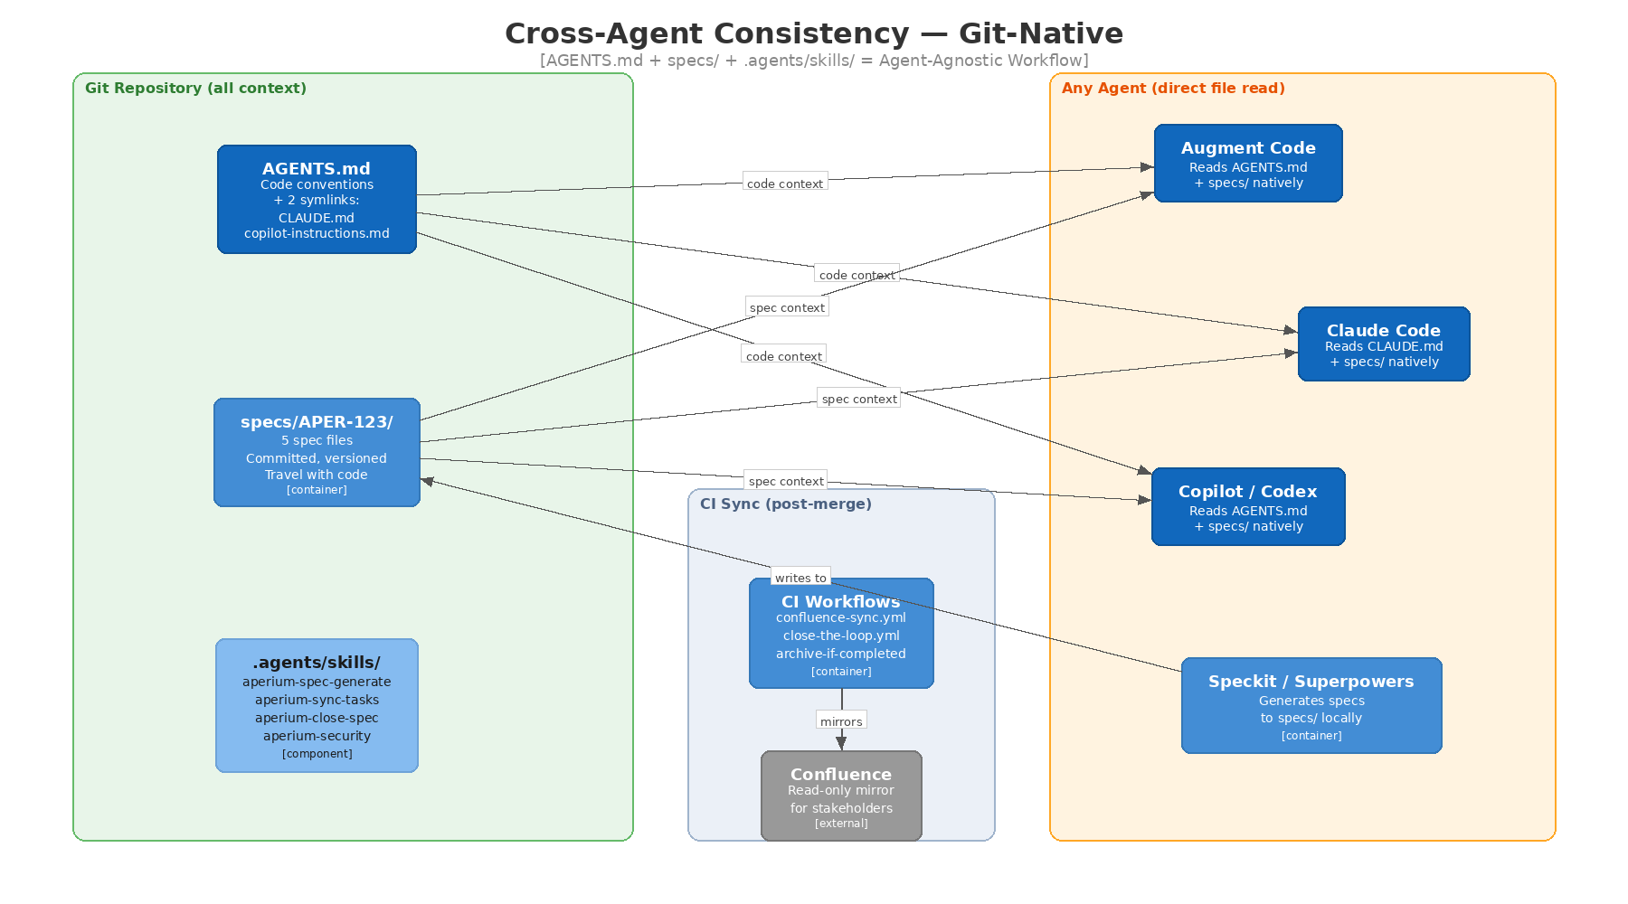
Figure 1: Cross-Agent Consistency — Everything in Git, Confluence Synced by CI

AGENTS.md — Simplified Symlink Strategy
AGENTS.md in the repository root is the single source of truth for code conventions.
Only two symlinks needed:
- ln -sfn AGENTS.md CLAUDE.md — for Claude Code
- mkdir -p .github && ln -sfn ../AGENTS.md .github/copilot-instructions.md — for Copilot
No symlinks needed for:
- Augment Code — reads AGENTS.md natively
- OpenAI Codex — reads AGENTS.md natively
- Cursor — auto-discovers AGENTS.md
This is significantly simpler than v2's four-symlink approach. Fewer files, fewer things to break.
AGENTS.md structure uses FIXED vs CUSTOMIZABLE markers:
- FIXED sections — team-wide standards (architecture, conventions, security rules, forbidden patterns, build commands). Maintained by tech lead. Updated via --update mode which refreshes only FIXED sections without touching CUSTOMIZABLE ones.
- CUSTOMIZABLE sections — personal preferences (editor settings, debug approaches). Each developer can modify these.
Content: ~80-100 lines covering: project identity, architecture overview, coding conventions, forbidden patterns, build/test commands, security requirements. Human-written only — research confirms LLM-generated context files degrade agent performance.

Three-Layer Context Model
All three context layers live in Git:
Layer 1 — Code Context: `AGENTS.md`
How to write code. Architecture, conventions, security, build commands. Changes rarely (once per sprint at most). Symlinked to CLAUDE.md and copilot-instructions.md.
Layer 2 — Feature Context: `specs/APER-123/`
What to build. Five Markdown files per feature: requirements.md, design.md, tasks.md, decisions.md, review-checklist.md. Created during spec phase, committed to feature branch, reviewed in same PR as code.
Layer 3 — Skill Context: `.agents/skills/`
How to do common workflows. SKILL.md files for spec generation, Jira sync, security assessment, etc. Industry-standard directory with native support in Augment and Codex.
Why this is better than the v2 two-layer split: All context is local, versioned, and atomic. An agent starting a session has everything it needs in the working tree. No network calls, no race conditions, no stale data.

The Unified Workflow — MCP-Driven Development Lifecycle v3
MCP is used for Jira ticket management only (via aperium-sync-tasks). Confluence sync is handled by CI workflows, not agents. Specs are always local files.
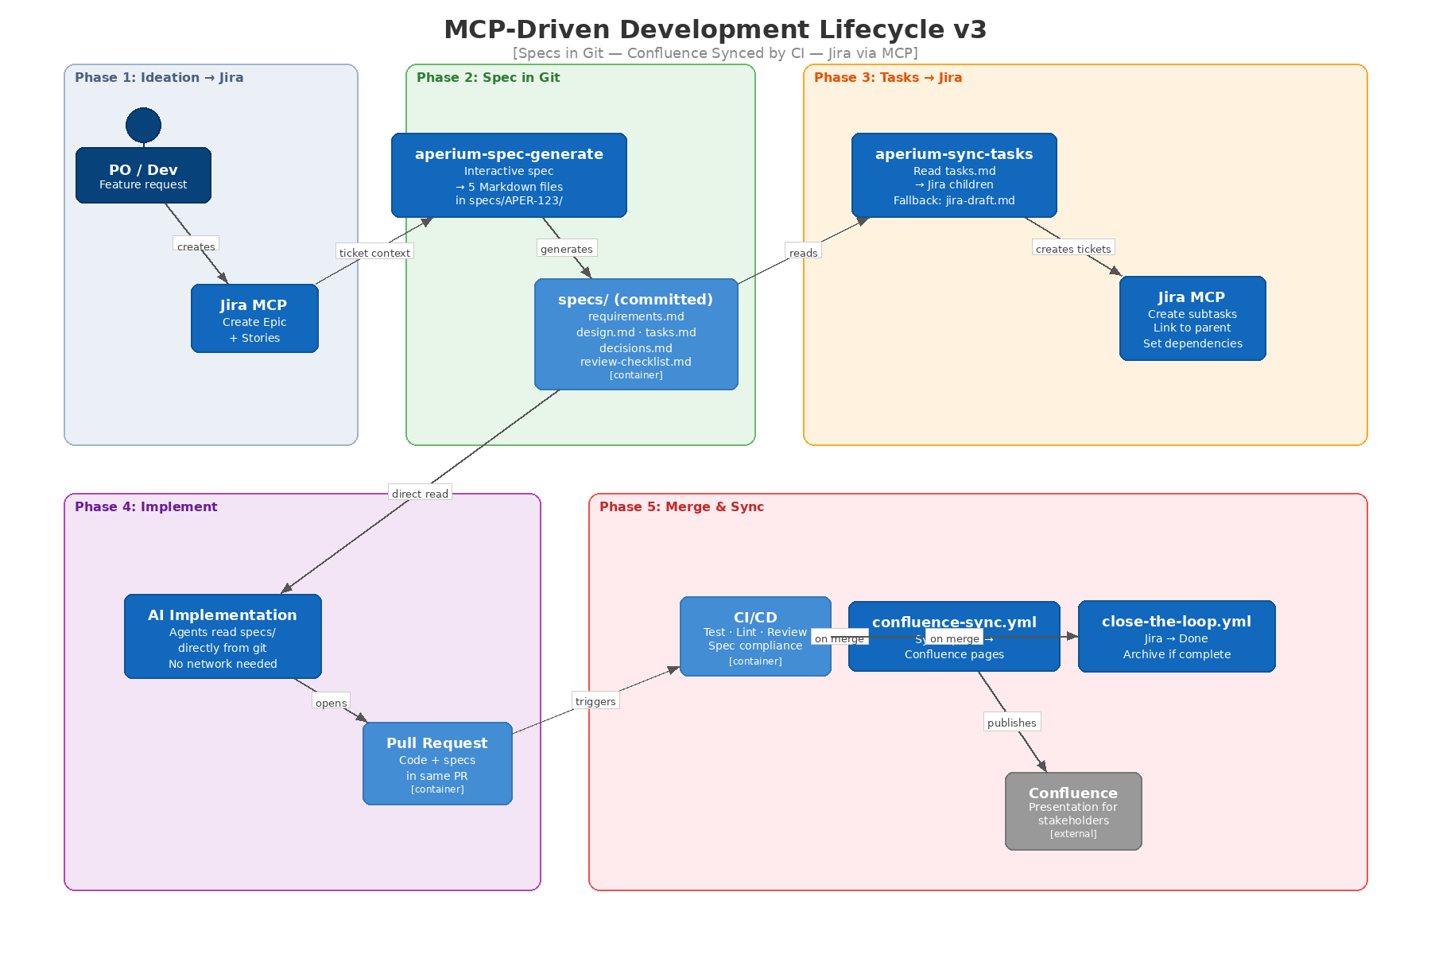
Figure 2: MCP-DLC v3 — Specs in Git, Confluence Synced by CI

Phase 1: Ideation & Ticket Creation (Jira MCP)
PO/dev describes feature → AI refines into user story + acceptance criteria → AI uses Jira MCP to create Epic + Stories. Draft-first pattern recommended: generate ticket content locally, review, then push to Jira.
MCP is used here because Jira is the work-tracking system that the whole org depends on. The aperium-sync-tasks skill includes a fallback: if the Jira MCP fails, it saves a jira-draft.md file that can be manually imported or retried later.

Phase 2: Spec Generation in Git
Developer triggers aperium-spec-generate (or Speckit/Superpowers directly). AI generates five files interactively:
- requirements.md — user stories, acceptance criteria, edge cases, out-of-scope
- design.md — architecture decisions, component interactions, data model, security
- tasks.md — numbered tasks, dependencies, test criteria, suggested tool
- decisions.md — ADRs made during planning (and updated during implementation)
- review-checklist.md — acceptance verification items
Files are written to specs/APER-123/ and committed to the feature branch. The PR is opened (or updated) so review can begin immediately.
For POs: They review in the PR (GitHub renders Markdown). Or they wait for merge, when CI syncs to Confluence for a richer viewing experience. For teams that want early PO visibility, a CI step can sync specs to Confluence on PR creation (not just merge).

Phase 3: Task Decomposition & Jira Sync
Developer runs aperium-sync-tasks:
- Reads specs/APER-123/tasks.md from local files
- Creates child tickets in Jira via MCP, linked to parent Epic
- Updates tasks.md with Jira ticket IDs for traceability
- Fallback: If MCP fails, saves jira-draft.md with ticket definitions for manual import
This is the only phase that requires MCP connectivity. If Jira is unavailable, the developer can proceed with implementation using the local task list and sync tickets later.

Phase 4: Implementation (Git-Native)
Developer works through tasks. Every agent reads AGENTS.md + specs/APER-123/ directly from files.
Agent-specific patterns:
Augment: Open specs/APER-123/tasks.md as context. Augment indexes the full repo including specs.
Claude Code + Superpowers: Superpowers activates TDD. Each task in isolated worktree. Subagents implement; main agent reviews. All read specs/ as local files.
Copilot Agent Mode: Smaller tasks. Prompt: "read specs/APER-123/tasks.md, implement task 3."
Codex: Async via GitHub Agent HQ. The dispatch includes spec content from the repo.
Spec updates during implementation: If the design changes during coding (it always does), the developer edits specs/APER-123/decisions.md directly and commits the change. The spec and code evolve together.

Phase 5: Merge & CI Sync
On PR merge, three CI workflows fire:
1. `confluence-discover` + `confluence-sync.yml`:
Finds or creates the Confluence page structure. Converts specs/APER-123/*.md to Confluence pages. Creates/updates pages under the Epic node.
2. `close-the-loop.yml`:
Transitions Jira tickets to Done. Checks whether all child tickets under the Epic are complete.
3. `archive-if-completed`:
If the Epic is fully done (all children completed), moves the Confluence page from "Active Specs" to "Completed Specs."
Failure handling: CI sync failures never block deployment. If Confluence or Jira is temporarily down, the sync retries on the next merge. Git remains the source of truth.

Skills, Plugins & Custom Extensions
Skills live in .agents/skills/ (industry standard, native support in Augment and Codex).
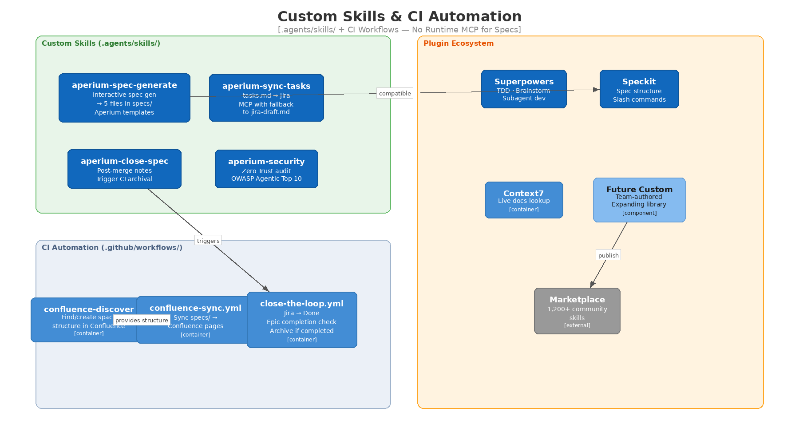
Figure 3: Custom Skills & CI Automation Architecture

Recommended Plugin Stack
Tier 1 — Install Immediately:
- Superpowers (obra/superpowers) — TDD, brainstorm, subagent dev, code review
- Speckit (github/spec-kit) — spec structure standard, 22+ agents
- Context7 — live docs lookup for dependencies
- Playwright — E2E test generation
- Frontend Design — polished UI generation
Tier 2 — Role-Specific:
- Commit Commands — conventional commit enforcement
- Feature Dev — end-to-end feature workflow

Custom Aperium Skills
1. `aperium-spec-generate` — Core Spec Skill
Generates five spec files interactively to specs/APER-123/. Pre-filled with Aperium architecture (FastAPI, React, MCP servers, PostgreSQL, Redis). Includes security considerations section. Compatible with Speckit's output format. No Confluence dependency — outputs pure Markdown locally.
2. `aperium-sync-tasks` — Jira Task Sync
Reads tasks.md, creates Jira child tickets via MCP. Includes error fallback: on MCP failure, saves jira-draft.md with full ticket definitions for manual import or later retry. Only skill that requires MCP connectivity.
3. `aperium-close-spec` — Post-Merge Closure
Adds implementation notes to specs/APER-123/decisions.md (what was built, deviations from plan, PR link). Marks review-checklist.md items as done. Triggers CI archival workflow.
4. `aperium-security` — Security Assessment
Zero-trust assessment on new features. OWASP Agentic Top 10. PII handling verification in MCP tool chains. Six-layer defense model check. Outputs report to specs/APER-123/ as part of the spec.
Building new skills: Use Superpowers' writing-skills module — it teaches agents to author skills using TDD. Skills in .agents/skills/ are auto-discovered by Augment and Codex.

Multi-Agent Orchestration
Parallel execution: Claude Code + Superpowers subagents in isolated worktrees. Each subagent reads the same specs/ files from the worktree — no sync issues.
Cross-tool parallel work: Different devs, different agents, same spec files in Git. Consistency enforced by AGENTS.md (code style) + specs/ (feature intent) + CI (automated checks).
Orchestration tools (if needed): Superpowers subagents for same-tool parallelism. Claude Squad for multi-tool session management. Start with Superpowers — add Claude Squad only if running 5+ agents in parallel.

Handling Urgent Requests
P0/P1: No spec required. Hotfix branch → fix → express review (< 2h) → deploy. Within 48h: retro-spec in specs/, commit, merge → CI syncs to Confluence.
P2: Abbreviated spec (requirements.md only) in specs/. Same process, prioritized SLA.
Principle: Even urgent work eventually gets a spec. Git is the team's memory. Confluence is the team's window.

Implementation Roadmap

Week 1-2: Foundation
- Create `AGENTS.md` — human-written, ~80-100 lines. Set up 2 symlinks.
- Create `specs/` directory with README explaining the structure
- Create `.agents/skills/` directory with initial skill stubs
- Add `specs/` and `.agents/skills/` to repo structure
- Install plugins — Superpowers, Speckit, Context7, Playwright on all team tools
- Configure Jira MCP — for the aperium-sync-tasks skill only
- Set up CI workflows — confluence-discover, confluence-sync.yml, close-the-loop.yml

Week 3-4: Pilot
- Build `aperium-spec-generate` skill — core custom skill
- Build `aperium-sync-tasks` skill — with MCP fallback to jira-draft.md
- Pilot 2-3 features using full MCP-DLC v3 workflow
- Document friction points — what's slow, broken, confusing
- Iterate on `AGENTS.md` — add conventions from pilot
- Verify CI sync — confirm specs appear correctly in Confluence after merge

Week 5-8: Rollout
- Full team adoption — all new features follow the workflow
- Build `aperium-close-spec` and `aperium-security` skills
- Set up AI code review with spec compliance in CI
- Establish sprint retro → AGENTS.md + skills update cadence
- Create prompt library — docs/prompts/ with 5 proven templates

Week 9-12: Optimization
- Measure metrics — spec-to-PR time, review turnaround, Confluence sync rate
- Pilot multi-agent orchestration — Superpowers subagents
- Train team on skill authoring — Superpowers writing-skills module
- Optimize CI sync — add draft sync on PR creation for early PO visibility
- Publish skills to internal registry or Anthropic marketplace

Summary of Recommendations
Area | Recommendation | Why
Code context | AGENTS.md + 2 symlinks | Augment/Codex read natively. Only Claude/Copilot need symlinks.
Spec storage | specs/APER-123/ in Git | Local file read, no MCP dependency, travels with code
Spec format | 5 Markdown files per feature | requirements, design, tasks, decisions, review-checklist
Confluence role | Read-only presentation layer | CI syncs on merge. Stakeholders view, devs never write.
Skills directory | .agents/skills/ | Industry standard, native Augment + Codex support
Spec generation skill | aperium-spec-generate | 5 files to specs/ locally. No MCP needed.
Jira sync skill | aperium-sync-tasks | MCP with fallback to jira-draft.md
Close spec skill | aperium-close-spec | Implementation notes + trigger CI archival
Security skill | aperium-security | Zero Trust + OWASP Agentic Top 10
CI: Confluence | confluence-sync.yml | Sync specs/ → Confluence on merge
CI: Jira | close-the-loop.yml | Transition Done + archive if complete
CI: Discovery | confluence-discover | Find/create Confluence page structure
Spec format tool | Speckit | 22+ agents, slash commands
Methodology tool | Superpowers | TDD, subagents, brainstorm, code review
IDE agent | Augment Code | 200K context, reads AGENTS.md natively
CLI agent | Claude Code + Superpowers | Deep reasoning, subagent orchestration
Async agent | Codex via Agent HQ | Reads AGENTS.md natively, fire-and-forget

Final Thought
The v2 design was architecturally sound but operationally wrong. Making Confluence a runtime dependency during development introduced fragility exactly where you need reliability — at the point where a developer is heads-down, in flow, iterating with an AI agent.
The corrected design is simpler and more resilient: specs in Git, Confluence via CI. Every agent reads local files. No network calls during development. Confluence exists for the people who need a nice view of the specs — POs, QA, stakeholders — but it's never in the critical path.
The MCP surface area is now minimal: Jira MCP in one skill (aperium-sync-tasks), with a local fallback file if even that fails. Everything else is local files and CI workflows.
The best architecture is the one developers actually follow. Making specs local, committed, and versioned — alongside the code they describe — means developers naturally keep them updated. Making Confluence a CI-synced mirror means stakeholders get their view without creating friction for developers.
Build the skills. Set up the CI workflows. Let the agents read local files. The system works because it's simple.

