**Challenge:** Build a web page that evaluates two poker hands and declares a winner. Feel free to use any standard web development framework: Groovy/Grails, Java, ASP.NET, etc.

**Basic Page Design:**

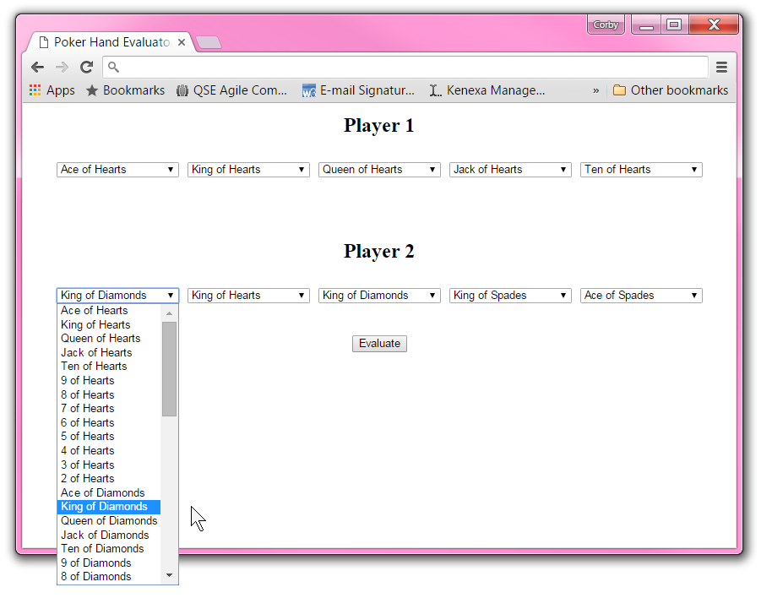

**Basic (mandatory) Requirements:**

* The user should be able to select from the cards of a standard deck to specify a poker hand for two players.
* When the user clicks the “Evaluate” button, the winner should be indicated. This could be accomplished graphically by drawing a box around or changing the color of the winner and/or with a message that is displayed below the “Evaluate” button.
* For the purposes of this challenge, the evaluation of the poker hands should be done on the server side. This can be accomplished in one of two ways:

1. Post-back method: Upon clicking the “Evaluate” button, the page will “post back” to the server where the evaluation is completed. The page will be re-drawn to include the winner.
2. Service Oriented method: Upon clicking the “Evaluate” button, the page will issue an AJAX call to the server containing the information for each player’s hand. The server will accept this information and respond with the winner. JavaScript on the page will accept this response from the server modify the page to indicate the winner.

**Advanced (optional) Requirements (please complete in the order listed below):**

1. Ensure that both of the poker hands are valid. That is, there are no duplicate cards.
2. Add a button for each player that will specify a random hand for that player.
3. Keep track of the number of hands each player has won and display it on the page.