Spatial Analysis of Workers’ Road Accident Hotspots in Bangladesh to Inform Safety Measures: Evidence from the Employment Injury Scheme Pilot Programme
Tasbiul Islam Nibir
Research & Documentation Officer
Funded by GIZ
Faruque Hasan
Junior MIS Specialist, EIS-PSU
Funded by ILO
05 November 2026

Contents

1 Abstract
This report examines where garment, textile and footwear workers in Bangladesh were killed or disabled in road accidents, and who those workers were. It uses 134 intake cases from the Employment Injury Scheme (EIS) pilot, with accidents dated from November 2022 to March 2026. A total of 121 accident points could be mapped with the worker’s journey route. A 1,000 m circle was drawn around each point, and overlapping circles were grouped into one zone. This produced 27 zones with two or more points. They hold 82 of the 121 mapped points (68%). The road with the most points was Dhaka to Mymensingh Highway (N3) (23), and national highways together hold 55 of the 102 points linked to a road.
The intake records show that 89% of the cases were deaths. Commuting accounted for 81% of cases, and 53% involved a worker on foot. Every case involving a woman was a commuting accident. The report describes the densest zones and sets out recommended actions. The zones show where cases are concentrated. They are not accident rates, because the number of people using each road is not known.
Keywords: occupational road safety; worker accidents; spatial clustering; road corridor risk; gender disaggregation; collision types; GIS; Bangladesh

2 Introduction
This report identifies where worker road accident cases recorded in the EIS pilot are concentrated. The aim is to help direct road-safety measures to the places with the most recorded cases.
Road injuries are a leading cause of death worldwide. They caused an estimated 1.34 million deaths in 2023, and the mortality rate in low-income countries was about six times that in high-income countries (GBD 2023 Road Injuries Collaborators, 2026). In Bangladesh, pedestrians are involved in nearly 50% of fatal collisions, rising to around 65% in the Dhaka metropolitan area (Debnath et al., 2021). An earlier study reported that national highways account for about 47% of pedestrian fatalities in the country (Sarkar et al., 2011). A study of Bangladeshi crashes also found that the leading factors linked to injury severity were not the same on highway and non-highway roads (Sakib et al., 2025).
Map-based methods have already been used to find crash concentrations on Bangladeshi roads. Khatun et al. (2024) used a severity index, kernel density estimation and hotspot analysis on the Kushtia-Jhenaidah highway (N704). Billah et al. (2026) identified 18 high-risk black spots among 69 crash-prone locations on the Dhaka-Mawa Expressway (N804). Each of these studies covers a single road. Commuting is also part of occupational road safety. In Spain, official reports recorded more commuting crashes than at-work crashes among occupational road injuries in every year from 2020 to 2024 (Sánchez-Toledo Ledesma and Fernández Laviada, 2026). Those figures describe Spain and may not apply to Bangladesh. This report uses a map-based approach across all mapped roads, for worker cases recorded in the EIS pilot.
The records used here are worker accident cases from the EIS pilot. Bangladesh launched the pilot in June 2022 for the export-oriented garment sector, with technical support from the ILO and GIZ. The cases cover two situations: road traffic accidents (RTA) that happened while a worker was travelling for their job (on duty), and commuting accidents that happened on the way to or from the workplace. The report addresses four questions: (1) where do accident cases cluster together; (2) which roads and journey routes have the most cases; (3) who is affected, in terms of gender and age; and (4) how were workers travelling when the accident happened, and does this differ between commuting and on-duty cases?

2.1 Study Scope
This is a descriptive study. Traffic counts, the size of the workforce in each area and the frequency of each trip are not available, so true risk rates cannot be calculated. The data can show where cases are concentrated and who was affected. The gender, age and transport mode figures come from the EIS intake dataset (details_all_cases.csv) and describe the reported cases only. Every case in the dataset ended in either death or disability, so minor injuries are not included.

2.2 Key Terms
- Case: one worker recorded in the EIS data.
- Commuting accident: an accident on the way between home and the workplace.
- On-duty RTA: a road traffic accident that happened while the worker was travelling for their job.
- Zone: a group of accidents whose 1,000 m circles overlap, so each accident lies within 2,000 m of at least one other accident in the group. A zone can hold a single case.
- Cluster: a zone with two or more cases.
- Road match: the road an accident point was linked to. A high-confidence match means the point lies close to a single road. A lower-confidence match means it lies further away or near more than one road, for example at a junction.

3 Materials and Methods

3.1 Data and Case Definition
Four data sources were used: points.parquet for journey points and accident locations, paths.parquet for the route lines, the EIS intake records (details_all_cases.csv), and a project OpenStreetMap extract (osm_roads.gpkg) to identify roads. In the original case files, each journey was mapped with three markers in order: A for the starting point, B for the accident point, and C for the destination. The middle (B) marker of each journey was treated as the accident. The Source field separates commuting and on-duty RTA records. Both types go through the same zoning and road-matching steps and differ only in colour on the maps.
GPS records are linked to the intake records by case file ID. Of the 134 intake cases, 118 have a usable mapped location. The other 16 appear only in the demographic and transport analysis. A further 2 mapped case files have no matching intake record, so they appear only in the spatial analysis. Records with invalid coordinates or empty route lines were removed before mapping. Case file 2025.EIS.000117 holds two mapped journeys, one under each journey type. Both are shown as recorded, which gives 121 accident points from 120 case files.
Table 1 summarises the mapped data. Mapped accident points are the B markers, and journey routes are the routes drawn for those journeys. Road-matched points lie within 50 m of a road in the OpenStreetMap extract. The remaining 19 points have no road in the extract within 50 m, and 16 of them are on-duty RTA records (see Limitations). Table 2 splits the mapped points by journey type.
Table 1: Analytical dataset and matching summary.
Indicator | Result
Mapped accident points | 121
Journey routes | 121
Distinct case files with GPS | 120
Zones with two or more points | 27
Road-matched points | 102
High-confidence road matches | 71

Table 2: Accident points and original routes by journey type.
Type | Accident points | Original routes
Commuting | 98 | 98
RTA | 23 | 23

3.2 Spatial Analysis
All distances were measured in metres using EPSG:32646 (UTM Zone 46N), a map projection that measures distance accurately across Bangladesh. A 1,000 m circle was drawn around every accident. Where circles touched or overlapped, they were joined into one zone, and any zone containing two or more cases was treated as a local cluster. The radius is only a way of grouping nearby cases. It does not mean an accident affected that whole area.
Each zone was given a priority class based on the number of cases it holds:
Table 3: Zone priority classes and the number of zones in each.
Priority class | Cases in zone | Zones in current data
Critical | 8 or more | 1
Very high | 5 to 7 | 2
High | 3 to 4 | 11
Elevated | 2 | 13
Observed | 1 | 39
Each accident was then linked to a road. The matching step (the match_accidents_to_roads() function in R/road_risk_analysis.R) finds the nearest OpenStreetMap road that carries vehicles, within 50 m. Footpaths and cycle tracks are ignored. If the nearest road is within 30 m and no other road is about as close, the match is marked high confidence. If the nearest road is 30–50 m away, or another road is within 5 m of the same distance (as at a junction), it is marked lower confidence. Where roads compete in this way, the more important road (for example a highway over a service lane) is chosen. Short OpenStreetMap road pieces that share the same route number or name are then combined into one corridor, and the cases on each corridor are counted.

3.3 Prioritisation Logic
Zone priority classes rest on case counts alone. Road counts, worker routes passing through a zone and the confidence of road matches give supporting context when comparing places. The recommendations are kept general because the data do not record how each crash happened, vehicle speeds, traffic volumes, shift times or the condition of the site.

4 Results

4.1 Overall Spatial Pattern
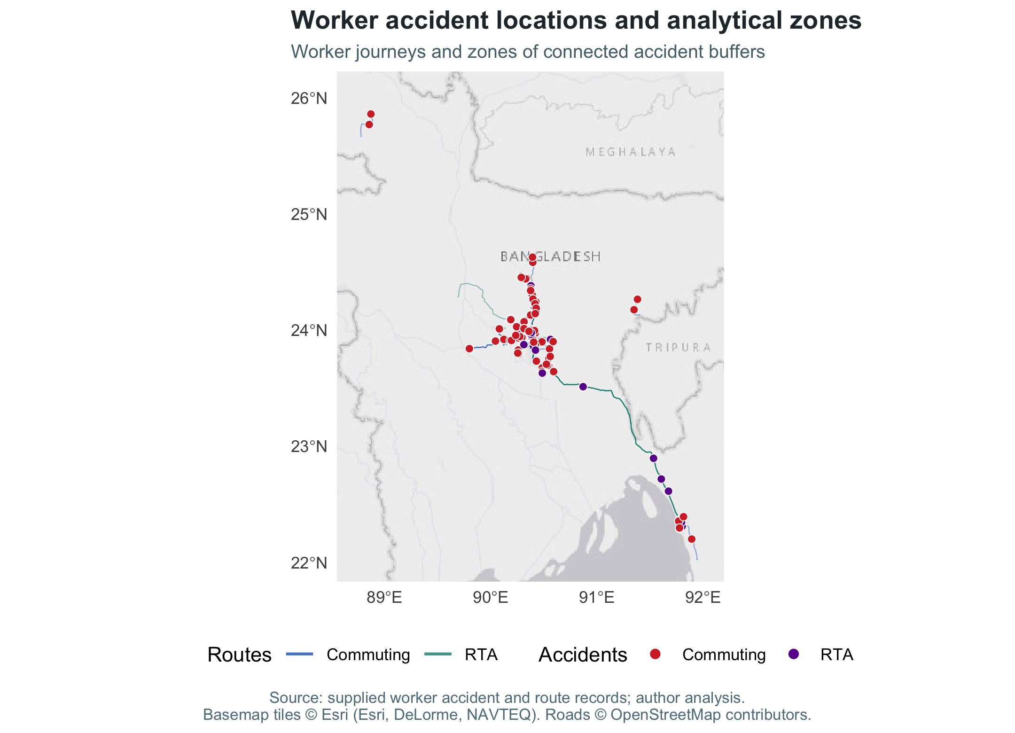
Figure 1: Geographic distribution of recorded worker accident cases and connected zones.
Figure 1 shows every mapped accident point (dots), the journey routes (lines) and the zones formed by overlapping 1,000 m circles (orange). In the intake records, the districts with the most cases are Gazipur, Dhaka, Narayanganj and Chattogram. On the map, 82 of the 121 accident points (68%) fall in a zone shared with at least one other point, and 39 are isolated.
When reading the map, look at the number of points in each zone, not the size of the orange area. A long, thin zone simply means the points are strung out along a road.
In total, 91 of the 121 journey routes (75%) pass within 1,000 m of an accident from a different case file.

4.2 Accident-Prone Roads
The table below lists the leading road corridors by number of road-matched points. Only corridors with an English road name or route number in OpenStreetMap are shown. High confidence and lower confidence show how certain the road match is for those cases (see Section 3.2). Share is the corridor’s percentage of all 102 road-matched cases.
Table 4: Named road corridors with the most recorded worker accident cases.
Road/corridor | Cases | High confidence | Lower confidence | Share (%)
Dhaka to Mymensingh Highway (N3) | 23 | 15 | 8 | 22.5
Dhaka to Chattogram Highway (N1) | 7 | 2 | 5 | 6.9
Joydebpur to Jamalpur Highway (N4) | 7 | 5 | 2 | 6.9
Dhaka to Aricha Highway (N5) | 5 | 4 | 1 | 4.9
Dhaka to Sylhet Highway (N2) | 4 | 3 | 1 | 3.9
National highway N503 | 3 | 3 | 0 | 2.9
National highway N540 | 3 | 3 | 0 | 2.9
Sagarika Road | 2 | 0 | 2 | 2.0
Cases concentrated on a few corridors
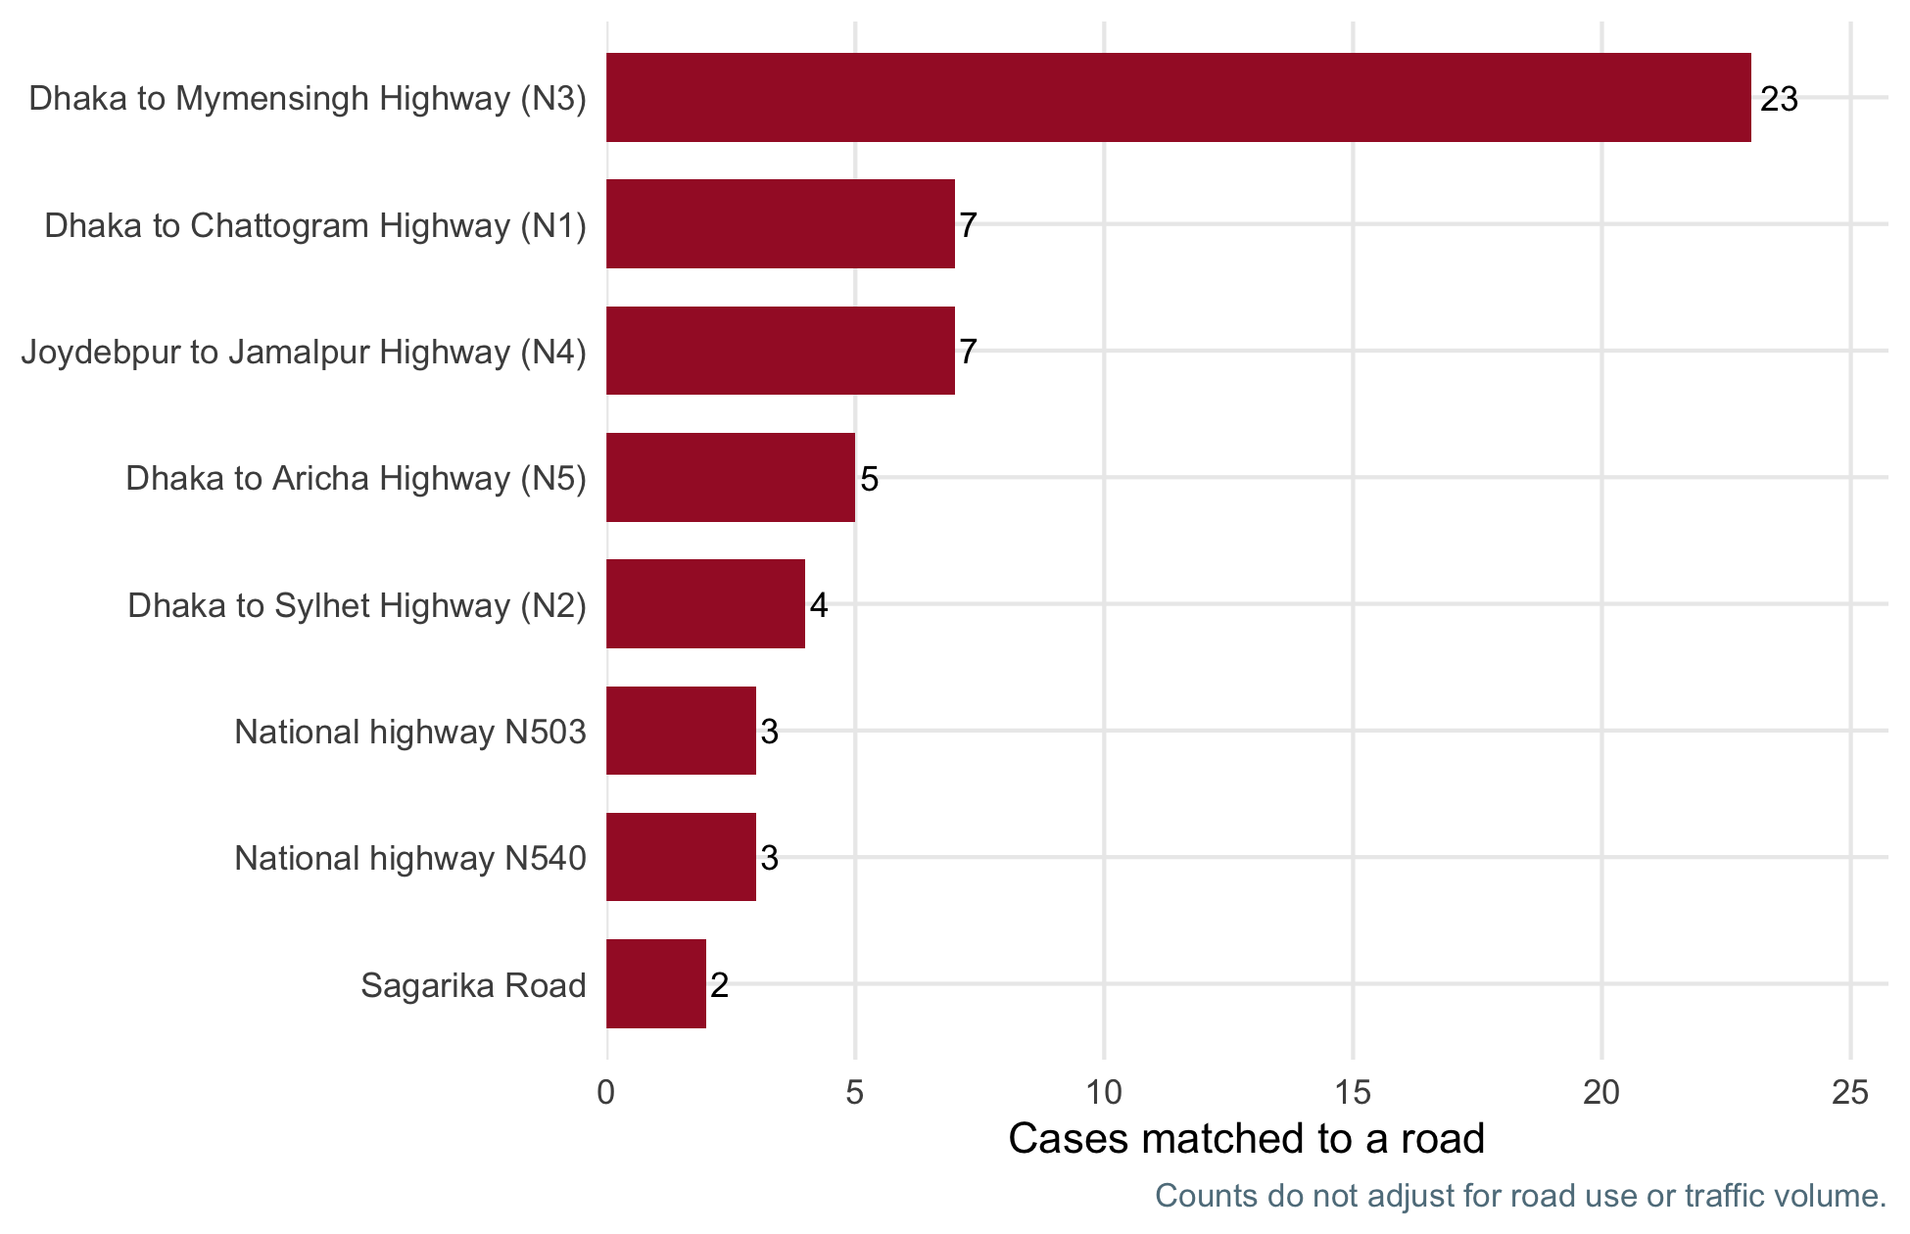
Figure 2: Leading named road corridors ranked by road-matched worker accident cases.
A small number of roads account for a large share of the cases. The top five corridors hold 46 of the 102 road-matched cases (45%), and national highways as a whole hold 55 (54%). Dhaka to Mymensingh Highway (N3) has the most, with 23 cases (23% of all matched cases). This makes it the first road to examine for safety improvements. Dhaka City Bypass (N105) also has 2 cases and ranks just below the table.
Corridors with many lower-confidence matches should be checked on site before any works are planned.

4.2.1 Journey Type: Commuting and RTA
Table 5: Spatial coverage by journey type. Each route is counted once.
Type | Original routes | Total route length (km) | Routes near another case’s accident | Accident locations
Commuting | 98 | 954.38 | 73 | 98
RTA | 23 | 1,808.76 | 18 | 23
The table above compares commuting and on-duty (RTA) journeys. Each route is counted once, even where the original file split it into several pieces. Routes near another case’s accident counts the routes that pass within 1,000 m of an accident from a different case file. These counts cover the mapped cases only. They are not national accident totals.
Commuting routes average 9.7 km (median 5.6 km). On-duty routes average 78.6 km (median 18.4 km). In total, 52% of on-duty points lie in a zone with another point, against 71% of commuting points.

4.3 Localised Hotspots
This section looks more closely at the densest zones. Zones are numbered by case count, so Zone 1 has the most cases. Every zone with more than 3 cases is mapped below (up to 10). Zone numbers are reassigned each time the report is produced, so they may change when new cases are added. The place name in each heading is a more reliable reference.
On each map, red dots are commuting accidents and purple dots are on-duty road traffic accidents (RTA). Both count equally towards a zone. The orange area is the zone, grey lines are the roads, and thicker grey lines are major roads (motorway, trunk or primary). The map extends 450 m beyond the zone to show the surroundings. The text for each zone gives its location and surroundings. Place names come from the case-file maps. The records do not state crash causes, so each site should be visited before any works are planned.
Table 6: The densest zones (more than 3 cases). Main road and district are the most frequent among the zone’s cases.
Zone | Cases | Commuting | RTA | Main road | District
1 | 9 | 6 | 3 | Dhaka to Mymensingh Highway (N3) | Gazipur
2 | 5 | 5 | 0 | Dhaka to Chattogram Highway (N1) | Narayanganj
3 | 5 | 1 | 4 | Dhaka to Mymensingh Highway (N3) | Dhaka
4 | 4 | 4 | 0 | Dhaka to Mymensingh Highway (N3) | Gazipur
5 | 4 | 3 | 1 | National highway N540 | Dhaka
6 | 4 | 4 | 0 | Sagarika Road | Chattogram
7 | 4 | 4 | 0 | Joydebpur to Jamalpur Highway (N4) | Gazipur

4.3.1 Zone 1: Gazipur Sadar – Vogra Bypass – Teknagopara Corridor (N3 Highway)
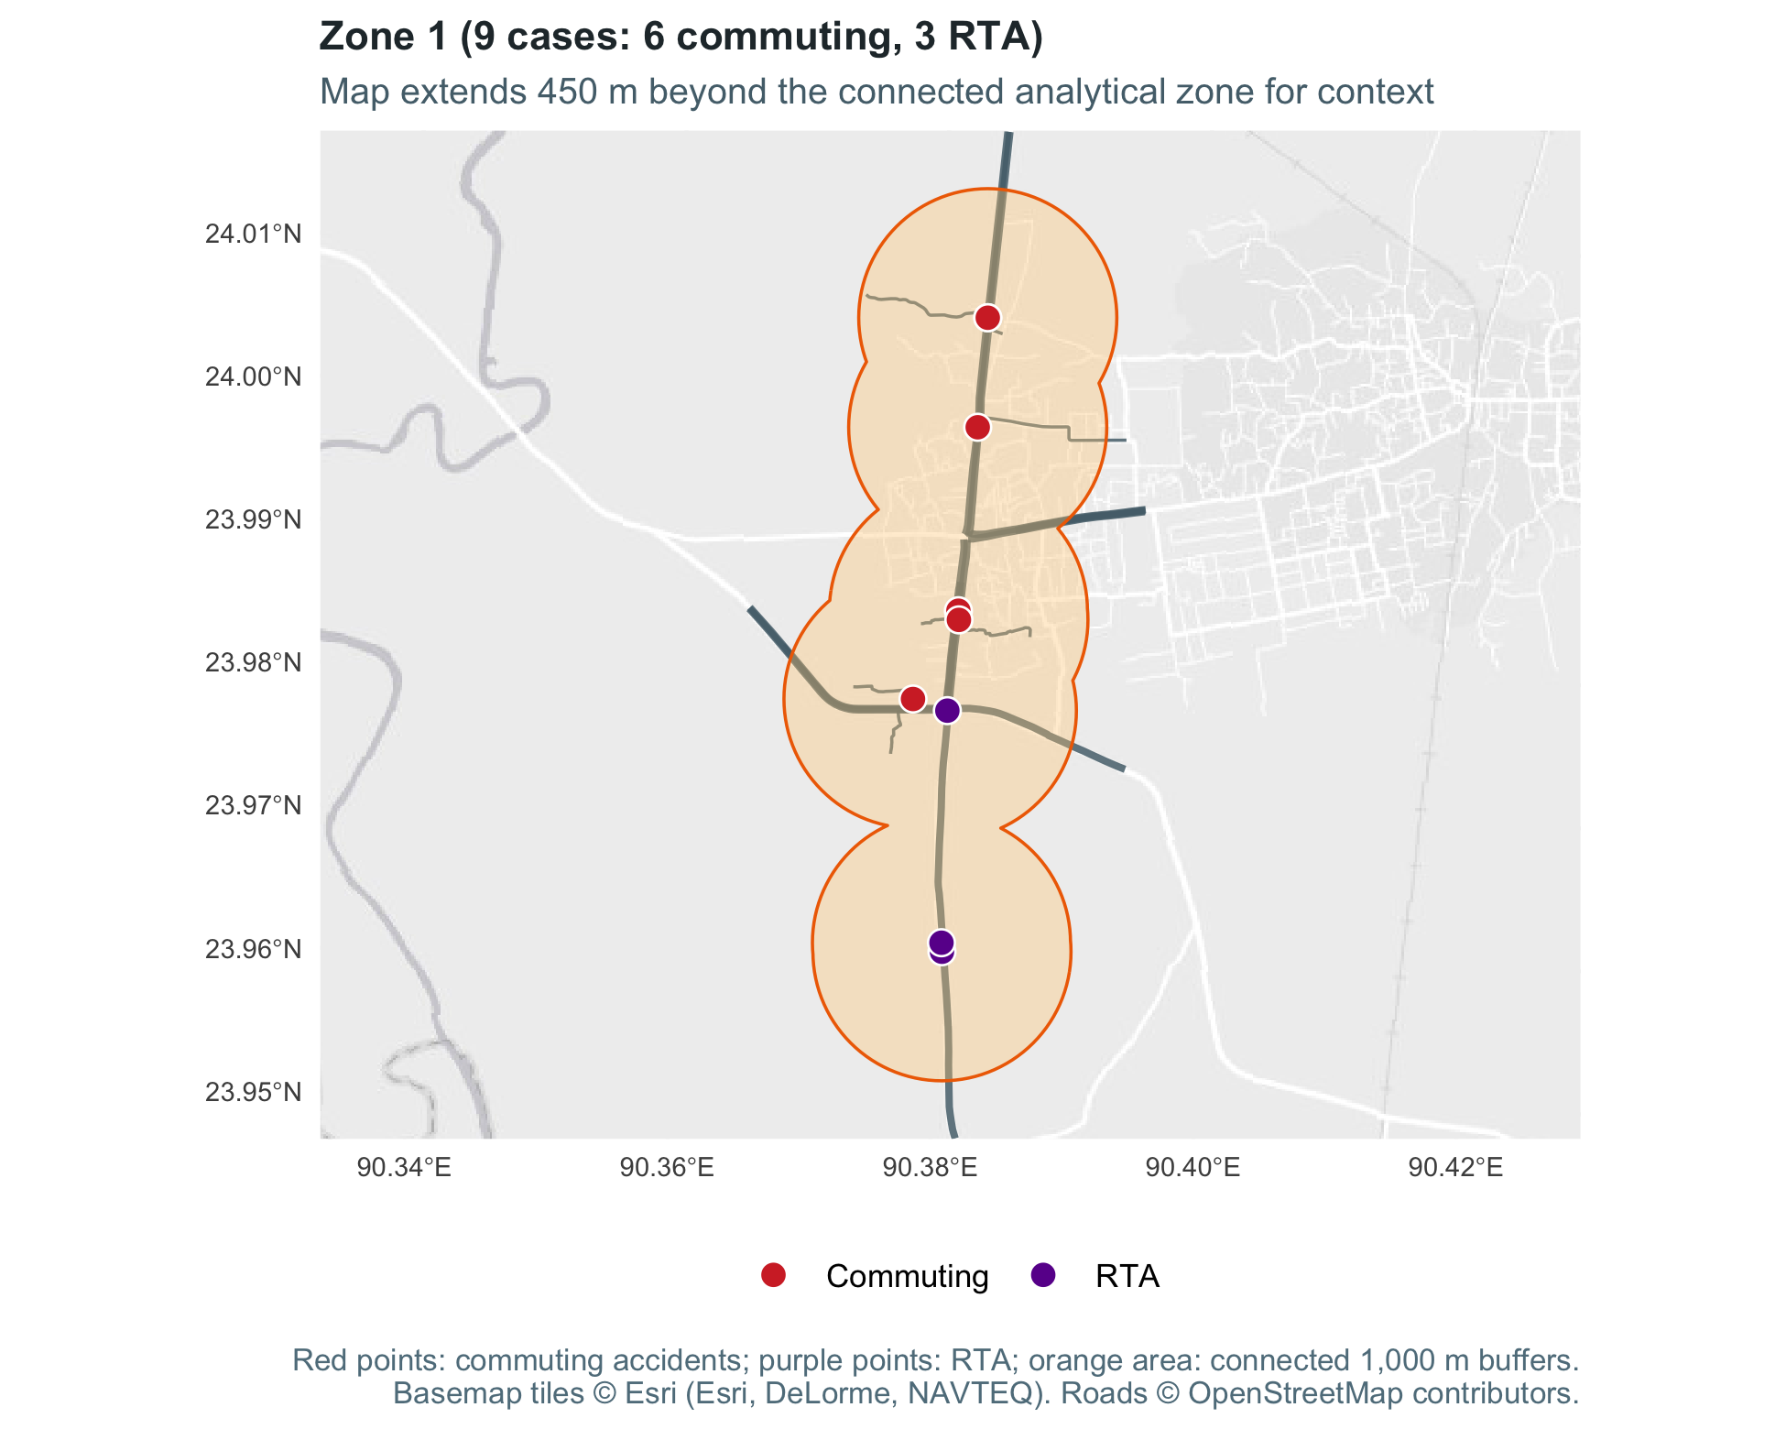
Recorded cases. 9 (6 commuting, 3 RTA). 6 of 9 involved a pedestrian. The most common matched road is Dhaka to Mymensingh Highway (N3) (6 of 9 cases).
Location. Gazipur Sadar Upazila, inside Gazipur City Corporation, along the N3.
What is around it. Vogra Bypass, Telipara and Teknagopara. The case-file maps also mark Amin Super Market and several factories nearby.

4.3.2 Zone 2: Kanchpur – Bandar – Dewanbag Industrial Belt (N1 Highway, Narayanganj)
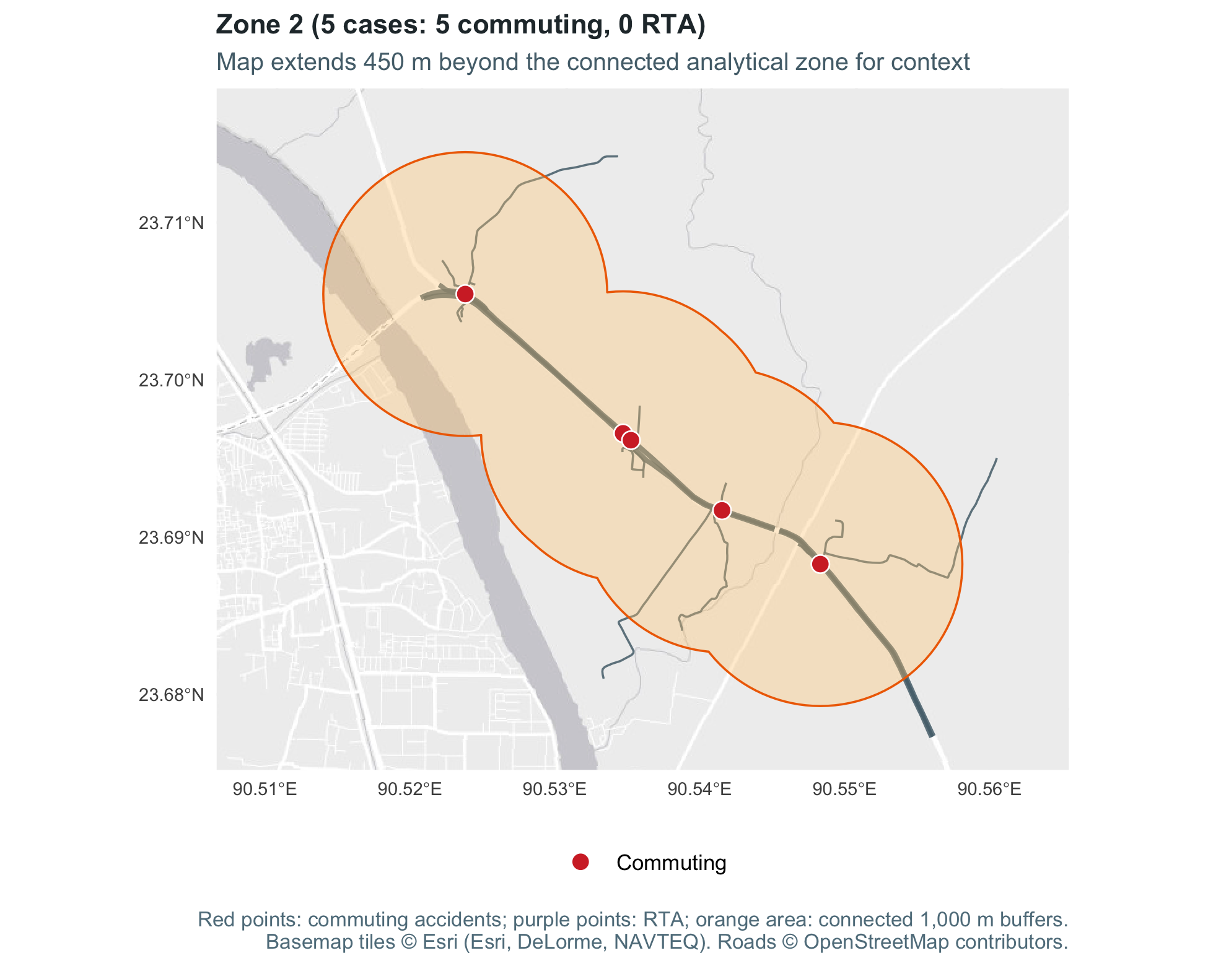
Recorded cases. 5 (5 commuting, 0 RTA). All involved a pedestrian. The most common matched road is Dhaka to Chattogram Highway (N1) (5 of 5 cases).
Location. Narayanganj District, on the eastern bank of the Shitalakshya River, covering Kanchpur Union (Sonargaon) and Bandar Upazila.
What is around it. The N1 highway near the Kanchpur Bridge interchange and Dewanbag. The case-file maps also mark several factories nearby.

4.3.3 Zone 3: Uttara – Jashimuddin Avenue – Airport Corridor (N3 Highway, Dhaka)
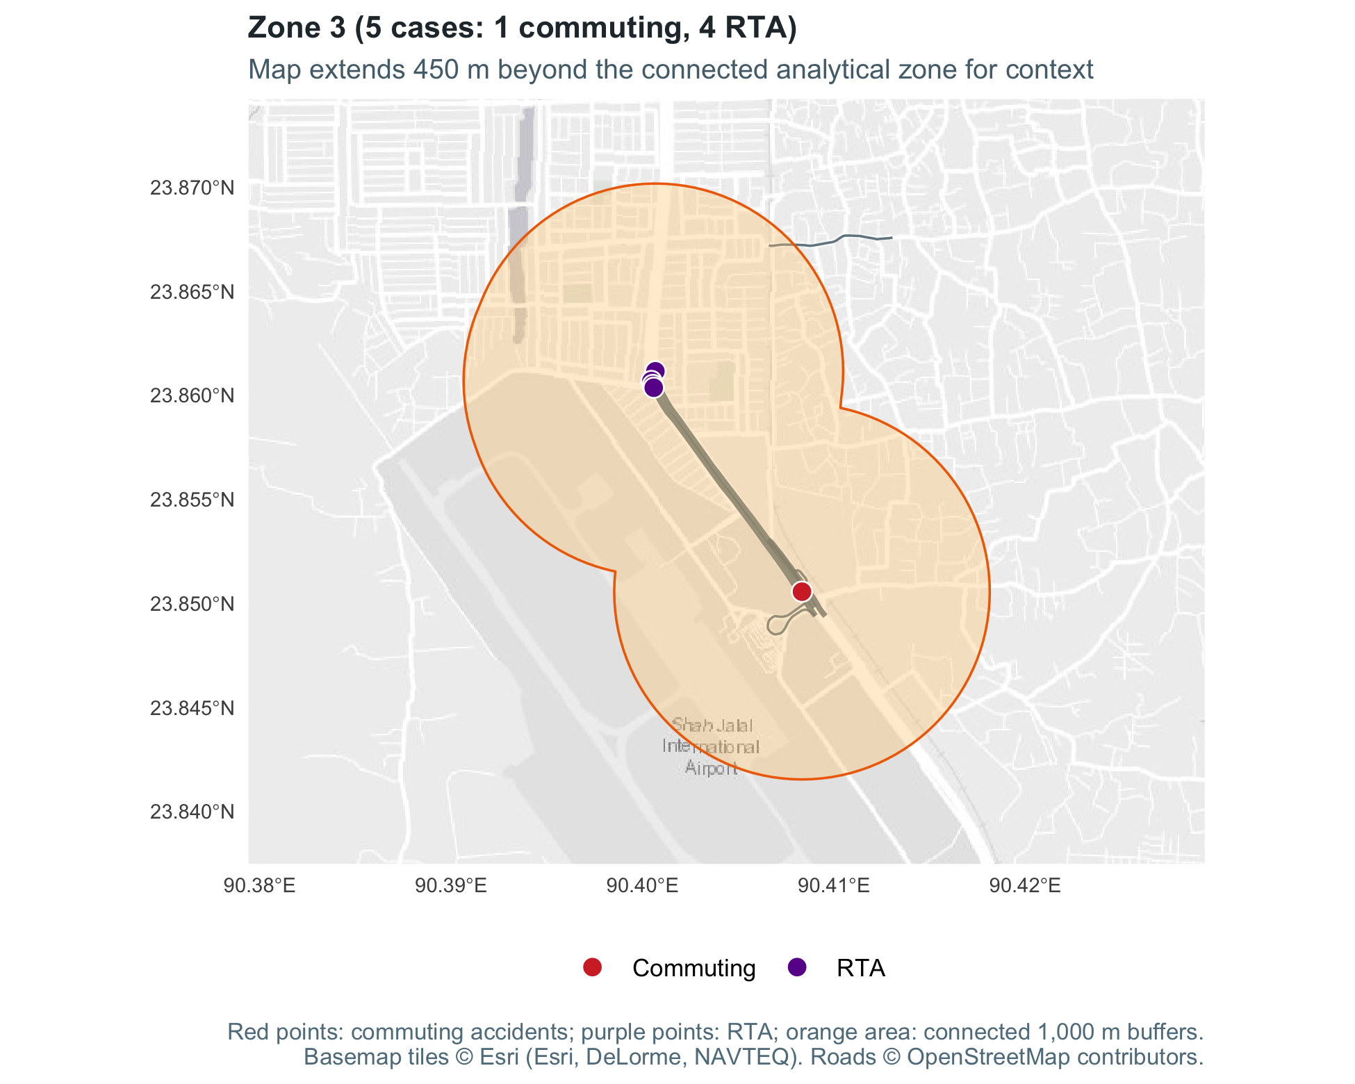
Recorded cases. 5 (1 commuting, 4 RTA). All involved a pedestrian. The most common matched road is Dhaka to Mymensingh Highway (N3) (3 of 5 cases).
Location. Northern Dhaka, around Jashimuddin Avenue in Uttara, along the N3.
What is around it. The case-file maps mark the Jashimuddin bus stop and the Airport Flyover.

4.3.4 Zone 4: Mawna – Gorgoria Master Bari Cluster (N3 Highway, Sreepur, Gazipur)
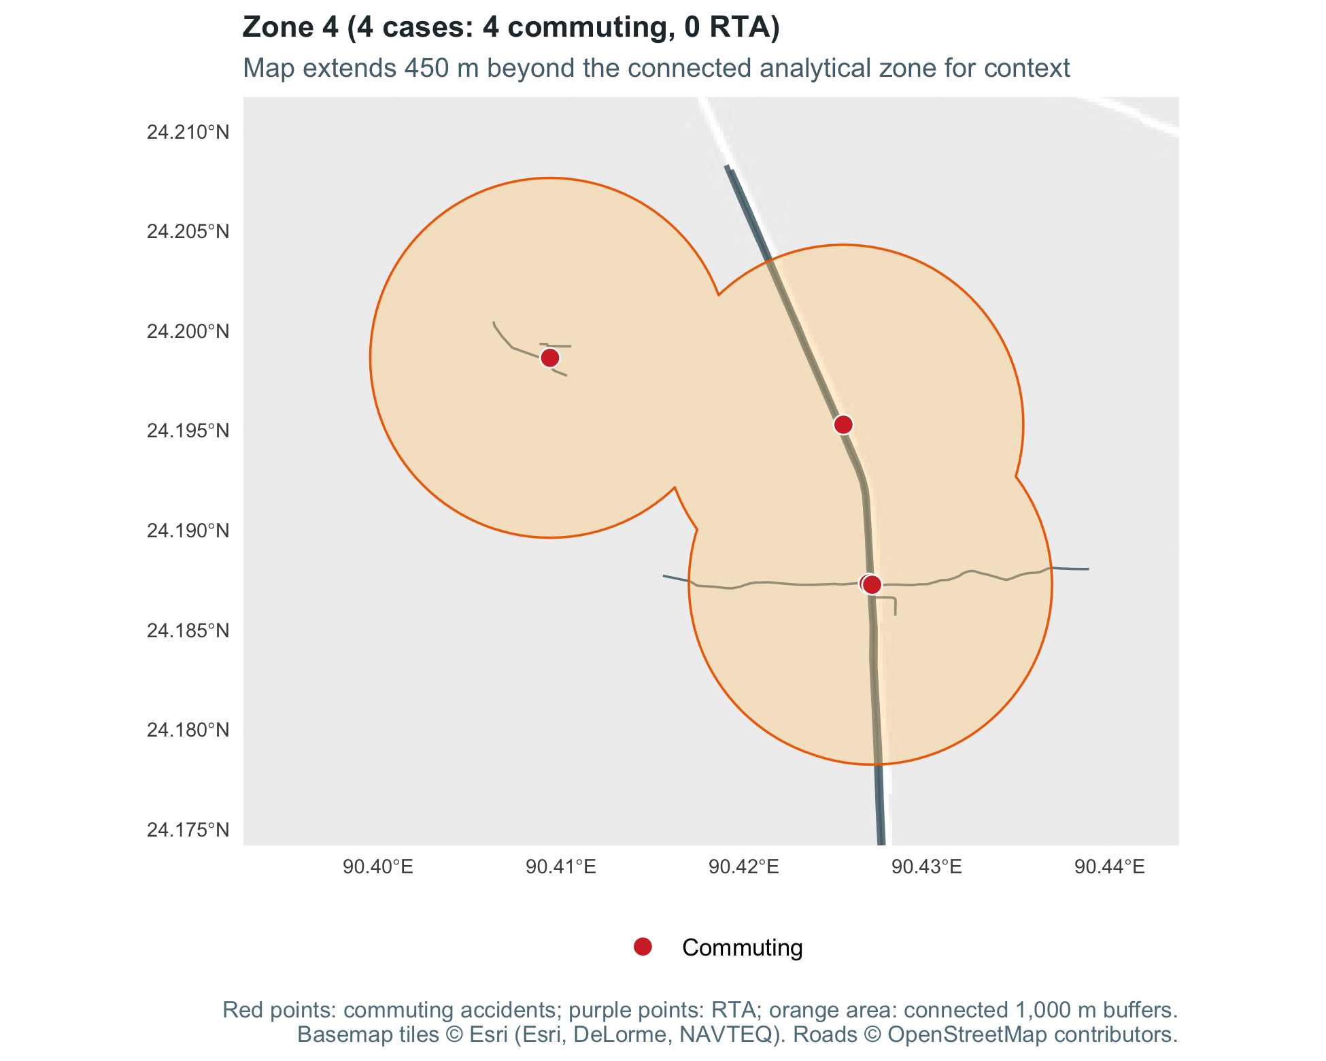
Recorded cases. 4 (4 commuting, 0 RTA). All involved a pedestrian. The most common matched road is Dhaka to Mymensingh Highway (N3) (3 of 4 cases).
Location. Sreepur Upazila in northern Gazipur, about 50 km north of Dhaka, around Mawna and the Gorgoria Master Bari market on the N3.
What is around it. The N3, near Gilar Chala Road. The case-file maps also mark several factories nearby.

4.3.5 Zone 5: Baipayl – Ashulia Corridor (N540 Highway, Dhaka)
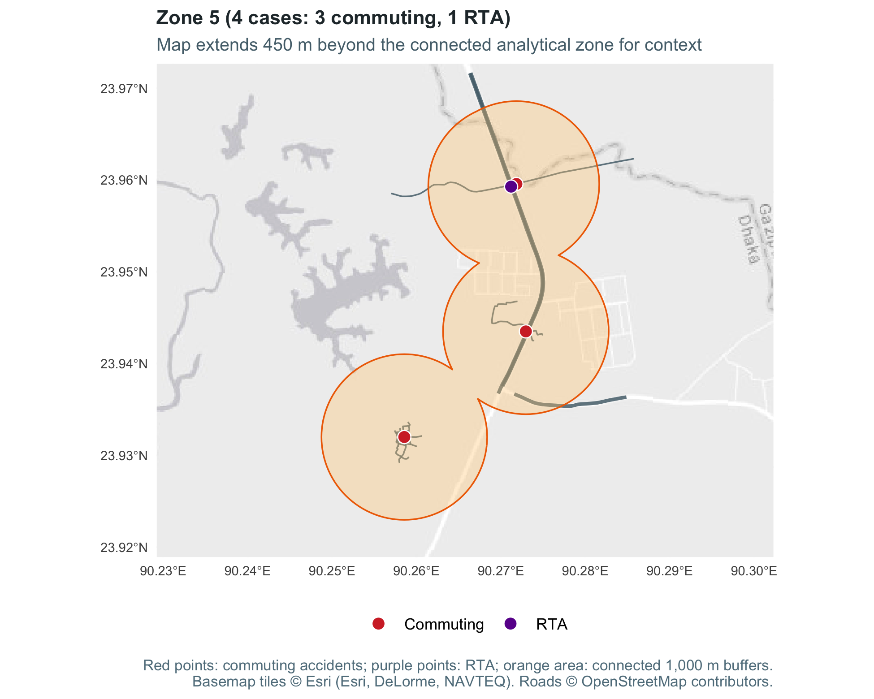
Recorded cases. 4 (3 commuting, 1 RTA). 3 of 4 involved a pedestrian. The most common matched road is National highway N540 (2 of 4 cases).
Location. Baipayl, in the Ashulia area of Savar Upazila, Dhaka District.
What is around it. The Nabinagar–Chandra Road (N540) and the Sreepur–Kashimpur Road.

4.3.6 Zone 6: Chattogram Industrial Belt – Sagarika Road & Pahartali Corridor
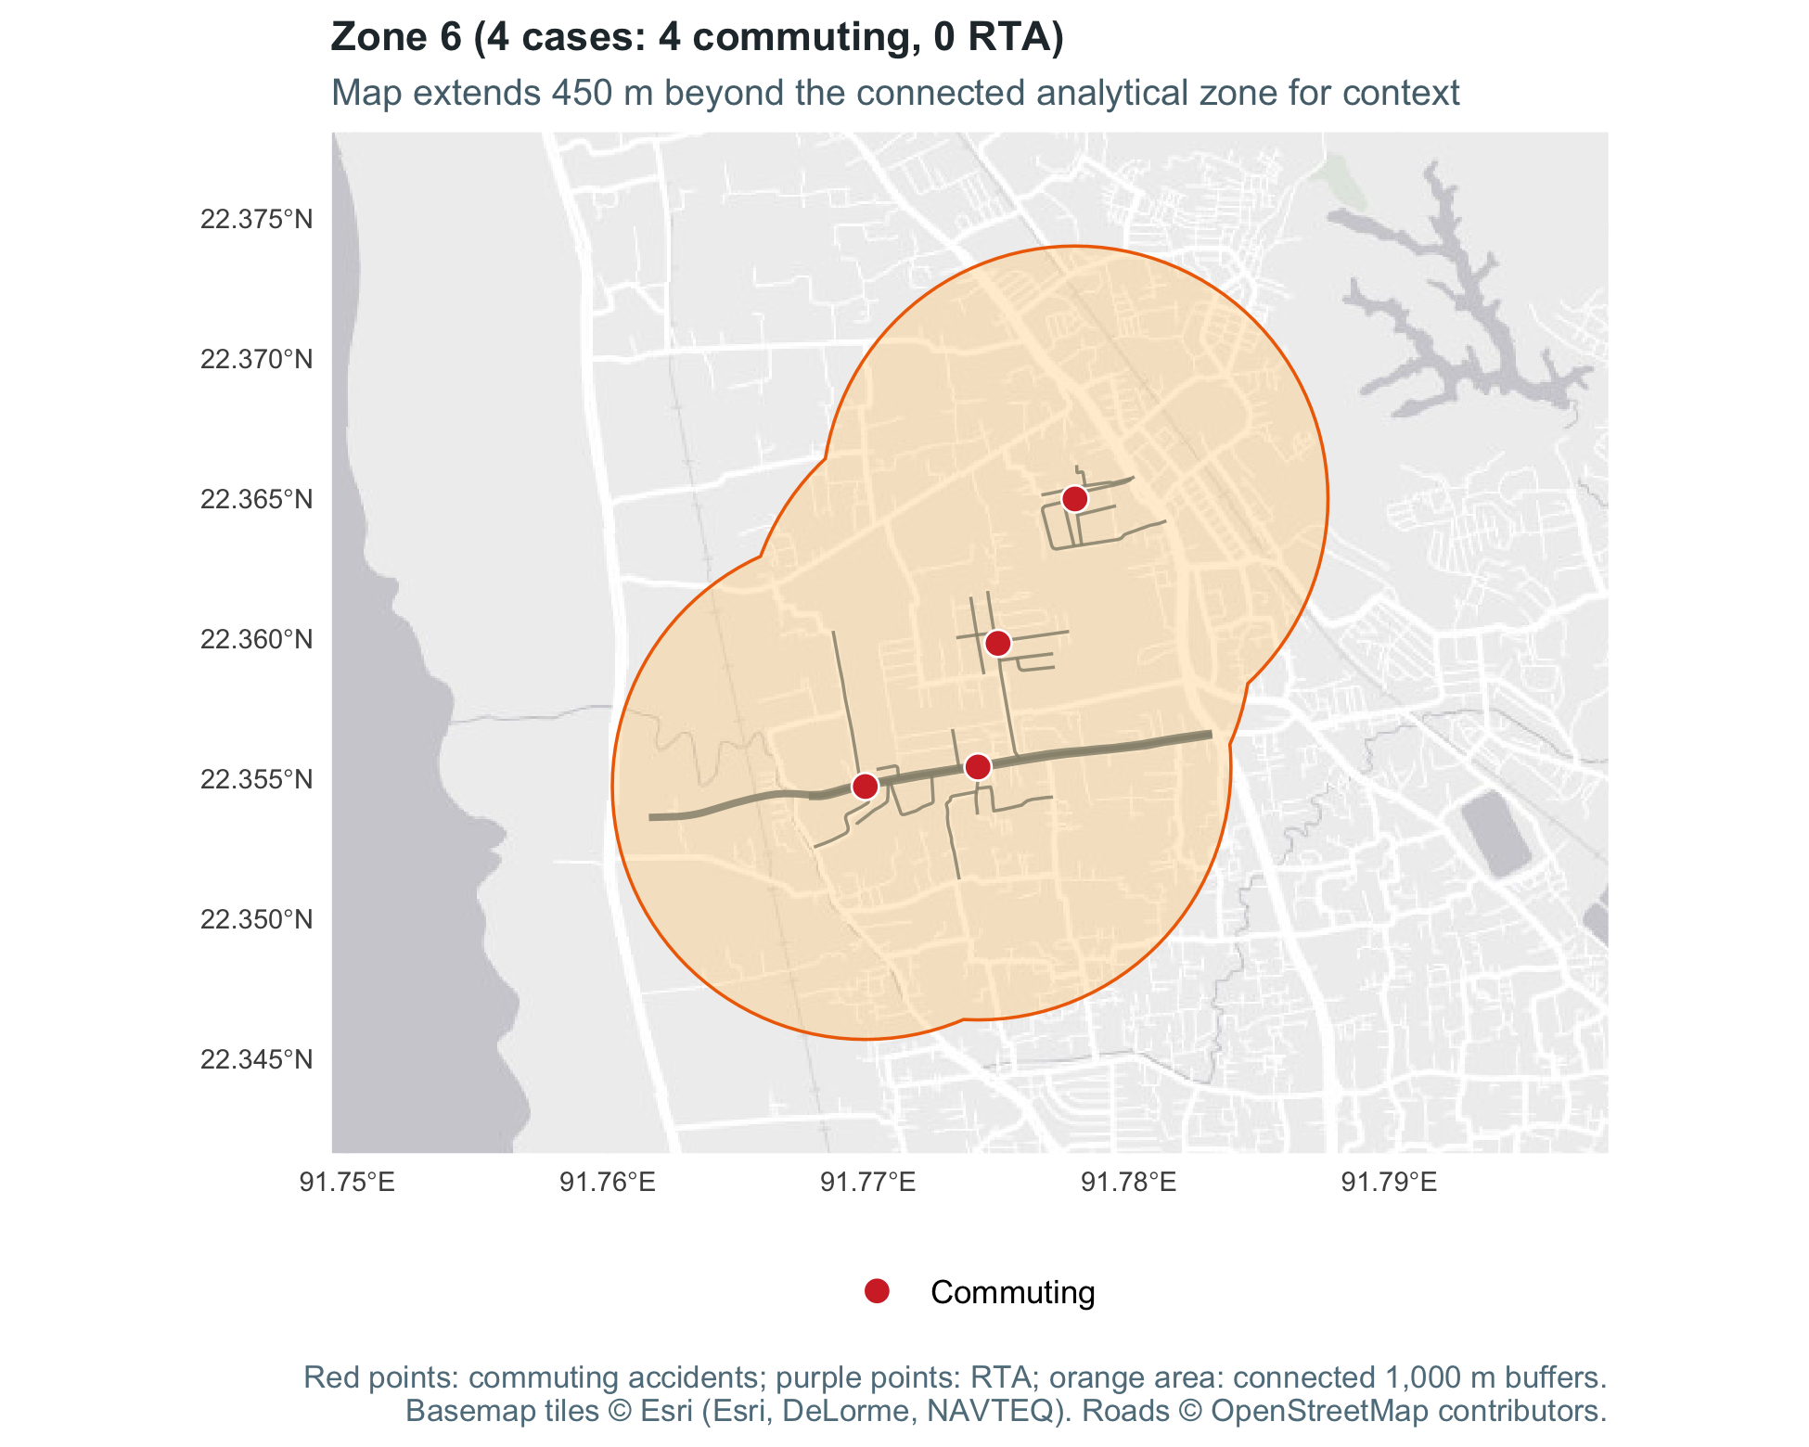
Recorded cases. 4 (4 commuting, 0 RTA). 0 of 4 involved a pedestrian. The most common matched road is Sagarika Road (2 of 4 cases).
Location. Pahartali and Halishahar, inside Chattogram City Corporation, along Sagarika Road towards the N1 near Latifpur.
What is around it. Sagarika Road and nearby factories.

4.3.7 Zone 7: Konabari – BSCIC Industrial Corridor (N4 / Konabari Flyover, Gazipur)
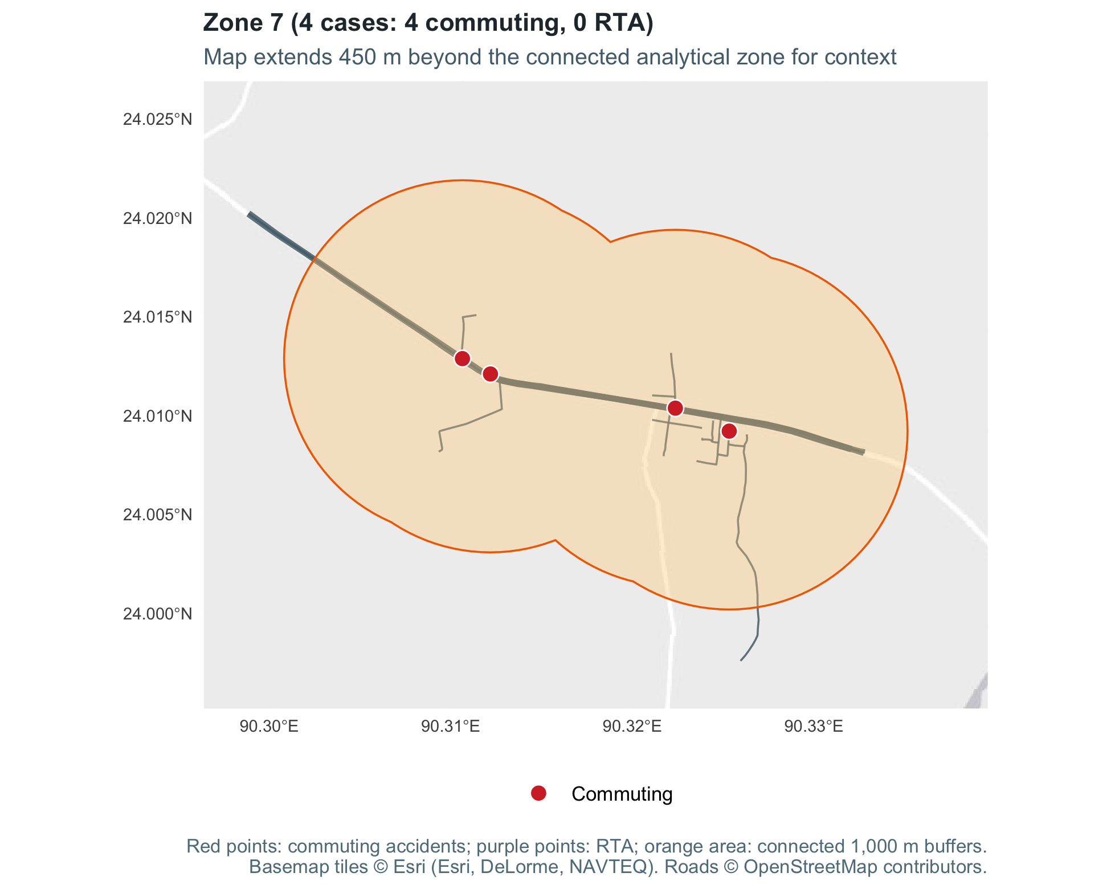
Recorded cases. 4 (4 commuting, 0 RTA). All involved a pedestrian. The most common matched road is Joydebpur to Jamalpur Highway (N4) (3 of 4 cases).
Location. Konabari, inside Gazipur City Corporation in western Gazipur, along the N4.
What is around it. The Konabari Flyover and the service roads beneath it, with BSCIC Main Road and Ambag Road nearby. The case-file maps also mark several factories nearby.

4.4 Gender Distribution of Affected Workers
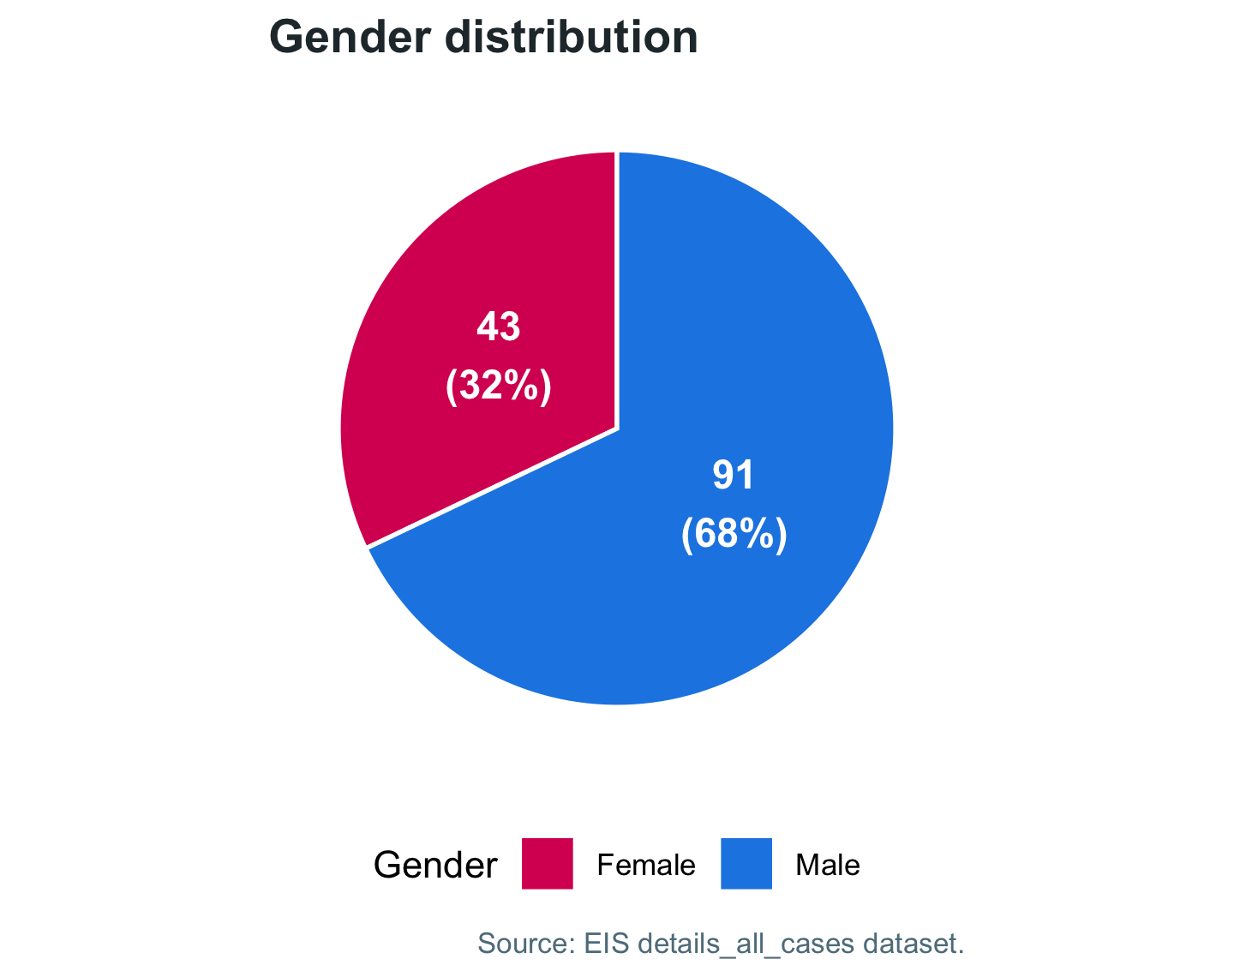
Figure 3: Overall gender distribution of EIS worker accident cases.
Table 7: Breakdown of EIS worker accident cases by gender.
Gender | Recorded cases | Share (%)
Female | 43 | 32.1
Male | 91 | 67.9
This section and the ones that follow use all 134 EIS intake cases, including those without a mapped location. Of these workers, 67.9% were men (91 cases) and 32.1% were women (43 cases). Workforce data by gender are not available, so these shares do not show risk by gender. The breakdown by case type is shown below.

4.4.1 Accidents by Case Type and Loss
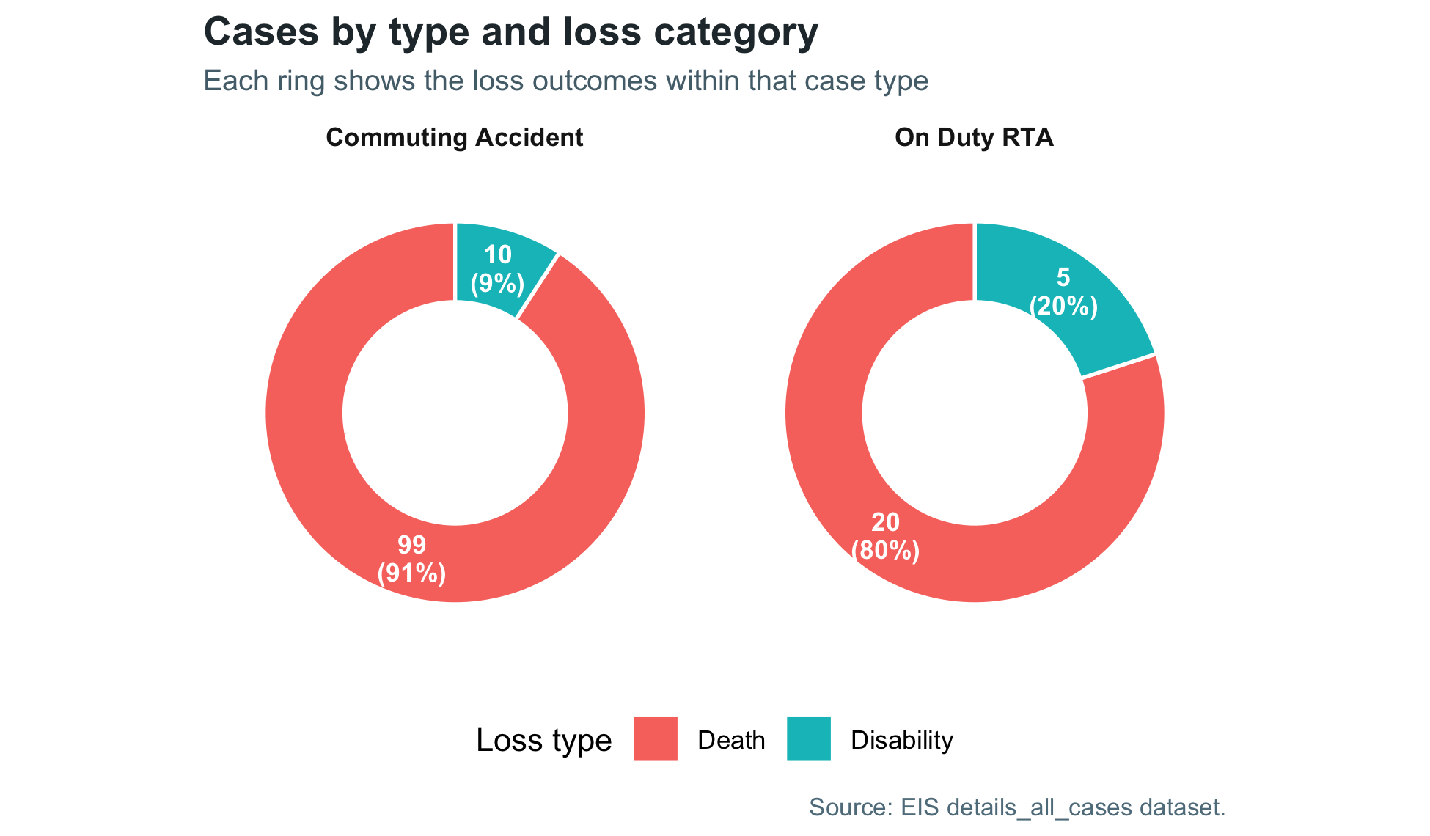
Figure 4: Distribution of recorded cases by case type and loss category.
The chart splits the cases by type of accident and by outcome (death or disability). Commuting accidents make up 109 of the 134 cases (81%), and on-duty RTAs make up 25 (19%).
119 of the 134 cases (89%) were deaths and 15 (11%) led to disability. Commuting accidents account for 99 of the 119 deaths. Minor injuries do not appear in these records.

4.4.2 Gender Distribution by Case Type
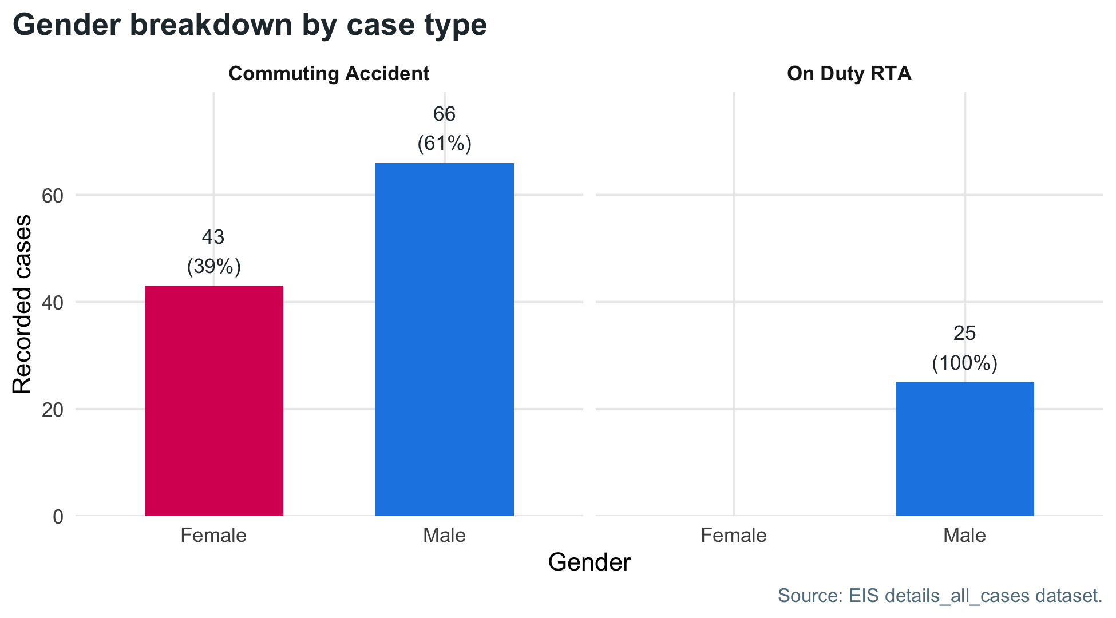
Figure 5: Gender composition within each EIS case type.

4.4.3 Gender Differences in Commuting Cases
All 43 cases involving a woman happened while commuting, and women make up 39.4% of all commuting cases. All 25 on-duty road traffic accidents involved men. Men had 66 commuting cases and 25 on-duty cases.
25 of the 43 cases involving women (58%) involved a worker on foot. The records do not give the time of day.

4.5 Incident Types and Transport Mode
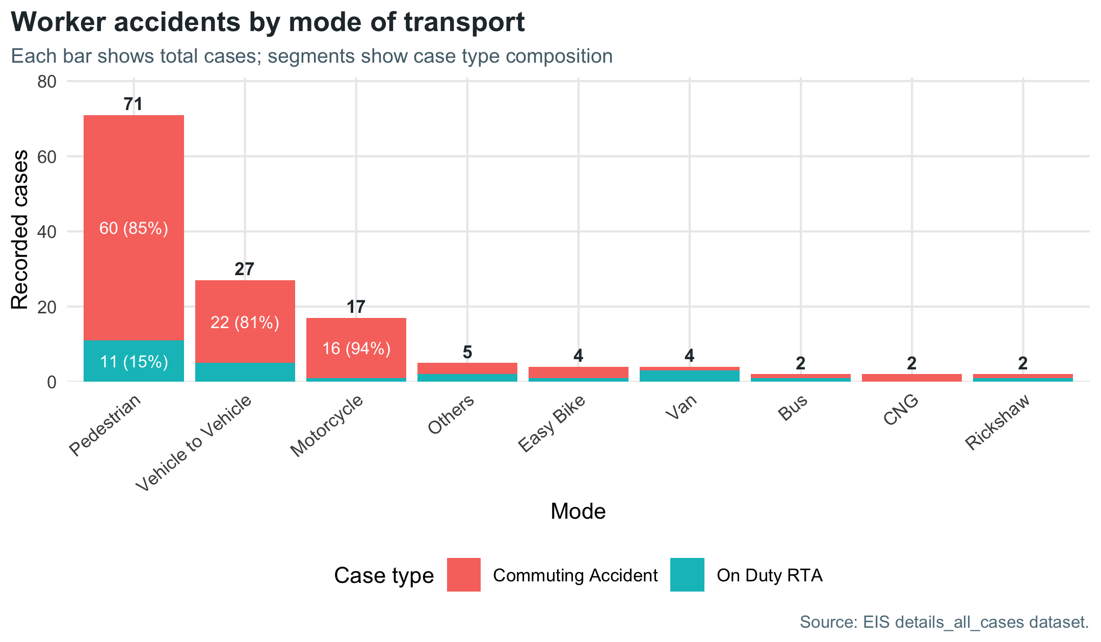
Figure 6: Distribution of EIS worker accident cases by mode of transport and case type.
Table 8: EIS worker accident cases by mode of transport.
Transport mode | Recorded cases | Share (%)
Pedestrian | 71 | 53.0
Vehicle to Vehicle | 27 | 20.1
Motorcycle | 17 | 12.7
Others | 5 | 3.7
Easy Bike | 4 | 3.0
Van | 4 | 3.0
Bus | 2 | 1.5
CNG | 2 | 1.5
Rickshaw | 2 | 1.5

4.5.1 Transport Mode in Recorded Cases
The Mode field records how the worker was travelling, or the type of crash, at the time of the accident. Vehicle to Vehicle is the record’s label for a collision between vehicles. Spelling variants in the original records (for example “Padestrain” and “Pedestrian”) were merged.
Walking is by far the most common category. 53.0% of cases (71) involved a pedestrian. Of these, 60 happened on the commute and 11 while on duty.
Crashes between vehicles are the next largest group, at 20.1% (27 cases: 22 commuting, 5 on duty). The records do not say which vehicles were involved.
Motorcycles come third, with 12.7% of cases (17; 16 commuting, 1 on duty). The workers in these cases range from machine operators and quality inspectors to merchandisers and senior staff.
The remaining 19 cases involve other modes: easy-bikes (4), vans (4), buses (2), CNG auto-rickshaws (2), rickshaws (2) and other or unspecified modes (5).

4.6 Age Distribution of Affected Workers
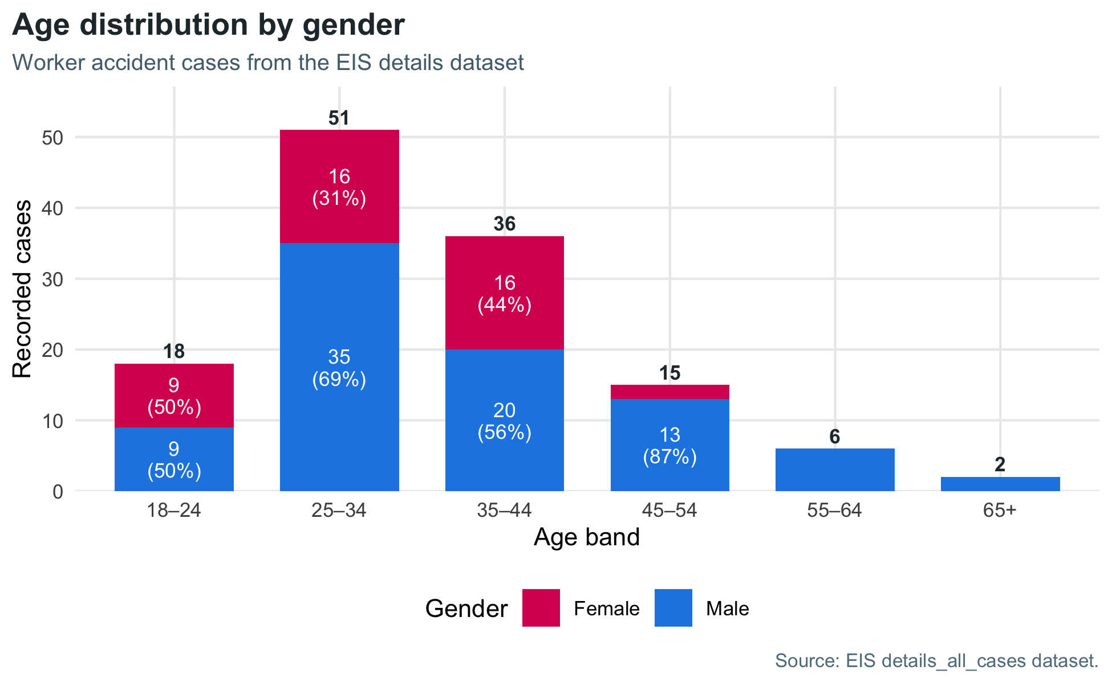
Figure 7: Age-band distribution of EIS worker accident cases by gender.
Table 9: EIS worker accident cases by age band.
Age band | Recorded cases | Share (%)
18–24 | 18 | 14.1
25–34 | 51 | 39.8
35–44 | 36 | 28.1
45–54 | 15 | 11.7
55–64 | 6 | 4.7
65+ | 2 | 1.6

4.6.1 Age Patterns in Recorded Cases
The age chart and table use 128 cases. A further 6 records with an age above 70 years were left out. The median age is 34 years.
The 25–34 and 35–44 groups together account for 87 cases (68%). Workers under 25 account for 18 cases (14%). Workers aged 45 and over account for 23 cases (18%). Workforce data were not available, so these figures do not show risk by age.

4.7 Highest-Priority Areas
Table 10: Leading zones with two or more cases, for field verification.
Zone | Recorded cases | Priority class | District
1 | 9 | Critical | Gazipur
2 | 5 | Very high | Narayanganj
3 | 5 | Very high | Dhaka
4 | 4 | High | Gazipur
5 | 4 | High | Dhaka
6 | 4 | High | Chattogram
7 | 4 | High | Gazipur
8 | 3 | High | Dhaka
9 | 3 | High | Gazipur
10 | 3 | High | Gazipur
This table lists the ten zones with the most cases, using the priority classes defined in Section 3.2. A further 4 zones hold the same number of cases as the last row. The zones at the top, especially those marked Critical or Very high, are recommended first for a road-safety audit. This report has not tested these patterns against chance. Zones marked Elevated hold two points and are recommended for monitoring as new records arrive. A zone can move up a class with only one or two new cases.

5 Discussion
The spatial analysis shows where the mapped points lie: 55 of the 102 road-matched points are on national highways, and 82 of the 121 points share a zone with another point. The intake records show who is affected and how: 81% of cases were commuting accidents, 53% involved a worker on foot and 89% ended in death.
These results show where recorded cases lie, but not why accidents happened there. The data do not record the time of day, the other vehicle or the exact sequence of events. Road-safety specialists should inspect each location before specific works are decided. Their findings should be checked against hospital, police and employer compensation records.

6 Recommendations
The table below links each recommendation to the finding it responds to. These are recommendations from the authors. Their effect has not been tested in this study.
Table 11: Recommended actions and the findings that support them.
Priority | Finding | Recommended action
Immediate | Zones and corridors with the most cases | Carry out day and night road-safety inspections at the top zones, focusing on factory gates, crossing points and bus stops.
Immediate | Cases with lower-confidence or unmatched road locations | Confirm the exact accident location on site before spending money on road works.
Short term | Many workers were on foot (53% of cases) | Build footbridges with ramps, signalised crossings with a safe middle island, and continuous footpaths.
Short term | All 43 cases involving women were commuting accidents | Install good street lighting along the main routes workers walk and at easy-bike and bus pick-up points; make crossings safe and well lit.
Short term | 55 of 102 road-matched points were on national highways | Reduce speeds near factory areas with traffic calming suited to each road type, median barriers and speed enforcement.
Mid term | Any completed safety improvement | Compare speeds, crossing behaviour and the number of new cases before and after the work to check that it is effective.
The overall aim is to separate people on foot from fast traffic wherever possible. Employers can support the road authorities in several ways. They can provide or hire safer transport and set up proper pick-up and drop-off points. They can require contracted drivers to keep to safe speeds, keep factory entrances well lit and clearly marked, and stagger shift times. They should also report accidents promptly.

7 Conclusion
In the EIS pilot records, the districts with the most cases are Gazipur, Dhaka, Narayanganj and Chattogram. National highways hold 54% of the road-matched points. Of all intake cases, 81% happened on the commute, 53% involved a worker on foot and 89% ended in death. All cases involving women were commuting accidents.
The roads and zones with the most points are recommended as the first places for inspection. The recommended measures are safe pedestrian crossings, continuous footpaths, slower speeds near factory gates, proper pick-up points for transport and better lighting at night. Each site should be inspected before work starts, and case numbers should be compared before and after any works. As the EIS pilot collects more cases, this report can be produced again from the updated data.

8 Reproducibility
The report is generated from EIS Pilot Report.Rmd. It reads the source Parquet, CSV and GeoPackage files directly, links GPS and intake records by case file ID, applies the rules described above, and creates all tables, figures and quoted numbers each time it is produced. When the data files are updated (for example, new cases added or a location corrected), producing the report again updates every result automatically. The road-matching functions are in R/road_risk_analysis.R.
The expected project structure is:
- EIS Pilot Report.Rmd: the report.
- R/road_risk_analysis.R: road-matching and corridor-summary functions.
- data/points.parquet, data/paths.parquet: mapped journey points and routes.
- data/details_all_cases.csv: EIS intake records.
- data/osm_roads.gpkg: OpenStreetMap road extract.
- word-reference.docx, word-tables.lua: page and table styles for the Word version.
Map background tiles are downloaded once and stored in data/maptiles_cache/. To produce the report, run the following from the project folder:
rmarkdown::render("EIS Pilot Report.Rmd", output_format = "pdf_document")
rmarkdown::render("EIS Pilot Report.Rmd", output_format = "word_document")
# To test a different zone radius, e.g. 500 m:
rmarkdown::render("EIS Pilot Report.Rmd", params = list(risk_radius_m = 500))
The default radius is 1,000 m. The data folder can also be changed with the project_data_dir parameter.

9 Limitations
The points below should be kept in mind when reading or citing the results of this report.

9.1 Coverage of the Records
These records are cases reported to the EIS pilot, not a full count of every road accident. They include only deaths and disabilities. The results describe these cases only. They should not be read as national accident totals.
Not every record appears in every part of the analysis. In total, 16 of the 134 intake cases have no map data (14 commuting and 2 on duty). They count in the gender, age and transport findings, but not in the zones or road counts. A further 2 mapped case files have no intake record. They count in the zones and road counts, but not in the gender, age and transport findings. The zone and road results may change as these gaps are filled.

9.2 Risk and Causes
The amount of traffic on each road, the number of workers in each area and how often they travel are not known. The counts in this report therefore show where cases happened, not how risky each road really is.
The records do not give the time of day, the other vehicle or the exact sequence of events. Clusters have not been tested against chance.

9.3 Road Matching
Accident locations were mapped from the case files. In total, 19 mapped points could not be linked to a road within 50 m, and 31 were linked with lower confidence.
Road lines and names come from a project OpenStreetMap extract that holds only road pieces close to the accident points. The extract does not cover every point: 10 of the 19 unmatched points lie more than 1 km from any road in it. Most unmatched points are on-duty RTA records (16 of 19), and only 7 of the 23 mapped on-duty cases have a road match. On-duty cases are therefore under-represented in the road counts.
Table 4 and Figure 2 show only corridors with an English name or route number. A further 32 road-matched cases lie on other roads and are left out of them. Dhaka City Bypass (N105) has the same number of cases as the last corridor in the table but falls outside it.

9.4 Zone Radius
The 1,000 m radius is a working choice. Results at other radii are not shown. The radius can be changed when the report is produced (see Reproducibility).

10 References and Data Provenance
Published literature
- Billah, M., Shaik, M. E., Hossain, M. S., Jahan Sakib, S. E., and Rahman, L. (2026). Identification and analysis of road traffic crash hotspots using Geographic Information System (GIS): A study on Dhaka-Mawa Expressway (N804), Bangladesh. Journal of Sensors, 2026(1), 5619948. https://doi.org/10.1155/js/5619948
- Debnath, M., Hasanat-E-Rabbi, S., Hamim, O. F., Hoque, M. S., McIlroy, R. C., Plant, K. L., and Stanton, N. A. (2021). An investigation of urban pedestrian behaviour in Bangladesh using the Perceptual Cycle Model. Safety Science, 138, 105214. https://doi.org/10.1016/j.ssci.2021.105214
- GBD 2023 Road Injuries Collaborators (2026). Global, regional, and national burden of road injuries 1990-2023: A systematic analysis for the Global Burden of Disease Study 2023. The Lancet Public Health, 11(9), e589-e603. https://doi.org/10.1016/S2468-2667(26)00141-6
- Khatun, M. S., Hossain, M. A., Kabir, M. A., and Rahman, M. A. (2024). Identification and analysis of accident black spots using Geographic Information System (GIS): A study on Kushtia-Jhenaidah national highway (N704), Bangladesh. Heliyon, 10(3), e25952. https://doi.org/10.1016/j.heliyon.2024.e25952
- Sakib, N., Paul, T., Das, S., and Hossain, A. (2025). Exploring the factors affecting injury severity in highway and non-highway crashes in Bangladesh applying machine learning and SHAP. IATSS Research, 49(2), 259-270. https://doi.org/10.1016/j.iatssr.2025.06.001
- Sánchez-Toledo Ledesma, A., and Fernández Laviada, N. (2026). Commuting crashes in Spanish occupational road traffic injury surveillance: An integrated descriptive analysis, 2020-2024. Traffic Injury Prevention. Advance online publication. https://doi.org/10.1080/15389588.2026.2717387
- Sarkar, S., Tay, R., and Hunt, J. D. (2011). Logistic regression model of risk of fatality in vehicle-pedestrian crashes on national highways in Bangladesh. Transportation Research Record, 2264(1), 128-137. https://doi.org/10.3141/2264-15
Data sources and other records
- International Labour Organization. News release on the launch of the pilot Employment Injury Scheme, June 2022. https://www.ilo.org/resource/news/pilot-employment-injury-scheme-launched-provide-income-protection
- OpenStreetMap contributors. Road geometry and attributes in the project extract, licensed under the Open Data Commons Open Database License (ODbL).
- EIS worker accident case and journey-route records supplied for this analysis.
- EIS case intake details: data/details_all_cases.csv.

