Monitortool/Toolbox/Workflowgenerator V1.00
Thomas Nickel
1.10.2020

Inhaltsverzeichnis
Introduction 2
Features: 3
Installation 4
Working with Toolbox 5
Starting Toolbox 5
The surface 5
Masterfile 6
Generate workflow 7
Collect results 9
Set resultdir 9
Set shared drive 9
Set backupdrive 9
Collect/store results button 9
Evaluation: 10
Characteristics of a Masterfile/Masterworkflow 11
Multitimeframe 11
Create portfolio 11
Clear databanks 11
Loop-generation 12

Introduction
Strategyquant is able to produce a large quantity of strategies in a short time. The right generation and filtering process is crucial for success.
StrategyquantX makes the workflow processing available for this purpose.

In the area of “Custom Projects” there is a possibility of generating your own workflows.
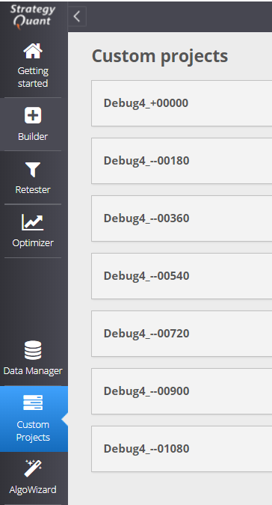Abbildung 1: StrategyquantX is able to handle more than 200 workflows at the same time.
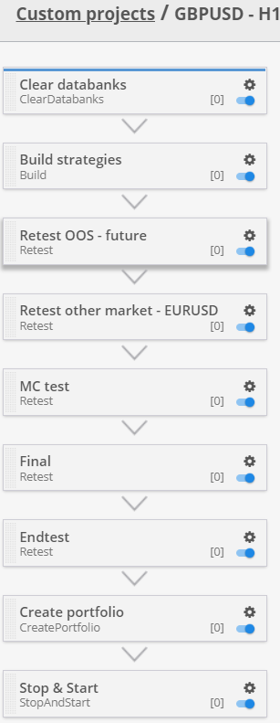Abbildung 2: This is a good workflow for GBPUSD H1 generation. Found im SQ forum under the link below.
I found the workflow for GBPUSD H1 under the the following link https://strategyquant.com/shared/gbpusd-simple-h1/.
I modified this workflow for my own analysis (https://drive.google.com/file/d/16IxUbKsg-yKdUj6Os33vAxAJdtRKZENI/view)

For more analysis options, we need several workflows that are shifted by n days. A workflow is considered good if it achieves profitable final tests over different periods of time.
The normal way to check this behavior is to generate several workflows that have been generated by hand. StrategyquantX have at this moment the possibility to clone an existing workflow. The data modification must be done by hand. This is a very time- consuming and error-prone task.
The workflow generator comes into play at this point.
The workflow generator is able to generate StrategyquantX workflows automaticaly.

Features:
Generation of 100 or more workflows with one click
Collect the results of this generated workflows with on click
Show all results with one click
Share automatically the results over a shared drive
Make a backup of the results

Installation
The first step of using Monitortool/Toolbox is the installation. Toolbox have an easy installation process.
Download Toolbox from webside https://monitortool.jimdofree.com/download/

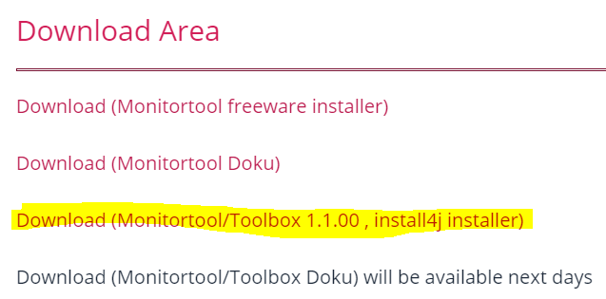
Run Setup
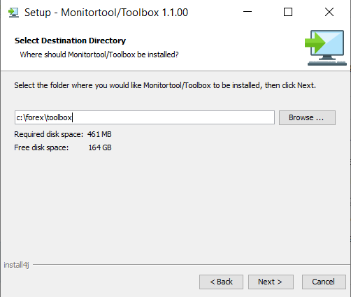Abbildung 3: I suggest to install toolbox not in the windows directory

Working with Toolbox

Starting Toolbox
After Installation you will find a new folder on the desktop.
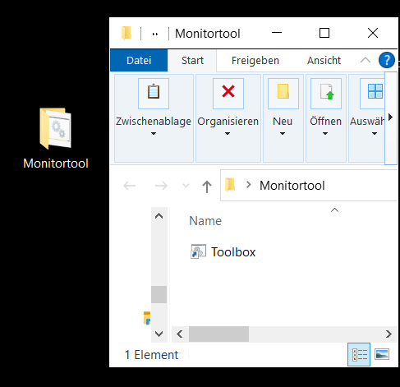
This folder contains a Toolbox starting icon. You can move this icon to the desktop if you want.

Start Toolbox by doubleclick

The surface
After double-click icon the Workflow Generator is activated.
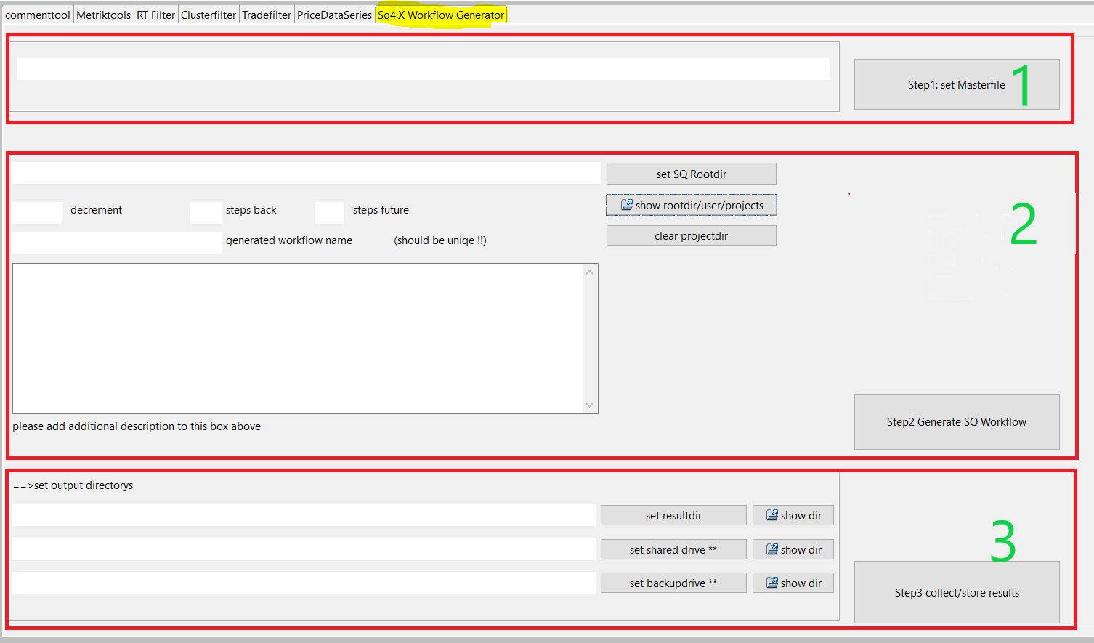
The workflow generation contains 3 main sections.
- Masterfile
- Generate workflow
- Collect results

Masterfile
The masterfile is the workflowfile which will be cloned and modified by the Toolbox/Workflowgenerator.
You can find the masterfile under the following location.
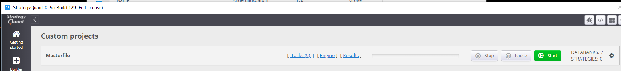
This file “project.cfx” is stored in the directory of the StrategyquantX installation.
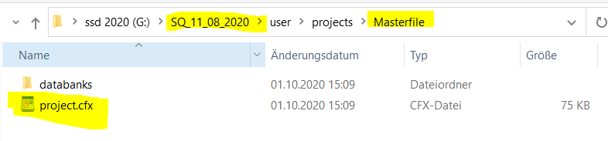
=> Give the workflow generator this file by clicking “set Masterfile”
An example masterfile can be found in the toolbox example directory.
On my computer I have 3 StrategyquantX installation parallel (See picture below). It is easier for handling the master-file, workflow and the results.
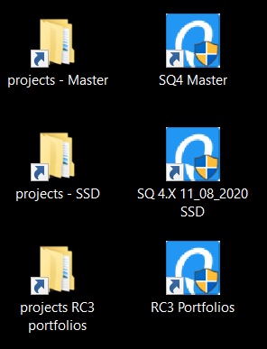Abbildung 4: This is my workplaye I have installed three different StrategyquantX on one computer. Please start only one SQ at the same time. In othercase you can get an memory problem

Generate workflow
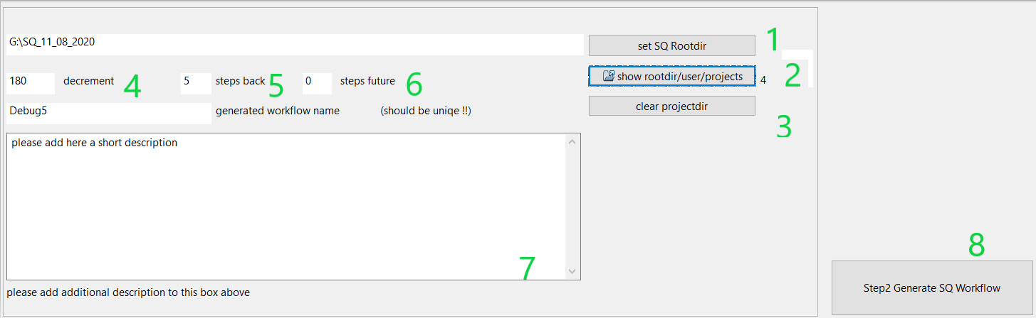
- This is the rootpath of the SQ installation. The rootpath of the SQ is required to save the generated workflows.
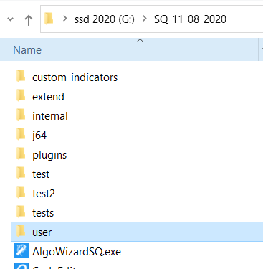Abbildung 5: The rootpath on my machine is G:\SQ_11_08_2020
  - You can look into the projectdir with one click. At the moment 4 Projects are stored in this location
  - Clear projectdir delete all workflows. Make sure that your master project is not deleted. The easiest way to ensure this is to keep the master project in a separate Strategyquant.
  - Every newly generated workflow is moved 180 days into the past.
  - Amount of generated workflows in the past
  - Amount of generated workflows in the future
  - Additional text possible
  - Click generate Workflow. (Make sure that no StrategyquantX is running before clicking this button !!)

After click generate a progress slider show the progress of the generation.
=> Ok the generation progress is very slowly a the moment. It can take 1-2 Minutes to generate the workflows. I will make it faster in one of the next releases.
The results can be checked by show project (2)
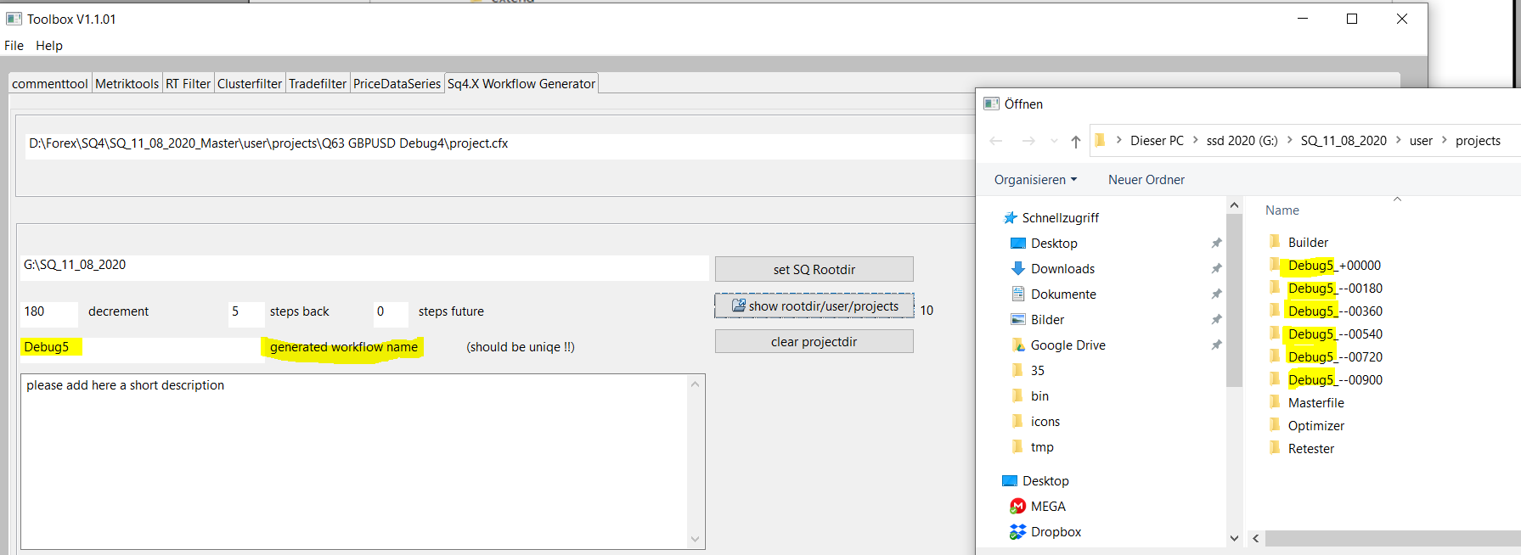
After the genertion process you can find the generated workflows.
In projects directory are the generated workflows.
“The generated workflow name” is self-explanatory.

After starting the StrategyquantX all workflows should be available.
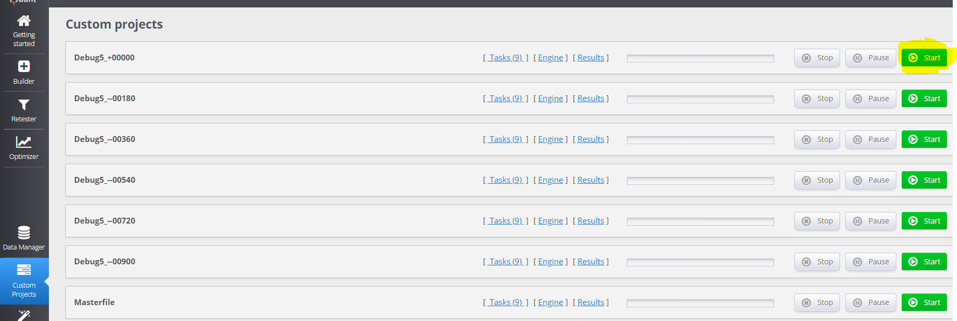Abbildung 6: After click start on the first workflow all worksflows will be done step by step

Collect results
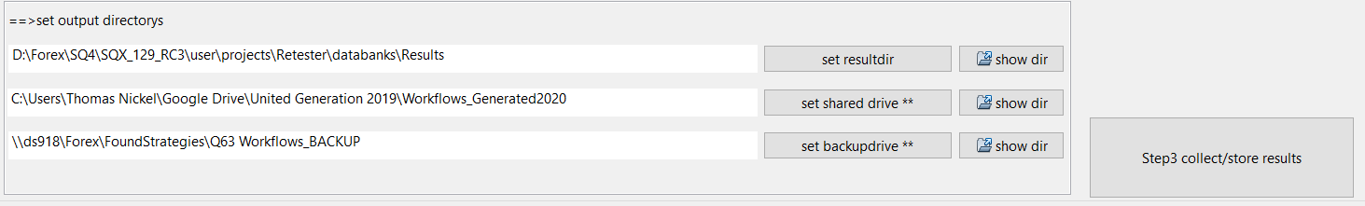

Set resultdir
The resultdir is the directory where the collected portfolios are stored. You can show the results in an esay way. This will be shown later

Set shared drive
All results will be stored in the shared drive too. This is for sharing this information with other team members.

Set backupdrive
In the backdrive will be stored a backup of all results.

Collect/store results button
Remark: Please stop all StrategyquantX before you click collect button.
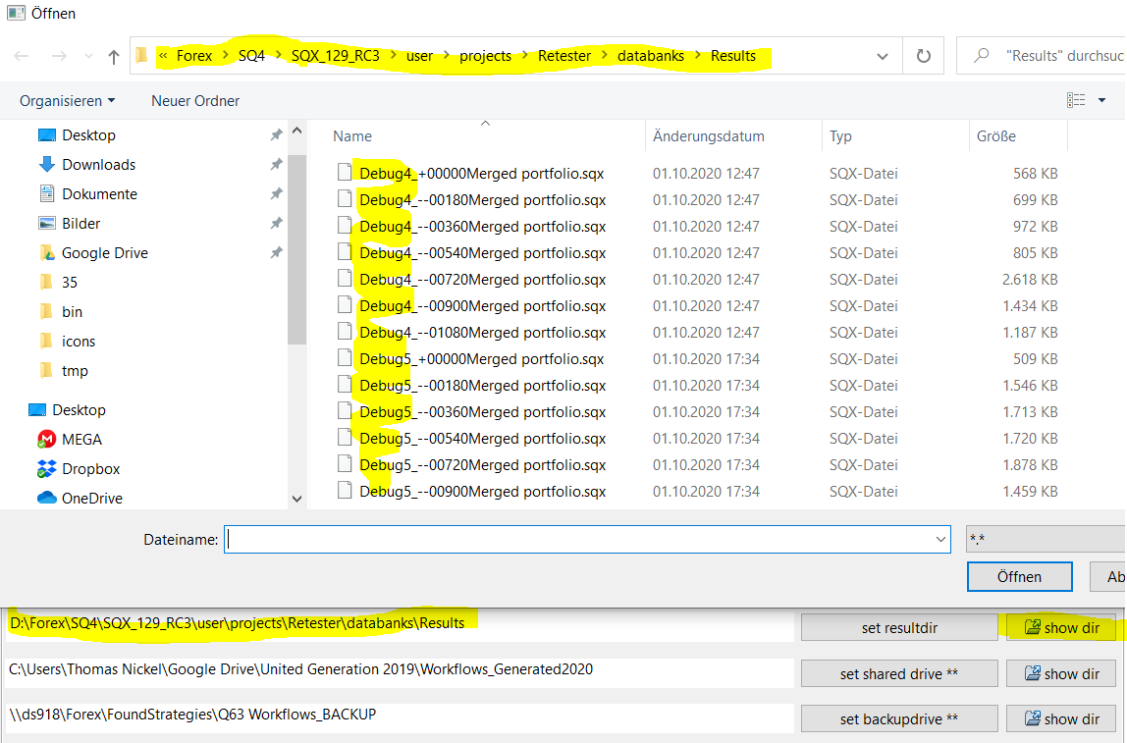Abbildung 7: click show dir to show results
After clicking “show dir” button, all results are stored in the target directory.
Start the appropiate StrategyquantX to show results in Retester.

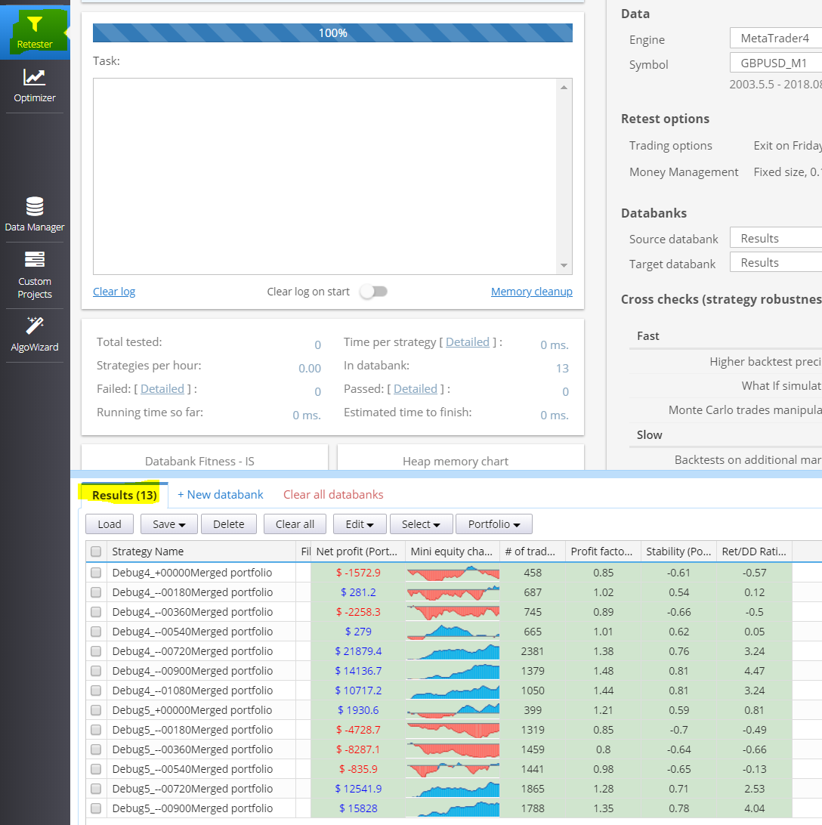

Evaluation:
Not all merged portfolios are positive. A workflow is perfect if all merged portfolios are positive.
It is very difficult to find a workflow with all merged portfolios are positive.
If you find a workflow which all merged portfolios are positive you can send to me tnickel@gmx.de
I will be happy. I will implement all what you want.

Characteristics of a Masterfile/Masterworkflow

Multitimeframe
Multitimeframe generation not working at the moment with the workflow generator. The problem is in the StrategyquantX. I have reported this issue. I hope that this will be solved in 4.130

Create portfolio
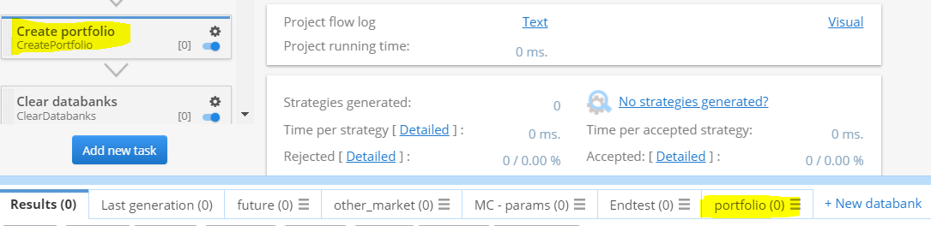
Every Masterworkflow should have a “CreatePortfolio” with a databank “portfolio”. The Toolbox fetches all generated files from the directory portfolio.

Clear databanks
It make sense to clear all databanks except portfolio at the end of the masterworkflow. If the databank are not cleaned it is possible that the memory consumption goes over 64GB. This can happen in big workflow evaluation over 100 Workflows in one Strategyquant. If the databanks are cleaned, the memory consumption is much lower
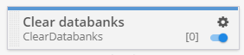
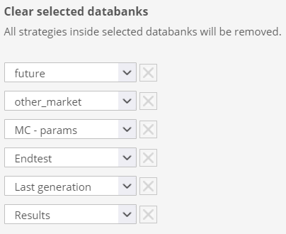

Loop-generation
You can make a loop generation.
Switch last workflow to a loop to the beginning.
