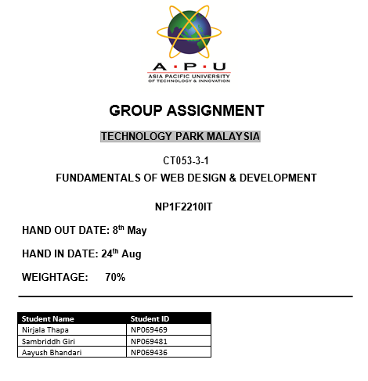

**Acknowledgement**

We would like to express our heartfelt appreciation to the individuals and organizations that played critical roles in the successful completion of the Shree Pashupati Gaushala Dharamshala Web Project. Our assignment would not have been possible without the steadfast aid, direction, and encouragement from a variety of sources.

To begin, we want to thank LBEF for providing us with this excellent chance to use our skills and experience in a practical setting, as well as for their constant support and direction during the project.

Our heartfelt appreciation also goes to the management and employees of Shree Pashupati Gaushala Dharamshala for their outstanding assistance. Their involvement in supplying critical information and resources has been critical in giving a complete picture of Dharamshala's services and products.

Furthermore, we gratefully recognize the efforts of our other students and peers, who provided assistance, criticisms, and support throughout the project's many stages. Their thoughts and contributions have improved our work and helped the project develop.

Finally, we'd want to thank our friends and family for their continuous support, compassion, and perseverance. Their faith in us and constant support have been the driving factor behind our hard work.

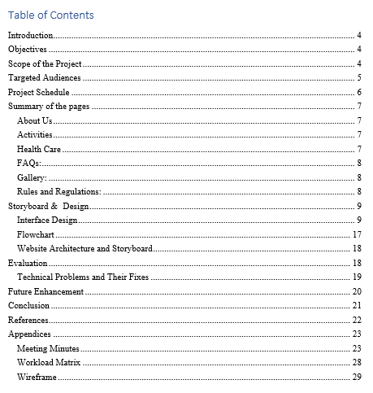

# Introduction

Founded in 1997, Shree Pashupati Gaushala Dharamshala stands as a testament to its resolute dedication to assisting those in need. With the valuable support of Marwari Samaj Samati, this establishment came into being. Managed by the Marwari Sewa Samiti, it oversees both the accommodation needs of pilgrims and the nurturing of cow grazing lands (PRADHAN, 2022).

Welcome to the official online portal of Shree Pashupati Gaushala Dharamshala, a sacred haven nestled in the heart of spiritual Kathmandu. Our website is specially designed to provide you a glimpse into the tranquil ambience and wide-ranging offerings that our sanctuary presents.

# Objectives

* to create a user-friendly interface that demonstrates knowledge of HTML, CSS, and JavaScript.
* to establishing a responsive design as a top priority to ensure excellent performance on a variety of devices.
* to provide comprehensive and accurate information about the range of facilities and services offered by Shree Pashupati Gaushala Dharamshala.

# Scope of the Project

The website serves as a comprehensive platform for providing thorough information on Pashupati Gaushala Dharamshala's facilities, services, history, and cultural importance. It covers a variety of topics. It is intended to convey every relevant detail regarding the dharamshala's facilities, services, history, and culture. The website will be user-friendly, performing effectively on various devices and protecting user data. The website's overall purpose is to enhance awareness, preserve cultural heritage, promote community engagement, and attract new members to Dharamshala. The website will be built utilizing languages such as HTML, CSS, and JavaScript, with a focus on delivering a user-friendly experience and guaranteeing accessibility for everyone.

Our website will encompass a comprehensive range of information, including:

**About Us**: This section contains two pages:

1. About Dharamsala
2. Location

**Activities:** There are three pages in this section:

1. Accommodation
2. Fooding
3. Cow Protection

**Health Care:** This section contains six pages:

1. Ambulance & Sabbahan
2. Homeopathy
3. Allopathy
4. Kritthim-Khutta
5. Regular Check-Up
6. Hemodialysis

**FAQs**

**Gallery**

**Rules and Regulations**

# Targeted Audiences

* Spiritual travelers seeking comfortable and affordable accommodation.
* Individuals interested in contributing to cow conservation efforts.
* Health-conscious individuals looking for holistic healthcare options.
* Pilgrims and devotees visiting nearby temples and religious sites.
* General visitors interested in exploring the serene atmosphere of our establishment.

# Project Schedule

Our project is divided into distinct phases:

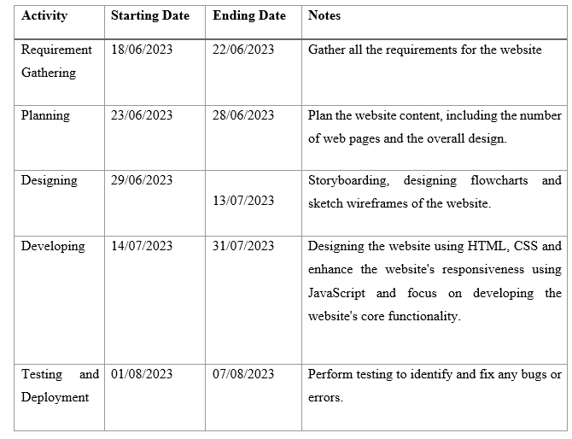

# Summary of the pages

## About Us

**About Dharamsala:** This webpage delves into the fascinating history and beginnings of Shree Pashupati Gaushala Dharamshala. This webpage will reveal the intricate tapestry of the Dharamsala's history, mission, and the underlying ideals that drive the dharamsala dedication to service.

**Location:**The "Location" tab will provide detailed instructions to Shree Pashupati Gaushala Dharamshala. This page provides easy navigation to Google Maps, which will take you to dharamsala.

## Activities

**Accommodation:** This page contains in-depth information on our lodging alternatives. Discover a variety of comfortable and affordable rooms, as well as information on their features and reasonable pricing.

**Fooding:** Explore the various dining options on this page. Discover our canteen offerings, which feature a selection of delectable and healthful vegetarian food**.**

**Cow Protection:** On this website, you can discover about the dedicated devotion towards preservation of cows. This website will give information about the complete safety and care provided to these sacred animals in Dharamsala. This website will explain in full the efforts in cow conservation and the humane practices that are a fundamental aspect of the Dharamsala's ethos.

## Health Care

1. **Ambulance & Sabbahan:** This page contains information on ambulance services and Sabbahan, which is a funeral van. These services are critical in providing important aid to those in need.
2. **Homeopathy:** Dive into the world of Dharamshala's homoeopathic remedies. Discover the concepts of homoeopathy and how they match with a holistic approach to health and well-being on this page.
3. **Allopathy:** Browse the allopathic healthcare options on this page. Discover the most contemporary medicinal treatments and services accessible to anyone in need.
4. **Kritthim-Khutta:** This page sheds light on Kritthim-Khutta, a specialized service provided at Dharamshala. Learn about the process of acquiring prosthetic legs and other services targeted at improving the well-being of those in need.
5. **Regular Check-Up:** This page will help you understand the significance of frequent health checks. Investigate how Dharamshala provides routine medical exams to protect well-being and promote proactive health management.
6. **Hemodialysis:** Through this page, explore the hemodialysis services at Dharamshala, a crucial treatment for kidney-related issues.

FAQs: Get answers to commonly asked questions and inquiries.

Gallery: View stunning graphics exhibiting our facilities and vibrant activities, as well as photos of our legendary founders.

Rules and Regulations: Discover guidelines describing what is allowed and what is not allowed within the Dharamsala premises.

Aside from the features listed above, our website has a number of additional interesting parts, such as a sitemap, which gives a structured overview of the layout of the site and content. In addition, we have carefully integrated an interactive and dynamic chatbot feature into our website, increasing user engagement and providing visitors with a quick and accessible way to seek information and support. This entire strategy for web development seeks to provide a full digital experience that responds to our audience's various needs and interests.

# Storyboard & Design

## Interface Design

The section outlines interface design, underscored by a user-centered UI development approach. A user-centered approach to UI development flourishes, emphasizing a thorough understanding of user demands, tasks, and contexts as central to the development process. The iterative nature of UI development necessitates regular prototyping, review, and active user and stakeholder participation. This iterative method ensures that the interface is aligned with user expectations and encourages cooperation for a better end product (Debbie Stone, 2005). While designing the interface for our website we have taken into consideration the following aspects:

**Logo and Branding Elements:**

Logos are essential in developing a brand's visual identity. They are important components that add greatly to a brand's overall aesthetics and awareness (Michael F. Walsh, 2010). In light of these concepts, our design approach contains the Dharamsala logo, which is beautifully complimented by a colour palette dominated by orange and yellow colours. This selection embodies the essence of Hinduism, representing service, peace, and humanity. In terms of typography, we kept things simple, using typefaces like Arial, Sans-Serif, and Times New Roman to provide unmistakable information.

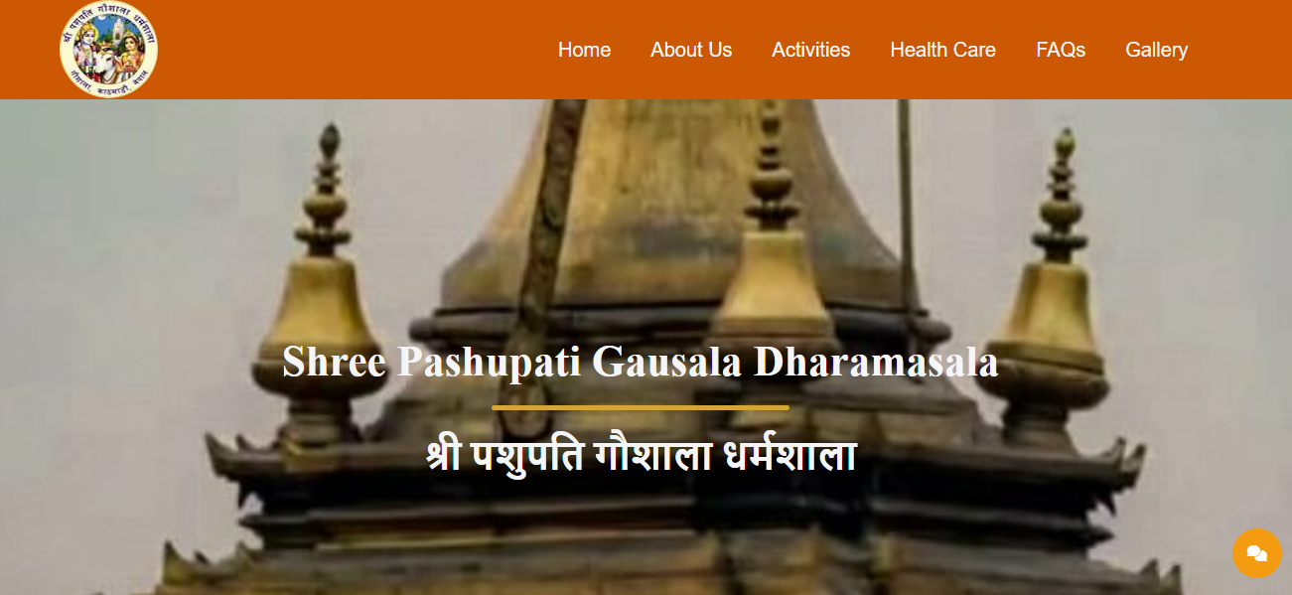

Figure 1: Header Part

**Imagery and Graphics:**

Using high-quality visuals to capture the essence of Shree Pashupati Gaushala Dharamshala is critical. A profound connection is built with guests by showing the premises, cow preservation measures, and tranquil settings.

Image and graphic formats must be optimized. Their planned application improves user comprehension and visual appeal. Our dedicated gallery includes photographs of the founders, healthcare facilities, cow protection, and other activities, all of which contribute to the visual appeal and educational value of the website.

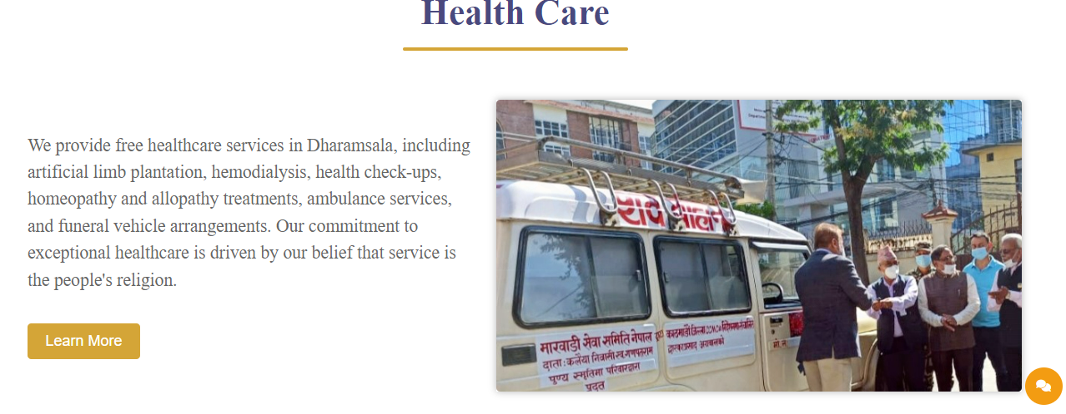

Figure 2: Image Animation

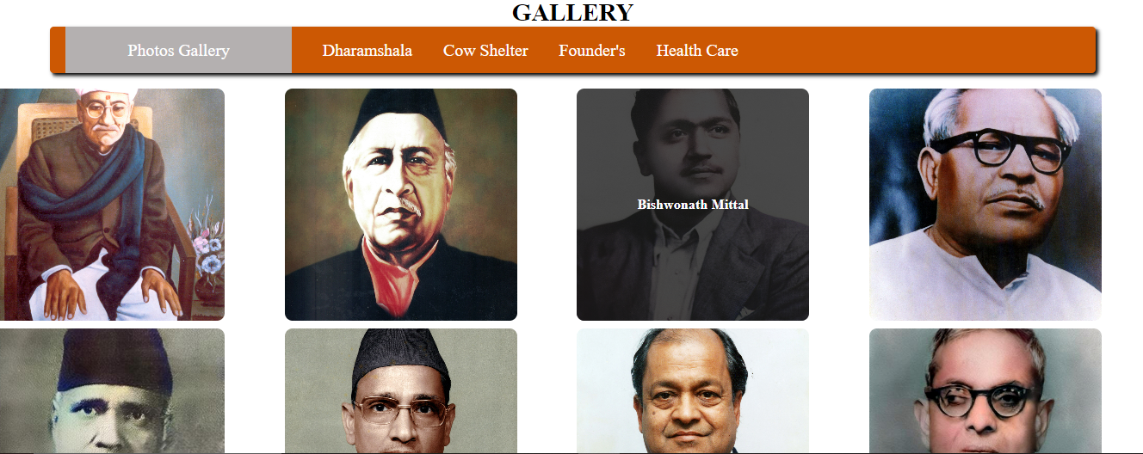

Figure 3: Gallery Page

**Navigation Structure:**

Our navigation structure is thoughtfully designed. Additionally, for enhanced mobile experience, we've implemented a menu toggle feature. Notably, the healthcare segment has been allocated a dedicated page to facilitate seamless navigation through various healthcare facilities.

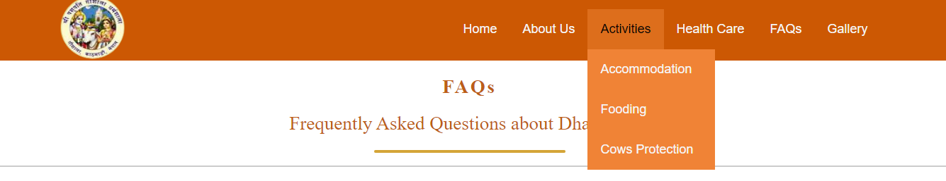

Figure 4: Navigation Bar in Desktop mode

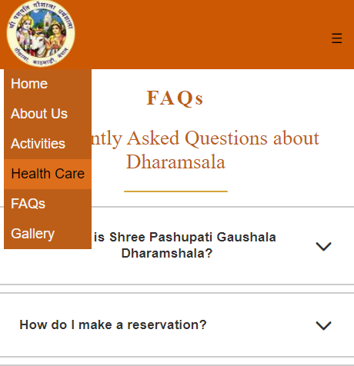

Figure 5: Navigation Bar in Mobile mode

**Animations and Transitions:**

Animations improve the user experience, particularly in the healthcare portion of the webpage, where we used keyframes to animate numerous graphics. Smooth transitions and intriguing hover effects are used across the page, giving dynamic involvements.

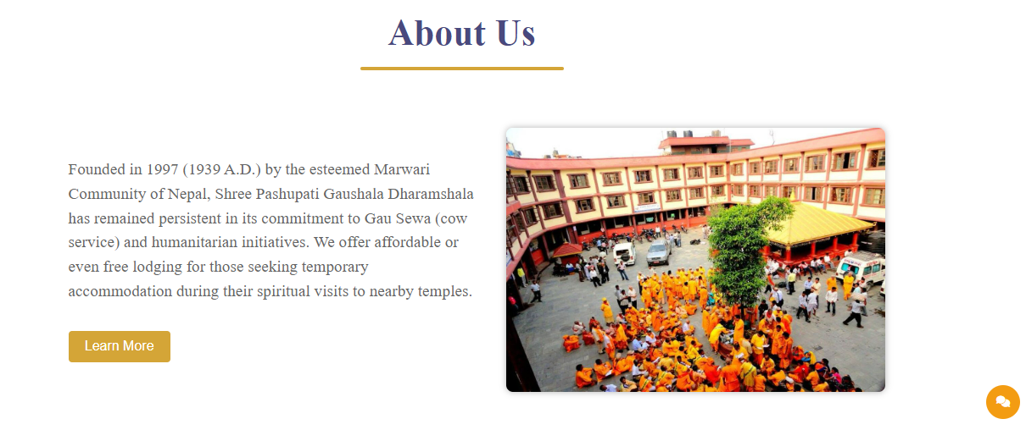

Figure 6: About Us section

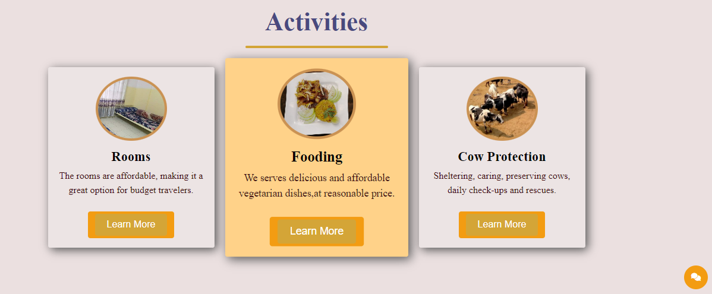

Figure 7: Hover effect

**Footer Design:**

The footer of our website includes access to the sitemap, rules and guidelines, as well as complete contact information and social network buttons. This layout allows visitors to effortlessly travel through crucial areas while remaining engaged via multiple internet channel.



Figure 8: Footer

**Responsive Design:**

It is critical to ensure that the website is responsive on a variety of devices. The interface design must easily respond to different screen sizes while maintaining both user-friendliness and aesthetic beauty. Our website has been deliberately built to be accessible on mobile devices and tablets. We produced a responsive layout by utilizing media queries. Each page has been optimized for device compatibility to provide a smooth transition from one device to the next while maintaining a consistent and ideal layout.

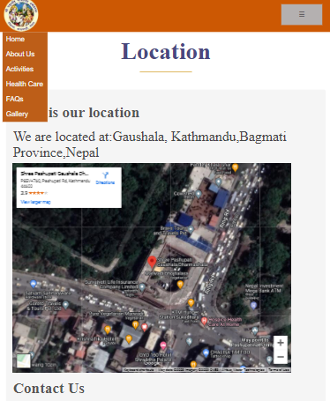

Figure 9: Mobile Mode

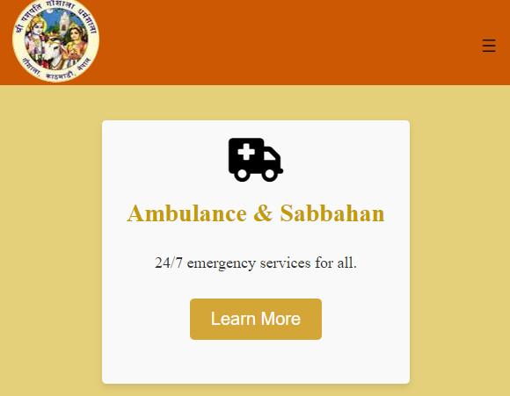

Figure 10: Tablet Mode

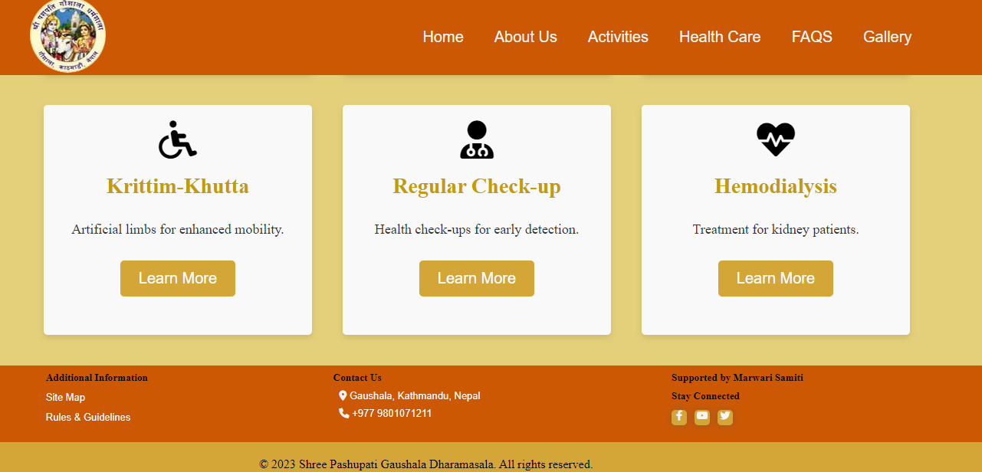

Figure 11: Desktop Mode

**Chatbot Integration for Users:**

The user-friendly chatbot is a notable addition to the Shree Pashupati Gaushala Dharamshala website's layout. This feature increases engagement and provides visitors with immediate assistance. The chatbot welcomes users and provides alternatives such as location-specific details or general institution information.

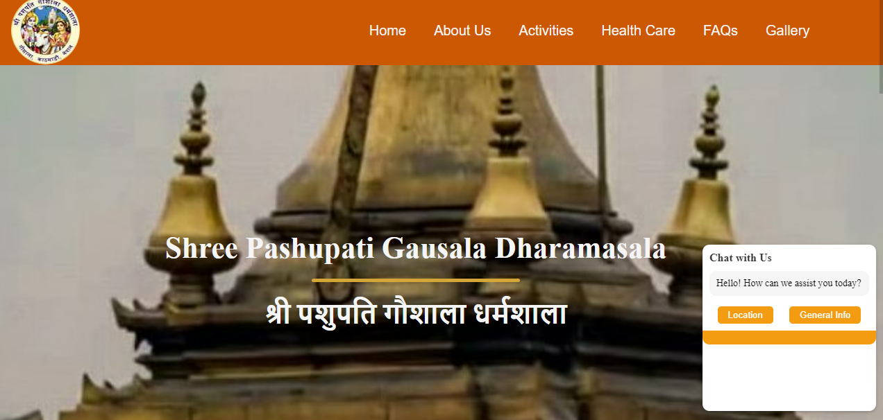

Figure 12: Chatbot feature

Upon selection, the chatbot walks customers through important facts or sends them to certain website parts, such as offering directions for visitors. This interactive feature demonstrates the institution's dedication to improving the user experience through technology.

## Flowchart

The flowchart of the home page is presented below:

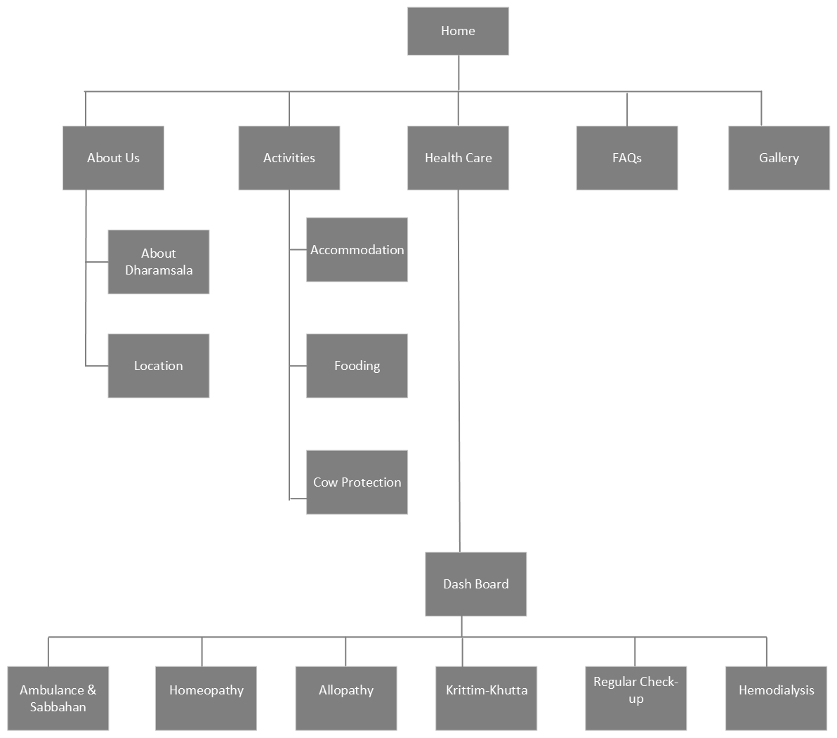

Figure 13: flowchart of nav bar

## Website Architecture and Storyboard

The storyboard uses a logical representation of the website's pages and elements to create a visual picture of the user's journey. The homepage serves as the main hub and gives access to each area via the navigation bar. Each component has its own page, complete with relevant information, images, and descriptions.

The homepage is the primary entry point, and the website's design is hierarchical. Users can then delve further into various parts based on their preferences. Because of this architecture, users may simply find the information they need.

# Evaluation

The evaluation phase of the Shree Pashupati Gaushala Dharamshala website project includes identifying the most significant technical obstacles encountered during creation, in addition to analyzing how the intended system manages existing concerns and possibilities.

Addressing Opportunities and Current Issues:

**1. Consolidated Information Platform:**

**Issue:** Lack of centralized information dissemination.

**Opportunity:** Provide visitors with up-to-date details about amenities, offerings, and principles.

**Solution:** The website acts as a communication hub, ensuring accurate and current information reaches visitors promptly.

**2.Improved Visitor Experience:**

**Issue:** A lack of publicly available healthcare-related information.

**Opportunity:** Create a specialized healthcare dashboard with detailed information on the facilities offered.

**Solution:** By developing a separate healthcare dashboard, visitors receive access to a variety of information on the Dharamshala's healthcare services.

**3. Cow Safety and Care Awareness:**

**Issue:** Lack of awareness about cow conservation's significance.

**Opportunity:** Promote cow safety and care alignment with institutional values.

**Solution:** The website educates users on the importance of cow protection and showcases the institution's commitment to this cause.

## Technical Problems and Their Fixes

**1. Flexible Design:**

**Issue:** Ensuring the website's adaptability to various devices and screen sizes posed a significant challenge.

**Solution:** To address this, CSS media queries were employed to adjust the design and layout for desktop, tablet, and mobile devices. Additionally, JavaScript was applied to enhance the responsiveness and fluidity of the interface, providing a consistent and user-friendly experience across different platforms.

**2. Slow Page Load Times:**

**Issue:** Slow page loading times hampered user experience and engagement.

**Solution:** Image optimization techniques were used to minimize file sizes without sacrificing quality. Compressing CSS and JavaScript files, as well as reducing HTTP requests, led to quicker page loading.

**User Testing and Improvement:**

The efficiency of the website was proven by user testing with staffs of Dharamsala itself. The study of feedback revealed opportunities for improvement.

Positive feedback emphasized the website's user-friendly design, simple navigation, and extensive material. Users have simple access to FAQs, healthcare services, and lodgings. Suggestions included adding more Dharamshala images to the image gallery.

The assessment validates that the website is in line with the institution's aims and that technical issues have been resolved successfully. The website serves both the institution and the users by resolving complaints and increasing involvement. Future sections will look at potential additions for more functionality and a better user experience.

# Future Enhancement

**Online Booking System:** An online booking system is on the horizon, aiming to simplify scheduling stays and healthcare appointments. This feature will revolutionize the booking process, offering visitors a seamless experience. Users can effortlessly select their desired accommodation and healthcare options, significantly enhancing convenience.

**User Reviews and Ratings:** A user review and rating system will be integrated across lodging, dining, and medical services. This will promote transparency and provide invaluable insights to potential guests

**Interactive Event Calendar:** A dynamic event calendar will soon grace the website, showcasing key events, religious ceremonies, and workshops held at the Dharamshala.

**E-Commerce for Donations**: As part of our commitment to philanthropy, an E-Commerce section will be introduced to facilitate seamless online donations. Users can contribute to cow protection and other noble causes with utmost ease, strengthening the institution's impact.

**Live Streaming Integration:** The future will see the incorporation of live streaming capabilities, allowing users to virtually participate in religious rituals and enlightening lectures. This integration will extend the institution's reach and foster a sense of unity among a broader audience.

**Social Media Linking:** While the institution's current social media presence might be modest, the website will be equipped with social media linking for potential future integration. This forward-thinking approach ensures readiness for embracing evolving technology and enhancing engagement with a wider online community.

# Conclusion

To summarize, the construction of the Shree Pashupati Gaushala Dharamshala website was a significant undertaking aimed at delivering essential information, services, and resources to the institution's stakeholders and visitors. Several major accomplishments have resulted from the project's collective efforts:

The website is an important instrument for improving the institution's online profile by providing people with access to critical information, room information, insights on cow preservation activities, and engagement with the local communities.

A user-centric experience has been achieved by tailoring the website to the distinct needs of pilgrims, tourists, and individuals seeking information on cow protection. The integration of an intuitive navigation system, visually appealing design, and relevant content has created an engaging and informative online journey.

Thorough consideration was given to the website's functionality, technological components, and design throughout the project. Leveraging HTML, CSS, and external libraries enabled the creation of responsive and visually pleasing web pages, ensuring a consistent user experience across various devices and screen sizes.

Comprehensive user services have been a priority, as evidenced by features like hotel reservations, healthcare information, and cow protection details. Multimedia elements such as images and videos have further enriched the user experience. The section also outlining future enhancements underscores the ongoing potential for website development and expansion. By actively embracing user feedback and emerging technologies, the institution can ensure that the website remains relevant and effective in meeting evolving user needs.

In essence, the Shree Pashupati Gaushala Dharamshala website stands as a testament to the organization's commitment to its mission, values, and community. Serving as a digital gateway, it connects users with vital services, information, and resources, fostering a sense of engagement and belonging. The utilization of HTML, CSS, and JavaScript, including the incorporation of a chatbot, underscores the effective utilization of diverse tools. The website's objectives have been achieved, offering a comprehensive online platform that reflects the organization's dedication to service and making a lasting impact on users and stakeholders as technology continues to advance.

# References

Debbie Stone, C. J. (2005). *User Interface Design and Evaluation.* Elsevier.

Michael F. Walsh, K. P. (2010, April 20). Do logo redesigns help or hurt your brand? The role of brand commitment. *Journal of Product & Brand Management, 19*(2), 76-84.

PRADHAN, A. R. (2022, feb 22). *The Pashupati Dharamshala Issue: Unholy nexus or socially beneficial?* Retrieved from nepalnews: https://nepalnews.com/s/nation/the-pashupati-dharamshala-issue-unholy-nexus-or-socially-beneficial-projects

# Appendices

## Meeting Minutes

**Meeting 1: Wireframe and Timeline Discussion**

Date: 18/06/2023

Time: 7.30 AM

Location: Computer Lab

Members: Nirjala Thapa, Samriddh Giri, Aayush Bhandari

Agenda:

* Discussion and preparation of the website's wireframe.
* Collection of essential details for the project.
* Creation of a project timeline.

Minutes:

The team gathered to outline the initial wireframe of the website, focusing on its structure and main components.

The team established a timeline that encompassed different project stages, from design and development to testing and deployment.

Tasks were assigned to individual team members to start gathering relevant information for their respective sections.

**Meeting 2: Requirements Analysis and Design Initiation**

Date: 22/06/2023

Time: 10.00 AM

Location: Computer Lab

Attendees: Nirjala Thapa, Samriddh Giri, Aayush Bhandari

Agenda:

* Thorough analysis of project requirements.
* Commencement of the website's layout and flowchart design.

Minutes:

The team convened to analyze the collected project requirements in detail. Different functionalities and features were discussed, such as healthcare information, and gallery integration.

The flowchart outlining the user journey through the website was created to ensure smooth navigation.

The design process was initiated, focusing on colour schemes, typography, and overall aesthetics aligned with the institution's identity.

**Meeting 3: Division of Webpages and Roles**

Date: 01/07/2023

Time: 10.00 AM

Location: Seminar Hall

Attendees: Nirjala Thapa, Samriddh Giri, Aayush Bhandari

Agenda:

* Division of webpages and responsibilities among team members.
* Discussion on the number of websites to be created and functionalities to be incorporated.

Minutes:

The team gathered to assign specific webpages and sections to individual team members based on their expertise and interests.

Different pages, including homepage, services, healthcare, gallery, and contact, were allocated among the team.

A comprehensive discussion took place regarding the necessary functionalities for each webpage, including interactive features and user engagement elements.

**Meeting 4: Review and CSS Fixes**

Date: 27/07/2023

Time: 7.30 AM

Location: Seminar Hall

Attendees: Nirjala Thapa, Samriddh Giri, Aayush Bhandari

Agenda:

* Examination of each other's developed webpages.
* Identification and resolution of CSS issues.

Minutes:

The team met to present and review the progress of their respective webpages.

Constructive feedback was provided on layout, content placement, and overall design.

CSS-related problems were discussed and resolved collaboratively, ensuring consistent design aesthetics and responsiveness across all pages.

**Meeting 5: Integration and Testing**

Date: 02/08/2023

Time: 10.00 AM

Location: Computer Lab

Attendees: Nirjala Thapa, Samriddh Giri, Aayush Bhandari

Agenda:

* Merging all developed webpages and components.
* Comprehensive testing of the entire website for functionality and user experience.

Minutes:

The team converged to integrate all the individual webpages and components into a unified website. Thorough testing was conducted to ensure seamless navigation, functionality, and responsiveness across devices. Any final adjustments and refinements were made to guarantee a smooth and cohesive user experience. The successful integration and testing marked the conclusion of the project, meeting its objectives effectively.

## Workload Matrix

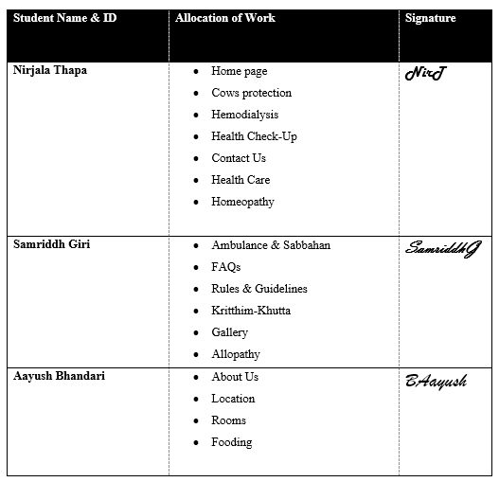

## Wireframe

Figure 14: wireframe of main page

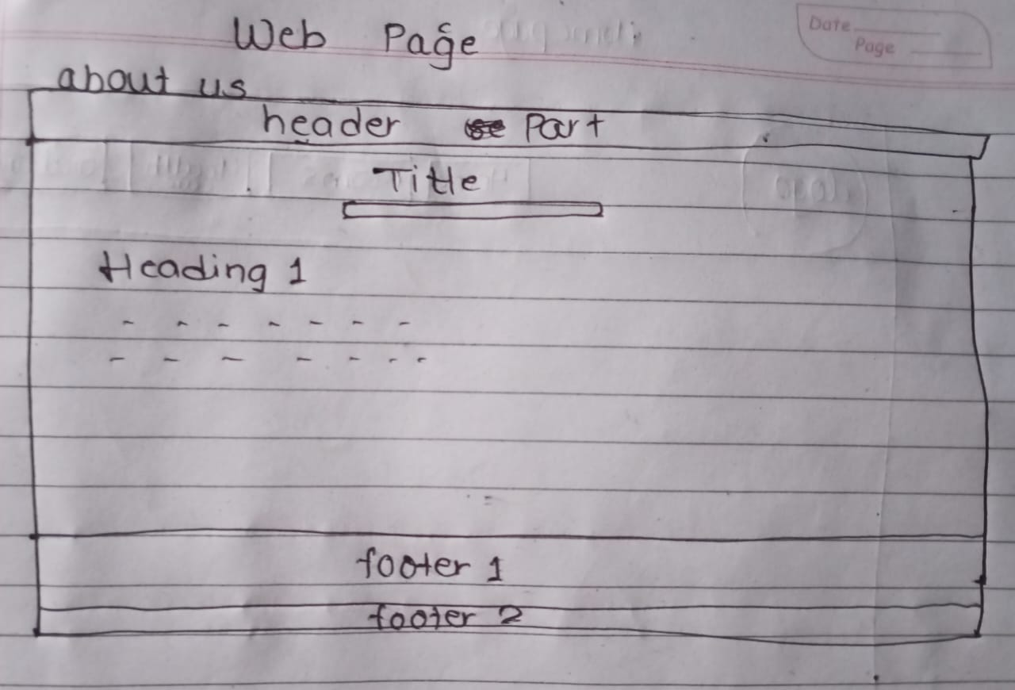

Figure 15: wireframe of about us page

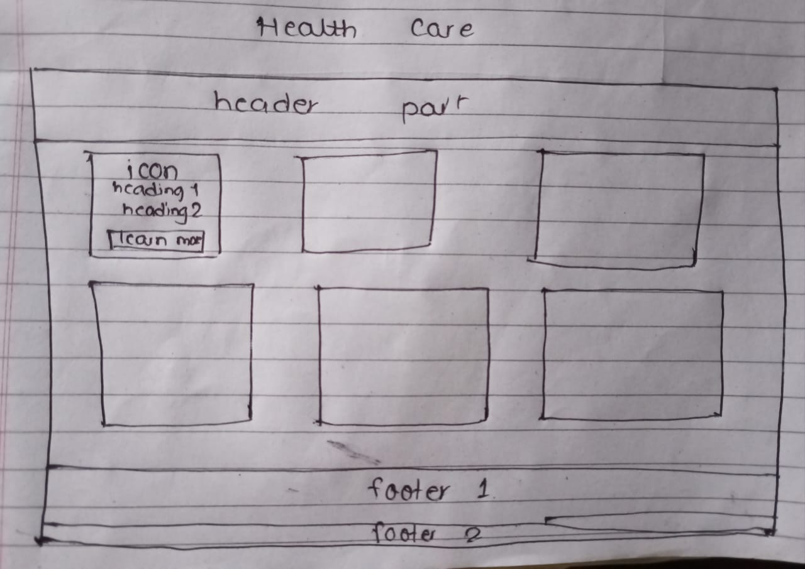

Figure 16: wireframe of health care dashboard