**APPLICATION ARCHITECTURE AND FLOW**

**NAME:** Navin Krishna

**EMAIL:** tnkrishnank@gmail.com

**PROJECT LINK:** <https://github.com/tnkrishnank/RBAC-Node-Express-React>

**TECH STACK OVERVIEW:**

This application follows a MERN-stack style architecture. Below is the tech stack used for the application development.

* **Frontend:** React.js
* **Backend:** Node.js with Express.js
* **Database:** MongoDB Atlas (Cloud)
* **Authentication:** JSON Web Tokens (JWT)
* **Mail Service:** Nodemailer
* **Endpoint Testing:** Postman

**ARCHITECTURE:**

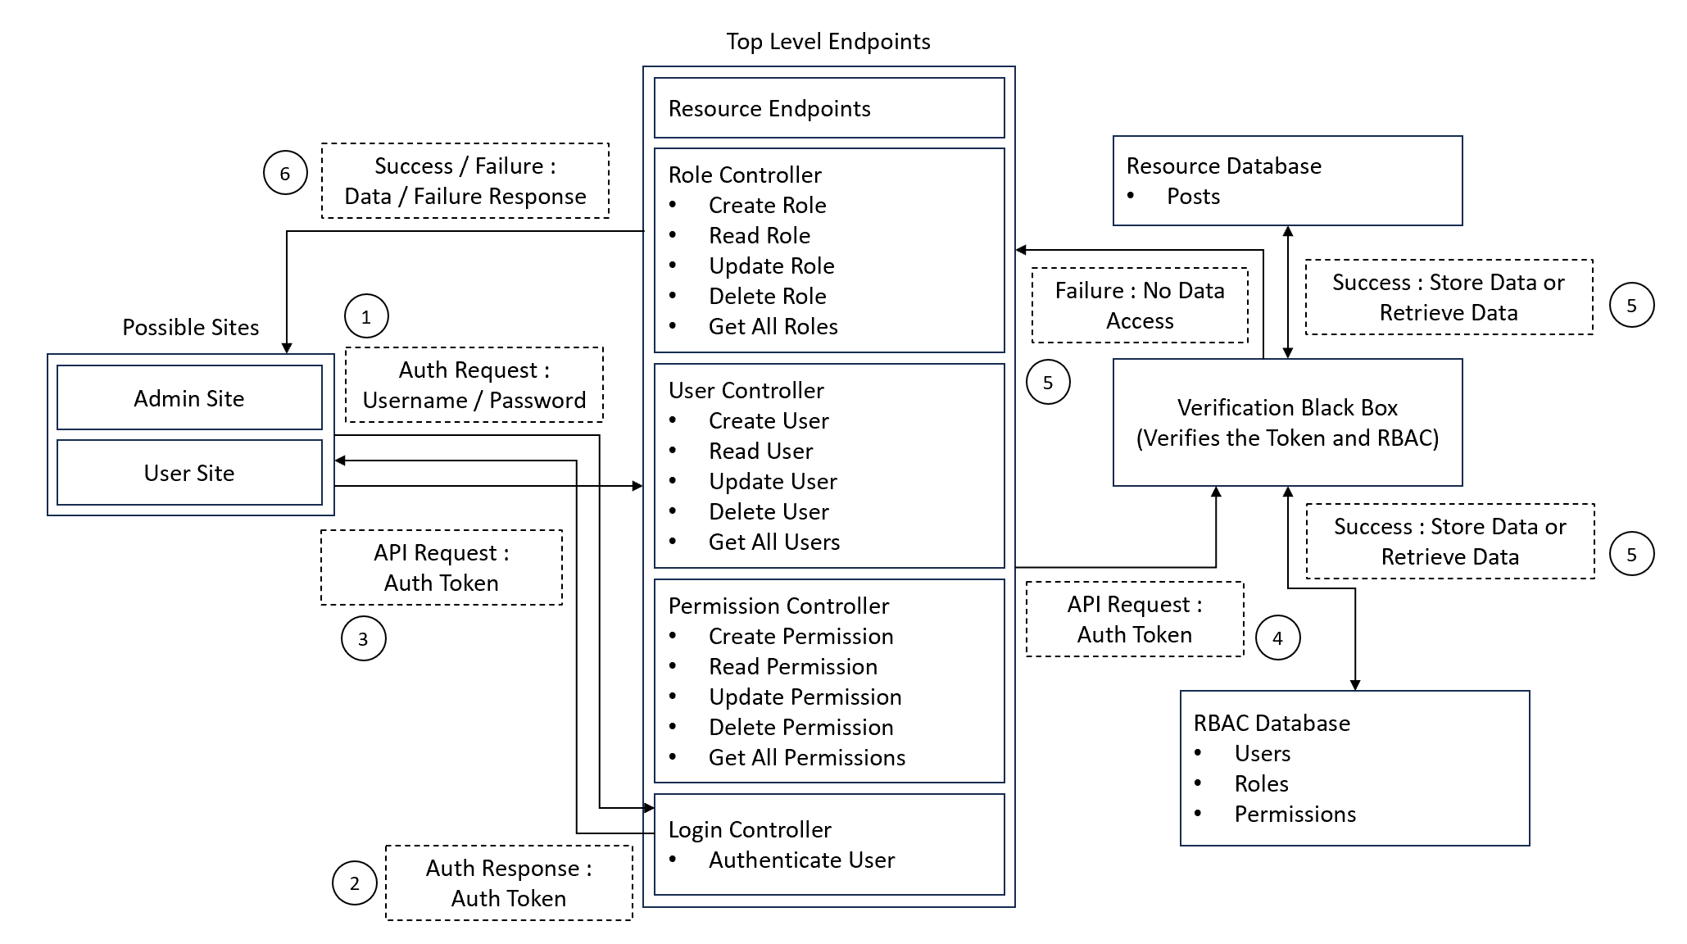

**BACKEND FLOW:**

**1. User Authentication Request**

* Users access either the Admin Site or User Site.
* They send an authentication request with Username and Password.
* This request is handled by the Authenticator at the backend.

**2. Authentication Response**

* The Login Endpoint verifies the credentials:
  + If correct: an Auth Token (JWT) is generated and returned to the client.
  + If incorrect: an error response is sent.
* The Signup Endpoint checks for username or email already exists in the database, and sends a verification mail to the user if the password satisfies the constraints.
* The user can then click on the link to verify their account and then login.
* This Auth Token is necessary for all subsequent secure API interactions.

**3. API Request with Auth Token**

* Once authenticated, the client makes further API requests to backend endpoints.
* These requests include the Auth Token in the Authorization Header.

**4. Token and RBAC Verification**

* Before allowing access to protected resources:
* The Verification Black Box middleware validates the JWT Token.
* It then checks the user's roles and permissions against the RBAC Database (Users, Roles, Permissions).
* If verification fails, access is denied immediately.

**5. Database Access Based on Permissions**

* After successful verification:
  + The request is allowed to interact with the Resource Database or the RBAC Database.
  + The Resource Database contains Posts in this project and RBAC Database contains Roles, Permissions and Users details.
* Flow:
  + Success: Data is either retrieved from or stored in the database.
  + Failure: If the user lacks necessary permissions, a "No Access" or "Unauthorized" error is returned.

**6. Response to Client**

* A Success Response (with data) or a Failure Response (with error details) is sent back.
* The client then renders or reacts based on this response.

**Note:**

* A Postman Collection JSON file is available inside the backend directory.
* Developers can import this collection into Postman and directly test all the backend API endpoints.

**FRONTEND FLOW:**

**1. Application Entry Points**

* The app has two main user flows:
  + Admin Portal: /admin
  + User Portal: / or /signup
* Users are routed based on their role after login.

**2. Authentication Handling**

* On login/signup, the JWT Token is received from the backend and stored in localStorage.
* Every time the user accesses protected routes:
  + The frontend checks if a valid token exists in localStorage.
  + If no token is found, the user is redirected to the Login Page.

**3. Route Protection**

* Admin Pages:
  + Before loading admin pages, the frontend verifies the user by calling the /verify-admin backend API.
  + If the user is not an admin, they are redirected back to the normal user page (/blogs).
* 404 Handling:
  + If users navigate to an invalid route, the app redirects them to a custom 404 Not Found Page.

**4. API Communication**

* Axios is used for making API requests.
* Every request includes the Authorization Header with the Bearer token for secure access.
* Responses are handled carefully:
  + On token failure (expired/invalid), the user is logged out and redirected to login.
  + On successful response, data is displayed accordingly.

**5. Post-Login Workflow**

* After a successful login the user is redirected to:
  + Admin Portal (/admin/dashboard) if the user is admin.
  + User Portal (/blogs) if the user is a normal user.

**6. Mail Verification**

* On signing up, a verification email is sent to the user's email (handled by nodemailer at the backend).
* The frontend shows a message asking the user to verify their email.
* Only after email verification, the user can login.