Advance Machine Learning HW2

Q5: Train the best model

**How to run the script**

python main.py

**Model architecture**

Due to resource limitation, I only built a six-layer convolutional network with the following architecture.

Conv(num_filters=32, filter_size=3) - BN - ReLU

2x2 max pooling

Conv(num_filters=64, filter_size=3) - BN - ReLU

2x2 max pooling

Affine - ReLU

Affine - softmax

**Best result**

|  |  |  |
| --- | --- | --- |
|  | Validation | Test |
| Accuracy | 0.792 | 0.735 |

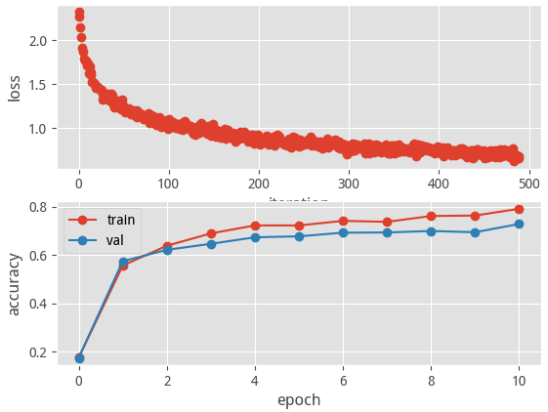

**Discussion**

1. Parameter tuning is critical to the model, including:
   * Model
     + n_layer: more layer you build, more information your model can capture(good for sophisticate problem)
     + num_filters
     + filter_size
     + reg
   * Solver
     + num_epochs: more epochs, better result (may cause overfitting, so regularization or early stop is important)
     + batch_size: if you have lots of memory, you can increase you batch size to accelerate the training process
   * learning_rate