* Getting information by shell commands:

+ whoami – username

+ id – user/group ID

+ uname – OS name

+ ps – running processes

+ top – resource usage

+ df – mounted file systems

+ man – reference manual

+ date – today date

+ cp – copy file

+ mv – change name/path

+ rm – remove file

+ touch – create empty file, update timestamp

+ chmod – change/modify file permissions

+ wc – get count of lines, words, chars in file

+ grep – return lines

* Navigating and working with directories

+ ls – list files and directories

+ find – find files in dir tree

+ pwd – get present working directory

+ mkdir – make directory

+ cd – change directory

+ rmdir – remove

* Printing file and string contents:

+ cat

+ more – print file contents page-by-page

+ head – print first N lines

+ tail – print last N lines

+ echo – print string or variable value

* Compression and archiving

+ tar – archive set of files

+ zip

+ unzip

* 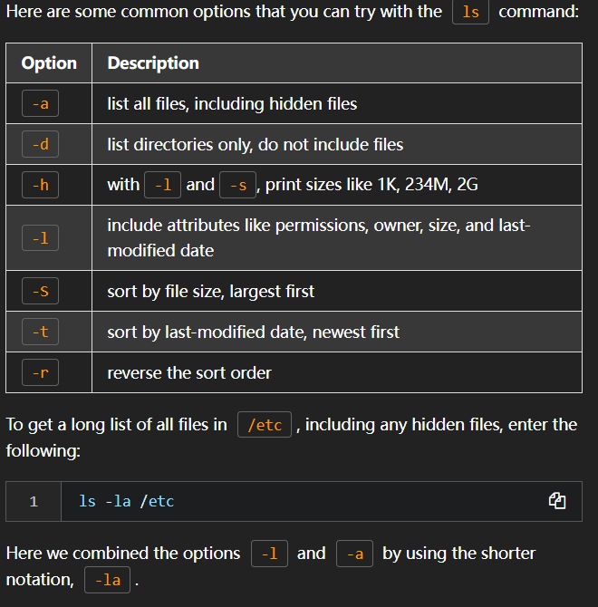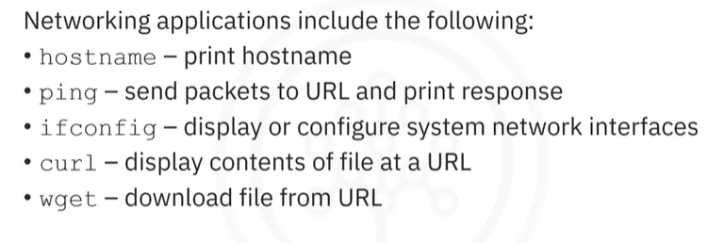Networking
* Listing dir contents :

+ ls

+ ls Downloads => list all contents in downloads

+ ls -l => list longer and better format of contents

+ pwd => current working dir

+ cd

* Finding files:

+ find . -name <file name>

+ find . -iname <file name>

* Create dir:

+ mkdir <dir name>

* Remove dir:

+ rm <folder name>

+ rm -r <folder name> : Delete folder with all it children

* Creating files:

+ touch – Create empty file, update file date

* Copy files and directories

+ cp

* Move files and directories

+ mv <file path / dir path>

* Managing file permissions

+ chmod – change file permissions

* Viewing file all at once

+ cat – print entire file contents

+ more - print file contents page-by-page

+ head – print first 10 lines

+ head -n N

+ tail - > last 10 lines

+ wc – count characters includes newline chars

+ wc -l -> exclude newline char

* A screenshot of a computer program

  Description automatically generatedSort views line-by-line

* Excluding repeated line

+ uniq -> filter repeated lines

* A screenshot of a computer

  Description automatically generatedExtracting lines matching a pattern

* Extracting slices

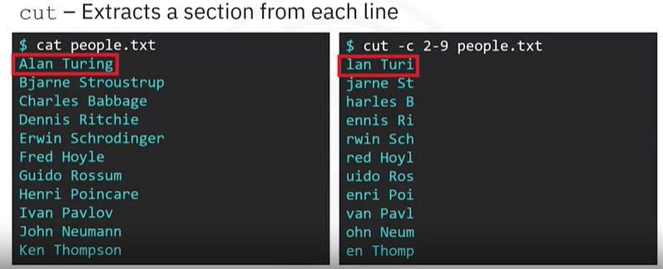

* Merge lines from different files : paste
* Getting network in4:

+ ifconfig -> configure the system network interfaces

* Testing server connections

+ ping -> Send ICMP packets to URL and print response

* Web scraping with curl

+ curl - > transfer dato to and from URL(s)

* Download files from URL:

+ wget <url>

* A screenshot of a computer

  Description automatically generatedFile acrchiving

