1. Install concourse server and fly cli: <https://www.digitalocean.com/community/tutorials/how-to-install-concourse-ci-on-ubuntu-16-04>
2. Set the target in fly cli: 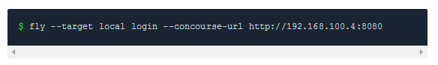
3. Create the pipeline
4. Deploy the pipeline to server 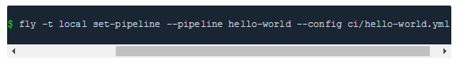
5. Un-pause the pipeline to start it. 

Links:

1. <https://specify.io/how-tos/concourse-ci-continious-integration-and-delivery-of-microservices>
2. <https://seroter.wordpress.com/2016/11/28/using-concourse-to-continuously-deliver-a-service-bus-powered-java-app-to-pivotal-cloud-foundry-on-azure/>
3. <https://github.com/starkandwayne/concourse-tutorial>
4. <https://github.com/concourse/time-resource>
5. <https://github.com/pivotal-cf/email-resource>
6. <https://github.com/patrickcrocker/cf-cli-resource>
7. <https://concourse.ci>

Notes:

1. Each job gets executed in a single container and this container gets destroyed as soon as the job is done.
2. To pass the outputs of one job to another, use a 3rd party storage.
3. Best practice is to separate the jobs as much as possible, scripts (.sh files) should be executed from a separate yaml file.
4. Keep all supporting yml and sh files in /ci folder on root
5. User credentials should be loaded from another secure yaml file located in local.

fly -t lite set-pipeline --pipeline <pipeline_name> --config <pipeline.yml> --load-vars-from secure.yml

Issues:

1. Do not code the pipeline in Windows machines to avoid unexpected errors.