OMS DEVELOPMENT ENVIRONMENT

UI Developer Guidance

Version 1.0
May 27, 2021

Table of Contents
I. Introduction 3
OMS (Operation Manager System) project is a part of Shinhan Finance ecosystem. It supports internal tasks for D&R team. 3
II. Install Required Software 3
1. Browser 3
2. IDE 3
3. Node.js and npm 3
4. Angular CLI 4
5. GIT & Source code 4
III. Configurations 4
IV. Build 5

- Introduction

OMS (Operation Manager System) project is a part of Shinhan Finance ecosystem. It supports internal tasks for D&R team.
- Install Required Software
- Browser
- You can use any browser of your choice. However, Google Chrome is recommended.
- IDE
- Following are the recommended editor and IDEs:
  - Visual Studio Code
  - WebStorm (not available for free)
  - Atom
  - Sublime Text
Selecting anyone you wish.
- Node.js and npm
- If Node.js and npm aren't already on your machine, install them. https://nodejs.org/en/download/
- To check which version you are using, run node -v and npm -v, please make sure that you don’t use node version older than 15.x.x and npm version older than 7.x.x
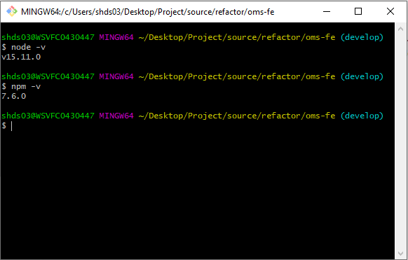
- Angular CLI
- Install the CLI using the node package manager:
npm install -g @angular/cli
- GIT & Source code
  - Install GIT follow the link:
    - https://git-scm.com/download/win
  - Get latest code on branch oms-production
    - https://git.shinhanfinance.com.vn/internal/oms/oms-fe
  - If you don’t have permission to get code, please contact your team leader.

- Configurations
- In oms-fe/ folder, open angular.json file, change port & host as you wish
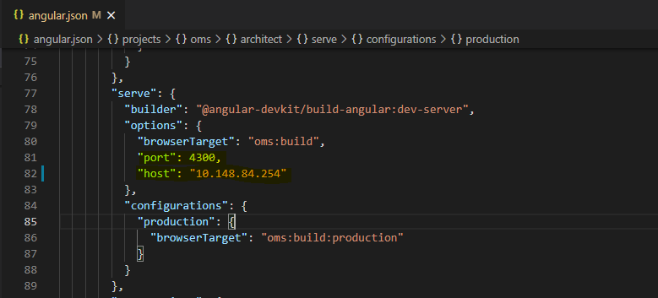
- In oms-fe/src/environments folder, open environment.ts file and config the backend url
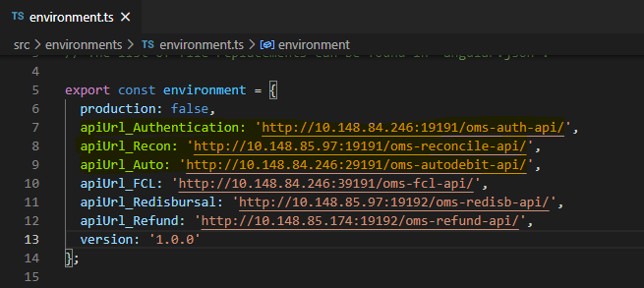

- Build
- In workspace directory oms-fe/
- Run npm install to download all dependency packages
- Run ng build --prod to compile source code into an output directory named dist/
- Run ng serve to start the server. Navigate to host:port (eg. http://localhost:4200/) to verify the server is started successfully.
