ETL Orchestration Project Summary

Multi-Source Data Orchestration Pipeline
Dockerized multi-source ETL orchestration pipeline using Apache Airflow, PostgreSQL, FastAPI, and Streamlit for sanctions intelligence and news aggregation.
Overview
This project is a Dockerized end-to-end data orchestration pipeline that:
- Scrapes data from multiple external sources
- Orchestrates workflows with Apache Airflow
- Merges and deduplicates datasets
- Stores structured data in PostgreSQL
- Exposes APIs through FastAPI
- Visualizes results with Streamlit
The system demonstrates a complete modern ETL/ELT architecture for sanctions intelligence and news aggregation.

Architecture
External Sources
↓
Scrapers / Crawlers
↓
Airflow DAG Orchestration
↓
Merge + Dedup Pipeline
↓
PostgreSQL
↓
FastAPI
↓
Streamlit Dashboard

Tech Stack
Layer | Technology
Orchestration | Apache Airflow
Backend API | FastAPI
Database | PostgreSQL
Dashboard | Streamlit
Containerization | Docker Compose
Data Processing | Python
Scheduling | Airflow Scheduler

Running Docker desktop images
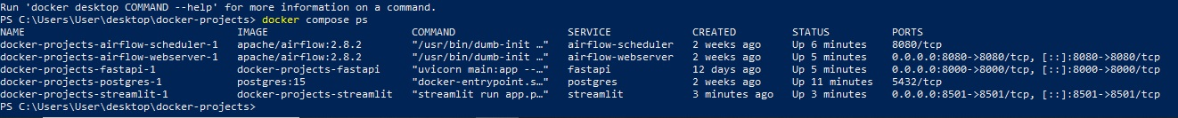

Data Sources
1. EU FSF Sanctions
Structured sanctions dataset.
Output:
/data/eu_fsf_sanctions.json
Approximate records:
~5900+

2. INEGI Scraper
Custom scraper for sanctioned providers.
Outputs:
/data/inegi_scraper.json
/data/inegi_playwright.json
Approximate records:
75 + 75

3. Kaldata News
SQLite-based news ingestion.
Output:
/data/kaldata.db

4. Telegraph News
SQLite-based news ingestion.
Output:
/data/telegraph.db

Airflow Orchestration
DAGs
DAG | Purpose
EU FSF DAG | Downloads sanctions data
INEGI DAG | Scrapes sanctioned providers
Kaldata DAG | Collects news data
Telegraph DAG | Collects news data
Merge DAG | Merges and stores all outputs
Merge Pipeline
The merge pipeline:
- Reads all JSON and SQLite outputs
- Normalizes records
- Deduplicates entries
- Classifies data types
- Saves structured data into PostgreSQL
Classification logic:
Data Type | Target Table
Sanctions | sanctions
News | news
Unknown/Other | raw_data

PostgreSQL Schema
sanctions
Stores sanctions-related entities.
Columns:
- id
- name
- source
- extra (JSONB)
- unique_key

news
Stores news articles.
Columns:
- id
- title
- body
- author
- url
- source

raw_data
Fallback storage for unclassified records.
Columns:
- id
- data (JSONB)
- source
- unique_key

PostgreSQL counts
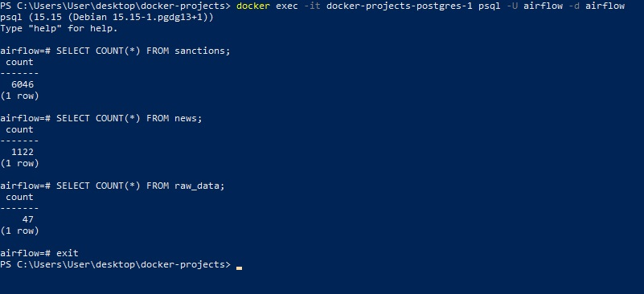

Deduplication
Deduplication is implemented using:
UNIQUE CONSTRAINTS
and:
ON CONFLICT DO NOTHING
This prevents uncontrolled duplicate growth across DAG reruns.

Current Dataset Status
Table | ApproximateRecords
sanctions | 6000+
news | 700+
raw_data | minimal

Localhost:8080
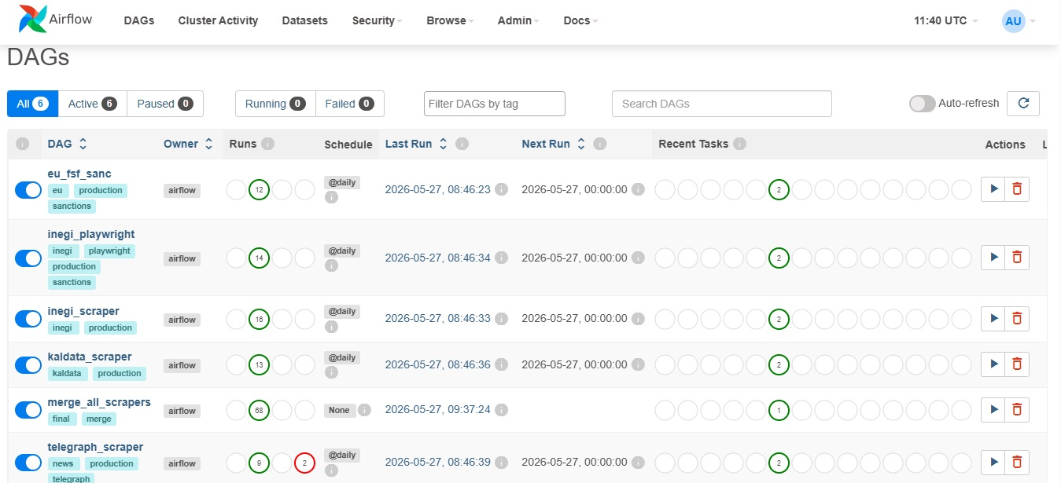

Streamlit Dashboard
The Streamlit dashboard provides:
- PostgreSQL integration
- Data table visualization
- Sanctions overview
- News overview
- Raw data inspection
Potential future improvements:
- Search
- Filters
- Charts
- Analytics
- Entity exploration
- Monitoring metrics

Streamlit localhost:8501

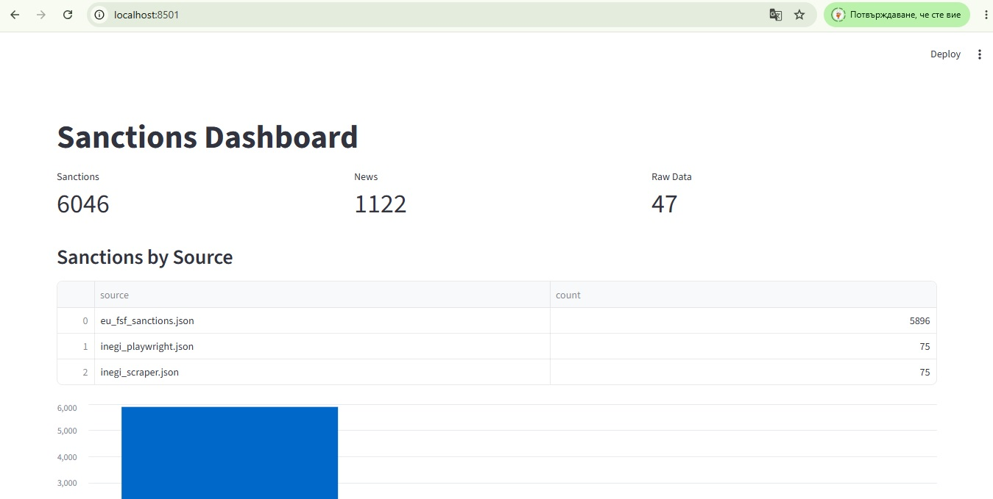

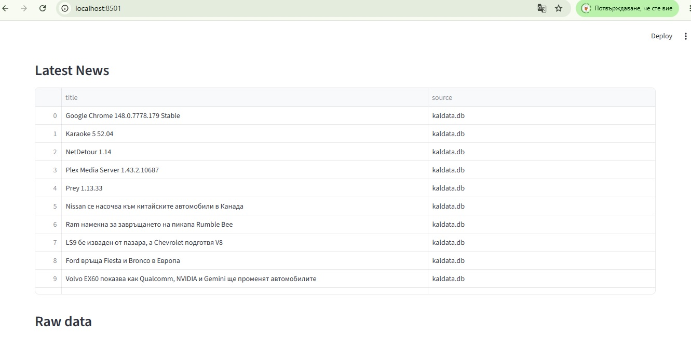

API Layer
FastAPI exposes REST endpoints:
Endpoint | Purpose
/sanctions | Retrieve sanctions
/news | Retrieve news
/raw | Retrieve fallback raw data

FastAPI http://localhost:8000/news
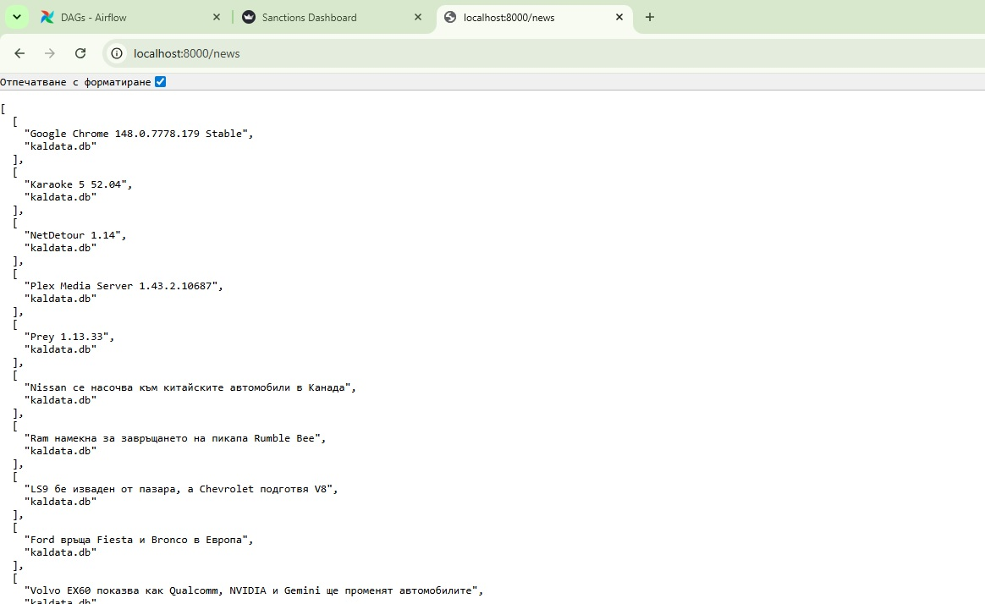

Dockerized Infrastructure
All services run through Docker Compose.
Services:
- airflow-webserver
- airflow-scheduler
- postgres
- fastapi
- streamlit
Shared volumes are used for:
/data
/logs
/dags

Docker Desktop
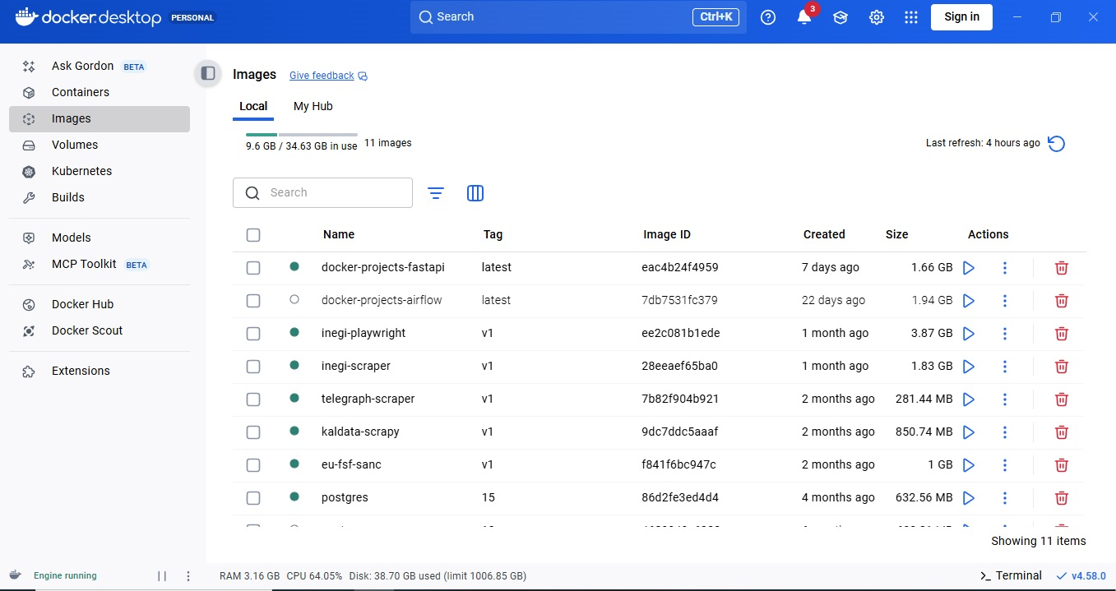

Key Engineering Challenges Solved
Shared Volume Consistency
Unified all containers to use:
/opt/airflow/data
preventing stale outputs and path mismatches.

Deduplication Stability
Implemented unique keys and PostgreSQL constraints to stabilize repeated DAG executions.

Classification Pipeline
Improved sanctions classification logic to correctly ingest EU sanctions datasets.

End-to-End Orchestration
Validated complete orchestration flow:
Scraper → Airflow → Merge → PostgreSQL → API → Dashboard

Result
The project demonstrates a fully operational orchestration pipeline capable of:
- Multi-source data ingestion
- Workflow orchestration
- Data normalization
- Deduplication
- Persistent storage
- API exposure
- Dashboard visualization
This architecture can be extended toward:
- Intelligence platforms
- Compliance monitoring
- Entity resolution systems
- Real-time alerting
- Analytics dashboards
- Search and vector retrieval systems

