

Project Report for ChronoFlow

Practice Module for Graduate Certificate in Architecting Scalable Systems

Team 1
Members:
CHEN YULIANG
FAN YAZHUOTING
LU SHUWEN
THET NAUNG SOE
XU ZIHANG

1. Introduction 4
1.1 Background 4
1.2 Business Needs 5
1.3 Stakeholders 6
1.4 Project Scope 7
1.4.1 Functionality in scope 7
1.4.2 Functionality out of scope 9
2. Project Conduct 9
2.1 Project Plan 9
2.2 Project Status 10
2.3 Project Metrics 10
3. Solution Overview 12
3.1 Logical Architecture & Design 12
3.1.1 Key Architectural Decisions 14
3.1.2 Tiers and Layers 17
3.1.3 Nodes and Subsystems 21
3.1.4 Platform Design 24
3.2 Physical Architecture & Design 28
3.2.1 Key Architectural Decisions 28
3.2.2 Technology and Services 34
3.2.3 Persistence Design 49
3.2.4 Detailed Design 54
3.3 Other Architectural Decisions 56
3.4 Architectural Limitation 60
4. Quality Attributes 62
4.1 Performance 62
4.2 Availability 62
4.3 Security 63
4.4 Extensibility and Maintainability 64
5. DevOps and Development Lifecycle 65
5.1 Source Control Strategy 65
5.2 Continuous Integration 65
5.3 Continuous Delivery 67
6. Performance Test 70
6.1 Introduction 70
6.2 Test Environment and Execution 70
6.3 Results and Observations 70
6.4 Scalability and Resource Utilization 71
6.5 Conclusion and Recommendations 72
7. Unit / Component and End-to-end Testing 73
8. GitHub Repo URL 74

Introduction

Background

The contemporary landscape of event coordination presents significant challenges for organizations and communities managing events of varying scales. Events manifest across diverse contexts—ranging from corporate workshops, academic conferences, and departmental celebrations to community engagement activities and private social gatherings. While the scope and formality of these events differ substantially, they share a common characteristic: once multiple stakeholder groups become involved, coordination complexity escalates exponentially.
A critical gap exists in the current event management ecosystem. The individuals typically tasked with organizing such events—administrative staff, department coordinators, community organizers, and volunteer leaders—rarely possess formal training in project management methodologies or expertise in utilizing complex project coordination tools. This skills mismatch creates a fundamental tension between the coordination requirements of multi-stakeholder events and the capabilities of those responsible for their execution.
Existing technological solutions demonstrate inherent limitations that exacerbate this challenge. Enterprise-grade project management platforms such as Asana, Trello, and Jira, while robust in functionality, impose steep learning curves and demand sophisticated understanding of workflow design, task dependencies, and agile methodologies. These platforms are optimized for professional project managers working in iterative development environments, making them prohibitively complex for occasional event organizers who require straightforward coordination mechanisms.
Conversely, commercial event management systems such as Eventbrite, Cvent, and Bizzabo are architected primarily for large-scale public events with emphases on ticket sales, attendee registration, marketing automation, and revenue generation. These platforms lack the internal coordination capabilities essential for organizational events where the primary concerns are task delegation, resource tracking, team communication, and operational execution rather than public marketing and monetization.
Consequently, event organizers frequently resort to fragmented, ad-hoc coordination approaches utilizing disparate tools: email threads for communication, spreadsheet documents for task tracking, instant messaging platforms for real-time updates, and cloud storage for document management. This toolkit fragmentation results in predictable failure modes including missed deadlines due to notification overload, inequitable task distribution stemming from poor visibility into workload allocation, inadequate budget oversight resulting from decentralized expense tracking, and compromised day-of-event coordination caused by information silos across communication channels.
The market therefore exhibits a demonstrable need for an intermediate-complexity solution: a system that provides sufficient structure to ensure effective coordination while maintaining the accessibility and usability required by non-specialist organizers. This solution must bridge the gap between oversimplified consumer tools and overengineered enterprise platforms, delivering professional coordination capabilities through an intuitive, role-based interface.

Business Needs

The ChronoFlow initiative addresses critical organizational inefficiencies in event coordination processes. The following business needs and strategic drivers underpin this project:
Primary Business Needs

- Operational Efficiency Enhancement: Organizations require streamlined event coordination processes that minimize time expenditure on administrative overhead, enabling event coordinators to allocate resources toward strategic planning and stakeholder engagement rather than logistical firefighting.
- Resource Optimization: Effective visibility into budget utilization, manpower allocation, and material resources is essential for optimizing organizational resource deployment and preventing cost overruns that commonly plague unstructured event management approaches.
- Quality Assurance: Structured workflows with built-in accountability mechanisms, evidence-based task verification, and progress tracking ensure consistent delivery quality across events, mitigating reputation risks associated with poorly executed gatherings.
- Scalability of Coordination Capacity: Organizations need systems that enable non-expert staff to coordinate increasingly complex events without proportional increases in training investment or external consulting expenditures.
- Risk Mitigation: Transparent task tracking, deadline management, and communication audit trails reduce operational risks including compliance violations, safety oversights, and coordination failures that could result in event cancellations or participant dissatisfaction.

Strategic Drivers

- Democratization of Event Management: Empower individuals across organizational hierarchies to successfully coordinate events, reducing dependency on specialized event planning personnel and enabling distributed coordination capabilities.
- Data-Driven Continuous Improvement: Establish systematic collection of pre-event planning data, real-time execution metrics, and post-event feedback to enable evidence-based refinement of event management practices over successive iterations.
- Transparency and Stakeholder Confidence: Provide comprehensive visibility into planning processes, budget allocation, and execution progress to build stakeholder trust and facilitate informed decision-making by event sponsors and organizational leadership.
- Workplace Equity: Implement objective workload visibility to ensure fair distribution of event-related responsibilities, preventing burnout among committed team members while identifying underutilization of available human resources.

Institutional Knowledge Preservation: Create structured documentation of event planning processes, task templates, and lessons learned to preserve organizational knowledge across staff transitions and enable replication of successful event patterns.

Stakeholders

Stakeholder | Description | Responsibilities and Interests
Platform Administrator | The system-level administrator who oversees the overall platform. | Manages global configurations, system policies, organization lifecycle, and ensures compliance and platform stability.
Organizer (Organization Administrator) | A user responsible for managing a specific organization and its activities. | Creates and manages organizations, events, groups, tasks, members, roles, budgets, and internal notifications. Oversees workflow execution and organizational performance.
Member (Organization Member) | A regular user who participates in the events. | Views assigned tasks, submits working hours, receives notifications, and contributes to event execution.
Attendee (Event Participant) | A participant of events. | Receive notification and performs QR code check-in during events.
GCS File Service | External cloud storage service. | Stores uploaded files and provides secure file retrieval services.
AWS Email Service | External email notification service. | Sends email-based system notifications to users.

Project Scope

Functionality in scope

User and Access Management
- Multi-role user account creation with granular permission management (Event Owner, Event Manager, Staff, Attendee roles)
- Bulk user provisioning via CSV/Excel upload for efficient large-scale user onboarding
- Role-based access control (RBAC) enforcement across all system features
- Secure authentication and session management mechanisms

Organizational Structure and Task Framework
- Hierarchical group creation with flexible nesting capabilities for complex organizational structures
- Task definition with comprehensive metadata (description, due dates, time estimates, priority levels, dependencies)
- Task assignment
- Task template library for recurring event activity patterns
- Real-time task status tracking with defined lifecycle states (Not Started, In Progress, Completed, Blocked, Deferred)

Visibility and Analytics
- Multi-tier dashboard architecture:
Organizer-level dashboard: Aggregated event metrics, overall status, milestone progress, and cross-functional coordination view
Individual-level dashboard: Personal task assignments, contribution metrics, time investment, and performance indicators
- Manpower effort visualization showing workload distribution and availability
- Progress tracking with visual indicators (Gantt charts, Kanban boards, burndown charts)

Communication and Notification
- Task-specific comment threads with chronological logging for traceability
- Notification automatically to associated role, such as role creation and task status updated.

Document and Evidence Management
- Centralized document repository with consistent storage architecture
- Task-associated file uploads supporting multiple formats (images, PDFs, spreadsheets, presentations)
- Secure access controls preventing unauthorized document access
- Evidence attachment for task completion verification (photos, receipts, completion certificates)
- Document retrieval and search functionality

Attendance Creation
- Automated QR code generation for each attendee with unique identification
- Email distribution of personalized QR codes prior to event commencement
- On-site QR scanning infrastructure for check-in validation

Functionality out of scope

To maintain project focus and feasibility within resource constraints, the following capabilities are explicitly excluded from the current project scope:
- Advanced analytics, reporting dashboards, and predictive performance analysis
- Integration with enterprise identity systems (e.g., SSO / OAuth corporate directories)
- Native mobile application development (the initial solution targets web-based access)
- Offline operation support or data synchronization without network connectivity
- Cross-organization collaboration features (inter-organizational workflows and resource sharing)

Project Conduct

Project Plan

Week | Plan
1 | - Domain-driven design analysis and bounded context mapping  - Define clear service boundaries and inter-service communication patterns  - Design database schemas  - RESTful API design
2 | - Establish project coding standards and conventions  - Decomposed monolithic system into microservices  - Run project successfully on local machine
3 | - Deploy microservice as K8S cluster  - Deploy cloud service and connection with project  - Set up CI/CD pipeline with deployment  - Develop 3 kinds of way of notification features
4 | - Do testing (performance test, load test)  - Make sure k8s service policy stable

Project Status

The project was completed as planned and met the definition of done requirements.
- Clear Design: Prototype/UI/acceptance criteria are finalized and approved.
- Development Completed: Code is committed, reviewed, and passes unit test coverage.
- Testing Passed: Functional validation, regression, performance, and security testing are completed with all critical bugs resolved.
- Deployable and Runnable: Deployment verification succeeds, documentation is completed.
- Business Confirmation: The requirement meets expectations and is available in the production environment.

Project Metrics

Week | Milestone
1 | This week mainly focus on design part. But no API design.  - Complete domain-driven design analysis and bounded context mapping  - Define clear service boundaries and inter-service communication patterns  - Design database schemas
2 | - Finish API design.  - Run gateway, user, event, task, attendee, file services successfully on local machine
3 | - Code K8S configuration files and deploy service successfully  - Deploy MySQL in master-slave pattern, Memorystore (Redis), Pub/Sub, GCS and Nginx instance  - Set up CI/CD pipeline with deployment  - Develop 3 kinds of way of notification features (Firebase push, Email and WebSocket)
4 | - Do testing with notification function.  - Do many quality tests and e2e testing.  - Modify K8S configuration to make sure cluster run stable

Name | Effort
Fan yazhuoting | Refactored and separated the User Service and Attendee Service.  Integrated distributed transaction management with Seata to ensure data consistency across microservices.  Oversaw project management activities, coordinating team progress and integration milestones.
Chen Yuliang | Refactored and separated the Task Service and File Service.  Assisted in integrating the Email Service with Google Cloud Pub/Sub for event-driven messaging  Optimized database queries to enhance performance and response time.  Contributed to database schema design and overall data layer improvements.
Thet Naung Soe | Refactored and separated the Notification Service  Implemented an event-driven architecture using Google Pub/Sub for asynchronous communication.  Built a background scheduler leveraging Firebase Cloud Messaging (FCM) for push notifications.  Developed a WebSocket gateway integrated with Reactive MongoDB for real-time updates.  Designed and implemented the notification database schema (MySQL) to support idempotency and persistent tracking.  Built and provisioned cloud infrastructure using Terraform, with Nacos configured for service registry and discovery.  Deployed and managed cloud-native applications through Kubernetes, enabling automated scaling and fault tolerance.  Developed the physical architecture, detailing infrastructure topology, Kubernetes deployment environments, and resource allocation.  Integrated the notification service with Task, User, Attendee and Event microservices.  Completed frontend integration with WebSocket and FCM, including UI enhancements for live notifications.
Lu Shuwen | Designed the logical architecture, defining system components, service interactions, and communication flow.  Implemented service protection and traffic control mechanisms using Alibaba Sentinel for resilience under load.  Structured and implemented the core code framework, ensuring consistency and scalability across microservices.
Xu Zihang | Refactored and separated the Event Service.  Set up and maintained the CI/CD pipeline for automated build, testing, and deployment across all services.  Created and executed unit tests to ensure service reliability and maintain code quality.  Conducted performance testing to evaluate system stability and optimize scalability under load.

Solution Overview

Logical Architecture & Design
For the demonstration of logical deployment diagram, we use the “Invite Attendee to Event” use case as a representative slice of the architecture. This flow is interesting because it cuts across multiple microservices and data stores since the organiser interacts with the Attendee domain, which must validate against the Event domain and then trigger the Notification domain. It therefore exercises several architecturally significant concerns at once , synchronous RPC between services, cross-service validation rules, persistence across separate databases, and asynchronous messaging for email / push delivery — making it a good example of how the overall solution is decomposed and integrated.
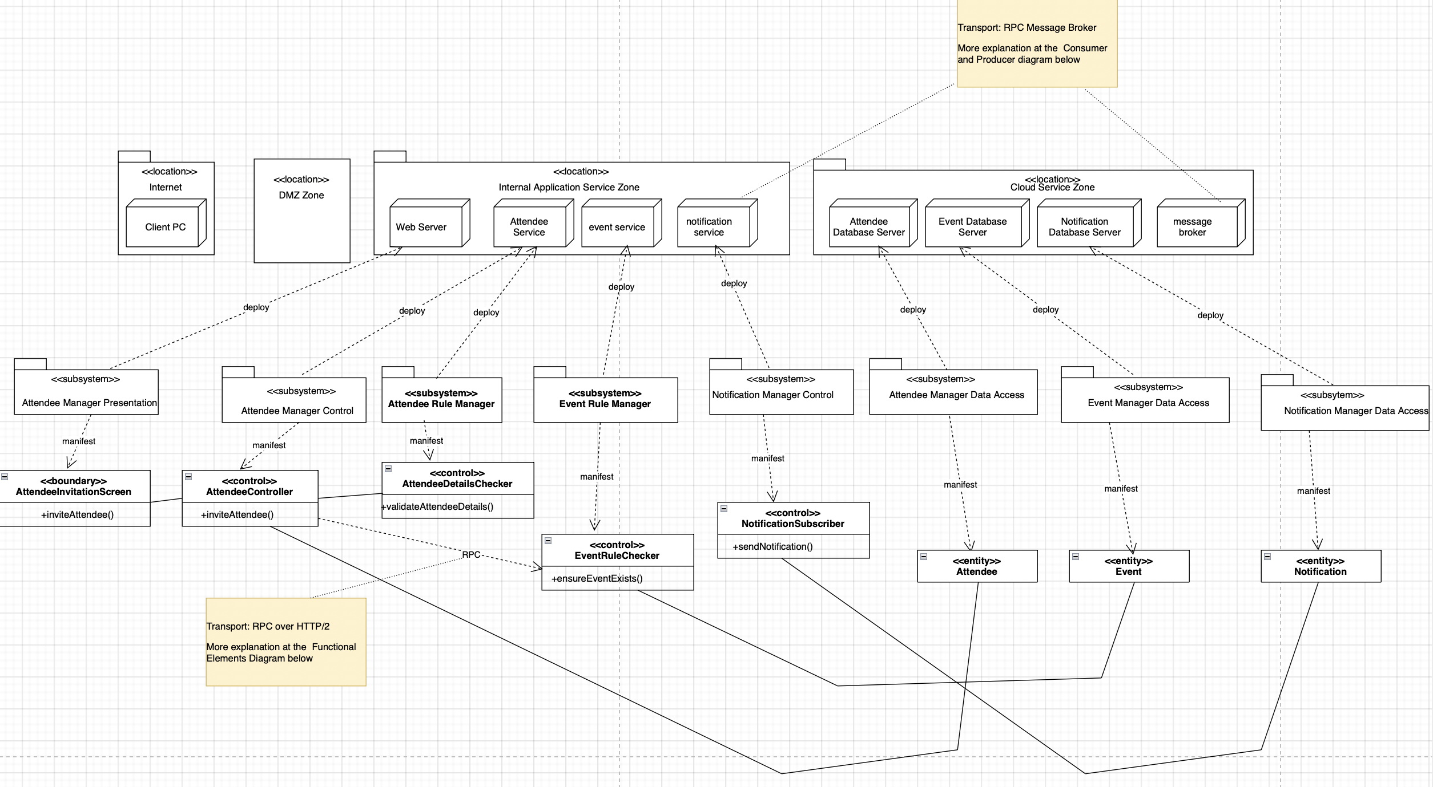

Figure 1. Logical Detail Deployment Diagram
The logical deployment diagram shows how this use case is realised across locations and subsystems. From the Internet zone, the organiser’s browser talks to the Web Server in the DMZ, which acts as the entry point into the Internal Application Service Zone. Within this internal zone, three key services participate: the Attendee Service owns attendee-centric logic, the Event Service owns event validation, and the Notification Service owns outbound notification processing. Each of these services is deployed independently but shares the same logical zone. In the Cloud Service Zone we separate persistence and infrastructure concerns: the Attendee, Event and Notification databases are hosted as distinct logical database servers, and a message broker provides asynchronous communication. The overall workflow is: the organiser submits invitations through the web front end, the request is routed to the Attendee Service, which validates against the Event Service over synchronous RPC, persists attendees into its own database, and then hands off notification work to the Notification Service via the broker.

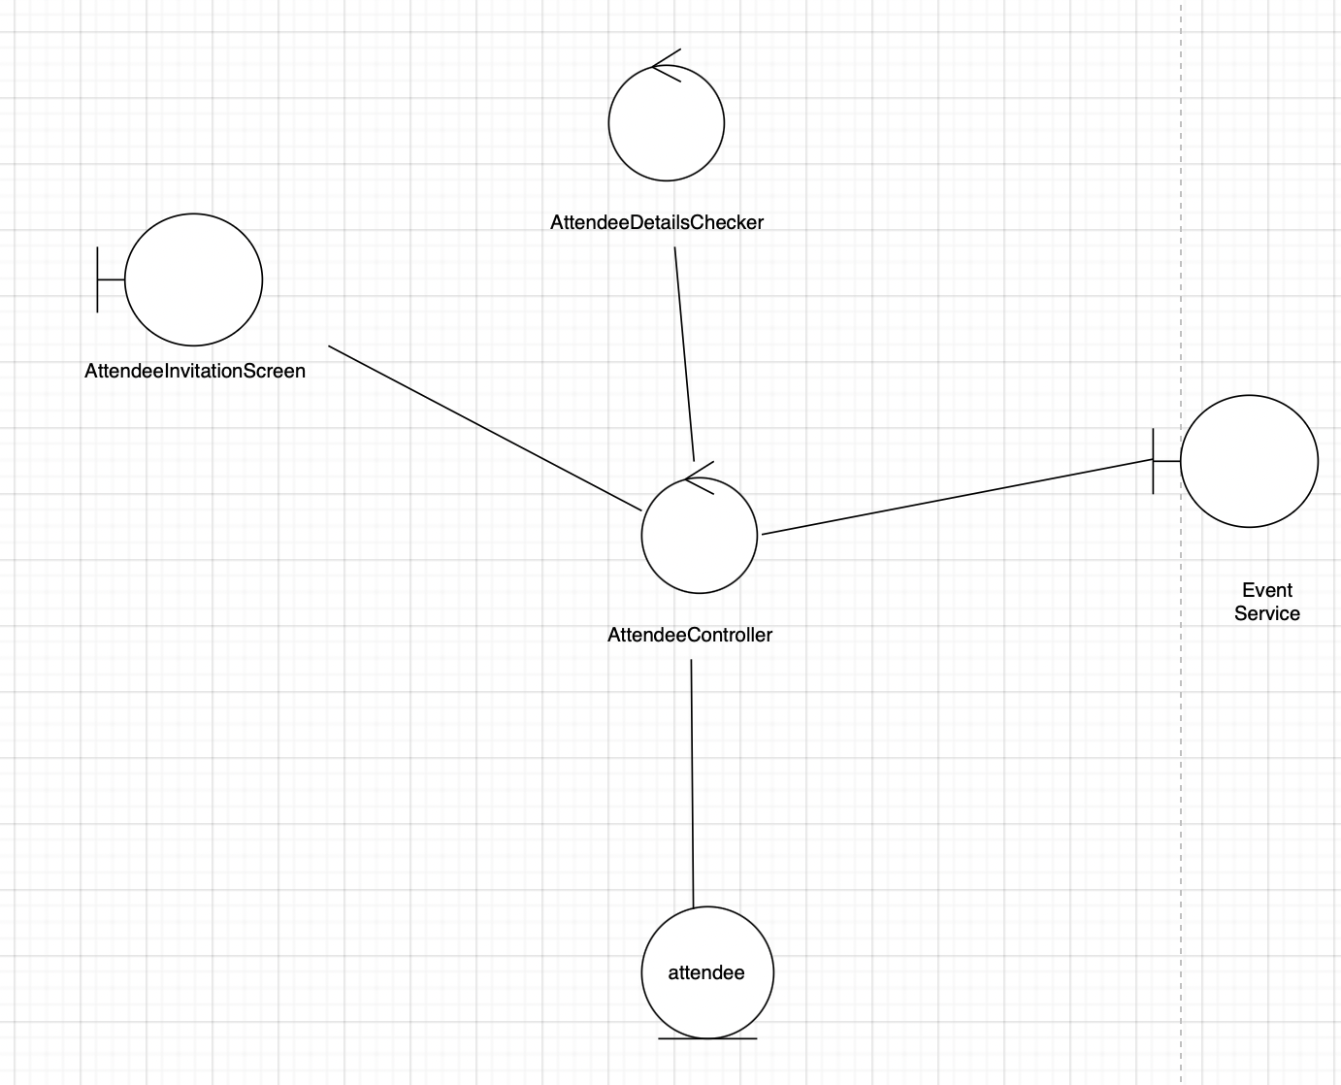

Figure 2. Functional Component Diagram
The functional component diagram for this use case details how responsibility is split inside the participating services. On the presentation side, AttendeeInvitationScreen is the boundary component handling user input and output. It delegates to AttendeeController in the Attendee Manager Control subsystem, which orchestrates the use case end-to-end. Validation rules are pushed into dedicated controls: AttendeeDetailsChecker encapsulates checks on attendee information, while EventRuleChecker in the Event Rule Manager subsystem encapsulates event-related rules and is reached via an RPC client from the Attendee service. Persistence is handled by the Attendee, Event and Notification Manager Data Access subsystems, which are the only components allowed to talk to their respective Attendee, Event and Notification entities.
Finally, NotificationSubscriber in the Notification Manager Control subsystem represents the domain-level subscriber that reacts to invitation events and prepares outbound notifications, keeping notification concerns out of the core Attendee flow.

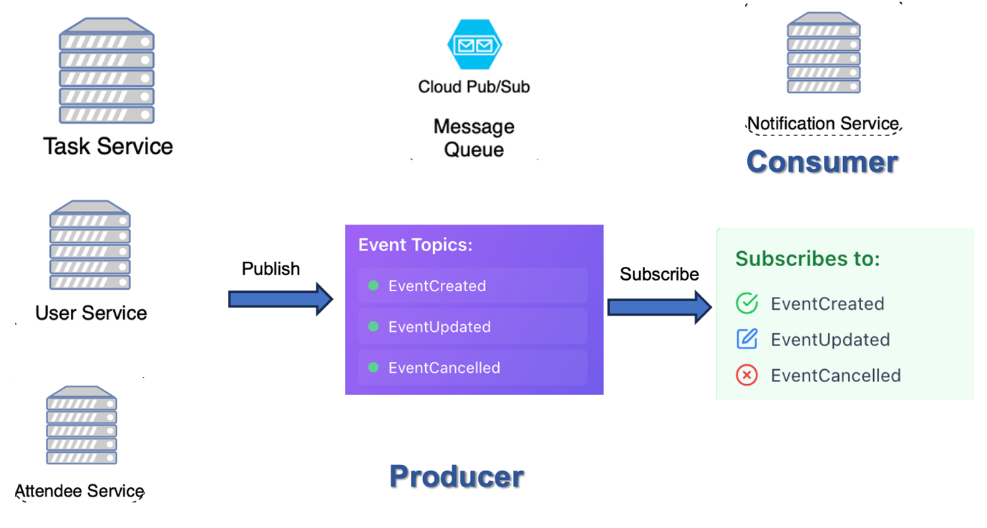

Figure 3. Producer–consumer diagram
The producer–consumer diagram then focuses on the asynchronous messaging aspect of the architecture. In this view, Attendee Service (alongside Task Service and User Service in other flows) plays the role of producer: after it has successfully created or updated domain state, it publishes a domain event (for example, “AttendeeInvited”) to the cloud message broker. The Notification Service is a dedicated consumer of these topics; it subscribes to the relevant event streams and drives delivery without the producing services needing to know the details.

Key Architectural Decisions

The transition from monolith to microservices required deliberate architectural decisions to balance complexity, operational overhead, and business value. The following table summarizes the key decisions that shaped the logical architecture:

Identifier | Description
AD-01 | Domain-Driven Microservices Decomposition  Decision: Decompose the monolithic system into domain-aligned microservices based on bounded contexts identified through Domain-Driven Design principles.  Rationale: Each business domain (User, Event, Task, Attendee, File, Notification) exhibits distinct data models, business rules, and change frequencies. Aligning service boundaries with business capabilities enables independent development, deployment, and scaling. For example, the Notification service can scale horizontally during high-volume email campaigns without affecting the stability of core Event or Task services.  Trade-offs: Increased operational complexity (multiple deployments, distributed monitoring) and inter-service communication overhead. However, this is mitigated by centralized configuration (Nacos), service mesh capabilities (Dubbo RPC), and observability tooling (Prometheus/Grafana).
AD-02 | API Gateway as Single Entry Point  Decision: Introduce Spring Cloud Gateway as the unified entry point for all external client requests, handling routing, load balancing, authentication, rate limiting, and protocol translation.  Rationale: A centralized gateway provides a stable API contract to frontend clients while allowing backend services to evolve independently. It enforces cross-cutting concerns (authentication via Sa-Token, circuit breaking via Sentinel) at the perimeter, preventing each service from implementing redundant logic. The gateway also enables dynamic service discovery via Nacos, automatically routing requests to healthy service instances without client-side configuration changes.  Trade-offs: The gateway becomes a critical path component and potential single point of failure. This is addressed through horizontal scaling (multiple gateway replicas) and health monitoring with automatic failover.
AD-03 | Hybrid Synchronous and Asynchronous Communication  Decision: Use synchronous RPC (Dubbo) for direct service-to-service queries requiring immediate responses, and asynchronous messaging (GCP Pub/Sub) for event-driven workflows and notification propagation.  Rationale: Synchronous calls are appropriate for operations requiring strong consistency (e.g., User Service validating attendee identity during check-in). Asynchronous messaging decouples services for eventual consistency scenarios (e.g., task status changes triggering notifications), improving resilience and reducing temporal coupling. For instance, if the Notification Service is temporarily unavailable, task updates still succeed, with notifications delivered once the service recovers.  Trade-offs: Increased complexity in handling distributed transactions and ensuring message delivery guarantees. Implemented compensating transactions and idempotency keys to maintain data consistency.
AD-04 | Shared Database per Service (Database per Service Pattern)  Decision: Each microservice owns its dedicated database schema within a shared MySQL cluster, with Redis providing cross-service caching and session state management.  Rationale: Isolated schemas prevent tight coupling through shared database tables, allowing services to evolve their data models independently without breaking other services. Cross-service queries are handled through API calls or replicated read models rather than JOIN operations across service boundaries. Redis serves as a shared cache to reduce database load for frequently accessed entities (e.g., user sessions, event metadata).  Trade-offs: Eliminates the possibility of ACID transactions spanning multiple services. Implemented the Saga pattern for distributed transactions (e.g., event creation with initial task assignments) using choreographed events and compensating actions.
AD-05 | Centralized Configuration and Service Discovery  Decision: Adopt Alibaba Nacos for centralized configuration management and dynamic service registration/discovery, replacing static configuration files.  Rationale: Microservices require runtime flexibility to adapt to infrastructure changes (e.g., service instance IP addresses, scaling events, deployment rollouts). Nacos provides hot-reload configuration updates without service restarts and maintains a service registry that automatically reflects instance health states. This eliminates hardcoded service endpoints and enables zero-downtime deployments through gradual traffic shifting.  Trade-offs: Introduces a dependency on Nacos availability. Mitigated through Nacos clustering and local configuration caching within each service to tolerate temporary registry outages.
AD-06 | Resilience Engineering with Circuit Breaking and Bulkheading  Decision: Integrate Sentinel for circuit breaking, rate limiting, and adaptive system protection across all service-to-service calls and external integrations.  Rationale: In a distributed system, cascading failures are a primary risk—if one service becomes slow or unavailable, it can exhaust connection pools and bring down dependent services. Sentinel provides fail-fast behavior (circuit breaking), request throttling (rate limiting), and isolation (bulkheading) to contain failures within service boundaries. For example, if the File Service experiences high latency, Sentinel trips the circuit breaker to prevent the Task Service from being blocked by file upload timeouts.  Trade-offs: Requires careful tuning of thresholds (error rates, latency percentiles, concurrent request limits) to avoid premature circuit trips while still providing protection. Sentinel dashboards provide real-time visibility for threshold adjustments.
These architectural decisions collectively establish a foundation for independent service evolution, operational resilience, and horizontal scalability while acknowledging the inherent complexity of distributed systems.

Tiers and Layers

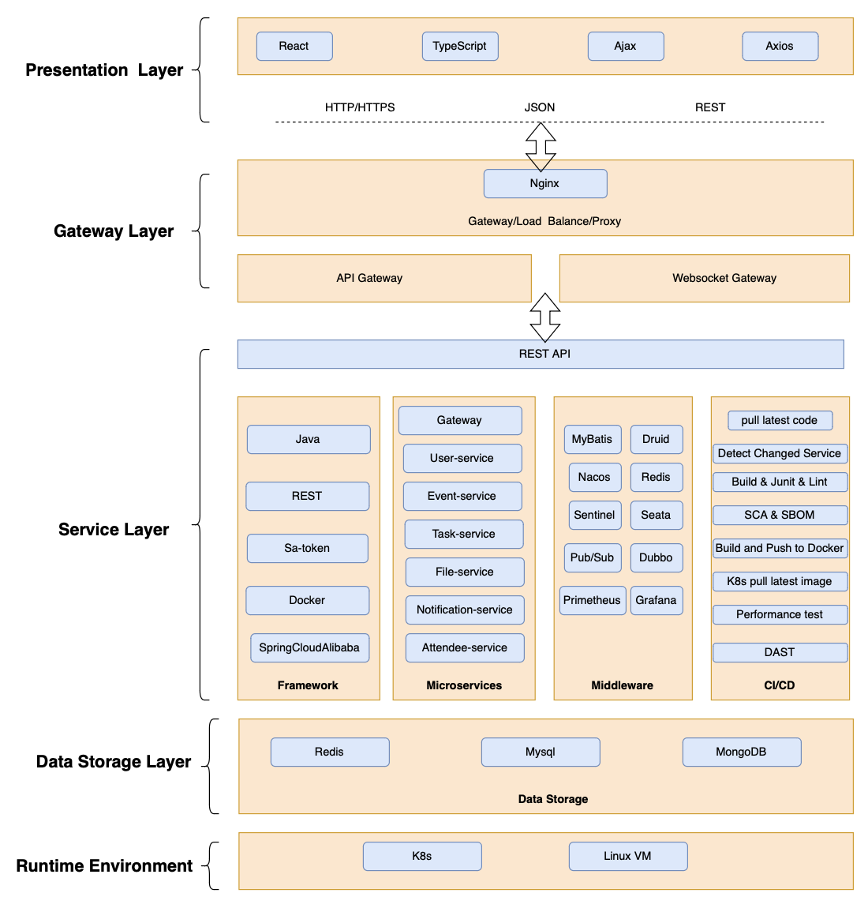
Figure 4. Tiers and Layers Diagram

The ChronoFlow microservices architecture is organized into five logical layers, each with distinct responsibilities and technological implementations. This layered structure promotes separation of concerns, testability, and independent evolution of components.

Presentation Layer

Purpose: Provides user-facing interfaces and handles client-side application logic, rendering, and user interactions.
Technologies: React 18.x with TypeScript for type safety, Axios for HTTP communication, and Ajax for asynchronous data fetching.
Responsibilities:
- Render dynamic UI components for event management, task coordination, attendee check-in, and group organization
- Handle client-side form validation, state management, and session persistence
- Communicate with backend services exclusively through the API Gateway using RESTful HTTP/HTTPS and JSON payloads
- Implement responsive design for cross-device compatibility (desktop, tablet, mobile)

Interaction Pattern: The presentation layer never directly accesses backend services. All requests are routed through the Gateway Layer, which enforces authentication, authorization, and rate limiting before forwarding to appropriate microservices.

Gateway Layer

Purpose: Acts as the unified entry point for all external traffic, providing routing, load balancing, security enforcement, and protocol translation.
Technologies: Nginx serves as the edge proxy for SSL termination and load balancing. Spring Cloud Gateway handles API routing, with Sentinel integrated for circuit breaking and rate limiting.
Components:
- Nginx Reverse Proxy: Terminates HTTPS connections, enforces SSL/TLS, handles DDoS protection, and distributes incoming requests across multiple Spring Cloud Gateway instances.
- API Gateway: Performs dynamic service discovery via Nacos, routes requests to backend microservices based on URI patterns, and applies cross-cutting concerns such as authentication (Sa-Token), request logging, and header enrichment.
- WebSocket Gateway: Maintains persistent bidirectional connections for real-time notifications and live updates (e.g., task status changes, check-in confirmations), using HTTP/2 multiplexing for efficient resource utilization.
Security Controls: Only login and registration endpoints are publicly accessible. All other routes require valid JWT tokens issued by the User Service and validated at the gateway. Failed authentication attempts trigger rate limit counters to prevent brute-force attacks.

Service Layer

Purpose: Implements core business logic, orchestrates workflows, and manages domain-specific rules. Each microservice owns a bounded context and exposes RESTful APIs and RPC interfaces.
Technologies: Java 17, Spring Boot 3.4.1, Spring Cloud Alibaba for service mesh capabilities, MyBatis-Plus for ORM, Sa-Token for authentication, and MapStruct for DTO/Entity mapping.

Core Microservices:
- Gateway Service: Orchestrates cross-service workflows and aggregates responses from multiple microservices for composite API endpoints.
- User Service: Manages user authentication, authorization, role-based access control (RBAC), and session management. Issues and validates Sa-Token JWT tokens.
- Event Service: Handles event creation, lifecycle management (draft, active, cancelled, completed), and validates time window constraints.
- Task Service: Manages task CRUD operations, state transitions (TODO → IN_PROGRESS → DONE), dependency tracking, and workload allocation.
- File Service: Handles file uploads, storage integration with Google Cloud Storage (GCS), metadata management, and generates signed URLs for secure file access.
- Notification Service: Sends transactional emails via AWS SES, push notifications, and in-app alerts.
- Attendee Service: Manages event participation, generates QR codes for check-in, validates check-in tokens, and tracks attendance records.
Inter-Service Communication:
- Synchronous RPC (Dubbo): Used for direct queries requiring immediate responses (e.g., Task Service calling User Service to validate task assignee).
- Asynchronous Messaging (GCP Pub/Sub): Used for event-driven workflows (e.g., Event Service publishing 'EventCreated' events consumed by Task Service to initialize default tasks).
Supporting Middleware:
- Nacos: Service registry and configuration center
- Sentinel: Circuit breaker, rate limiter, and flow control
- Seata: Distributed transaction coordinator (for Saga pattern implementation)
- Prometheus/Grafana: Metrics collection and visualization
- Dubbo: High-performance RPC framework

Data Storage Layer

Purpose: Provides persistent storage for domain entities, session state, and file objects, with each service managing its own data schema.
Technologies:
- MySQL: Primary relational database with master-slave replication for read scalability. Each microservice owns dedicated schemas within the shared MySQL cluster to enforce logical data isolation.
- Redis: Distributed cache (Lettuce client) for session tokens, frequently accessed entities (user profiles, event metadata), and rate limit counters. Provides sub-millisecond read latency and reduces database load.
- MongoDB Atlas: Document store for semi-structured data such as notification templates, and event activity streams where flexible schemas are beneficial.
Data Access Pattern:
- Services never share database tables or execute cross-service SQL joins. Data replication and denormalization are used where eventual consistency is acceptable.
- MyBatis-Plus mappers abstract SQL operations, with HikariCP connection pooling for optimal database connection management.
File Storage: Google Cloud Storage (GCS) serves as the external file repository for task attachments, QR codes, and uploaded documents. The File Service generates time-limited signed URLs to grant temporary access without exposing permanent storage credentials.

Runtime Environment Layer

Purpose: Provides the infrastructure substrate for deploying, running, and scaling containerized microservices.
Technologies:
- Kubernetes Orchestrates service deployments, manages pod lifecycle, and provides declarative scaling through Horizontal Pod Autoscalers (HPA).
- Docker: Packages each microservice as an immutable container image with all runtime dependencies. Images are tagged with Git commit SHAs for traceability and stored in Docker Hub for version-controlled artifact management.
Key Capabilities:
- Self-healing: Kubernetes automatically restarts failed containers and reschedules pods on healthy nodes
- Declarative scaling: HPA monitors CPU/memory metrics and dynamically adjusts pod replicas (2-4 replicas per service)
- Rolling updates: Zero-downtime deployments through gradual pod replacement with readiness/liveness probe validation
- Service mesh foundation: Kubernetes Services provide DNS-based service discovery and load balancing within the cluster.

Nodes and Subsystems

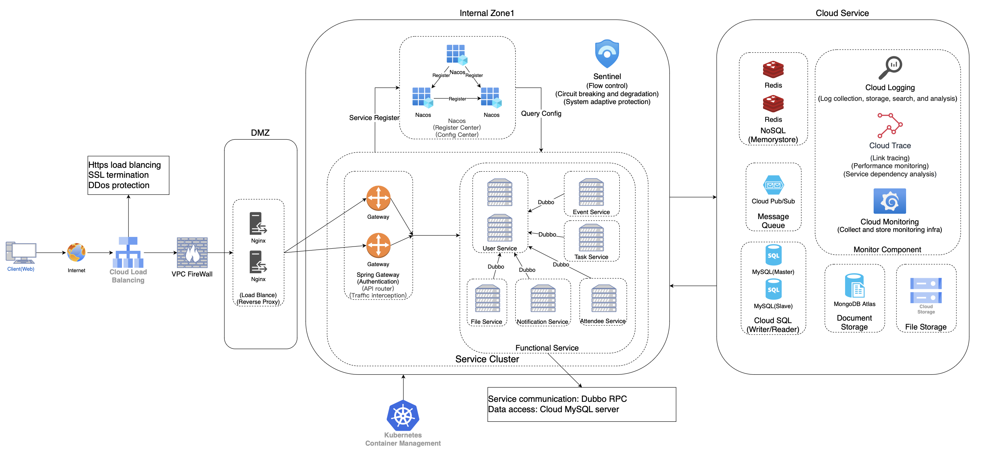

Figure 5. Nodes and Subsystems Diagram
This section describes the major logical subsystems and their relationships within the ChronoFlow microservices architecture. Each subsystem encapsulates a specific business domain and exposes well-defined interfaces for inter-subsystem communication.

Functional Service Cluster
The functional service cluster comprises domain-specific microservices that implement core business capabilities. These services are stateless (session state stored in Redis) and horizontally scalable.

Key Subsystems:

1. User Management Subsystem
- Responsibilities: Authentication, authorization, user profile management, role and permission administration
- Dependencies: Redis (session storage), MySQL (user entities), Nacos (configuration)
- Interfaces: RESTful APIs for user CRUD, JWT token issuance/validation, Dubbo RPC for internal authentication checks
2. Event Management Subsystem
- Responsibilities: Event lifecycle management, scheduling, capacity planning, and group management
- Dependencies: User Service (organizer validation), Task Service (event-task associations), MySQL (event entities)
- Interfaces: REST APIs for event CRUD, event state transitions, Pub/Sub events ('EventCreated', 'EventCancelled')
3. Task Coordination Subsystem
- Responsibilities: Task creation, assignment, status tracking, dependency management, and workload analytics
- Dependencies: Event Service (task-event binding), User Service (assignee validation), File Service (task attachments)
- Interfaces: REST APIs for task CRUD and state machine operations, Pub/Sub events ('TaskStatusChanged', 'TaskAssigned')
4. Attendee Management Subsystem
- Responsibilities: Attendee registration, QR code generation, check-in validation
- Dependencies: Event Service (attendee-event associations), Notification Service (QR code email delivery)
- Interfaces: REST APIs for registration and check-in, WebSocket for real-time attendance updates
5. File Management Subsystem
- Responsibilities: File upload, storage coordination, metadata management, and secure access control
- Dependencies: GCS (object storage), Task Service (file-task associations)
- Interfaces: REST APIs for file upload and signed URL generation, Dubbo RPC for metadata queries
6. Notification Subsystem
- Responsibilities: Multi-channel notification delivery (email, push, in-app), template management, and delivery tracking
- Dependencies: AWS SES (email delivery), User Service (recipient preferences), MongoDB (notification logs)
- Interfaces: Pub/Sub event consumers, REST APIs for notification history queries, WebSocket for real-time push.

Infrastructure Service Registry (Internal Zone 1)

The service registry subsystem provides core infrastructure capabilities that enable microservices to discover, configure, and communicate with each other dynamically.
Nacos Cluster
- Service Discovery: Maintains a real-time registry of service instances with health status, IP addresses, and metadata. Services register on startup and deregister on shutdown.
- Configuration Management: Centralized configuration store with namespace isolation (dev, staging, prod). Supports hot-reload of configuration changes without service restarts.
- Query Config: Provides APIs for retrieving service metadata and configuration snapshots
Sentinel (Flow Control)
- Circuit Breaking: Monitors error rates and latency of outbound calls. Opens circuits when thresholds are exceeded to prevent cascading failures.
- Rate Limiting: Enforces request quotas per service/endpoint to prevent resource exhaustion from traffic spikes or malicious actors.
- System Protection: Adaptive degradation based on system load (CPU, memory, thread pool utilization) to maintain service availability under stress.

Cloud Service Integration Layer

External cloud services provide specialized capabilities that complement the core microservices. These integrations are abstracted through adapter patterns to isolate vendor-specific dependencies.
Messaging Infrastructure
- Cloud Pub/Sub (GCP): Asynchronous event distribution for domain events (EventCreated, TaskAssigned, UserRegistered). Provides at-least-once delivery guarantees with message ordering within partitions.
- Message Queue Pattern: Publishers emit events without knowledge of subscribers. Consumers independently subscribe to relevant topics, enabling loose coupling and independent scalability.
Storage Services
- Redis (NoSQL Cache): Shared cache for session tokens, rate limit counters, and hot-path data. Provides sub-millisecond latency for read-heavy workloads.
- Cloud SQL (MySQL): Managed relational database with automated backups, replication, and patch management. Provides master-slave read replicas for query offloading.
- MongoDB Atlas: Document store for audit logs and semi-structured data with flexible schema evolution
- File Storage (GCS): Object storage for large binary files (attachments, QR codes, exports) with lifecycle policies and encryption at rest
Observability Stack
- Cloud Monitoring (GCP): Aggregates metrics, logs, and traces across all services. Provides dashboards for latency percentiles, error rates, and resource utilization.
- Cloud Logging: Centralized log aggregation with structured JSON logging and query capabilities
- Cloud Trace: Distributed tracing for end-to-end request flow analysis across service boundaries.

Platform Design

Bounded Context and Domain Entities

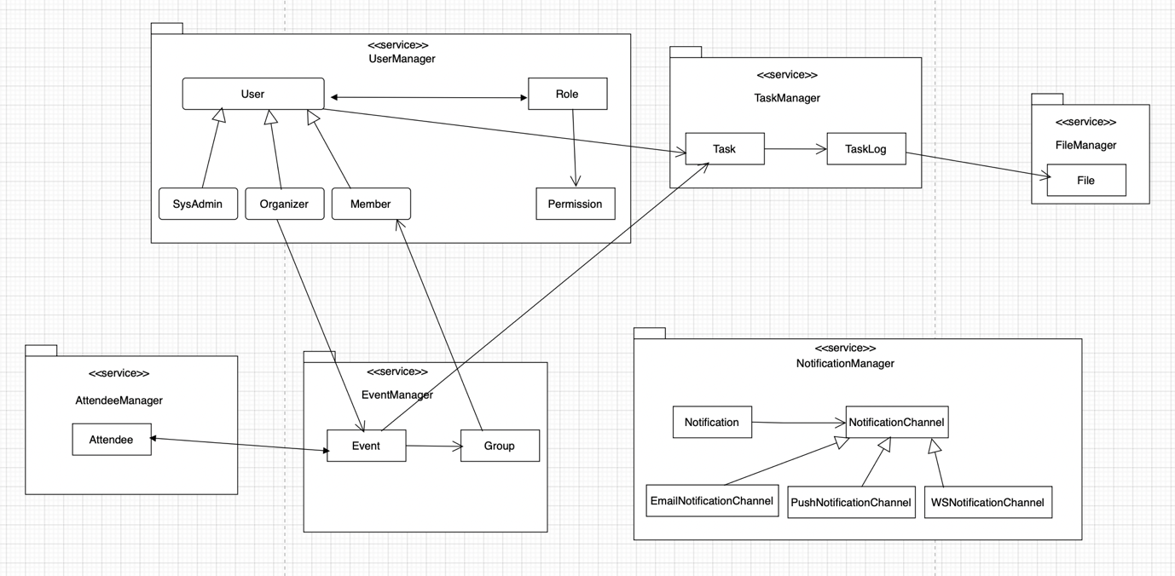

Figure 6. Bounded Context and Domain Entities Diagram
This diagram shows how the domain is carved up into bounded contexts and the key domain entities inside each one. Each box labelled <<service>> is a bounded context / microservice with its own model and persistence; arrows across boxes represent references by ID or contracts, not shared tables or objects.
UserManager is the identity and authorisation bounded context. Its main aggregate root is User, which owns the user’s lifecycle and references exactly one Role. SysAdmin, Organizer, and Member are business-level role types modelled as specialisations of Role. Permission is another entity inside this context and a role aggregates multiple permissions, and permissions can be reused across roles. No other context manipulates roles or permissions directly . They only see user identifiers and role names through API contracts which keeps all authorisation logic cohesive inside UserManager.
EventManager owns the planning side of the product. An Event represents an internal workshop / hackathon etc., while Group captures the team structure within an event (e.g. groups of members or staff). Events and groups reference users coming from UserManager, so the event model stays independent of the user model.
AttendeeManager is a separate bounded context focused on Attendee as its aggregate root. An attendee links a person to a specific event and the relationship to Event from EventManager. This separation allows us to evolve attendee check-in rules, QR codes, and contact information without polluting the core event planning model.
TaskManager governs operational work items within events. Its main aggregate is Task, with TaskLog as a child entity that records status changes, work notes, and cost / effort tracking. Tasks are associated to events and users via IDs, but all task business rules (states, transitions, ownership) are encapsulated within this bounded context. FileManager is a small supporting context where File is the aggregate; tasks and task logs only store file references, and FileManager is responsible for mapping those to actual objects in cloud storage.
Finally, NotificationManager encapsulates cross-channel messaging.It is linked to one or more NotificationChannel entities, which are specialised into EmailNotificationChannel, PushNotificationChannel, and WSNotificationChannel. This keeps channel-specific concerns (template variables, provider IDs, delivery status) inside NotificationManager, while other bounded contexts (TaskManager, EventManager, AttendeeManager) just raise events “send notification X to user Y”.
This overall structure follows DDD by giving each sub-domain its own model, aggregate roots, and clear boundaries, while the relationships between them are expressed through well-defined contracts rather than shared data structures.

Aggregates and Domain Events

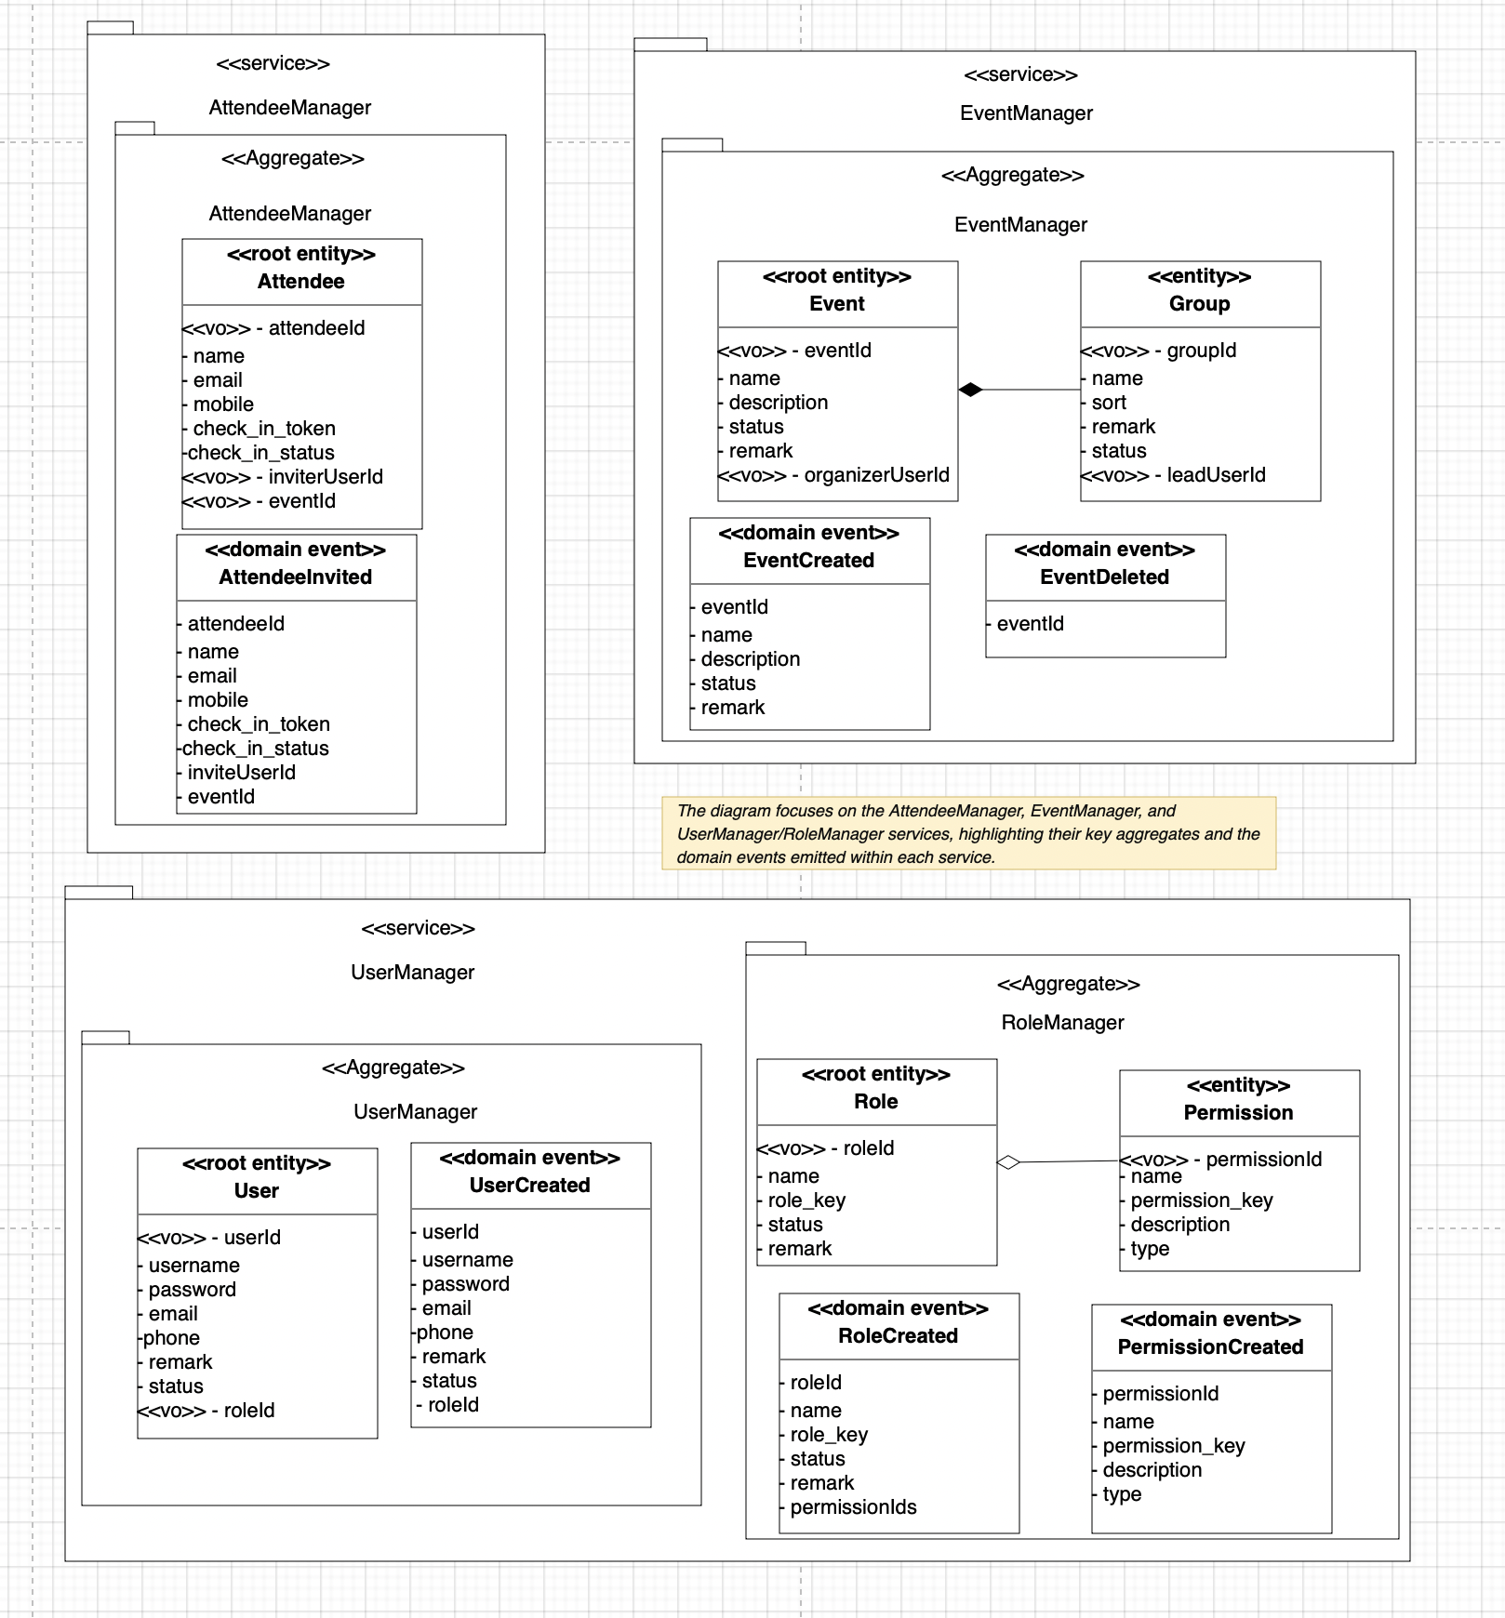
Figure 7. Aggregates and Domain Events
This diagram captures the core aggregates and domain events inside three key bounded contexts: AttendeeManager, EventManager, and Identity & Access Management (UserManager + RoleManager). Each context defines its own aggregate roots and events so that business rules are enforced locally while remaining decoupled from other services.
In the AttendeeManager context, the aggregate root is Attendee. It owns all state relevant to a single invitee: identity (attendeeId, email, mobile), association with an event (eventId, inviterUserId), and check-in lifecycle (check_in_token, check_in_status). The domain event AttendeeInvited is raised when a new attendee is successfully registered. Conceptually, this event represents the “commit” of the invitation and carries just enough data for downstream processes (notification, QR generation, analytics) without exposing internal persistence details.
In the EventManager context, Event is the aggregate root and Group is a child entity within the same aggregate. Event encapsulates high-level properties such as name, description, status, and organiserUserId, while Group models sub-structures like breakout teams or working groups under that event (groupId, name, leadUserId, etc.). Business rules such as “groups cannot exist without an event” or “only active events can create groups” are enforced inside this aggregate. Two domain events, EventCreated and EventDeleted, mark important lifecycle transitions of the event and are later used to coordinate behaviour in other contexts (e.g. cleaning up attendees or tasks).
For Identity & Access Management, the UserManager aggregate root is User, which encapsulates login identity (username, password), contact details, status, and a reference to the user’s assigned role (roleId). The domain event UserCreated is raised when a new user account is provisioned and acts as the canonical trigger for initialising related data in other services. In the RoleManager context, Role is the aggregate root and Permission is a contained entity. A role aggregates a set of permissions (permissionIds) and expresses coarse-grained capabilities such as “Organizer” or “Member”. The domain events RoleCreated and PermissionCreated signal changes to the access model and enable read-side projections or caches to stay in sync with the authoritative role/permission definitions.
Together, these aggregates and events form the backbone of the domain model: each bounded context owns its data and invariants, expresses meaningful business transitions via domain events, and prepares the ground for asynchronous integration without leaking internal table structures or technical implementation concerns.
How the platform is designed to interact with the producers and consumers.
The platform is designed so that every bounded context can play both producer and consumer roles, using a mix of synchronous RPC and asynchronous messaging, while keeping strict aggregate boundaries. For synchronous interactions, services call each other via RPC (e.g. HTTP/2 / Dubbo-style contracts). Typical examples are the AttendeeManager querying EventManager to verify that an event exists and is still open for registration, or TaskManager querying UserManager for basic user details. These calls always use IDs only (eventId, userId, roleId) rather than passing rich domain objects across service boundaries, so each context remains the sole owner of its aggregates and invariants.
For asynchronous interactions, the same aggregates emit domain events (AttendeeInvited, UserCreated, etc.), which are transformed into integration messages and published to a message broker . In this model, the service that owns the aggregate acts as the producer, and other services subscribe as consumers: for example, NotificationManager consumes AttendeeInvited and UserCreated to send multi-channel notifications, and read-model components may consume UserCreated or AttendeeInvited to update authorization caches. Because consumers rebuild their own local projections from messages instead of sharing domain objects, each bounded context can evolve independently while still reacting to changes elsewhere.
Across both sync and async paths, the design enforces the DDD rule that a single transaction only mutates one aggregate at a time. All cross-aggregate or cross-service effects are triggered via IDs and events (plus outbox pattern in the implementation), rather than by holding object references to foreign aggregates.

Physical Architecture & Design

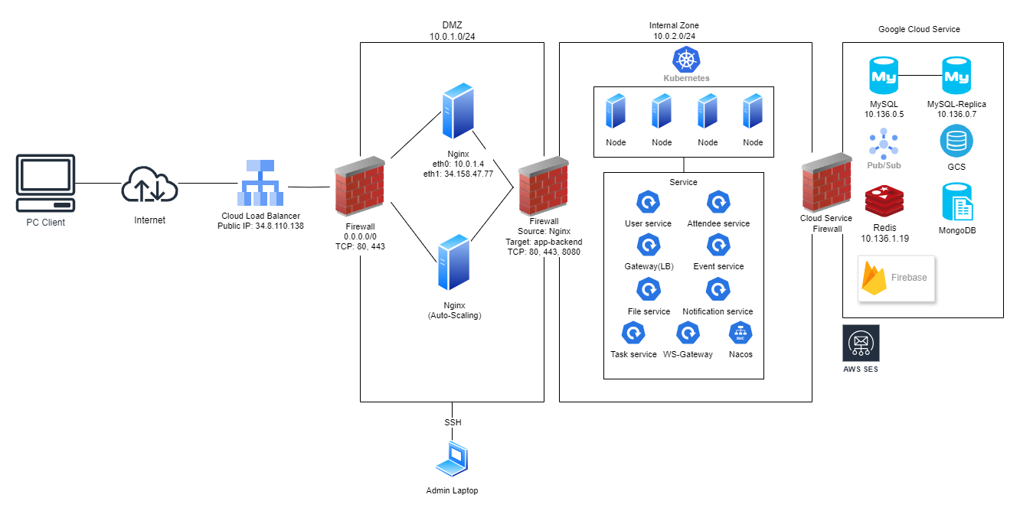
We designed a three-tier network architecture based on Google Cloud Platform, using a custom VPC design that implements network isolation and firewall policies. Our cloud services are all deployed in IaaC mode(Terraform code will be included in attachments). Please check Terraform code for details configuration.

Figure 8. Physical Architecture Diagram

Key Architectural Decisions

The key architectural decisions taken are as follows:
Identifier | Description
AD-07 | Issue  Determine whether the application’s public entry point should:  - Use a Google Cloud Load Balancer (GCLB) directing traffic to a Managed Instance Group (MIG) of Nginx reverse proxy servers  - Use a single Nginx instance directly exposed to the Internet as the primary entry point.  Architectural Decision  Use Google Cloud HTTP(S) Load Balancer as the public entry point, routing traffic to a Regional Managed Instance Group (MIG) of Nginx servers deployed across multiple zones.  Assumptions  - The system must support high concurrency and variable traffic volume.  - High availability (HA) is a key requirement due to production workload.  - Deployment should follow cloud-native practices, including auto-scaling and self-healing.  Alternatives  Alternative A — Use Cloud Load Balancer + Regional MIG (Chosen)  Alternative B — Deploy a Single Nginx Server Exposed Directly  Alternative C — Use Multiple Nginx VMs with DNS Round-Robin  Justification  1. High Availability  - Chosen: GCLB + MIG ensures cross-zone redundancy; if a zone fails, traffic is automatically routed to healthy Nginx nodes.  - Single Nginx: Single point of failure; downtime equals total service interruption.  - DNS RR: No health checks; DNS caching delays failover.  2. Auto-Scaling  - Chosen: MIG auto-scales based on CPU or request load, ensuring elasticity under traffic spikes.  - Single Nginx: Cannot scale horizontally.  - DNS RR: Requires manual instance provisioning.  3. Auto-Healing  - Chosen: MIG automatically recreates unhealthy Nginx instances based on health checks.  - Single Nginx: Requires manual restart/fix.  - DNS RR: No automated instance recovery.  4. Security  - Chosen: Cloud LB provides edge-level TLS termination, DDoS protection, WAF integration, and IP filtering.  - Single Nginx: Must manually implement and maintain all security layers.  - DNS RR: No centralized security policy enforcement.  5. Cost Efficiency  - While Cloud LB adds cost, the benefits — auto-scaling, resilience, reduced maintenance — outweigh the additional expense, especially under production workloads.
AD-08 | Issue  Determine where to host critical data and middleware components (MySQL, Pub/Sub, Redis, MongoDB, etc.):  - Self-manage each component on VMs (user-managed MySQL on Compute Engine VMs, Redis on VMs, run a self-hosted message broker, self-hosted MongoDB).  - Use managed cloud services (Cloud SQL for MySQL, Google Pub/Sub, Memorystore for Redis, and a managed MongoDB offering such as MongoDB Atlas or a managed document DB).  Architectural Decision  Use managed cloud services as the primary hosting model for data and middleware: Cloud SQL (MySQL) for relational data, Google Pub/Sub for messaging, Memorystore for Redis caching/session store, and a MongoDB Atlas. Self-managed VMs may be used only for constrained cases where strict operational control or specialized configurations are mandatory.  Assumptions  - The system must be production-grade with strong availability and predictable operational SLAs.  - Workloads may have variable traffic patterns and require elastic scaling.  - Compliance and audit logging are required; encryption at-rest & in-transit is expected.  Alternatives  Alternative A — Use Managed Cloud Services (Chosen)  Alternative B — Self-Managed on VMs  Alternative C — Hybrid Approach  Use managed services for messaging and caching (Pub/Sub, Memorystore) while self-managing the primary database (MySQL/MongoDB) on VMs  Justification  1. Availability & Resilience  - Managed: Cloud providers operate managed services with built-in high availability, automated failover, and multi-AZ replication.  - Self-Managed: Achieving equivalent HA requires significant engineering: clustering, replication, failover automation, monitoring, and runbooks — higher risk of misconfiguration.  2. Scalability  - Managed: Services provide near-instant vertical/horizontal scaling options (Cloud SQL read replicas, Pub/Sub autoscaling, Memorystore scaling) and handle underlying storage growth transparently.  - Self-Managed: Scaling often requires manual instance resizing, sharding, or cluster reconfiguration which can be error-prone and time-consuming.  3. Security & Compliance  - Managed: Built-in encryption at rest/in transit, IAM integration, audit logs simplify compliance. Workload Identity / IAM can be used to grant least privilege.  - Self-Managed: All security controls must be implemented and verified by the team (disk encryption, key management, secure backups), increasing compliance burden.  4. Reliability & Disaster Recovery  - Managed: Automated backups, cross-region replication options, and provider-managed DR simplify recovery processes.  - Self-Managed: DR requires manual design and testing (backup retention, cross-region replication, failover scripts).  5. Performance & Predictability  - Managed: Provider SLAs and sizing guidance give predictable baseline performance.  - Self-Managed: Potential for better-tuned performance for special workloads but requires expertise to achieve and maintain.  6. Cost Considerations  - Managed: Often higher unit cost vs raw VMs, but total cost of ownership (TCO) can be lower when factoring personnel, outage risk, and engineering time.  - Self-Managed: Lower compute costs possible, but increased ops staffing, longer incident MTTR, and maintenance windows can make it more expensive over time.
AD-09 | Issue  Determine which service governance framework should be adopted for microservices communication and service discovery:  - Use Nacos + Dubbo for service registration, discovery, RPC communication, and configuration management.  - Use Istio for service mesh, traffic control, observability, and security via sidecar proxies.  Architectural Decision  Adopt Nacos + Dubbo as the primary service governance and RPC communication framework. Nacos will provide service registration, configuration management, and health checking, while Dubbo will handle high-performance RPC invocation and load balancing between microservices. Istio will not be adopted due to its operational complexity and lack of immediate need for full service-mesh capabilities.  Assumptions  - The system uses Java-based microservices where Dubbo works natively and efficiently.  - Team experience is mainly in Spring Cloud Alibaba / Dubbo stack, not Istio or Envoy.  - Deployment needs to remain simple and cost-efficient.  - The system is not yet large enough to require full mesh-level traffic shaping or zero-trust service-to-service mTLS.  Alternatives  Alternative A — Use Nacos + Dubbo (Chosen)  Alternative B — Use Istio Service Mesh  Justification  - Performance & Latency  - Nacos + Dubbo: Dubbo is a high-performance RPC framework optimized for Java microservices. Direct application-to-application RPC communication avoids sidecar overhead.  - Istio: Adds an Envoy sidecar to every pod, resulting in 20–50ms extra latency in some cases.  - Operational Complexity  - Nacos + Dubbo: Works seamlessly with existing Spring Boot/Spring Cloud Alibaba ecosystem.  - Istio: requires maintaining Pilot, Mixer, Envoy sidecars, certificates, mesh policies. Higher learning curve for developers and platform engineers.  - Team Capability and Development Speed  - Nacos + Dubbo: Team is already familiar with Dubbo, Nacos, and Alibaba ecosystem — faster delivery. Less DevOps burden and simpler CI/CD.  - Istio: Steeper learning curve and risk of misconfiguration

Technology and Services
ChronoFlow’s physical architecture is built primarily on Google Cloud Platform, with selected managed services and observability/tooling components to meet the target quality attributes of performance, availability, security, and operability. The choices below focus on architecturally significant technologies and the trade-offs made when selecting them.
- Network Architecture Design

DMZ Zone
- DMZ serves as the security boundary layer, deploying Nginx reverse proxy servers.
- Firewall rules configured to only expose ports 80 and 443 for external access.
- Frontend configured with Cloud Load Balancer (Public IP: 34.8.110.138) to distribute traffic to different available zones.
Internal Application Zone
- Firewall configured to allow only Nginx from DMZ to access backend applications (ports 80, 443, 8080).
- Kubernetes cluster is deployed here and can have more available zones.
Google Cloud Services Zone
- Connected through cloud provider's private network and IAM (Identity and Access Management) access control.
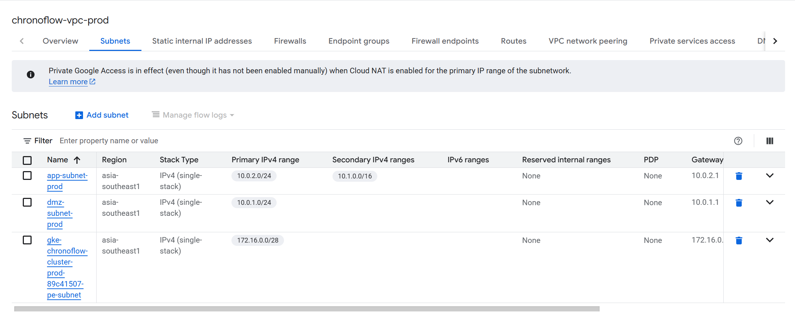
Figure 9 . VPC Subnet
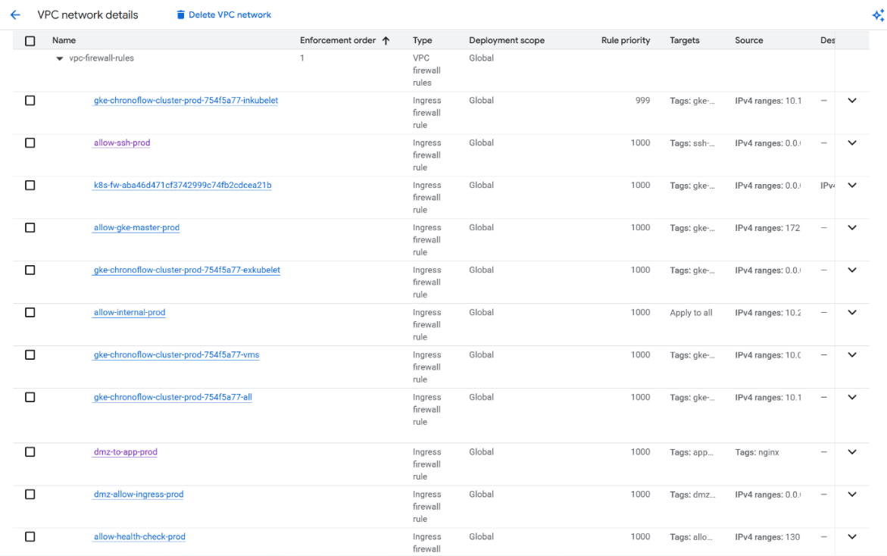
Figure 10. VPC Firewall
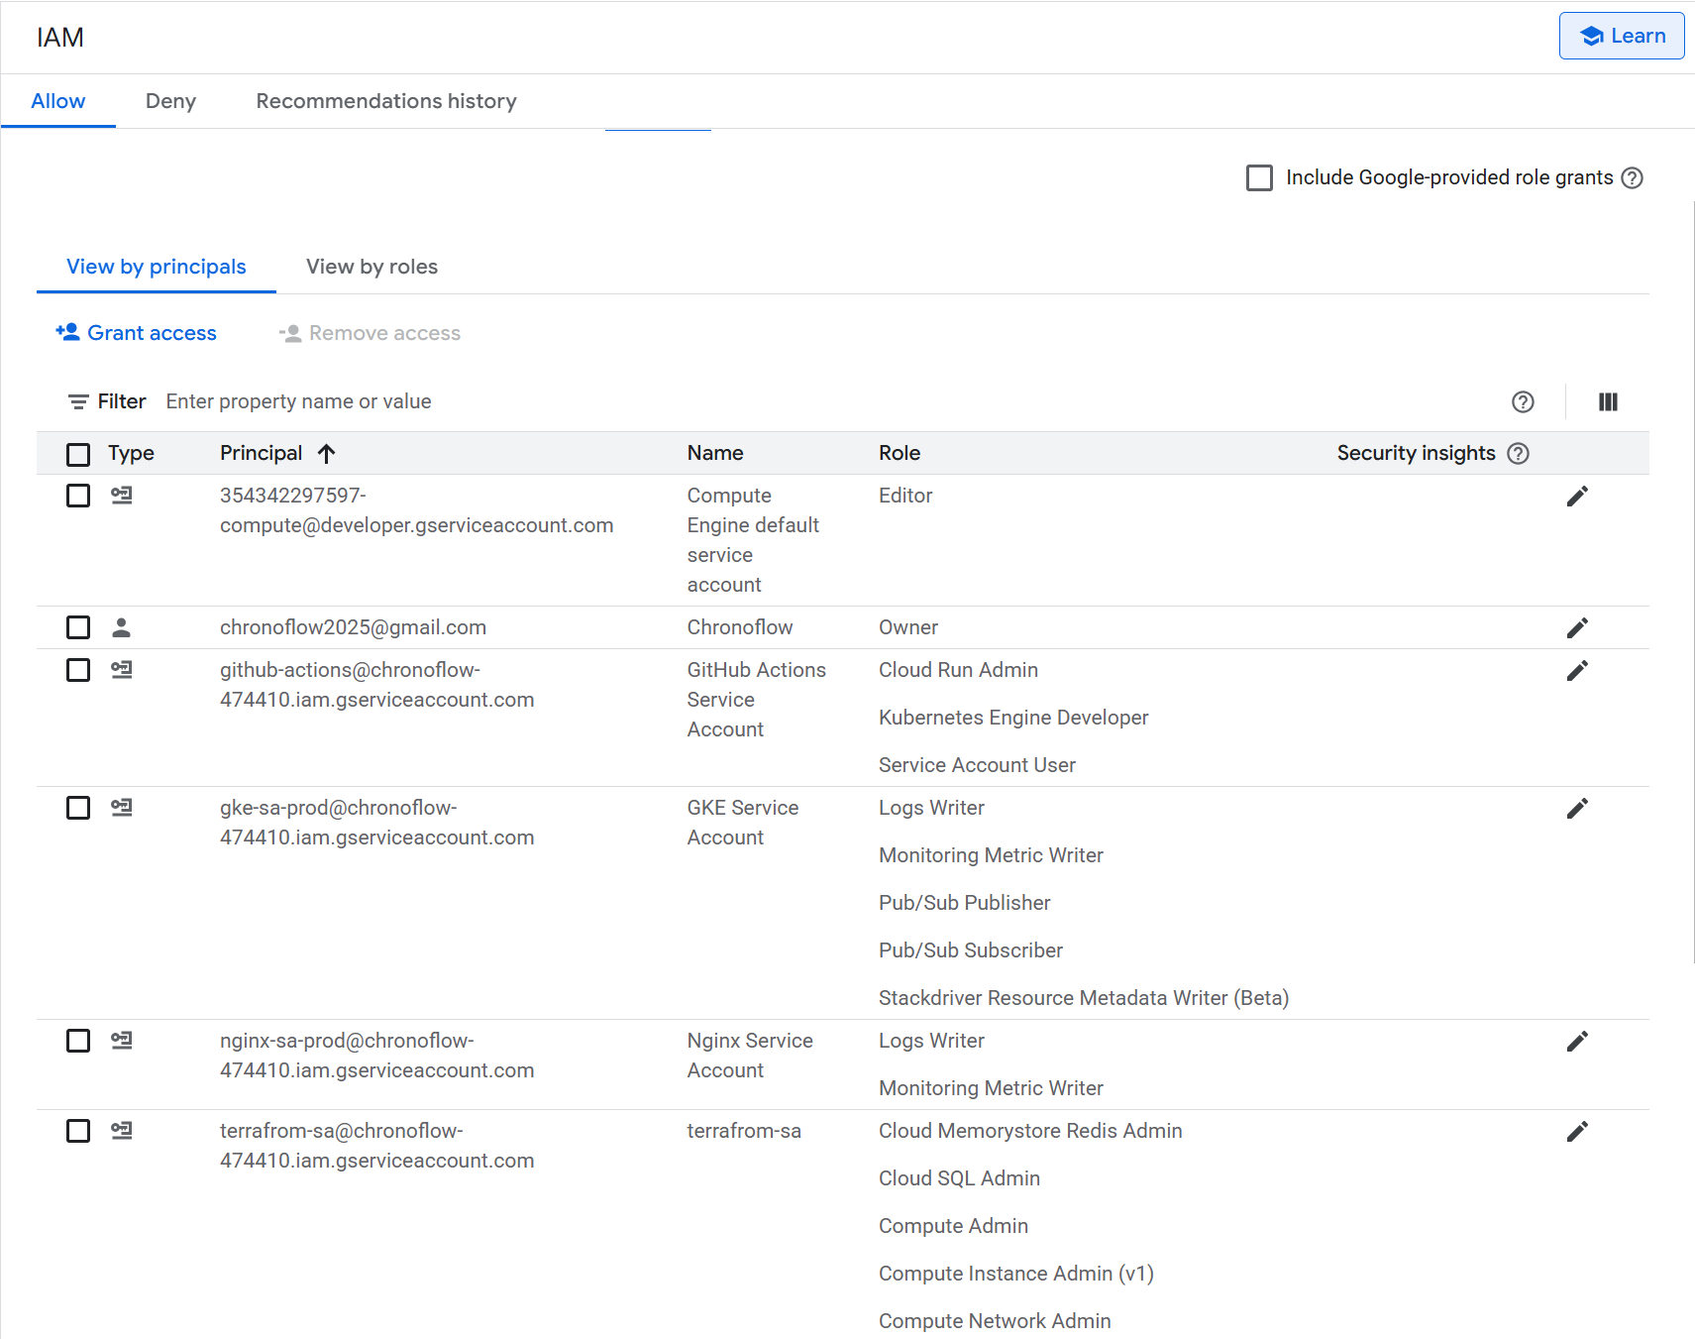
Figure 11. IAM Control

This network architecture follows a classic three-tier zoning approach to enforce defence-in-depth and least-privilege access. The DMZ subnet terminates public traffic at Nginx and the Cloud Load Balancer, while the Internal Application Zone and Google Cloud Services Zone remain fully private, reachable only via controlled firewall rules and IAM-bound service accounts. Separating these zones allows security policies, logging, and monitoring to be tuned differently for edge, application, and data layers. It also supports scalability: the DMZ can scale Nginx independently of the Kubernetes cluster, and managed services such as Cloud SQL, Redis, and Pub/Sub can scale or be upgraded without exposing them directly to the internet. Overall, this layout improves confidentiality, integrity, and availability while keeping the blast radius of any misconfiguration or compromise as small as possible.
The main trade-off of this design is increased complexity compared to a single flat VPC where all components share one subnet and broader firewall rules. Multiple subnets, targeted firewall rules, private service access, and fine-grained IAM roles require more upfront design, ongoing maintenance, and careful coordination when developers or CI pipelines need access. There is also additional cost and configuration effort associated with components like the external load balancer and separate Nginx layer. However, for a cloud-native system that aims to be production-ready, these costs are accepted in exchange for stronger isolation, clearer trust boundaries, and more predictable scaling and operations.
- Cloud Service Components

  - Nginx Instance Group
In the DMZ zone, the Nginx reverse proxy servers are not deployed as standalone virtual machines; instead, they are centrally managed through a Managed Instance Group (MIG). This architecture provides autoscaling, high availability, multi-zone redundancy, and automatic healing, ensuring that the frontend layer remains stable even under high traffic conditions.
The Nginx servers are created using an Instance Template, which predefines all runtime parameters, including:
- Machine type (e2-medium)
- Startup script for automatic Nginx installation and configuration deployment
- Customized Nginx configuration (load distribution, static caching, security headers)
- Firewall rule attachments
- Automatic registration to Cloud Monitoring on startup
The unified template ensures configuration consistency across all Nginx instances, enabling rapid scaling and seamless instance replacement. The Instance Group is configured as a Regional MIG, distributing instances across multiple zones. In the event of a zone failure, incoming traffic is automatically routed to healthy instances in other zones, detected by the Load Balancer’s health checks. No manual intervention or service restart is required.
The MIG also includes an autoscaling policy, dynamically adjusting the number of instances based on workload. When CPU usage exceeds 70%, the group automatically scales out, with a minimum of 1 instance and a maximum of 4 instances. Additionally, health checks and auto-healing are enabled: the system performs health checks every 5 seconds on port 80, and if an instance fails the check, the Load Balancer immediately removes it from the rotation. The MIG then automatically recreates the unhealthy instance to maintain service reliability.
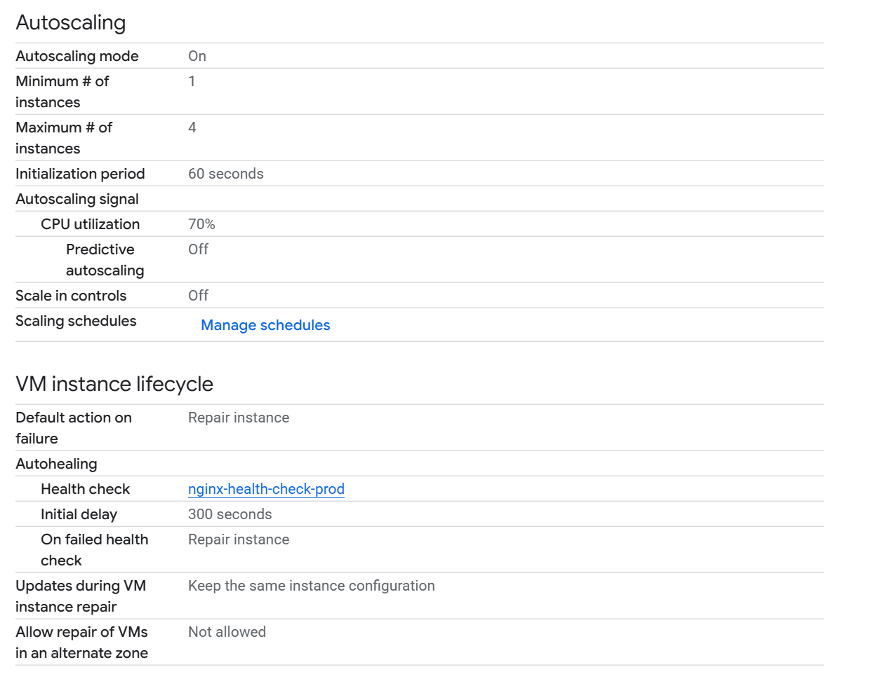
Figure 12. Nginx Configuration

Using a Managed Instance Group for Nginx in the DMZ was chosen to make the edge layer elastic and highly available without manual VM management. The instance template guarantees that every Nginx node starts with the same machine type, startup script, security headers, and monitoring configuration, so scaling out does not introduce configuration drift. A regional MIG, combined with health-checked HTTP(S) load balancing, allows traffic to fail over automatically across zones when one zone or instance becomes unhealthy. Autoscaling on CPU utilisation (target 70%, 1–4 instances) ensures that capacity grows during peak load but shrinks during quiet periods, balancing performance and cost while keeping the frontend responsive.
Compared to a single, manually managed Nginx VM, the MIG approach introduces extra complexity, instance templates, autoscaling policies, health checks, and regional placement all need to be designed, tested, and maintained. It also adds some overhead in terms of boot time and cloud resources, and Nginx configuration changes must be rolled out carefully via template updates or startup scripts rather than quick edits on a single server. However, these costs are accepted because the system gains automatic recovery from instance failure, resilience to zone outages, and predictable horizontal scaling behaviour—capabilities that are hard to achieve reliably with standalone VMs.
  - GKE
Our cluster is deployed as a GKE Standard Cluster (non-Autopilot), allowing complete control over node machine types, disk configuration, autoscaling behaviour, and network properties. The cluster is deployed in a single zone for now due to resource constraints, but the design supports future expansion to multi-zone or regional deployments. The cluster removes the default node pool and creates a custom node pool to ensure strict control over capacity and machine specifications.

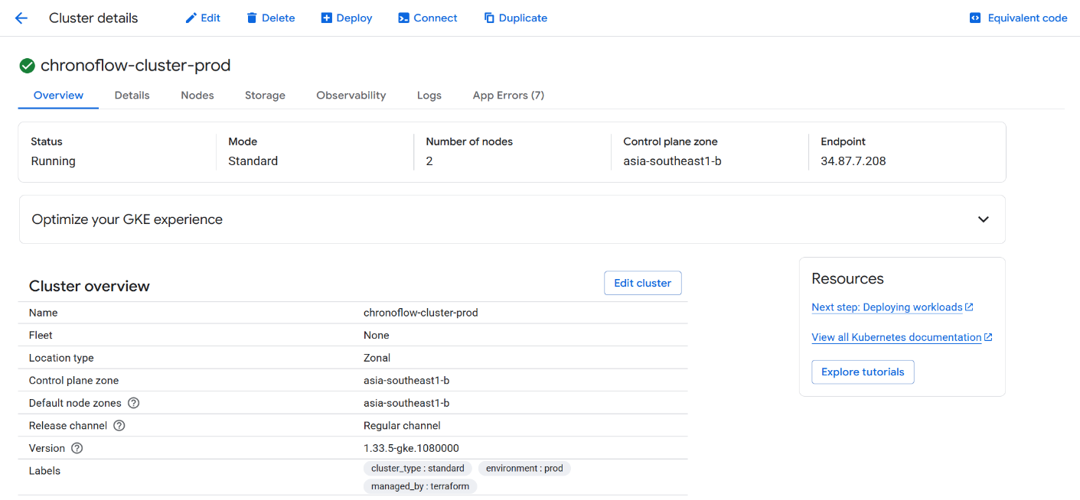
Figure 13. Cluster Details
The cluster runs inside a custom VPC, using a dedicated application subnet. It adopts VPC-native (IP aliasing) networking, which assigns isolated secondary ranges for: Pods and Services to prevent IP conflicts, improves routing efficiency, and supports large-scale microservice deployments. 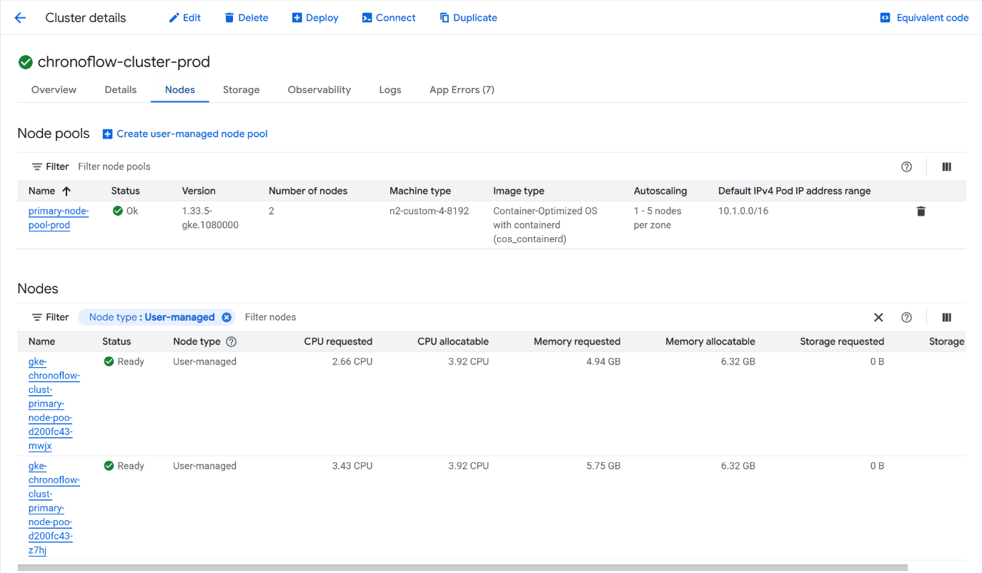
Figure 14. Cluster Node Pool
We managed sensitive key in K8S Secrets and use them as environment variables. For non-sensitive properties, we storage them in Config Map. 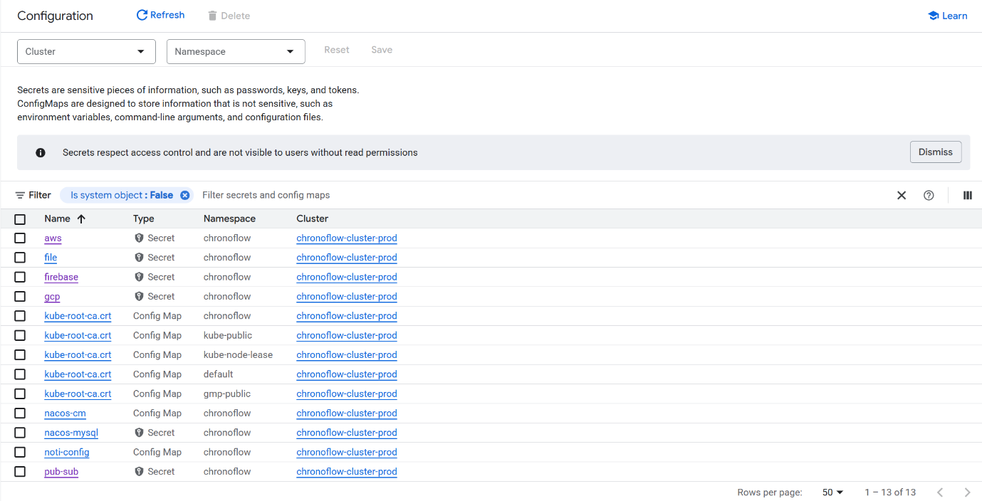
Figure 15. Cluster Secret & Config Map
We uses HPA to automatically scale pods based on CPU utilization, PDB to ensure minimal service disruption during maintenance or upgrades, Liveness and Readiness probes to monitor container health and restart unhealthy instances automatically, and Namespaces to isolate different environments and enforce clear security and resource boundaries.
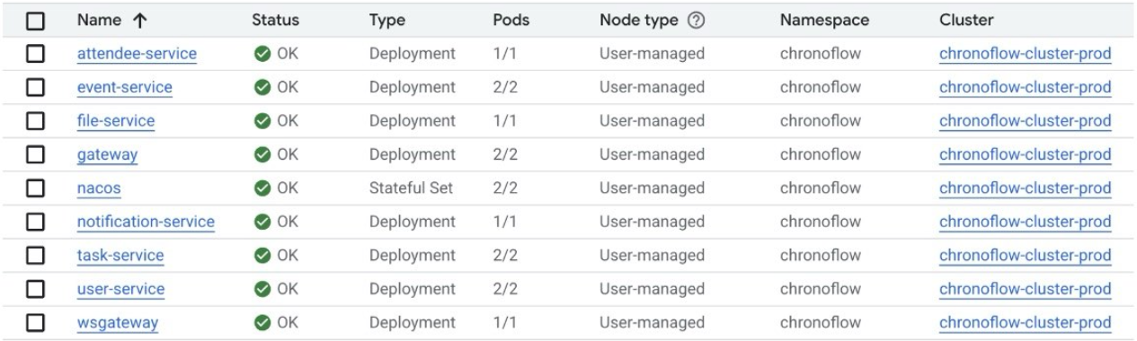
Figure 16. Cluster Workload
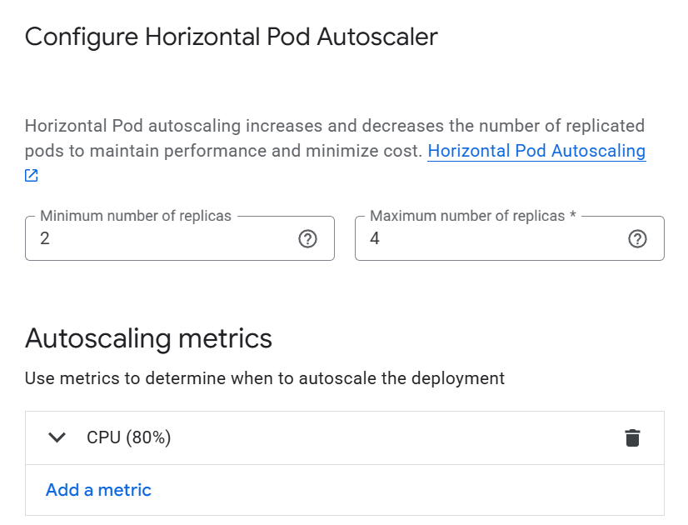
Figure 17. HPA

GKE Standard is selected to give fine-grained control over node types, capacity and network configuration, which is important for a microservice-based system that needs to tune resource limits per workload instead of relying on opaque autoscaling. Removing the default node pool and creating a custom one ensures that only explicitly managed nodes are used, simplifying capacity planning and cost tracking. Running the cluster inside a custom VPC with VPC-native (IP alias) networking provides dedicated address ranges for Pods and Services, avoiding IP exhaustion and routing conflicts as the number of services grows. Using Kubernetes Secrets for sensitive keys and ConfigMaps for non-sensitive properties follows 12-factor configuration principles and keeps credentials out of images. Platform features such as HPA, PDBs, liveness/readiness probes, and namespaces are used to align the platform with key quality attributes: HPA for elastic scalability, PDBs and probes for high availability and graceful rollouts, and namespaces for isolation and clearer security boundaries.
Compared to GKE Autopilot or a fully serverless platform (e.g. Cloud Run), this approach requires more operational effort: the team must manage node pool sizing, autoscaling thresholds, OS images, cluster upgrades, and capacity reservations. VPC-native networking and multiple configuration objects (Secrets, ConfigMaps, HPAs, PDBs) increase the complexity of troubleshooting and require stricter governance to avoid misconfiguration. The current single-zone deployment also means that a zonal outage would still impact the cluster, even though the design can be extended to regional clusters later. Nevertheless, these trade-offs are accepted in order to gain predictable performance, tighter cost control, and a platform that can evolve with more advanced multi-zone or multi-cluster strategies as ChronoFlow grows.

  - Cloud SQL
We use Cloud SQL (MySQL) as relational DB in Master-Slave pattern.
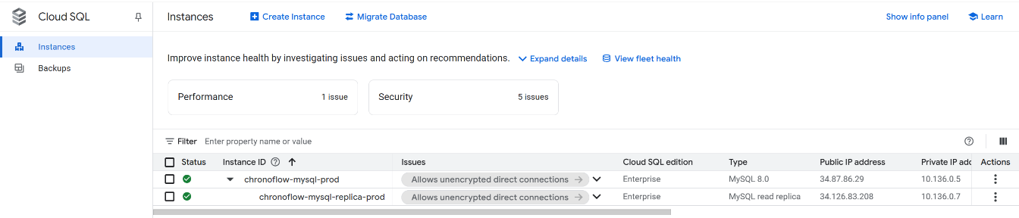
Figure 18. Cloud SQL Dashboard
The primary instance handles all writes and critical transactional reads, while the read replica serves non-critical or reporting queries, reducing load on the primary. Both instances are deployed with private IPs inside the VPC, so all access is through the Internal Application Zone using service accounts and IAM-controlled connections. Cloud SQL also provides automated backups, minor-version upgrades, point-in-time recovery and built-in monitoring, which simplifies operational management for the ChronoFlow microservices.
The main trade-offs of this choice are cost and flexibility. Cloud SQL is more expensive than running MySQL on self-managed VMs, and certain low-level configurations (OS tuning, custom plugins) are restricted by the managed service. The master–replica setup also introduces eventual consistency on the read replica, so the application must tolerate slightly stale data for read-heavy flows. In addition, relying on a cloud-native database service increases provider lock-in, making migration to another cloud or on-premises environment more involved.
  - Pub/Sub
We use Google Pub/Sub as the managed message queue for ChronoFlow’s event-driven flows. Application services (e.g. task-service, attendee-service) publish notification events to a dedicated topic, and the notification-service subscribes to this topic to consume and process messages asynchronously. Pub/Sub provides durable storage, at-least-once delivery, and automatic retry with backoff, so transient failures in the notification-service do not cause data loss. We explicitly manage acknowledgements for successfully delivered notifications and send failures to a dead-letter path for inspection. To keep producers simple and ensure idempotency on the consumer side, we pair Pub/Sub with an outbox pattern in the producer services, so outgoing events are first stored transactionally in the database and then dispatched, avoiding lost or duplicated messages when failures occur around commit time.
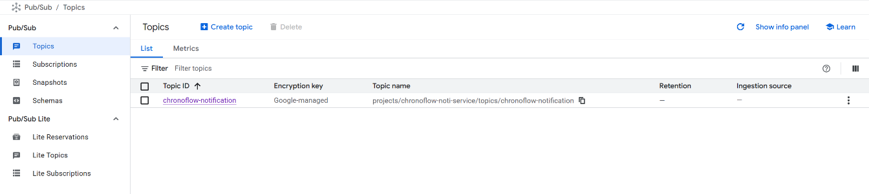
Figure 19. Pub/Sub Topic
Compared to running our own RabbitMQ or Kafka cluster, Pub/Sub trades some control for a highly managed, auto-scaling service. We do not need to operate brokers, partitions, or storage volumes, and Pub/Sub’s serverless model can absorb traffic spikes without pre-provisioning capacity.
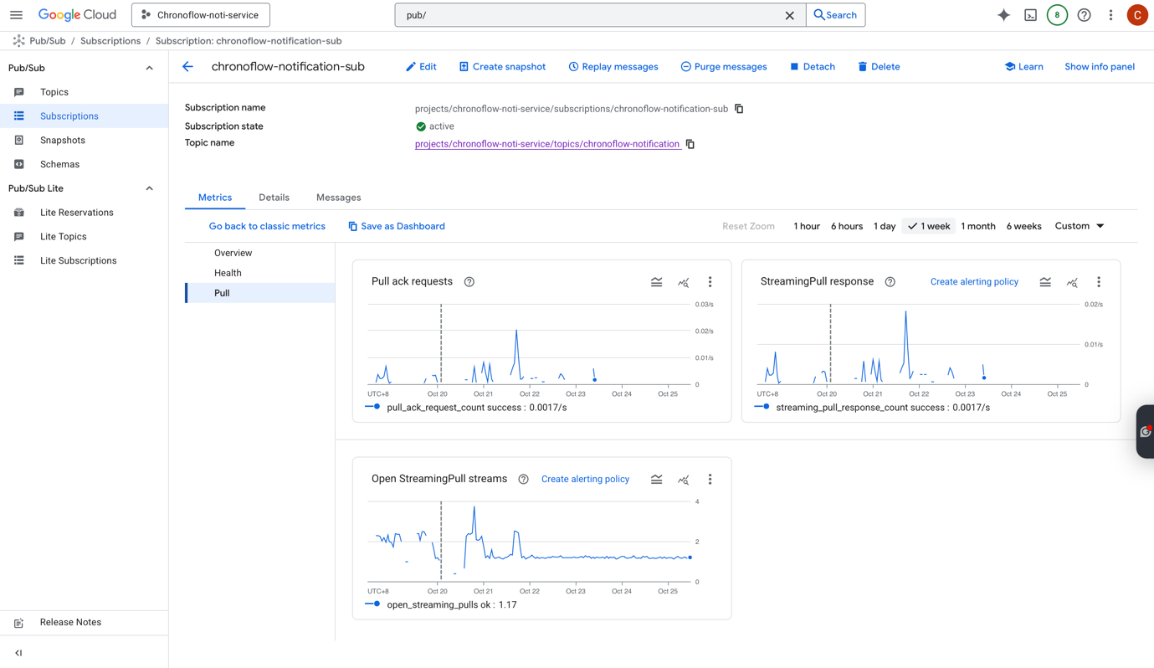
Figure 20. Pub/Sub Dashboard
However, this also means we give up fine-grained control over message ordering, partitioning, and protocol features that systems like Kafka or RabbitMQ provide. Pub/Sub’s retention window and delivery semantics are tuned for cloud workloads rather than long-term event streaming analytics, and its GCP-specific APIs create stronger vendor lock-in than protocol-standard tools like Kafka. These trade-offs are acceptable for ChronoFlow, where we prioritise low operational overhead, reliable asynchronous delivery, and simple scaling over advanced broker customisation.

  - GCS
We use Google Cloud Storage (GCS) to store files attached to tasks, and also to host Nginx startup scripts, log archives, and frontend static assets. Using GCS keeps all storage within the same cloud as the rest of our infrastructure, reducing integration complexity and latency compared to introducing a separate storage provider. For user-facing files, we expose them through time-limited signed URLs so that objects are only publicly accessible for 15 minutes, balancing usability with access control. This allows our services to delegate file download to GCS while keeping application nodes stateless and simplifying backup and lifecycle management via bucket policies.
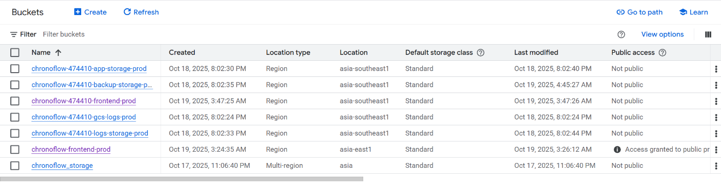
Figure 21. GCS Dashboard
However, managing signed URLs and bucket policies introduces configuration overhead and requires careful security review to avoid accidentally over-exposing objects.
  - Memorystore (Redis)
We use Memorystore (Redis) as a high-performance in-memory cache for data that requires low-latency access. It is mainly used to cache user session tokens and authorization metadata at the Spring Gateway, so most authentication and authorization checks can be served directly from Redis instead of repeatedly querying Cloud SQL. We also use it as a central rate limiter store, allowing the gateway and other services to share request counters and enforce throttling consistently across instances. This reduces response time for protected APIs and offloads repetitive lookups from the relational database, improving both throughput and user experience.

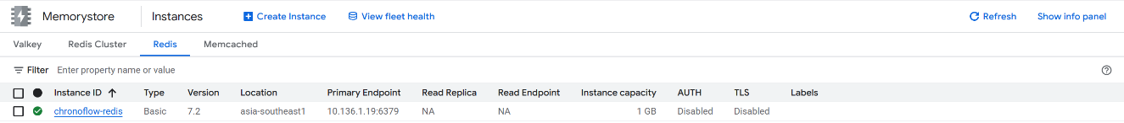
Figure 22. Memorystore Dashboard
The trade-offs of using Memorystore are additional cost and operational complexity compared to keeping all state in the application or database layer. Because Redis is an in-memory cache, data is volatile and must be treated as non-authoritative; the system must tolerate cache misses or evictions and always have a fallback path to Cloud SQL. The basic tier instance is also single-zone, so it does not provide the same cross-zone resilience as some other managed services. Finally, relying on a cloud-managed Redis service introduces provider lock-in and requires careful configuration of network access and credentials, but these trade-offs are acceptable given the performance benefits for authentication and rate limiting.
  - MongoDB
We use MongoDB Atlas to store semi-structured, document-based data, primarily notification logs. The cluster is deployed as a three-node replica set on GCP (asia-southeast1), managed entirely by Atlas. Notification-service writes one document per notification event, capturing channel, payload, status, and metadata such as last-seen and clicked timestamps. For the WebSocket channel, we integrate Reactive MongoDB with Spring WebFlux so that reading and writing notification documents is non-blocking.This works well with asynchronous events coming from Google Pub/Sub and real-time delivery to the frontend over WebSocket. Instead of discarding messages once they are pushed, we persist them in MongoDB to support UX features such as showing unread counts, differentiating seen vs clicked notifications via UI colors, and reconstructing a user’s recent activity history.
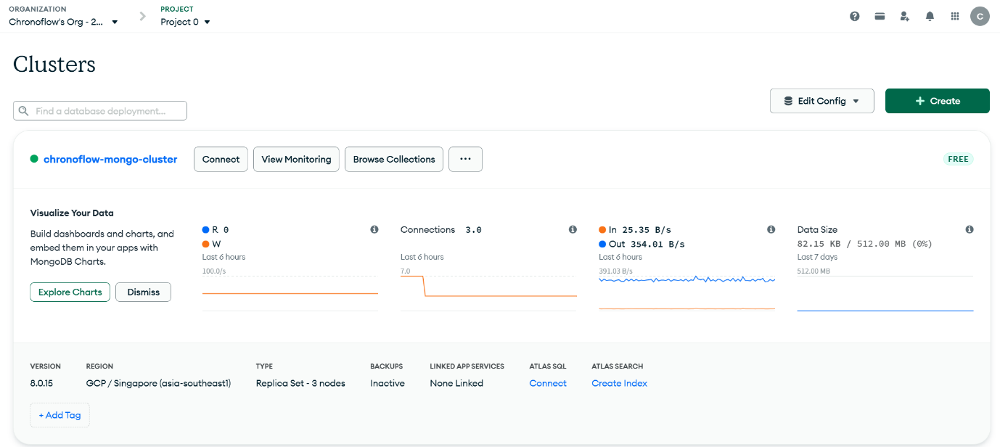
Figure 23. MongoDB Dashboard

The main trade-offs come from introducing a second persistence technology alongside Cloud SQL. While MongoDB’s flexible schema and document model are a natural fit for evolving notification payloads, it increases operational and conceptual complexity. Developers must understand two query languages, two transaction models, and two sets of backup/monitoring tools. Even though Atlas handles replication and failover, it is an additional managed service to configure, secure, and pay for. Consistency guarantees also differ since notification state in MongoDB may briefly lag behind related transactional updates in Cloud SQL, so the system must tolerate eventual consistency between the two stores. We accept these trade-offs because they keep the relational database focused on core transactional data, while MongoDB provides a scalable, non-blocking store optimised for high-volume, user-facing notification history.

  - Firebase
We use Firebase Cloud Messaging (FCM) to push real-time notifications to users’ browsers, mainly for new tasks, reminders, and status updates. Once the user grants notification permission in the browser, a Firebase service worker registers and maintains a device token that our notification service can target. This lets us deliver updates even when the user is not actively viewing the ChronoFlow tab, while the browser-side Firebase SDK handles token refresh, background delivery, and integration with the native notification UI.
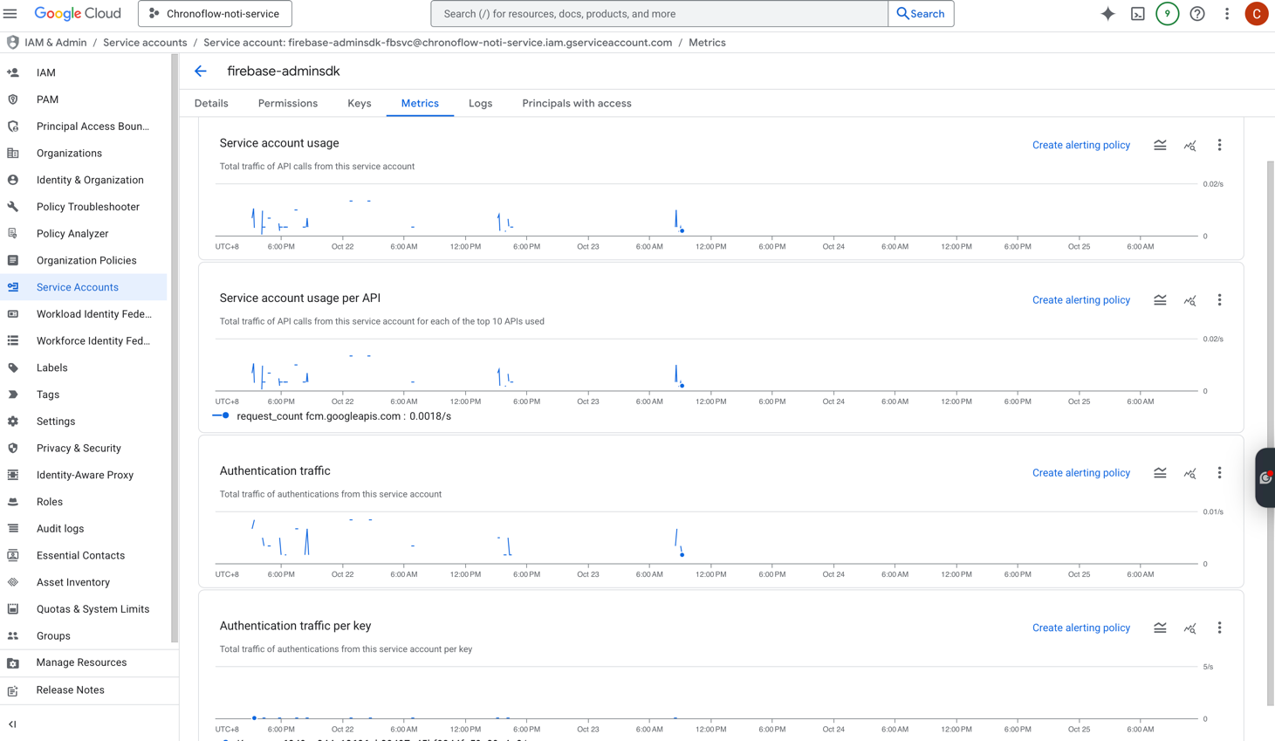

Figure 24. Firebase Dashboard
The trade-offs of using Firebase include an additional external dependency and tighter coupling to Google’s push ecosystem. While FCM greatly simplifies browser push compared to building and managing our own Web Push infrastructure, it introduces another set of credentials, service accounts, and quotas to manage. It is also oriented around Google’s tooling and may require extra adaptation if we later want to support non-web clients or migrate away from Google services. Furthermore, because delivery is best-effort and depends on browser and OS behaviour, we cannot rely on FCM alone for critical guarantees and must still persist notifications in our backend store. These trade-offs are acceptable for ChronoFlow, where the priority is low-friction, real-time user engagement with minimal operational overhead.

  - AWS SES
We use AWS Simple Email Service (SES) as the email delivery channel for the application, integrated with our own custom email domain. SES handles the heavy lifting of SMTP delivery, reputation management, and scaling, so our notification-service only has to construct messages and call the SES API. The SES console and CloudWatch metrics give us visibility into sends, bounces, and complaints, which helps us monitor deliverability and detect configuration or content issues early. We also leverage SES Email Templates to store reusable layouts for different business events and render them on the fly at send time.
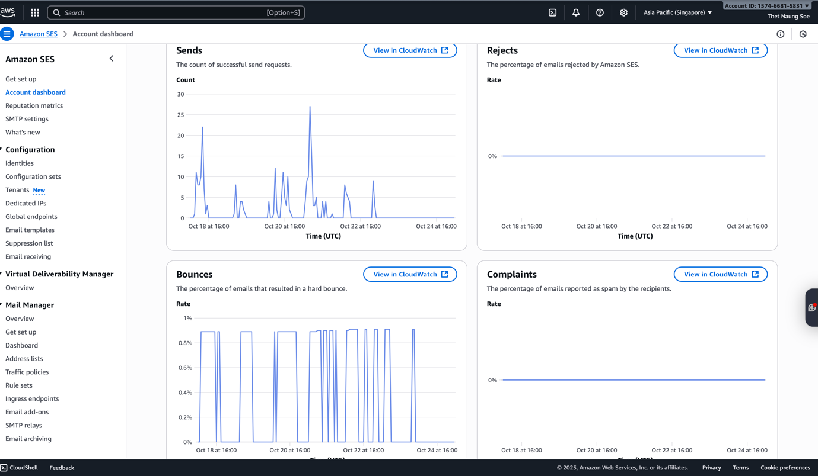
Figure 24. AWS SES Dashboard
The main trade-offs are around feature richness and ecosystem complexity. SES is highly reliable and cost-effective, but it is optimised for programmatic sending rather than rich, marketing-style templates; building visually complex, localised templates typically requires an external template engine or additional tooling in our codebase. Using SES alongside GCP services also introduces multi-cloud complexity (separate IAM, credentials, and monitoring stacks), though it gives us flexibility to pick a best-of-breed email service. Overall, we accept these trade-offs because SES provides stable, scalable email delivery with good observability at a relatively low operational cost.
- Service Governance and Observability Components
  - Nacos – Service Registry & Configuration Management
We use Nacos as the central service registry and configuration center within the microservices architecture.
- Provides real-time service registration and discovery for all backend services.
- Supports automatic health checks to ensure only healthy instances receive traffic.
- Manages dynamic configuration for microservices, allowing runtime updates without redeployment.
- Ensures consistency between environments by storing application configuration centrally.
  - Dubbo – High-Performance RPC Framework
We use Dubbo as the RPC communication framework between microservices.
- Provides high-performance, low-latency request handling suitable for synchronous business flows.
- Supports multiple load-balancing strategies. We use round-robin.
- Integrates directly with Nacos for service discovery.
- Offers built-in timeout control, retry mechanisms, and connection pooling.
  - Sentinel – Traffic Protection & Runtime Stability
We use Sentinel as runtime protection and flow control to maintain system stability under high traffic or anomalous workloads. The details of configuration can be found in attachment.
- Rate limiting to prevent excessive QPS from overwhelming backend services.
- Circuit breaking to isolate failures and avoid cascading service outages.
- Concurrency control to ensure fair resource allocation.
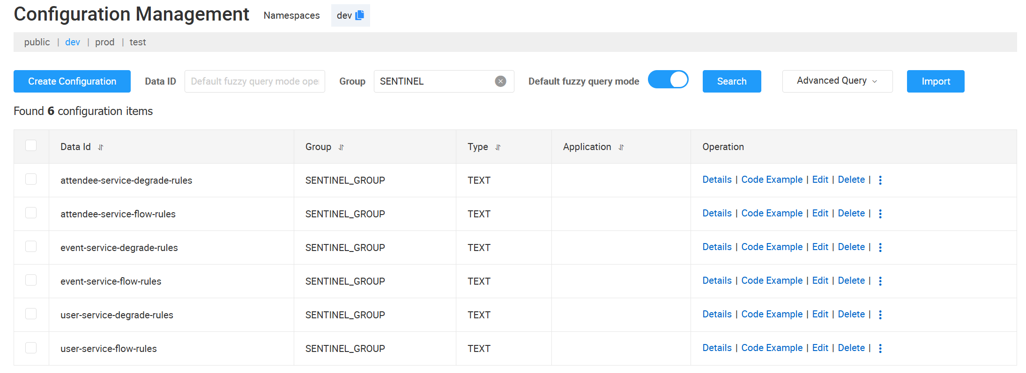
Figure 25. Sentinel Configuration
  - Zipkin – Distributed Tracing
We use Zipkin as the distributed tracing system to visualize and analyze end-to-end request flows across microservices.
- Captures latency information for each service call.
- Helps identify slow components, bottlenecks, and long-tail latency issues.
- Integrates with Spring Cloud Alibaba and Dubbo for automatic span generation.
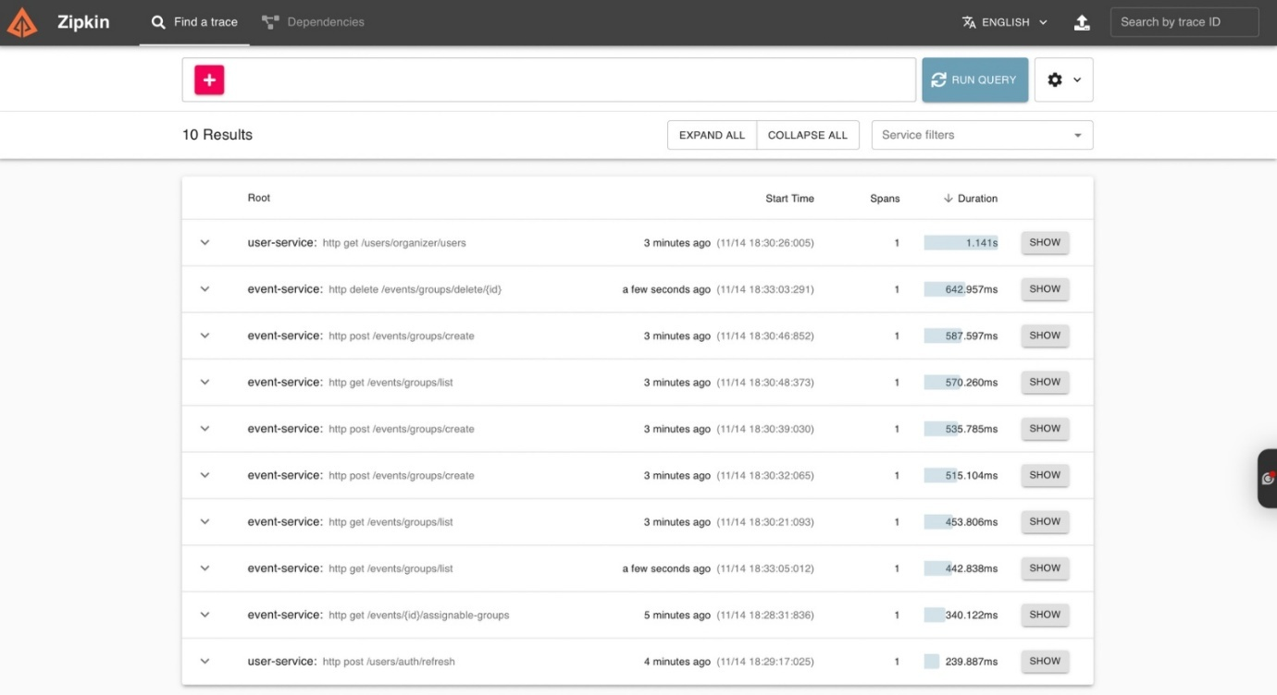
Figure 26. Zipkin Dashboard

Choosing Nacos, Dubbo, Sentinel, and Zipkin as the core components of the microservice governance stack is driven by the system’s need for high-performance communication, dynamic service management, runtime protection, and end-to-end observability. These four components are highly compatible within the Java ecosystem, and when integrated, they form a lightweight yet comprehensive governance solution. The stack fits naturally into a Java-centric environment, offers fast implementation, and keeps operational costs low, making it a mainstream choice for many production-grade enterprise systems.
However, adopting this SDK-based governance model also introduces certain coupling and operational overhead. Unlike service-mesh solutions such as Istio that provide a “sidecar-based, non-intrusive” model, Dubbo, Sentinel, and Zipkin require application-level integration, meaning governance capabilities are partially tied to business code, and they consume additional JVM resources at runtime. This approach also has limited multi-language support, making it more suitable for organizations where Java is the dominant technology stack. For large-scale or multi-cluster deployments, Nacos requires careful handling of metadata storage, rule synchronization, and service instance consistency. Zipkin, as a distributed tracing system, may impose additional storage and backend processing costs under high call volume or higher sampling ratios. Overall, this stack trades off some language neutrality and full decoupling in exchange for higher performance, greater flexibility and control, easier debugging, and significantly lower operational complexity compared to a service mesh—making it a highly cost-effective choice for performance-sensitive, Java-centric microservice architectures.

Persistence Design
In ChronoFlow, business data is managed primarily in a relational MySQL database (Cloud SQL), modelled using normalized tables for tenants, users, roles, events, tasks, attendees and file metadata. Related records that belong to the same business operation (for example, creating an event together with its initial tasks or assigning attendees) are updated inside a single database transaction. At the application layer we use transactional boundaries to ensure that either all changes for that operation are committed, or none are, so the relational model remains consistent after each request.
For concurrency and asynchronous processing, especially in the notification flow, we use a MySQL-based outbox pattern together with Google Pub/Sub. Notification events are first written to an outbox table in Cloud SQL and then published to Pub/Sub from there. This allows us to achieve at-least-once delivery while still being able to detect and ignore duplicates on the consumer side (idempotency using recipient keys and message identifiers). Delivery status is also tracked in the database, and these records are kept without a fixed expiry so that operational teams can audit notification behaviour over time.
Different storage technologies are used for different persistence horizons. Long-lived, authoritative data (tenants, users, events, tasks, attendees, file metadata, notification outbox records) is stored in Cloud SQL with no predetermined end date, as it may be needed for reporting and audit. Session-scoped state such as login tokens and frequently accessed user profile attributes is cached in Redis (Memorystore). This data is ephemeral and can be reconstructed from the relational store if needed. For user-facing notification history, we use MongoDB with a TTL of 90 days, so notification documents are automatically removed after three months. This keeps recent activity available to the user while preventing unbounded growth of the log store.

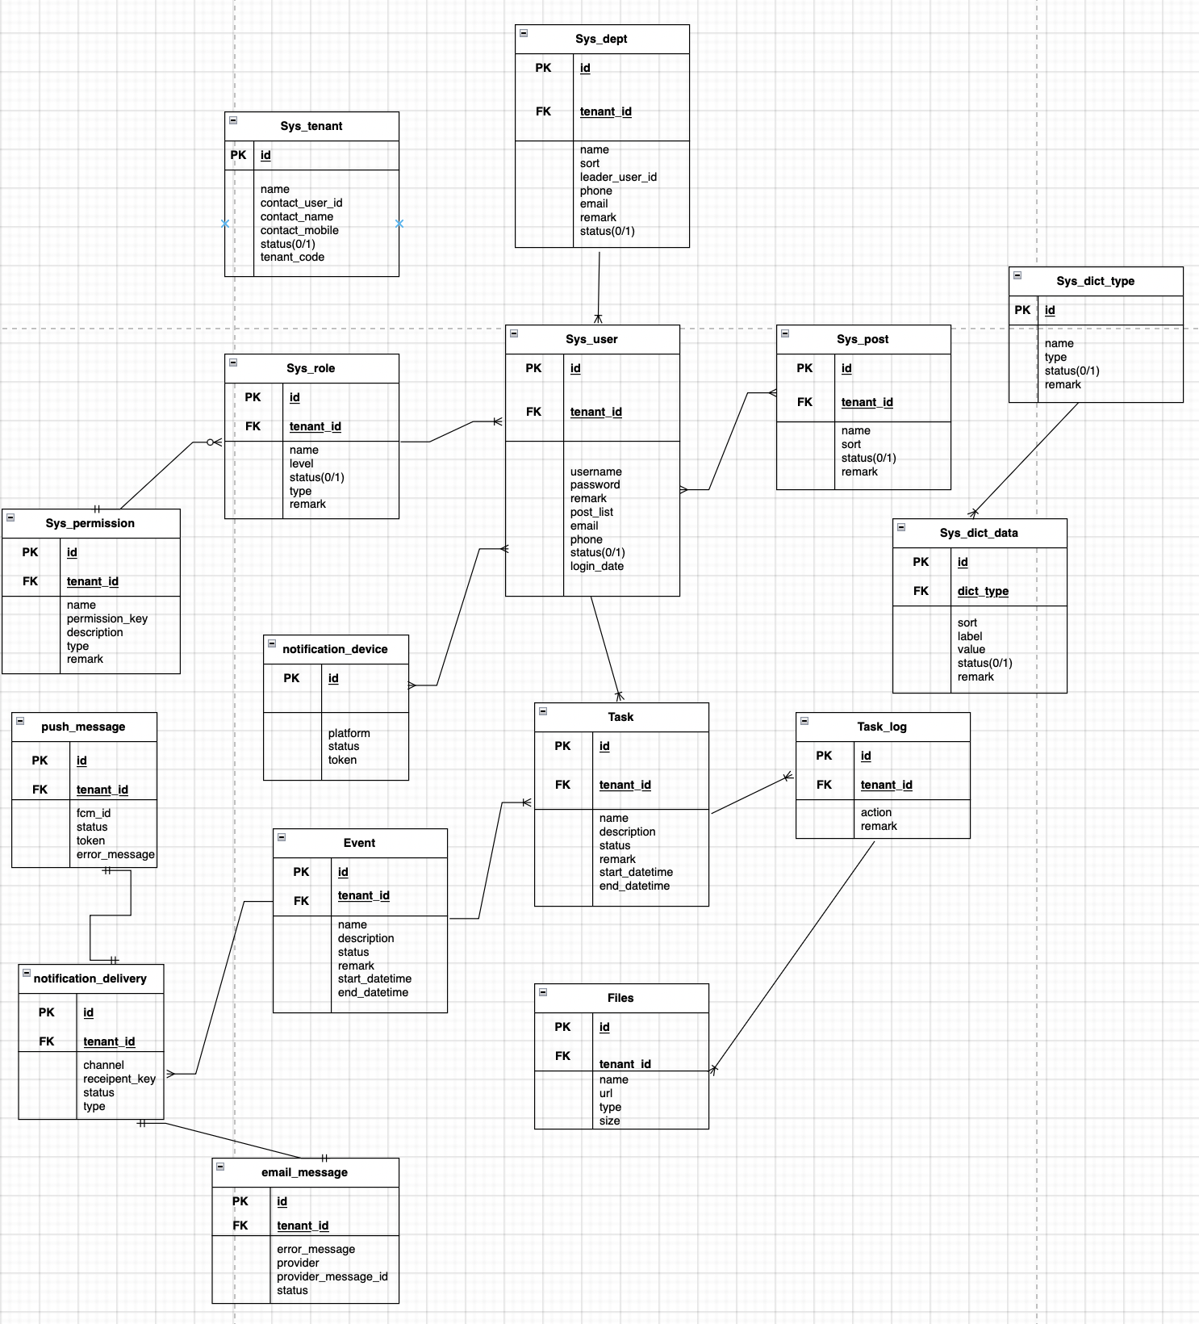
Figure 27. Logical data model

Information architecture of the solutions

(1) Core business / transactional data
Data format:
This group covers tenants, users, roles, events, tasks, attendees and file metadata. The data is highly structured and relational, so it is stored as records in relational tables with well-defined columns, primary keys and foreign keys (e.g. event_id, task_id, tenant_id). Each row represents a single business entity instance, and relationships (1-N, M-N) are captured through foreign-key columns in the usual RDBMS style.
Proposed storage technology:
Cloud SQL MySQL (RDBMS). MySQL is a good fit because the core domain has strong relational requirements (multi-table joins, constraints and reporting queries) and needs ACID transactions to keep aggregates consistent (e.g. event + tasks + attendees). Using Cloud SQL gives us a fully managed MySQL instance with automated backups, replication and monitoring, so the team can focus on schema design and application logic instead of database operations.
Security requirements and controls:
This data group contains sensitive information such as user credentials and contact details, so we enforce strong confidentiality and integrity. Database access is restricted to the internal VPC via private IP and service accounts following least-privilege IAM roles. All connections use TLS, and data at rest is encrypted using the cloud provider’s managed keys. Passwords are never stored in plain text; they are stored as salted, one-way hashes. Application-level access control further ensures that tenants can only see their own records (tenant scoping on every query).
Trade-off consideration:
Choosing MySQL gives us mature transactional guarantees and rich SQL support, but it also introduces schema rigidity, changes to tables require migrations and coordination across services. Scaling is primarily vertical or via read replicas; horizontal sharding is possible but more complex than with some NoSQL stores. Compared to a schemaless document database, we trade flexibility for strong consistency and simpler reporting, which is acceptable for ChronoFlow’s core business data where correctness and integrity are more important than extreme write flexibility.
(2) Session and application state cache
Data format:
This group contains short-lived state, such as authenticated user profiles, session tokens and rate-limit counters. It is stored as key–value pairs, where the key encodes the user or session identifier and the value holds a small JSON/string blob or numeric counter. The data is optimised for very fast lookups and is treated as ephemeral; it can be recomputed from the core business data if needed.

Proposed storage technology:
Google Memorystore for Redis (managed key–value / in-memory cache). Redis is designed for low-latency key–value access, supports TTL on keys, and integrates well with Spring for storing session data and counters. Using a managed Redis service offloads node management and failover, while allowing us to scale the cache independently from the application pods.
Security requirements and controls:
Although the data is less sensitive than core transactional data, it still contains identifiers and tokens, so access is restricted to the internal VPC. The Redis instance is created without public IP, and only application pods with the correct network and IAM/service account permissions can connect. TLS in transit is enabled where supported, and session tokens are signed and validated at the application layer so that compromise of the cache alone cannot forge identities. Keys are configured with appropriate TTLs so cached state expires automatically.
Trade-off consideration:
Using Redis provides excellent performance and simplifies stateless application design, but the data is not durable—a cache failure or eviction can drop entries. The system must therefore be able to fall back to MySQL (or force re-authentication) when cache misses occur. Compared to keeping all state purely in the database, we introduce an additional infrastructure component to manage, but we significantly reduce database load and improve response times for authenticated operations, which is important for user experience.
(3) Notification history and real-time messaging data
Data format:
This group stores semi-structured notification documents per user and per message. Each record is a JSON-like document containing fields such as channel, payload, timestamps (created, seen, clicked) and status flags. The schema is flexible to allow new fields to be added over time without migrations, and documents are grouped by user or by notification stream rather than normalised into many relational tables.
Proposed storage technology:
MongoDB Atlas as a managed document database. The JSON document model matches the evolving structure of notification payloads across multiple channels (email, WebSocket, push) without requiring frequent schema changes. Atlas provides a managed replica set with good write throughput and integrates well with Reactive MongoDB + Spring WebFlux, enabling non-blocking reads and writes in the real-time notification pipeline. We also configure a TTL index (90 days) so older notification documents are automatically removed.
Security requirements and controls:
Notification data contains user identifiers and activity history (e.g. what was seen or clicked), so it is treated as sensitive application data, though not as critical as credentials. The Atlas cluster is deployed in a private network, with access restricted via VPC peering and IP allow-lists from our GCP environment. At the application layer, tenant scoping and user authorisation ensure a user can only access their own notification stream. The TTL policy also reduces long-term privacy and compliance risks by limiting how long detailed activity history is retained.
Trade-off consideration:
Introducing MongoDB alongside MySQL means operating two different persistence technologies, which increases complexity for developers (two query models, two clients, two monitoring paths). Compared to storing notifications purely in relational tables, we trade off simpler cross-entity joins and a single data store for a more flexible schema, better fit for high-volume, semi-structured events, and efficient non-blocking access in the real-time notification flow.
(4) File attachments and static assets
Data format:
This group covers files attached to tasks and their corresponding task logs, such as images, PDFs and spreadsheets uploaded by organisers or staff. The binary content is stored as objects in an object store, each identified by a unique object key. Lightweight metadata (e.g. file name, MIME type, size, uploader, upload time, linked task_id / task_log_id) is persisted in the relational model so that the application can efficiently look up attachments and generate short-lived signed URLs for secure download and viewing.
Proposed storage technology:
Google Cloud Storage (GCS) as an object storage service. GCS is designed for storing large, unstructured binary objects with high durability and availability. It integrates well with other GCP services and supports signed URLs, lifecycle policies and versioning. We keep only references and metadata in MySQL while the actual file bytes live in GCS, which keeps the database lean and lets storage scale independently of the application.
Security requirements and controls:
Attachment data may contain sensitive event-related documents, so direct public access is not allowed. Buckets are private by default, and access is granted only to service accounts from the internal GCP project. Files are served to end-users via time-limited signed URLs (e.g. 15 minutes), ensuring that even if a URL is leaked it expires quickly. All data is encrypted at rest using GCP-managed keys, and all access is over HTTPS. Metadata in MySQL is tenant-scoped and protected by the same application-level authorisation rules as other business entities.

Trade-off consideration:
Using GCS introduces an additional external service and changes the access pattern from simple database reads to a two-step lookup (DB metadata + object store access). Object storage is also eventually consistent and does not support transactional updates in the same way as an RDBMS. However, compared to storing files directly in the database or on local disks, GCS provides much better scalability, durability and cost efficiency for large files, and it aligns with the stateless, cloud-native design of the overall solution.

Detailed Design

Architecturally Representative Use Case: Create Task with Multi-Channel Notifications
The “Create Task with multi-channel notifications” use case is architecturally representative because it exercises almost every part of ChronoFlow: the API gateway and task microservice, asynchronous messaging via Pub/Sub, the notification microservice, Redis, MongoDB, Cloud SQL, GCS, AWS SES, Firebase and the WS-Gateway. It also showcases our key design themes: microservice architecture, event-driven architecture, outbox/idempotency patterns, and a pluggable notification framework that supports multiple providers and channels without changing business logic.

Software design – detailed design of classes and collaborators
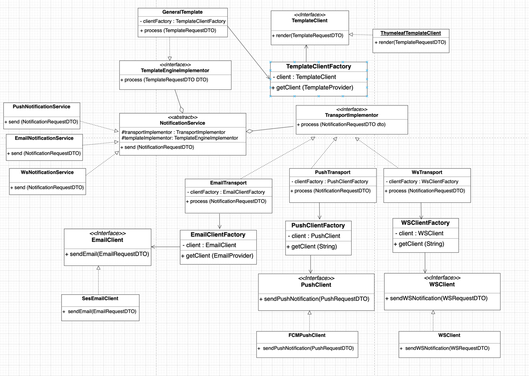
Figure 28. Notification Service Detailed Software Design
At the software level, the notification subsystem is built around an abstract NotificationService that coordinates templating and delivery. Concrete services (EmailNotificationService, PushNotificationService, WsNotificationService) each target a specific channel but share the same flow.They delegate template rendering to a TemplateEngineImplementor (bridge to different template engines via TemplateClientFactory and clients like ThymeleafTemplateClient), then hand off the rendered content to a TransportImplementor. Channel-specific transports (EmailTransport, PushTransport, WsTransport) in turn rely on factories (EmailClientFactory, PushClientFactory, WSClientFactory) to obtain the right provider client (SesEmailClient, FCMPushClient, WSClient) at runtime. This combination of Bridge + Factory + Strategy patterns lets us plug in new providers or channels without changing the high-level use case logic. On the persistence side, the notification microservice owns an outbox table in MySQL to track delivery attempts per event and uses Redis keys for short-lived idempotency checks, while MongoDB stores per-user notification history for the WebSocket channel.
Physical architecture workflow – end-to-end component flow
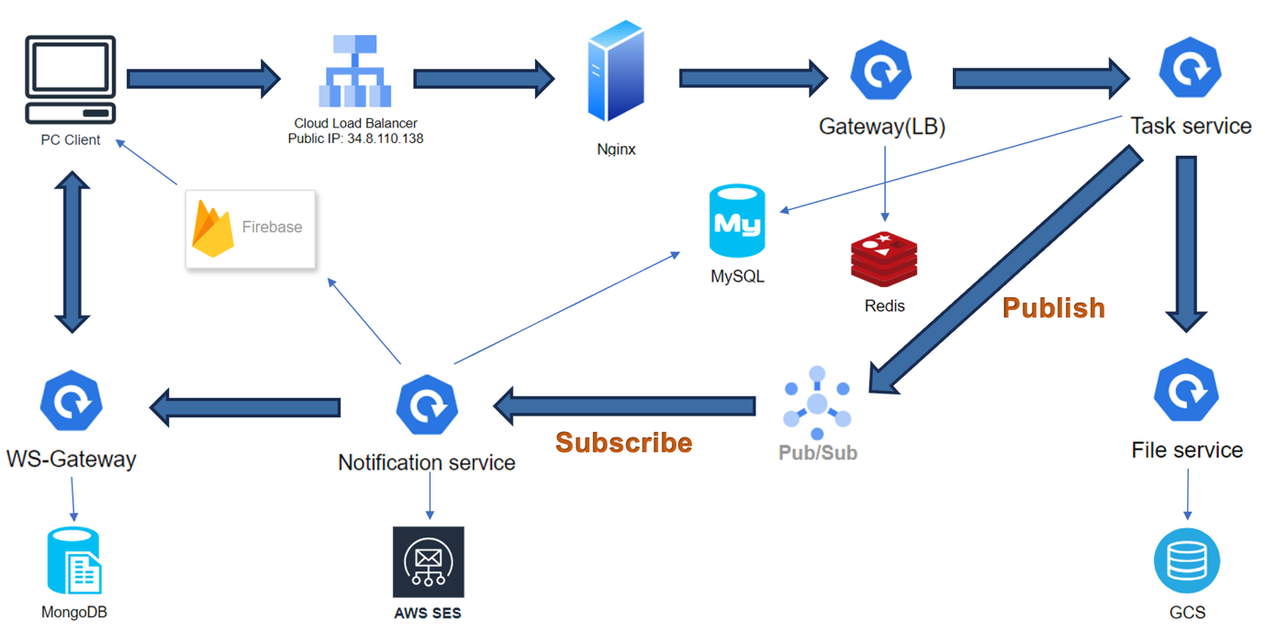
Figure 28. Notification Service Physical Architecture Design
- Task creation and persistence
  - The user submits a “Create Task” request from the browser.
  - The request flows through the Cloud HTTP(S) Load Balancer → Nginx in the DMZ → API Gateway → Task microservice on GKE.
  - The Task service validates the request, stores the new task (and any attachment metadata) in Cloud SQL (MySQL), uploads attachment binaries to GCS, and then publishes a TaskCreated event to a Google Pub/Sub topic.
- Asynchronous event delivery
  - Pub/Sub durably stores the TaskCreated message and delivers it to subscribed consumers.
  - The notification microservice (running on the same GKE cluster) subscribes to this topic and receives the event independently of the original HTTP request lifecycle.
- Notification fan-out and reliability controls
  - Upon receiving the event, the notification microservice records an outbox entry in MySQL to track the multi-channel notification.
  - For each required channel (email, Firebase push, WebSocket), it uses the notification design described above to render templates and call the appropriate provider (AWS SES, Firebase, WS-Gateway).
  - A short-lived Redis key is used to prevent duplicate sends during transient retries, while the MySQL outbox provides longer-term idempotency and audit of all attempts.
- Real-time delivery and user experience
  - AWS SES delivers email notifications to recipients’ inboxes.
  - Firebase Cloud Messaging sends browser push notifications to users who have granted permission.
  - The WS-Gateway pushes notifications over WebSockets to connected browsers and persists notification documents in MongoDB for unread counts, last-seen/ clicked state, and recent history.
  - Optionally, Redis caches badge counts or notification summaries so that the UI can render updated state with minimal latency.
This separation of responsibilities means the software design (pluggable notification framework + outbox/idempotency logic) maps cleanly onto the physical architecture (GKE microservices, Pub/Sub, Cloud SQL, MongoDB, Redis, SES, Firebase, GCS), and the same pattern can be reused for other domain events beyond “Create Task”.

Other Architectural Decisions

The key architectural decisions taken are as follows:
Identifier | Description
AD-10 | Issue  Determine how domain services (e.g., Task, Attendee) should trigger notifications across the system:  - Use synchronous RPC/REST calls from domain services directly to the Notification service.  - Use an asynchronous event-driven approach with Google Pub/Sub and an Outbox pattern for reliability.  Architectural Decision  Adopt an event-driven integration between domain services and the Notification service, using Google Pub/Sub as the message bus and a MySQL + Redis–backed Outbox/Idempotency pattern within the notification service to guarantee at-least-once delivery.  Assumptions  - User-facing actions (e.g., create task) must remain fast; notifications should not block the main transaction.  - Eventual consistency between core data and notifications is acceptable.  - At-least-once delivery is preferred over at-most-once; duplicates must be handled safely.  Alternatives  - Alternative A — Pub/Sub + Outbox (Chosen)  - Alternative B — Synchronous Dubbo / REST from Task/Attendee/User to Notification service.  - Alternative C — Batch polling (Notification scans DB periodically for new changes).  Justification  User-perceived latency  - Chosen: Publishing to Pub/Sub after commit keeps the HTTP request fast since the expensive notification work is moved out of that path and done asynchronously, so the user sees a quick response even if SES/Firebase/etc. are slow.  - Synchronous: Any slowdown in Notification or downstream providers would directly slow down task creation.  - Batch: Introduces delay between event and notification; not suitable for near real-time UX.  Resilience and decoupling  - Chosen: If the Notification service is down, Pub/Sub buffers events and domain services continue operating. Services evolve independently.  - Synchronous: Notification downtime would cause failures or retries in Task/Attendee services.  - Batch: Tight coupling to DB schema; harder to evolve and scale.  Delivery guarantees & idempotency  - Chosen: Outbox table + Redis idempotency keys let us safely handle Pub/Sub retries and ensure no user receives duplicate notifications within a window.  - Synchronous: Requires complex retry logic and compensation in each caller.  - Batch: Harder to track exact delivery state per event.
AD-11 | Issue  Decide how to provide real-time updates to browser clients:  - Terminate WebSocket connections in the main API Gateway or individual services.  - Introduce a dedicated WebSocket Gateway microservice that only handles WS connections and fan-out.  - Avoid WebSockets entirely and rely on HTTP polling.  Architectural Decision  Introduce a dedicated WS-Gateway microservice that manages WebSocket connections, integrates with MongoDB for notification history, and receives events from the Notification service, instead of mixing WebSockets into the main API gateway.  Assumptions  - A significant number of concurrent users may keep the app open during events.  - Real-time updates are important for UX (task changes, notifications, check-in events).  - We want to keep the main HTTP gateway stateless and simple.  Alternatives  - Alternative A — Dedicated WS-Gateway (Chosen)  - Alternative B — WebSockets in API Gateway / all services  - Alternative C — Long polling / SSE only  Justification  - Independent scaling and resource isolation  - Chosen: WS-Gateway can scale based on connection count and message rate without impacting API Gateway CPU/memory.  - Gateway WS: Long-lived WS connections compete with normal HTTP traffic on the same pods.  - Polling: Generates extra HTTP load and latency.  - Simplicity of services  - Chosen: Backend microservices expose simple RPC/events and only WS-Gateway deals with connection management, subscriptions, and push.  - Gateway WS: Gateway becomes complex, and each service might need WS knowledge.  - Polling: Push semantics must be approximated in every client.  - History and UX features  - Chosen: WS-Gateway + MongoDB store per-user notification documents for unread counts and history; nicely aligned with the real-time channel.  - Gateway WS / Polling: Harder to centralize history and delivery state.
AD-12 | Issue  Determine how many persistence technologies should be used:  - Use a single relational database (MySQL) for all data (including notifications, cache-like data, and files as BLOBs).  - Use polyglot persistence: MySQL for core transactions, Redis for cache/session, MongoDB for notification documents, and GCS for file objects.  - Use a single NoSQL document database for everything (e.g. MongoDB storing relational-style documents + binary files).  Architectural Decision  Adopt a polyglot persistence approach: Cloud SQL (MySQL) for core business / transactional data, Memorystore (Redis) for session and rate-limit caching, MongoDB Atlas for semi-structured notification history, and Google Cloud Storage for file attachments.  Assumptions  - Different data groups have different access patterns and lifetimes (strongly relational vs ephemeral vs document vs large binary).  - Managed services are available for all chosen technologies (reducing operational overhead).  - The team is comfortable working with multiple data technologies.  Alternatives  - Alternative A — Polyglot persistence (Chosen)  - Alternative B — Single RDBMS (store JSON + BLOBs in MySQL).  - Alternative C — Single document store (MongoDB) for all data.  Justification  - Fit-for-purpose storage  - Chosen:  - MySQL handles relational joins and ACID for tenants/events/tasks.  - Redis provides in-memory speed for session and throttling.  - MongoDB suits evolving notification documents with TTL.  - GCS is ideal for large binary objects.  - Single RDBMS: Harder to scale; mixing hot cache data and large BLOBs with OLTP tables.  - Single document store: Relational queries and constraints become harder; files still need separate handling.  - Performance and scalability  - Chosen: Load is spread across stores; each can scale independently.  - Single RDBMS/Doc: One store becomes the bottleneck for all workloads.  - Complexity trade-off  - Chosen: Higher conceptual complexity (multiple clients, backups, monitoring), but mitigated by managed services and clear data-group boundaries.  - Single store: Simpler in the short term, but risks long-term performance, maintenance, and schema evolution challenges.

Architectural Limitation

The key outstanding architectural issues in the solution are as follows:

Identifier | Issue and impact | Description | Resolution | Owner | Status
AISS–01 | Cluster-level availability is limited to a single zone; a full zonal outage would still bring the platform down. | As described in Section 4.2, ChronoFlow achieves high availability within the GKE cluster through replicated Deployments, HPA, PDBs and Kubernetes self-healing. However, the current chronoflow-cluster-prod is a zonal GKE Standard cluster (e.g. asia-southeast1-b) running all nodes in a single availability zone. This means the platform is resilient to pod and node failures inside the zone, but not to a complete zonal outage . In that scenario, all microservices would be unavailable until GCP restores the zone. This limitation is mainly due to free-tier cost constraints for this project. | In a future hardening phase, upgrade the deployment to a regional GKE cluster or enable multi-zone node pools, so workloads are spread across at least two zones). This would align the infrastructure availability with the high-availability patterns already implemented at the application layer (replicas, HPA, PDB). For the current academic deployment, we accept the zonal risk and mitigate it via frequent Cloud SQL backups and careful scheduling of maintenance during low-usage periods. | ChronoFlow platform / architecture team | Open (planned for post-project enrichment)

Quality Attributes

Performance
ChronoFlow is designed to sustain high throughput and low latency through layered optimizations in gateway routing, caching, asynchronous messaging, and autoscaling.
At the entry point, all external traffic passes through Spring Cloud Gateway, which provides client-side load balancing and dynamic service discovery across all backend microservices — including user, event, task, file, attendee, and notification domains. This design allows horizontal scaling at both the gateway and service tiers.
Each service integrates Sentinel for runtime traffic management. Rate-limiting, circuit breaking, and degradation rules are centralized in Nacos, allowing hotspot protection to be adjusted dynamically without code redeployment. Database access is optimized through Druid connection pools with master/slave routing and configurable limits, ensuring predictable latency even under bursty workloads.
Redis supports both response caching and rate control counters, storing high-frequency lookups and throttling metadata in memory for instant retrieval. Inter-service communication leverages Dubbo and GCP Pub/Sub for asynchronous event propagation, effectively reducing blocking calls and improving concurrency. The WebSocket Gateway uses HTTP/2 multiplexing and compression to maintain lightweight push channels for real-time updates.
Performance testing with Gatling validated these design goals: under simulated workloads of up to 1,000 concurrent users, the system maintained stable throughput in the range of tens to hundreds of requests per second, with 95th-percentile response times well below SLA thresholds. Even when constrained by GCP free-tier CPU and memory quotas, the system demonstrated excellent stability and efficiency, confirming the scalability of the architecture.

Availability
ChronoFlow ensures high availability through redundant deployment, health monitoring, and managed orchestration.
Each microservice is deployed as a replicated Kubernetes Deployment with rolling updates, readiness and liveness probes, and graceful shutdown hooks. Horizontal Pod Autoscalers (HPA) monitor CPU utilization to dynamically scale pods between two and four replicas during demand surges, while Pod Disruption Budgets (PDB) guarantee service continuity during maintenance or node upgrades.
Figure 9. HPA & PDB configuration are shown below.
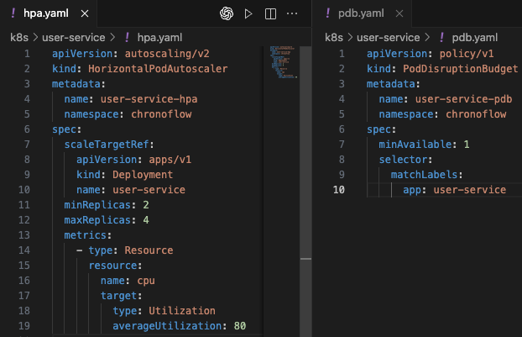
Figure 29. HPA & PDB configuration
Centralized configuration and service discovery via Nacos enable seamless recovery when instances fail — clients automatically reroute to healthy endpoints without manual intervention. Managed Prometheus scrapes metrics from Spring Boot Actuator endpoints, providing real-time visibility into resource utilization, request latency, and health status. These observability tools allow early detection of anomalies and rapid fault isolation.
In addition, the GKE Standard cluster provides strong self-healing and resiliency capabilities. When pods fail, Kubernetes automatically reschedules them on healthy nodes, and workloads are rebalanced to sustain service continuity. Combined with readiness and liveness probes, the overall design achieves fault tolerance at both the service and infrastructure levels.

Security
Security is embedded into every layer of the solution, following the DevSecOps principle of “shift-left”.
At the perimeter, the API Gateway enforces authentication and authorization on every route, applying strict whitelisting for only login and registration endpoints. The system uses Sa-Token for unified session management — defining token lifetime, concurrency limits, and HTTP-only cookies to prevent session hijacking.
Authorization logic resides in a shared framework security module, ensuring consistent role and permission validation across services through cached session state. Rate-limit policies protect downstream integrations (push notifications, email, and WebSocket channels) against abuse. Sensitive credentials such as API keys and service accounts are injected at runtime through Kubernetes Secrets and ServiceAccounts, eliminating hardcoded secrets.
Security assurance is integrated into the CI/CD pipeline:
- SonarCloud performs static code analysis on every pull request (Grade A across all metrics).
- SCA and SBOM scans automatically identify vulnerable dependencies (e.g., outdated Tomcat/Netty versions) with version recommendations.
- DAST (OWASP ZAP) conducts dynamic runtime scans — the latest full scan passed 134 checks with no critical or high-severity vulnerabilities.
Together, these controls ensure both preventive and detective coverage across the development lifecycle.

Extensibility and Maintainability
ChronoFlow’s modular, contract-driven design ensures long-term evolvability and maintainability.
The system adopts a Maven multi-module structure, separating shared APIs, framework code, and individual service implementations. This allows new domains to be added or existing services to be upgraded independently, while maintaining shared libraries centrally. Contract-first RPC interfaces (via Dubbo) define clear service boundaries, promoting loose coupling between modules.
Within each service, MapStruct-based DTO/VO mappers minimize boilerplate and enforce consistent data models. Automated unit and performance tests cover critical flows such as authentication and task management, with Gatling simulations validating system resilience under load.
Maintainability is further strengthened by the GitHub Actions CI/CD pipeline, which enforces code style and quality gates, runs automated test suites, generates SBOM/SCA reports, and supports zero-downtime rolling deployments.
Documentation (Swagger-UI), continuous monitoring (Prometheus), and high code maintainability ratings (SonarCloud Grade A) together ensure that ChronoFlow can be safely extended, enhanced, and maintained by future teams.

DevOps and Development Lifecycle

Source Control Strategy
Repository & modules. ChronoFlow is a single Git monorepo with a Maven multi-module layout (gateway, user-service, task-service, event-service, file-service, attendee-service, notification-service, plus shared common, framework, and shared-api). Shared modules allow version alignment and one-shot upgrades of common libraries.
Branching model. We use a simplified GitFlow:
- dev — integration branch for day-to-day work.
- main — production-ready branch. Only fast-forward merges from PRs reviewed on dev are allowed.
As shown in Figure 10. CI/CD Pipeline for ChronoFlow Microservices — it first detects which microservices are affected by recent commits and then selectively runs build, test, and deployment jobs for those impacted services. Shared module updates trigger a full rebuild to maintain version consistency across the monorepo.
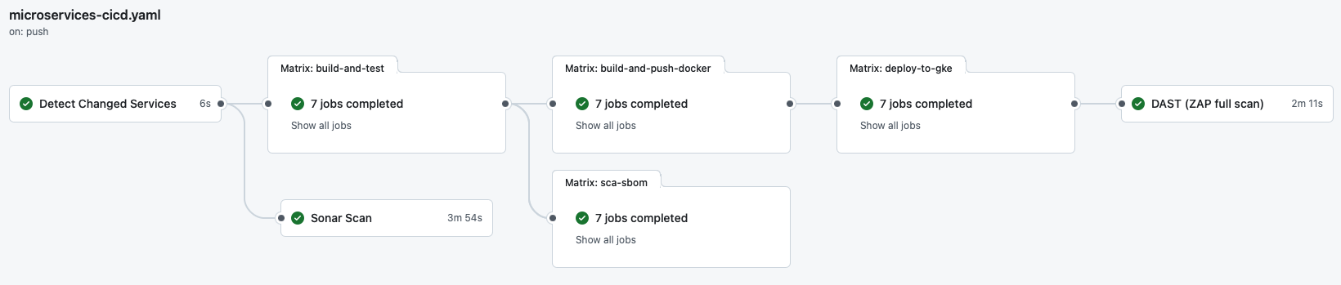
Figure 30. CI/CD Pipeline for ChronoFlow Microservices
Change isolation & ownership. Each service has its own directory and Dockerfile. Cross-cutting changes in shared modules intentionally trigger a rebuild of all services (see §5.2 “Detect Changed Services”).
PR policy & reviews. All merges into main go through pull requests with mandatory reviewer approval and passing status checks (lint, unit tests, quality gate, SCA/SBOM).
Access control. Contributors authenticate through GitHub; protected branches enforce non-admin approval, signed commits, and disallow force-pushes. Secrets are never committed; build-time credentials are injected from GitHub Encrypted Secrets / GCP Secret Manager.

Continuous Integration
Triggers.
- push to main or dev.
- pull_request events (opened/synchronize/reopened) for quality gates before merge.
Change scoping (cost control). A Detect Changed Services job (using dorny/paths-filter) computes the impacted service list.
- If only certain service folders changed, CI runs matrix jobs just for those services.
- If any shared module changed, the pipeline builds all services to avoid ABI drift.
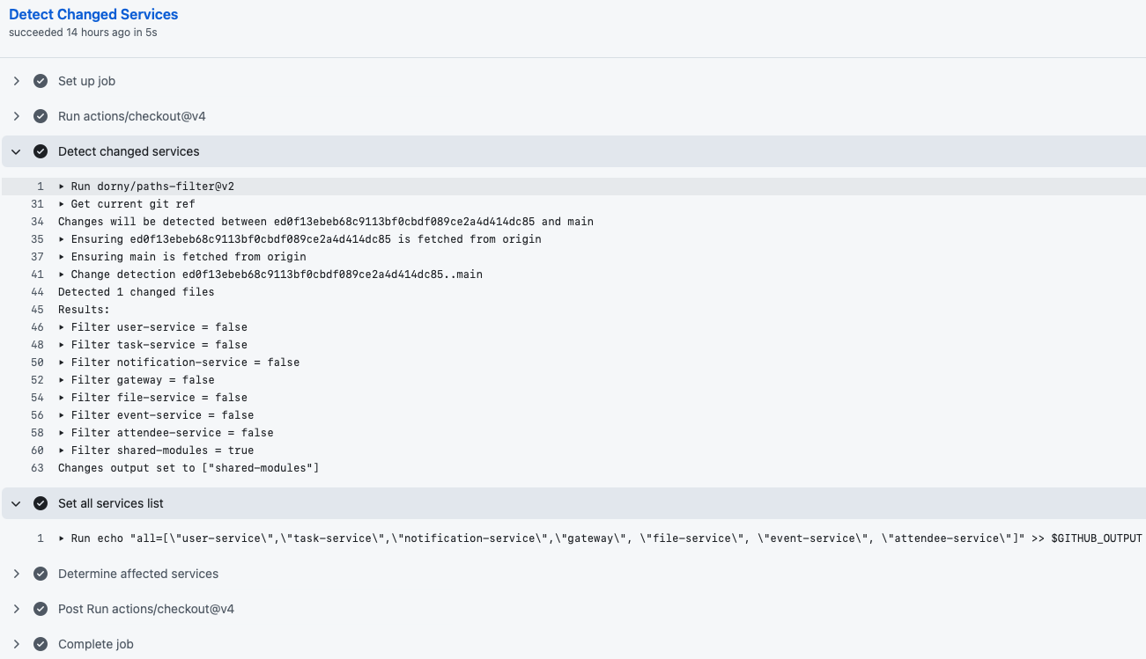
Figure 31. Detect Changed Services
Core CI stages (per impacted service).
- Build & JUnit & Lint
  - JDK 17; Maven spotless:check, checkstyle:check, and clean verify.
  - Test results fail the job on any unit test error.
  - JAR artifacts are uploaded for later Docker packaging.
- SCA & SBOM
  - Generate CycloneDX JSON SBOM.
  - Run Anchore/Grype SCA in SARIF and table formats (severity-cutoff: high, only-fixed: true) to surface actionable CVEs.
  - Upload SBOM/SCA artifacts for auditability.
- SonarCloud Scan (branch: main)
  - Static analysis (Security, Reliability, Maintainability) and coverage reporting.
  - CI respects the Sonar Quality Gate (as shown in Figure 12. Sonar Cloud below): findings are visible on the PR and block promotion until resolved.
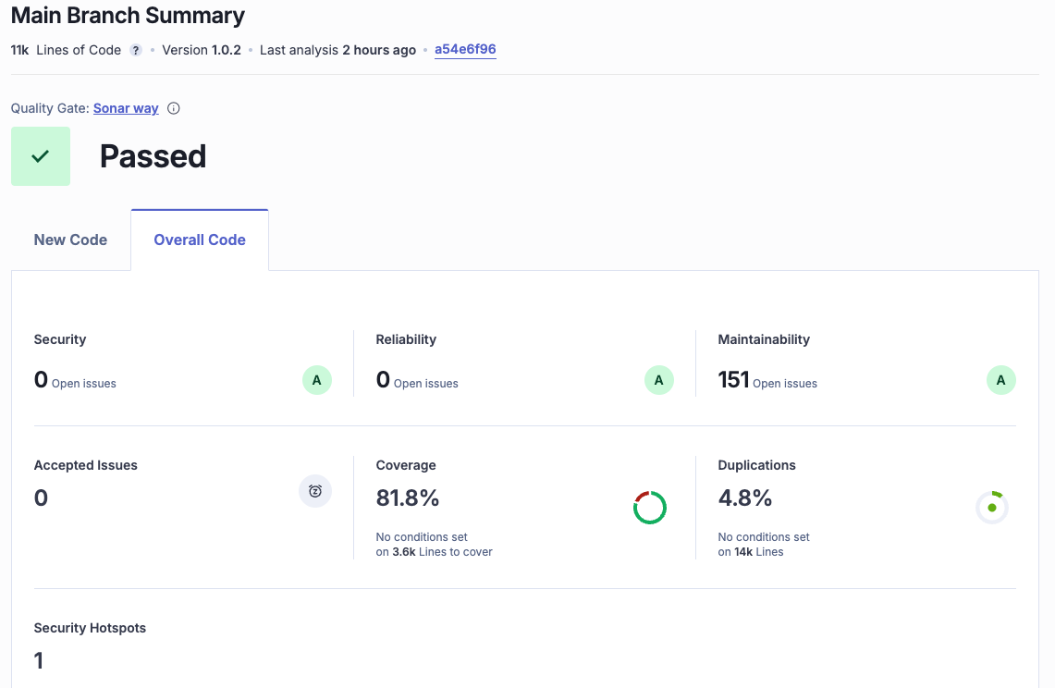
Figure 32. Sonar Cloud
Scheduled & on-demand performance CI.
- A separate workflow runs Gatling on a dedicated perf VM:
  - Triggers: workflow_dispatch (manual) and cron (Tue/Fri 02:00 UTC).
  - The runner securely copies a shell script to the VM, executes the simulation with environment secrets, and fetches the HTML/tgz report back as an artifact.
  - This keeps heavy load generation off the GitHub runners and close to the target cluster.
- See Section 6 (performance test) for details.
CI outputs (evidence).
- Service JARs and SCA reports (*.sarif, *.txt)
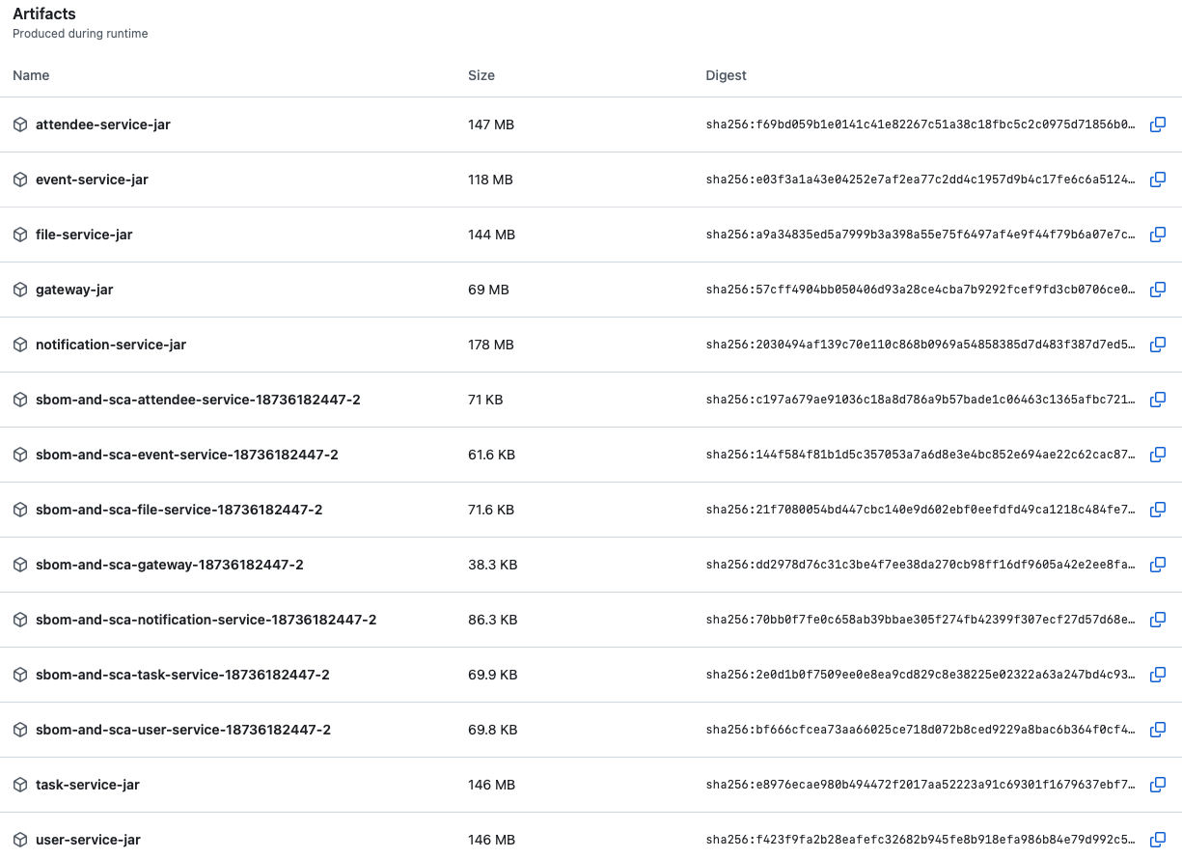
Figure 33. Artifacts

Continuous Delivery
Environments & promotion.
- Dev: pushes/PRs run CI but do not deploy.
- Prod-like (GKE Autopilot): merges to main trigger Docker build/push and gated deploy when vars.USE_GKE == 'true'. Promotion occurs by merging a reviewed PR from dev → main, after all CI quality gates pass.
Container build & publish.
- Reuses CI JAR artifacts; docker/build-push-action produces multi-tag images (branch, commit-sha, latest on default branch) and pushes to Docker Hub / registry with build-cache enabled.
Kubernetes deployment.
- Auth via google-github-actions/auth (GCP Service Account JSON).
- gcloud container clusters get-credentials then kubectl apply manifests per service (or kubectl set image fallback).
- A rollout gate waits on kubectl rollout status --timeout=10m.
- Post-deploy verification prints Deployment/Pod/Service state and the most recent Kubernetes events.
Operational safeguards.
- HPA scales pods during traffic spikes; PDB preserves at least one replica during maintenance.
- Readiness/Liveness probes ensure only healthy pods receive traffic.
- Observability is standardised: Prometheus scrapes /actuator/prometheus; Google Cloud instance dashboards (below) provide latency, error-rate, CPU/memory, and pod counts.
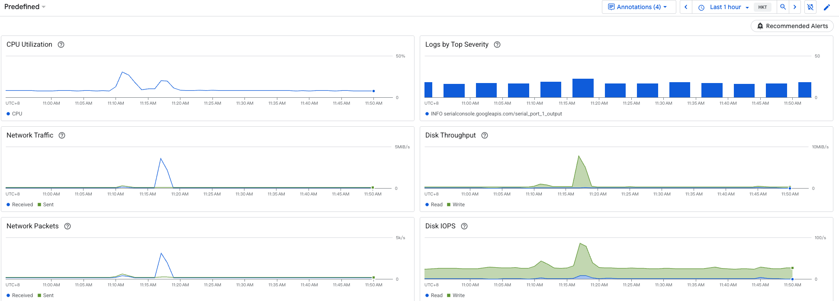
Figure 34. Google Cloud Matrixes
Post-deploy security & quality checks.
- DAST (OWASP ZAP Full Scan) runs against the deployed base URL; HTML/XML/JSON reports are uploaded. Exit codes are handled so warnings (no criticals) do not fail the whole release, but still surface as artifacts.
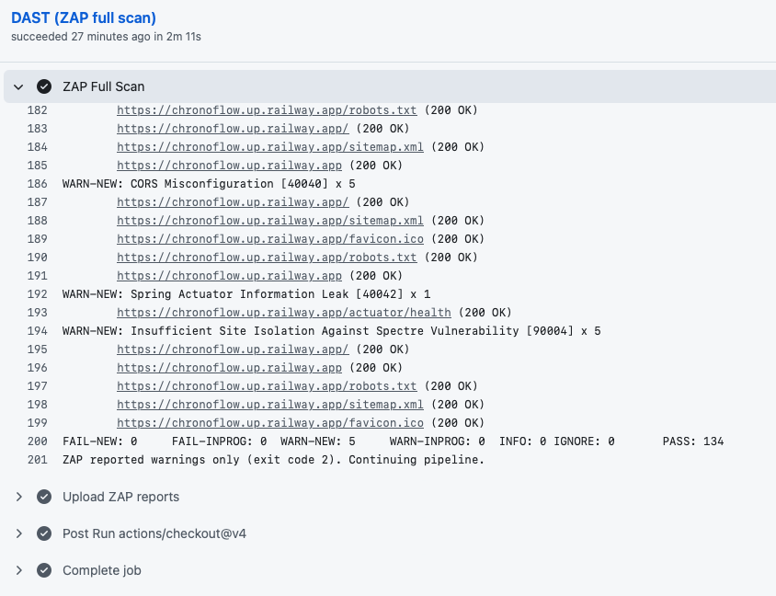
Figure 35. DAST
Roll-back.
- Roll-back is kubectl rollout undo deployment/<service> to the previous image; images are content-addressed and tagged per commit for deterministic reversions. If manifests are used, a previous manifest set can be re-applied from the repository history.
Release governance.
- Approval to promote from dev → main is via PR review (code owners). Quality gates include: green CI, Sonar Quality Gate passed, SCA high-severity fixed (or accepted with justification), and—when applicable—perf/DAST reviewed.
CD outputs (evidence).
- Docker image tags in the registry, ZAP reports (zap-report.html/xml/json), and CI run pages linking to all artifacts.
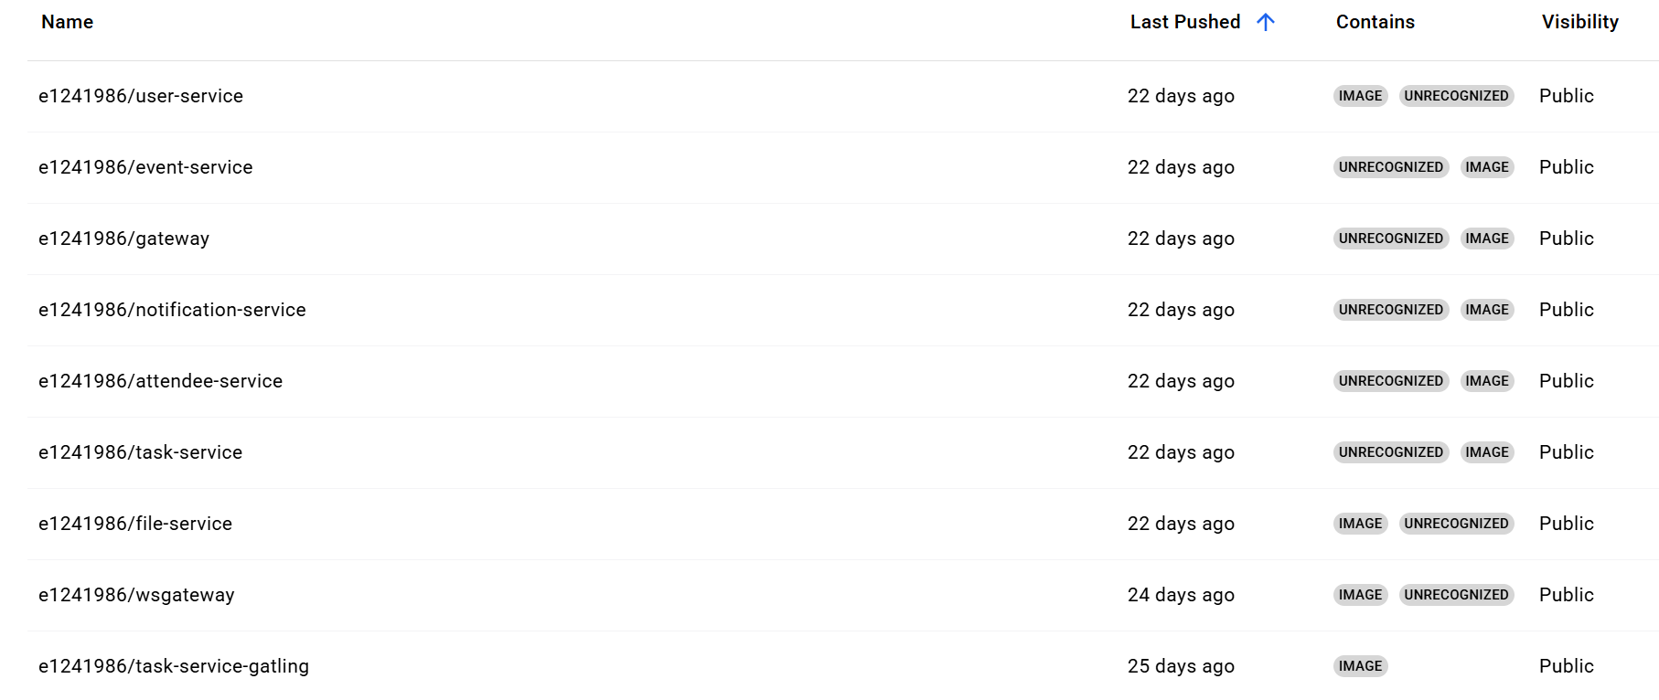
Figure 36. Docker Image

Performance Test

Introduction
This performance test aims to validate the scalability, stability, and responsiveness of ChronoFlow’s core microservices—specifically the login and get-task operations—under varying concurrency levels. The test demonstrates how the system behaves under stress and how the DevSecOps pipeline integrates continuous performance assurance. The testing was performed on Google Kubernetes Engine (GKE) within the GCP Free Tier environment, where CPU and memory resources are inherently limited by the account quota, rather than by intentional configuration. These limitations provide a realistic baseline for evaluating system behavior under constrained conditions.

Test Environment and Execution
The testing setup consisted of ChronoFlow microservices deployed on GKE, while the load generator (Gatling 3.10.4) was executed from a dedicated testing VM. The workload script performed combined login and get-task transactions under increasing concurrency. Execution lasted approximately 1 minute and 35 seconds, reaching a peak of over 1,000 active users before ramping down. The test can be executed through three modes:
- Automatic Schedule – A dedicated GitHub Actions workflow triggers the test every Tuesday and Friday at 2:00 AM.
- Manual Workflow Trigger – Developers can manually start it from the CI/CD dashboard.
- Manual VM Execution – Engineers may initiate tests directly on the VM using SSH
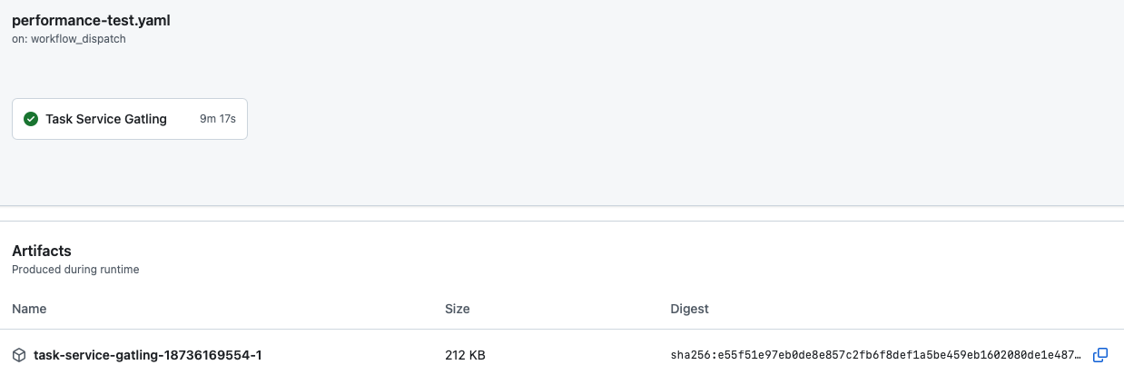
Figure 37. Performance Test through Github

Results and Observations
The Gatling report showed 2440 successful and 0 failed requests, achieving a 100% success rate. Global assertions were met—95th percentile response time ≤ 60 seconds, and success rate ≥ 99%. Response-time distribution revealed that most requests were processed within hundreds of milliseconds, with a small long tail extending into tens of seconds during the peak ramp. Throughput reached approximately 600 requests per second at the maximum, maintaining about 20 requests per second in the stable phase. A few timeout cases (60s) were observed during the sharp concurrency climb, aligning with expected queue delays rather than service crashes.
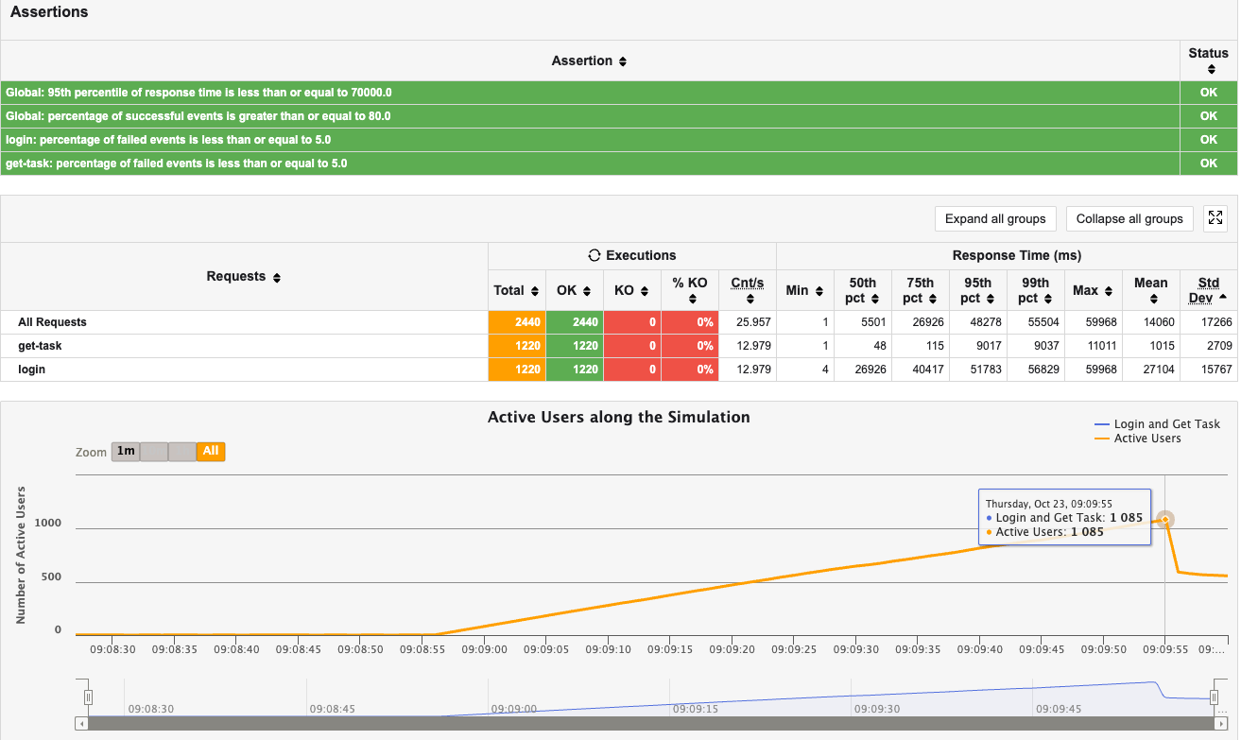
Figure 38. Performance Test Report
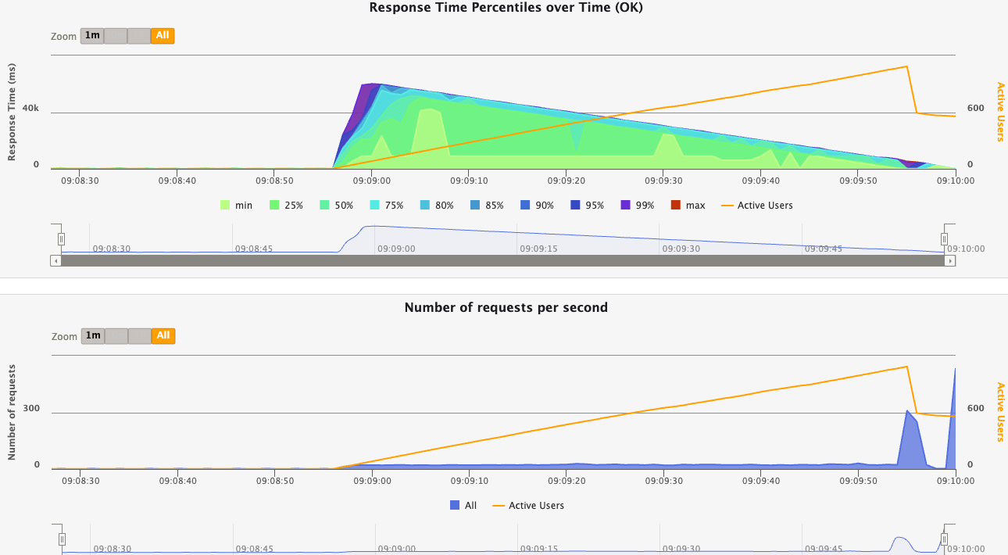
Figure 39.Request & Response

Scalability and Resource Utilization
As the load increased, GKE’s horizontal pod autoscaler dynamically launched additional pods for critical services such as user-service. During the peak, CPU utilization for some pods exceeded 150% of their defined request limits, indicating full resource usage rather than inefficiency. Despite operating under GCP’s free-tier restrictions, the system sustained stable throughput, demonstrating effective horizontal scalability and resilience under constrained environments.
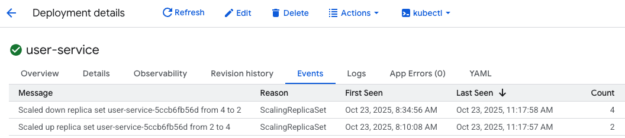
Figure 40. Auto Scale
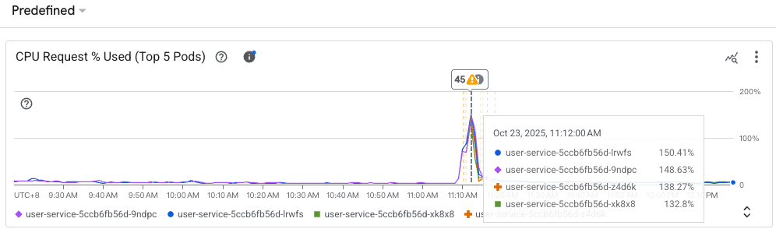
Figure 41.CPU Matrix

Conclusion and Recommendations
The performance test confirms that ChronoFlow’s microservices architecture maintains high reliability and responsiveness even under heavy concurrent load. All predefined quality gates were satisfied, and the system automatically scaled to meet demand without manual intervention. To further enhance accuracy and reproducibility, future tests should migrate to a production-grade GKE cluster with higher quotas and maintain weekly trend baselines using scheduled workflows. Overall, the results validate the robustness and scalability of ChronoFlow’s design and its seamless integration with the DevSecOps performance pipeline.

Unit / Component and End-to-end Testing

For the frontend, we treat each React component as a small unit and validate it with automated tests (using Vitest and React Testing Library). On the backend, every microservice has its own JUnit + Mockito–based unit test suite that covers controllers, services, and repository logic in isolation. Collectively, these tests focus on business rules, validation, and state transitions without calling real infrastructure (databases, message brokers, or external APIs).
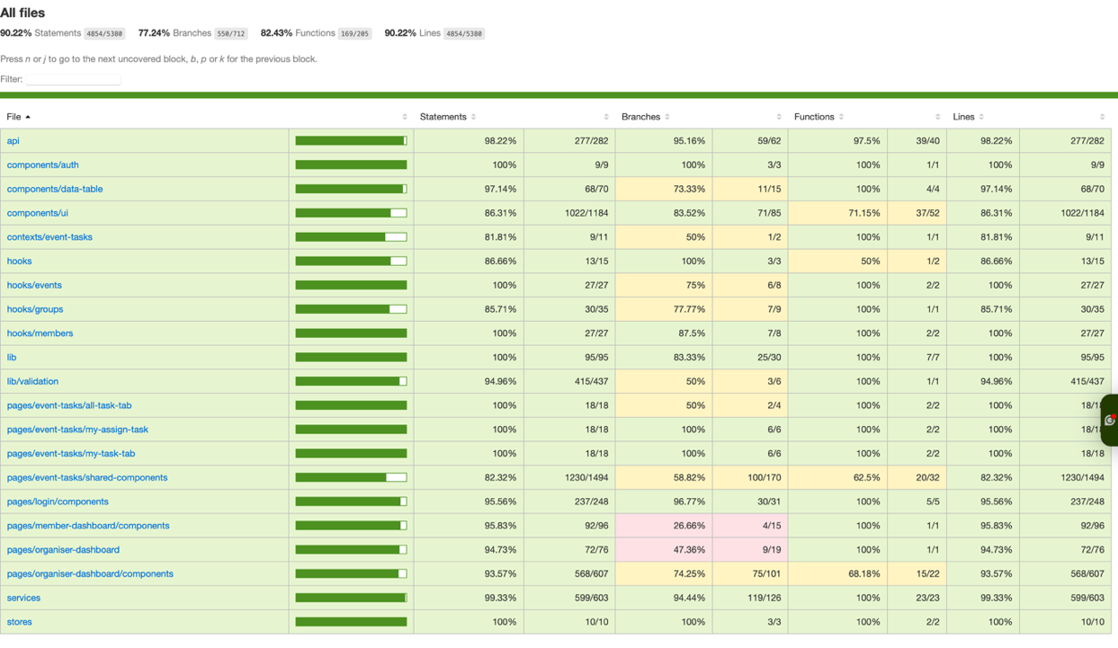
Figure 41. Test Coverage
In this report show the frontend coverage as a representative sample: we achieve ~90%+ line coverage across core modules (API client, pages, shared components, hooks, and state stores), with especially strong coverage on the authentication flow, event/attendee management screens, and reusable table components. This combination of backend and frontend unit tests gives strong confidence that small refactors or styling changes do not silently break business rules, and that each microservice’s core domain logic behaves correctly in isolation.

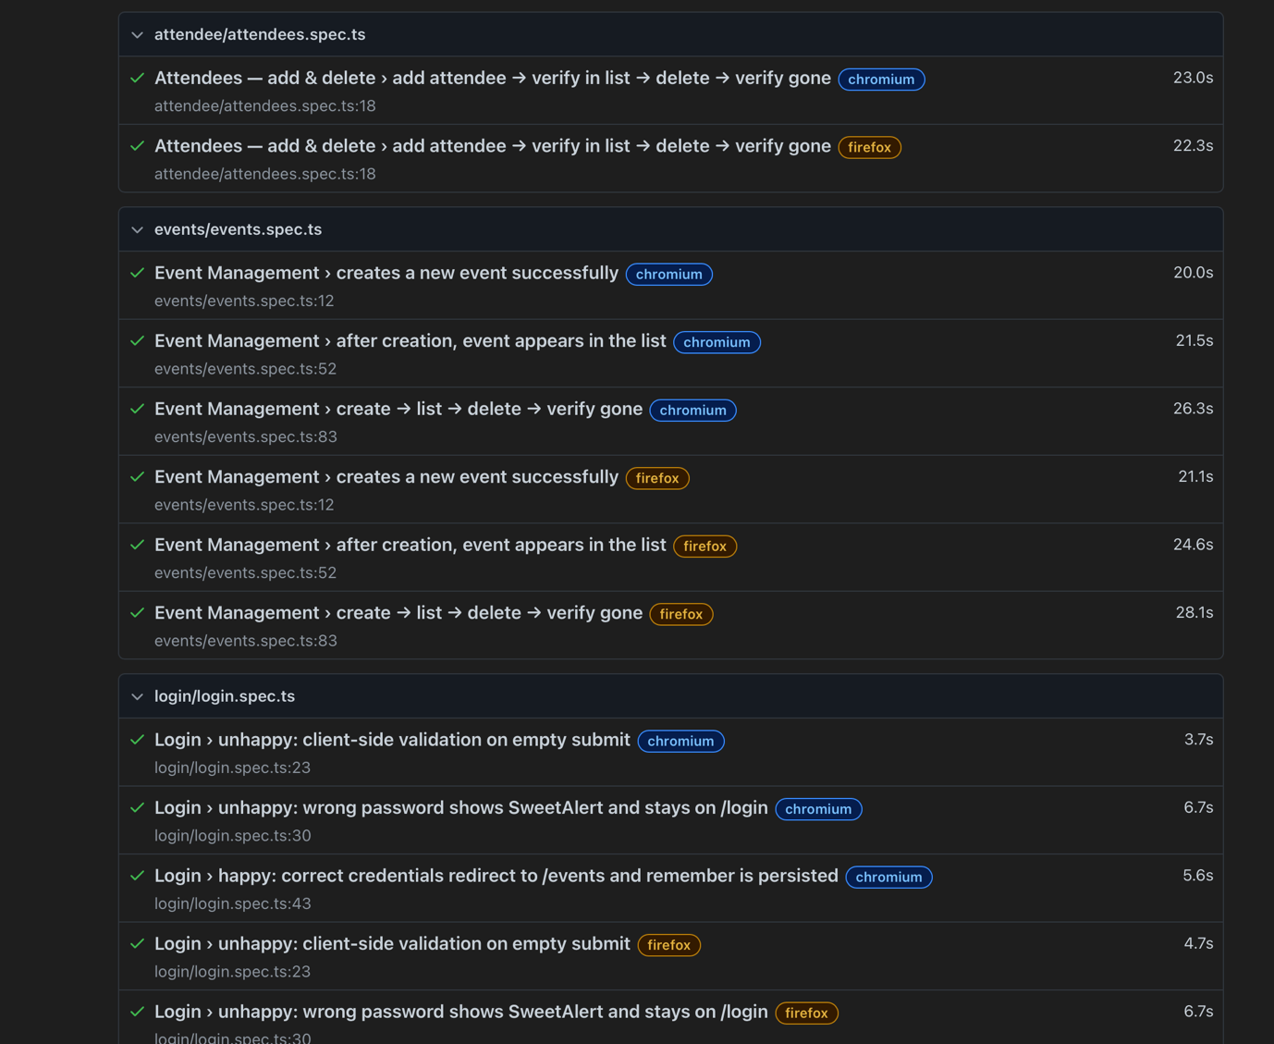

Figure 43. End-to-End Testing Report
On top of unit tests, we run end-to-end (E2E) tests using Playwright against a dedicated test environment. The CI pipeline spins up the frontend and backend on the testing server, then executes browser-level scenarios in both Chromium and Firefox. The E2E suite covers critical user journeys such as: successful and failed login attempts; creating an event, verifying it appears in the listing, then deleting it; and adding & deleting attendees while ensuring the list reflects the changes. These tests run automatically in GitHub Actions for pull requests to the test branch, and the pipeline fails if any scenario breaks. Playwright’s HTML report is archived as a build artifact, giving the team a traceable history of UI regressions and performance over time. Together, the unit/component tests and E2E tests provide layered assurance: fast feedback on individual components plus realistic validation of the full stack under browser conditions.

GitHub Repo URL

Front-end Github Repo URl | https://github.com/YuuKiSSa/Chronoflow_Microservice_FE
Back-end Github Repo URl | https://github.com/XXXZZZHHH123/Chronoflow_Microservice

