TNTConcept 0.21.X Installation Guide

Index of Contents
1 Introduction 2
1.1 Glossary of Terms 2
2 Prerequisites 2
3 Needed Software 3
4 Installing the Web Application 3
4.1 Updating from previous releases 4
4.1.1 Needed information 4
4.1.2 New properties 4
4.2 Installation 5
4.2.1 Downloading and installing Java Development Kit 1.6 5
4.2.2 Downloading and installing MySQL 6
4.2.2.1 Configuring the MySQL Server instance 9
4.2.3 Downloading and installing MySQL GUI Tools 15
4.2.4 Downloading and installing the server 16
4.2.4.1 Downloading and installing Tomcat 6 16
4.2.4.2 Downloading and installing JBoss Application Server 4.2.3 JDK6 19
4.2.5 Creating the initial database 21
4.2.6 Installing TNTConcept on the server 28
4.2.6.1 Tomcat 6 configuration 28
4.2.6.2 JBoss configuration 29
4.2.7 Configuring the application 31
5 Database migration 32
5.1 Explanation of the migration concept and console mode 33
5.2 Carrying out the migration process 33
6 Starting the application 36
7 License 37

Introduction
This document explains how to update or install TNTConcept, release 0.21.X.

Glossary of Terms
This document contains certain keywords that must be replaced by a value-dependent environment. These terms are:
- $TOMCAT6: Base directory installation of Tomcat 6. For example, it could be c:\tomcat or c:\tomcat6 under Windows.
- $JBOSS: Base directory installation of JBoss. For example, it could be c:\jboss.
- $CONFIG: Configuration directory for TNTConcept. It is recommended to set it to c:\tntconcept on windows systems and /etc/tntconcept on Unix systems, though its location is fully configurable through the file $TOMCAT6/conf/server.xml.
- $DB: Database name. From version 0.2 it is recommended to name the database tntconcept. However, in version 0.1, it was recommended to create the database with the name intraweb. The database name is fully configurable through the file $TOMCAT6/conf/server.xml.
- $DBUSER: Database user with access and modify permissions to the $DB database. This user should be created when creating the database during the first TNTConcept installation. The database user name is fully configurable through the file $TOMCAT6/conf/server.xml (but it obviously has to match the one configured in MySQL).
- $DBPASSWD: Password for the $DBUSER database user. This password is specified when creating the user $DBUSER in the database creation during the first TNTConcept installation. The password is fully configurable through the file $TOMCAT6/conf/server.xml (but it obviously has to match the one configured in MySQL).
- $TEMPDIR: Directory in which the TNTConcept installation file (tntconcept-web-tomcat-0.21.X-installer-tomcat-0.21.X.tar.gz or tntconcept-web-0.21.X-installer-jboss-0.21.X.tar.gz) has been extracted.

Prerequisites
This release can be installed from scratch or on top of a release higher than 0.2.
If you have the 0.1 release installed and you have no data stored on the application that you wish to keep, it is recommended to install the application from scratch. However, if you have a 0.1 release installed and wish to keep the data, you must first install release 0.2, and only then install release 0.21.X.
Another prerequisite to bear in mind is that from release 0.10 it is necessary to change the server. You can choose either Tomcat 6 or JBoss 4.2.X. Please find below a table showing the compatibility between versions of TNTConcept and servers.

 | 0,9 or previous | 0,10 or higher
Tomcat 5.5 | x
JBoss 4.2.X |  | x
Tomcat 6 |  | x

(from JDK version 1.6 it is necessary to use JBoss 4.2.3 JDK6)

Needed Software
To properly install TNTConcept you will need:
- Java Development Kit, version 1.6.
- Tomcat 6.0.X or JBoss 4.2.3 JDK6.
- MySQL 5.0 or higher (we recommend using 5.1.X).
- MySQL GUI Tools.

Installing the Web Application
If you are installing from scratch, please skip paragraph 4.1 and follow the steps in "4.2. Installation". Then continue with chapter 5.
Otherwise, if you are updating an existing installation, please read carefully paragraph 4.1.

Updating from previous releases
IMPORTANT
If you are updating your application, please note that release 0.21.X can only be applied to an installation of version 0.2 or higher, never to a previous version. See chapter “2. Prerequisites” for further information.
From version 0.7, the way of retrieving properties files has been modified. If you are upgrading from earlier versions, please check paragraph “4.2.7 Configuring the application”.

Needed information
If you are upgrading from a 0.9.X or previous release of TNTConcept you probably have a Tomcat5 server installed and running, and a MySQL database with all your information. You must therefore consult the file $TOMCAT5\conf\server.xml and note down the following information to be able to configure your new Tomcat 6 or JBoss 4.2.X server (highlighted in red):
<Context path="/tntconcept" docBase="tntconcept">
<Manager pathname=""/>
<Environment name="TNTConceptConfigDir" type="java.lang.String" value="$CONFIG"/>
<Resource name="jdbc/TNTConcept" auth="Container" type="javax.sql.DataSource"
maxActive="100" maxIdle="30" maxWait="10000" driverClassName="com.mysql.jdbc.Driver"
username="$DBUSER" password="$DBPASSWD"
url="jdbc:mysql://localhost:3306/$DB?autoReconnect=true"/>
</Context>

New properties
In the file $CONFIG/autentia.properties some new properties have been included:
- schemaSecurityMatrix: File name of the XML Schema validation for the application security configuration file (securityConfiguration.xml). This property should not be changed.
- ValidateSecurityMatrixXML: Boolean value that indicates whether to proceed (true) or not (false) to the validation of the XML security settings (securityConfiguration.xml). By default this value is set to true, but you can disable the validation changing its value to false.
NOTE: If the validation is active and the file does not meet the schema validation, the application will not start. The validation schema has been adapted to the current file, so there should be no problem in carrying out the validation.

Installation
Extract the installation file (tntconcept-web-tomcat-0.21.X-installer-tomcat-0.21.X.tar.gz or tntconcept-web-0.21.X-installer-jboss-0.21.X.tar.gz) in a directory on your machine ($TEMPDIR).
If you have JDK 1.6, MySQL 5.X and MySQL GUI tools already installed, you can skip to paragraph 4.2.4 (though we recommend checking the MySQL Server instance configuration, in paragraph 4.2.2.1).
If you don't, we will subsequently describe the detailed installation under Windows.

Downloading and installing Java Development Kit 1.6
Download and install from: http://www.oracle.com/technetwork/java/javase/downloads/index.html the latest version of JDK 6.
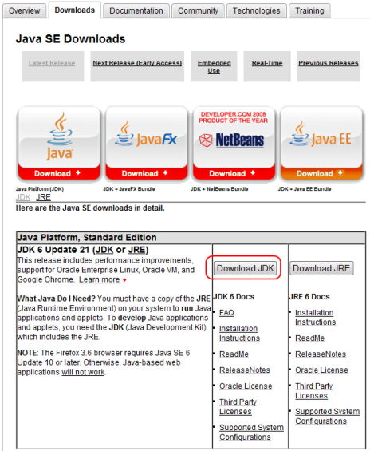

Downloading and installing MySQL
From: http://dev.mysql.com/downloads/mysql/ you can download version 5.X
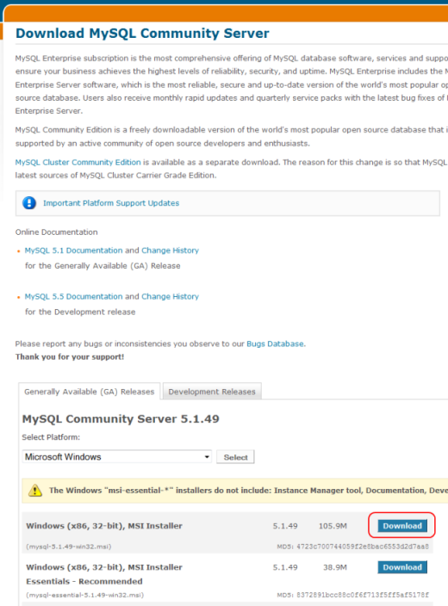

Run the installation file:
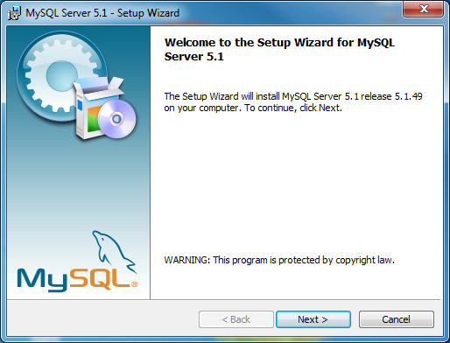
choose typical setup
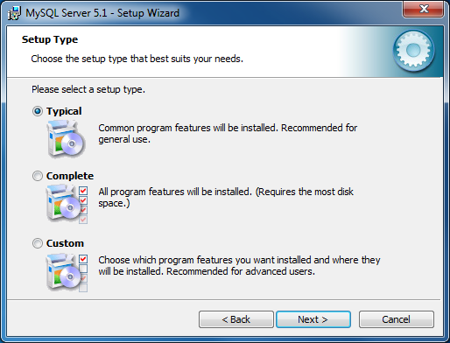
and, once the installation has finished, check the “Configure the MySQL Server now” box
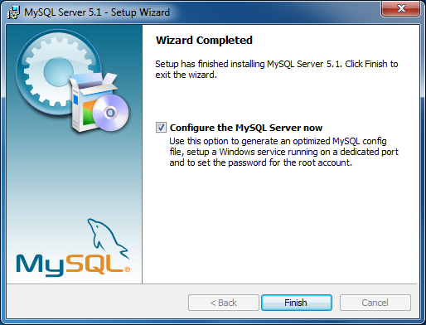
(you may also configure the MySQL Server instance at a later time, by running the MySQL Server Config Wizard).

Configuring the MySQL Server instance

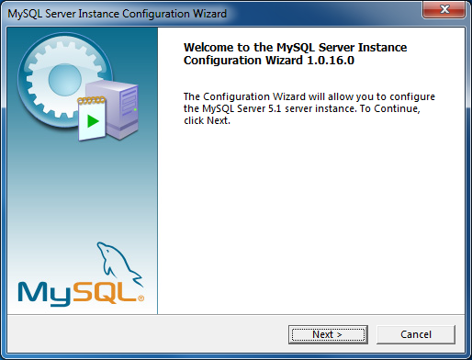
Choose “Detailed Configuration”
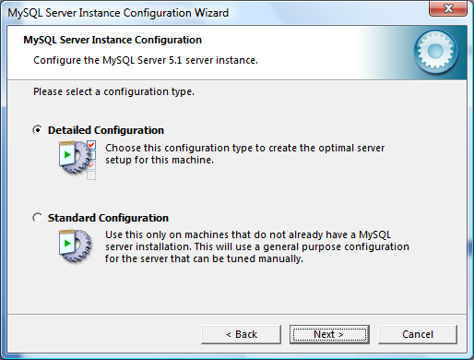
Select “Server Machine”
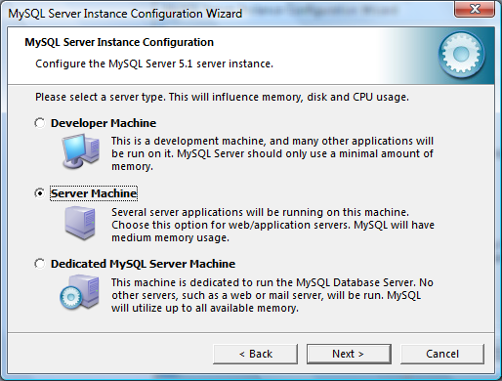
Select “Multifunctional Database”
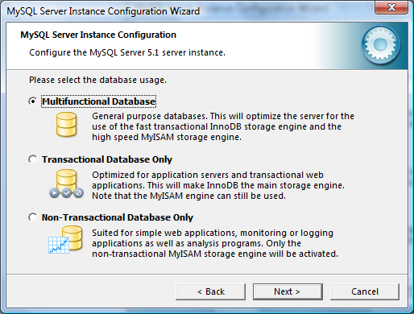
Keep the default options for the tablespace:
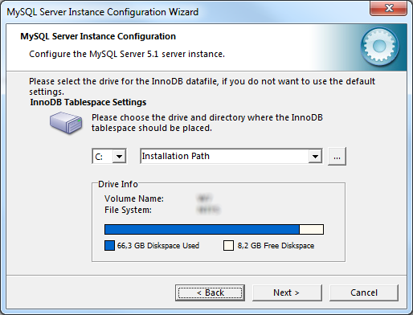
and also for the number of concurrent connections (Decision Support (DSS)/OLAP):
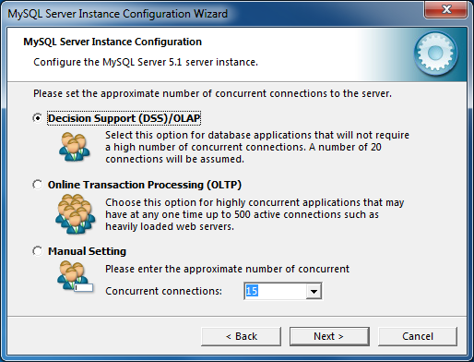
Keep the default port number and add the firewall exception:
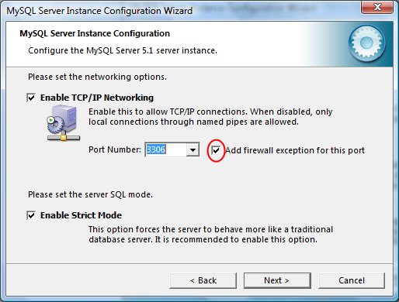
Then select “Manual Selected Default” and choose UTF-8:
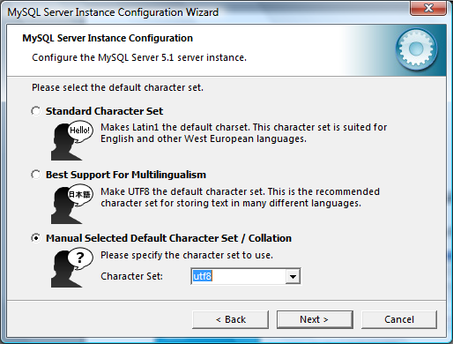
Keep the default option to install as a Windows service:
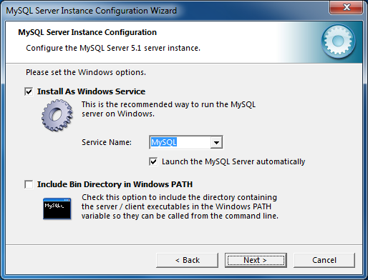
Do not forget to write down the root password:
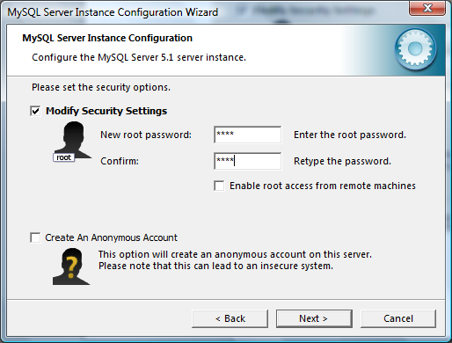
And, finally, click on Execute:
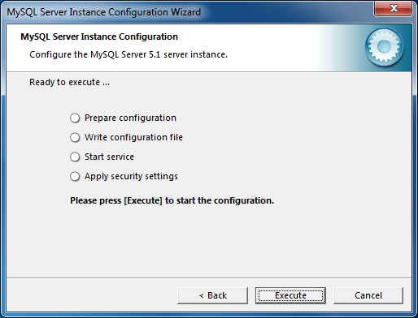
After the execution, you should obtain the following screen:
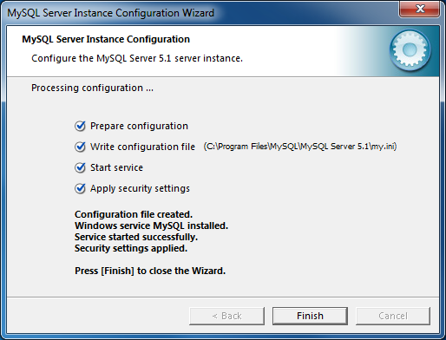

Downloading and installing MySQL GUI Tools
Download from: http://dev.mysql.com/downloads/gui-tools/
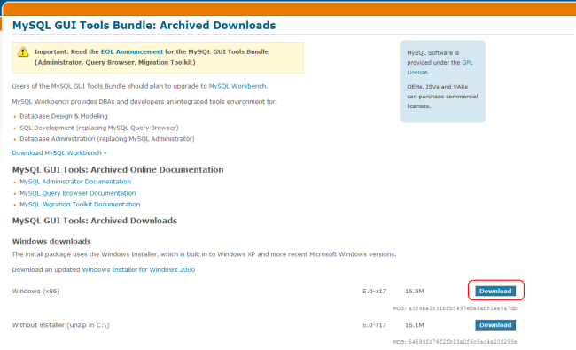
Install the tools with the default options (complete setup):
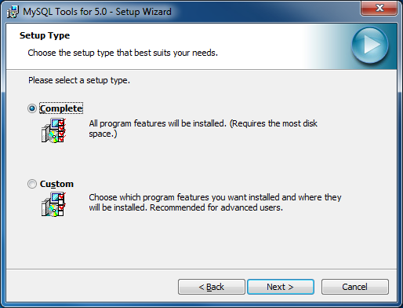

Downloading and installing the server
You must choose between Tomcat 6 and JBoss 4.2.3 JDK6 (JBoss 4.2.X version compatible with JDK 1.6).
Again, we will describe the Windows installation process.

Downloading and installing Tomcat 6
Download from the Apache web page: http://tomcat.apache.org/download-60.cgi the latest Tomcat 6 version:
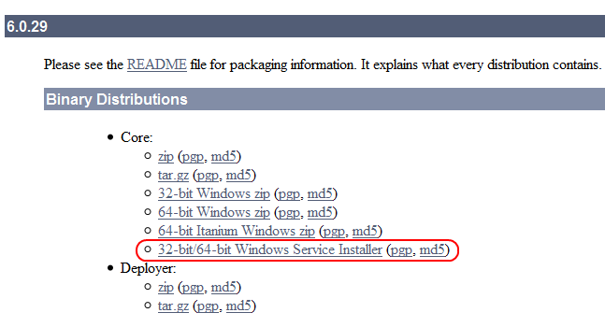
Download the Windows Service Installer and run it.
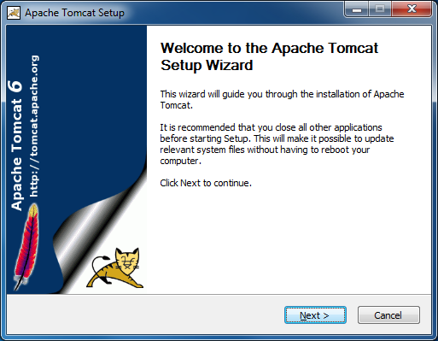
Choose normal installation:
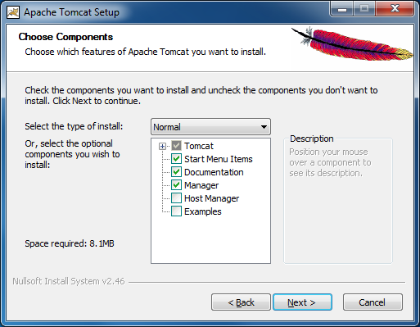
And install in c:\tomcat (using this directory is not compulsory, it is just a recommendation):
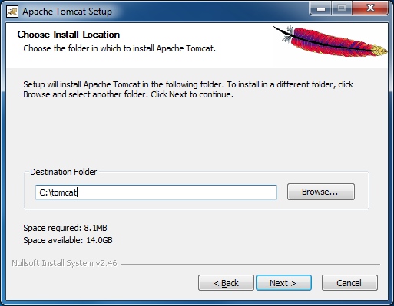
Choose login and password for admin:
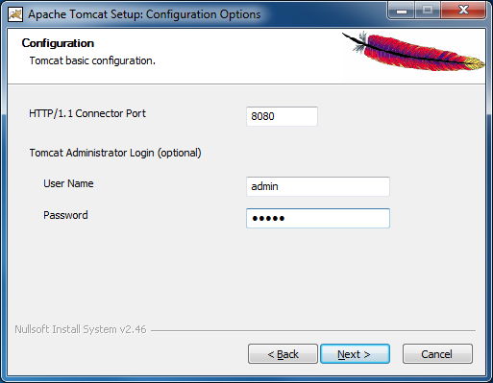
and choose your installed Java version (the wizard will offer it by default):
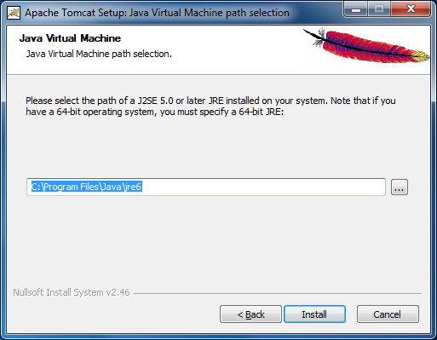
The installation will create a Windows service (Apache Tomcat 6) to start or stop the Tomcat server.
To manage this service, use the Administration Tools in the Control Panel (in Windows7 they are found under System and Security).

Downloading and installing JBoss Application Server 4.2.3 JDK6

In http://labs.jboss.com/jbossas/downloads/, select 4.2.3:
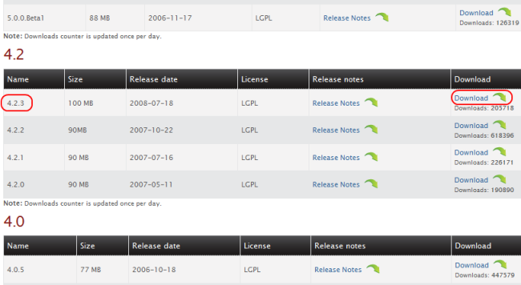

and choose GA-jdk6:
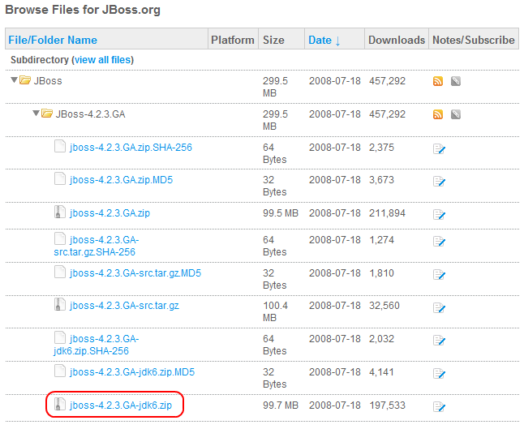
Once the file is downloaded, extract it in your file system. For example, in c:\jboss.

Creating the initial database
Once the MySQL server is installed , you can create the database that TNTConcept will use.

To do it, run the MySQL Administrator tool, that will request the root password previously set:

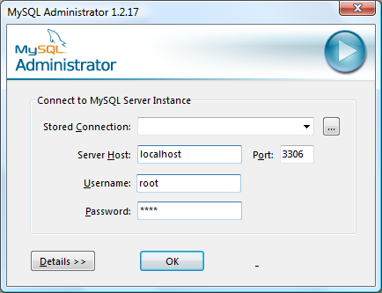

In the schema list (click on Catalogs and place the cursor in the lower left window), right click and choose create new schema:

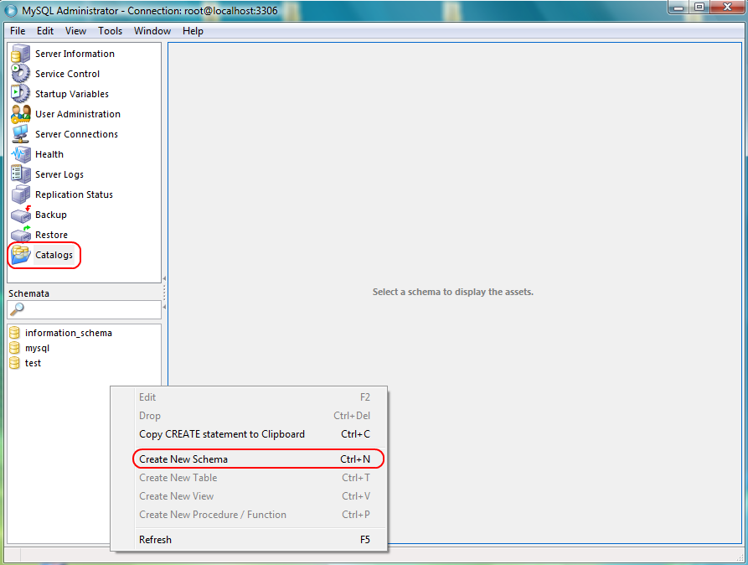
and name it “tntconcept” (you can choose any other name, but this will match the remaining configurations):

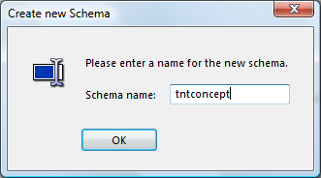

Then, click on User Administration and, again using the pop-up menu choose Add new user to create the user that will use the application:
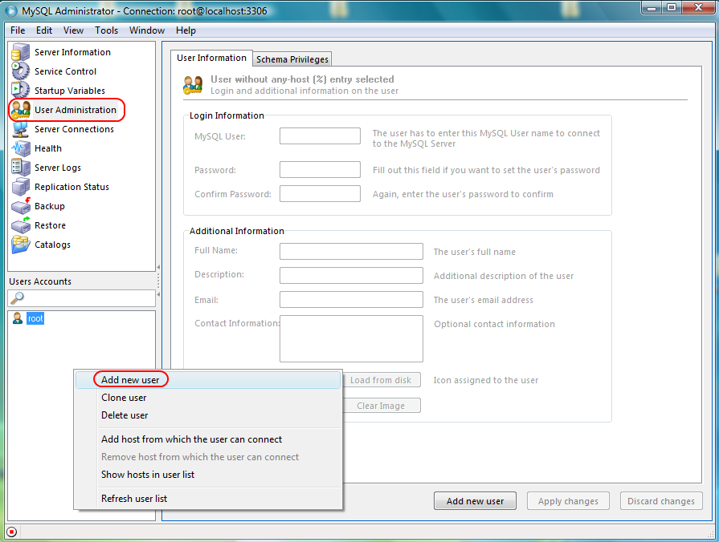
You will now need to give it a name and assign a password to it. In this guide, we will use "tnt" and "tnt" (please note that it is not strictly necessary to create a new user. If you want, you can skip these steps and move directly on to the MySQL Query Browser execution, using root. Nevertheless, the remainder of the document will assume the creation of the tnt user).

Once done, click on Apply Changes:
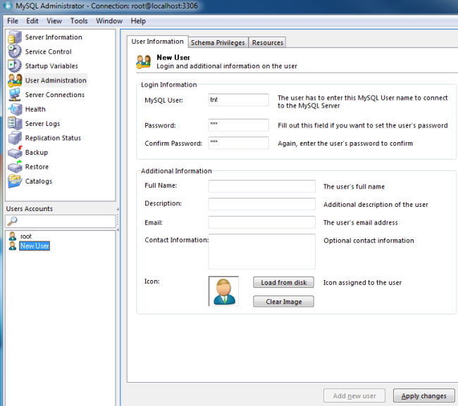

In the Schema Privileges tab chose the "tntconcept" schema previously created, and move all privileges on the right list to the left list using the corresponding button. Apply the changes.
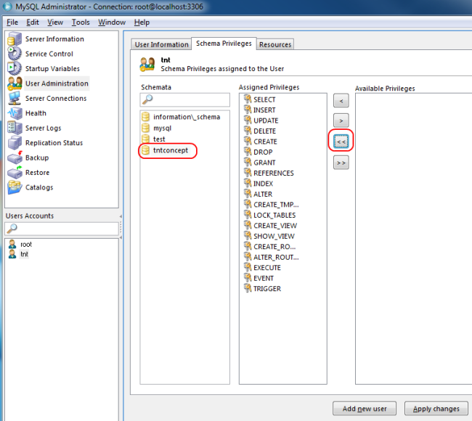

Close the MySQL Administrator application and run MySQL Query Browser.

Access the “tntconcept” database as “tnt” user:
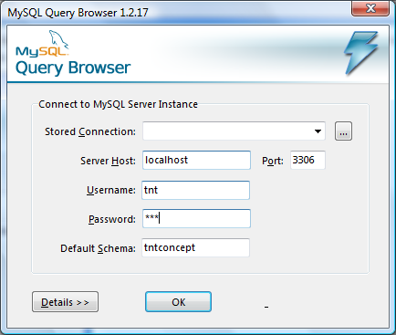
And run the database creation script enclosed in the application installation.

To do it, choose New Script Tab in the File menu:

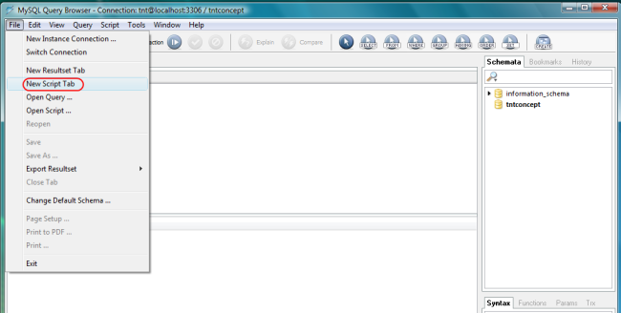

And in the new tab, paste the contents of the script $TEMPDIR/sql/mysql/createTables.sql. Click on Execute:

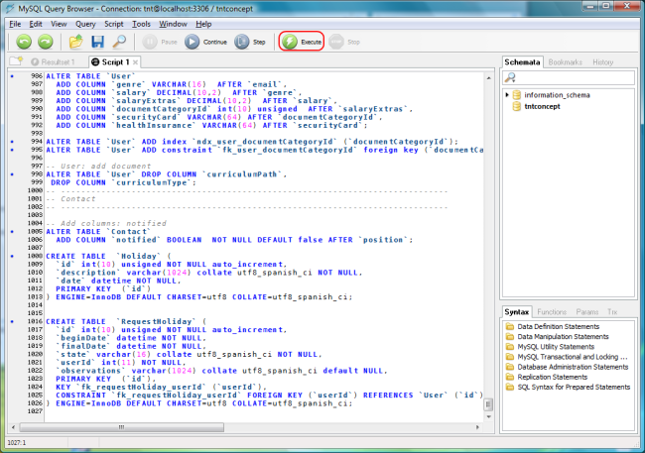
This completes the database installation. You can now close the MySQL Query Browser application (exit without saving the script).
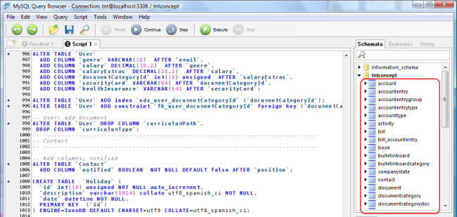

Installing TNTConcept on the server
As indicated before, you may opt between a Tomcat 6 server or a JBoss 4.2.3 server. We will describe below the configuration steps for each server (remember that you will need to download the TNTConcept installation package that matches the chosen server).
In both cases, you will need a database driver JAR file (JDBC driver) to connect to MySQL.
Said file can be downloaded from MySQL website: http://dev.mysql.com/downloads/connector/j/
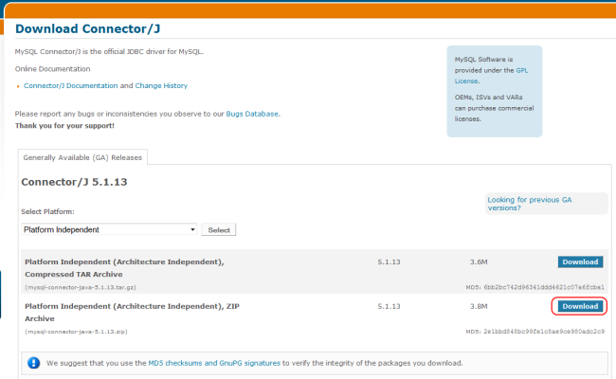
Sometimes it may come included in the MySQL distribution, depending on the operating system. A copy of this file (mysql-connector-java-5.1.X-bin.jar) is also included in the installation file, under the $TEMPDIR/lib directory.

Tomcat 6 configuration
Copy the $TEMPDIR/app/tntconcept.war provided in the installation file in the $TOMCAT6/webapps directory.
You will need to configure the web application context in Tomcat, so that it will know how to access the database and the application configuration directory. To do so, please modify the $TOMCAT6/conf/server.xml file.

Open the file and define a new web application context using the following XML fragment, to be placed within the virtual host, just before the label </Host>:

<Context path="/tntconcept" docBase="tntconcept">
<Manager pathname=""/>
<Environment name="TNTConceptConfigDir" type="java.lang.String" value="$CONFIG"/>
<Resource name="jdbc/TNTConcept" auth="Container" type="javax.sql.DataSource"
maxActive="100" maxIdle="30" maxWait="10000" driverClassName="com.mysql.jdbc.Driver"
username="$DBUSER" password="$DBPASSWD"
url="jdbc:mysql://localhost:3306/$DB?autoReconnect=true"/>
</Context>

</Host> CAUTION! Please make sure to keep the </Host> label after the context
You have to replace the values in red with the correct values in your installation (if you are doing an update please read section 4.1.1). Regarding the value of the TNTConceptConfigDir ($CONFIG) context variable , it is advisable to use /etc/tntconcept in Unix systems and c:/tntconcept on Windows, but you may point it to any other directory.
The database name ($DB) must be replaced by the real name of your database. For example, if you installed version 0.1, the database will probably be called intraweb. For all other versions it is recommended to call the database tntconcept.
In this guide's example, the file would look as follows:
<Context path="/tntconcept" docBase="tntconcept">
<Manager pathname=""/>
<Environment name="TNTConceptConfigDir" type="java.lang.String" value="c:/tntconcept"/>
<Resource name="jdbc/TNTConcept" auth="Container" type="javax.sql.DataSource"
maxActive="100" maxIdle="30" maxWait="10000" driverClassName="com.mysql.jdbc.Driver"
username="tnt" password="tnt"
url="jdbc:mysql://localhost:3306/tntconcept?autoReconnect=true"/>
</Context>

Additionally, you will need to copy the MySQL connector JAR file to $TOMCAT6/lib.

JBoss configuration
Copy the $TEMPDIR/app/tntconcept.war provided in the installation file in the $JBOSS/server/default/deploy directory.
You will need to create a datasource to access the database. To do it, copy the $TEMPDIR/jboss/tntconcept-ds.xml file to $JBOSS/server/default/deploy and edit it:
<datasources>
<local-tx-datasource>
<jndi-name>jdbc/TNTConcept</jndi-name>
<connection-url>jdbc:mysql://localhost:3306/$DB</connection-url>
<driver-class>com.mysql.jdbc.Driver</driver-class>
<user-name>$DBUSER</user-name>
<password>$DBPASSWD</password>
</local-tx-datasource>
</datasources>

replacing the values highlighted in red with the correct values from your environment (if you are doing an update please read section 4.1.1).
In this guide's example, the file would look as follows:
<datasources>
<local-tx-datasource>
<jndi-name>jdbc/TNTConcept</jndi-name>
<connection-url>jdbc:mysql://localhost:3306/tntconcept</connection-url>
<driver-class>com.mysql.jdbc.Driver</driver-class>
<user-name>tnt</user-name>
<password>tnt</password>
</local-tx-datasource>
</datasources>

The server also needs to know which is the application configuration directory. Please copy the $TEMPDIR/jboss/tntconcept-service.xml file to $JBOSS/server/default/deploy and edit it:
<server>
<mbean code="org.jboss.naming.JNDIBindingServiceMgr"
name="jboss.tests:service=JNDIBindingServiceMgr">
<attribute name="BindingsConfig" serialDataType="jbxb">
<jndi:bindings
xmlns:xs="http://www.w3.org/2001/XMLSchema-instance"
xmlns:jndi="urn:jboss:jndi-binding-service:1.0"
xs:schemaLocation="urn:jboss:jndi-binding-service:1.0 resource:jndi-binding-service_1_0.xsd">
<jndi:binding name="TNTConceptConfigDir">
<jndi:value type="java.lang.String">$CONFIG</jndi:value>
</jndi:binding>
</jndi:bindings>
</attribute>
<depends>jboss:service=Naming</depends>
</mbean>
</server>

modifying the value in red to point to the configuration directory (if you are doing an update please read section 4.1.1).
It is advisable to use /etc/tntconcept in Unix systems and c:/tntconcept on Windows, but you may point it to any other directory.

In this guide's example, the file would look as follows::
<server>
<mbean code="org.jboss.naming.JNDIBindingServiceMgr"
name="jboss.tests:service=JNDIBindingServiceMgr">
<attribute name="BindingsConfig" serialDataType="jbxb">
<jndi:bindings
xmlns:xs="http://www.w3.org/2001/XMLSchema-instance"
xmlns:jndi="urn:jboss:jndi-binding-service:1.0"
xs:schemaLocation="urn:jboss:jndi-binding-service:1.0 resource:jndi-binding-service_1_0.xsd">
<jndi:binding name="TNTConceptConfigDir">
<jndi:value type="java.lang.String">c:/tntconcept</jndi:value>
</jndi:binding>
</jndi:bindings>
</attribute>
<depends>jboss:service=Naming</depends>
</mbean>
</server>

Additionally, you will need to copy the MySQL connector JAR file to the $JBOSS/server/default/lib directory.

Configuring the application
Once the context is defined, you will need to copy the configuration files located in the $TEMPDIR/config directory in the installation package to the $CONFIG directory (specified in the TNTConceptConfigDir context variable in the previous step). These files are:
- log4j.properties (logging configuration files)
- autentia.properties (application properties)
- logo.bmp (company logo for reports)
- securityConfiguration.xml (security configuration file)
- securityConfiguration.xsd (XSD file to validate the security configuration file)
- docroot folder. Contains the application CSS style sheets (.css)
Once copied, you may edit the files and modify the configuration parameters to your liking. We will briefly explain the main properties to change. The remaining properties should be left unmodified, unless you know exactly what you are doing.

IMPORTANT
All file and directory paths in the configuration files must use the slash /, instead of the backslash \. This applies even to Windows systems. If backslash \ is used in Windows, the application may not dump traces, won't be able to attach files to registries and it may even have problems starting up.
- log4j.properties:
  - Under the heading “# Default file appender”, uncomment the log4j.appender.file.File property according to your platform (Windows or Unix) to specify the directory where the application should dump its traces. Such traces are generated during the execution of the application and can be used for debugging or to obtain information about what is happening.
  - Under the heading “# Migration log appender”, uncomment the log4j.appender.migration.File property according to your platform (Windows or Unix) to specify the directory where you want to dump the database migration traces. Such traces are only generated when the application is updated from one version to another.
  - Under the heading “# Security log appender”, uncomment the log4j.appender.security.File property according to your platform (Windows or Unix) to specify the directory where you want to dump the security related traces.

- autentia.properties:
  - Under the heading “# Uploaded files path”, uncomment the pathFicheros property according to your platform (Windows or Unix) to specify the directory where you want to store the file attachments of the application. The binary file attachments are documents (Word files, images, PDFs, ...) which can be uploaded to the server associated with certain types of registries (ie: CVs of users, quality documents ...)
  - Under the heading “# Personal report path”, uncomment the pathReports property according to your platform (Windows or Unix) to specify the directory where you want to store the personal report files. The application allows the use of user specified reports (in addition to those already defined), which must be created with JasperReports and loaded in this directory.
  - reportLogoName. Contains the name of the image used for reports. This image is searched under the path $CONFIG.
  - isUsingExternalCss. Indicates whether the CSS files are searched within the $CONFIG directory (true) or the internal files of the application included in the .war are used.
  - documentRoot. Folder within $CONFIG where the CSS files are searched for . Only relevant if the previous property is true.

Database migration
Before entering the application, it may be necessary to migrate the structure and contents of the database to the format of the installed version. Obviously, as the application evolves the data structure must evolve as well. With each version, new fields and tables are added and certain data values might be modified. All these changes are implemented through SQL scripts that alter the database to fit it from earlier versions to the currently installed one.

Explanation of the migration concept and console mode
TNTConcept tries to to make the migration process as automatic as possible, to avoid the need to work with low level MySQL tools. To that end we have the concept of console mode or locked application.
When a new version of TNTConcept is installed, the contents of the data in the database and executable Java classes are not synchronized: new classes expect to find fields and tables that might not exist in the previous version. To detect this condition, the application, during startup, compares the version of Java classes with the version of the data in the database (stored in a table named Version). If the version of the Java classes is higher than that of the database, the application enters console mode and remains "locked".
When the application is locked only the application console can be accessed, which is a simple page that allows migrating the database (ie launching scripts to migrate the SQL database):

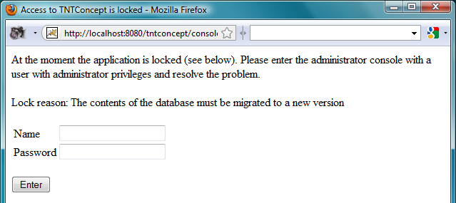
Once we enter the console with an administrator user and the migration process is properly executed, the database is updated to the new version and the application is unlocked. The console will not appear until the next version upgrade. Note that not all version upgrades require a database migration.

Carrying out the migration process
IMPORTANT
We strongly recommend making a backup of the database before migrating it to prevent data corruption or data loss during the process. This is not necessary if you are installing the application from scratch, only if you are upgrading.

Start Tomcat (o JBoss) and connect to the application entering the following address in the browser: http://localhost:8080/tntconcept. You will see that, upon connection, the usual start screen is not shown, but the TNTConcept administration console:
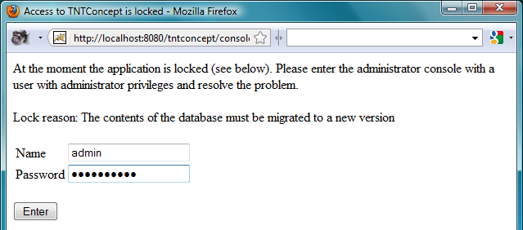
Enter an administrator user and password (the default user administrator is admin and the password adminadmin). The console menu will be shown. Clicking on “Migrate database”, you will see an explanation of the function and a button to carry out the migration:
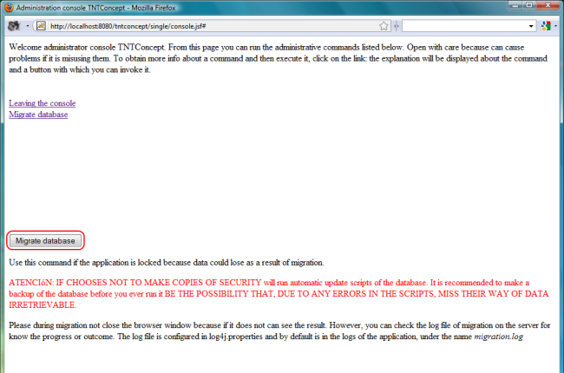
Press the button, which will run the scripts for updating the database. The application will report the result once the process is finished. You can see the detailed result of the migration in the trace file set in $CONFIG/log4j.properties under the key log4j.appender.migration.File.
Once the database is migrated, if all went well, click on "Leaving the console".
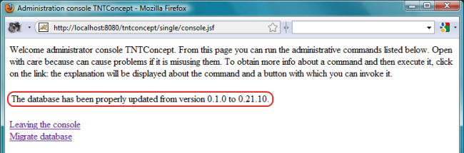
Then close your browser, start a new one, and access again to: http://localhost:8080/tntconcept.

Starting the application
If everything is properly configured and the Tomcat (or JBoss) and MySQL services started, you can go to a browser and run the application (http://localhost:8080/tntconcept):
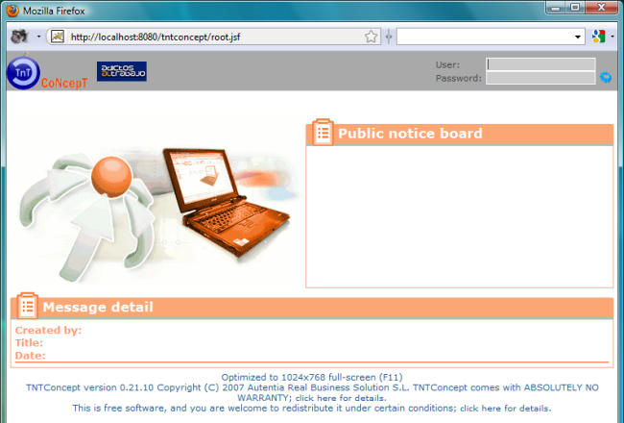
To allow you to enter for the first time, the application creates a user with manager profile and the following details:
User: admin
Password: adminadmin
(you will be requested to change the password in the first access).
You must also bear in mind that when you create a new user (using the Administration → Users menu) the password assigned by default is 'password'.
The current user's password can be changed from the Administration menu.
Additionally, you can reset users' passwords with an administrator user by editing the user and clicking on the icon .
Besides, the application creates an initial company named 'Nuestra Empresa' (that means 'Our Company') with empty data. You should edit it and enter the correct data for your company. Reports and other parts of the application use this company data to generate information.

License
GNU Free Documentation License
Version 1.3, 3 November 2008

Copyright (C) 2000, 2001, 2002, 2007, 2008 Free Software Foundation, Inc.
<http://fsf.org/>
Everyone is permitted to copy and distribute verbatim copies
of this license document, but changing it is not allowed.

0. PREAMBLE

The purpose of this License is to make a manual, textbook, or other
functional and useful document "free" in the sense of freedom: to
assure everyone the effective freedom to copy and redistribute it,
with or without modifying it, either commercially or noncommercially.
Secondarily, this License preserves for the author and publisher a way
to get credit for their work, while not being considered responsible
for modifications made by others.

This License is a kind of "copyleft", which means that derivative
works of the document must themselves be free in the same sense. It
complements the GNU General Public License, which is a copyleft
license designed for free software.

We have designed this License in order to use it for manuals for free
software, because free software needs free documentation: a free
program should come with manuals providing the same freedoms that the
software does. But this License is not limited to software manuals;
it can be used for any textual work, regardless of subject matter or
whether it is published as a printed book. We recommend this License
principally for works whose purpose is instruction or reference.

1. APPLICABILITY AND DEFINITIONS

This License applies to any manual or other work, in any medium, that
contains a notice placed by the copyright holder saying it can be
distributed under the terms of this License. Such a notice grants a
world-wide, royalty-free license, unlimited in duration, to use that
work under the conditions stated herein. The "Document", below,
refers to any such manual or work. Any member of the public is a
licensee, and is addressed as "you". You accept the license if you
copy, modify or distribute the work in a way requiring permission
under copyright law.

A "Modified Version" of the Document means any work containing the
Document or a portion of it, either copied verbatim, or with
modifications and/or translated into another language.

A "Secondary Section" is a named appendix or a front-matter section of
the Document that deals exclusively with the relationship of the
publishers or authors of the Document to the Document's overall
subject (or to related matters) and contains nothing that could fall
directly within that overall subject. (Thus, if the Document is in
part a textbook of mathematics, a Secondary Section may not explain
any mathematics.) The relationship could be a matter of historical
connection with the subject or with related matters, or of legal,
commercial, philosophical, ethical or political position regarding
them.

The "Invariant Sections" are certain Secondary Sections whose titles
are designated, as being those of Invariant Sections, in the notice
that says that the Document is released under this License. If a
section does not fit the above definition of Secondary then it is not
allowed to be designated as Invariant. The Document may contain zero
Invariant Sections. If the Document does not identify any Invariant
Sections then there are none.

The "Cover Texts" are certain short passages of text that are listed,
as Front-Cover Texts or Back-Cover Texts, in the notice that says that
the Document is released under this License. A Front-Cover Text may
be at most 5 words, and a Back-Cover Text may be at most 25 words.

A "Transparent" copy of the Document means a machine-readable copy,
represented in a format whose specification is available to the
general public, that is suitable for revising the document
straightforwardly with generic text editors or (for images composed of
pixels) generic paint programs or (for drawings) some widely available
drawing editor, and that is suitable for input to text formatters or
for automatic translation to a variety of formats suitable for input
to text formatters. A copy made in an otherwise Transparent file
format whose markup, or absence of markup, has been arranged to thwart
or discourage subsequent modification by readers is not Transparent.
An image format is not Transparent if used for any substantial amount
of text. A copy that is not "Transparent" is called "Opaque".

Examples of suitable formats for Transparent copies include plain
ASCII without markup, Texinfo input format, LaTeX input format, SGML
or XML using a publicly available DTD, and standard-conforming simple
HTML, PostScript or PDF designed for human modification. Examples of
transparent image formats include PNG, XCF and JPG. Opaque formats
include proprietary formats that can be read and edited only by
proprietary word processors, SGML or XML for which the DTD and/or
processing tools are not generally available, and the
machine-generated HTML, PostScript or PDF produced by some word
processors for output purposes only.

The "Title Page" means, for a printed book, the title page itself,
plus such following pages as are needed to hold, legibly, the material
this License requires to appear in the title page. For works in
formats which do not have any title page as such, "Title Page" means
the text near the most prominent appearance of the work's title,
preceding the beginning of the body of the text.

The "publisher" means any person or entity that distributes copies of
the Document to the public.

A section "Entitled XYZ" means a named subunit of the Document whose
title either is precisely XYZ or contains XYZ in parentheses following
text that translates XYZ in another language. (Here XYZ stands for a
specific section name mentioned below, such as "Acknowledgements",
"Dedications", "Endorsements", or "History".) To "Preserve the Title"
of such a section when you modify the Document means that it remains a
section "Entitled XYZ" according to this definition.

The Document may include Warranty Disclaimers next to the notice which
states that this License applies to the Document. These Warranty
Disclaimers are considered to be included by reference in this
License, but only as regards disclaiming warranties: any other
implication that these Warranty Disclaimers may have is void and has
no effect on the meaning of this License.

2. VERBATIM COPYING

You may copy and distribute the Document in any medium, either
commercially or noncommercially, provided that this License, the
copyright notices, and the license notice saying this License applies
to the Document are reproduced in all copies, and that you add no
other conditions whatsoever to those of this License. You may not use
technical measures to obstruct or control the reading or further
copying of the copies you make or distribute. However, you may accept
compensation in exchange for copies. If you distribute a large enough
number of copies you must also follow the conditions in section 3.

You may also lend copies, under the same conditions stated above, and
you may publicly display copies.

3. COPYING IN QUANTITY

If you publish printed copies (or copies in media that commonly have
printed covers) of the Document, numbering more than 100, and the
Document's license notice requires Cover Texts, you must enclose the
copies in covers that carry, clearly and legibly, all these Cover
Texts: Front-Cover Texts on the front cover, and Back-Cover Texts on
the back cover. Both covers must also clearly and legibly identify
you as the publisher of these copies. The front cover must present
the full title with all words of the title equally prominent and
visible. You may add other material on the covers in addition.
Copying with changes limited to the covers, as long as they preserve
the title of the Document and satisfy these conditions, can be treated
as verbatim copying in other respects.

If the required texts for either cover are too voluminous to fit
legibly, you should put the first ones listed (as many as fit
reasonably) on the actual cover, and continue the rest onto adjacent
pages.

If you publish or distribute Opaque copies of the Document numbering
more than 100, you must either include a machine-readable Transparent
copy along with each Opaque copy, or state in or with each Opaque copy
a computer-network location from which the general network-using
public has access to download using public-standard network protocols
a complete Transparent copy of the Document, free of added material.
If you use the latter option, you must take reasonably prudent steps,
when you begin distribution of Opaque copies in quantity, to ensure
that this Transparent copy will remain thus accessible at the stated
location until at least one year after the last time you distribute an
Opaque copy (directly or through your agents or retailers) of that
edition to the public.

It is requested, but not required, that you contact the authors of the
Document well before redistributing any large number of copies, to
give them a chance to provide you with an updated version of the
Document.

4. MODIFICATIONS

You may copy and distribute a Modified Version of the Document under
the conditions of sections 2 and 3 above, provided that you release
the Modified Version under precisely this License, with the Modified
Version filling the role of the Document, thus licensing distribution
and modification of the Modified Version to whoever possesses a copy
of it. In addition, you must do these things in the Modified Version:

A. Use in the Title Page (and on the covers, if any) a title distinct
from that of the Document, and from those of previous versions
(which should, if there were any, be listed in the History section
of the Document). You may use the same title as a previous version
if the original publisher of that version gives permission.
B. List on the Title Page, as authors, one or more persons or entities
responsible for authorship of the modifications in the Modified
Version, together with at least five of the principal authors of the
Document (all of its principal authors, if it has fewer than five),
unless they release you from this requirement.
C. State on the Title page the name of the publisher of the
Modified Version, as the publisher.
D. Preserve all the copyright notices of the Document.
E. Add an appropriate copyright notice for your modifications
adjacent to the other copyright notices.
F. Include, immediately after the copyright notices, a license notice
giving the public permission to use the Modified Version under the
terms of this License, in the form shown in the Addendum below.
G. Preserve in that license notice the full lists of Invariant Sections
and required Cover Texts given in the Document's license notice.
H. Include an unaltered copy of this License.
I. Preserve the section Entitled "History", Preserve its Title, and add
to it an item stating at least the title, year, new authors, and
publisher of the Modified Version as given on the Title Page. If
there is no section Entitled "History" in the Document, create one
stating the title, year, authors, and publisher of the Document as
given on its Title Page, then add an item describing the Modified
Version as stated in the previous sentence.
J. Preserve the network location, if any, given in the Document for
public access to a Transparent copy of the Document, and likewise
the network locations given in the Document for previous versions
it was based on. These may be placed in the "History" section.
You may omit a network location for a work that was published at
least four years before the Document itself, or if the original
publisher of the version it refers to gives permission.
K. For any section Entitled "Acknowledgements" or "Dedications",
Preserve the Title of the section, and preserve in the section all
the substance and tone of each of the contributor acknowledgements
and/or dedications given therein.
L. Preserve all the Invariant Sections of the Document,
unaltered in their text and in their titles. Section numbers
or the equivalent are not considered part of the section titles.
M. Delete any section Entitled "Endorsements". Such a section
may not be included in the Modified Version.
N. Do not retitle any existing section to be Entitled "Endorsements"
or to conflict in title with any Invariant Section.
O. Preserve any Warranty Disclaimers.

If the Modified Version includes new front-matter sections or
appendices that qualify as Secondary Sections and contain no material
copied from the Document, you may at your option designate some or all
of these sections as invariant. To do this, add their titles to the
list of Invariant Sections in the Modified Version's license notice.
These titles must be distinct from any other section titles.

You may add a section Entitled "Endorsements", provided it contains
nothing but endorsements of your Modified Version by various
parties--for example, statements of peer review or that the text has
been approved by an organization as the authoritative definition of a
standard.

You may add a passage of up to five words as a Front-Cover Text, and a
passage of up to 25 words as a Back-Cover Text, to the end of the list
of Cover Texts in the Modified Version. Only one passage of
Front-Cover Text and one of Back-Cover Text may be added by (or
through arrangements made by) any one entity. If the Document already
includes a cover text for the same cover, previously added by you or
by arrangement made by the same entity you are acting on behalf of,
you may not add another; but you may replace the old one, on explicit
permission from the previous publisher that added the old one.

The author(s) and publisher(s) of the Document do not by this License
give permission to use their names for publicity for or to assert or
imply endorsement of any Modified Version.

5. COMBINING DOCUMENTS

You may combine the Document with other documents released under this
License, under the terms defined in section 4 above for modified
versions, provided that you include in the combination all of the
Invariant Sections of all of the original documents, unmodified, and
list them all as Invariant Sections of your combined work in its
license notice, and that you preserve all their Warranty Disclaimers.

The combined work need only contain one copy of this License, and
multiple identical Invariant Sections may be replaced with a single
copy. If there are multiple Invariant Sections with the same name but
different contents, make the title of each such section unique by
adding at the end of it, in parentheses, the name of the original
author or publisher of that section if known, or else a unique number.
Make the same adjustment to the section titles in the list of
Invariant Sections in the license notice of the combined work.

In the combination, you must combine any sections Entitled "History"
in the various original documents, forming one section Entitled
"History"; likewise combine any sections Entitled "Acknowledgements",
and any sections Entitled "Dedications". You must delete all sections
Entitled "Endorsements".

6. COLLECTIONS OF DOCUMENTS

You may make a collection consisting of the Document and other
documents released under this License, and replace the individual
copies of this License in the various documents with a single copy
that is included in the collection, provided that you follow the rules
of this License for verbatim copying of each of the documents in all
other respects.

You may extract a single document from such a collection, and
distribute it individually under this License, provided you insert a
copy of this License into the extracted document, and follow this
License in all other respects regarding verbatim copying of that
document.

7. AGGREGATION WITH INDEPENDENT WORKS

A compilation of the Document or its derivatives with other separate
and independent documents or works, in or on a volume of a storage or
distribution medium, is called an "aggregate" if the copyright
resulting from the compilation is not used to limit the legal rights
of the compilation's users beyond what the individual works permit.
When the Document is included in an aggregate, this License does not
apply to the other works in the aggregate which are not themselves
derivative works of the Document.

If the Cover Text requirement of section 3 is applicable to these
copies of the Document, then if the Document is less than one half of
the entire aggregate, the Document's Cover Texts may be placed on
covers that bracket the Document within the aggregate, or the
electronic equivalent of covers if the Document is in electronic form.
Otherwise they must appear on printed covers that bracket the whole
aggregate.

8. TRANSLATION

Translation is considered a kind of modification, so you may
distribute translations of the Document under the terms of section 4.
Replacing Invariant Sections with translations requires special
permission from their copyright holders, but you may include
translations of some or all Invariant Sections in addition to the
original versions of these Invariant Sections. You may include a
translation of this License, and all the license notices in the
Document, and any Warranty Disclaimers, provided that you also include
the original English version of this License and the original versions
of those notices and disclaimers. In case of a disagreement between
the translation and the original version of this License or a notice
or disclaimer, the original version will prevail.

If a section in the Document is Entitled "Acknowledgements",
"Dedications", or "History", the requirement (section 4) to Preserve
its Title (section 1) will typically require changing the actual
title.

9. TERMINATION

You may not copy, modify, sublicense, or distribute the Document
except as expressly provided under this License. Any attempt
otherwise to copy, modify, sublicense, or distribute it is void, and
will automatically terminate your rights under this License.

However, if you cease all violation of this License, then your license
from a particular copyright holder is reinstated (a) provisionally,
unless and until the copyright holder explicitly and finally
terminates your license, and (b) permanently, if the copyright holder
fails to notify you of the violation by some reasonable means prior to
60 days after the cessation.

Moreover, your license from a particular copyright holder is
reinstated permanently if the copyright holder notifies you of the
violation by some reasonable means, this is the first time you have
received notice of violation of this License (for any work) from that
copyright holder, and you cure the violation prior to 30 days after
your receipt of the notice.

Termination of your rights under this section does not terminate the
licenses of parties who have received copies or rights from you under
this License. If your rights have been terminated and not permanently
reinstated, receipt of a copy of some or all of the same material does
not give you any rights to use it.

10. FUTURE REVISIONS OF THIS LICENSE

The Free Software Foundation may publish new, revised versions of the
GNU Free Documentation License from time to time. Such new versions
will be similar in spirit to the present version, but may differ in
detail to address new problems or concerns. See
http://www.gnu.org/copyleft/.

Each version of the License is given a distinguishing version number.
If the Document specifies that a particular numbered version of this
License "or any later version" applies to it, you have the option of
following the terms and conditions either of that specified version or
of any later version that has been published (not as a draft) by the
Free Software Foundation. If the Document does not specify a version
number of this License, you may choose any version ever published (not
as a draft) by the Free Software Foundation. If the Document
specifies that a proxy can decide which future versions of this
License can be used, that proxy's public statement of acceptance of a
version permanently authorizes you to choose that version for the
Document.

11. RELICENSING

"Massive Multiauthor Collaboration Site" (or "MMC Site") means any
World Wide Web server that publishes copyrightable works and also
provides prominent facilities for anybody to edit those works. A
public wiki that anybody can edit is an example of such a server. A
"Massive Multiauthor Collaboration" (or "MMC") contained in the site
means any set of copyrightable works thus published on the MMC site.

"CC-BY-SA" means the Creative Commons Attribution-Share Alike 3.0
license published by Creative Commons Corporation, a not-for-profit
corporation with a principal place of business in San Francisco,
California, as well as future copyleft versions of that license
published by that same organization.

"Incorporate" means to publish or republish a Document, in whole or in
part, as part of another Document.

An MMC is "eligible for relicensing" if it is licensed under this
License, and if all works that were first published under this License
somewhere other than this MMC, and subsequently incorporated in whole or
in part into the MMC, (1) had no cover texts or invariant sections, and
(2) were thus incorporated prior to November 1, 2008.

The operator of an MMC Site may republish an MMC contained in the site
under CC-BY-SA on the same site at any time before August 1, 2009,
provided the MMC is eligible for relicensing.

ADDENDUM: How to use this License for your documents

To use this License in a document you have written, include a copy of
the License in the document and put the following copyright and
license notices just after the title page:

Copyright (c) YEAR YOUR NAME.
Permission is granted to copy, distribute and/or modify this document
under the terms of the GNU Free Documentation License, Version 1.3
or any later version published by the Free Software Foundation;
with no Invariant Sections, no Front-Cover Texts, and no Back-Cover Texts.
A copy of the license is included in the section entitled "GNU
Free Documentation License".

If you have Invariant Sections, Front-Cover Texts and Back-Cover Texts,
replace the "with...Texts." line with this:

with the Invariant Sections being LIST THEIR TITLES, with the
Front-Cover Texts being LIST, and with the Back-Cover Texts being LIST.

If you have Invariant Sections without Cover Texts, or some other
combination of the three, merge those two alternatives to suit the
situation.

If your document contains nontrivial examples of program code, we
recommend releasing these examples in parallel under your choice of
free software license, such as the GNU General Public License,
to permit their use in free software.

